**Community Insight Mapping:**

**Unveiling Socio-Economic Dynamics for Informed Decision-Making in San Marcos, TX**



**Project Manager**: Pamela Boyd

**Assistant Project Manager:** Jonathan Knoll

**GIS Analyst**: Devin Peters

**GIS Analyst**: Alee Sho

February 21, 2024

**Table of Contents**

1. Introduction

1.1 Summary………………………………………………………….…….……1

1.2 Purpose……………………………………………………………………….1

1.3 Scope…………………………………………………………………….....1-2

2. Literature Review………………………………………………………….………...…..2-4

3. Data

3.1 Master Data List………………………………………………….....…...…4-6

4. Methodology

4.1 Data Processing ……………………………………………………………..6

4.2 Analysis……………………………………………………………………...6

4.3 Flowchart………………………………………………………………….....7

4.4 Implication of Results……………………………………………………..…7

5. Budget…………………………………………………………………………...…….......8

6. Timeline...............................................................................................................................9

7. Deliverables………………………………………………………………………............10

8. Conclusion

8.1 Summary……………………………………………………………...…......10

8.2 Impacts…………………………………………………………………........10

9. References……………………………………………………………………………..11-12

10. Appendix

10.1 Participation.........................................................................................................13

**1. Introduction**

1.2 Summary

Communities often face various challenges that require financial assistance. As a result, city governments must prioritize areas in need of support. In collaboration with the City of San Marcos, this study aims to identify and address socioeconomic disparities within the community. Through data analysis and geospatial visualization, the partnership aims to enhance the city's understanding of local needs and ensure the appropriate distribution of grants and resources to its residents. This approach allows for specific allocation of financial grants to disadvantaged communities based on their specific needs.

1.3 Purpose

The goal of this study is to create information products to be used as a tool for policymakers to distribute financial grants to the socioeconomically disadvantaged communities within the city of San Marcos. The products will facilitate an understanding of disparities within the community, benefiting not only key decision-makers but also the general public. Increased awareness and comprehension of these disparities will lead to heightened empowerment as a secondary outcome.

1.4 Scope

The study area of this project will include all census tracts that intersect with the San Marcos city limits (Figure 1). Analyzing data at the census tract level allows for a more granular understanding of the socio-economic conditions experienced by residents in different parts of the city. Because the dataset primarily comprises US Census data, the analysis will focus on the period from 2010 to 2022.

Figure 1. Map of study area



**2. Literature Review**

This literature review serves as a foundational component of this proposal, providing an overview and synthesis of existing research and resources relevant to developing community-level data products. The insights gained from this review will guide the creation of information products designed to meet the unique requirements of stakeholders for the City of San Marcos.

2.1 Exploring the Socio-Economic Landscape of San Marcos

Looking at the socio-economic landscape of San Marcos, it is evident that disparities exist, with 27.7% of its population residing below the poverty line (United States Census Bureau QuickFacts, 2022). Moreover, the diverse and dynamic landscape of San Marcos has led to severe weather occurrences such as flooding and wildfires, further widening the socio-economic

gap. Additionally, various intertwined factors, such as health, pollution, housing, and transportation, contribute to the percentage of poverty and inequalities (*Climate and Economic Justice Screening Tool*, n.d.). Although San Marcos is often described as a college town with over 7,000 students living on campus seasonally (Texas State University, 2023), there are over 70,000 permanent residents (United States Census Bureau QuickFacts, 2022). Within this population, 9.4% are at least 65 years old or older, 10.5% are living with a disability, and 17.5% under the age of 65 have no health insurance (United States Census Bureau QuickFacts, 2022). These factors, among others not listed, present several opportunities for the city to investigate where funds should be allocated.

2.2 Implications of Socio-Economic Inequalities

Previous studies have highlighted the critical role of socioeconomic factors in shaping the lifespan of individuals within a community (Gutin & Hummer, 2021). This connection is further underscored by research showing that income inequality exacerbates health disparities, with wealth concentrated among fewer individuals, thereby widening the gap in life expectancy between the affluent and the disadvantaged (Rogers et al., 2020). Moreover, the repercussions of social inequality are considerable in younger age groups, where higher mortality rates persist due to violence, drug overdoses, and accidents (Gutin & Hummer, 2021). Overall, understanding the complexity of these disparities requires considering numerous factors, including transportation, education, environmental conditions (American Lung Association, 2023), housing, access to healthcare, and other social determinants (Leider et al., 2020).

2.3 Leveraging GIS for Community Equity

By using Geographic Information Systems (GIS), we can visualize areas that require more funding to have a significant impact on public health and illustrate how various geographical factors influence health and socio-economic outcomes. (Gill et al., 2023). Solving social inequities can be tough and costly, but using GIS along with modern mapping technology can help facilitate progress dramatically in this area (Wang, 2019). As mapping becomes more recognized and used due to the advances in data science, we can use GIS to see where and when things happen in space (Petrović et al., 2019). In conclusion, GIS can ensure efficiency and accuracy. They are indispensable in leveraging data analysis and visualization for effectively

allocating funds to the areas within the city that are most in need, thus narrowing disparities among neighborhoods.

**3. Data**

3.1 Master Data List

* Socioeconomic
  + Percent of population where household income is at or below 200% of poverty level
    - *Source: American Community Survey from 2015-2019, United States Census Bureau*
* Climate Change
  + Projected flood risk
    - *Source: Climate Risk Data Access from 2022, First Street*
  + Projected wildfire risk
    - *Source: Climate Risk Data Access from 2022, First Street*
  + Expected population and building loss rate due to natural hazards
    - *Source: National Risk Index from 2014-2021, FEMA*
* Energy
  + Energy cost
    - *Source: LEAD Tool from 2018, Energy.gov*
  + Air pollution
    - *Source: Fusion of model and monitor data from 2017, EPA.gov*
* Health
  + Rate of asthma
    - *Source: PLACES data from 2016-2019, Centers for Disease Control and Prevention*
  + Rate of diabetes
    - *Source: PLACES data from 2016-2019, Centers for Disease Control and Prevention*
  + Rate of heart diseases
    - *Source: PLACES data from 2016-2019, Centers for Disease Control and Prevention*
  + Low life expectancy
    - *Source: U.S. Small-Area Life Expectancy Estimates Project (USALEEP) from 2010-2015, Centers for Disease Control and Prevention*
* Housing
  + Housing cost
    - *Source: Comprehensive Housing Affordability Strategy dataset from 2014-2018, Office of Policy Development and Research (PD&R)*
  + Lack of green space
    - *Source: Percent Developed Imperviousness (CONUS) from 2019, Multi-Resolution Land Characteristics Consortium*
  + Likelihood of lead paint in housing
    - *Source: American Community Survey from 2015-2019, United States Census Bureau*
* Legacy Pollution
  + Proximities to hazardous waste facilities
    - *Source: Treatment, Storage, and Disposal Facilities (TSDF) data from 2020, EPA.gov*
* Transportation
  + Traffic proximity and volume
    - *Source: Traffic data from 2017, EPA.gov*
  + Transportation barriers
    - *Source: Transportation access disadvantage from 2022, U.S. Department of Transportation*
  + Diesel particulate matter exposure
    - *Source: National Air Toxics Assessment (NATA) from 2014, EPA.gov*
* Water and Wastewater
  + Wastewater discharge
    - *Source: Risk-Screening Environmental Indicators (RSEI) model from 2020, EPA.gov*
* Workforce Development
  + Individuals over 25 years old without at least a high school diploma
    - *Source: American Community Survey from 2015-2019, United States Census Bureau*

**4. Methodology**

4.1 Data Processing

All data for this project was obtained through the CEJS tool from the geoplatform.gov website. The tool provides data on the nine burdens this project covers. Specifically, the website provides a downloadable shapefile that embeds the CEJS data into every census tract in the United States. Fields in the census tract attribute table cover a specific subsection of each burden, such as the rate of asthma within a census tract.

4.2 Analysis

Using the census tract data from the CEJS website, maps will be produced using ArcGIS Pro to cover each burden subsection (Figure 2). This will be done by displaying the individual census tract fields and categorizing the display into classes. Each class denotes the presence or absence of disadvantage within a given census tract, while concurrently specifying the degree of disadvantage.

4.3 Flowchart

Figure 2. Flowchart

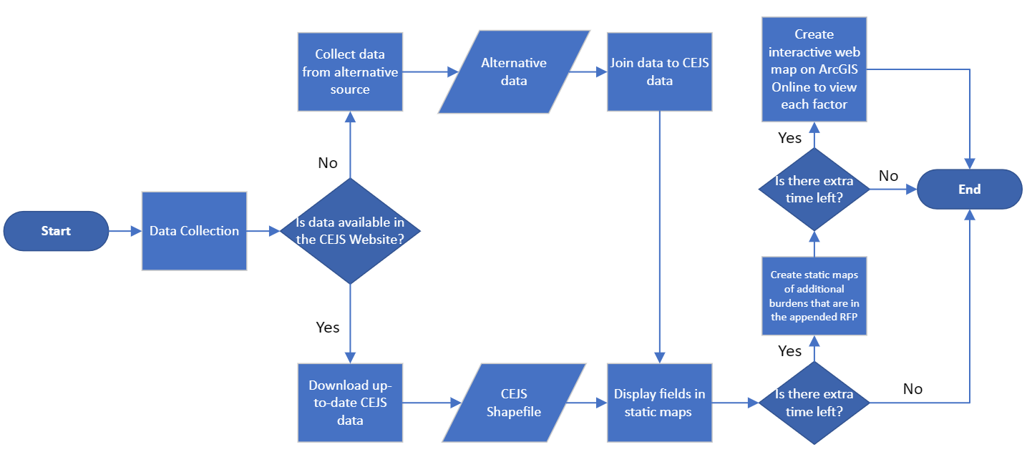

4.4 Implication of Results

The results will indicate which census tracts are disadvantaged based on the specified factors. Some census tracts may fall into many burden categories, and some may not fall into any. By knowing which census tracts are disproportionately affected by the burdens, financial grants can be allocated effectively.

An important limitation of this study is that much of the data was not recorded within the past year. Most data ranged between the years 2014 and 2020. Because data are not being produced regularly, this study cannot be repeated every year without producing the same results. Another limitation of this study is that the census tracts include data from outside of the city limits of San Marcos. Data from different cities, such as Kyle, TX, is included in these analyses and may not accurately reflect San Marcos.

**5. Budget**

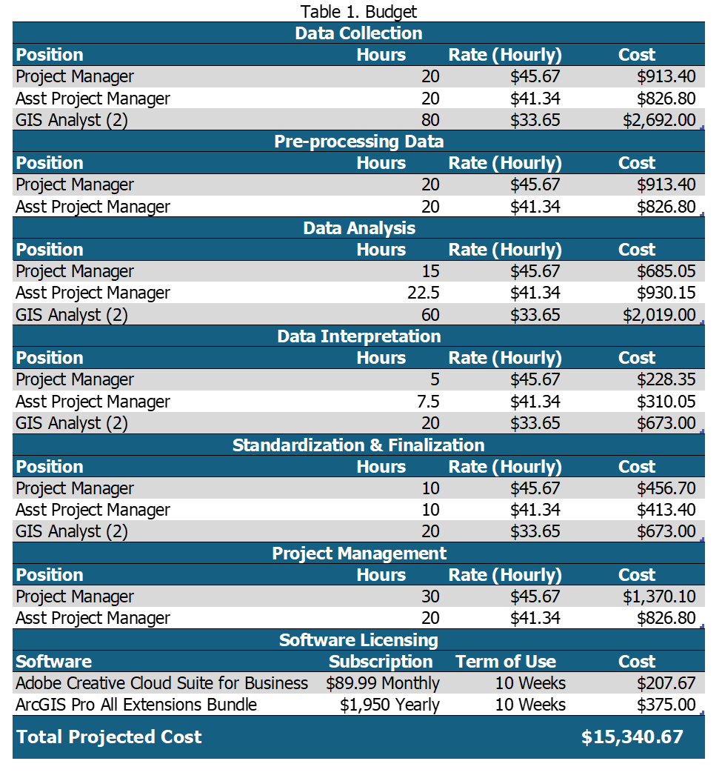

**6. Timeline**

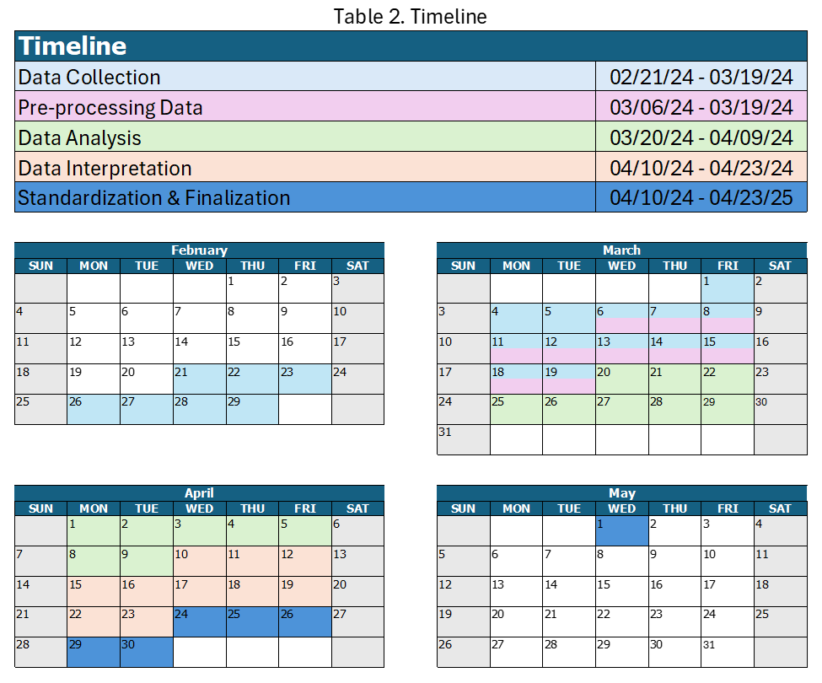

**7. Deliverables**

Upon project completion, the City of San Marcos will receive a set of tailored information products that outline the City's population and resources, specifically the

economically disadvantaged. These will assist City staff in gaining a comprehensive understanding of and support for the community, while also offering insights into the efficient securing and allocation of grants. The products include customizable, one-page reports using ArcGIS Pro for each burden or factor requested. We will provide data management workflows for long-term data upkeep, along with comprehensive documentation (proposal, progress reports, and final report). Lastly, presentation slides and a map poster summarizing the project results will facilitate knowledge sharing. This streamlined package ensures efficient information response, smooth grant applications, and informed decision-making by City staff.

**8. Conclusion**

8.1 Summary

Detecting socioeconomic disparities can require significant resources in terms of both time and money. However, leveraging data and technological advances enables the feasibility of interpreting findings to visualize them spatially. These factors represent highly effective methods for conducting precise community analyses.

8.2 Impacts

By providing reports that are easily interpreted on San Marcos' socioeconomic disparities, policymakers and grant coordinators can identify the areas that need the most assistance at the census tract level. In turn, the city can efficiently address these disparities by prioritizing which areas are lacking and effectively allocating funds. Addressing these disparities not only improves the well-being of these communities but also promotes greater equity and prosperity for the entire community.

**9. References**

American Lung Association. (2023, November 2). Disparities in the impact of air pollution*.* <https://www.lung.org/clean-air/outdoors/who-is-at-risk/disparities#:~:text=First%2C%20groups%20may%20face%20greater,increasing%20exposure%20to%20harmful%20pollutants>.

*Climate and Economic Justice Screening Tool*. (n.d.). Retrieved February 13, 2024, from [https://screeningtool.geoplatform.gov/en/methodology#10.41/29.8686/-97.927](https://screeningtool.geoplatform.gov/en/methodology%2310.41/29.8686/-97.927)

Gill, G., Fahnestock, L., De Vito, R., Somaiya, C. K., Streuli, S., Ramírez, D., Baker, R., Johnstone, A., Dyjack, D., & Randhawa, M. (2023c). Investing in retail food Safety: Assessing the NEHA-FDA Retail Flexible Funding Model Grant Program’s distribution through an SDOH lens. *Journal of Food Protection*, 86(12), 100181. <https://doi.org/10.1016/j.jfp.2023.100181>

Gutin, I., & Hummer, R. A. (2021). Social inequality and the future of US life expectancy. *Annual Review of Sociology*, 47(1), 501–520. <https://doi.org/10.1146/annurev-soc-072320-100249>

Leider, J. P., Meit, M., Mac McCullough, J., Resnick, B., Dekker, D., Alfonso, Y. N., & Bishai, D. (2020). The state of rural public Health: Enduring needs in a new decade. *American Journal of Public Health*, 110(9), 1283–1290. <https://doi.org/10.2105/ajph.2020.305728>

Petrović, A., Manley, D., & Van Ham, M. (2019). Freedom from the tyranny of neighbourhood: Rethinking sociospatial context effects. *Progress in Human Geography*, *44*(6), 1103–1123. <https://doi.org/10.1177/0309132519868767>

Rogers, R. G., Hummer, R. A., Vinneau, J. M., & Lawrence, E. (2020). Greater mortality variability in the United States in comparison with peer countries. *Demographic Research*, 42, 1039–1056. <https://doi.org/10.4054/demres.2020.42.36>

Texas State University. 2023. *Facts & data*. <https://brand.txst.edu/using-the-brand/writing/facts-and-data.html>

United States Census Bureau QuickFacts. 2022. *U.S. Census Bureau QuickFacts: San Marcos city, Texas.* Census Bureau QuickFacts. <https://www.census.gov/quickfacts/fact/table/sanmarcoscitytexas/PST045222>

Wang, F. (2019). Why public health needs GIS: a methodological overview. *Annals of GIS*, 26(1), 1–12. <https://doi.org/10.1080/19475683.2019.1702099>

**10. Appendix**

10.1 Participation

* Pamela Boyd- Project management, client engagement, proposal outline and formatting, subject matter research, table of contents, literature review, conclusion, references, appendix, PowerPoint presentation, proofreading and editing documents, and map standardization.
* Johnathan Knoll- Project management, data processing and analysis, data research, introduction-summary, purpose, scope, flow chart, methodology, and map production.
  + Maps produced: 90th Percentile for Asthma, 90th Percentile for Diabetes, 90th Percentile for Heart Disease, 90th percentile for Low Life Expectancy,90th Percentile for Energy, PM 2.5 Air Concentration, and 200% or Below Poverty Level Household Income
* Devin Peters- Data processing and analysis, logo design and branding, data research, timetable, budget, deliverables section, and map production.
  + Maps produced: DOT Travel Barrier Score, Traffic Proximity and Volume, Diesel Particulate Matter Exposure, Projected Flood Risk, Projected Wildfire Risk, Expected Population, and Building Loss Rate to Natural Hazards
* Alee Sho- Data processing and analysis, data research for each burden/factor, master data section for proposal, map production and visualization, and map standardization.
  + Maps produced: Housing burden, Percent pre-1960s Housing, Lack of greenspace, High school education and Proximity to Hazardous Waste