**Community Insight Mapping:**

**Unveiling Socio-Economic Dynamics for Informed Decision-Making in San Marcos, TX**

**Project Manager**: Pamela Boyd

**Assistant Project Manager:** Jonathan Knoll

**GIS Analyst**: Devin Peters

**GIS Analyst**: Alee Sho

March 26, 2024

**Table of Contents**

1. **Introduction**

1.1 Summary..............................................................................................1

1.2 Purpose Statement............................................................................1-2

1.3 Scope...................................................................................................2

1. **Tasks**

2.1 Work Completed.................................................................................3

2.2 Present Work.......................................................................................3

2.3 Work Scheduled...............................................................................3-4

2.4 Problems.............................................................................................4

1. **Conclusion**..............................................................................................................4-5
2. **Introduction**
   1. Summary

This report updates the City of San Marcos (COSM) on the progress of the socio-economic mapping project undertaken by River City Socio-Economic Mapping Solutions. Since our last meeting, we have completed all scheduled tasks and anticipate finishing the project by May 1, 2024, as outlined in our original proposal. This report details the purpose of the project, scope and timeline revisions, completed tasks, work scheduled, and issues encountered.

* 1. Purpose Statement

The objective of this project is to create information products to be used as a tool for policymakers to distribute financial grants to the socioeconomically disadvantaged communities within the city of San Marcos. The products will facilitate an understanding of disparities within the community, benefiting not only key decision-makers but also the general public. Increased awareness and comprehension of these disparities will lead to heightened empowerment as a secondary outcome. Using the Climate and Economic Justice Screening Tool (CEJS), we will consider the following economic burdens:

* Socioeconomic – percent of the population where household income is at or below two hundred percent of the poverty level.
* Climate change – projected flood risk, projected wildfire risk, expected population, and building loss rate due to natural hazards.
* Energy – energy cost and air pollution.
* Health – rate of asthma, rate of diabetes, rate of heart diseases, and low life expectancy.
* Housing – housing cost, lack of green space, and the likelihood of lead paint in housing.
* Legacy pollution – proximity to hazardous waste facilities.
* Transportation – traffic proximity and volume, transportation barriers, and diesel particulate matter exposure.
* Water and wastewater – wastewater discharge.
* Workforce development - individuals over twenty-five years old without at least a high school diploma.
  1. Scope

Our original study area for this project included all census tracts that intersected with the San Marcos city limits. The revised study area (Figure 1.) includes the boundary of the Extra-Terrestrial Jurisdiction (ETJ) interacting with the city limit of San Marcos. The inclusion of the ETJ in our analysis is crucial because it captures areas adjacent to the city limits where socio-economic burdens may still impact residents and communities, ensuring a more accurate identification of areas in need of grants beyond solely within the city boundaries of San Marcos.

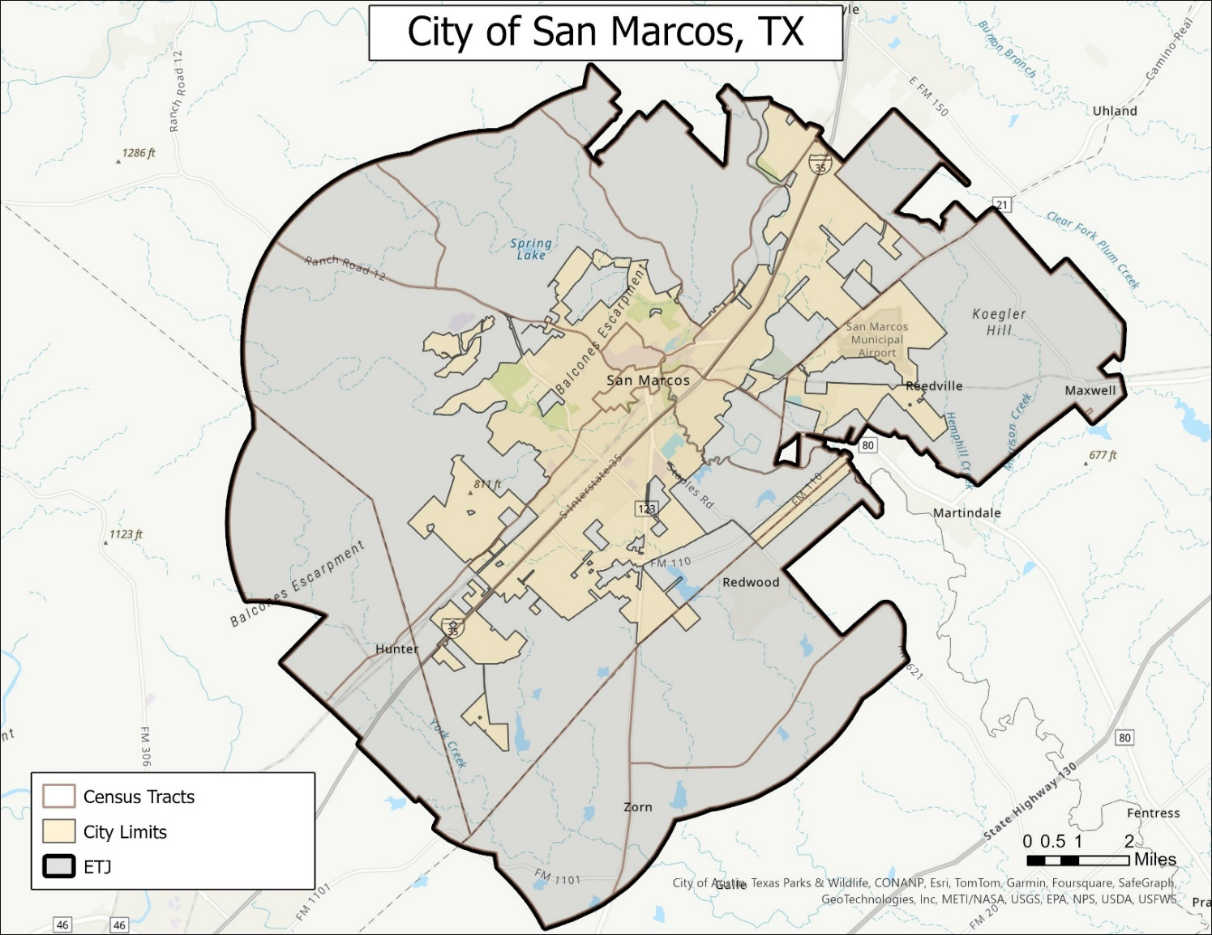Figure 1. Revised study area

**2. Tasks**

2.1 Work Completed

Since our last communication, we have made significant progress in aligning the project with your requirements and feedback. This includes incorporating the ETJ instead of having only the San Marcos city limit and the census tract. The goal here is to focus on what data falls within the ETJ zone. We also filled the ‘holes’ or ‘gaps’ within the ETJ to ensure a more accurate and visually representative depiction of its boundary.

Furthermore, we have adjusted our color scheme to no longer represent the most burdened areas with red or heavily saturated colors. Instead, we have opted for tones such as neutral, earth, or pastel to convey the desired message without unintentionally implying negative connotations.

2.2 Present Work

At this point, the focus of our project is to display our maps while being mindful of historical representations of burdened communities. In addition to employing different tones or color schemes, we have begun to reverse our color gradients, depicting darker colors for regions with greater opportunity rather than for the more burdened areas. By using lighter colors to emphasize areas in need, our maps foster a more equitable visual representation. We are also experimenting with various base maps to enhance the visual appeal and clarity of our symbology.

2.3 Work Scheduled

Our revised timetable (Table 1.) displays an updated timeline of our project with the following: From March 27th to April 16th, we will be interpreting our collected data. We expect to have our twenty unfinalized maps produced by April 16th. From April 17th to April 29th, we will use our time to finalize and format the products based on the preference of the COSM team. Our final product will be produced by April 29th. On May 1st, we will present our final presentation and deliverables.

Table 1. Timeline

2.4 Problems

The main issue we face is that our data may not accurately represent the needs of the city alone due to incorporating the San Marcos ETJ as our scope. The San Marcos ETJ intersects census tracts that use data from other cities and counties, potentially skewing the representation of burdens within San Marcos. Additionally, we have encountered difficulties in displaying our symbology without introducing biases among map viewers. Specifically, the use of darker colors to symbolize areas of more opportunity can inadvertently give the impression that those areas are more burdened. To address this, we intend to create multiple maps presenting the same data for the COSM to decide which approach is the best.

**3. Conclusion**

In conclusion, our team has made significant progress and is on schedule to provide a complete project by the requested date. Specifically, we intend to have twenty maps that cover the socioeconomic burdens of San Marcos to identify areas most suited for grants. If time allows, we will make these maps accessible through a web mapping application. Moreover, we may produce more maps to cover additional burdens at the request of the client.