**Community Insight Mapping:**

**Unveiling Socio-Economic Dynamics for Informed Decision-Making in San Marcos, TX**

**Project Manager**: Pamela Boyd

**Assistant Project Manager:** Jonathan Knoll

**GIS Analyst**: Devin Peters

**GIS Analyst**: Alee Sho

May 1, 2024

**Table of Contents**

**Abstract**..........................................................................................................................................1

1. **Introduction and Problem Statement**...................................................................................1-3

**2. Data**..........................................................................................................................................3-6

**3. Methods**...................................................................................................................................6-7

3.1 Data Processing and Workflow......................................................................................6

3.2 Data Interpretation......................................................................................................6-7

3.3 Standardization..............................................................................................................7

**4. Results and Discussion**.........................................................................................................7-10

4.1 Results......................................................................................................................7-10

4.2 Discussion...................................................................................................................10

**5. Conclusions**.........................................................................................................................10-12

**6. References**...........................................................................................................................13-14

**Appendix I**...............................................................................................................................25-28

**Appendix II**..................................................................................................................................29

**ABSTRACT**

This project focused on generating twenty maps that pinpointed the burdened areas in San Marcos. Leveraging data extracted from the Climate and Economic Justice Screening (CEJS) Tool, a meticulous process of data processing and visualization was undertaken using Geographic Information Systems (GIS). The methodology involved a strategic approach to data selection and integration, ensuring the accuracy and reliability of the resultant maps. Through this process, datasets were transformed into accessible and actionable insights, catering to the needs of policymakers tasked with allocating financial grants to the city's burdened areas. The project's findings unveiled varying degrees of socioeconomic challenges across different regions of San Marcos. By identifying these burdened areas, the project provided invaluable information essential for making informed decisions regarding the distribution of financial resources. Ultimately, the project succeeded in shedding light on the disparities within San Marcos, paving the way for targeted interventions to foster equitable development and social progress within the city.

**1. Introduction and Problem Statement**

The primary challenge addressed in this project pertains to the equitable allocation of financial grants to socioeconomically disadvantaged communities in San Marcos. Despite the acknowledged significance of directing resources toward these communities, an obstacle exists in accurately identifying and prioritizing areas requiring support. The absence of community information products interferes with policymakers' ability to make informed decisions and prevents effective strategies for addressing socioeconomic disparities. Figure 1 shows the project's study area, including all census tracts that intersect with the city of San Marcos’ extraterritorial jurisdiction (ETJ) and city limits.

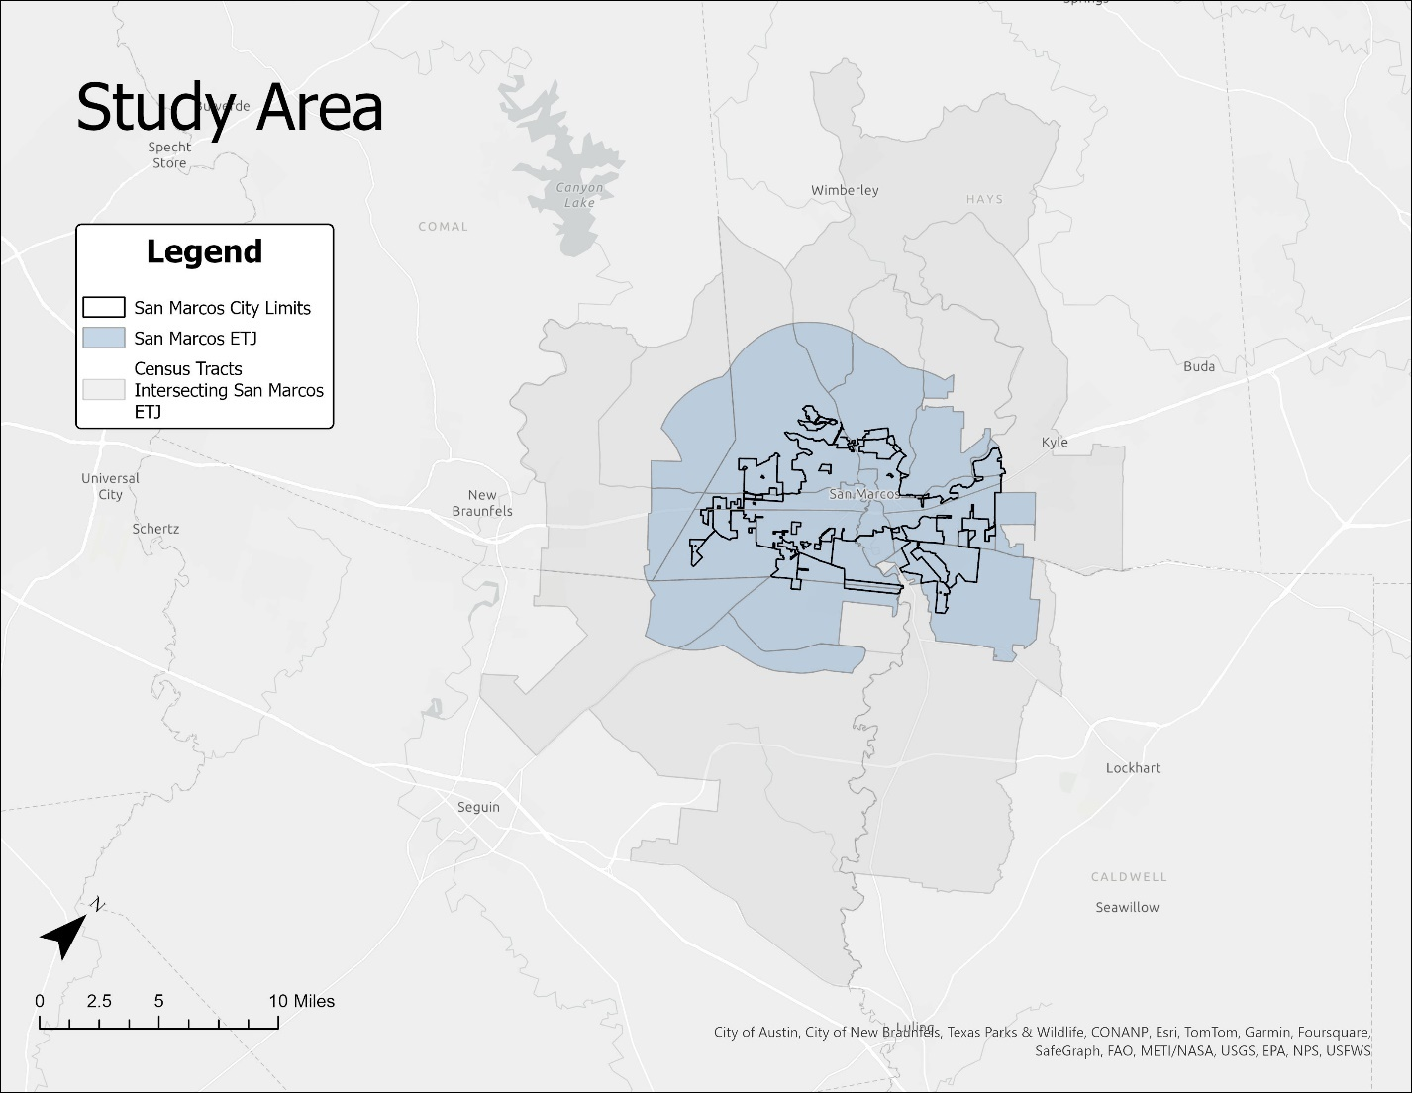

Figure 1. Study area, City of San Marcos

Looking at the socio-economic landscape of San Marcos, it is evident that disparities exist, with 27.7 percent of its population residing below the poverty line (United States Census Bureau QuickFacts, 2022). Moreover, the diverse and dynamic landscape of San Marcos has led to severe weather occurrences such as flooding and wildfires, further widening the socio-economic gap. Additionally, various intertwined factors, such as health, pollution, housing, and transportation, contribute to the percentage of poverty and inequalities (Climate and Economic Justice Screening Tool, n.d.). Although San Marcos is often described as a college town with over 7,000 students living on campus seasonally (Texas State University, 2023), there are over 70,000 permanent residents (United States Census Bureau QuickFacts, 2022).

To tackle this challenge, we have leveraged Geographic Information Systems (GIS) for spatial analysis and visualization. By using GIS, we can visualize areas that require more funding to have a significant impact on public health and illustrate how various geographical factors influence health and socio-economic outcomes. (Gill et al., 2023). Solving social inequities can be tough and costly, but using GIS along with modern mapping technology can help facilitate progress dramatically in this area (Wang, 2019). As mapping becomes more recognized and used due to the advances in data science, we can use GIS to see where and when things happen in space (Petrović et al., 2019). GIS is indispensable in leveraging data analysis and visualization to effectively allocate funds to the areas within the city that are most in need, thus narrowing disparities among neighborhoods.

**2. Data**

To ensure that the study was based on reliable, precise, and accurate information, a wide variety of data sources were utilized, including the Climate and Economic Justice Screening (CEJS) Tool. The CEJS Tool provides comprehensive socio-economic and environmental data that is essential for identifying areas of climate vulnerability and socio-economic disparities. Using the CEJS Tool, we considered the following economic burdens:

* Socioeconomic
  + Percent of population where household income is at or below 200% of poverty level
    - *Reference Source: American Community Survey from 2015-2019, United States Census Bureau*
* Climate Change
  + Projected flood risk
    - *Reference Source: Climate Risk Data Access from 2022, First Street*
  + Projected wildfire risk
    - *Reference Source: Climate Risk Data Access from 2022, First Street*
  + Expected population and building loss rate due to natural hazards
    - *Reference Source: National Risk Index from 2014-2021, FEMA*
* Energy
  + Energy cost
    - *Reference Source: LEAD Tool from 2018, Energy.gov*
  + Air pollution
    - *Reference Source: Fusion of model and monitor data from 2017, EPA.gov*
* Health
  + Rate of asthma
    - *Reference Source: PLACES data from 2016-2019, Centers for Disease Control and Prevention*
  + Rate of diabetes
    - *Reference Source: PLACES data from 2016-2019, Centers for Disease Control and Prevention*
  + Rate of heart diseases
    - *Reference Source: PLACES data from 2016-2019, Centers for Disease Control and Prevention*
  + Low life expectancy
    - *Reference Source: U.S. Small-Area Life Expectancy Estimates Project (USALEEP) from 2010-2015, Centers for Disease Control and Prevention*
* Housing
  + Housing cost
    - *Reference Source: Comprehensive Housing Affordability Strategy dataset from 2014-2018, Office of Policy Development and Research (PD&R)*
  + Lack of green space
    - *Reference Source: Percent Developed Imperviousness (CONUS) from 2019, Multi-Resolution Land Characteristics Consortium*
  + Likelihood of lead paint in housing
    - *Reference Source: American Community Survey from 2015-2019, United States Census Bureau*
* Legacy Pollution
  + Proximities to hazardous waste facilities
    - *Reference Source: Treatment, Storage, and Disposal Facilities (TSDF) data from 2020, EPA.gov*
* Transportation
  + Traffic proximity and volume
    - *Reference Source: Traffic data from 2017, EPA.gov*
  + Transportation barriers
    - *Reference Source: Transportation access disadvantage from 2022, U.S. Department of Transportation*
  + Diesel particulate matter exposure
    - *Reference Source: National Air Toxics Assessment (NATA) from 2014, EPA.gov*
* Water and Wastewater
  + Wastewater discharge
    - *Reference Source: Risk-Screening Environmental Indicators (RSEI) model from 2020, EPA.gov*
* Workforce Development
  + Individuals over 25 years old without at least a high school diploma
    - *Reference Source: American Community Survey from 2015-2019, United States Census Bureau*

The CEJS Tool offered several reference sources to cross-reference and further validate the CEJS data, updating any discrepancies to ensure that our analysis was based on the most reliable and current information. Ultimately, no significant discrepancies were found, confirming the precision of the CEJS data, which was ultimately used for our analysis. However, due to the varying time frames of data collection across the burden classifications, the accuracy of the data varied and was determined by the most recent dataset’s availability.

Our project hinged on precise data to effectively highlight the areas most burdened by various challenges. These burdens serve as critical indicators, shedding light on neglected communities across our map. Initially, our clients provided the foundational data that allowed us to transform raw statistics into a visually compelling narrative. While preserving the original data's integrity and defining the different levels of burdens across regions, we customized its presentation by refining the census tracts to fit within our map's scope. This strategic adjustment greatly improved the visual clarity and impact. The raw data provided to us was initially in the WGS 1984 projection and coordinate system. However, to better suit the requirements of our study area, we transformed it into the NAD 1983 HARN State Plane Texas S Central FIPS 4204 (US Feet) projection and coordinate system. This adjustment ensured compatibility and accuracy with the spatial context of our research

**3. Methods**

3.1 Data Processing and Workflow

The team used ArcGIS Pro software, a GIS platform, to process and interpret the collected data. Figure 2 details the workflow and rationale of this process.

Figure 2. Flowchart detailing project workflow

An initial step in the GIS process involved delineating the study area by merging the city boundary shapefile with the extraterritorial jurisdiction (ETJ) boundary shapefile. The merging process was critical in defining clear jurisdictional boundaries and ensuring that the study covered all relevant geographic areas comprehensively. Following this, a census tract shapefile from the US Census Bureau that included burden data for each tract was used. This shapefile was overlaid with the city and ETJ boundaries to select tracts for more detailed analysis based on their geographical and socio-economic relevance to the study goals. The focus was further refined by creating a clipped shapefile from these selected tracts, which isolated the areas within the ETJ. This process was essential for concentrating the analysis on the city’s jurisdictional limits and the tracts most pertinent to the research objectives.

3.2 Data Interpretation

During the data interpretation process, particular attention was paid to the representation of burden levels across different communities. A neutral blue color gradient was used for the visual representation of these levels to avoid any potential negative connotations and ensure a respectful and unbiased depiction of the data. The burden levels within each tract were carefully analyzed and depicted using this gradient color scheme, with numerical labels assigned to each tract reflecting the degree of burden based on a national percentile scale. This visualization technique ensured that the burden data was consistently represented across various classifications, making it easier for viewers to understand the distribution and intensity of burden across the study area. Lastly, in areas where census tracts extended beyond the ETJ, the team employed a grayed-out and slightly transparent polygon feature to mark the boundaries and extents of each tract clearly. This approach significantly enhanced the clarity and interpretability of the map visualizations.

3.3 Standardization

Ensuring the uniformity of our visual outputs was a critical component of our methodology. All maps produced (Figures 3-22) during the study conformed to the specifications provided by the city of San Marcos and were further tailored by our research team to ensure consistent data presentation across all visual materials. The city provided outline templates for the maps, which helped maintain consistency across all representations. Key map components such as scales, legends, and labels, were standardized across all classifications. We conducted thorough checks for any inconsistencies or oversights in these components to guarantee the accuracy and professionalism of all our maps. This methodological framework was purposefully designed to ensure precision and reliability when conducting the study. It addressed both the analytical needs and the sensitivities of the communities involved, aiming to provide insights that are both scientifically robust and socially considerate.

**4. Results and Discussion**

4.1 Results

Regarding our project's results, our emphasis on data collection, symbology, and cartography ensured that we maintained high accuracy and precision for each information product (Figures 3-22). We encountered minimal issues in this regard, allowing us to confidently interpret and visualize the socioeconomic disparities and areas requiring support within the city of San Marcos, demonstrated in the following figure descriptions. Through our visual analysis, we were able to discern discernible patterns and recurring themes, shedding light on the underlying dynamics of socioeconomic disparities and environmental vulnerabilities within the community.

* In Figure 3, we observe the proportion of individuals aged 25 or older who have attained less than a high school diploma. Most areas show a high rate of high school completion, with one exception falling within the 30th to 59th percentile range.
* Figure 4 depicts the population percentile where household income is at or below 200% of the poverty level. A stark difference in household income is observable between the western and eastern portions of the city, with I-35 serving as a clear boundary. The western portion of the map indicates tracts falling below the 30th percentile, whereas the eastern portion ranges from the 30th to the 89th percentile.
* Figure 5 depicts the amount of PM2.5 in the air, which can be used to gauge air pollution. The values are nearly the same for the entire city, ranging between the 73rd and 78th percentile.
* Figure 6 illustrates low life expectancy, calculated based on the average remaining years of individuals within these census tracts. The census tract encompassing Texas State University is assigned a percentile value of 0, likely attributed to its younger population.
* Figure 7 depicts heart disease rates among adults. There are low percentile values at and around Texas State University.
* Figure 8 depicts asthma rates among adults. The census tract that includes Texas State University is considered burdened, with a percentile value of 91.
* Figure 9 depicts diabetes rates among adults. One census tract had no data, but the remaining census tracts did not fall into the burdened category.
* Figure 10 depicts the energy burden. This is based on the average energy expenses in a given area. No census tracts fall into the burdened category, but there are relatively high values in the eastern part of the San Marcos ETJ.
* Figure 11 depicts the share of properties at risk of flood due to natural hazards over the next 30 years. Within the study area, only one census tract was over the 90th percentile. This census tract rests along the center to the southern section of I-35. The remaining regions fall within the 30th to the 60th percentile.
* Figure 12 depicts the share of properties at risk of fire due to natural disasters over the next 30 years. A significant portion of the study area falls above the 90th percentile. The rest of the area falls just short of the burdened classification, scoring mainly in the 80th percentile.
* Figure 13 depicts the expected building loss rate due to natural hazards over the next 30 years. Again, a significant portion of the study area is above the 90th percentile with the rest close by in the 80th percentile.
* Figure 14 depicts the expected population loss rate due to natural hazards over the next 30 years. Although there is a greater spread in areas within the 60th to 90th percentile range, this map is similar to the other climate burden maps. All the study areas fall in the first or second classifications for more burdened areas, with a large percentage above the 90th percentile.
* Figure 15 illustrates the housing burden, which refers to housing costs. Several areas fall within the 90th percentile, while the remaining regions also exhibit notably high values.
* Figure 16 displays the percentage of housing constructed before 1960, indicating potential exposure to lead paint. While a significant portion of the areas show low or no burden, one area falls within the 60th to 89th percentile, coinciding with the location of Texas State University.
* In Figure 17, we observe the absence of green space, indicated by the percentage of land covered with developed surfaces such as pavement or concrete. The western areas of San Marcos show abundant greenery, while the eastern regions have less green space.
* Figure 18 depicts the city's proximity to hazardous waste sites. While most areas fall within the no-burden percentile, like Figure 16, a notable concentration is found near Texas State University.
* Figure 19 depicts travel barriers such as a lack of public transportation, traffic congestion, toll roads, etc. None of the study areas fell into the least burdened category. However, most of the study area was widely dispersed, with only four tracts above the 90th percentile.
* Figure 20 depicts diesel particulate matter exposure in air quality samples. All the study areas fall within the two lowest categories of burden, with only the tracts running along Interstate 35 falling into the higher of the two classifications, the 30th to 60th percentile.
* Figure 21 depicts traffic proximity and volume. Much like Figure 20, Figure 21 shows the most burdened areas along Interstate 35. However, three census tracts score above the 90th percentile for burden.
* Figure 22 depicts the wastewater discharge percentile within each census tract. Much of the city falls into the 0-29th percentile. However, one census tract in the northeast portion of the city is in the 79th percentile, and two census tracts in the southwest portion are in the 30th percentile.

4.2 Discussion

The project's limitations primarily arise from the Modifiable Areal Unit Problem (MAUP), potentially resulting in skewed results of socioeconomic disparities and areas requiring support due to the predetermined boundaries of census tracts. When revisiting the project, precisely delineating boundaries between areas with different socioeconomic characteristics could be enhanced by analyzing at the block level rather than the census tract level. However, this approach requires additional time due to the challenges and processing requirements involved. Another approach to tackle the MAUP would involve using interpolation techniques to better understand how the relationships among socioeconomic variables change across different areas within the city.

Moreover, the availability of more current data would profoundly impact the analysis outcomes, particularly in light of San Marcos' exponential population growth. With an updated population count reflecting this rapid expansion, we would better understand crucial factors such as poverty (Figure 4) and educational attainment (Figure 3). This enhanced understanding would empower the city to allocate resources strategically to areas in greatest need, facilitating targeted interventions and ensuring equitable development. Additionally, it would allow leaders to make more informed decisions aligned with the evolving needs of our dynamic and growing city based on more comprehensive and up-to-date information.

**5. Conclusions**

This project has contributed valuable insights into identifying burdened areas within San Marcos and facilitating the equitable distribution of resources to communities in need. Leveraging GIS, we applied a data visualization approach to highlight socioeconomic disparities and areas of environmental vulnerability without engaging in extensive data analysis. We focused on ensuring the accurate representation and visualization of the provided datasets. Through this process, we gained a deeper appreciation for the importance of precise data visualization techniques in informing decision-making processes and promoting social equity. By effectively communicating socio-economic and environmental data through maps, we have provided policymakers with actionable insights to address disparities and allocate resources effectively.

Looking ahead, there are ways to refine our methodology to enhance the accuracy and applicability of our findings. One approach addresses limitations such as the potential biases introduced by census tract boundaries and the need for more current data. Additionally, future work could involve the development of an interactive web map, allowing the public to explore the data and engage with the information more interactively. Continued collaboration with stakeholders and ongoing engagement with the community is crucial to ensuring the relevance and impact of these information products. Community engagement could be achieved by holding sessions or outreach programs to involve residents in the decision-making process. Finally, exploring additional variables or factors contributing to socioeconomic disparities beyond those covered in this project could provide a more comprehensive understanding of the issues at hand.

In addition to the insights gained from our project's results, our team learned valuable lessons throughout the process. Firstly, we developed a better grasp of the challenges policymakers face when distributing resources, particularly in rapidly growing cities like San Marcos. Dealing with the intricate issues of socioeconomic gaps and environmental risks affirmed the necessity of using spatial data to guide decisions and allocate resources strategically to meet the community's needs. Furthermore, we learned the significance of considering historical representations and biases in data visualization. As we worked to ensure accurate representation and visualization of our datasets, we became acutely aware of the potential for biases to influence perceptions and interpretations of spatial data. This experience showed us the importance of adopting fair and equitable research methodologies rooted in social justice and inclusivity principles. By acknowledging and addressing biases in data visualization, we can foster fairness and equity, leading to better decision-making and positive societal impacts. In conclusion, through ongoing collaboration and knowledge sharing, the city can work towards creating a future that is fairer and stronger for everyone.

**6. References**

American Lung Association. (2023, November 2). Disparities in the impact of air pollution*.* <https://www.lung.org/clean-air/outdoors/who-is-at-risk/disparities#:~:text=First%2C%20groups%20may%20face%20greater,increasing%20exposure%20to%20harmful%20pollutants>.

*Climate and Economic Justice Screening Tool*. (n.d.). Retrieved February 13, 2024, from [https://screeningtool.geoplatform.gov/en/methodology#10.41/29.8686/-97.927](https://screeningtool.geoplatform.gov/en/methodology%2310.41/29.8686/-97.927)

*Equity Index.* (n.d.). City of Tacoma. Retrieved March 17, 2024, from <https://cityoftacoma.org/government/city_departments/equity_and_human_rights/equity_index.>

Gill, G., Fahnestock, L., De Vito, R., Somaiya, C. K., Streuli, S., Ramírez, D., Baker, R., Johnstone, A., Dyjack, D., & Randhawa, M. (2023c). Investing in retail food Safety: Assessing the NEHA-FDA Retail Flexible Funding Model Grant Program’s distribution through an SDOH lens. *Journal of Food Protection*, 86(12), 100181. <https://doi.org/10.1016/j.jfp.2023.100181>

Gutin, I., & Hummer, R. A. (2021). Social inequality and the future of US life expectancy. *Annual Review of Sociology*, 47(1), 501–520. <https://doi.org/10.1146/annurev-soc-072320-100249>

Leider, J. P., Meit, M., Mac McCullough, J., Resnick, B., Dekker, D., Alfonso, Y. N., & Bishai, D. (2020). The state of rural public Health: Enduring needs in a new decade. *American Journal of Public Health*, 110(9), 1283–1290. <https://doi.org/10.2105/ajph.2020.305728>

Multi-Resolution Land Characteristics (MRLC) Consortium. 2024. <https://www.mrlc.gov/data>.

Petrović, A., Manley, D., & Van Ham, M. (2019). Freedom from the tyranny of neighbourhood: Rethinking sociospatial context effects. *Progress in Human Geography*, *44*(6), 1103–1123. <https://doi.org/10.1177/0309132519868767>

Rogers, R. G., Hummer, R. A., Vinneau, J. M., & Lawrence, E. (2020). Greater mortality variability in the United States in comparison with peer countries. *Demographic Research*, 42, 1039–1056. <https://doi.org/10.4054/demres.2020.42.36>

Texas State University. 2023. *Facts & data*. <https://brand.txst.edu/using-the-brand/writing/facts-and-data.html>

United States Census Bureau QuickFacts. 2022. *U.S. Census Bureau QuickFacts: San Marcos city, Texas.* Census Bureau QuickFacts. <https://www.census.gov/quickfacts/fact/table/sanmarcoscitytexas/PST045222>

Wang, F. (2019). Why public health needs GIS: a methodological overview. *Annals of GIS*, 26(1), 1–12. <https://doi.org/10.1080/19475683.2019.1702099>

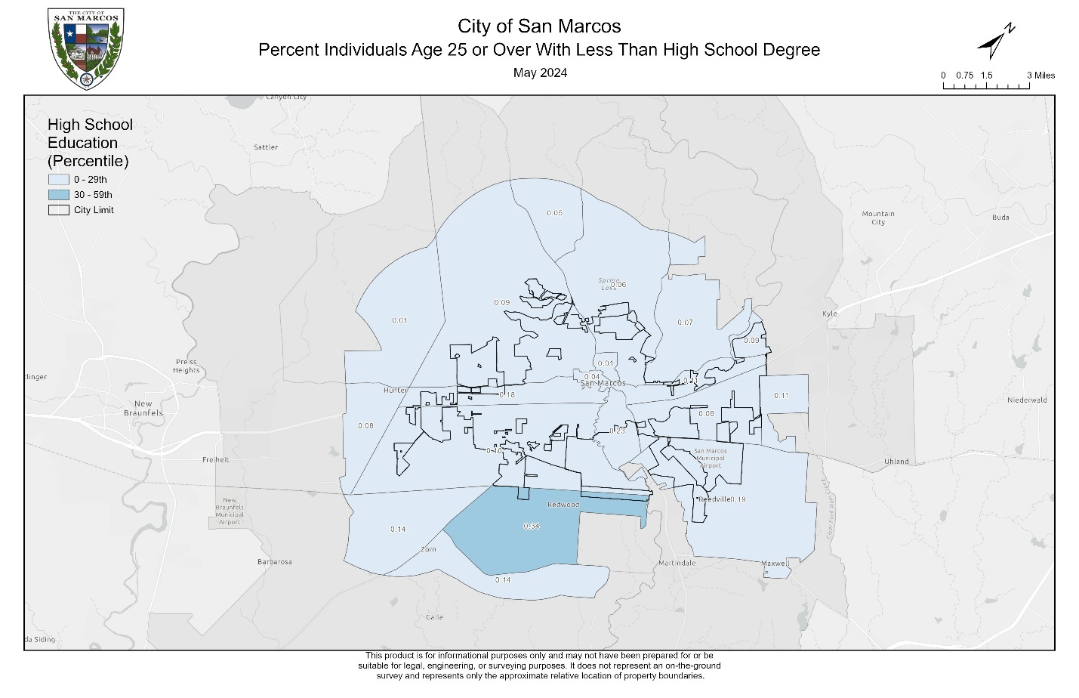

Figure 3. Percent individuals age 25 or over with less than a high school degree (percentile)

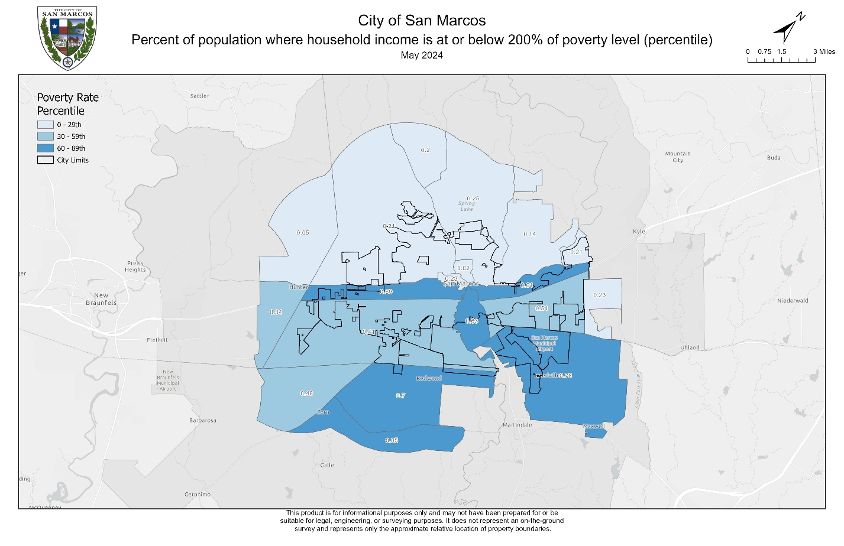

Figure 4. Percent of population where household income is at or below 200% of the poverty level (percentile)

Figure 5. PM2.5 in the air (percentile)

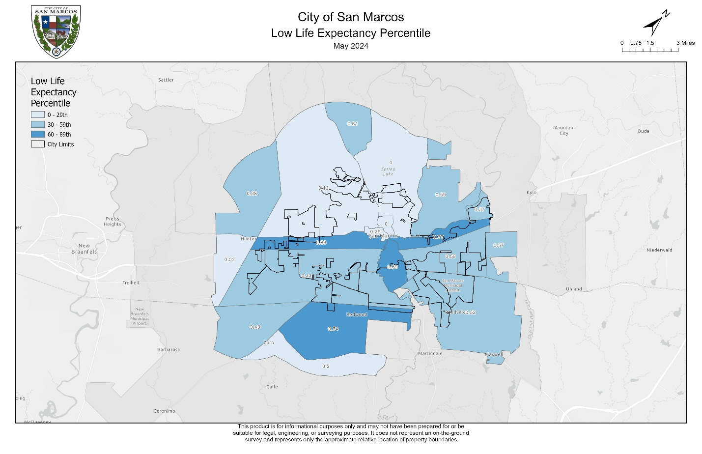

Figure 6. Low life expectancy (percentile)

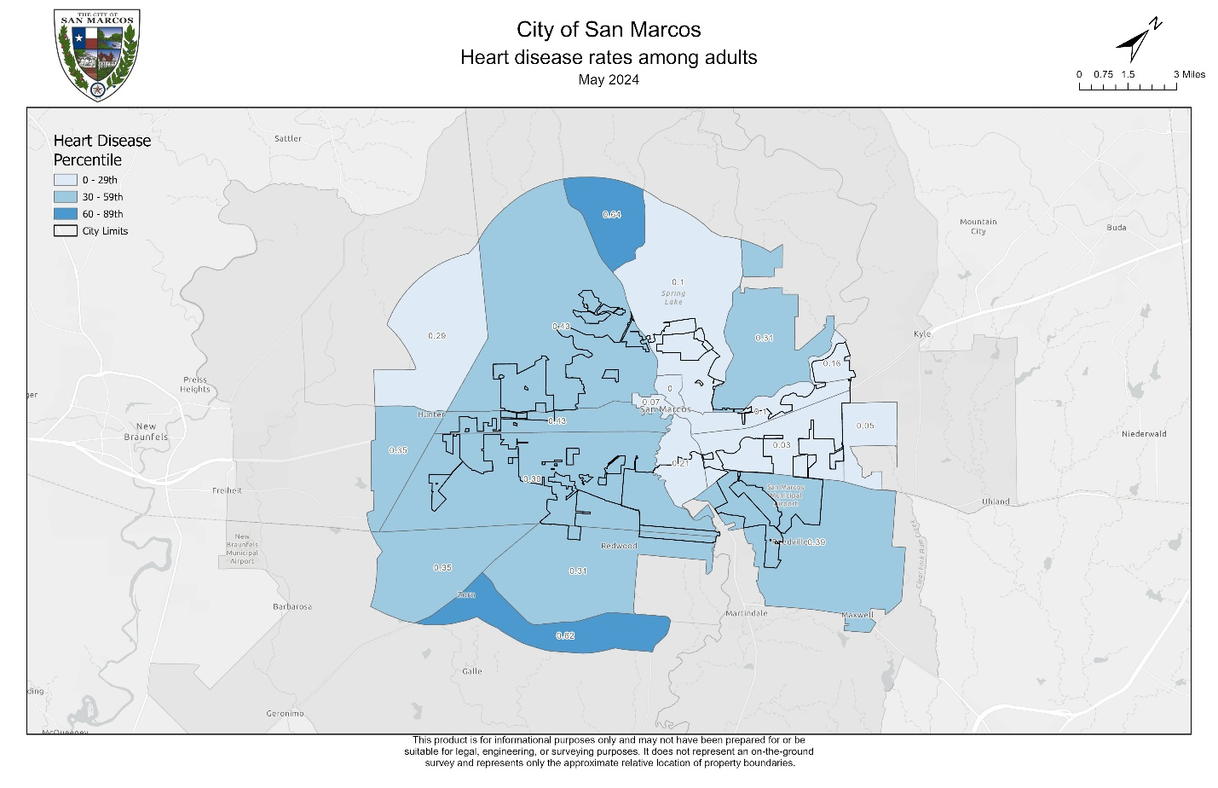

Figure 7. Heart disease rates among adults (percentile)

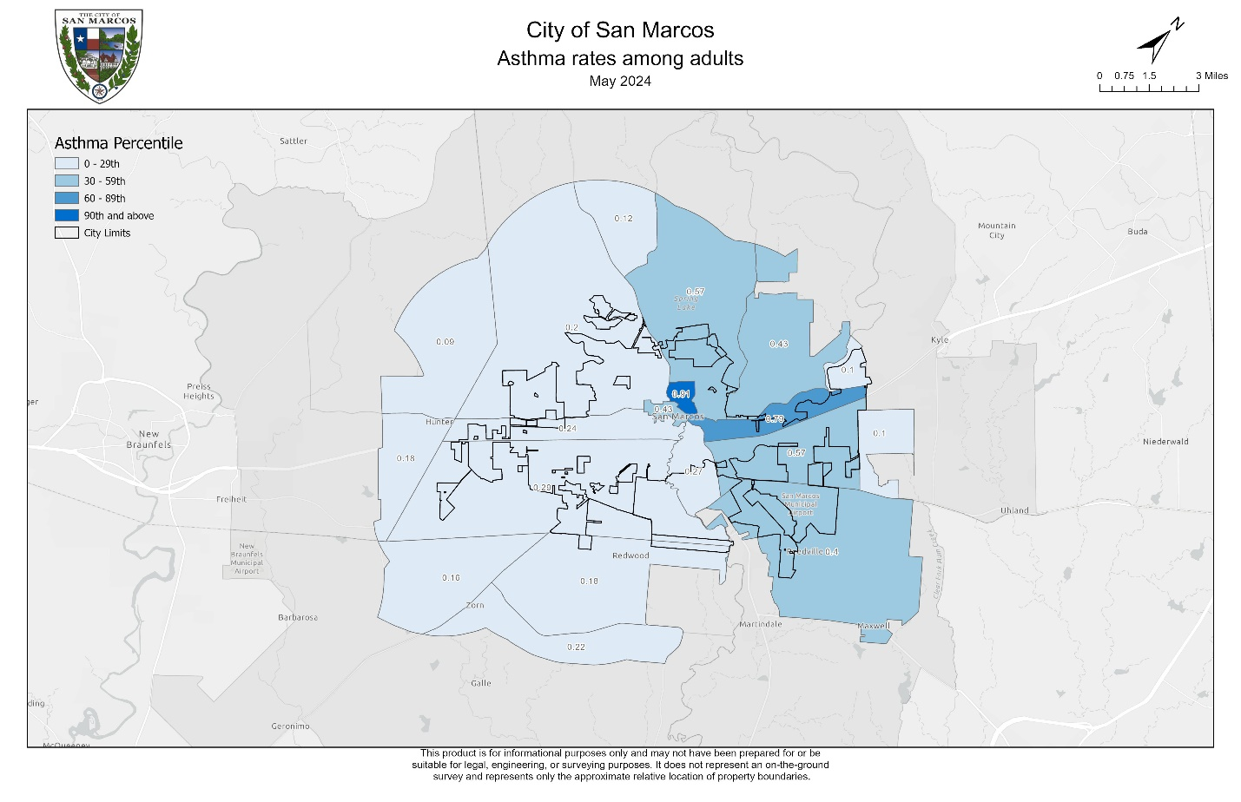

Figure 8. Asthma rates among adults (percentile)

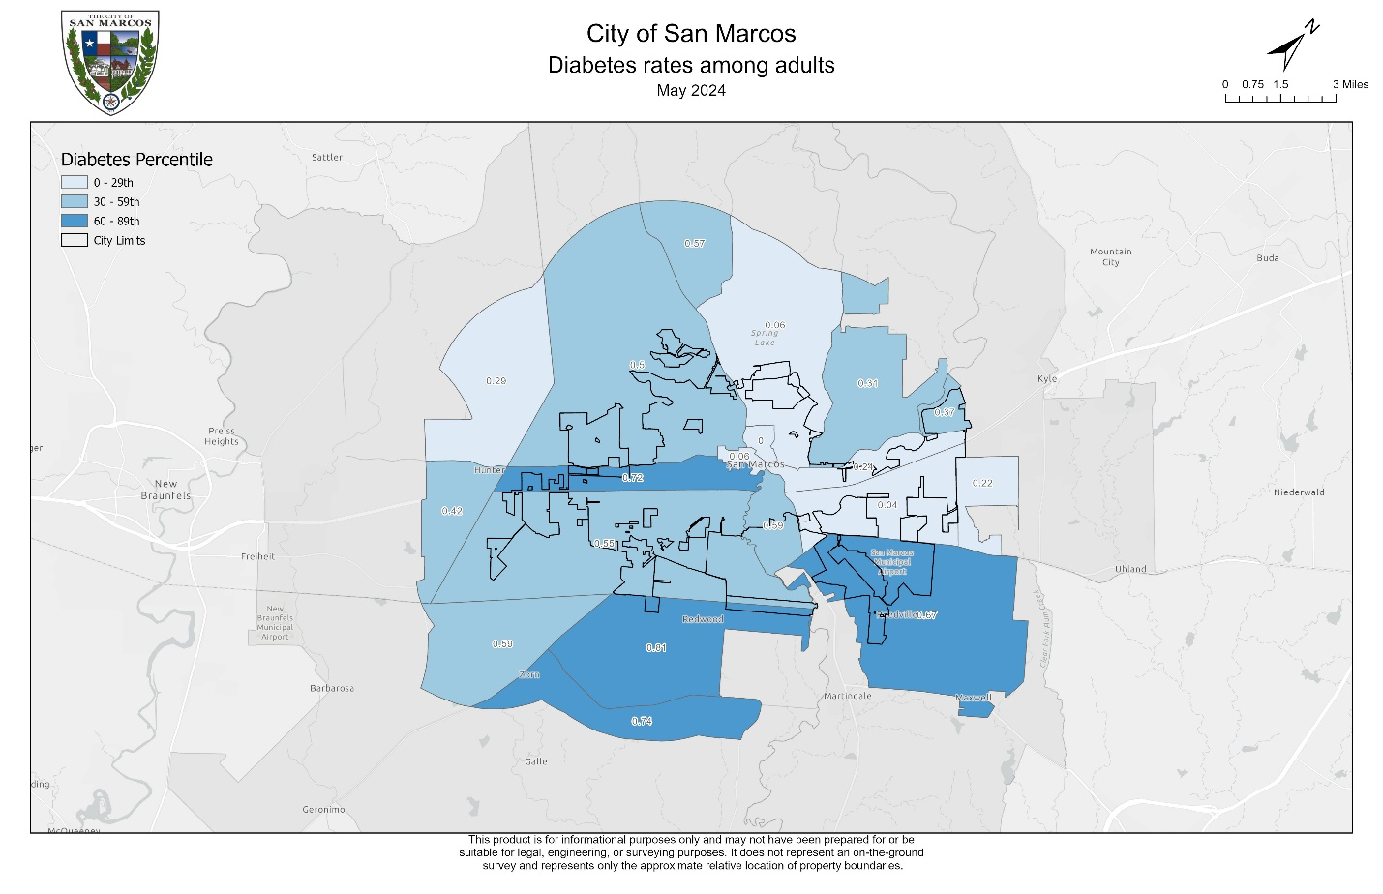

Figure 9. Diabetes rates among adults (percentile)

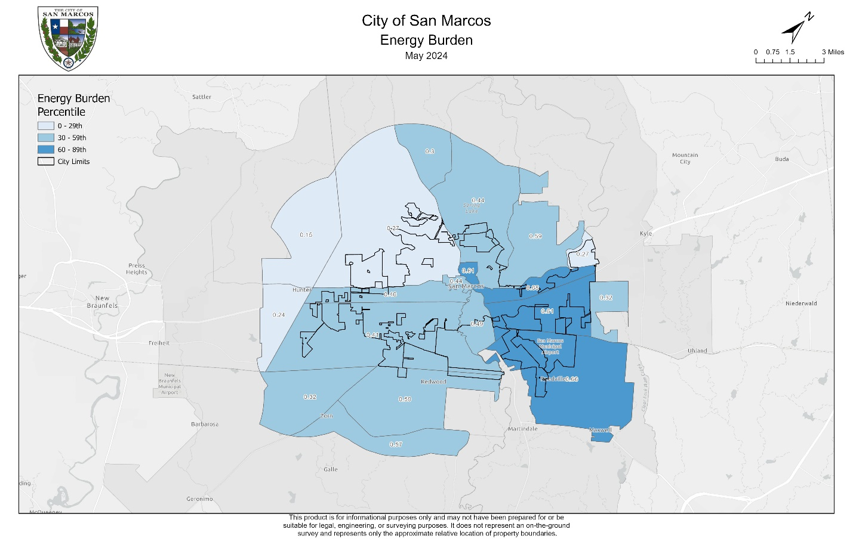

Figure 10. Energy burden (percentile)

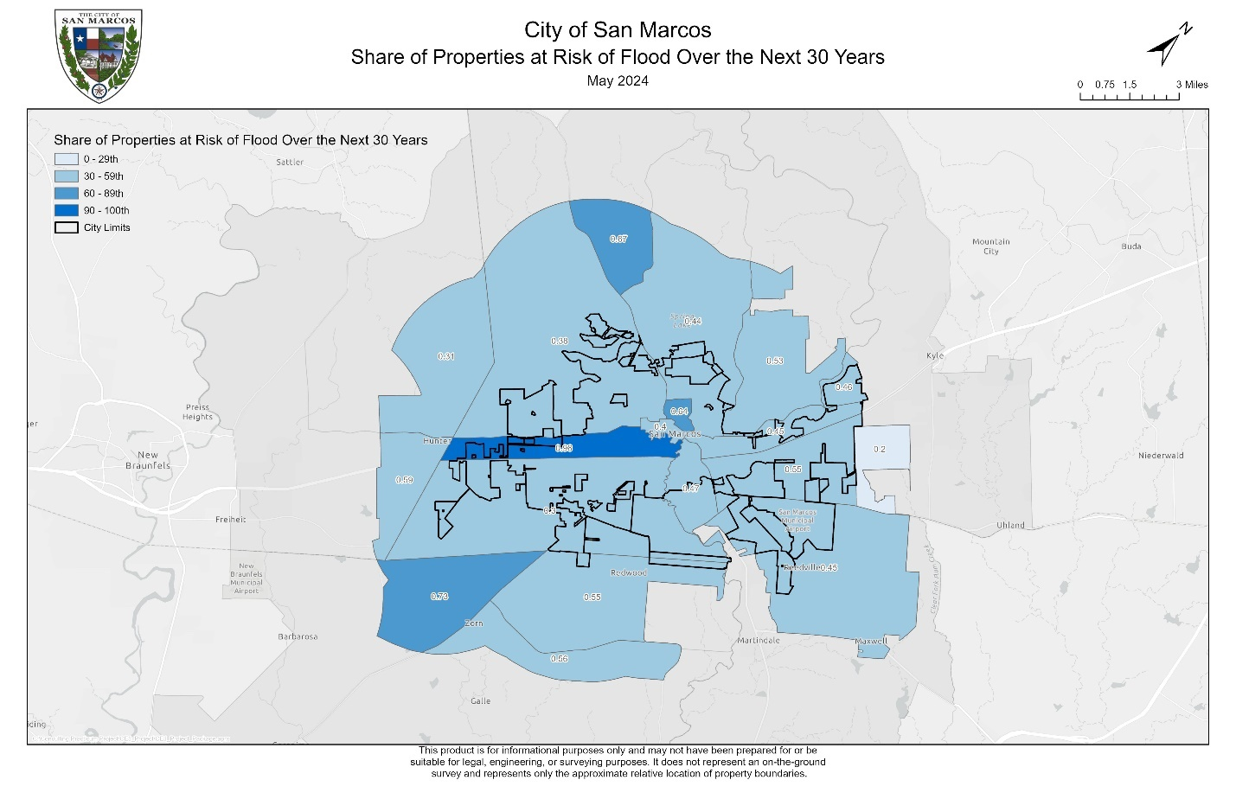Figure 11. Share of properties at risk of flood over the next 30 years(percentile)

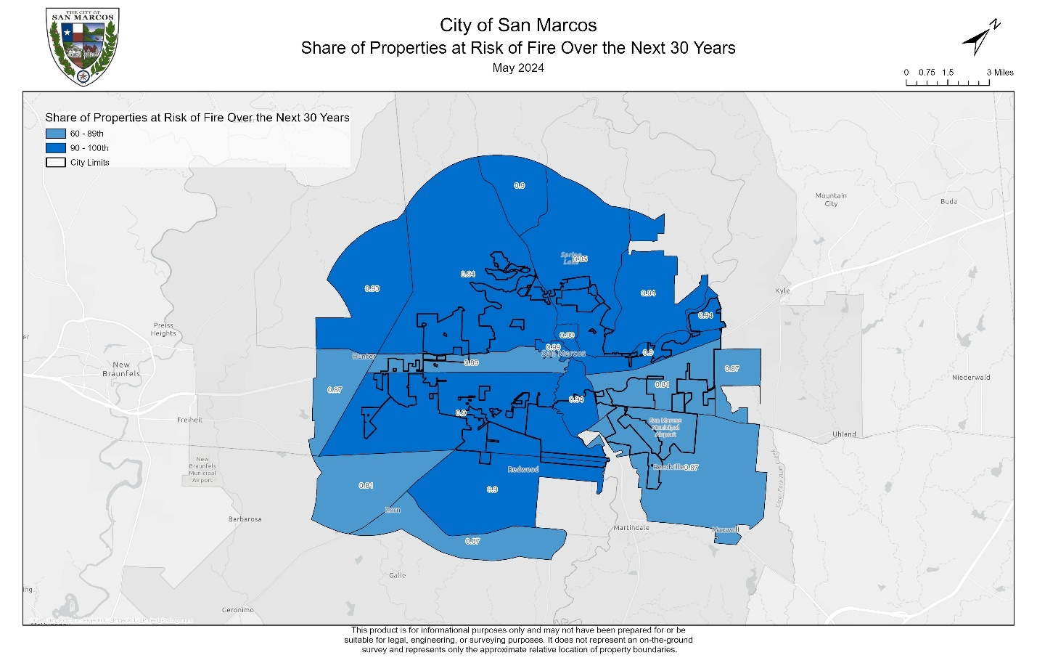

Figure 12. Share of properties at risk of fire over the next 30 years (percentile)

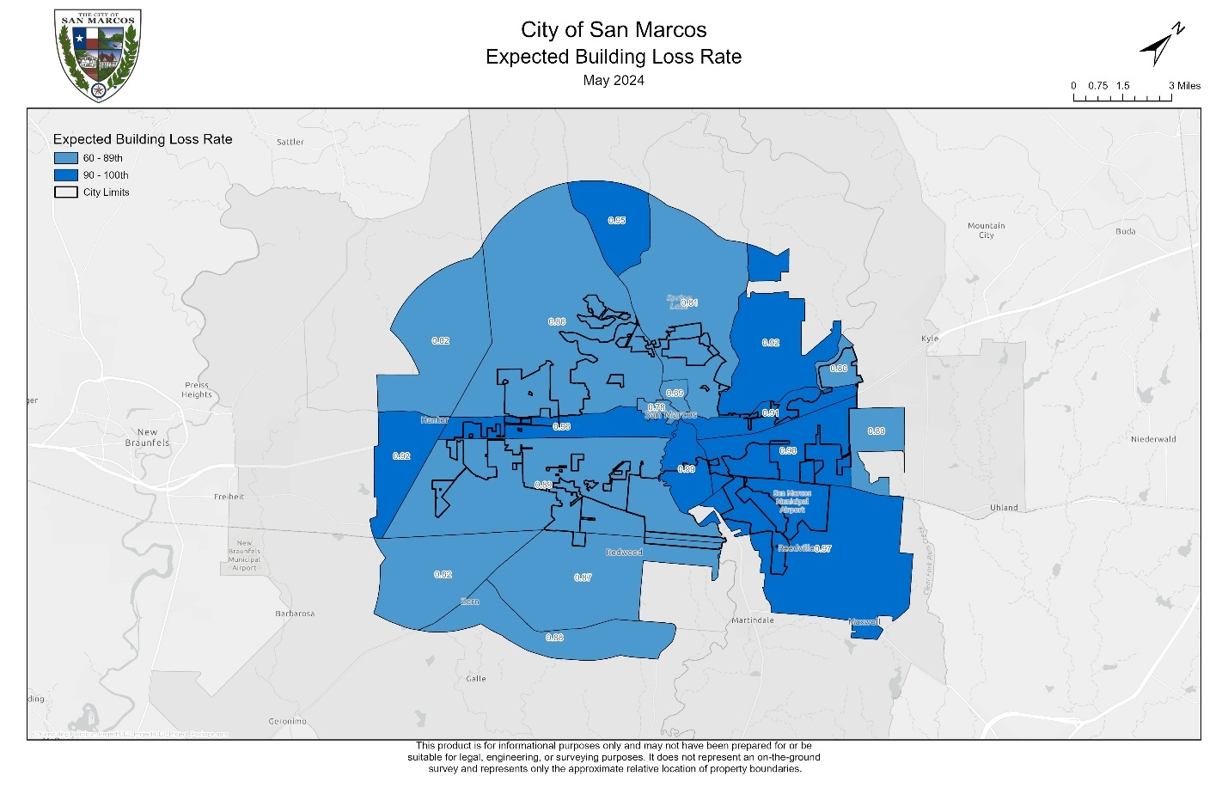

Figure 13. Expected building loss rate due to natural hazards (percentile)

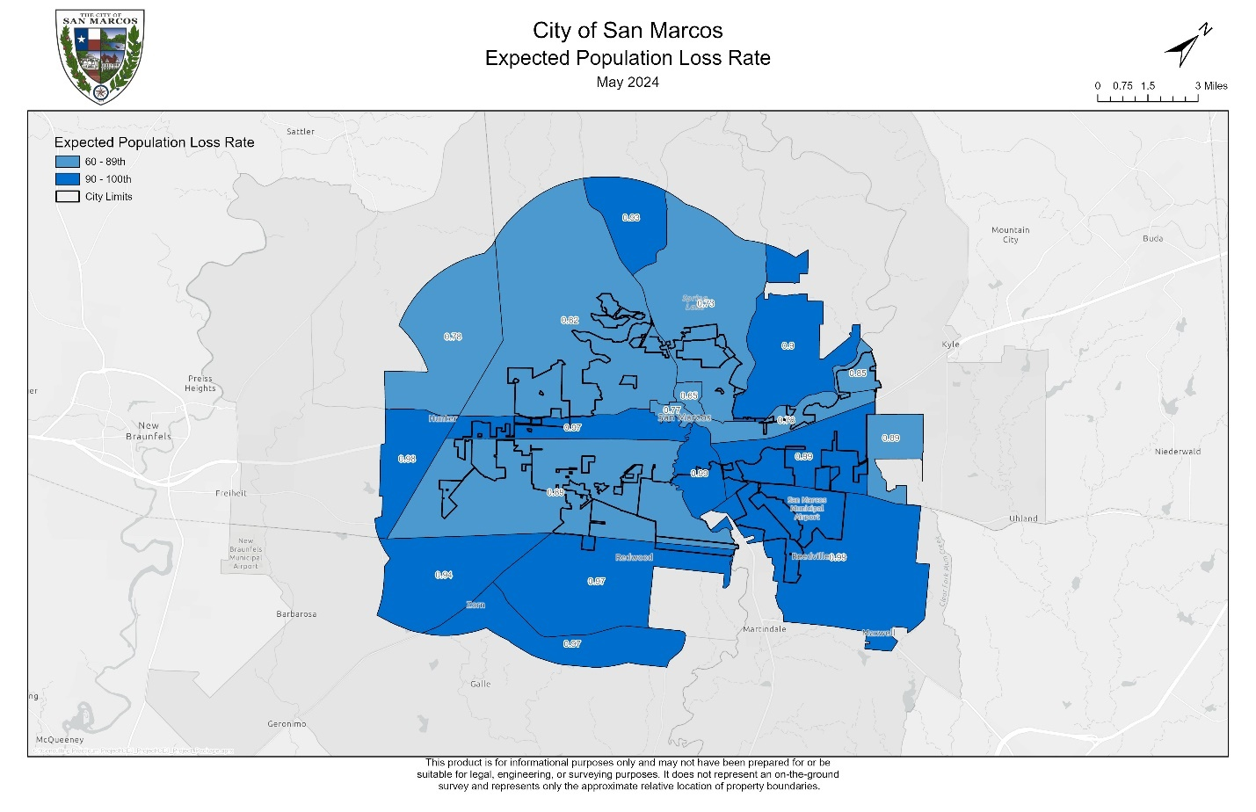

Figure 14. Expected population loss rate (percentile)

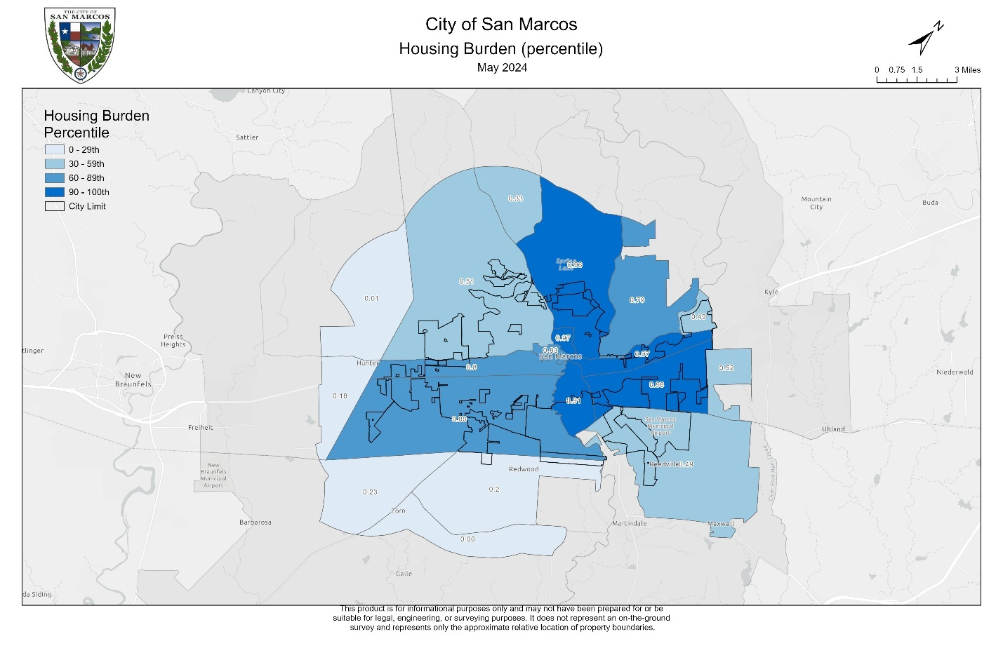

Figure 15. Housing burden

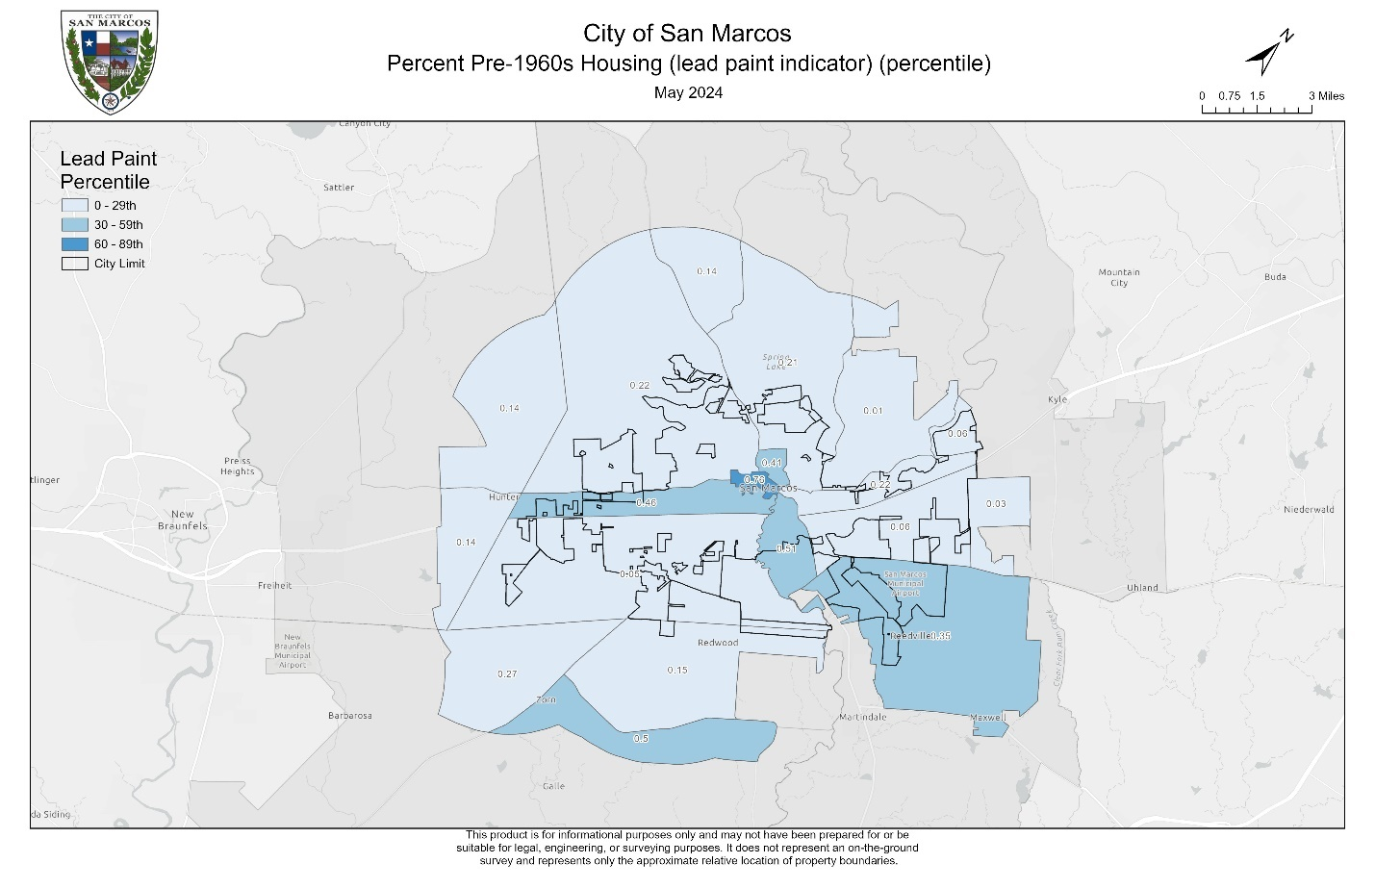

Figure 16. Percent pre-1960s housing (lead paint indicator) (percentile)

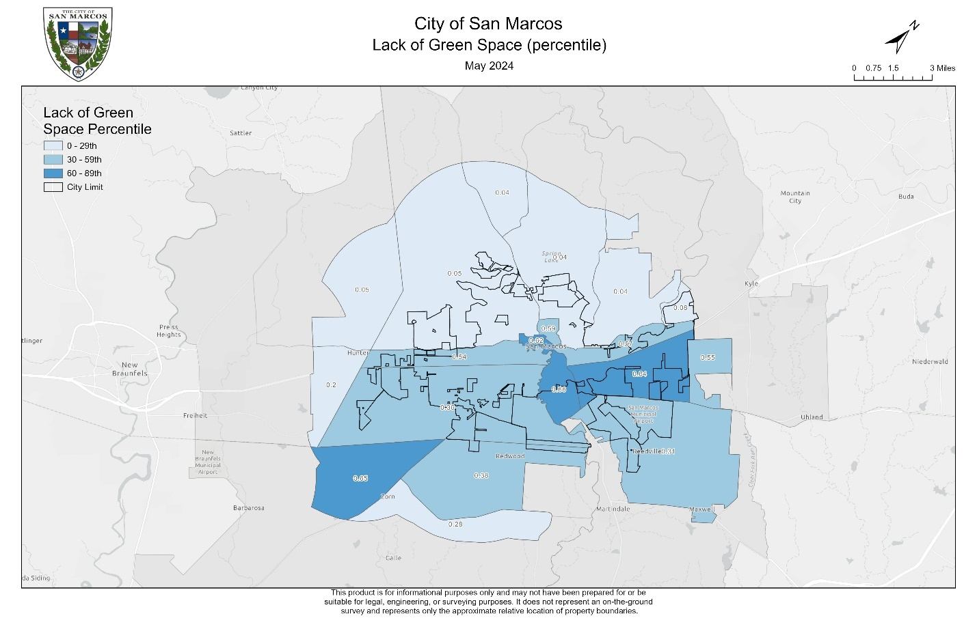

Figure 17. Lack of green space (percentile)

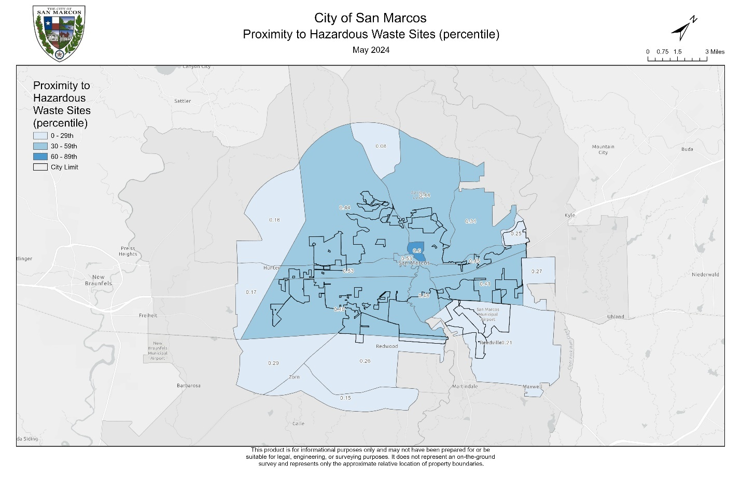

Figure 18. Proximity to hazardous waste sites (percentile)

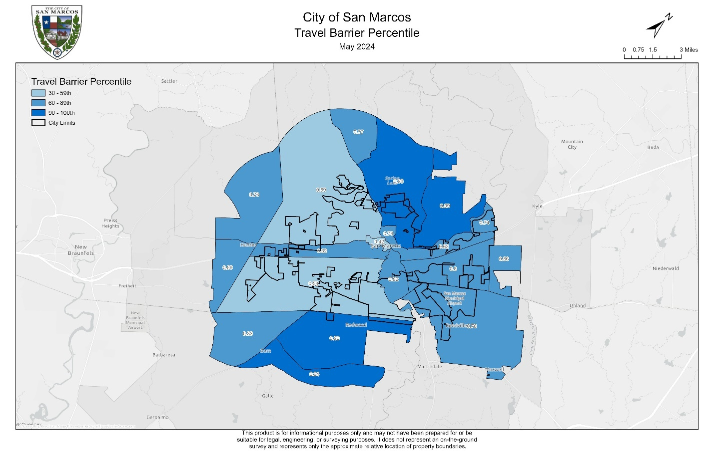

Figure 19. Travel barrier (percentile)

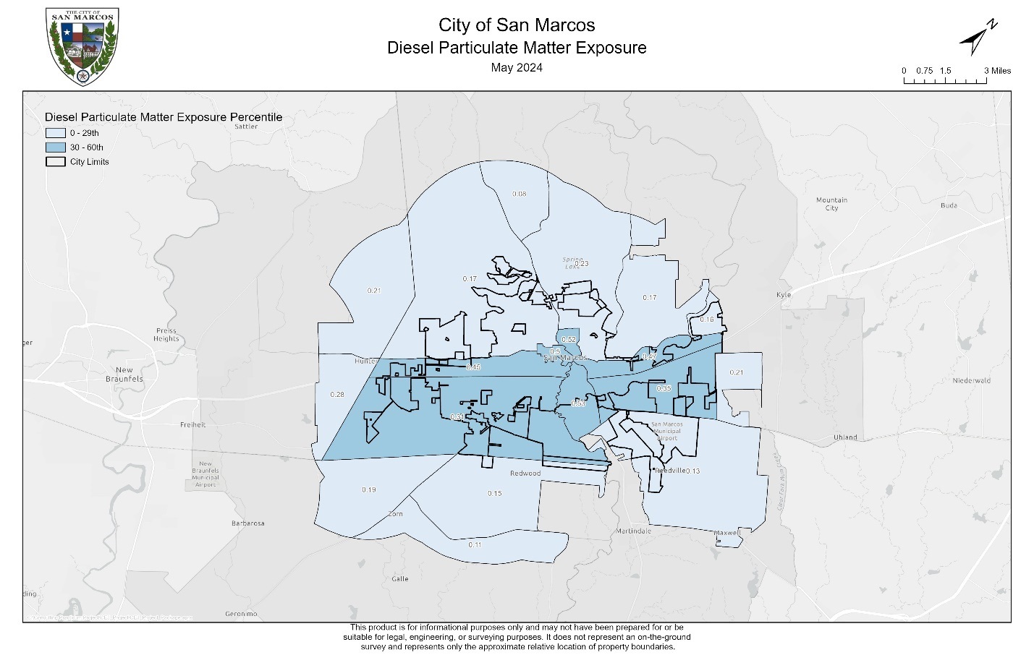

Figure 20. Diesel particulate matter exposure (percentile)

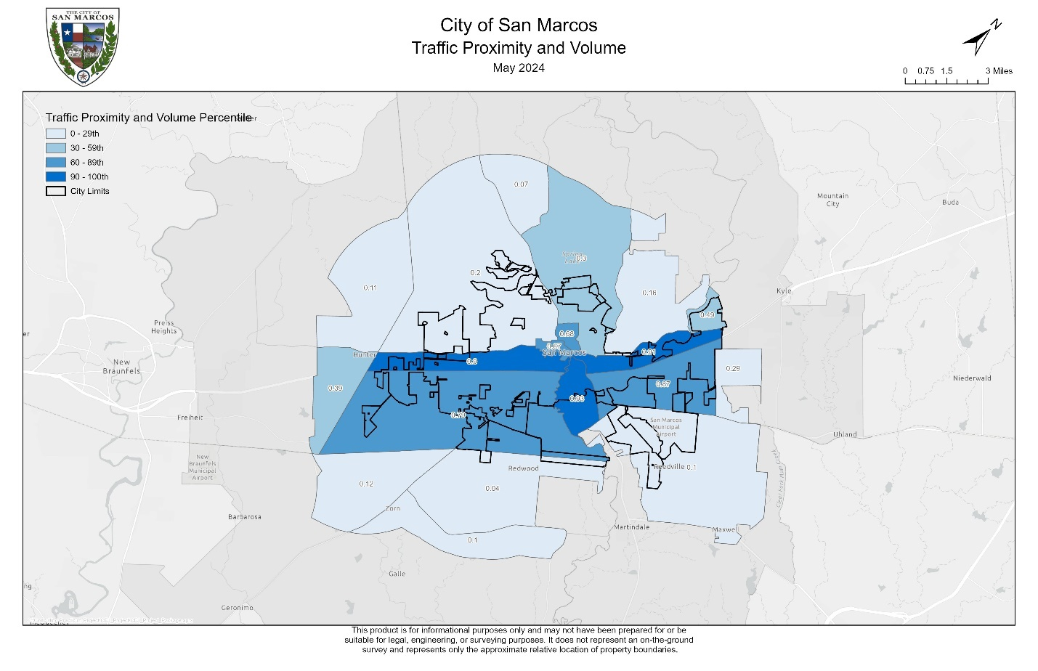

Figure 21. Traffic proximity and volume (percentile)

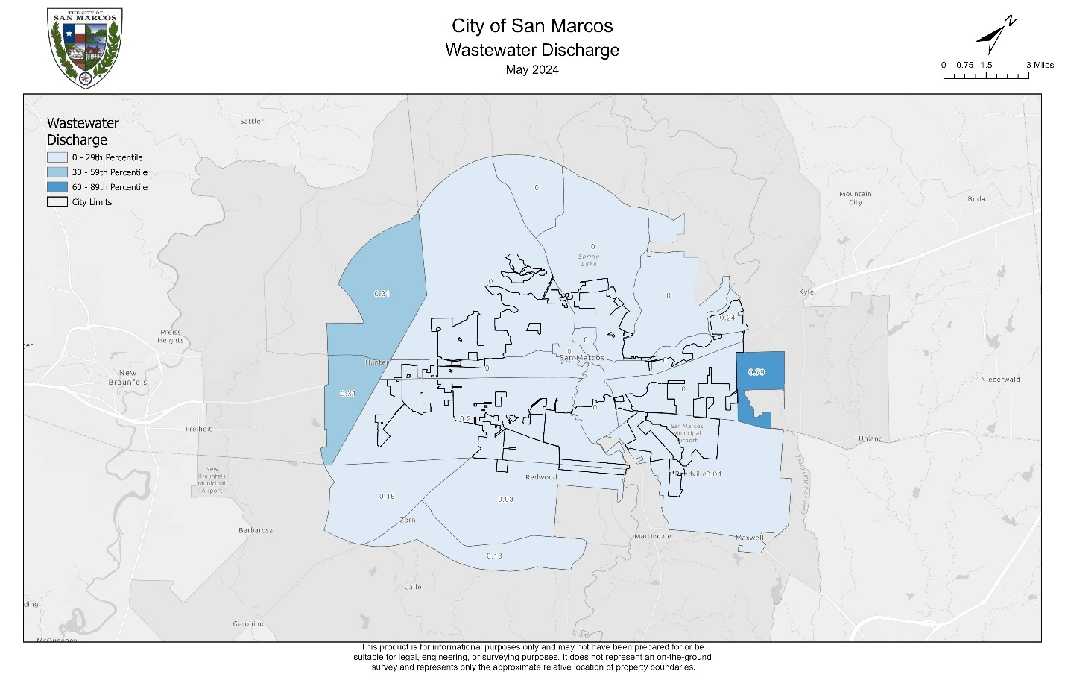

Figure 22. Wastewater discharge (percentile)

**Appendix I.** Group Members' Contribution

Pamela Boyd-Project Manager

* Project management: organized our tasks and time together during labs and outside-of-class meetings, sent weekly reminders to keep the team on task, organized our files and deliverables, and delegated tasks.
* Writing:
  + Proposal: Table of Contents, Literature Review, Conclusion, References, and Appendix
  + Progress report: Summary & Problems
  + Final Report: Table of Contents, Introduction and Problem Statement, Results and Discussion, Figure 22 description, Conclusion, References, Appendices, and helped write the Readme.docx
* Client engagement: contacted the client via email and GroupMe each time our group had a question that needed clarification.
* Editing and formatting: developed outline, ensured correct formatting and organization throughout, and conducted final edits and additions to the Proposal, Progress Report, and Final Report.
* Subject-matter research: I produced a literature review for the initial Proposal on the city of San Marcos’ Socio-economic Landscape, Socio-economic Implications, and Leveraging GIS for Community Equity. I also researched diversity, equity, and inclusion practices involving cartographic representation for use in our final maps.
* Map creation: two different versions of the Scope map of the City of San Marcos, an example of the original Poverty map for the Proposal and Progress Report, and a reversed gradient Poverty map for the Progress Report
* Presentations: created PowerPoint presentations for the Proposal, Progress Report, and Final Report. Assigned slides to each team member.
* Metadata: made a .html file for each of the layers used to create the final maps.

Jonathan Knoll-Assistant Project Manager

* Project management: performed project management duties especially when the project manager was not readily available. Duties included delegating tasks, helping lead meetings, organizing time used on tasks, and scheduling meetings.
* Writing:
  + Proposal: Introduction, Summary, Purpose, Methodology, and Scope
  + Progress Report: Scope & Conclusion
  + Final Report: Abstract, Figures 4-10 descriptions in the Results section, and helped write the Readme.docx
* Data collection and processing: processed and analyzed data for 90th Percentile for Asthma, 90th Percentile for Diabetes, 90th Percentile for Heart Disease, 90th percentile for Low Life Expectancy,90th Percentile for Energy, PM2.5 Air Concentration, Wastewater Discharge, and 200% or Below Poverty Level Household Income.
* Figures and tables:
  + Created flow chart used in Proposal, poster, and Final Report.
  + Created metadata table used in Final Report.
* Map creation: 90th Percentile for Asthma, 90th Percentile for Diabetes, 90th Percentile for Heart Disease, 90th percentile for Low Life Expectancy,90th Percentile for Energy, PM2.5 Air Concentration, and 200% or Below Poverty Level Household Income, Wastewater Discharge, and Study Area for poster and Final Report.
* Map standardization: 90th Percentile for Asthma, 90th Percentile for Diabetes, 90th Percentile for Heart Disease, 90th percentile for Low Life Expectancy, 90th Percentile for Energy, PM2.5 Air Concentration, Wastewater Discharge, and 200% or Below Poverty Level Household Income.

Alee Sho-GIS Analyst

* Writing:
  + Proposal: Master Data List
  + Progress Report: Purpose Statement & list of socioeconomic burdens
  + Final Report: Master Data List, Figures 3, 15, 16, and 17 descriptions in the Results section and the Data section narrative.
* Data collection and processing: Processed and analyzed data for Housing Cost, Lack of Green Space, The Likelihood of Lead Paint in Housing, and Percent of Individuals Age 25 Or Over With Less Than a High School Degree.
* Map creation: Housing Cost, Lack of Green Space, The Likelihood of Lead Paint in Housing, Proximity to Hazardous Waste Sites, Percent of Individuals Age 25 or Over With Less Than a High School Degree.
* Map standardization: Housing Cost, Lack of Green Space, Likelihood of Lead Paint in Housing, Proximity to Hazardous Waste Sites, Percent Individuals Age 25 or Over with Less Than a High School Degree.
* Master Data List: Created a list of the twenty different burdens used for our project with reference sources included.

Devin Peters-GIS Analyst

* Writing:
  + Proposal: Deliverables section.
  + Progress Report: Tasks section.
  + Final Report: Methods, Figures 11, 12, 13, 14, 19, 20, and 21 descriptions in the Results section & parts of the Data section.
* Data collection and processing: processed and analyzed data for DOT Travel Barrier Score, Traffic Proximity and Volume, Diesel Particulate Matter Exposure, Projected Flood Risk, Projected Wildfire Risk, Expected Population, and Building Loss Rate to Natural Hazards.
* Logo design and branding: created River City Socio-Economic Mapping Solutions logo and company name.
* Figures and tables:
  + Developed the timetable of project tasks for Proposal.
  + Developed project budget and table for Proposal.
  + Developed timetable of project tasks for Progress Report.
* Map creation: DOT Travel Barrier Score, Traffic Proximity and Volume, Diesel Particulate Matter Exposure, Projected Flood Risk, Projected Wildfire Risk, Expected Population, and Building Loss Rate to Natural Hazards.
* Map standardization: DOT Travel Barrier Score, Traffic Proximity and Volume, Diesel Particulate Matter Exposure, Projected Flood Risk, Projected Wildfire Risk, Expected Population, and Building Loss Rate to Natural Hazards.

**Appendix II.** Metadata

|  |  |
| --- | --- |
| **Filename** | **Description** |
| usa.shp.html | Every US census tract which includes data on the factors listed in the CEJS tool. |
| columns.html | This is downloaded from the CEJS tool. It includes the name and description of the shapefile columns. |
| 1.0-codebook.html | This is downloaded from the CEJS tool. It is not necessary for analysis, but it gives demographic data and individual values for each burden for every US census tract. |
| Master Data List.html | This includes the burdens that were mapped out, the data source from which the CEJS tool collected the data, and the year the data was collected. |
| Extraterritorial_Jurisdiction_(ETJ).shp.html | This is combined with the San Marcos city limits to create the study area. It is downloaded from the City of San Marcos open database on ArcGIS Online. |
| City_Limits.shp.html | This is downloaded from the City of San Marcos open database on ArcGIS online. This is used to show where the city limits are within the San Marcos ETJ. |