Emerald Crown Trail

Data Compilation and

Web Map Development

May 2021

Parker Brockman - Project Manager
Michael Henry - GIS Analyst
Daniel Vasquez - GIS Analyst
Isaac Brown - GIS Analyst
Chelsea Huggins - GIS Analyst

Table of Contents

Abstract - - - - - - - 2

Introduction - - - - - - - 2-4

Data - - - - - - - - 4-6

Table 1 - - - - - - 5-6

Methodology - - - - - - - 6-9

Data Collection - - - - 7
Dealing with the inability to work on the same map 7
Shapefile Cleanup - - - - 7-8
Merging Shapefiles - - - - 8
Joining Attributes - - - - 8-9
Creating the Access Point Shapefile - - 9
Webmap Development and Implementation - 9

Results and Discussion - - - - - 10-16

Figure 1 - - - - - 10
Figure 2 - - - - - 11
Figure 3 - - - - - 12

Conclusion - - - - - - - 16

References - - - - - - - 17

Appendix 1 - - - - - - - 18

Appendix 2 - - - - - - - 19

Abstract
The Emerald Crown Trail is a proposed trail network system uniting the cities of San Marcos, Kyle, Buda and South Austin. As the Central Texas region continues to attract more people, there is a growing need for transportation and recreation resources. The Emerald Crown Trail is designed to alleviate the number of motorized vehicles on the highways by presenting a viable transportation alternative. Additionally, as the population increases, parks and green spaces will become an important outlet for community recreation purposes. The Emerald Crown Trail strives to unite these spaces by creating a trail network system across the Hays county portion of the IH-35 corridor. While the Emerald Crown Trails includes constructed trails, there is a large portion of proposed and conceptual trails. The completion of the Emerald Crown Trail will be a group effort with multiple stakeholders involved to see the project through to the end. This is where our group, the Emerald Crown Coalition (ECC), comes into the fold. The ECC was tasked with refining data and creating an online interactive web map. The web map was designed to garner community and stakeholder interest as well as move closer towards final implementation.

Introduction
Various regions throughout the world are connected by comprehensive trail networks. These regional pathways provide the people that live near them with a means of transportation and a more comprehensive sense of place that is inclusive of local ecology, as well as an opportunity to nourish both their physical and mental health. Currently, some individual municipalities in Central Texas have their own isolated trail networks, but the broader region lacks such a network and the abundance of benefits it would provide. For this reason, the Emerald Crown Trail has been planned to connect the municipalities of Hays County with over 98 miles of trail as well as connecting to the Violet Crown trail network in South Austin.
Stakeholders invested in the planning and construction of the Emerald Crown Trail are faced with the simultaneous tasks of organizing groups in the several municipalities of Hays county for the physical construction of the trail, as well as stimulating the interest of other groups of stakeholders: governmental agents, non-profits, and the public. This is a formidable task, and acquiring funding and support from stakeholders not directly involved in the construction of the trail is essential for the process of completing it.
To garner the attention of and provide information to these stakeholders, the San Marcos Greenbelt Alliance has corresponded with the geographic information system (GIS) consulting practicum class at Texas State University in order to develop an accurate, publicly-accessible web map showing information about the trail and its development status.
This project is a continuation work done by several different groups: the previous GIS consulting practicum group which conducted the initial pathfinding analysis for the Emerald Crown Trail, the Emerald Crown Trail work group including the San Marcos Greenbelt Alliance and Great Springs Project and the public focus group with whom they consulted to finalize main and alternative trail routes, and National Park Service staff that created the initial trail shapefile.
The tasks that have befallen this group relate to data cleanup and compilation, shapefile creation, and web map development. Data cleanup involved editing the Emerald Crown Trail shapefile initially developed by the National Park Service using ArcGIS Pro in order to make it comply with the guidelines set forth by the ECT master plan, along with making the lines in the webmap accurate enough to potentially use the map to navigate at an on-the-ground level. Compilation involved joining attributes from other shapefiles such as jurisdiction and land cover land use to display on the final web map. Additionally, a shapefile consisting of proposed access points was created by using nominal information about proposed access points and trailheads in the ECT master plan. Finally, using the data procured from the previous processes, a web map was developed using the ESRI Web Appbuilder. This application will need to be hosted on a server before it can be accessed by the public, which is a service this project group cannot provide.
The scope of the project remained roughly the same throughout the project. Because of time constraints, we were not able to do trail grading analysis or find data on certain attributes to attach such as trail width, but we were able to fulfill the broader requirements of the project.

Data
Due to the large amount of spatial information needed for this project, gathering the necessary data was essential to our efforts. The majority of our data had previously been acquired by the San Marcos Greenbelt Alliance and the Great Springs Project. In addition to the files already provided to us, we have gathered additional data from the City of Kyle, City of Buda, City of San Marcos, TxDOT, and ESRI ArcOnline. Since an important aspect of this project relates to data compilation, the number of shapefiles used is fairly large. However, none of these shapefiles were used to conduct analysis since that was outside of the achievable scope of this project. Instead, they were used for shapefile correction for the Emerald Crown Trail, as well as in spatial joins and identity functions to create trail attributes to display on the final webmap.
Most of the data shown in the table below (Table 1), such as parks, roads, parcels, and jurisdiction, should be highly accurate. Since these shapefiles are important for governance and are developed by local sources at a local scale, the accuracy of the shapefiles provided to the group is fairly reliable. The original Emerald Crown Trail shapefile, however, was inconsistent with the guidelines set out in the ECT masterplan and already-established trail networks in each city area. This is due to the fact that it was created as a loose sketch of the trail by National Park Service staff, not intended to be used for on-the-ground navigation.

Table 1: List of Data Files Used
Entity | Attributes | Spatial Object | Status | Source | Year
Road | Roads by location | Lines | Available | SMGA box | 2016
Trail | Trail by segments | Lines | Available | SMGA box | 2017
Trail Construction / Status |  | Lines | Available | SMGA box | 2020
Park | Parks by cities | Polygon | Available | SMGA box | 2017
Land Parcels | Land parcel lots by cities | Polygons | Available | SMGA box / City of San Marcos | 2017
Hays County DEM Raster | Elevation Data | Raster | Available | SMGA box | 2016
ESRI satellite imagery basemap | Satellite imagery | Raster | Available | ESRI | 2020
LCLU Map | Land cover and land use | Polygon | Available | SMGA box / TNRIS | 2003, 2016
San Marcos Trails | Trail network | Line | Available | SMGA box | 2017
Kyle Trails | Trail network | Line | Available | SMGA box | 2017
Buda Trails | Trail network | Line | Available | SMGA box | 2017
Area of Interest | General area of interest | Polygon | Available | SMGA box | 2017
City Limits | City limits of | Polygon | Available | SMGA box / TxDOT | 2015, 2021
Jurisdiction | Territorial jurisdiction | Polygon | Available | SMGA box | 2017
Low Water Crossings | Low water crossing in the area | Point | Available | SMGA box | 2016
Protected  Areas | Protected areas | Polygon | Available | Great Springs  Project Staff | 2020
Access Points | Access points named in the ECT master plan | Point | Unavailable, had to be created | ECT master plan, Google maps, ESRI global georeferencing | 2021

Methodology
The nature of this project is atypical for the Texas State GIS Consulting practicum class, and therefore the methodology is as well. Instead of one large analysis task, this project consisted of several different steps involving data editing and compilation, shapefile creation, and web app development. No analysis was conducted. Due to the piecemeal nature of this project, no established methodology encompassed the specific workflow of this project. Instead, a collection of different methodologies were used at different points in this project. These were either pulled from the collective GIS experience of this work group or developed over the course of this project in order to contend with unforeseen problems.
Data collection
To begin the process of cleaning up the shapefiles, we first had to acquire them. This was achieved in a few ways. Two of the main sources were the San Marcos Greenbelt Alliance and the Great Springs Project. They provided us with the majority of the data used for this project through dropbox. This included, but was not limited to, the ECT trail files and the other trails already established in the area. We had to ask for a few additional data shapefiles that were not provided, like the land-cover and land-use shapefile, so that we could include them later on.
Dealing with inability to work on the same map
One of the biggest issues we ran into during the course of the project was the inability to work on the same GIS map at the same time. We tried to use ArcGIS Online, but we found that it wouldn’t save any edits that we were making to the map and nobody else could see the edits we did make. We also tried to use the ESRI App Builder (the app used to create the final web map) collectively, but we were having trouble with that as well. Eventually we settled on sharing data through dropbox so that we could all use the data freely and then reshare it. We then created a group on ESRI Online so that we could share shapefiles for the web map there as well.
Shapefile cleanup
Once we had all of the data that we needed for the trail itself, our team began the task of cleaning up the ECT shapefile initially created by the National Park Service. The initial plan was to edit the shapefile collectively using a map on ArcGIS online. However, this proved impossible. In lieu of collective editing, we began by assigning each member of our team a portion of the trail shapefile to clean up and review on their individual ArcGIS Pro programs. These segments were split up based on jurisdiction, with one person each assigned to Kyle, Buda, and unincorporated areas in Hays County and two people assigned to San Marcos. We combed over every trail segment within the shapefile and cross-referenced them to ESRI satellite imagery to create the most accurate line file as was reasonably possible. Lines vertices were edited to comply with the guidelines set forth in the ECT master plan and snapped to currently-existing trails where appropriate.
Merging shapefiles
Once we completed the shapefile cleanup, we compiled every edited trail section from the previous step into a final shapefile for the entirety of the Emerald Crown Trail. Because of some of the edits that were made at the ends of the individual sections, the ends of the trails had to be reconnected for the final shapefile. Once the merging of the shapefiles was completed, we were able to begin attaching attributes to the entire trail starting with the construction status.
Joining attributes
When it came to creating the final deliverables, we thought it would be best if we presented the ECT layer with most of the attributes that we needed to display. We began by joining the final ECT layer with the status of the trails. Those statuses being classified into Existing, Proposed, Proposed - Pending Trail Easement, Private Road, or Conceptual. By accomplishing this, we were able to use simple SQL functions to individually show the status of the different parts of the trail. Additionally, we attached the jurisdiction into which each part of the trail falls, including Kyle, San Marcos, Mountain City, etc. Late within our project timeline we were given a shapefile of the San Marcos trail which we added into the Final ECT shapefile as well. Lastly, we were able to use land cover/land use data and use the Identity tool within ArcGISPro to overlay with our ECT layer. Our output consisted of land cover data specifically for the ECT line layer. The Identity tool allowed us to effectively “join” the data we had compiled from the ECT layer and the land classification data.
Creating the access point shapefile
One of the datasets we were asked to include in the final web map was access point and trailhead data. Since there was no data or information available to reference, we had to manually find and create a dataset for this. We began by cross referencing the names and general locations of access points on the ECT master plan with the addresses that we could find on Google Maps. Using this information, we then created an excel spreadsheet with the names of the access point, the address, the hours (where applicable), and if parking was available for that specific location. We then used ESRI’s geocoding service to create a shapefile with the proposed access points.
Webmap development and implementation
The final step of this project was creating a web map application. This web map application would need to be able to accurately display our data and allow for user interaction. After some previous difficulties, we were finally able to create our web map application through ESRI ArcGIS Web AppBuilder. In order to launch a web app, we began by creating a basic web map on ESRI ArcOnline. We added our final trail segment, ETJ, access points, land cover land use, and protected lands layer data to the web map. We then began to format the data to best fit the web map application interface. During this step, we included a filter system that allows the user to use sliders to toggle certain portions of the Emerald Crown Trail layer off and on. Additionally, the user can toggle all the layers, which we have included to focus on different aspects of the map, on and off. Lastly, we have added a basemap gallery that allows the user to switch between multiple basemaps to see the data in different formats.

Results and Discussion
A central component of our project was compiling all available shapefiles that our predecessors had originally created and going through each of them to correct the overall quality of the data. One of main discrepancies (Figure 1) that the data had was low accuracy. The old trail shapefiles would run through the center of a city block or meander in the middle of the river. By using a detailed topography basemap and editing at a very large scale (in other words, closely zoomed in), we were able to shift the shapefile onto the actual trail if it wasn’t there already, or move the line onto pieces of land that made more sense than where it had been placed before.
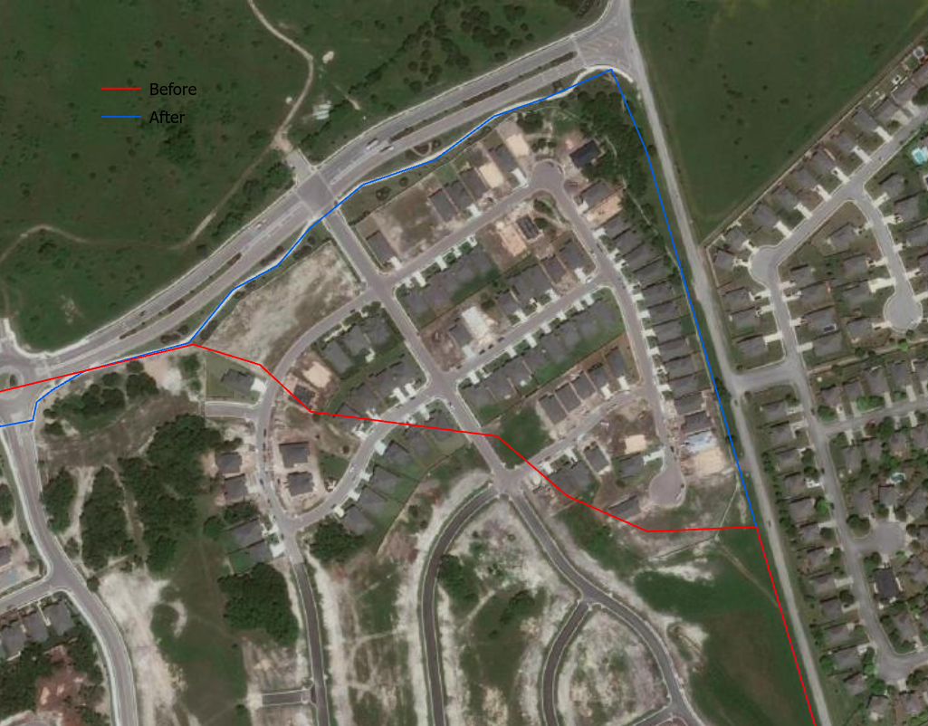
Figure 1- An example of low accuracy, the main data quality issue the ECC dealt with
A smaller data quality issue that we dealt with was lack of completeness. We were dealing with lack of information because the different shapefiles were distributed throughout the three cities that we were working with, and it proved difficult to obtain all the information until a month ago. From there, we lacked whole sets of data, such as trail width, simply because it hadn’t been obtained by any working party.
However, we were able to push past these issues and created a high-quality interactive map with all the essential features asked for in the original Request for Proposal from the SMGA. The viewer has the ability to turn layers on and off depending on the data they are wanting to see. For example, on one of the layers (Figure 2) one would be able to see the Emerald Crown Trail in full, as well as existing and proposed access points. This is helpful so that a potential hiker could plan out their best route as well as the best option for parking.
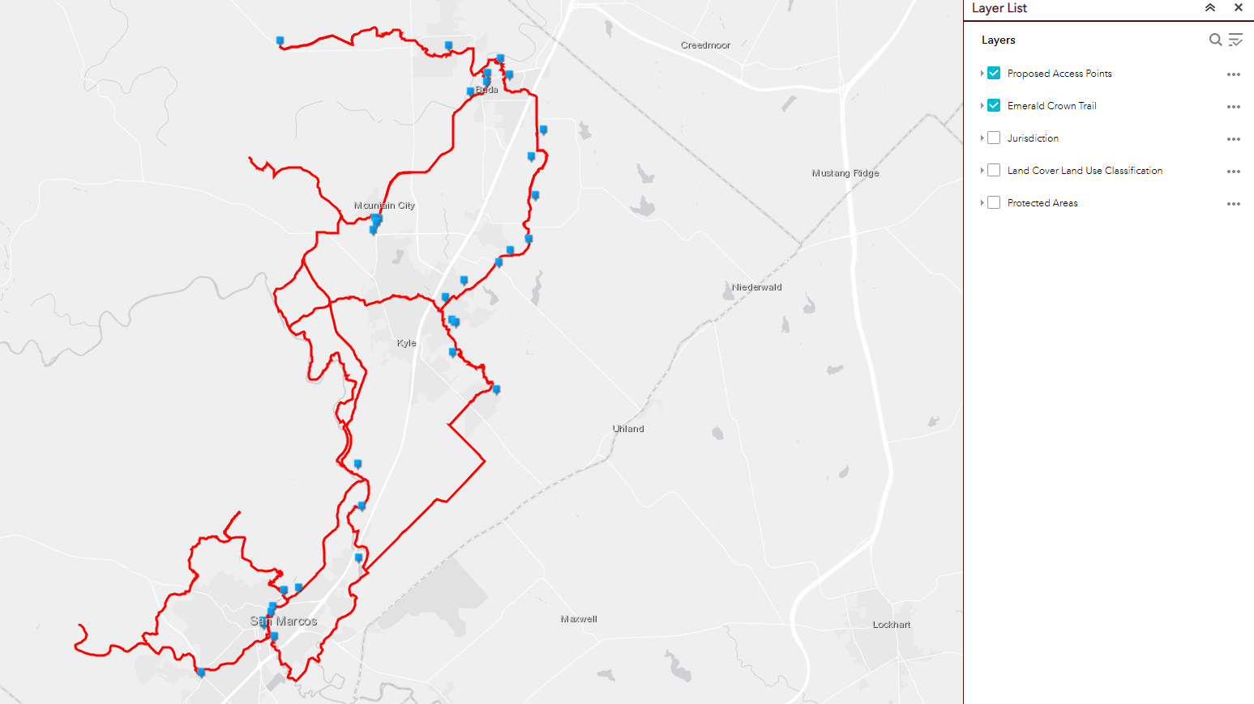
Figure 2- One of the layers on the final map depicting the ECT as well as access points

Additionally, we were able to create map layers for jurisdiction, protected areas, trails by city, existing trails versus proposed trails, and land use/land cover (Figure 3). By including the LCLU layer and the ECT shapefile, we were able to use the Identity tool to create a new ECT shapefile with unique values showcasing the LCLU of each portion of the ECT. This is important because when it comes time to build the proposed trails, the SMGA will be able to choose the best trail material based on the land cover that’s occurring at each trail.
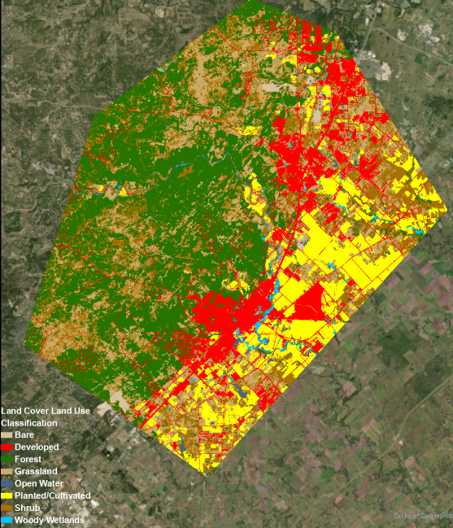
Figure 3- Land Use/Land Cover layer

In all, we were able to compile the total length of the ECT in miles and we compiled and cleaned roughly 98.2 miles (Or 518,245.3 feet) of trail segments (all statuses). With this web map, Mark Taylor, our Head of Contact for the project this semester, and the SMGA will be able to share their progress with the cities of San Marcos, Kyle and Buda when they meet for their quarterly meetings. This map shows the progress of their work, as well as what must be done in order to be completed. Stakeholders and analysts will be able to see areas of possible difficulties when it comes to dealing with protected area statuses, jurisdictions, or trail status. We think that this will be a valuable resource to the SMGA, who otherwise would possibly not have been able to create as in-depth and interactive of a web map.
As we reached the end of our project, we realized that one of the biggest limitations that we had was a lack of certain types of data, with no viable way of acquiring them. For example, one of the map layers requested by the SMGA in the Request For Proposal was trail width. Unfortunately, there is no existing data available at the moment with that information, nor were we able to go out and find that information ourselves given the scope of this project. Around 88% of the trails that make up the ECT are proposed and not yet built, so unfortunately that map layer will have to be added at a future date. While we were able to produce a map that included the most important factors needed to show to shareholders and the community, the availability of different data would have only increased the value of the map and saved time for the SMGA in the future, as they’re a group composed of volunteers and have limited resources.
Additionally, towards the end of the project one of the biggest limitations we had that contributed to not being able to set up a fully-functioning web app for the client was the lack of communication from one of the GIS analysts. After requesting certain parts of the trail data that was missing from our folders, Mark put us into contact with an analyst, who at the beginning of the semester offered the City of Buda’s server and file space in order to host the final map and allow for full editing control. The Emerald Crown Coalition reached out to the analyst so that further discussions could take place, but unfortunately we have not heard back from them. Because of this, we had to change our course of action from building a web app with full editing control to anyone who is designated as a contributor, to creating a web map on ESRI Online that is only editable by members of the ECC, and will have to be rebuilt in the future as the Emerald Crown Trail progresses. However, this should be easily-achievable with the shapefiles we will provide.
If we were to repeat the project with the knowledge that we have now, there’s several things that we would do differently. First, we would make sure that we had all of the data we needed at the beginning of the project. With this project, we were given pieces of the data from the different cities all at different times, so it was very stop-and-go. We would be able to work on one portion of a map, then would have to wait until the next piece of data came our way to work on the next section of the map, which disrupted our overall workflow and productivity.
Second, we’d make sure we had a clearer picture of what the client wanted. Within the SMGA work group and the Great Springs Project, there seemed to be some slight differences in expectations and outcomes, and this led to some initial confusion as to what exactly was expected of us in the beginning of the semester. There was also a bit of miscommunication between the SMGA and Dr. Yuan regarding what the client actually wanted. We spent about 10 hours initially researching trail grades and how to rate them because we thought one of the main tasks was to run analysis over each of the trails in order to give them a grade, only to find out it was close to impossible since most of the trails are proposed (several factors important for trail grading have to do with the physical characteristics of the trail itself). In addition, we learned that trail grading was a low priority task for the client. This was time that could have been better spent on data compilation and refinement.
If we had more time, we would find more attributes to add to the interactive web map in order to increase its value to the client and save them from having to do more work in the future, since they have limited time and resources. We would be able to potentially research more factors, such as trail material, devise where optimal parking lots could be built in relation to the roads and neighborhoods around it in order to increase traffic to the trail system, and run analyses to find ideal spots along the trails for possible camping sites so that multi-day trips could become an option.
Ideally, we would have also been able to figure out how to use ESRI Web App Builder so that the client would be able to have full editing control of the final map. As it is now, the map was made through ESRI Online, and will have all the interactive qualities needed to be useful to the SMGA during the stage of development that the trail is currently in. However, part of the reason this wasn’t able to be completed in the time allotment given to us was because we weren’t able to get into contact with the party responsible for hosting the final map on its own server.
Our project was a bit different in that we had to use GIS in order to fulfill the requirements. We refined the data through ArcGIS Pro and uploaded the shapefiles onto the ESRI Online web host. There aren’t any pros or cons to having to use GIS, although there may have been another platform, such as QGIS, that would have completed the job just as easily; it just happened that everyone in the group has only had experience with ArcGIS Pro. A possible con with the ArcGIS platform is that in order to use it, you have to have access through licensing, which can be expensive. Since we are students, we have access to ArcGIS for free through Texas State, but in the future, SMGA may want to utilize QGIS as it is an open-sourced platform.

Conclusions
Working with the San Marcos Greenbelt Alliance and Great Springs Project has been a great experience. We were able to gain valuable insights to the implementation processes that accompany such a project. Mark has been a great client and showed how willing he was to help us. He constantly went out of his way to provide us contacts and information in order to complete our project.
Using a variety of GIS tools and processes, we were able to display a refined Emerald Crown Trail shapefile within our web app. In conclusion, Emerald Crown Coalition has edited and refined data in order to create an accurate web app that may be used as a resource for stakeholders and members of the public. While we wish we were able to include more data and attributes, we are glad to have contributed to the overall Emerald Crown Trail process.
With that being said, future work on the project could include adding more trail information to the web map such as grading and width. Any future work also implies maintaining the Emerald Crown Trail shapefile if any rerouting were to take place. We are glad to build upon the data we were given to create a framework for future work groups. The SMGA could look into ways of involving the community with citizen scientists by creating a program that allows individuals to rent out a handheld GPS unit and collect trail data. This would save valuable time and money for their organization. If our refined data and web app help make future design implementation easier or ignite stakeholder interest, our efforts will have been worthwhile.

References

Ballantyne, M., & Pickering, C. (2015). The impacts of trail infrastructure on vegetation and soils: Current literature and future directions. https://www.sciencedirect.com/science/article/pii/S030147971530236X
Judge, S., & Harrie, L. (2020, April 27). Visualizing a Possible Future: Map Guidelines for a 3D Detailed Development Plan. Retrieved from https://link.springer.com/article/10.1007/s41651-020-00049-4
Styskel, E. (2016). Trail Building 101 Part 1: Trail Planning and Design. Retrieved from https://www.wafarmforestry.com/sites/default/files/pdfs/TrailBuilding101%20v20161217ED.pdf
T.D.E.C. (2007, March). Pathways to Trail Building. American Trails.Org. https://www.americantrails.org/images/documents/TNpathways.pdf

Appendix 1: Group Member Contributions

Parker Brockman - Project Manager

My main job throughout the semester was acting as the liaison between the group members assigned to this task and organizing the broader methodology and direction of this project, including communicating the guidelines for the edited ECT shapefile. I also worked directly on editing the San Marcos portion of the ECT shapefile with Danial and geocoded the access points shapefile. I also helped to write and edit every report.

Michael Henry - GIS Analyst
Throughout the semester, I worked with the data in the majority of stages as well as helped with the various reports needed. I began with refining the Kyle portion of the initial Emerald Crown Trail. I was also one of the primary people for manually finding the trailhead data for that dataset. Overall I was able to help out in almost every section of the project as well as present a lot of the project. I also helped with the writing of the proposal, progress report, and final report as well as the powerpoint presentation.

Daniel Vasquez - GIS Analyst
Throughout the semester, I worked directly with the data at all stages. Beginning with refining the San Marcos portion of the initial Emerald Crown Trail. I also used land cover land use data to properly identify segments of the Emerald Crown Trail shapefile with the corresponding land classification. Additionally, I was the primary creator of the web app as my account was the only one able to edit the web map.

Isaac Brown - GIS Analyst
I mostly worked with the data management part of this project along with the making of the web map. Alongside that I did a lot of the Spatial joins and the joining of attribute tables and shapefiles. Also making sure all the data within these shapefiles are correct. Then worked on the WebApp with Daniel to finish off the project.

Chelsea Huggins - GIS Analyst
During the semester, I worked with the trail shapefiles from Buda, as well as the San Marcos loop. After everyone completed their portion of the data cleanup, I went through and merged all of the refined trail files to make the final ECT shapefile. I’ve helped write and format every report completed so far, and worked on the results/discussion portion of the final report. I also designed and formatted the logo and poster, while others supplied the blurbs for the abstract, background, methodology, and conclusion.

Appendix 2: Metadata

FinalECT | PROJECTION: NAD_1983_StatePlane_Texas_South_Central_FIPS_4204_Feet  LAST UPDATED: 2021-04-14  OBJECT TYPE: composite  Spatial representation type: vector
NewECTFinal_Identity | PROJECTION: NAD_1983_StatePlane_Texas_South_Central_FIPS_4204_Feet  LAST UPDATED: 2021-04-21  OBJECT TYPE: composite
SpringLake_trailpoint | PROJECTION: NAD_1983_StatePlane_Texas_South_Central_FIPS_4204_Feet  LAST UPDATED: 2017-12-03 12:22:18
Access Points | PROJECTION: NAD_1983_StatePlane_Texas_South_Central_FIPS_4204_Feet  LAST UPDATED: 2021-04-14  Object type: point
Central Texas Protected Lands | PROJECTION: NAD_1983_StatePlane_Texas_South_Central_FIPS_4204_Feet  DATE 2019-12-18  OBJECT TYPE: composite

