Expansion Proposal for the South Alamo Regional Alliance for the Homeless (SARAH)

Consultants

Darrin Speer – Team Manager
Travis Banneyer – GIS Analyst
Stancil Barton – GIS Analyst
Brandon Trevino – GIS Analyst
Kennedy Watson – GIS Analyst

Filing Date: March 2nd

Table of Contents

Introduction Summary…………………………………………………………………………….…………….2
Purpose…………………………………………………………………………………………….2
Scope…………………………………………………………………….………………………...2

Literature Review………………………………………………………………………….………3

Data……………………………………...………………………………………...………………7

Methodology………………………………………….…………………………………………...8

Budget……………………………………………..……………………………..………………11

Timetable…………………………………………………………...……………………………11

Final Deliverables……………………………………………………..…………………………12

Conclusion………………………………………………………………….……………………12

References………………………………………………...……………………………………..13

- Introduction

  - Summary
San Antonio, Texas is one of multiple major cities experiencing increasing homelessness among the general population, including youth and young adults. The South Alamo Regional Alliance for the Homeless (SARAH) is an organization that focuses on providing resources such as food, showers, recreation, community, and educational outreach to displaced youth and young adults in Bexar County. Texas Location Solutions (TLS) has researched numerous studies pertaining to youth homelessness and the factors leading youth to become homeless for the purpose of creating a weighted risk factor system. The risk factor weights were utilized as part of the methodology to locate the most suitable areas that provide resources for homeless youth. At the bottom, we provide a budget and timetable to detail the time and finances required for the project.

1.2 Purpose
TLS aims to assist SARAH in an expansion project that will provide more resource access areas for displaced peoples in Bexar County. To assist SARAH with this endeavor, TLS will locate the most suitable areas based on several weighted risk factors that succumb youth and young adults to homelessness. This includes, but is not limited to, mental health issues, lack of affordable housing, unemployment, poverty, and minimum wages. There will be three access points providing services to our target homeless population and two drop-in centers. The drop-in centers will provide a variety of services such as food, shower, and outdoor recreation for the current and at-risk homeless youth. The access points will provide a quick stop for homeless youth in need of necessities such as food and water.

1.3 Scope
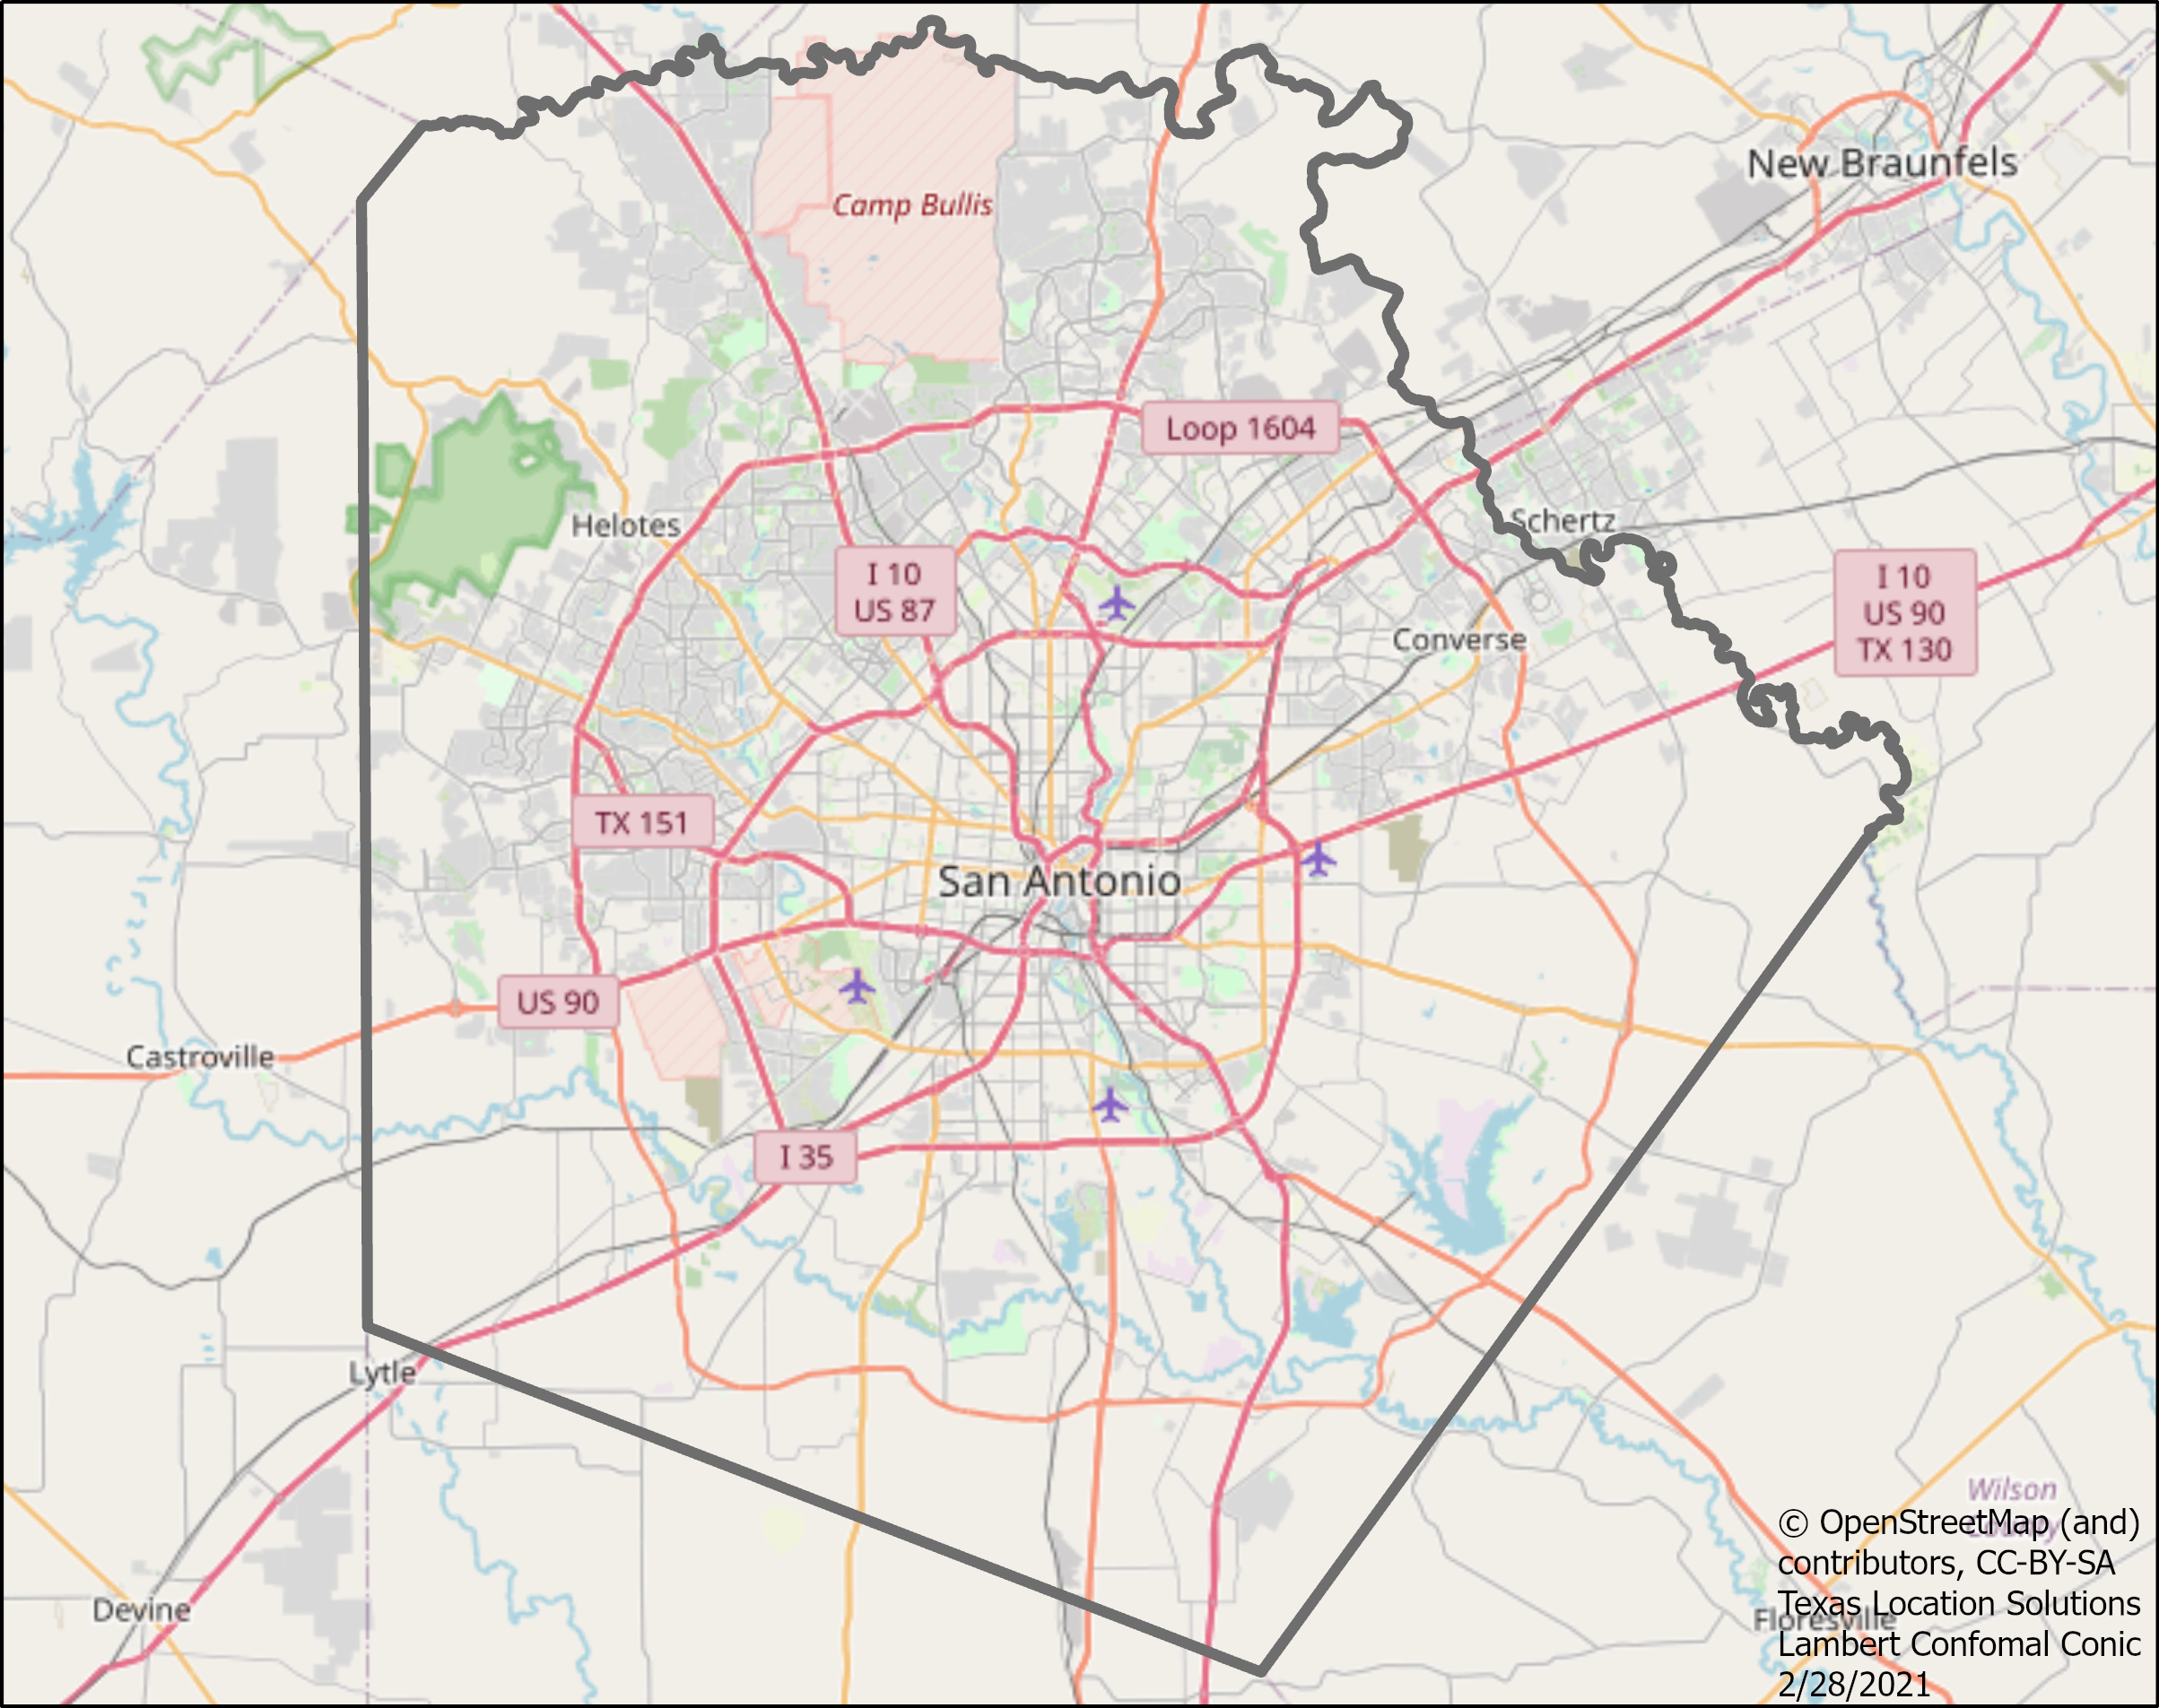
The geographic area of study will be encompassed within the greater San Antonio area - specifically Bexar County. The literature research and findings range from 2015 to 2020, while the GIS data is currently up to date. The map shown (Fig. 1) is provided by the TLS team. The GIS analyst team was assigned to this project in late January and will give a final report on April 28th. The presentation of the final report is scheduled for May 3rd.

- Literature Review
To signify the impact of homelessness in Bexar County, broader studies on homelessness and the factors associated with it must be discussed. The literature review is organized in a large-to-small geographic fashion. While the start of the review introduces geospatial analysis and its potential use for homelessness studies, the following sections analyze national studies on homelessness, and Bexar County studies on homelessness, respectfully.

(Figure 1. Bexar County)

2.1 Geospatial Techniques
Geospatial Analysis can help address and map homelessness in any specific area. Specific examples include:
*combining a zip code layer with a layer of addresses for service and housing purposes,
*recording locations of homeless populations, and locations of public and affordable housing, &
*mapping accessibility of transportation data (TxDOT).
The most obvious, yet prominent GIS techniques for addressing homelessness is to combine zip code data layers with factors such as race, income, education, and unemployment. These techniques, among others, are used to create mapping patterns, spatial relationships, trends, and the like. Overlaying these factors, among other prevalent factors that contribute to homelessness, is a tremendous aid for mapping service areas and Drop-In Centers.
2.2 Studies Outside of Bexar County
National studies have proven that there are a multitude of factors that pertain to homelessness. For example, a collaborative analysis performed by the California Poly Lab and University of Chicago Poverty Lab determined that “a minimum of approximately 50 features is required to obtain acceptable performance in predictive models, with optimal performance requiring somewhere between 150 to 200 features” (CalPolicyLab pg. 12). While most studies differ in methodology, the major risk factors and indicators for homelessness remain similar. According to a multitude of organizations including the Department of Housing and Urban Development (HUD), Child Trends Data Bank, and the Philadelphia College of Osteopathic Medicine, the most prominent factors include mental health issues, lack of affordable housing, unemployment, poverty, and minimum wages. Substance abuse and a lack of nearby needed services are also noticeable risk factors. Studies also show that in most cases, these factors can “stack” on top of each other to worsen the situation. For example, more studies performed by HUD concluded that in 2012, approximately 25% of renters in the United States had “extremely low incomes”. This is important to recognize because studies show that 3 out of 4 households categorized as “extremely low income” use over 50% of their income to rent and utilities. Further, there is a disproportionate number of homeless and displaced peoples among (1) military veterans, (2) the LGBTQ community, and (3) people of color. For example (1), findings from the 100,000 Homes Campaign discovered weighted characteristics pertaining to mortality of homelessness. The weight is designated as an “adjusted odds ratio” (aOR) - The results are as follows:

Being a veteran = 1.10
Having less than a high school education = 1.09
Accessing informal income = 2.37
Having a history of foster care = 1.14
Chronic homelessness for 1-5 years = 1.36
Chronic homelessness for more than 5 years = 1.96
Incarceration = 1.32
Drug and/or alcohol abuse = 1.10
Intravenous drugs = 1.13
Daily drinking for the past month = 1.98
Being Unsheltered = 1.12
Receiving Entitlements = 1.63
As it pertains to mortality of homelessness, this study concludes that being a military veteran is equivalent to abusing drugs and/or alcohol, and worse than “having less than a high school education”.
(2) According to statistics provided by youth.gov, approximately 20% to 40% of the 1.6 million youth ages 12 to 17 that have experienced at least one night of homelessness identified as LGBT. In addition, analysis performed by Voices of Youth Count determined that people of the LGBTQ community have a 120% higher risk of homelessness than the average American citizen.
(3) Voices of Youth Count also determined that Black or African American youth have an 83% higher risk of homelessness than the average American citizen.
In addition, multiple risk factors at the same time vastly increases the likelihood of homelessness. A study conducted by the Library of Parliament concluded this and added that 10 to 20% of all homelessness individuals fall into this category.
All research and studies performed show similar results. Increased access to employment, affordable housing, and stability are crucial to curbing the risk factors of homelessness and displacement.

2.3 Bexar County PIT Count(s) and Statistics:
As previously mentioned, this expansion project takes place in San Antonio, Texas. It is paramount that the current homelessness and poverty situation(s) in the area are properly researched. In their most recent Point-In-Time Count (PIT Count) report, the South Alamo Regional Alliance for the Homeless (SARAH) has aimed to identify the full scope of the increasing homeless population in the greater San Antonio area. According to the report, SARAH revealed a 45% increase in the number of homeless young adults since last year. To add, homelessness in parenting youth has increased by almost 75%, with unaccompanied youth homeless increasing by 55% during the same time frame. In addition, the number of displaced people in Bexar County has increased by 2%, and unsheltered homelessness increased 7%. There has also been a 2% decrease in shelter accessibility. The report included demographic statistics that stated the average age of displaced persons in San Antonio was 38 years old, with the median age being 39. Of the total displaced peoples counted, 59% were males, 30% were female, and 11% were “transgender or non-conforming gender”. Findings related to ethnicity also paint a clearer picture of the situation in San Antonio: according to the PIT Count, 72% of the displaced population are white, 24.4% are black, and the remaining percentages reported as multi-racial, native American, Asian, and Pacific Islander.
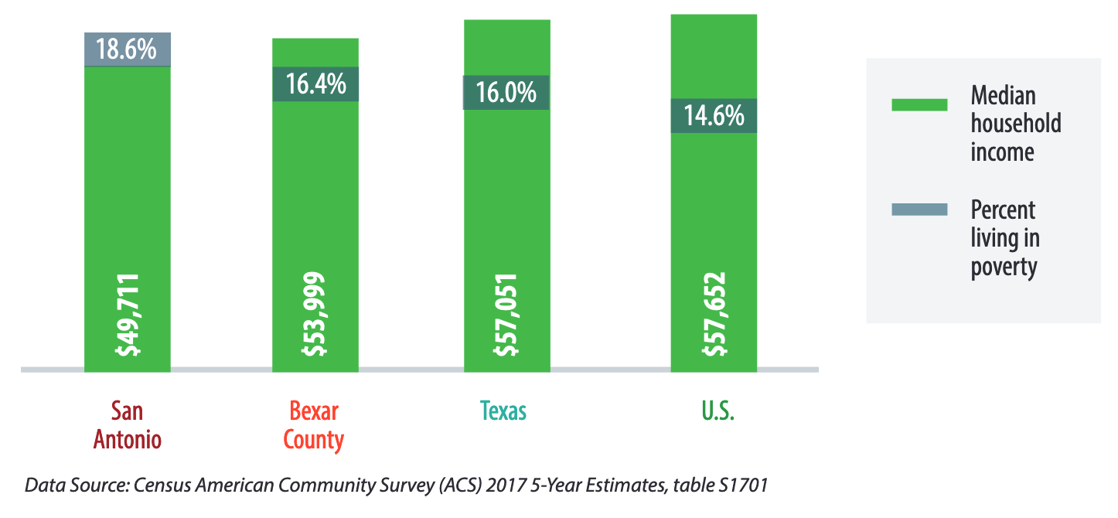
A report put out by the City of San Antonio (Status on Poverty) confirms that when these issues and risk factors are “combined”, homelessness becomes much more likely. For example: People that did not graduate high school are more than three times as likely to live in poverty than the average citizen. Combine this with the fact that housing prices in the city rose by 50% from 2005 to 2016, the result creates an environment with higher poverty levels (figure 2). To add, during the same time period, income only rose by an average of 23% (Mayor’s Housing Policy Task Force).
(Figure 2. Census American Community Survey)

Given the goals of our project, and the information gathered, using raster analysis will be more beneficial. Raster analysis re-enforces spatial relationships via location of the cells. To add, we will be required to weigh our risk factors. This can only be performed using tools that require raster inputs.

With our task being to locate the most suitable areas for SARAH’s expansion project, these statistics are not only relevant, but will help determine the weighted importance of the risk factors associated with homelessness and “at risk of” homelessness. The weighted risk factors are listed and detailed in the Methodology (PAGES 8-9).

- Data
The section comprises the master data list utilized to locate the access point and drop-in locations. The data originates from six sources: Bexar County GIS Data, SARAH, US Census, San Antonio GIS Portal, LoopNet, and OpenStreetMap.

Entity | Attributes | Spatial Object | Status | Source | Year
Public Libraries | -Location  -Hours of operation  -Phone Numbers | Point | Available | Bexar County GIS Data | 2021
Public Schools | -Location  -Service Availability  -Hours | Point | Available | Bexar County GIS Data | 2021
Factors Predicting Youth at Risk of Homelessness | -Education Level  -Foster Care  -Veteran Status  -Income  -Unsheltered Youth | Point | Available | SARAH  U.S. Census | 2020
Side Walks | -Side Walk Locations | Line | Available | San Antonio GIS Portal | 2021
Transportation | -Bus Stops | Line/Point | Available | OpenStreetMap | 2019
Access Hubs | -Location  -distance from H4H  -Hours | Point | Available | SARAH | 2021
Suitable Drop-Off Locations | -6,000-8,000 sqft  -Coordinates | Point | Available | LoopNet | 2021
Suitable Access Points | -Public Facilities  -Coordinates | Point | Available | LoopNet | 2021
Census Tracts | -Borders  -Population  -Area | Polygon | Available | Bexar County | 2019
Bike Routes | -Bike Routes | Line | Available | San Antonio GIS Data | 2021

- Methodology

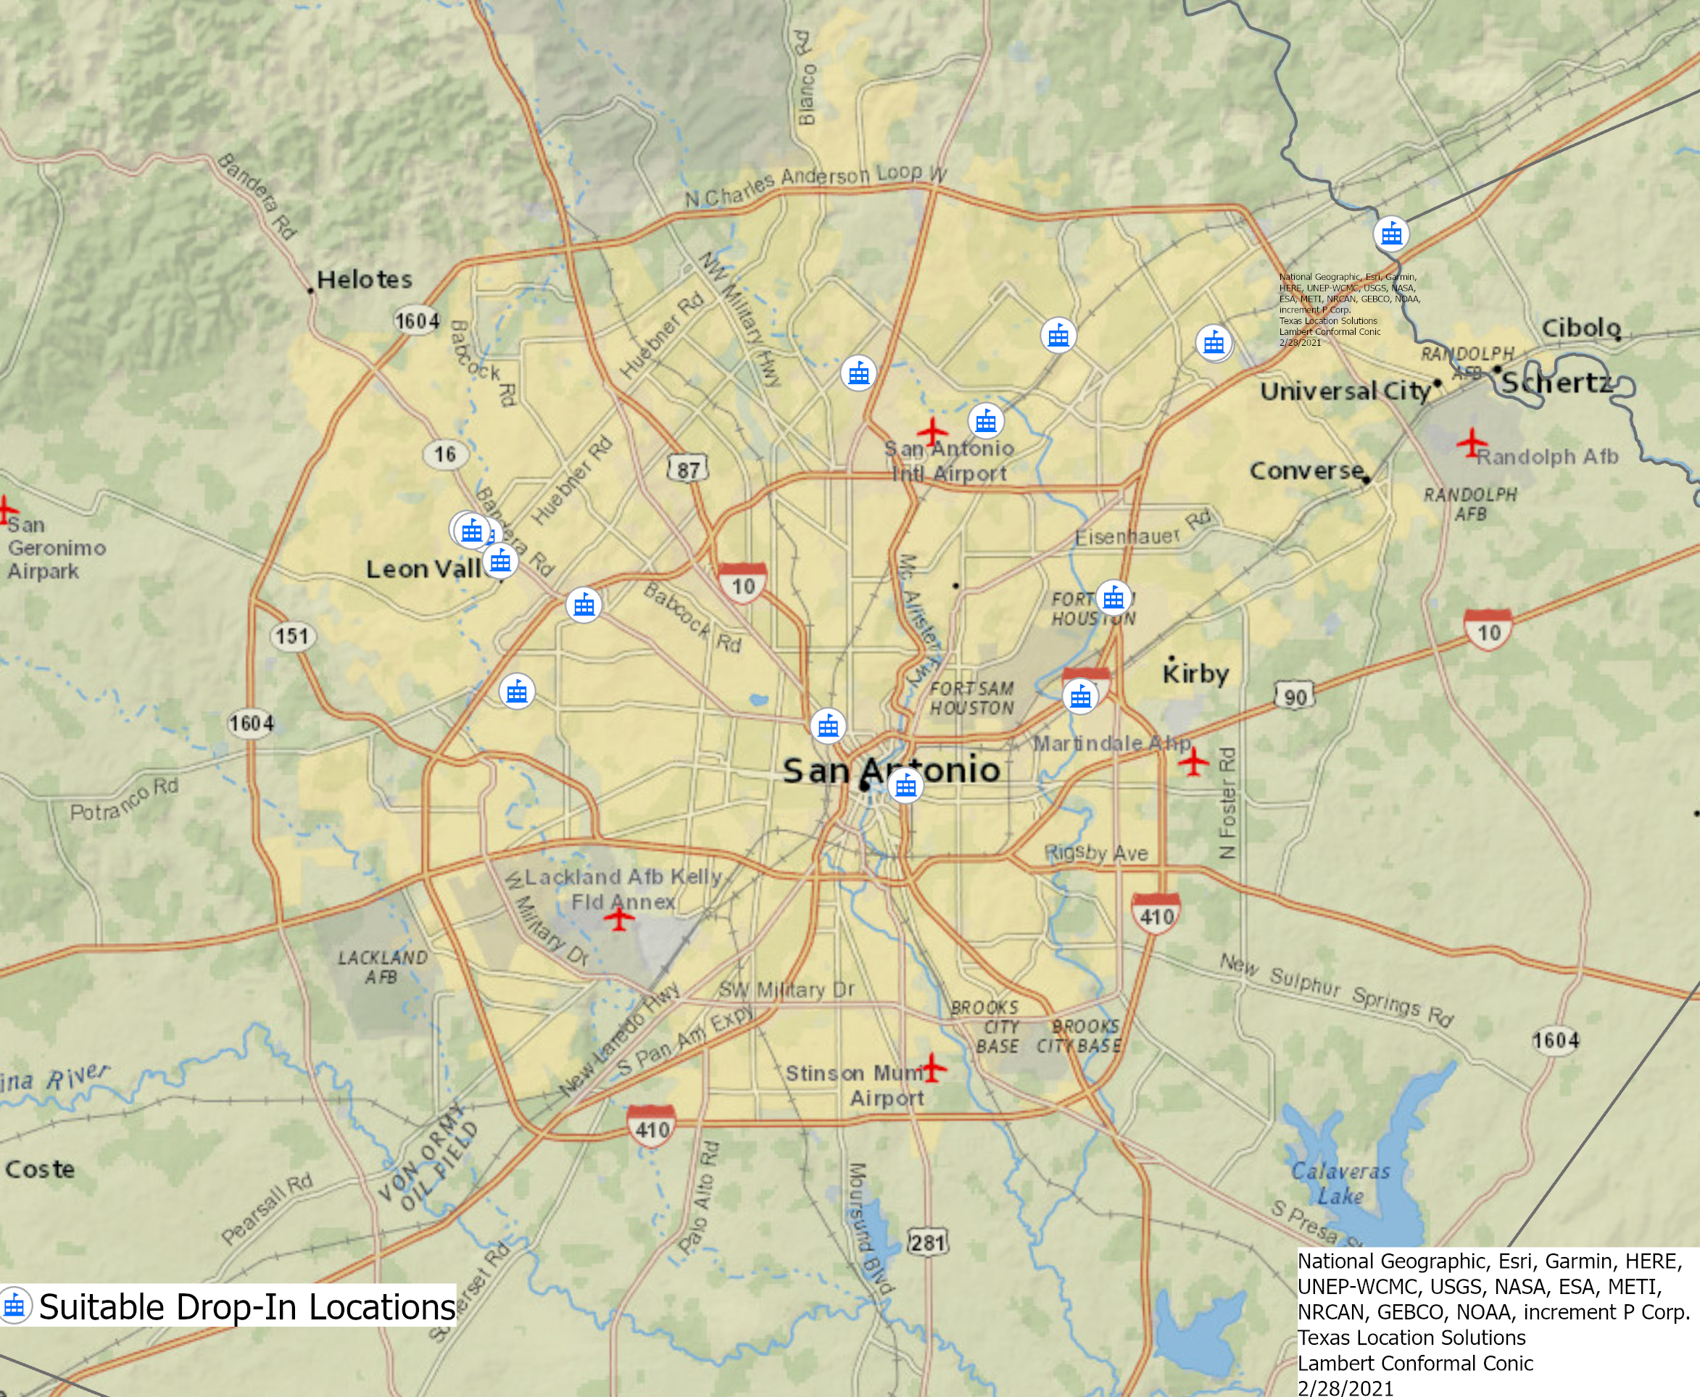
4.1 Preprocessing the Data
Preprocessing the data for this case required manual data entry, file conversions, and georeferencing. The data for the suitable drop-in locations and access points transpires from LoopNet. Subsequently, the information warranted manual data entry into an Excel file for the purpose of utilizing the information in ArcGIS Pro. The excel spreadsheet contains attributes such as address, price, square-footage, availability, hours of viewing, and coordinates for each building. It is important to note that this list will be continuously updated, as the number of suitable locations for the expansion project will change over time. The excel data requiring conversion to CSV comprised the SARAH Access Hubs, the suitable drop-in locations, and the suitable access points. The SARAH Access Hubs, drop-in locations, and access points were then georeferenced within ArcGIS Pro for the purpose of displaying their locations within the software.

4.2 Assigning Weights to Risk Factors Predicting Youth Homelessness
Assigning weights to factors predicting youth homelessness required utilizing a Heuristic approach. This specific approach relies on assigning weights by obtaining knowledge through expert opinion and previous studies. In this case, the expert opinion transpired from Dr. Azza Kamal’s knowledge and experience in this field of work. Previous studies center on homelessness indicators, weighing homelessness indicators, preventing homelessness, housing, welfare, and foster care involvement. In determining the factors predicting youth homelessness, this project employed literature from previous studies.
We implemented a 0-1 rating system, where the total number of the factors equals 1. The major factors found at the Census Tract level are lack of affordable housing/unsheltered youth, unemployment, poverty, lack of nearby needed services, veteran status, education level, and foster care experience. The weights are as follows:
Lack of Affordable Housing/Unsheltered Youth: 0.2
Unemployment: 0.15
Poverty: 0.15
Lack of Nearby Needed Services: 0.1
Veteran Status: 0.1
Education Level: 0.15
Foster Care: 0.15

TOTAL: 1.00

The weights were given due to prevalence in various studies research, with special consideration given to studies that included interviews of displaced persons. If the number of factors and/or factor weights change, it will be noted in the upcoming Progress Report.

4.3 Analysis
The analysis of the project encompasses creating buffers for each layer, converting the buffers to polygons, transforming the polygons to rasters, reclassifying the weight of the rasters, and combining each raster. The rasters transpire from exercising the polygon to raster tool. After the rasters are formed, the weight of each raster is reclassified based on the factors predicting youth homelessness and proximity to suitable access points and drop-in centers. Subsequently, the most suitable access points and drop-off locations are determined through employing the weighted sum tool. The tool multiplies each raster and sums them into one layer.

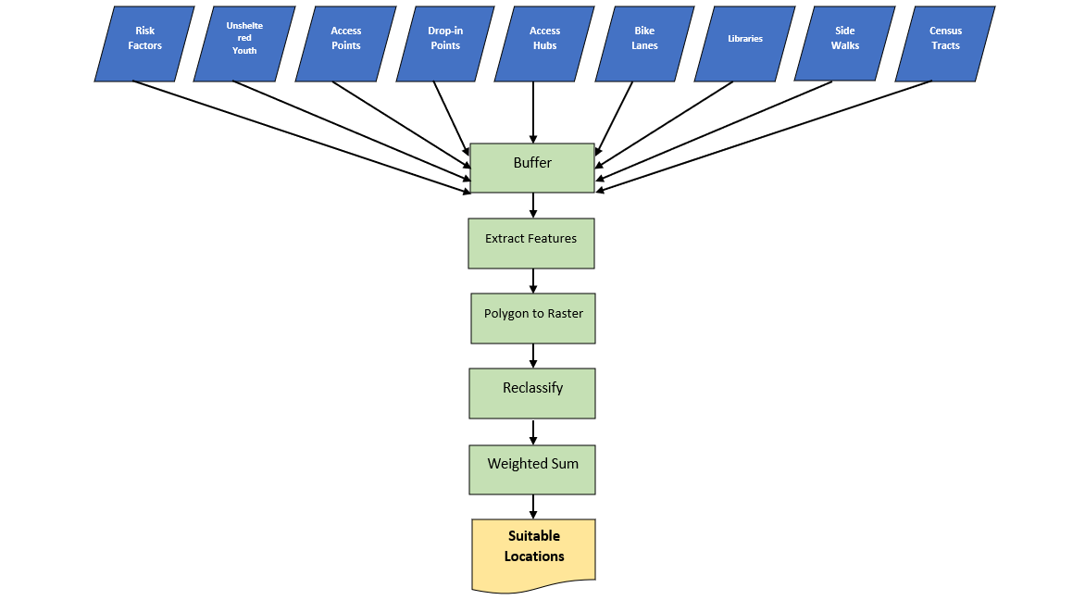
(Figure 4. Flowchart)

- Budget VI. Timetable
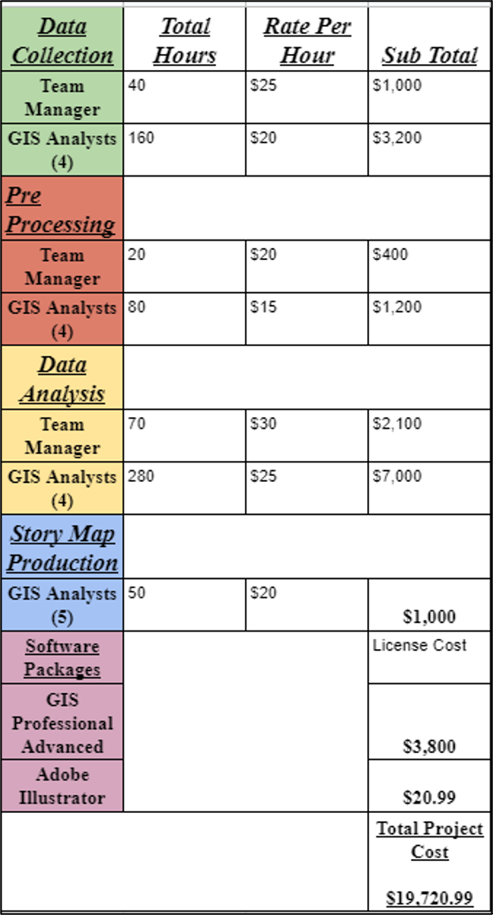
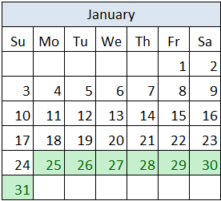
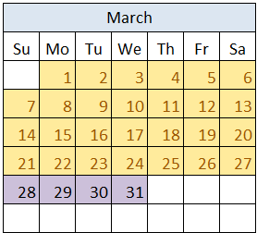

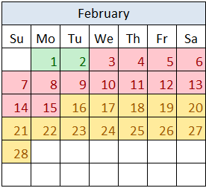
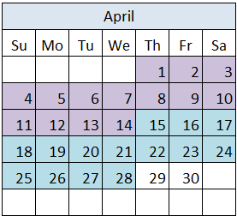

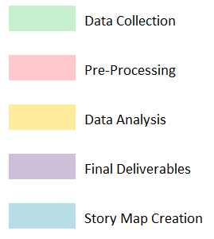

- Final Deliverables
- Project proposal and progress report
- A final report that includes the following:
  - Introduction and problem statement
  - Clear and concise methodology
  - Table of data used in the study (including geography, year, source/link and instructor information)
  - Analysis results and discussion
  - Conclusions and recommendations
- Data set and Geo-processed maps:
  - GIS Map Package of all maps
  - Shapefiles of all layers created, acquired from different agencies/downloaded from Census + other portals
  - Full metadata citations
- A Web map visualizing the analysis results (ESRI Story Map)

VIII. Conclusion
The aim of this project is to map 4-5 locations that provide the homeless youth with services and resources based on existing resource facilities and weighted risk factors contributing to youth homelessness. The 3 access points will provide necessities to the homeless youth such as food and water. The two drop-in centers will provide resources such as showers, food, and recreation areas for the homeless youth.

IX. References: Websites, Journals, Reports, Art
2020 Point-In-Time Count Report: San Antonio and Bexar County (pp. 1-40, Rep.). (2020). San Antonio, Texas: South Alamo Regional Alliance for the Homeless.
Building Png Photo Background - Business Buildings Clipart Transparent Png [Digital image]. (n.d.). Retrieved February 24, 2021, from https://www.pikpng.com/pngvi/ibRwTmJ_building-png-photo-background-business-buildings-clipart-transparent-png/
Caton, C., Dominguez, B., Schanzer, B., Hasin, D., Shrout, P., Felix, A., . . . Hsu, E. (2005, October). Risk factors for long-term HOMELESSNESS: Findings from a longitudinal study of FIRST-TIME homeless single adults. Retrieved February 24, 2021, from https://www.ncbi.nlm.nih.gov/pmc/articles/PMC1449432/
Eath.maps.arcgis.com. (n.d.). Retrieved February 24, 2021, from https://eath.maps.arcgis.com/apps/Cascade/index.html?appid=0c56e846dacb4663926cdbc8570ea4f6
Echenberg, H., & Jenson, H. (n.d.). Risk Factors for Homelessness (pp. 1-13, Rep. No. PRB 08-51E). Library of Parliament.
Hill, T., & Tamminen, K. A. (2020). Examining the Library as a Site for Intervention: A Mixed-Methods Case Study Evaluation of the “Innovative Solutions to Homelessness” Project. Journal of Library Administration, 60(5), 470–492.
Homeless Children and Youth (pp. 1-16, Rep.). (n.d.). Child Trends DataBank.
Homeless in America : examining the crisis and solutions to end homelessness : hearing before the Committee on Financial Services, U.S. House of Representatives, One Hundred Sixteenth Congress, first session, February 13, 2019. (2019). U.S. Government Publishing Office.
Homelessness & Housing. (n.d.). Retrieved February 24, 2021, from https://youth.gov/youth-topics/lgbtq-youth/homelessness
Homelessness in America: Overview of Data and Causes (pp. 1-4, Rep.). (n.d.). National Law Center on Homelessness and Poverty.
Homelessness statistics by state. (n.d.). Retrieved February 24, 2021, from https://www.usich.gov/tools-for-action/map/#fn[]=1400&fn[]=2800&fn[]=6200&fn[]=10000&fn[]=13200&year=2019&all_types=true
Missed opportunities: Youth homelessness in America. (n.d.). Retrieved February 24, 2021, from https://voicesofyouthcount.org/brief/national-estimates-of-youth-homelessness/
Montgomery, A. E., Szymkowiak, D., Marcus, J., Howard, P., & Culhane, D. P. (2016). Homelessness, unsheltered status, and risk factors for mortality. Public Health Reports, 131(6), 765-772. doi:10.1177/0033354916667501
Predictive and/or Protective Factors for HomelessnessFrom Homelessness Policy Research Institute Partners (Rep.). (n.d.). Homelessness Policy Research Institute.
Ross, C., & Selekman, R. (n.d.). Analysis of Data on Youth With Child Welfare Involvement at Risk of Homelessness (pp. 1-17, Rep.). Youth-At-Risk of Homelessness.
Status of Poverty in San Antonio (pp. 1-28, Rep.). (2019). San Antonio, Texas: City of San Antonio.
Tenant protection vouchers. (n.d.). Retrieved February 24, 2021, from https://www.childwelfare.gov/topics/systemwide/service-array/housing/
Teresa Hill & Katherine A. Tamminen (2020) Examining the Library as a Site for Intervention: A Mixed-Methods Case Study Evaluation of the “Innovative Solutions to Homelessness” Project, Journal of Library Administration, 60:5, 470-492, DOI: 10.1080/01930826.2020.1729626

Von Wachter, T. M., Bertrand, M., Pollack, H., Rountree, J., & Blackwell, B. (n.d.). Predicting and Preventing Homelessness in Los Angeles (pp. 1-14, Rep.). California Policy Lab & University of Chicago Poverty Lab.
GIS Technology and Homelessness - Using GIS to Solve 3 Common Problems in Helping the Homeless [PDF]. (2016, April). Bitfocus, Inc.
References: Data Sources
Bexar County open data portal. (n.d.). Retrieved February 24, 2021, from https://gis-bexar.opendata.arcgis.com/
Bus stops and stations in San Antonio. (n.d.). Retrieved February 24, 2021, from https://mygeodata.cloud/data/download/osm/bus-stops-and-stations/united-states-of-america--texas/bexar-county/san-antonio
City of San ANTONIO open data. (n.d.). Retrieved February 24, 2021, from https://opendata-cosagis.opendata.arcgis.com/search?tags=Transportation
GIS (geographic Information Services). (n.d.). Retrieved February 24, 2021, from https://www.sanantonio.gov/GIS/GISData
Sidewalks. (n.d.). Retrieved February 24, 2021, from https://opendata-cosagis.opendata.arcgis.com/datasets/sidewalks
Data.census.gov. (n.d.). Retrieved March 01, 2021, from https://data.census.gov/cedsci/map?t=Educational+Attainment&g=0500000US48029.140000&tid=ACSST5Y2019.S1501&hidePreview=false&vintage=2019&layer=VT_2019_140_00_PY_D1&cid=S1501_C01_001E&palette=Teal&break=5&classification=Natural+Breaks&mode=thematic
Data.census.gov. (n.d.). Retrieved March 01, 2021, from https://data.census.gov/cedsci/table?t=Official+Poverty+Measure%3APoverty&g=0500000US48029.140000&tid=ACSST5Y2019.S1701&hidePreview=false
Data.census.gov. (n.d.). Retrieved March 01, 2021, from https://data.census.gov/cedsci/map?t=Employment&g=0500000US48029.140000&tid=ACSST5Y2019.S2301&hidePreview=false&vintage=2019&layer=VT_2019_140_00_PY_D1&cid=S2301_C01_001E&palette=Teal&break=5&classification=Natural+Breaks&mode=thematic
Data.census.gov. (n.d.). Retrieved March 01, 2021, from https://data.census.gov/cedsci/map?t=Veterans&g=0500000US48029.140000&tid=ACSST5Y2019.S2101&hidePreview=false&vintage=2019&layer=VT_2019_140_00_PY_D1&cid=S2101_C01_001E&palette=Teal&break=5&classification=Natural+Breaks&mode=thematic
SARAH. (2021, January). [Unsheltered Youth Locations and Characteristics]. Unpublished raw data.
SARAH. (2021, January). [Access Hubs Providing Services to Homeless Youth]. Unpublished raw data.
(n.d.). Retrieved February, 2021, from https://www.loopnet.com/search/industrial-space/san-antonio-tx/for-lease/?sk=e8cfad6199b9a50493a0bb51363b1196
Google search. (n.d.). Retrieved February 28, 2021, from https://www.google.com/search?tbs=lf%3A1%2Clf_ui%3A2&tbm=lcl&sxsrf=ALeKk00SeOoY_UvTtyBShUKxxymlAUpxxg%3A1614572561007&q=homeless%2Bshelters%2Bsan%2Bantonio%2Btx&rflfq=1&num=10&sa=X&ved=2ahUKEwjlvNm_n47vAhUOM6wKHd64BNwQjGp6BAgSEGw&biw=1474&bih=790#rlfi=hd:;si:;mv:[[29.7384064,-98.4605091],[29.306454900000002,-98.5743366]];tbs:lrf:!1m4!1u3!2m2!3m1!1e1!1m4!1u2!2m2!2m1!1e1!2m1!1e2!2m1!1e3,lf:1,lf_ui:2

Participation
Darrin Speer - Summary, Purpose, Data, Methodology, Flow Chart, Pre-processing Data, PowerPoint
Travis Banneyer - Logo Design, Scope, Timetable
Stancil Barton - Scope, Literature Review, Pre-processing Data, Final Deliverables, PowerPoint
Brandon Trevino - Budget, Editing, Timetable, PowerPoint
Kennedy Watson - Logo Design, Summary, Purpose, Editing

