Progress Report: Expansion Project for the South Alamo Regional Alliance for the Homeless (SARAH)

Consultants

Darrin Speer – Team Manager
Stancil Barton – GIS Analyst
Brandon Trevino – GIS Analyst
Kennedy Watson – GIS Analyst

Filing Date: March 30th

Table of Contents

Introduction
Summary……………………………………………………………………………….3
Purpose…………………………………………………………………........................3
Scope…………………………………………………………………………………...3
Tasks
Work Completed……………………………………………………………………….4
Completed Maps……………………………………………………………………….4
Present Work…………………………………………………………………………...5
Work Scheduled………………………………………………………………………..6
Problems
Risk Factors……………………………………………………………………………7
Data…………………………………………………………………………………….7
Conclusion………………………....………………………………...………………..…........7

1. Introduction

1.1 Summary

Texas Location Solutions (TLS) has worked through the data sources provided in the proposal to preprocess the majority of our weighted risk factors, and reassigned weights to race/ethnicity. Maps reflecting access hubs, access points, sidewalks, unsheltered youth, and suitable drop-in locations have been completed. Currently, we are working on polygon conversion and the final Story Map. In addition, we have updated the timetable to reflect our current work balance and schedules more accurately, and plan to have the project completed by the end of April.

1.2 Purpose

TLS has continued its collaboration with SARAH to locate 4-5 potential drop-in and access points that will provide services such as food, water, showers, recreation, and community/educational outreach to displaced and “at risk of homelessness” youth in Bexar County. We have put together spatial data that will assist us in identifying five locations that will provide resources and services for the homeless in Bexar County, Texas. There will be three access points providing services to our target homeless population and two drop-in centers.

1.3 Scope

The scope of the expansion project has remained unchanged. We are looking at suitable locations within Bexar County, with special consideration given to the Central San Antonio area. Due to spatial data, we have obtained, we are giving special consideration to Central and Southeastern San Antonio. To add, we are continuously analyzing and updating the availability of the most suitable drop-in locations within Bexar County.

2. Tasks

2.1 Work Completed

The work completed consists of preprocessing five of our seven risk factors, polygon conversions, and updating the story map. The five preprocessed risk factors are as follows: Unsheltered Youth Locations, Youth Unemployment Rate, Youth Poverty, Education Level, and Mental Health. Concerning raster analysis, TLS has transformed all data into polygons except for five risk factors: “Lack of Nearby Needed Services”, “Race/Ethnicity”, “Educational Attainment”, “Mental Health”, and “Poverty”. With respect to the story map, TLS has generated an outline and format. To illustrate, there is a completed introduction section, a map portraying the scope of the study area, a flow chart, budget, and timetable

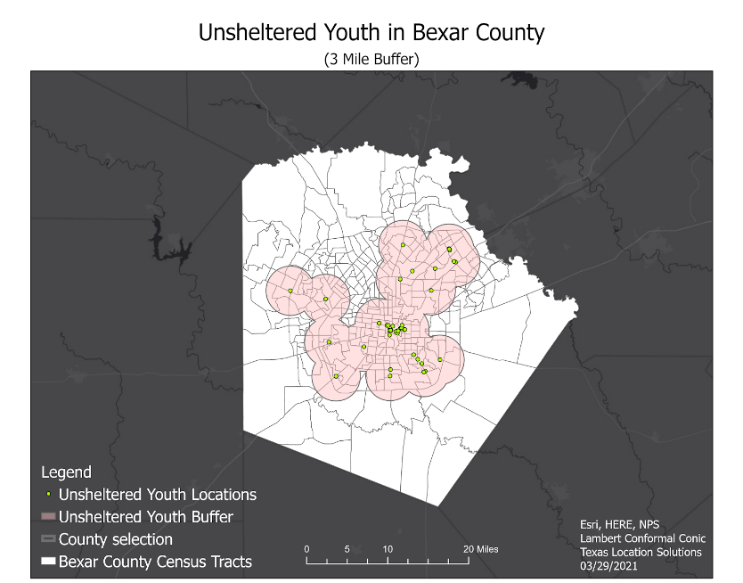
Completed Maps
Figure 1.4 Access Hubs Buffer

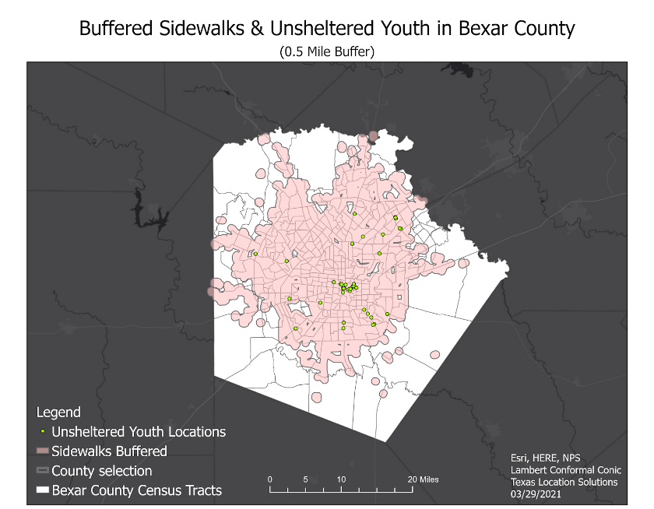
Figure 1.1 Unsheltered Youth Buffer
Figure 1.2 Sidewalks Buffer

Figure 1.4 Access Hubs Buffer
Figure 1.3 Drop-In Locations Buffer
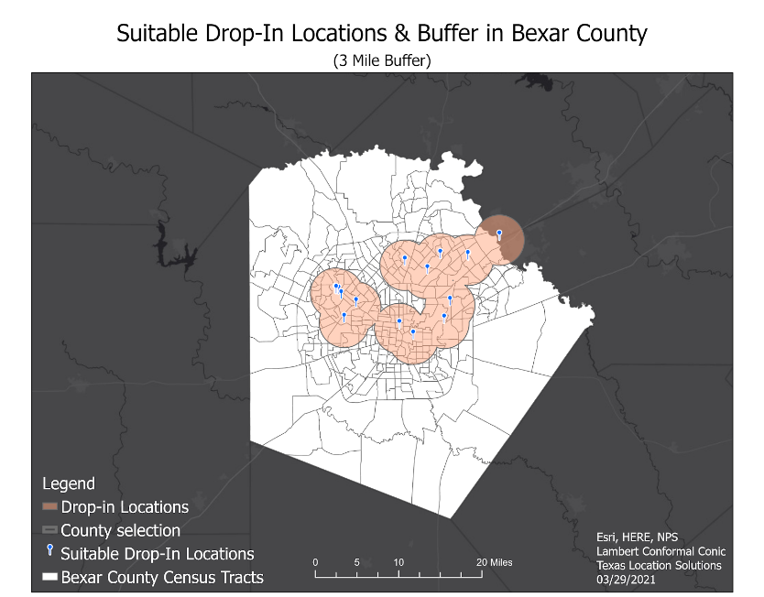
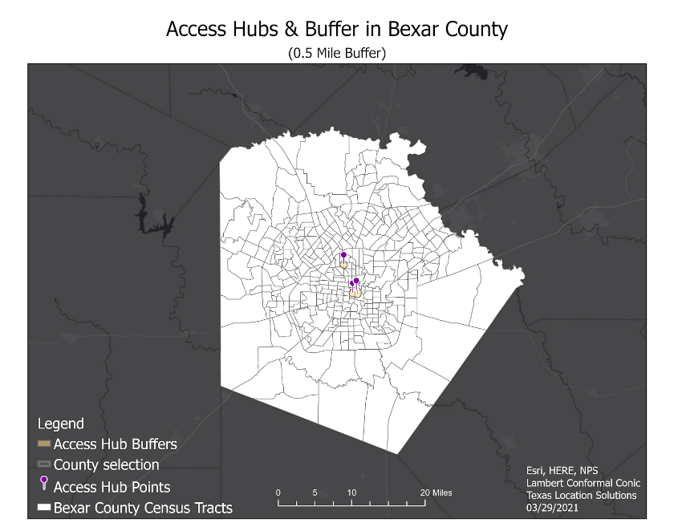

2.2 Present Work

Currently, we are working on polygon conversion, updating the story map, and preprocessing risk factors. Speaking on polygon conversion, we are in the process of converting risk factor data into polygons. This conversion is occurring through creating shapefiles from selected attributes of preprocessed risk factor data. Regarding the story map, we are continually updating it as other objectives are met within the project. Concerning the risk factors, the two risk factors in the preprocessing stage are Lack of Nearby Needed Services and Race/Ethnicity. The previous data utilized for the Lack of Nearby Needed Services consisted of those lacking computer/internet access, stable plumbing, AC/Heat, and transportation. After reviewing the data, TLS has chosen to employ libraries, community centers, social service providers, and relevant non-profits in lieu of the previous data. About race and ethnicity, TLS previously planned to weigh race as one risk factor with a single weight. The problem in this step is the exclusion of ethnicity in the weighing process. After realizing the importance of ethnicity, we are employing it to help assign the appropriate weights. The new weights are as follows: A/A (Hispanic): 0.0085; A/A (Non-Hispanic): 0.0034; White (Hispanic): 0.078; and White (Non-Hispanic): 0.017.

2.3 Scheduled Work

Looking ahead, we plan to convert each polygon into raster format. Following this conversion, we will have to add weights to each raster, and finally, combine the rasters to render the suitable drop-in and access point locations. In addition, we plan to incorporate our finished products into the story map: a revised introduction, literature review, data table, methodology, flow chart, budget, and finalized maps displaying the suitable drop-in and access point locations.

Revised Timetable:
The timetable has been edited to provide more time for preprocessing our data for each of the risk factors:

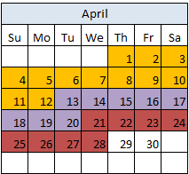
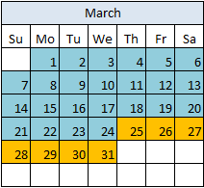
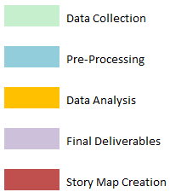
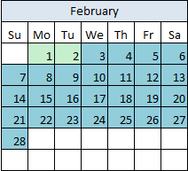
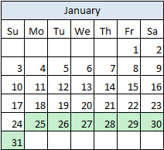

2.4 Problems

One of the major problems we encountered is the potential for data inaccuracy due to in-situ data collection conditions. An example of this includes physically locating the homeless youth in Bexar County and making sure individuals were counted properly. Another potential source for data inaccuracy consists of individuals unwilling to report their mental health issues/LGBTQ status, resulting in the inability to acquire some data due to its sensitive nature. In obtaining risk factor data from the Census Bureau, we found that the age groups vary for each risk factor. While some of the data included age ranges within our scope of study, it also included ages ranges that exceeded the age limit we planned to work with.

3. Conclusion
At this stage of our project, we have finished processing data for all risk factors except for “Lack of Nearby Needed Services” and “Race” as well as updated their corresponding weights so each factor is better represented. The timetable has been altered to provide adequate time for the preprocessing phase of our project that took longer than initially expected, but we are still on track to finish the geospatial analysis by April 12th. In the final stages of this project, we are currently identifying locations for 4 - 5 new access points for homeless youth and to provide maps for each risk factor.

Participation
Darrin Speer: Editing, PowerPoint Slides, Tasks
Brandon Trevino: Conclusion, Editing, PowerPoint Slides, Timetable
Kennedy Watson: Editing, Maps, PowerPoint Slides, Problems
Stancil Barton: Editing, Introduction, PowerPoint Slides

