Expansion Project for Suitable Access Points and Drop-In Locations:
South Alamo Regional Alliance for the Homeless (SARAH)
Final Report

Consultants

Darrin Speer – Team Manager
Stancil Barton – GIS Analyst
Brandon Trevino – GIS Analyst
Kennedy Watson – GIS Analyst

Filing Date: April 28th

TABLE OF CONTENTS

ABSTRACT……………………………………………………………………………………....2

1. INTRODUCTION…………………………………………..……………..…….….….............2
1.1 Client Requirements for Access Points and Drop-In Centers……..….….……...…....3

2. DATA…………………………………………………………………………………………..3

3. METHODOLOGY……………………………….…………………………………………….5
3.1 Data Preparation………………………………………………………………………5
3.2 Creating Polygons from Risk Factor Data to Prepare for Raster Combination……...7
3.2.1. Educational Attainment …….………….…………………..…………..……...7
3.2.2. Unemployment ……………………..………………………..………………..7
3.2.3. Lack of Nearby Needed Services…..…..………...………..…………………..8
3.2.4. Age Ratio by Poverty…………..…….………………………….…………….8
3.2.5. Income…………………..…………..….……………………………………...8
3.2.6. Unsheltered Youth………………………..……….…………………………..9
3.2.7. Race by Age……………………………...……..…………………….………..9
3.3 Utilizing Raster Analysis to Determine Suitability of Service Locations..….………..9
3.3.1. Polygon to Raster Conversion……………………………………..…..….…...9
3.3.2. Reclassification of Raster Values….……..……….…….…………………….10
3.3.3. Combining Rasters to Produce Final Results….……………..……………….10

4. RESULTS AND DISCUSSION……………………..………………….…………………….11
4.1. Final Results……………………….…………………………….………………….11
4.2. Limitations…………..………….……….……………….………………………….15
4.3. Exclusions…………..………………….………….……..………………………….16

5. CONCLUSION…………………………..…….………………………………….…………..16

6. REFERENCES………………………………………………………………………………..18

APPENDIX I: MAPS…………..…….…………………………..……………………………...20

APPENDIX II: METADATA………………..….……………………………………………….43

APPENDIX III: CONTRIBUTIONS…………………………..……………….……………….44

Abstract
Access to resources and information for homeless youth, as well as those at risk of homelessness in the San Antonio area is not as readily available as it should be. In an effort to rectify this problem, our study aims to identify four to five access points and drop-in center locations within Bexar County that have the capability of providing services such as food, water, showers, recreation, and community outreach. Our final result consists of a series of maps that portray the most suitable locations. Each map analyzes and displays the distribution of ‘homelessness risk factors’ that have been weighted proportionally by their impact and significance.

1. Introduction

San Antonio, Texas is a rapidly growing metropolitan area in the Central Texas region, and one of multiple major cities experiencing homelessness amongst youth and young adults. This rapid growth has created an increasing need for resources and information regarding homelessness. The South Alamo Regional Alliance for the Homeless (SARAH) is trying to combat this issue. SARAH is an organization that looks to combat this problem by establishing access points that provide food, showers, recreation, and community outreach to the displaced youth of Bexar County. Along with these access points, drop-in centers provide information to not only homeless youth, but also to those who are “at-risk” of becoming homeless. Texas Location Solutions (TLS) has collaborated with SARAH in an expansion project that will provide four to five potential access point locations (two of which will be drop-in centers) that will provide homeless-based resources and services. In order to assist SARAH with this endeavor, TLS has located the most suitable areas based on a multitude of data, such as weighted risk factors that include poverty level, race by age, education level, lack of nearby needed services, unsheltered youth locations, and unemployment. Originally, we wanted to use people identifying as LGBTQ+, veteran status and ‘cognitive disabilities’ as risk factors. However, the existing data is insufficient to apply towards our research and risk factor weighting system.
Utilizing a GIS is ideal for this type of location analysis since it allows us to compare multiple factors that affect homelessness within the same area and create a visual representation of the aforementioned populous in order to generate a better plan for homeless youth and young adults. During the early stages of the project, we believed the southeastern and central (downtown) areas would be the most optimal locations for the new access points and drop-in centers. This was based on the current locations of existing facilities as well as the current distribution of homeless youth in Bexar County.

1.1 Client Requirements for Access Points and Drop-In Centers

Access Points
- Must be an existing organization that provides service to the homeless population
- They must be in walkable range to most at-risk youth and young adults
- Identified locations need to be further away from other homeless service and housing campuses in San Antonio.

Drop-In Centers
- Estimated needed space is ~6,000 to 8,000 sq ft.
- Locations must be further away from other homeless service and housing campuses in San Antonio.
- They must be close to where most youth experiencing homelessness congregate
- Indoor space and outdoor spaces are required. The outdoor space should have potential for greenspace, playgrounds, basketball courts, etc.

2. Data

This section comprises the master data list, utilized to locate current and potential access point and drop-in locations. It should be noted that all maps were created using Lambert Conformal Conic (Texas_South_Central_StatePlane_4204) as our Projected Coordinate System, and “WGS 1984” for the Geographic Coordinate System. The data originates from six sources: Bexar County GIS Data, SARAH, US Census - American Community Survey, San Antonio GIS Portal, LoopNet, and OpenStreetMap.
The aforementioned data sources are extremely reliable, as all but two come from federal, state and local government entities. As it pertains to LoopNet, its reliability is shown via the continuous updating of its property information, prices, and attention to detail when describing each property for sale or rent. OpenStreetMap has shown reliability since its inception, with positive reception from the GIS and Data Science community about its free-to-use, open source, user friendly model. We found that all of our data was paramount to our research and our clients’ wishes, as it shows social and geographic data relating to ‘at risk of homelessness’ youth, and where they are located.
We created the data for the Access Points, Lack of Nearby Needed Services, and LoopNet layers from scratch. To create the data for the Access Points and Lack of Nearby Needed Services, we identified potential Access Points that meet the criteria for homeless resources and assistance, but currently do not provide them. In order to create the LoopNet data, we recorded the suitable properties (according to criteria given to us by SARAH), entered specific data pertaining to the information acquired into Microsoft Excel, saved the data into a csv. file, and uploaded it into the working folder for our ArcGIS analysis. From there, we joined the data to the “Bexar_County_Census_Tracts” layer. We felt this data was necessary in order to give a more detailed outlook on the current property market, as well as the current prices that meet SARAH’s criteria for their desired drop-in centers.
Given the goals of our project and the information gathered, using raster analysis was more beneficial. Raster analysis re-enforces spatial relationships via
location of the cells. Additionally, since we weighed our risk factors, we were required to use tools that only raster inputs can utilize.

Data Table:

Entity | Attributes | Spatial Object | Status | Source | Year
Factors Predicting Youth at Risk of Homelessness | -Education Level  -Unemployment Rates  -Poverty  -Lack of Nearby Needed Services  -Income  -Unsheltered Youth Locations  -Race/Ethnicity | -Point/Polygon | Available | SARAH  U.S. Census - ACS, Google | 2020
Access Hubs | -Coordinates | Point | Available | SARAH | 2021
Suitable Drop-In Locations | -6,000-8,000 sqft  -Coordinates | Point | Available | LoopNet | 2021
Suitable Access Points | -Public Facilities  -Coordinates | Point | Available | LoopNet | 2021
Census Tracts | -Borders  -Population  -Area | Polygon | Available | Bexar County | 2019

3. Methodology

3.1 Data Preparation

To carry out this project, we created maps for each individual risk factor. This consisted of scrubbing data for all factors and making a series of graduated color maps based on our “Bexar_County_Census_Tracts” shapefile. After each map was created, a weighting system was put into place. The weights were determined based on our literature research, with higher weights distributed to more impactful risk factors. In the last stage of our project, all of the risk factors were combined into one map to display areas of Bexar county where risk levels of homelessness are at their highest.
Choosing which risk factors to use and assigning weights to each one required obtaining knowledge through expert opinion and previous studies with our literature review, providing the bulk of the information. Previous studies focused on specific indicators of homelessness, such as ‘Lack of Affordable Housing’, ‘Income Level’, and availability of homeless resources. Dr. Azza Kamal’s knowledge and experience was also a great aide in helping us decide which risk factors and weights were necessary. Upon completion of the literature review, TLS collaborated on which risk factors were the most impactful and prevalent. Special consideration was given to studies that included interviews of displaced persons. The factors we chose to add in our weighting system are as follows: Education Level, Poverty, Unemployment, Income Level, Lack of Nearby Needed Services, Unsheltered, and Race. After the factors were selected, we implemented a 0 - 5 rating system. The lowest number (0) represents “least desirable” areas, and the highest number (5) represents “most desirable” areas. The weights are as follows:

Lack of Nearby Needed Services: 5
Race (Youth): 0 - 5
A/A (Non-Hispanic) Population:
NoData = 0
0 - 1 = 1
2 - 18 = 2
19 - 53 = 3
54 – 77 = 4
78 – 110 = 5
White (Hispanic) Population:
NoData = 0
14 – 229 = 1
230 – 409 = 2
410 – 595 = 3
596 – 867 = 4
868 – 1466 = 5
White (Non-Hispanic) Population:
NoData = 0
0 – 192 = 1
193 – 390 = 2
391 – 738 = 3
739 – 1408 = 4
1409 – 3099 = 5
‘Two or More Races’ Population:
NoData = 0
268 – 550 = 5
Income: 0 - 5
Unsheltered: 5
Poverty: 0 - 5
Education: 0 -5
Unemployment: 0 – 5

The factors ranging from 0 to 5 depend on the population density of each risk factor, excluding Unsheltered Youth and Lack of Nearby Needed Services. They also involve various factors involving our filtering of races, income levels, poverty levels, etc.

3.2 Creating Polygons from Risk Factor Data to Prepare for Raster Combination

3.2.1 Educational Attainment
In order to portray educational attainment in a spatial sense, we created two maps for two educational levels: (1) high school education, and (2) “less than a high school education” - both are filtered to feature only the ages of 18-24. Each map portrays the population of the educational attainments, on a graduated color scale. As implied in the legend, the darker the red, the higher the number of people representing that education level in that individual Census Tract.

3.2.2 Unemployment
In order to look at unemployment, we made two separate layers for unemployment rates: one for rates among ages 16-19, and one for rates among ages 20-24. Both layers were given Natural Breaks (Jenks). The ‘16-19’ layer ranges from 0.00% to 75.00%, while the ‘20-24’ layer ranges from 0.00% to 65+%. It should be noted that during a more “normal” year, we would not have felt it necessary to create so many classes to portray this data. With that said, this has not been a normal year. Due to the COVID pandemic, unemployment rates have skyrocketed to upwards of 14.8% (Congressional Research Service). We wanted to accurately show the damage caused to Bexar County by showing how widespread unemployment has been over the last 12 months.

3.2.3 Lack of Nearby Needed Services
We took a unique approach to properly represent the ‘lack of nearby needed services’ in Bexar County. Specifically, we created a map displaying locations of entities that currently do not provide services for the homeless youth of Bexar County, but have the potential to provide services to the homeless youth of Bexar County. The locations transpire from researching suitable public facilities and non-profit organizations that can potentially provide services to homeless youth and young adults. The latitude and longitude of each location was recorded in Excel and later utilized within our raster analysis.

3.2.4 Age Ratio by Poverty
The ‘Poverty’ risk factor transpires from the United States Census Bureau’s formula for calculating poverty among families. Step 1 consists of determining the poverty threshold for a family. Step 2 encompasses calculating total household income for the year. Step 3 entails dividing the total family income by the poverty threshold. All values over 1 represent families who are not living in poverty. All families with a value of .99 or less are living in poverty. Our ‘Poverty’ maps represent all families who fall into the category of under .99 or less. The ages in each map range from 12-24 years old and are categorized by ‘Under .50’, ‘Between .50-.74’, and ‘Between .75-.99’. Each map transpires from utilizing a graduated color scheme to represent the youth and young adults in Bexar County who live in poverty.

3.2.5 Income
To display the income level, we singled out the income feature of the Bexar County Census Tracts attribute table and turned it into a graduated color scheme with 5 classes and Natural Breaks. Median income for whites, blacks, and Hispanics were analyzed - white alone, Hispanic/Latino for any race, and African Americans alone. Maps were also done to portray race and “at risk of homelessness” criteria, financially speaking (36k and below).

3.2.6 Unsheltered Youth
Due to the sensitive nature of this information, the ‘unsheltered’ youth data was privately provided to us by SARAH. While TLS did not pre-process or create this information, attributes of this data were useful for bolstering the validity of externally collected data. This data also assisted in visualizing what areas of Bexar County have no pre-existing establishments that provide support and resources for at-risk of displacement and displaced youth and young adults in relation to their location.

3.2.7 Race by Age
To display ‘Race by Age’ a map was created for each of the races that were represented in the original unsheltered youth data including Hispanic, black, white, and those of two or more races. To begin, data for each race was filtered out from the original census tract data file to find only those in the age ranges of 15 - 24 (Youth Population). Because the Census is divided by male and female, as well as smaller age increments. All age groups (15-24) had to be combined with male and female data. This gave the total population for each race ages 15-24 across all Census Tracts in Bexar county. Each new data file was then joined to the Bexar County Census Tracts shapefile individually using the tract as a common field. New layers were made after each join to allow for the creation of multiple maps, and a graduated colors map was created based on the total youth population for each race.

3.3 Utilizing Raster Analysis to Determine Suitability of Service Locations

3.3.1 Polygon to Raster Conversion
Each polygon required conversion to raster format. The conversion is necessary to the analysis since we are utilizing rasters to locate the suitable access points and drop-in locations that will serve the homeless youth. Concerning the risk factors, all but the Lack of Nearby Needed Services and Unsheltered Youth data were polygons, so the conversion to raster was fairly simple. Access Points, Access Hubs, Drop-In Locations, Lack of Nearby Needed Services, and Unsheltered Youth data required buffering before conversion to raster since they were point data. Each received a buffer of 3 miles excluding the Access Hubs (.5 miles) and Access Points (1 mile). The buffer distances were determined through examining the proximity of the homeless youth to sidewalks, bus stops, and estimating a reasonable distance an unsheltered youth is willing to walk to receive services. Once the point data was buffered, the buffers were converted to rasters.

3.3.2 Reclassification of Raster Values
Reclassifying the data is paramount since each raster must retain the same values in order to produce accurate final results. The risk factors, access points, access hubs, and drop-in locations were reclassified on a scale of 0 to 5. In short, values of 0 are least desirable while values of 5 are most desirable. Values of 0 were included due to the fact that the data obtained from the Census Bureau contained missing data for multiple Census Tracts. Replacing the missing data with values of 0 allowed for more accurate results concerning the combination of all rasters. After the reclassification of each raster, we were able to begin the process of combining the rasters into one map.

3.3.3 Combining Rasters to Produce Final Results
In order to produce the final results of the raster analysis, it was necessary to combine each raster. The process consisted of combining the risk factors, access points, access hubs, lack of nearby needed services, unsheltered youth and drop-in locations into a single raster file. The goal of this process was to combine the values of each raster in order to display a map portraying (1) Census Tracts at risk for youth homelessness based on the risk factors and (2) areas where new access points and drop-in locations are most needed. The areas in which youth and young adults are ‘at risk of homelessness’ and require entities to service the homeless youth population are deemed most suitable. The areas in which youth are at the least amount of ‘at risk for homelessness’ and do not require entities to service homeless youth are deemed least suitable.

Flowchart:

4. Results & Discussion

4.1 Final Results

Below are the final result maps from our analysis. The first map shows the suitability levels of each Census Tract in Bexar County. The second map is the same as the first, but with Access Points and Drop-In Locations layers added to the map. We felt that adding this map was necessary in an effort to show what locations are available at the present time. As with any data pertaining to rental spaces and buildings ‘for sale’, the availability and number of locations are subject to change.
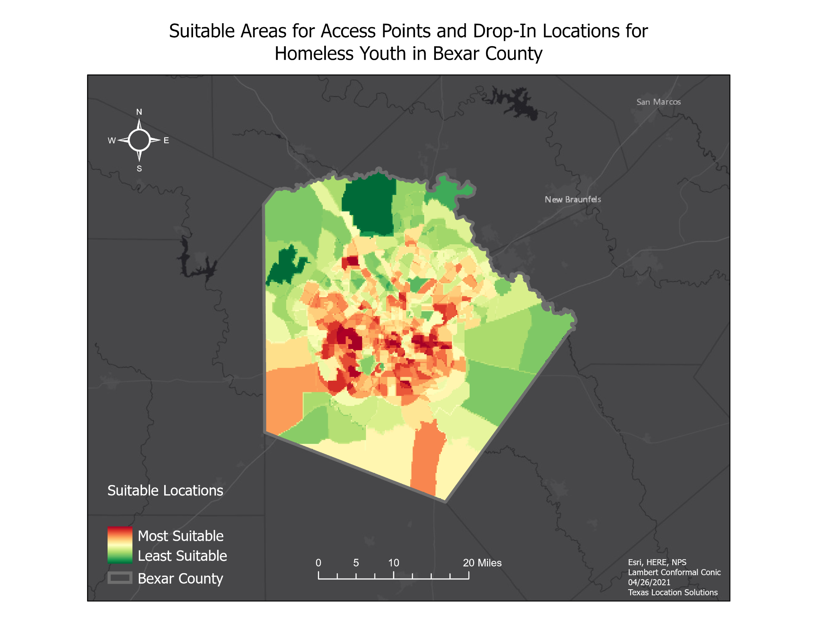
(Figure 1: Suitable Areas for Access Points and Drop-In Locations for Homeless Youth in Bexar County)

Figure 1 is a map that displays Bexar County Census tracts with our combined weighted sum of risk factor data in a graduated color scheme where ‘Most Suitable’ (Red) indicates areas that would be highly impacted by SARAH’s expansion plan, while ‘Least Suitable’ (Green) indicates areas that would be less impacted by SARAH’s plans of expansion. Figure 2 adds the Access Points and Drop-In Locations to the same final result.
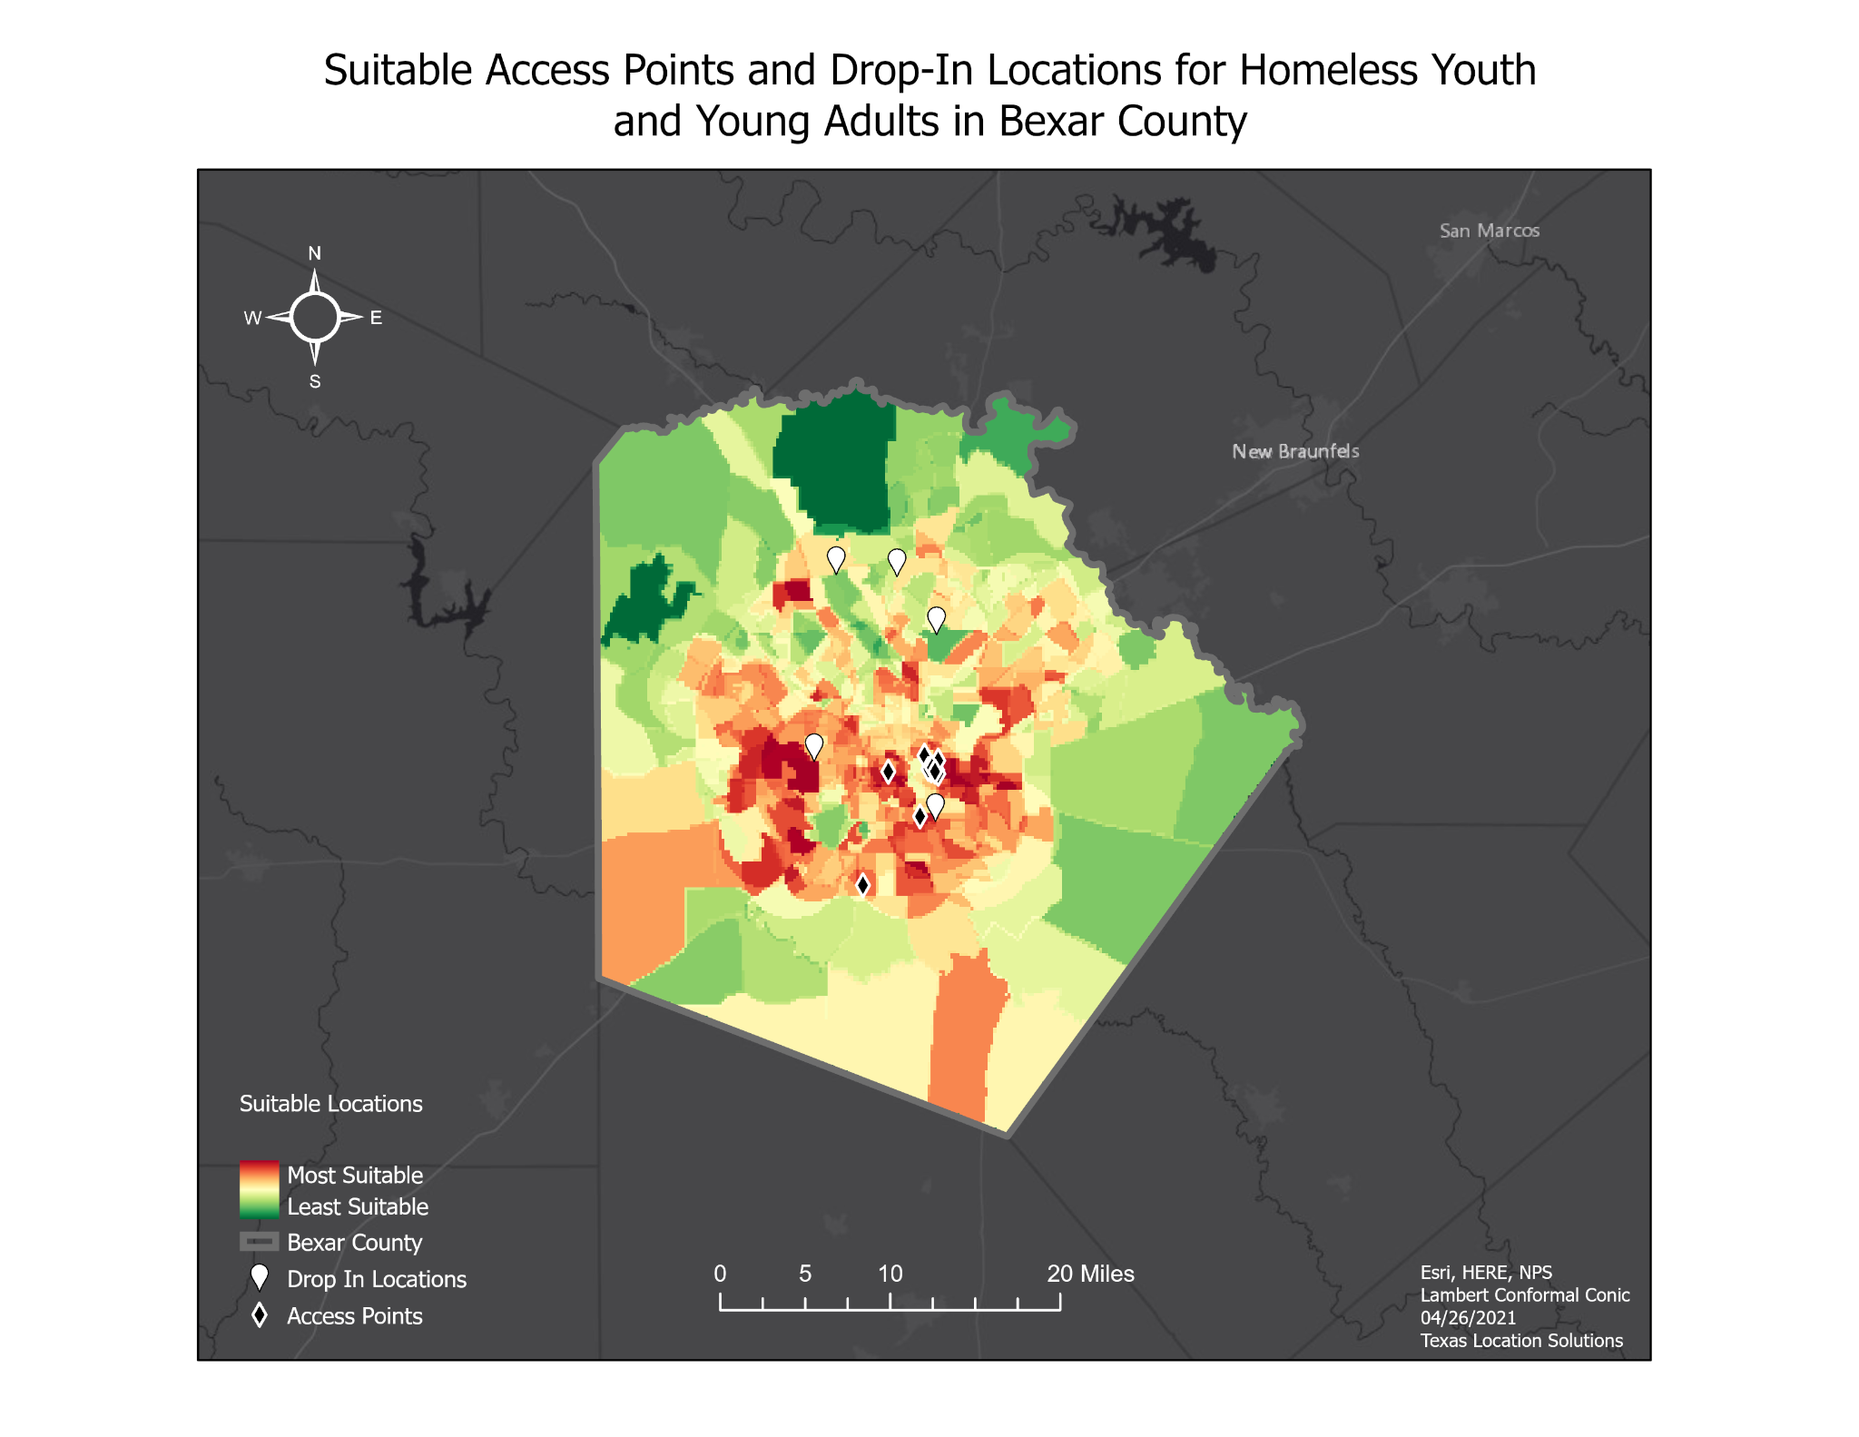
(Figure 2: Suitable Access Points and Drop-In Locations for Homeless Youth and Young Adults in Bexar County)

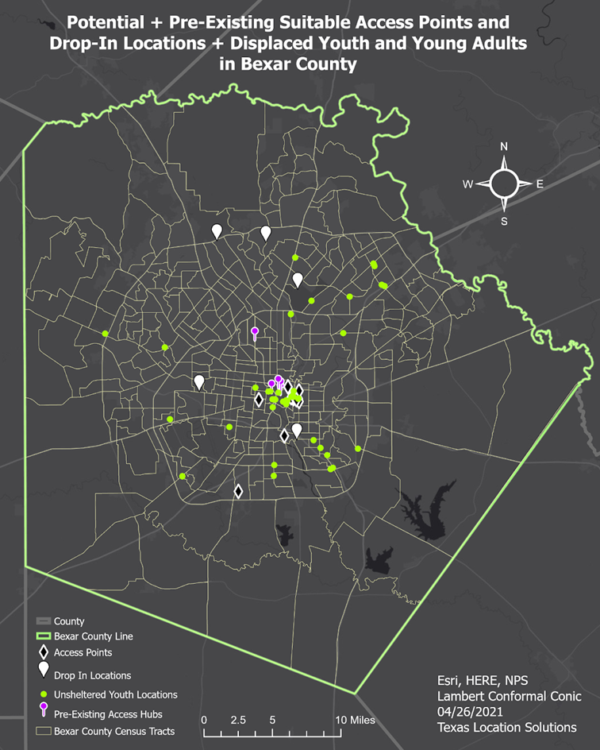
(Figure 3 Potential and pre-existing suitable access points and drop-in locations + unsheltered youth and young adults in Bexar County)
Figure 3 portrays the potential suitable access points and drop-in locations we are proposing to SARAH and the already existing access hubs in relation to the locations of unsheltered youth and young adults within Bexar County. Note that several groups of unsheltered youth are heavily clustered in the center of the county. We believe this is due to available access points being clustered in that same area.

The results show that Western and Eastern sections of downtown San Antonio are very suitable locations for more homelessness services. The area close to University of Texas-San Antonio is also a very suitable location. It should be noted that while the center of San Antonio is also dark red, we believe the data is slightly skewed because that is where the majority of services currently are. Therefore, more people experiencing homelessness will spend a majority of their time in this area.

4.2 Limitations

A multitude of our risk factors from the census bureau had missing data. This affected our analysis because in some instances, we weren’t able to portray the “full picture”. In order to properly change and filter out our data, we had to turn all ‘NoData’ sections into ‘0’. This was most prevalent for our Income data and unemployment. In income among white (Non-Hispanic) peoples alone, we were forced to eliminate 49 Census Tract rows that contained ‘NoData’, as they were interfering with the reclassification process.
Concerning the production of our final results, we originally converted the access points, access hubs, lack of nearby needed services, unsheltered youth and drop-in location data into point density rasters. Once combined with the risk factors, the point density rasters heavily skewed the final results. To solve this issue, we combined the risk factors into a single raster file. Next, we disregarded the point density rasters and converted the original point data to polygons through buffering. After, we converted the polygons to rasters and reclassified them to give them the same values as the risk factors (values ranging from 0 to 5). Once reclassified, we combined them with the risk factors to produce a map of our final results.

4.3 Exclusions

During the beginning stages of this project, there were several criteria that we considered to be ‘homelessness risk factors’ that we were unable to include in our GIS analysis. These issues were due to a combination of data availability and the targeted age groups. The most prevalent factors we were unable to properly utilize were the LGBTQ+ community, veterans, and mental illness.
According to statistics provided by youth.gov, approximately 20% to 40% of the 1.6 million youth (ages 12 to 17) that have experienced at least one night of homelessness identified as LGBTQ+. In addition, analysis performed by Voices of Youth Count determined that people of the LGBTQ community have a 120% higher risk of homelessness than the average American citizen. Based on the literary research we conducted on the relativity of youth who identify as LGBTQ and youth homelessness, it is evident that LGBTQ status is a major factor for youth and young adults at risk of homelessness. With that said, we could not incorporate it in our data analysis due to the lack of available data due to the aforementioned reasons above, as well as the personal and sensitive nature of the subject.
Similarly, we determined that cognitive disabilities play a major role in youth and adult homelessness but found that there was not a sufficient amount of in-situ data collected to include it in our analysis due to its very personal and sensitive nature. Thirdly, in practically every literary source we read, veteran/disabled veteran status is a huge risk factor for homelessness in young adults and older. We decided to include it in this section because while it doesn’t play a role in youth homelessness, we feel it is important to mention. Our StoryMap (page 17) contains sourced infographics that further demonstrate the severity of these factors.

5. Conclusion

Our final map for this project turned out better than any of us could have imagined and we were very satisfied to see the data compiled into one final product. Ideally, this analysis could be used as a “model” for other major cities to display areas that are of high risk of homelessness, and to help influence policy to improve life for displaced people. The process would remain relatively the same, but risk factor research and social data could be altered. For example, our study focused on youth and young adults. Other departments can follow this model, but focus on other age groups. Additionally, our hope would be that people in the LGBTQ+ community, veterans, and/or people experiencing mental illness become a more relevant factor in these discussions and analyses. Compared to our original predictions which we found were relatively inaccurate, the areas of highest risk in Bexar county were not the south east but mostly central. This project strengthened our skills in research, pre-processing and creation of spatial and social data, GIS, communication and teamwork.

We would like to thank Dr. Yuan, Dr. Kamal, Khan Bin Asad and Texas State University for giving us the opportunity to work on this project, and to assist SARAH in their efforts to better the lives of homeless youth and young adults within Bexar County and the greater San Antonio area.

Link to StoryMap: https://txst.maps.arcgis.com/apps/Cascade/index.html?appid=1053716635bb49ae9603493282c19790

6. References
Bexar County open data portal. (n.d.). Retrieved February 24, 2021, from https://gis-bexar.opendata.arcgis.com/
Bus stops and stations in San Antonio. (n.d.). Retrieved February 24, 2021, from https://mygeodata.cloud/data/download/osm/bus-stops-and-stations/united-states-of-america--texas/bexar-county/san-antonio
Bureau, U. (2020, August 26). How the Census Bureau measures poverty. Retrieved April 27, 2021, from https://www.census.gov/topics/income-poverty/poverty/guidance/poverty-measures.html
City of San ANTONIO open data. (n.d.). Retrieved February 24, 2021, from https://opendata-cosagis.opendata.arcgis.com/search?tags=Transportation
GIS (geographic Information Services). (n.d.). Retrieved February 24, 2021, from https://www.sanantonio.gov/GIS/GISData
Sidewalks. (n.d.). Retrieved February 24, 2021, from https://opendata-cosagis.opendata.arcgis.com/datasets/sidewalks
Data.census.gov. (n.d.). Retrieved March 01, 2021, from https://data.census.gov/cedsci/map?t=Educational+Attainment&g=0500000US48029.140000&tid=ACSST5Y2019.S1501&hidePreview=false&vintage=2019&layer=VT_2019_140_00_PY_D1&cid=S1501_C01_001E&palette=Teal&break=5&classification=Natural+Breaks&mode=thematic
Data.census.gov. (n.d.). Retrieved March 01, 2021, from https://data.census.gov/cedsci/table?t=Official+Poverty+Measure%3APoverty&g=0500000US48029.140000&tid=ACSST5Y2019.S1701&hidePreview=false
Data.census.gov. (n.d.). Retrieved March 01, 2021, from https://data.census.gov/cedsci/map?t=Employment&g=0500000US48029.140000&tid=ACSST5Y2019.S2301&hidePreview=false&vintage=2019&layer=VT_2019_140_00_PY_D1&cid=S2301_C01_001E&palette=Teal&break=5&classification=Natural+Breaks&mode=thematic
Data.census.gov. (n.d.). Retrieved March 01, 2021, from https://data.census.gov/cedsci/map?t=Veterans&g=0500000US48029.140000&tid=ACSST5Y2019.S2101&hidePreview=false&vintage=2019&layer=VT_2019_140_00_PY_D1&cid=S2101_C01_001E&palette=Teal&break=5&classification=Natural+Breaks&mode=thematic
SARAH. (2021, January). [Unsheltered Youth Locations and Characteristics]. Unpublished raw data.
SARAH. (2021, January). [Access Hubs Providing Services to Homeless Youth]. Unpublished raw data.
(n.d.). Retrieved February, 2021, from https://www.loopnet.com/search/industrial-space/san-antonio-tx/for-lease/?sk=e8cfad6199b9a50493a0bb51363b1196
Google search. (n.d.). Retrieved February 28, 2021, from https://www.google.com/search?tbs=lf%3A1%2Clf_ui%3A2&tbm=lcl&sxsrf=ALeKk00SeOoY_UvTtyBShUKxxymlAUpxxg%3A1614572561007&q=homeless%2Bshelters%2Bsan%2Bantonio%2Btx&rflfq=1&num=10&sa=X&ved=2ahUKEwjlvNm_n47vAhUOM6wKHd64BNwQjGp6BAgSEGw&biw=1474&bih=790#rlfi=hd:;si:;mv:[[29.7384064,-98.4605091],[29.306454900000002,-98.5743366]];tbs:lrf:!1m4!1u3!2m2!3m1!1e1!1m4!1u2!2m2!2m1!1e1!2m1!1e2!2m1!1e3,lf:1,lf_ui:2

Appendix I: Maps
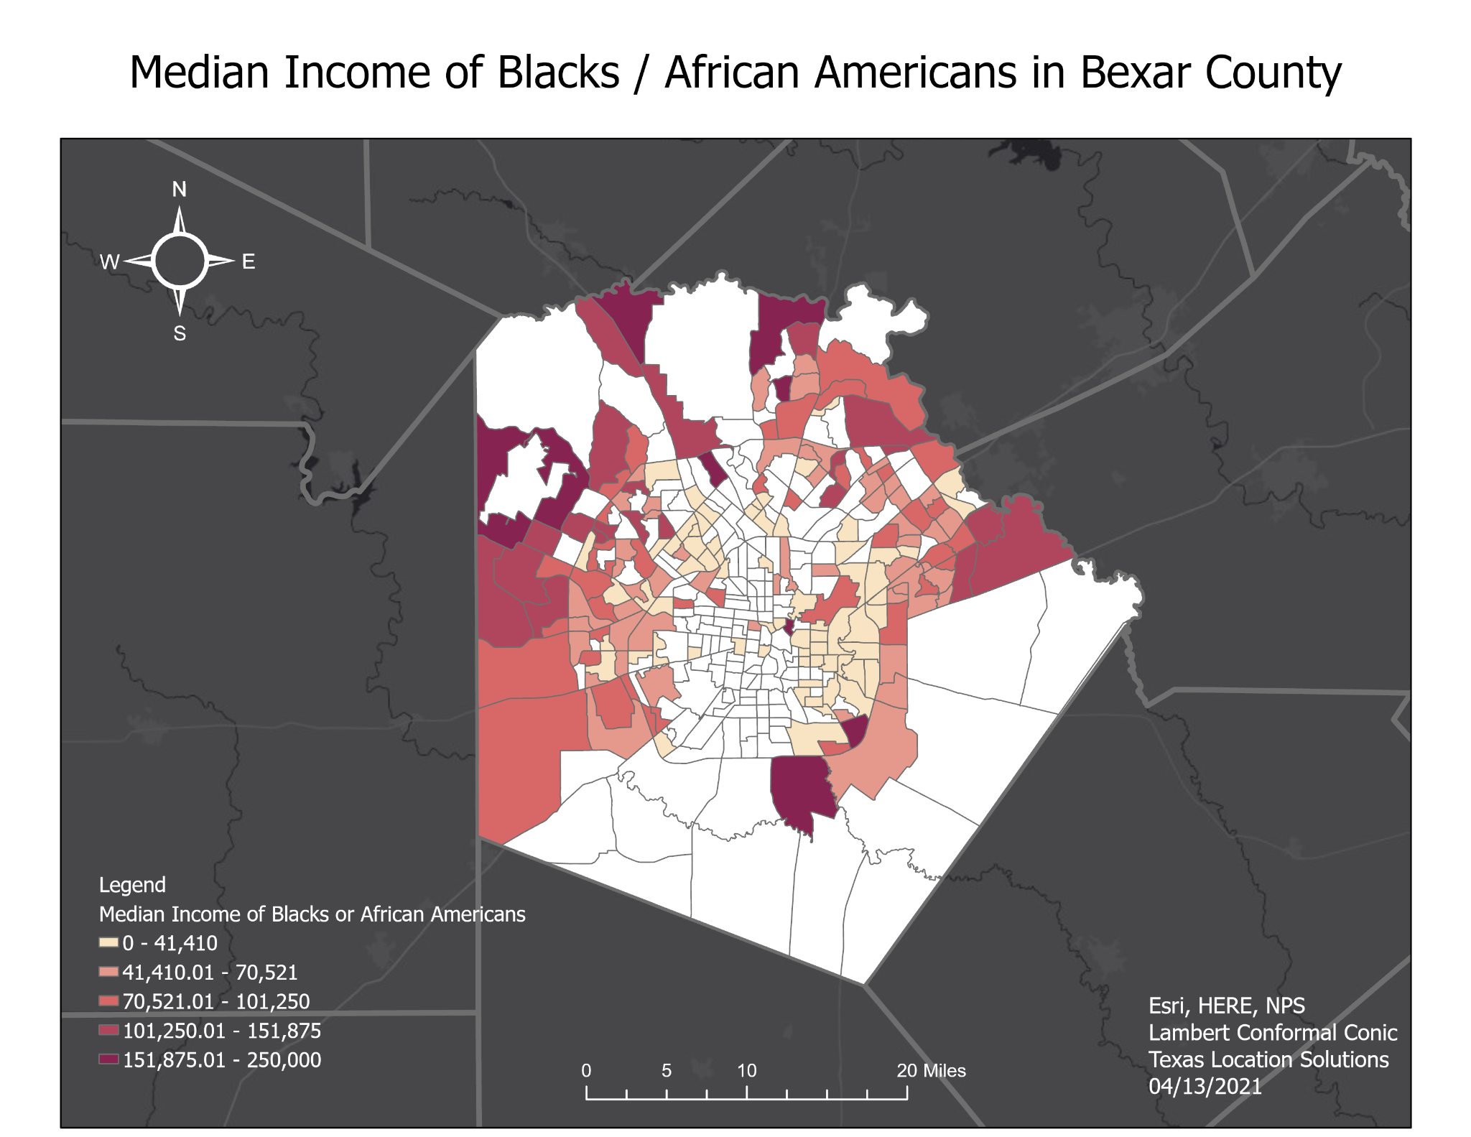
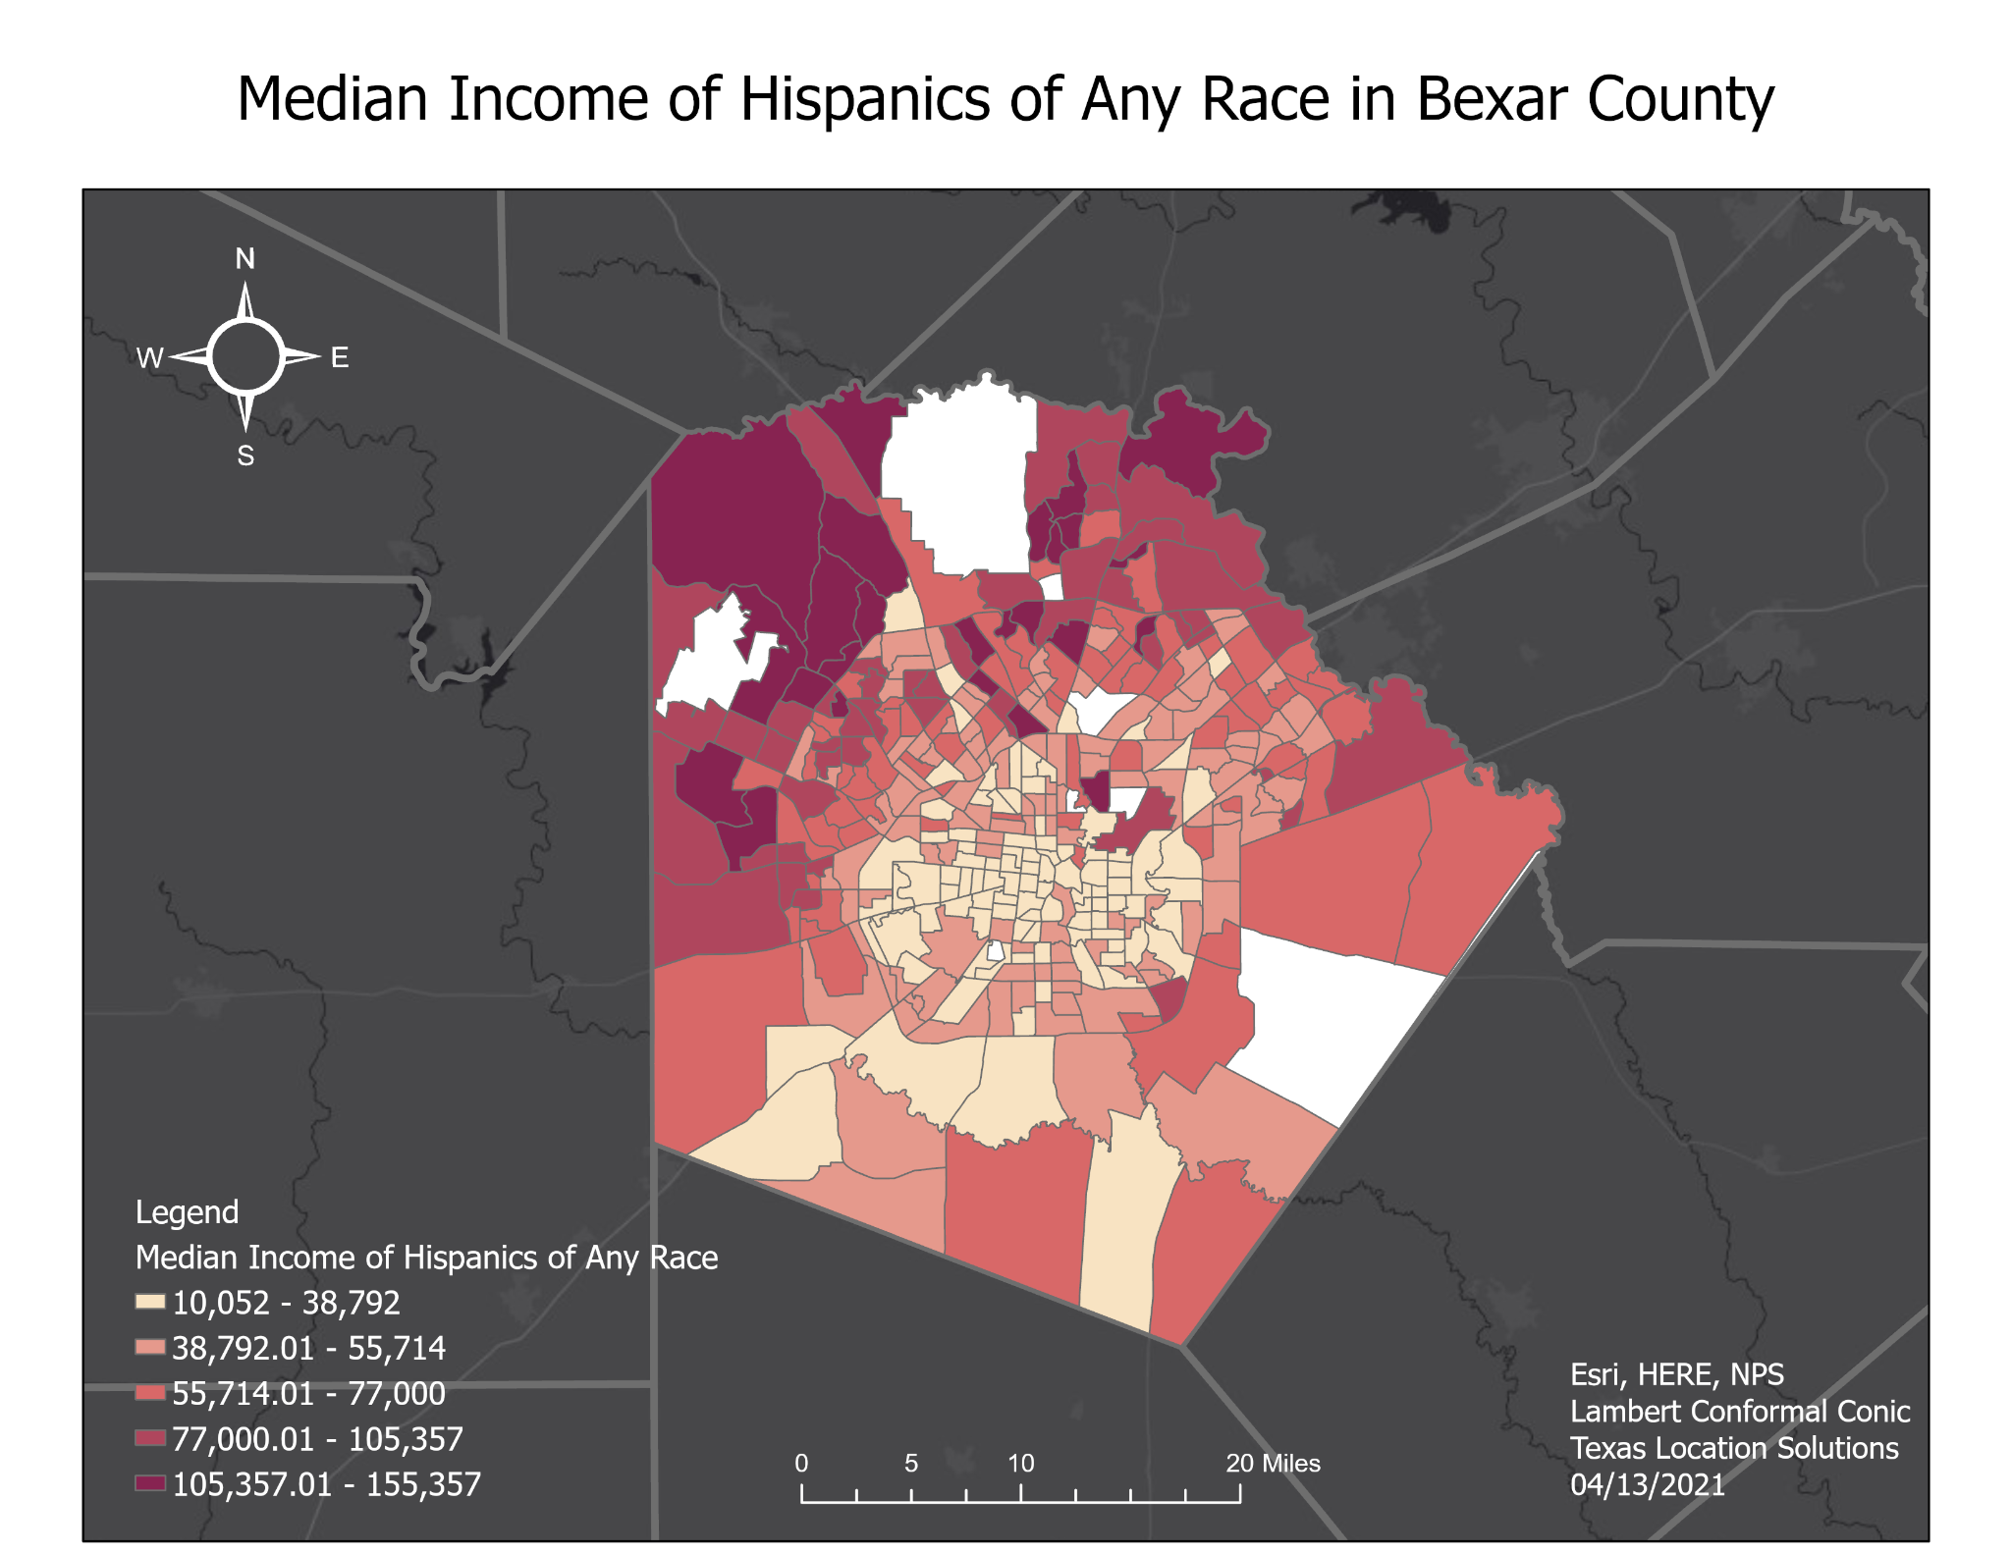
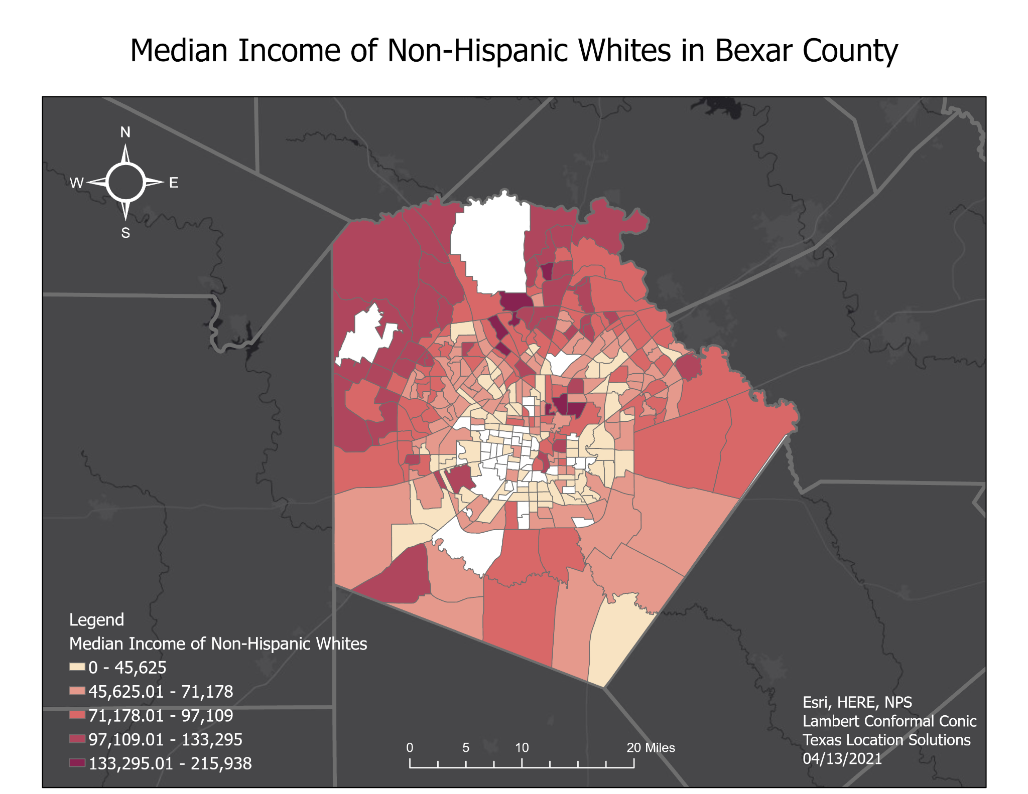
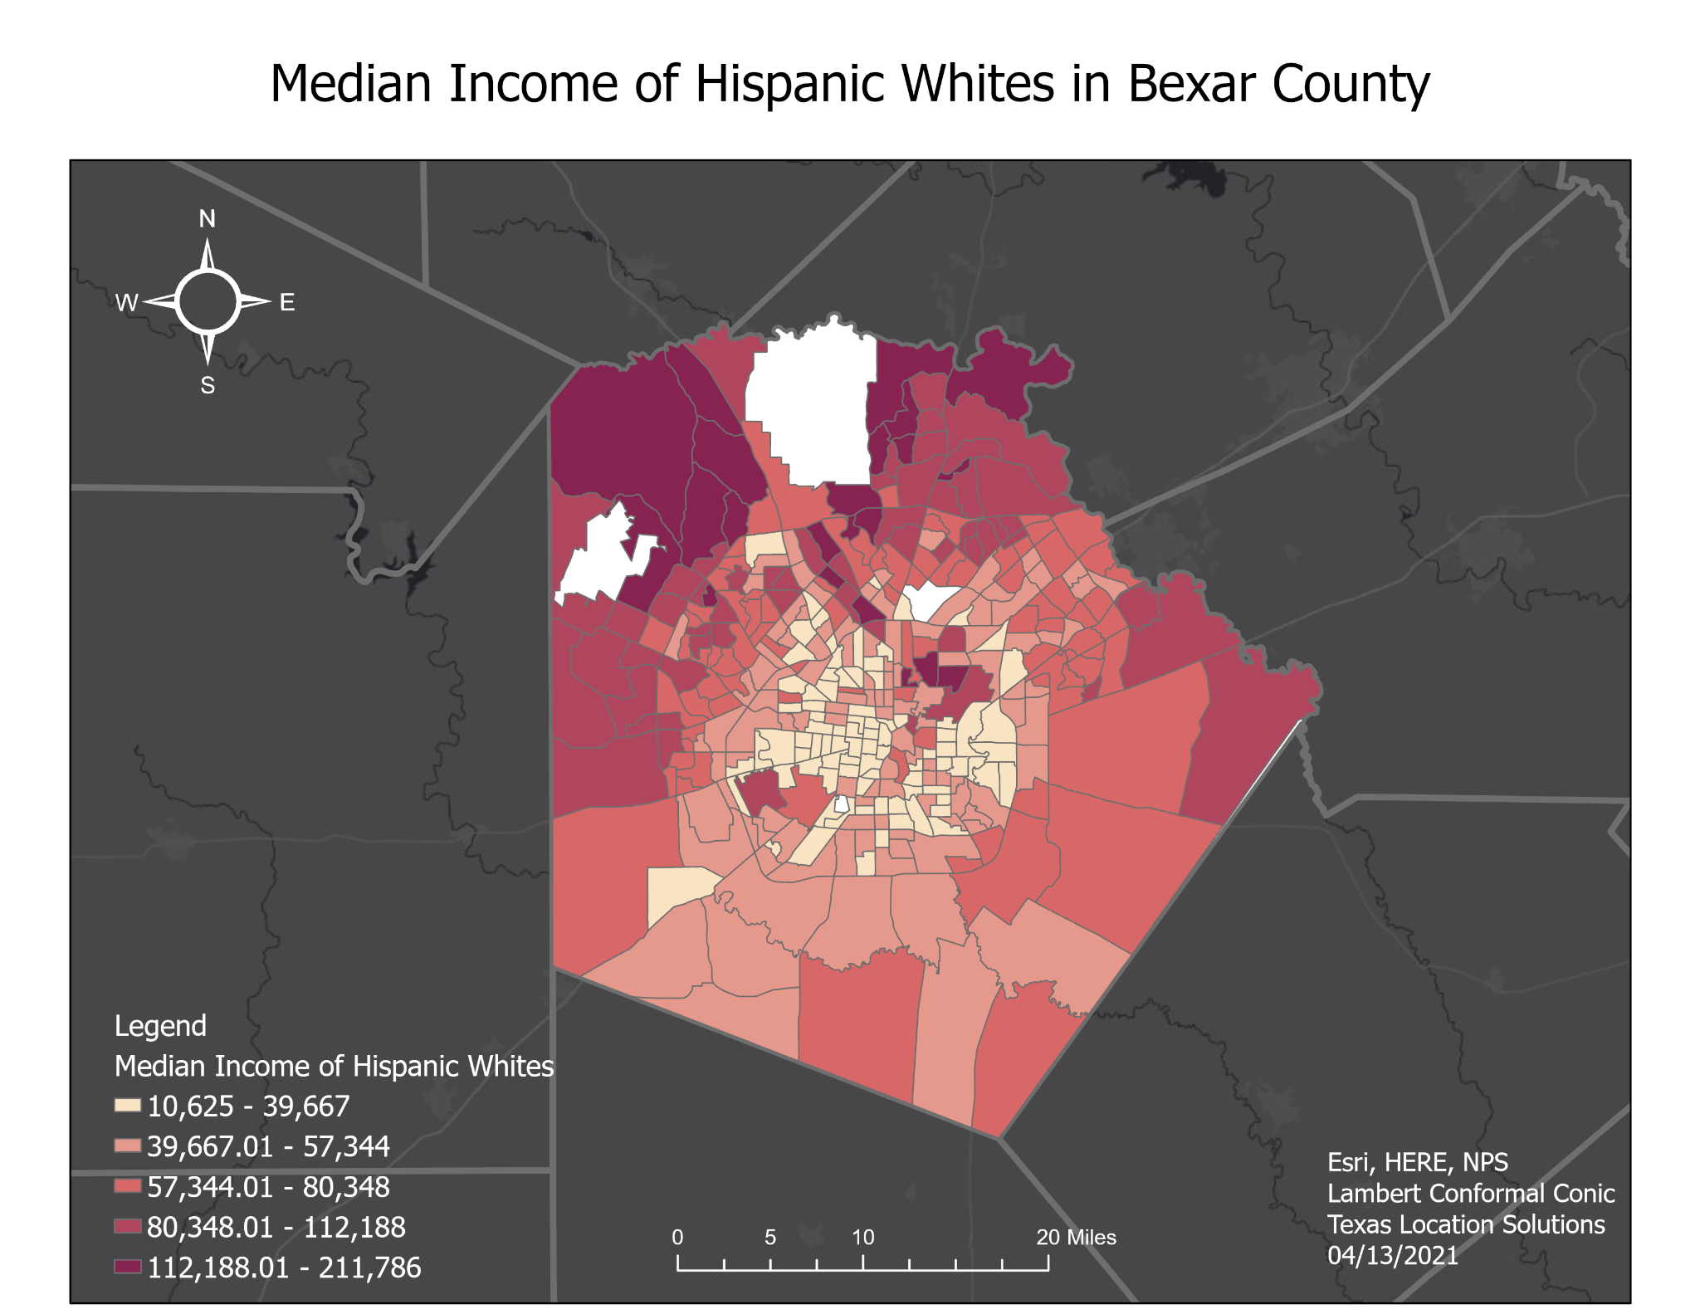
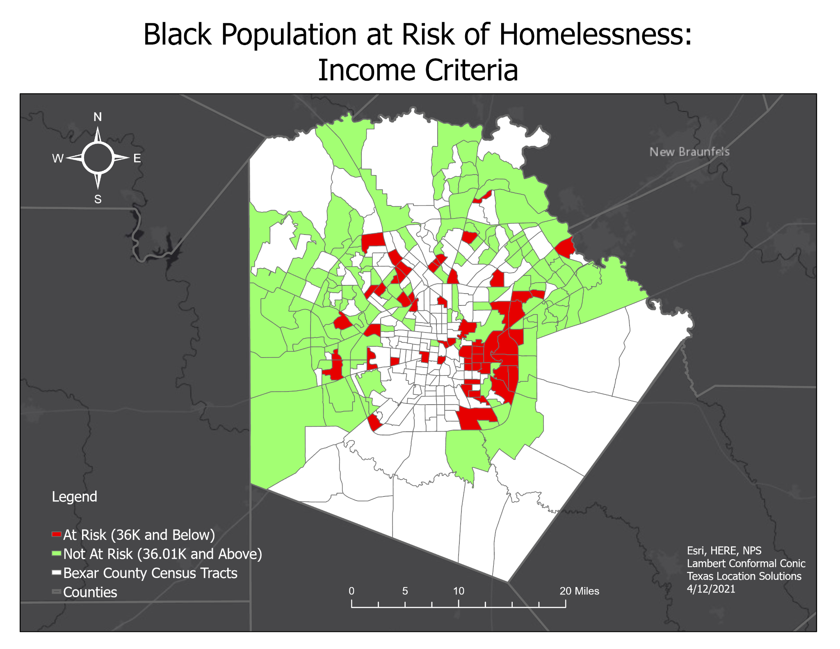

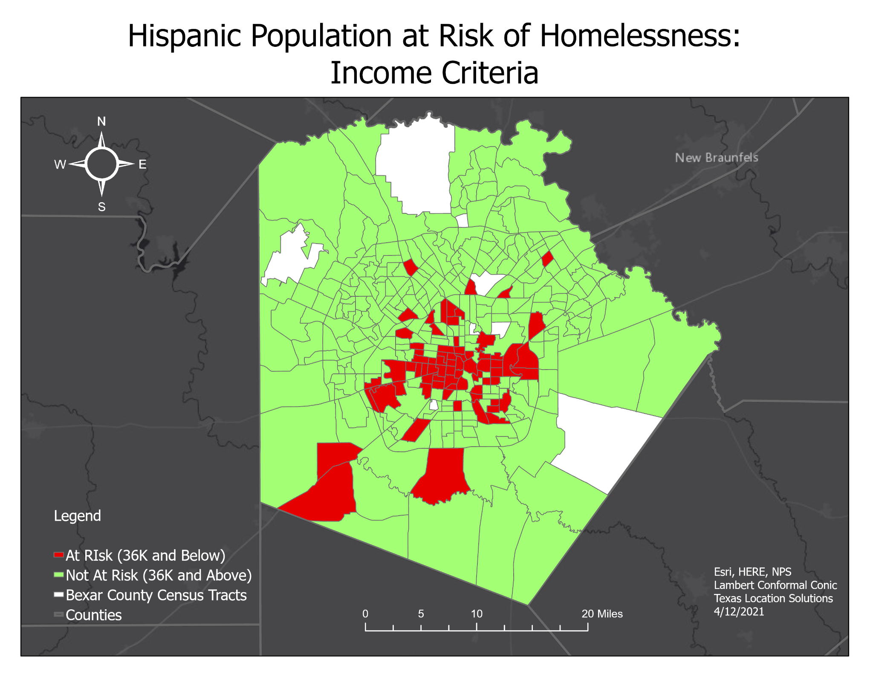

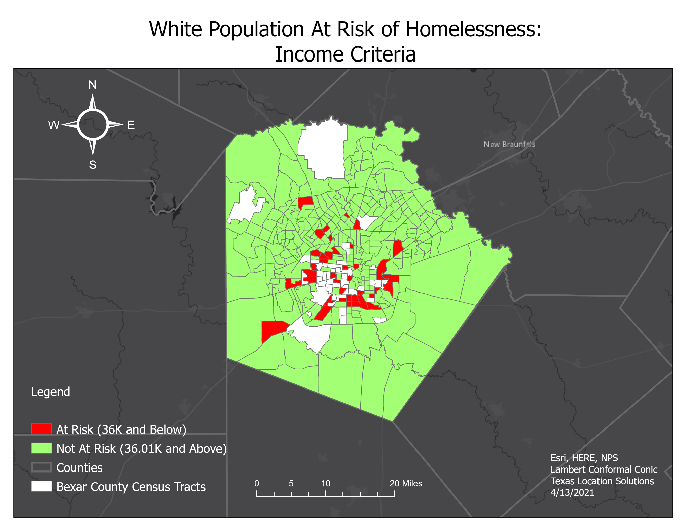

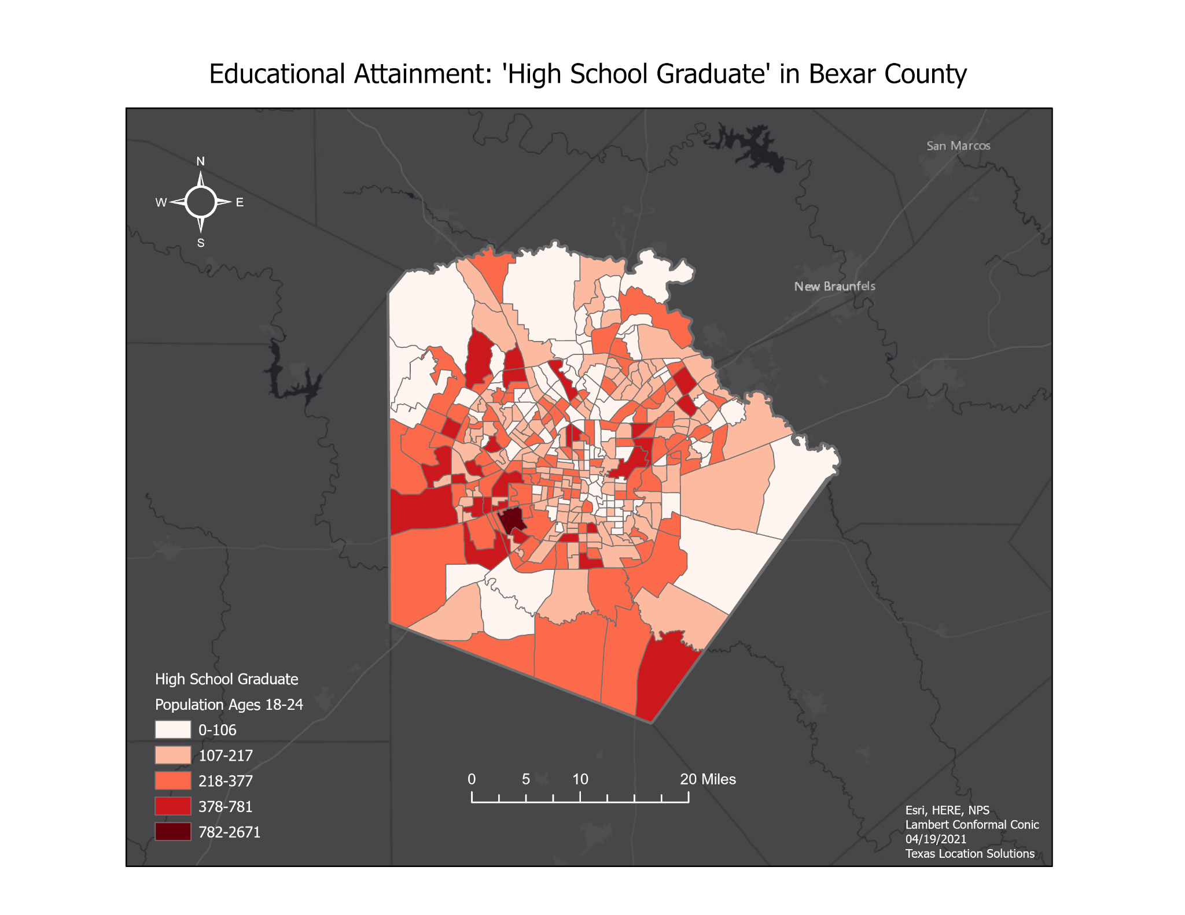

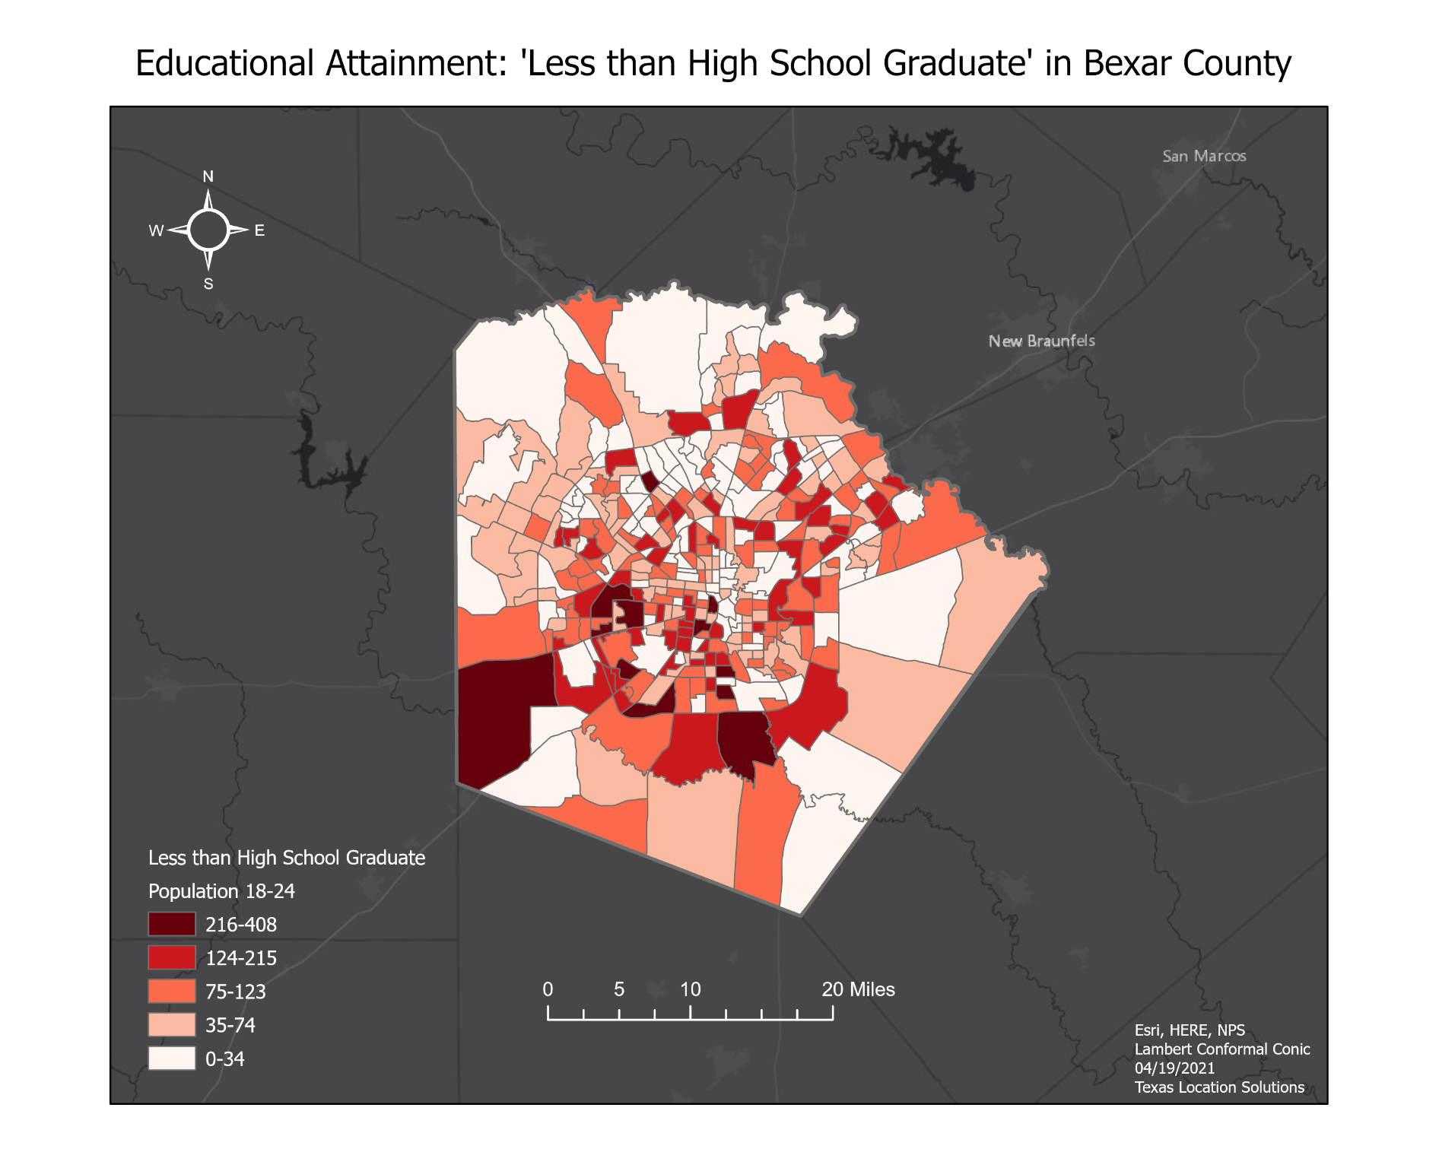

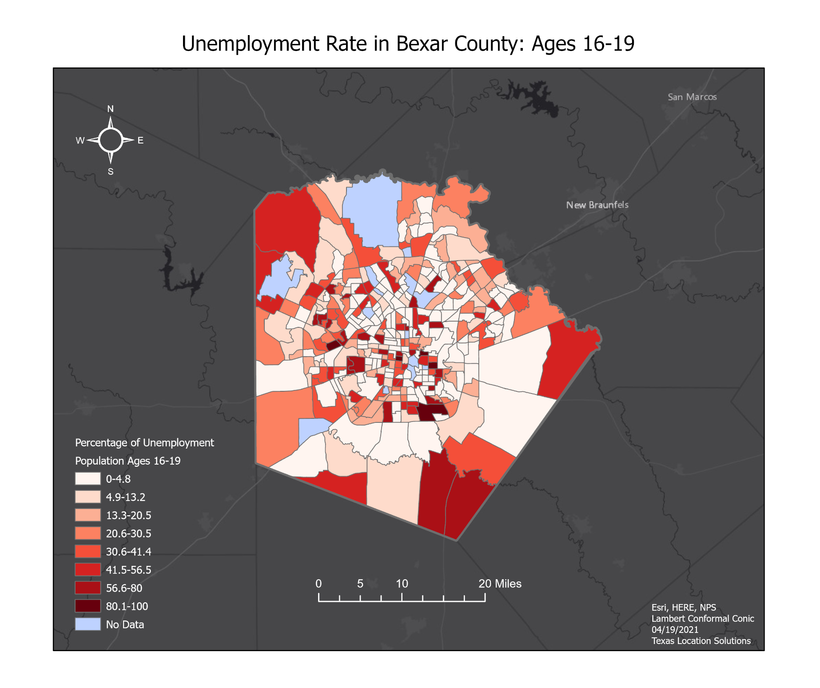

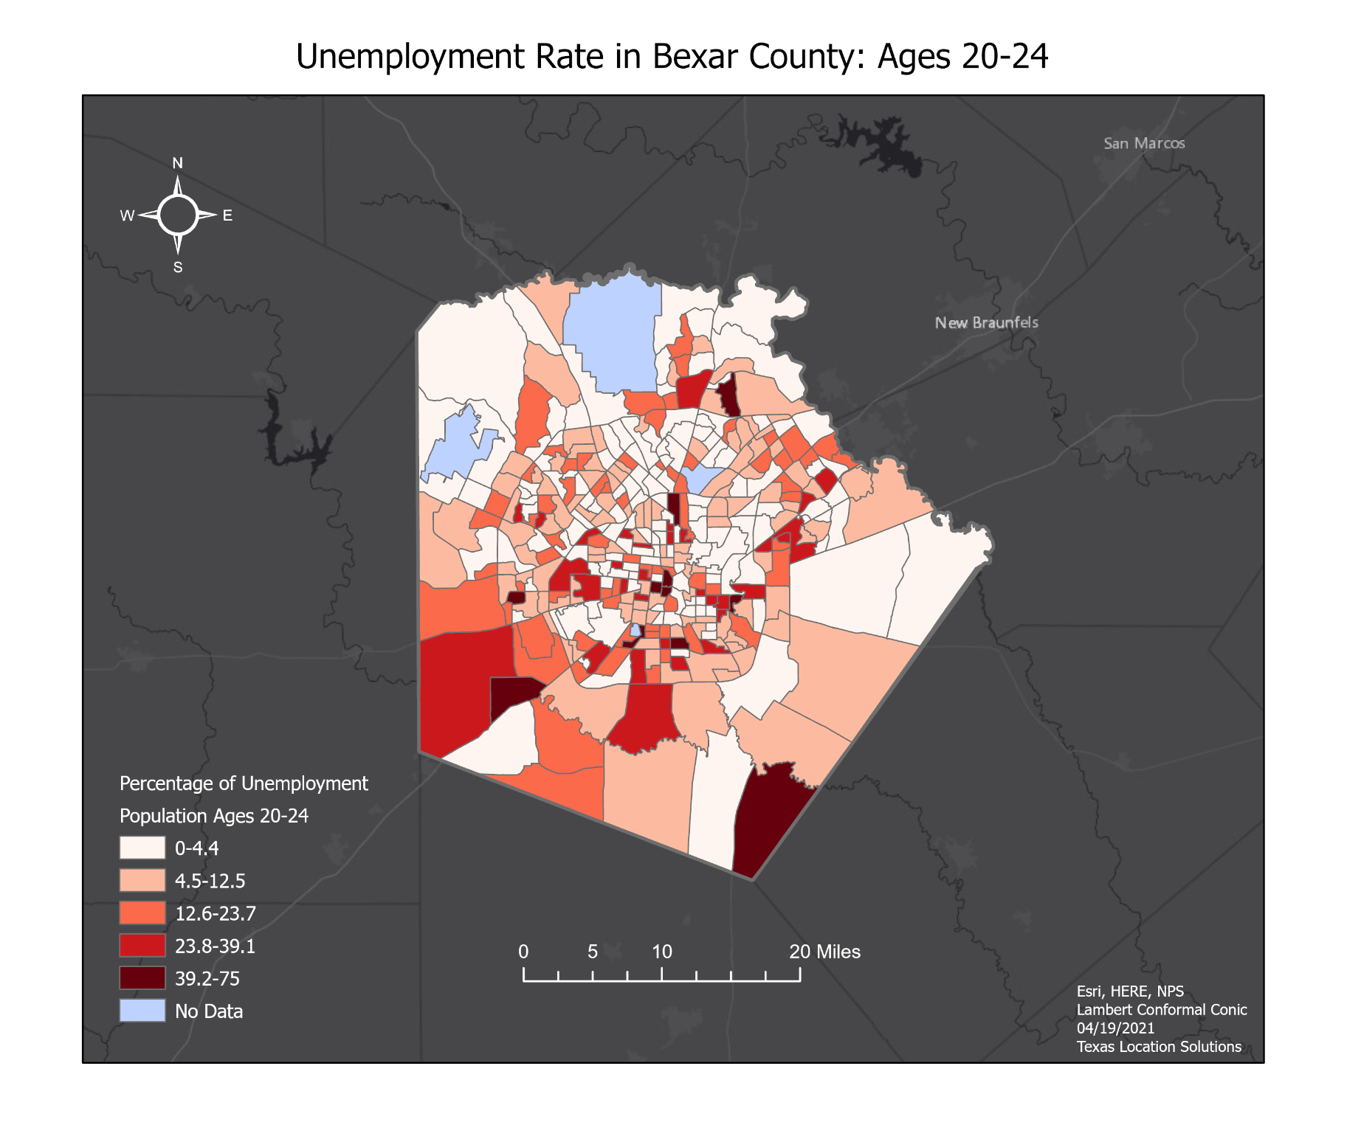

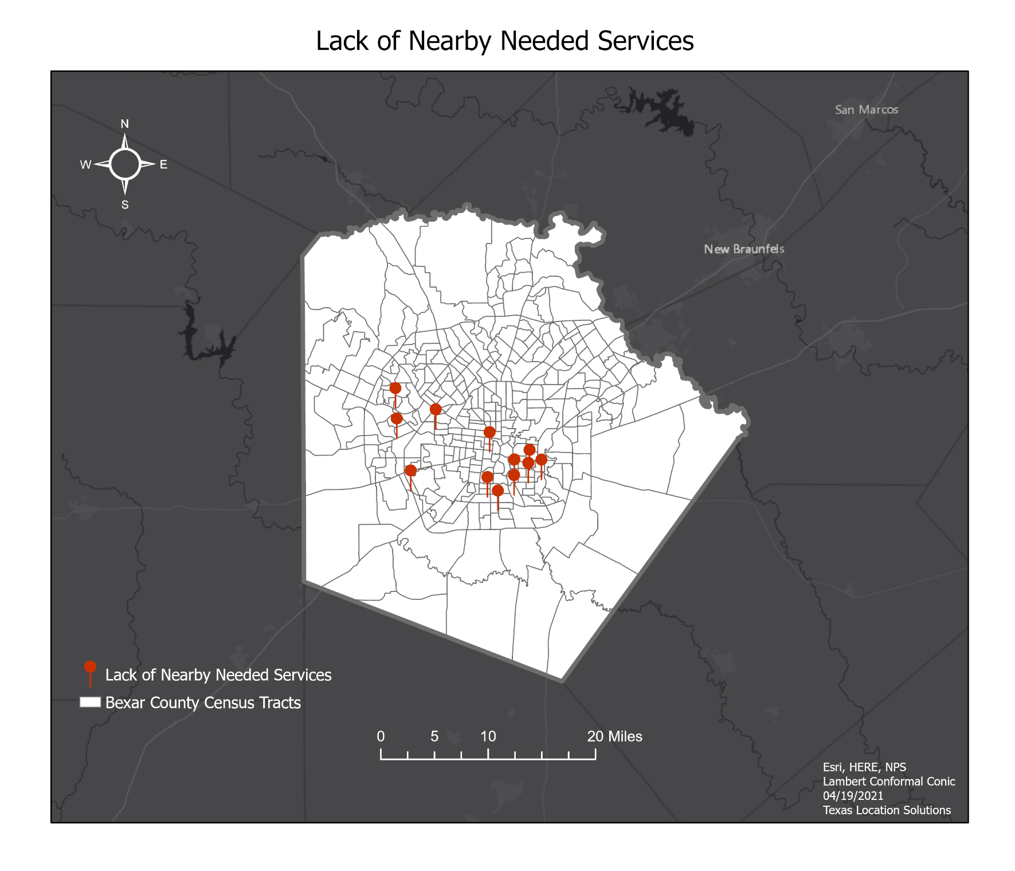

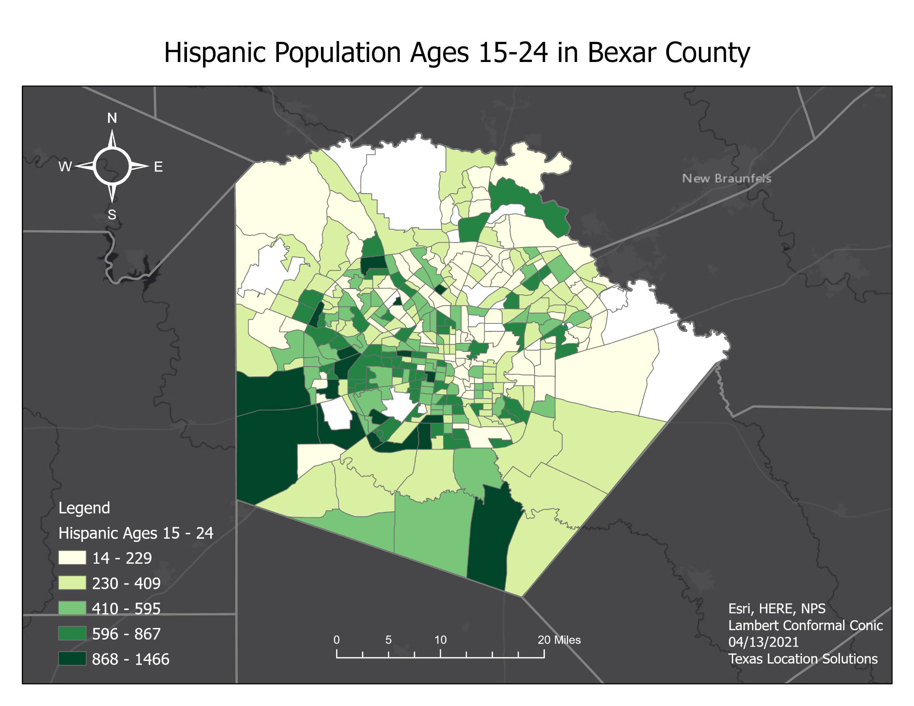

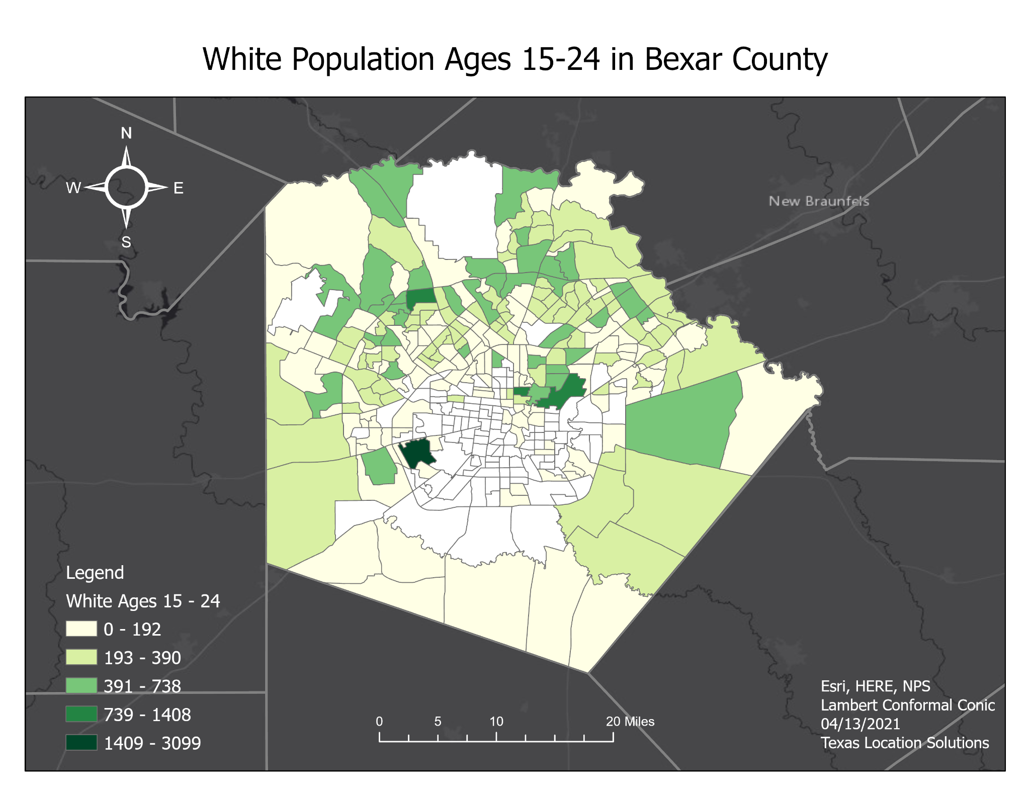

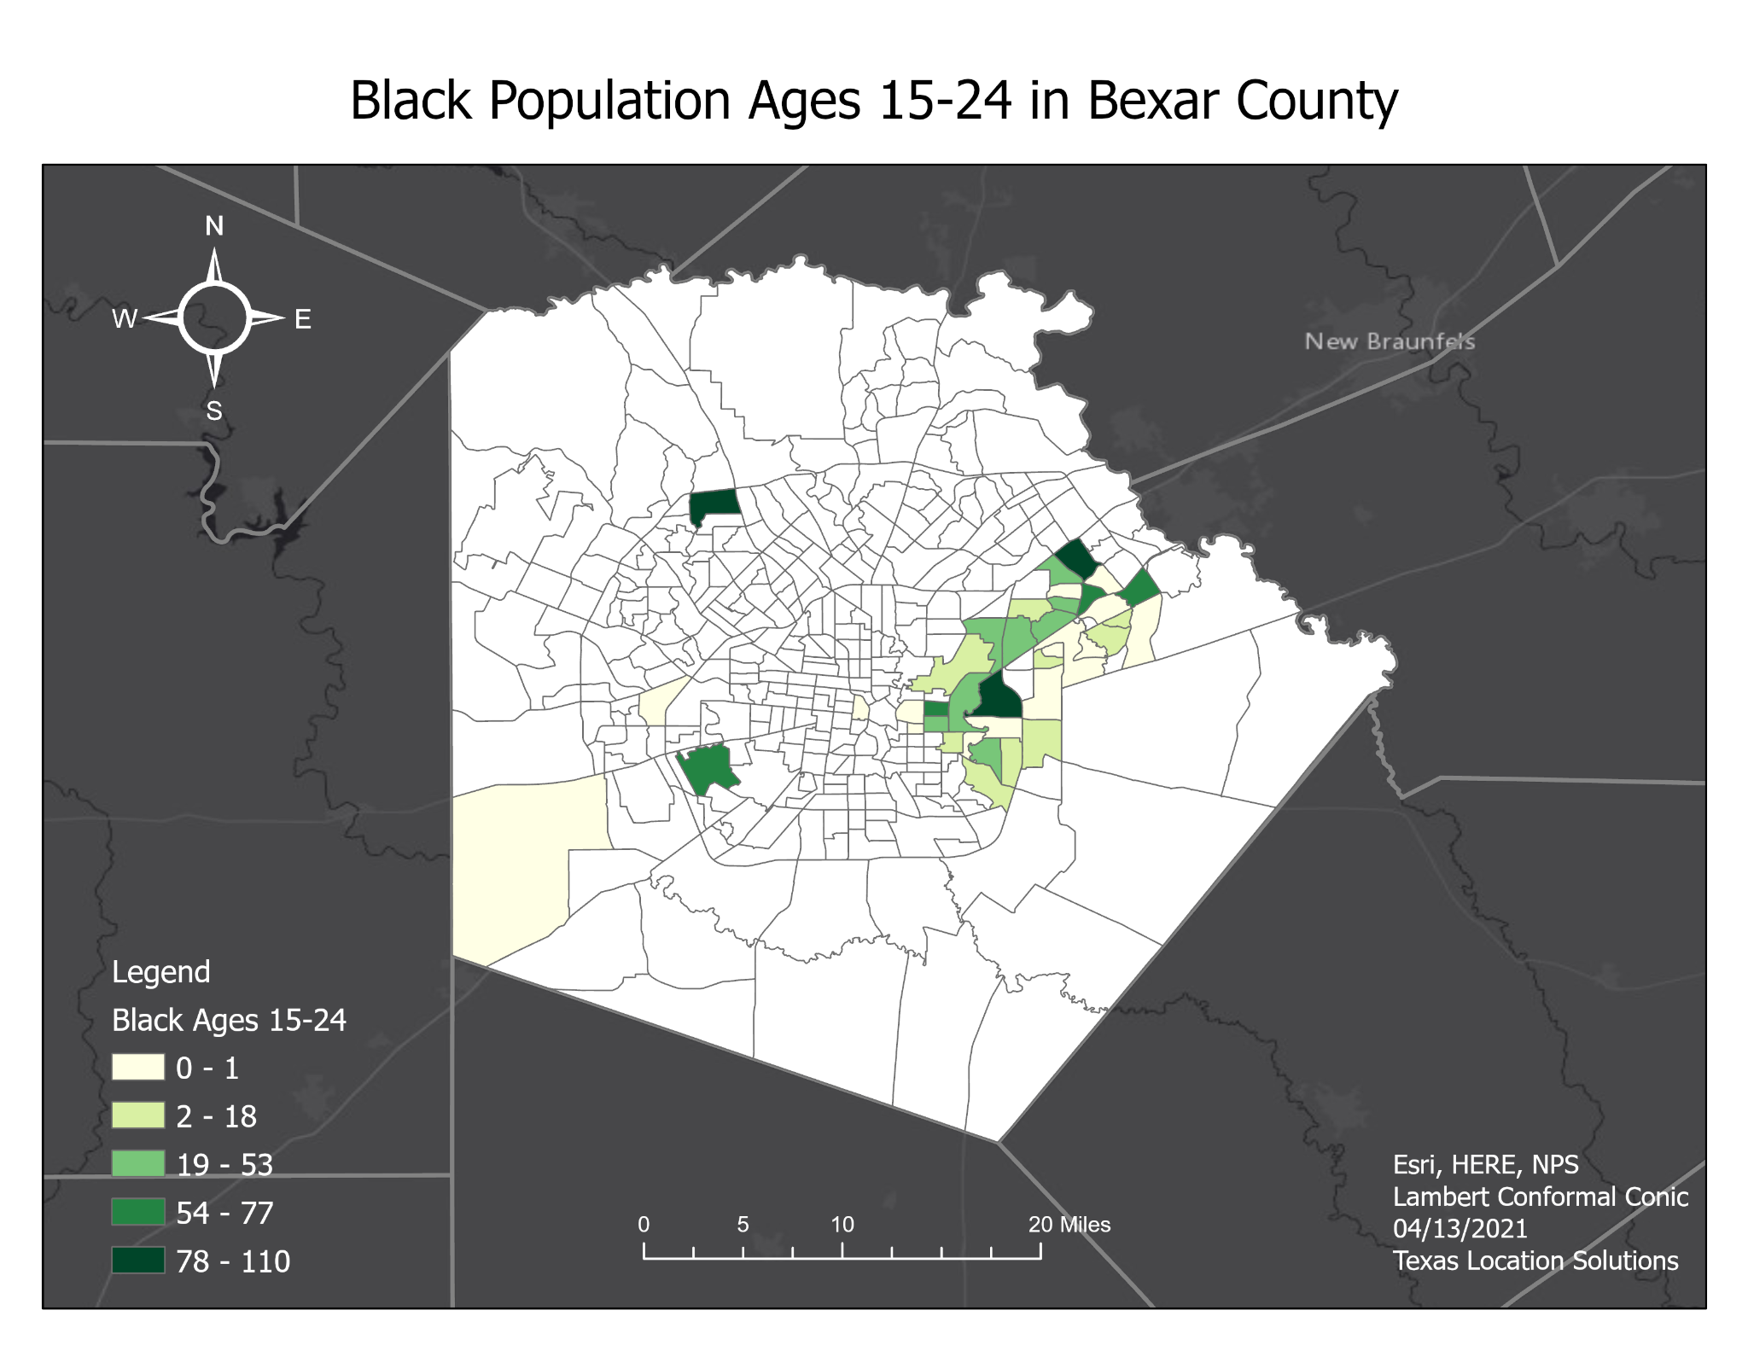

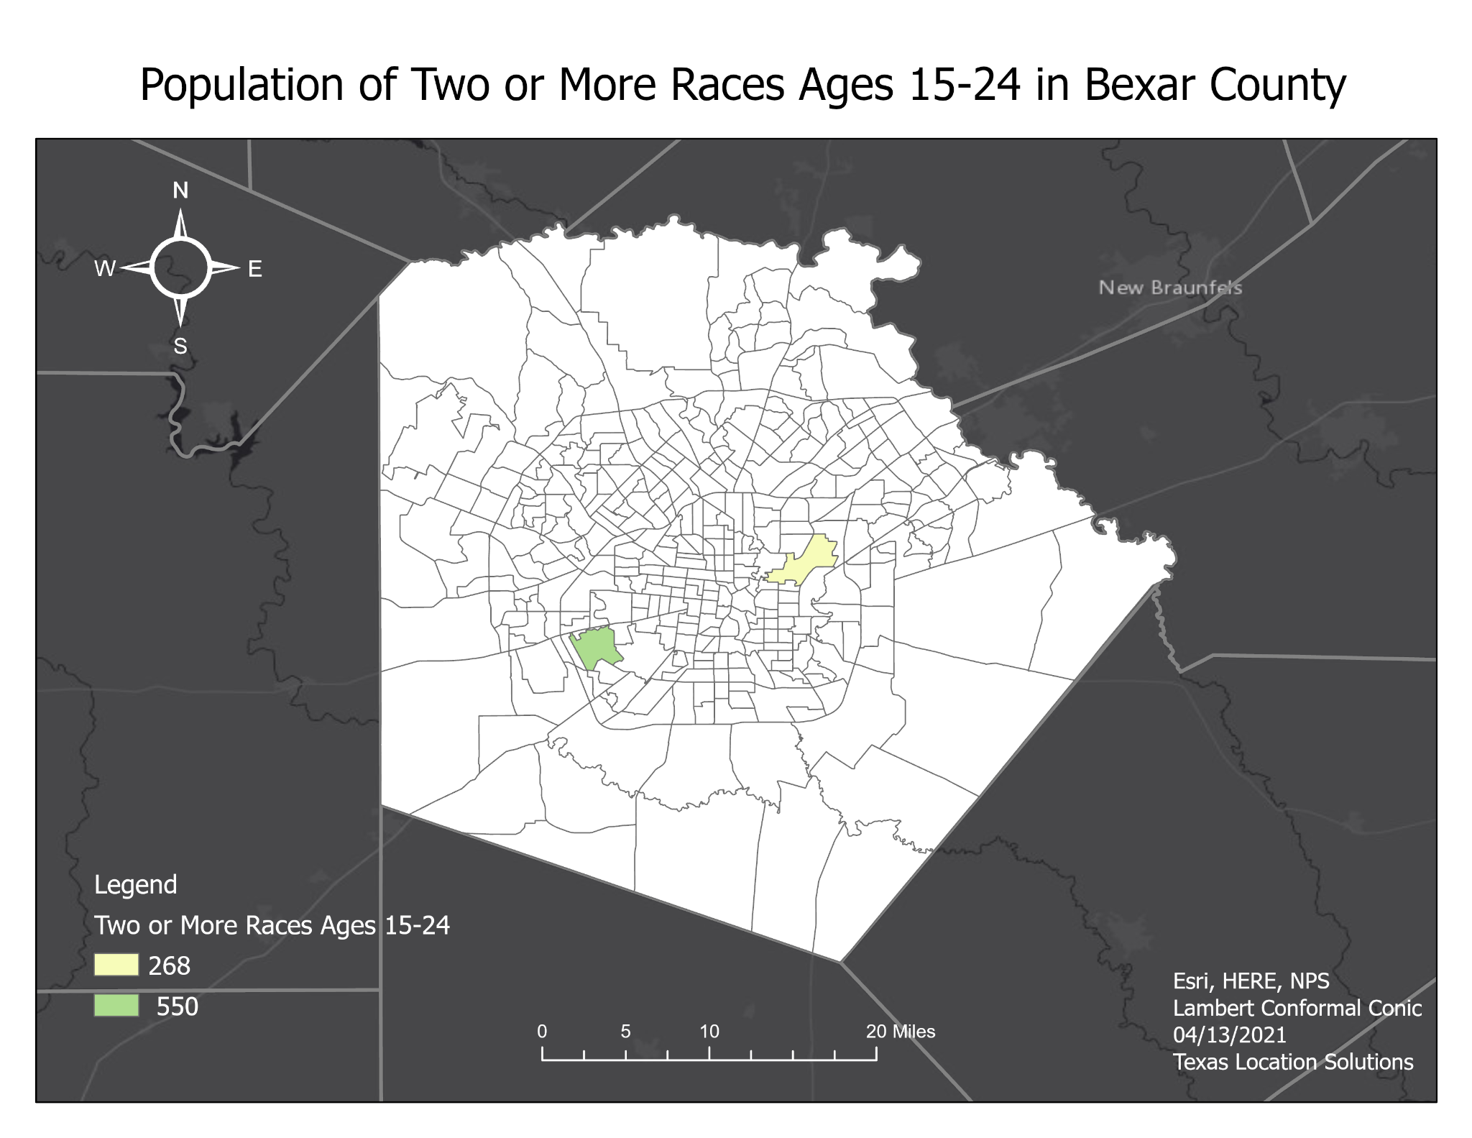

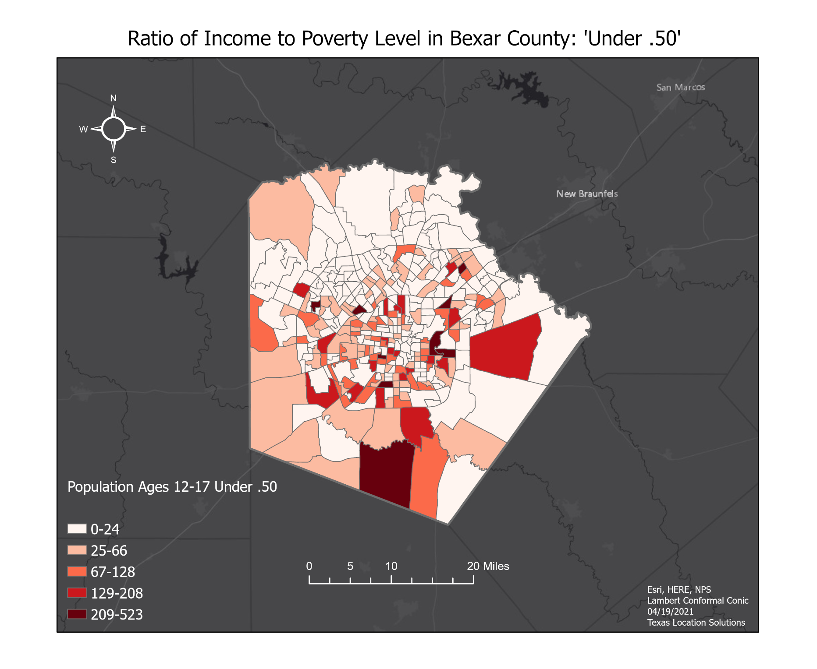

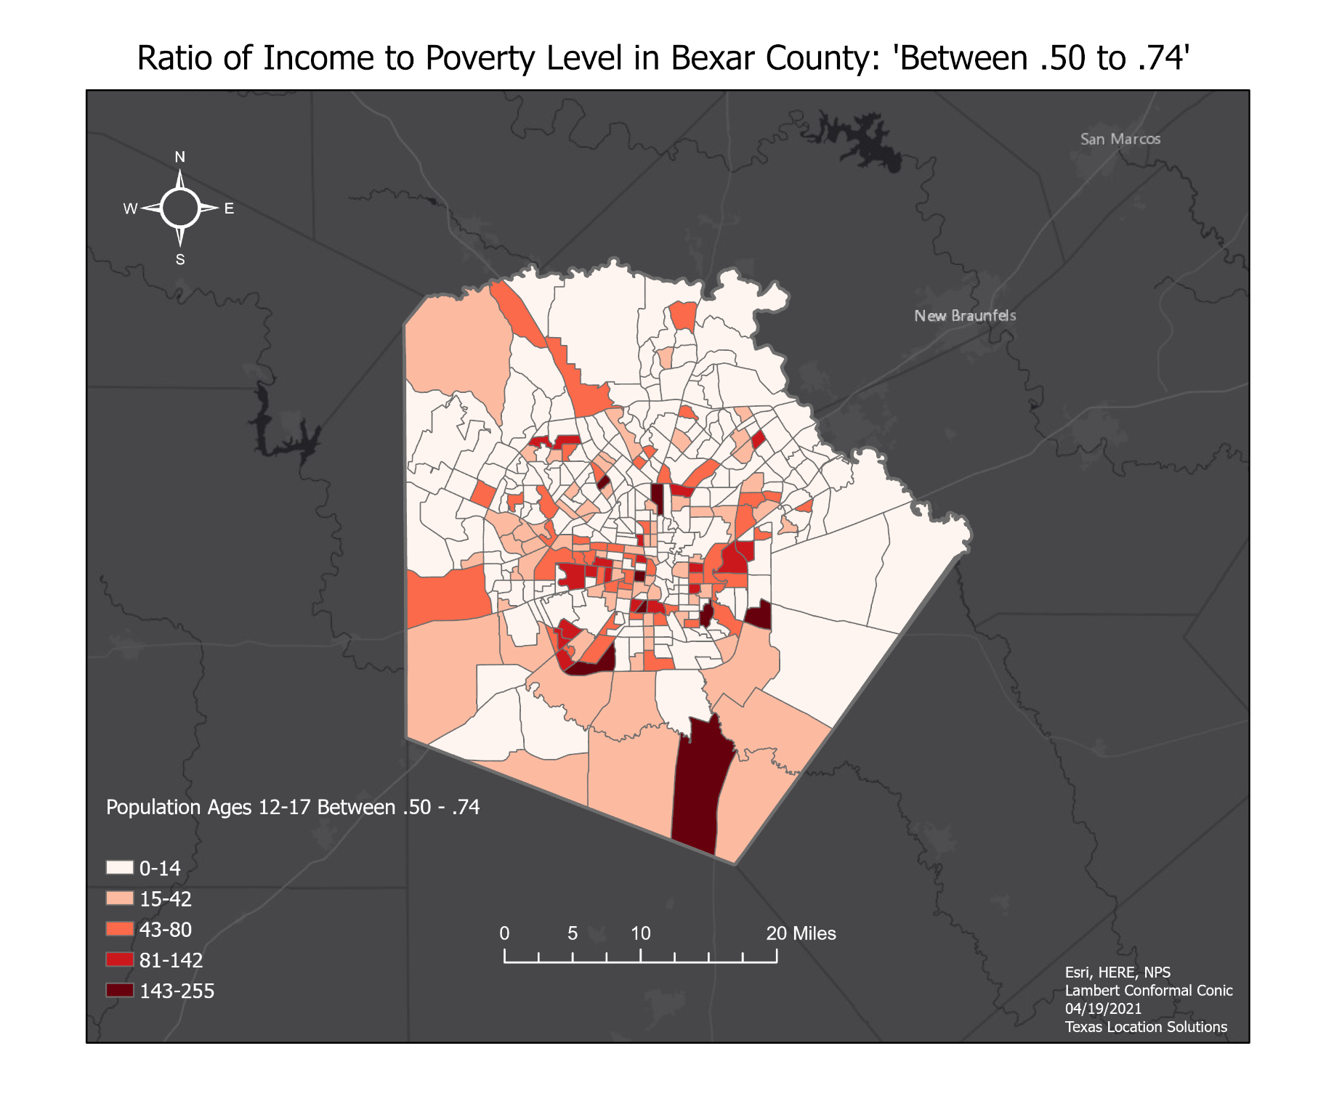

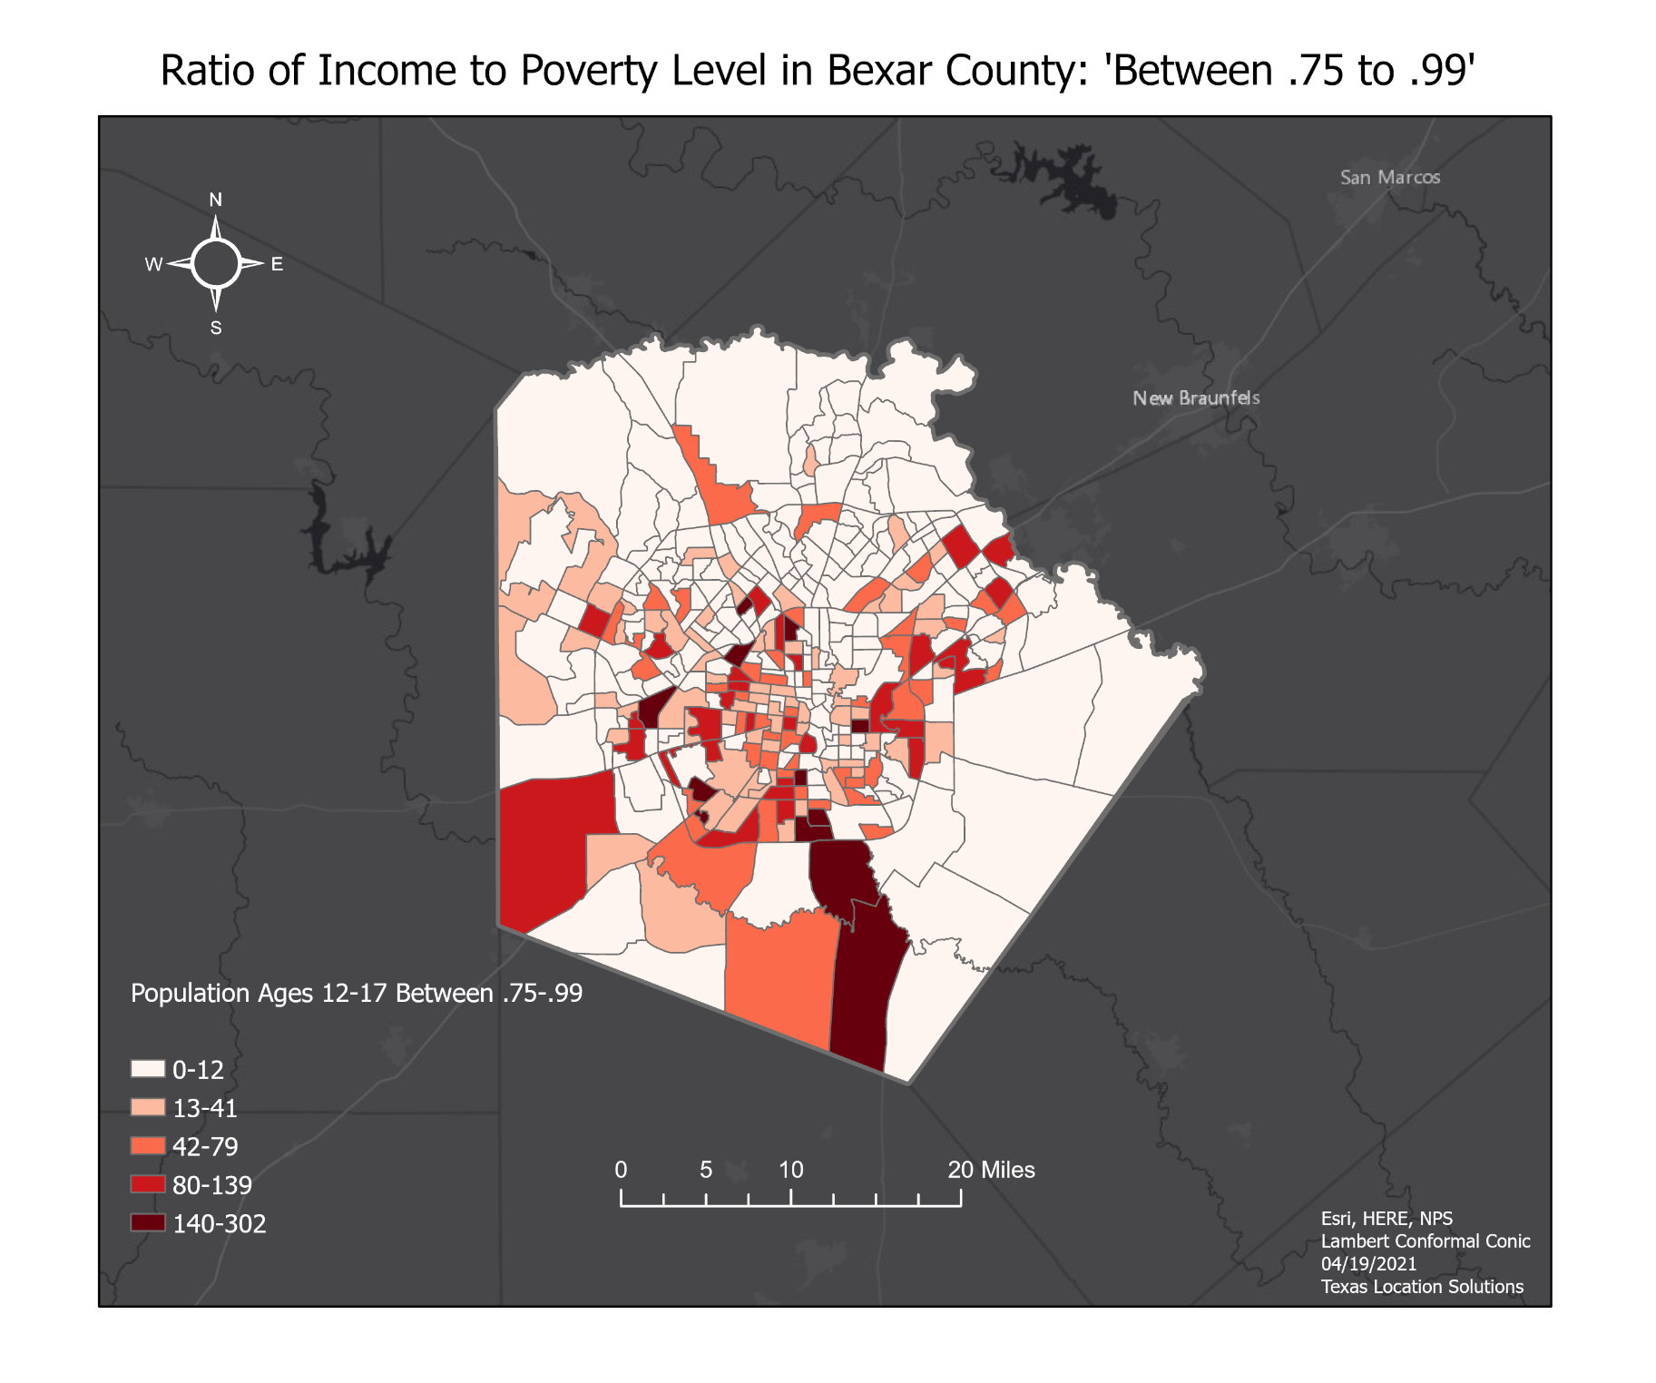

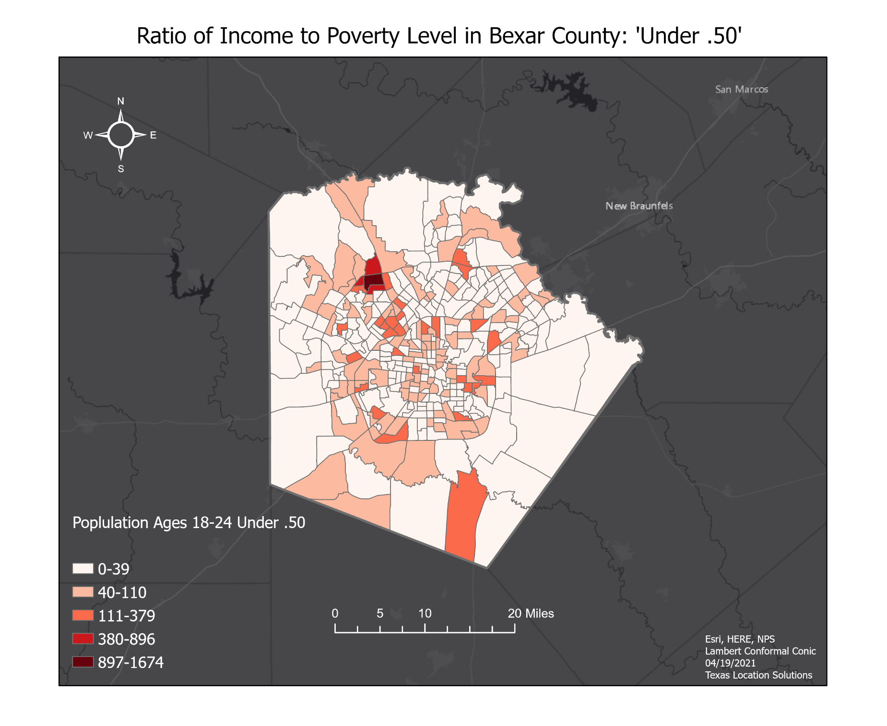

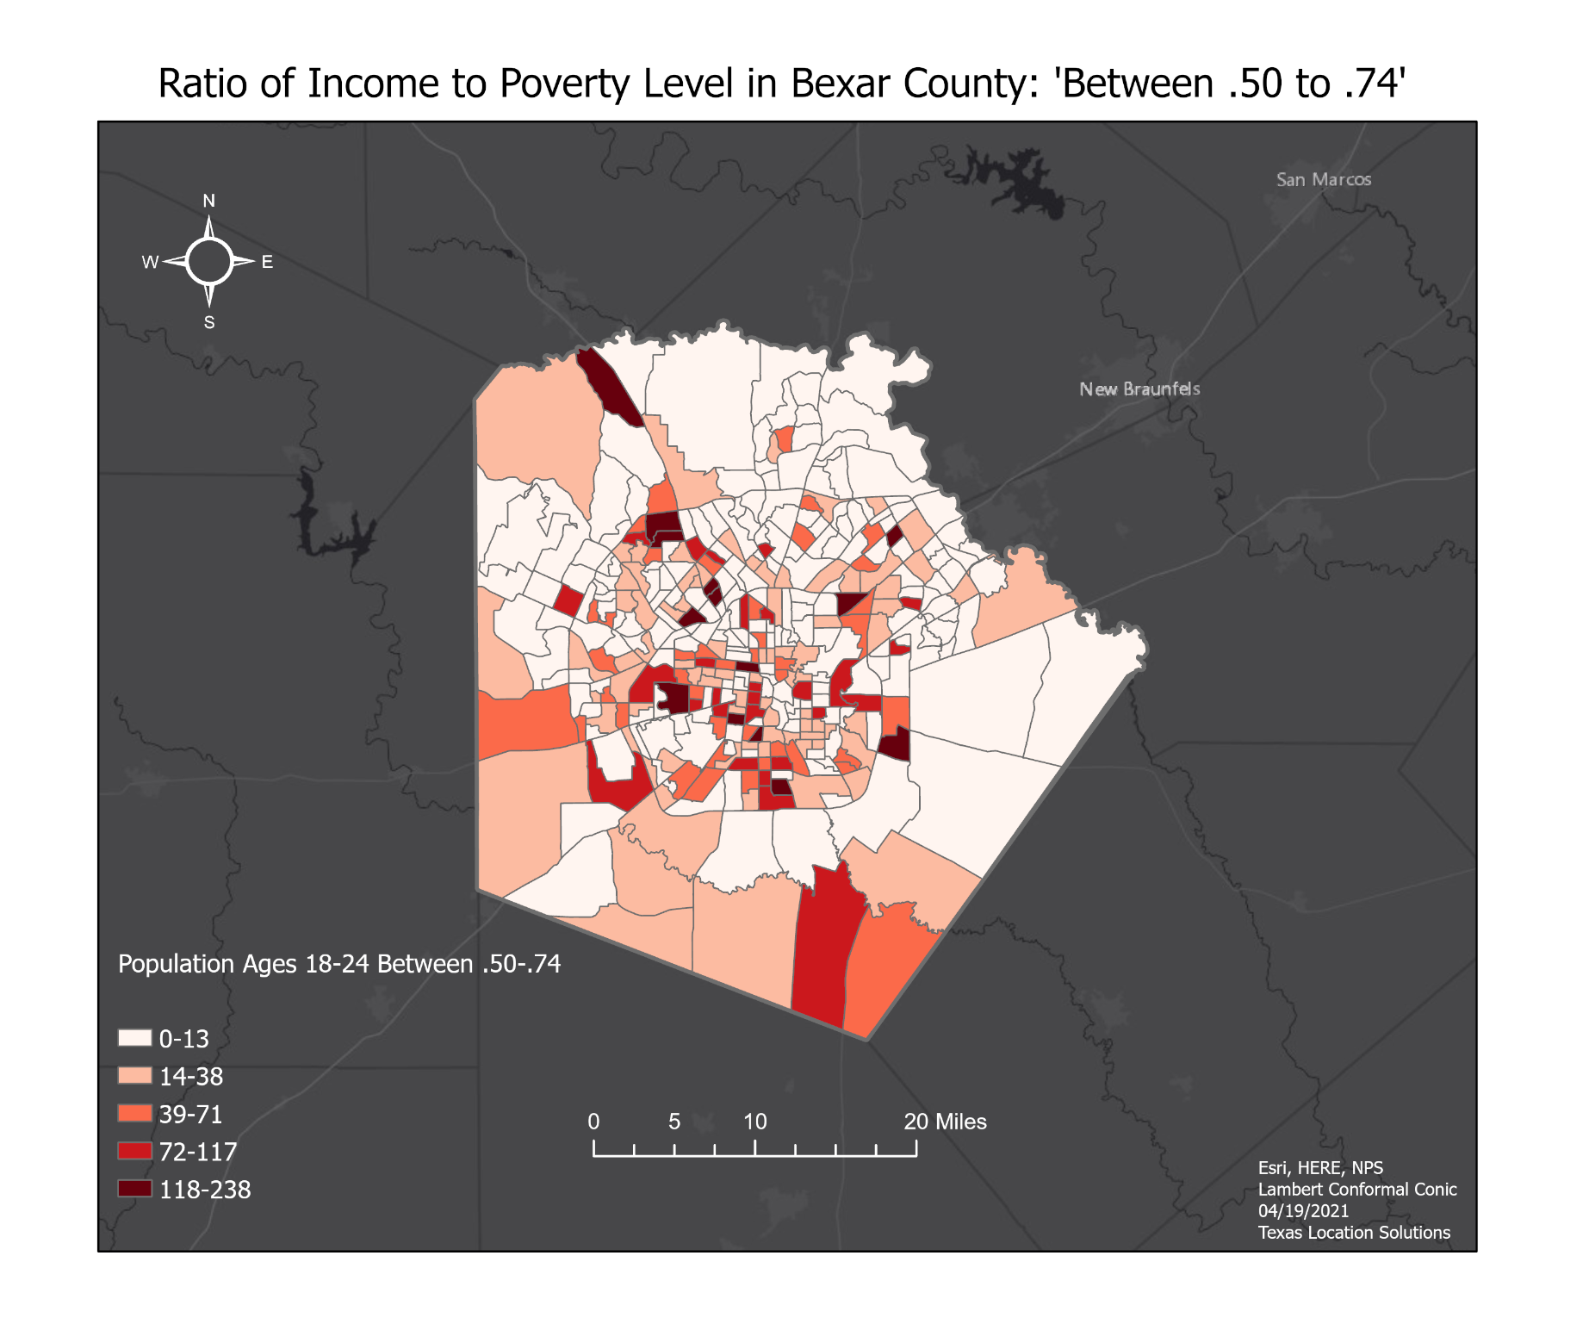

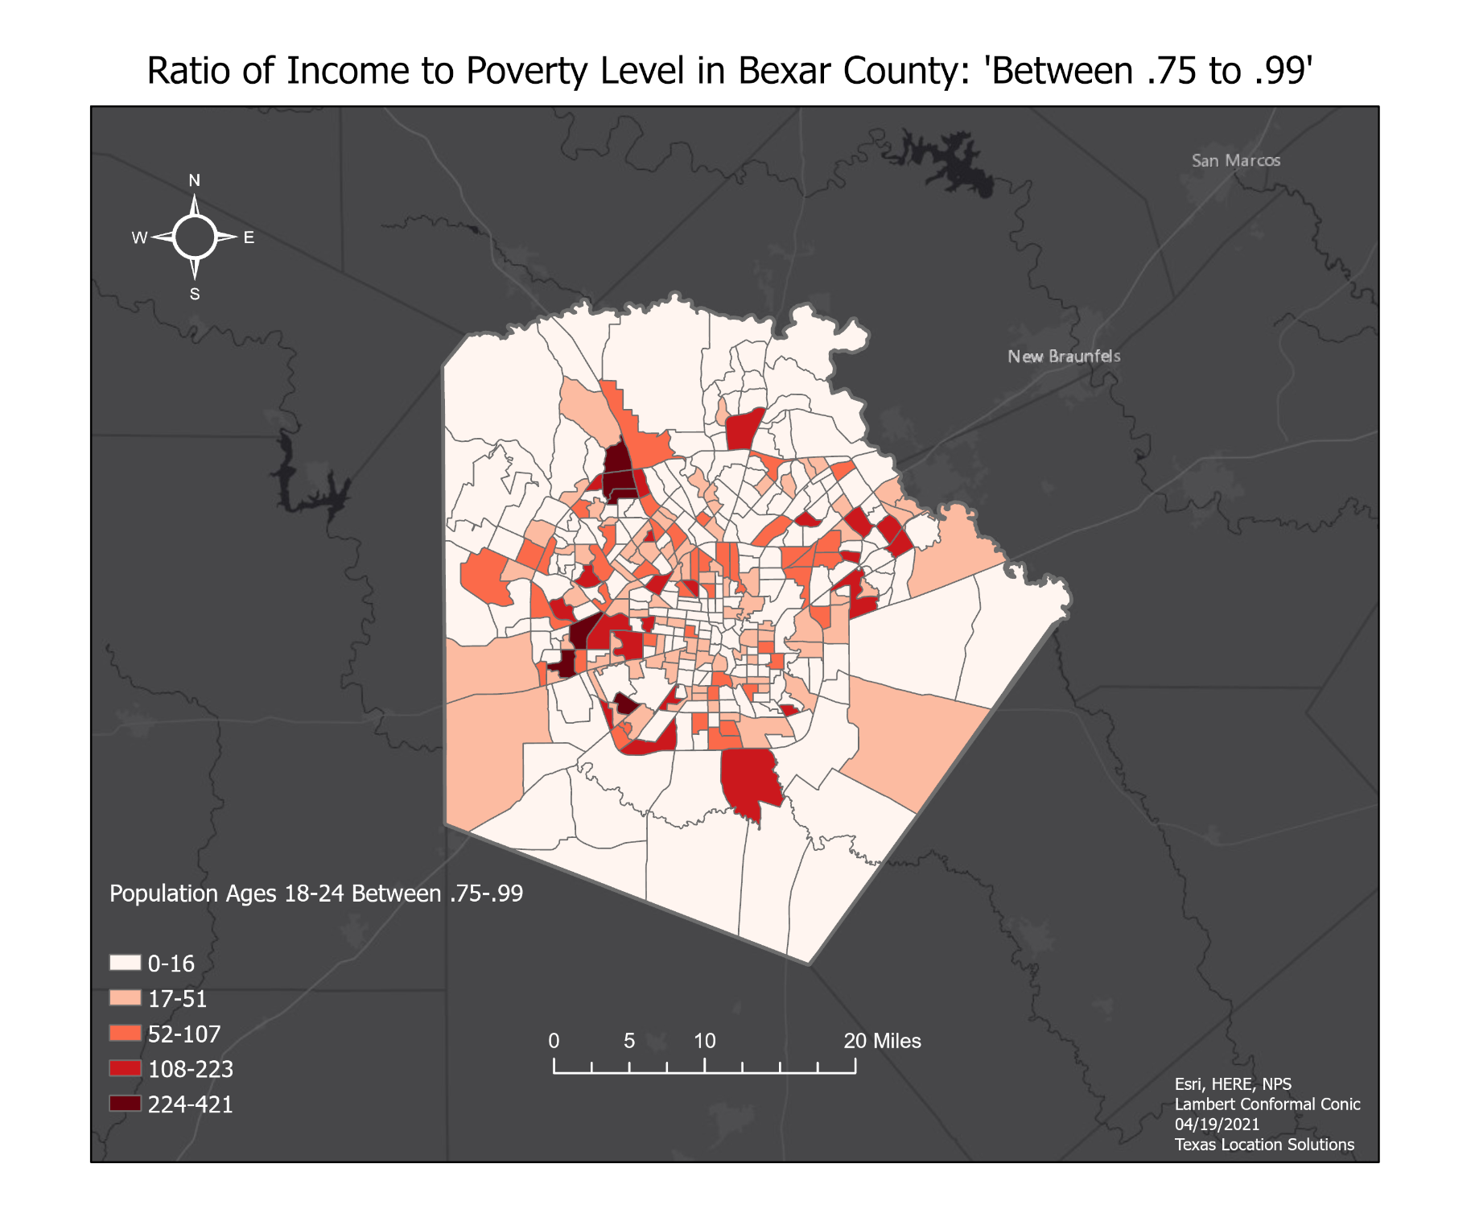

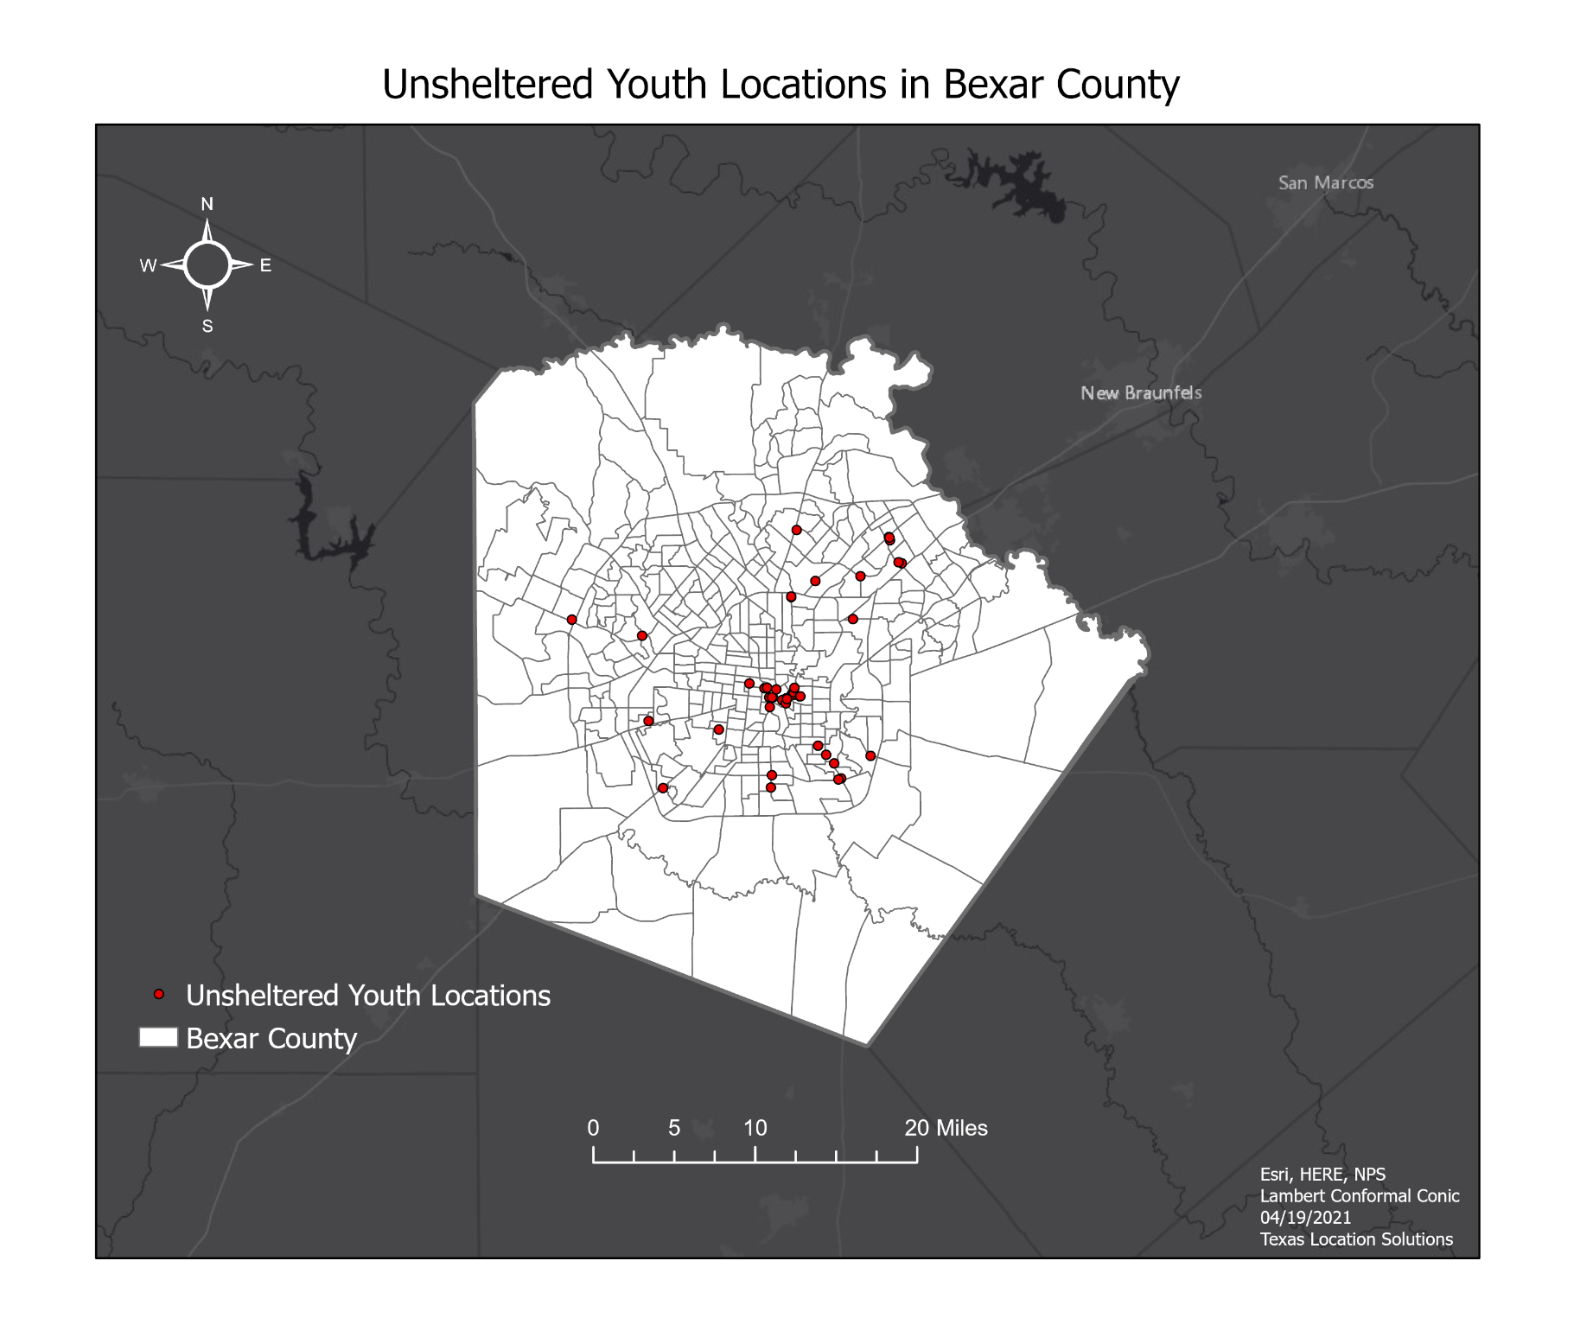

Appendix II: Metadata
File Name | Description
Income | Metadata describing “income” risk factor”
EducationalAttainment | Metadata describing “education level” risk factor
Unemployment | Metadata describing “unemployment” risk factor
PovertyLevel | Metadata describing “education level” risk factor
Race | Metadata describing “education level” risk factor
UnshelteredYouth | Metadata describing “education level” risk factor
NearbyNeededServices | Metadata describing “education level” risk factor
BexarCounty | Metadata describing Bexar County, Texas

Appendix III: Participation
Darrin Speer: Creation and Pre-processing of Loopnet data and Census Bureau Data, Paper: Methodology: (3.1, 3.2.1, 3.2.2, 3.2.3), Flowchart, Results & Discussion (4.2), Appendix I (Maps): Education, Lack of Nearby Needed Services, Poverty, Unemployment, Unsheltered Youth Locations, Suitable Access Point and Drop-In Locations. editing. PowerPoint. Uploaded Metadata and created the “Final Deliverables Zipfile” for submission.
Stancil Barton: Creation and Pre-processing of Loopnet data, Appendix I (Maps): Black Population at Risk of Homelessness: Income Criteria; White Population at Risk of Homelessness: Income Criteria; Hispanic Population at Risk of Homelessness: Income Criteria). Paper: Introduction, Data, Methodology (3.1, 3.2.1, 3.2.2, 3.2.3, 3.2.5, 3.2.6), Results & Discussion (4.2, 4.3), Conclusion, References, Appendix I (Maps): Black Population at Risk of Homelessness: Income Criteria; White Population at Risk of Homelessness: Income Criteria; Hispanic Population at Risk of Homelessness: Income Criteria), editing. PowerPoint. StoryMap. ReadMeFile. Metadata {25 total}: Access_Hubs_FINAL, Lack_of_Nearby_Needed_Services, Unsheltered_Youth_Locations, Access_Points, Drop_In_Locations, Bexar_County_Outline, Suitable_Locations, Access_Points_Buffer, Unsheltered_Youth_Buffer, Lack_Of_Nearby_Needed_Services_Buffer, Drop_In_Locations_Buffer, Access_Hubs_MultiRingBuf, Hispanic_Latino_Income_Any_Race_Poly, Black_Income_Poly, White_Alone_Income_Poly, Poverty_18_24_Between_(.75-.99)_Poly, Poverty_18_24_Between_(.50-.74)_Poly, Poverty_18_24_Under_(.50)_Poly, Poverty_12_17_Between_(.75-.99)_Poly, Poverty_18_24_Under_(.50)_Rec, Poverty_12_17_Between_(.75-.99)_Rec, Poverty_12_17_Between_(.50-.74)_Rec, Poverty_12_17_Under_(.50)_Rec, Unemployment_Rate_16_19_Rec, Unemployment_Rate_20_24_Rec.
Brandon Trevino: Paper: Abstract, Introduction, Methodology (3.1, 3.2.7), Appendix II (Table), editing. PowerPoint. Maps: Hispanic Population Ages 15-24 in Bexar County, Black Population Ages 15-24 in Bexar County, White Population Ages 15-24 in Bexar County, Population of Two or More Races Ages 15-24 in Bexar County. Metadata {44 total}: Poverty_12_17_Under(.50), Poverty_12_17_Between(.50-.74), Percentage_of_Unemployment_16_19, Percentage_of_Unemployment_20_24, High_School_Graduate_18_24, Less_than_High_School_Graduate_18_24, LNNS_Buf_Rec, LNNS_Ras, Drop_Ins_Buf_Rec, Drop_Ins_Ras, Access_Hubs_MultiBuf_Rec, Access_Hubs_Ras, Access_Points_Buf_Rec, Access_Points_Ras, Unsheltered_Youth_Buf_Rec, Unsheltered_Youth_Ras, LNNS_Rec, Poverty_18_24_Between_(.75-.99)_Rec, Poverty_18_24_Between_(.50-.74)_Rec, Unemployment_Rate_20_24_Ras, Unemployment_Rate_16_19_Ras, Poverty_12_17_Under_(.50)_Ras, Poverty_12_17_Between_(.50-.74)_Ras, Poverty_12_17_Between_(.75-.99)_Ras, Poverty_18_24_Under_(.50)_Ras, Poverty_18_24_Between_(.50-.74)_Ras, Poverty_18_24_Between_(.75-.99)_Ras, Black_Race_Poly, Hispanic_Race_Poly, Two_or_More_Races_Poly, White_Race_Poly, Bexar_County_Census_Tracts_Poly, Less_HS_Grad_18_24_Rec, BlackRace_15_24_Pop_Rec, HispanicRace_15_24_Pop_Rec, WhiteRace_15_24_Pop_Rec, TM_Races_Rec, Black_Income_Rec, White_Income_Rec2, Hispanic_Income_Rec, White_alone_income_PolygonToRaster, Hispanic_latino_of_any_race_income, Black_income_, TwoorMoreRaces_15_24
Kennedy Watson: Maps: Median Income of Blacks/African Americans in Bexar County, Median Income of Hispanics of Any Race in Bexar County, Median Income of Non-Hispanic Whites in Bexar County, Median Income of Hispanic Whites in Bexar County. Paper: Methodology (3.2.6), Results & Discussion (4.1, 4.3), editing. PowerPoint. Poster.

