Tree Canopy Vulnerability Index
Progress Report

Prepared for:
City of Austin Community Tree Preservation Division
Prepared by:
Linsey, Morgan (Graphic Designer & Researcher)
Crock, Kevin (Editor & Researcher)
Chace, Abigail (GIS Specialist & Researcher)
Ramirez, Rodrigo (Tito) (Graphic Designer & Assistant Manager)
White, Zane (Project Manager)

30 March 2020
1. Introduction -------------------------------------------------------------------------- 1
1.1. Summary ----------------------------------------------------------------------- 1
1.2. Purpose Statement ---------------------------------------------------------- 1
1.3. Scope --------------------------------------------------------------------------- 2
2. Tasks --------------------------------------------------------------------------------- 2
2.1. Works Completed ------------------------------------------------------------ 2
2.2. Present Work ------------------------------------------------------------------ 3
2.3. Work Scheduled -------------------------------------------------------------- 3
2.4. Problems ----------------------------------------------------------------------- 4
3. Timeline ------------------------------------------------------------------------------ 5
4. Conclusion -------------------------------------------------------------------------- 5

1. Introduction
1.1 Summary
Progress on the creation of the tree canopy vulnerability index is going as we expected it to at this point in our scheduled timeframe. We have been adding processes to our model and have completed clipping all the data to our study area, the city limits of Austin. We have also performed the geometric intersects of the data files with the tree canopy coverage from 2014 as well as the impervious cover data. As a group, we have also setup Zoom and have been collaborating to properly implement this as a communication tool moving forward. Finally, we have been researching various geostatistical methods and regression analysis models in order to implement the most appropriate one for the vulnerability index.
1.2 Purpose Statement
For the creation of the vulnerability index, we are staying on target with our original timeframe of fourteen weeks. We still expect to have our final outputs and deliverables complete by May 4th. We are currently in the middle of completing the workflow that was given to us as well as finishing our weighting matrix, which we will use for our geostatistical analysis. Once completing these tasks, we will be able to deliver the final product which will be the tree canopy vulnerability index for the city of Austin.
1.3 Scope
Regarding our original project proposal, we do not anticipate any major changes to the tasks and processes we have described as well as any change to the scope of our project. We still expect to create our vulnerability index following the wok flow given to us, using the data provided to us as well.
2. Tasks
2.1 Work Completed
We were able to clip the data provided to the jurisdiction of Austin, Texas. We then converted all raster data to vector data for intersecting from the tree canopy tiff. We then used the dissolve tool for the tree canopy layer to allow for a faster processing of the data. We were also able to run the intersect tool with the zoning layer as well as the tree canopy layer. We created new fields in each of the tables and calculated the percentage of tree canopy per zoning parcel. On top of this, we intersected all environmental constraints with the zoning layer. This will later allow for an analysis of the environmental constraints when we fully complete how we would like to proceed with our weighted matrix. From here, we intersected the impervious cover layer with the zoning layer data. We calculated the percentage of impervious cover per zoning parcel just like the tree canopy cover. Figure 1 shows an example of the tree canopy overlaid with the zoning file.
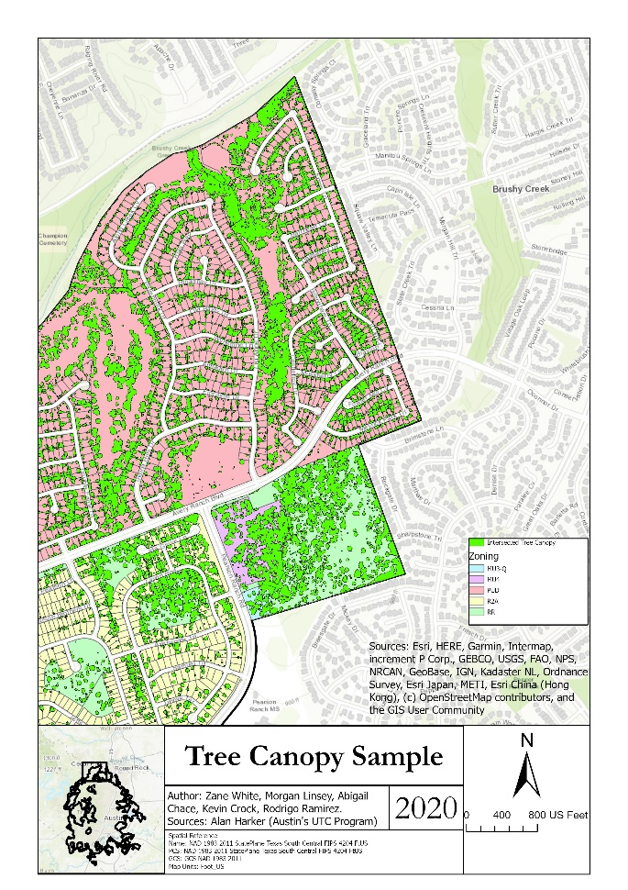
Figure 1

2.2 Present Work
We a currently working on determining the proper weights for the tree canopy vulnerability matrix. We are also currently working on calculating percentages that each environmental constraint occupies in each zoning parcel. This will allow us to determine the more specific impact each environmental constraint has on the zoning land parcels. We also plan on integrating Boolean processes for our final deliverable.
2.3 Work Scheduled
Over the course of April, we intend on creating our overall tree canopy vulnerability index, creating metadata files, working on regression analysis, and our cartographic representation. We will begin with standardizing our different environmental factors by converting variables to percentages and applying weights and creating a combined score. By implementing a regression method, we will do a geostatistical analysis with our different variables. Lastly, we will put our cartographic skills together to create a poster to appropriately exhibit our whole project.
2.4 Problems
The biggest obstacle we have faced so far while processing data was converting the tree canopy layer from raster to vector file format. This step was required to intersect the tree canopy with the zoning layer in order to calculate the percent of canopy per parcel. Due to the size of the tree canopy file, the processing time when using the on-campus computers were extremely lengthy and sluggish, never allowing the tool to finish running before crashing. As a group, many different members attempted to run the vector to raster tool on their personal laptops and ultimately only one succeeded. The output gave us separate polygons gave us two separate attribute values: one representing trees and the other representing the areas with no trees. A simple query allowed us to extract the tree values making the data file much smaller and user friendly for all group members to work with on their personal laptops.

3. Timeline
Week of April 1st | Presentation with client via Zoom
Week of April 6th | Continued regression analysis and vulnerability index formation
Week of April 13th | Standardization of weighted matrix and vulnerability index
Week of April 20th | Begin generation of final cartographic outputs and visuals  Possible meeting with Land Division
Week of April 27th | Finalization of cartographic outputs, deliverables, and vulnerability index
Week of May 4th | Final presentation with client and final deliverables and outputs

4. Conclusion
For our project so far, we have made good progress and are staying on track with our timeline. We have run into a few problems with the tree canopy layer and processing of the data due to the sheer amount of it, but we are still intending on completing the project on time. The final deliverables will be ready by May 4th.
Participation
– Cover Page (Zane)
– Table of Contents (Zane)
– Introduction (Tito)
– Tasks (Abigail, Kevin-primaries, but everyone is going to be involved)
– Timetable (Morgan)
– Conclusion (Zane)

