Tree Canopy Vulnerability Index
Final Report

Prepared for:
City of Austin Community Tree Preservation Division
Prepared by:
Linsey, Morgan (Graphic Designer & Researcher)
Crock, Kevin (Editor & Researcher)
Chace, Abigail (GIS Specialist & Researcher)
Ramirez, Rodrigo (Tito) (Graphic Designer & Assistant Manager)
White, Zane (Project Manager)
29 April 2020
Abstract --------------------------------------------------------------------------------- 1
- Introduction and Problem Statement ----------------------------------------- 2
- Data -------------------------------------------------------------------------------------- 3
- Methodology -------------------------------------------------------------------------- 5
  - Data Organization and Processing --------------------------------------- 6
  - Creating the Weighted Matrix ---------------------------------------------- 8
  - Environmental Constraints ------------------------------------------------- 8
  - Weighting Matrix Implications -------------------------------------------- 11
- Findings and Discussion--------------------------------------------------------- 13
  - Standard Deviation------------------------------------------------------------ 13
  - Regression Analysis -------------------------------------------------------- 14
  - Implications --------------------------------------------------------------------- 15
  - Data Challenges --------------------------------------------------------------- 16
  - Data Limitations and Recommendations ----------------------------- 17
- Conclusion --------------------------------------------------------------------------- 18
- References --------------------------------------------------------------------------- 18
Appendix I: Group Member Contributions -------------------------------- 19
Appendix II: Metadata ------------------------------------------------------------ 23
Abstract
The growth and development of Austin has come with the increase of citizens and impervious cover inside the city. This study assesses the effect that impervious cover and other environmental features have on the growth of urban tree canopy. To locate and visualize potential areas for tree development, the group created a vulnerability index that rates how land parcels support or limit tree growth. This index was created by applying specific weights to each of the variables that affect tree health. We then performed an addition of factors calculation in order to create a range of values that is displayed by color classification on a map. The conclusions drawn from this index are that impervious cover and transit priority networks are the factors that most negatively impact urban tree growth. On the other hand, environmental factors such as proximity to creeks, springs, and aquifers promote tree development. This index is intended to be used by city officials for rezoning efforts, as well as citizens interested in environmental details about their property. In the coming years, this data should stay updated with tree canopy and impervious cover data to further study the balance between the city and its natural environment.

- Introduction and Problem Statement
In recent years, there has been an influx of people that are moving to urban areas of living. The urban population of the world has increased from 34% in 1960 to 54% in 2014 and is showing signs of continuous growth with no intent on slowing down (“Urban Population Growth.”). The city of Austin in the great state of Texas is one of the most rapid growing big cities in the United States (Weissman). With this large migration of people moving to urban areas, resources such as tree canopy can become scarce within the city. Without proper urban tree canopy (UTC) coverage, there can be problems such as pollution and increased temperatures inside of the city. To help identify and visualize areas of Austin that are at risk of being most heavily impacted, we have created a vulnerability index to highlight areas of higher risk and change. This vulnerability index was created from current and proposed zoning changes from the city, with other factors such as impervious cover and environmental constraints, to show vulnerable areas of UTC. This index could be used by city officials to better visualize zoning changes and understand the impact they could have on Austin’s UTC. It can also be used to identify areas where there is new potential for tree canopy development and growth based on proposed increases or decreases to impervious cover allowed. This index should prove useful in helping to minimize the loss of urban tree canopy in the city of Austin as it continues to grow and expand.
When creating the vulnerability index our group hypothesized that the most impactful factors would be impervious cover (IC), maximum IC percent allowed by zone, and existing tree canopy. From this, our group expected to be able to create multiple final outputs that would be helpful in the process of assessing urban tree canopy health in response to rezoning efforts and changes by the city. Our group believed that the final map products should clearly locate and depict areas with the most increase to impervious cover and areas that have the most at-risk tree canopy. We evaluated and selected multiple environmental constraints and factors that would affect the health of tree canopy. We expected that IC would be the variable that most negatively affected the growth of UTC. We also expected to be able to identify environmental constraints and social indices that would be most impactful on the loss and growth of urban tree canopy.
- Data
For this project, we used a compilation of environmental factor data, planning cadastre data, tree canopy data, and vulnerability indices such a social, community, and climate. We were provided with our data from the City of Austin. All data sets have been created, updated, and maintained within the last 6 years. The data comes from a reliable source and proves to be accurate and precise. All data was necessary in order to create a consistent tree canopy vulnerability index that could be used to map the potential increase or decrease of tree canopy cover within in the city of Austin. All aspects of our datasets allow us to get a better evaluation as we analyze and weigh the different factors. Environmental factors that were deemed helpful in providing UTC were given a positive weight, while environmental factors that prove to be harmful were given a negative weight. The size of each of the weights were determined by the literature review and careful evaluation from the team. Planning cadaster, such as impervious cover, allows us to assess areas that are less likely to have tree canopy cover.
Entity | Attributes | Spatial Objects | Status | Source
Austin Tree Canopy Data | 1-3 | Cellular Raster | Available | City of Austin
Current Austin Zoning | Zoning, shape area | Polygon | Available | City of Austin
Proposed Austin Zoning | Zoning, shape area | Polygon | Available | City of Austin
Austin City Limits Boundary | Shape, shape area, shape length, city name | Polygon | Available | City of Austin
Rock Outcrop | Shape, BRG id, name, case number, average height, plan set data, feature status, latitude, longitude, field check request, feature comments, shape length | Polyline | Available | City of Austin
Creek Buffers | Shape, BRG ID, name, feature type, case number, plan set date, latitude, longitude, field check request, feature comments | Polygon | Available | City of Austin
Critical water quality zones | Shape, creek buffers id, drainage area ordinance, watershed regulation area, critical water quality zone, minimum buffer distance, maximum buffer distance, shape length, shape area | Polygon | Available | City of Austin
Edwards Aquifer Zone | Shape, EA zone buffer, zone, shape length, shape area | Polygon | Available | City of Austin
Floodplains | Shape, drainage id, source citation, shape length, shape area | Polygon | Available | City of Austin
Erosion hazard zone | Shape, erosion hazard id, buffer distance, shape length, shape area | Polygon | Available | City of Austin
Seeps and springs | Shape, BRG id, name, feature type, case number, other id number, plan set date, feature status, elevation, latitude, longitude, field check list request, feature comments | Point | Available | City of Austin
Wetlands | Shape, BRG id, name, feature type, case number, plan set date, feature status, latitude longitude, field check request, feature comments, shape length, shape area | Polygon | Available | City of Austin
Social Vulnerability Index | Shape, Geoid10, social vulnerability index, shape length, shape area | Polygon | Available | City of Austin
Community Wildfire Risk | Shape, percent wildland, wildfire risk class, wildfire risk score, shape length, shape area | Polygon | Available | City of Austin
Climate Vulnerability Index | Shape, Geoid10, climate vulnerability Index, shape length, shape area | Polygon | Available | City of Austin
Zoning Proposed | Shape, zoning id, proposed zoning, impervious cover increase proposed, parcel acres, shape length, shape area | Polygon | Available | City of Austin
Transit priority network and corridors | Shape area, shape length | Polygon | Available | City of Austin
Impervious Cover 2017 | Shape, impervious cover id, parent feature id, source, origin feature class, max height, elevation, base elevation, shape length, shape area | Polygon | Available | City of Austin
Steep Slopes | Shape, dissolve, shape length, shape area | Polygon | Available | City of Austin

- Methodology
The process for completing this project required two major parts. One part was compiling and organizing all the data together into one shapefile for analysis. The second part was creating a weighted matrix based on research, applying that weighted matrix to the data creating a vulnerability index and finally, running a regression analysis of the final outputs. Both of these parts were essential for our project and allowed us to organize and understand our data.
3.1 Data Organization and Processing
The first step in the process was setting the environments for our workspace. Our projected coordinate system was set to NAD_1983_StatePlane_Texas_Central_ FIPS_4203_(US Feet), and projections were set to Lambert Conformal Conic. This projection was also used for the data received from the City of Austin. The processing and masking extent were then set to the study area. Then we began by clipping all the data provided by the city to Austin’s full jurisdiction. The tiff for the tree canopy was then converted from raster to vector. The resulting file contained over 2 million polygons with the attributes being either 1 or 3 representing areas with or without trees. The areas without polygons, 3, were selected using the select by attribute and deleted. Once all the files were clipped to the study area and converted to vector, we intersected all environmental constraints with Austin City’s zoning layer. This was to make sure that each row or parcels identification had an environmental constraint associated with it. We also created a new field and calculated the acreage of each land parcel (feature shape area / 43560 sq ft) for simple understanding purposes. We then proceeded to create multiple fields representing each environmental constraint and run a simple percentage calculation (feature shape area / parcel shape area), to get the percentage of the environmental constraint in decimal form. This allowed each parcel to be more detailed and contain the percentages of each of the environmental constraints compared to a Boolean yes/no approach. For example, a parcel may be fifty-percent wetland, and then also have several other smaller percentages of the other constraints like floodplains, seeps and springs, and erosion hazard zones. For layers that only had lines and points instead of polygons, we had to use a Boolean yes/no to calculate the fields for those specific environmental constraints. We were able to select the specific parcels by running a select by attribute intersection and populating the parcels in the field appropriately (1 = Yes , 0 = No). When intersecting tree canopy, the results showed the intersection of multiple polygons present inside a single land parcel. Those polygons were calculated together using the based on the FID field within the table from the zones. Then it was realized that some of the resulting files were slightly over 100 percent. To fix this, a data repair function was ran on all environmental constraints with a shape area in order to rectify the error. The resulting files were then spatial joined to the main zoning file, so that the zones would contain the environmental constraints percentages as attributes. A new field for the tree canopy percentages was also created and recalculated. Again, there were multiple polygons representing the tree canopy per parcel. All attempts to merge the file failed so we ran the summary statistic tool to summarize the tree canopy percentage based on the PHASE_2_UI field. From the statistic table, we joined the summed statistic to the main zoning file after verifying that both files had the same number of elements within each layer. We then recalculated the percentage of tree canopy (tree canopy area from summed statistics / parcel shape area). The final zoning file contained all the environmental constraints percentages and tree canopy percentages for each parcel of land.
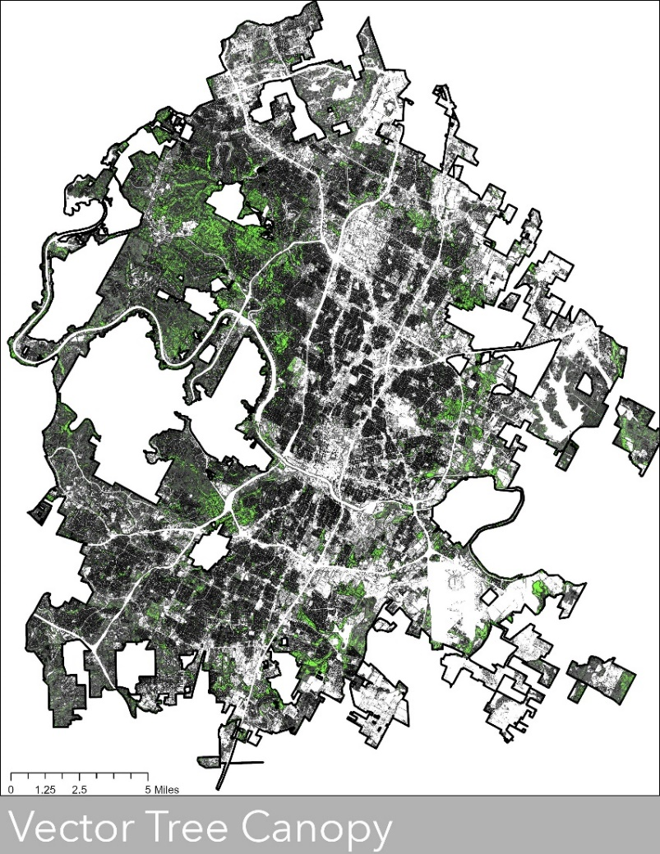
Figure 1. Tree Canopy of Austin
3.2 Creating the Weighted Matrix
The first step in creating the weighted matrix was to conduct a thorough literature review over the environmental constraints, social indices, and impervious cover. For each of the environmental constraints, background research was conducted in order to begin assigning weights and values to each variable. For each of the environmental factors, the group had to determine whether the environmental constraint would help promote tree canopy development or hinder the growth of tree canopy development. Once the effect of each variable was determined, weights for all the constraints, as well as the proposed changes in the form of impervious cover and the transit priority zone, were implemented into a weighted matrix. The scale chosen to represent the different variables was from negative five to positive five. The more negative the score a constraint received meant that the constraint was harmful or hindered the growth and development of healthy vegetation and tree canopy. The higher value a constraint received meant that it promoted or favored the growth and expansion of vegetation. For example, the transit network and current impervious cover received a negative score because there would be little to no tree canopy growing in these zones. Where factors like wetlands, and Edwards Aquifer zones received positive values because they provide very favorable conditions that would promote vegetation health.
3.3 Environmental Constraints
Creek Buffers
Through literature review, we found these types of buffers surrounding creeks to be beneficial to tree canopy. These buffers prevent any building to be done within them and although trees would not grow within the creek, being a nearby water source is extremely beneficial towards promoting tree canopy growth and decreasing the possibility of vulnerability for tree canopy within these buffers. For this environmental constraint, we weighted it a positive four (+4).
Critical Water Quality Zones
These zones are defined as areas where there are buffers around bodies of water tagged by the city with the critical water quality title. These areas are at risk of increased pollution which can also cause erosion hazards and increased flooding. When it came to weighing these zones, these areas hinder tree canopy growth through poor soil health and water quality, these water zones were weighted as negative four (-4).
Edwards Aquifer Zone
Comprised of two zones, a contributing zone and a recharge zone, these areas are found to offer areas with reduced soil erosion, have increased vegetation and offer trees increased areas for growth. Although tree canopy is less vulnerable in these areas’ aquifer zones do not promote the growth of canopy cover. With these in mind, it was determined the weight for these zones to be given a positive two (+2).
Floodplains
Within floodplains are creeks and streams. Trees highly benefit from not only growing on the banks of these bodies of water, but also help the city immensely through their roots. By doing this, trees are filtering out pollutants from the stream which helps combat flooding and maintaining stream flow. This area is least vulnerable because without canopy cover over these areas, the overall ecosystem around creeks and streams begin to die off. Pollutants in the water end up in other vegetation within the streams and creeks themselves, making the city more at risk for floods. This was weighted positive four (+4) being one of the higher positively weighted variables within the matrix.
Erosion Hazard Zone
Erosion hazard zones are areas within creeks, rivers and streams where increased volume and velocity speeds up erosion on the banks collapsing the soil around them and widening these bodies of water. This affects tree canopy greatly as these areas are at risk most for erosion. The overall health of the tree canopies within this area and residents with properties in these areas are more in danger to collapse. Because of this erosion hazard zones were weighted negative four (-4) as they play a large part to tree canopy health and to Austin residents.
Rocky Outcrops
These outcrops are natural formations usually limestone in overhangs, and are areas generally defined as an area where there is visible exposure to rock. These areas tend to not have much vegetation within them as generally there is more rocks underneath the surface level of exposed rock. Due to this, for the index, rocky outcrops were weighted negative five (-5) as there was not a high amount of tree canopy present to begin with within and overall restrict of tree canopy growth.
Seeps & Springs
These are areas where water flows and comes from. Water is beneficial to trees and promote tree growth, these areas vary in sizes and were determined to not be areas that would promote tree canopy growth, instead support overall vegetation growth. These areas where water was present were given a positive two (+2) weight.
Wetlands
Generally, areas of deep-water swamps and freshwater marshes. Reasons being as they offer tree canopy optimum water supply and generally aren’t disturbed by other environmental factors like erosion zones or steep slopes. Furthermore, wetlands give tree canopy ample area to grow without being disturbed by urban factors like impervious cover and a transit priority zone. These areas were identified to be the least vulnerable for tree canopy and given a positive five (+5) weight.
Slope
Slopes varied within the data set from high to low and when it came to weighing, we wanted to ensure that variability was considered. High slope areas make it harder for trees to grow and expand as trees are more vulnerable to exposed roots due to the slope of the land. However, slopes did not necessarily mean tree cover was more vulnerable to slope as a moderate slope was determined to be somewhat positive for tree canopy. This was compared to lower slope areas where trees are less vulnerable to root exposure due to the slope. To account for this, a weight of positive three (+3) was given to slope.
Transport Priority Zone
We found that tree canopy was most vulnerable as these areas are mostly comprised of concrete streets or highways where tree canopy is not present. In addition to this, tree canopy growth is not promoted and upkept, making trees in these areas the most vulnerable within the index. After research and review, the score of negative five (-5) was given to transit priority zones, which was the lowest in the scale.
Impervious Cover
Impervious cover was one of the main factors that was requested for analysis. These areas are urban, man-made structures such as small-scale urban buildings or larger scale skyscrapers and generally are made of water-resistant material such as concrete, asphalt and rooftops. This affects canopy health by limiting the amount of sun and water a tree canopy can get, largely affecting the current canopy cover within these areas as well as future canopy growth. Due to this, anywhere there was any impervious cover, a negative five (-5) weight was given, which was the most negative weight in the matrix when it came to canopy vulnerability. Whether there was an increase, a decrease or no change, impervious cover whether 10% or 70% has a large affect on tree canopy growth overall.
3.4 Weighting Matrix Implementation
When all the variables were provided their appropriate weights and the matrix was completed, work was started on the process of implementing the weighted matrix into the current dataset and then create the vulnerability index. Each parcel contained all other information provided by the clients such as zoning classification, tree canopy coverage, and all changes regarding impervious cover. After this, we verified that the parcel data contained all the correct percentages of environmental constraints within each parcel and that they visually match up to what was present on the map. Then to implement the weighting matrix, new fields were created in the attribute table for each of the applicable environmental constraints and were calculated to the weight to be assigned to it using the formula: (Percentage of the Environmental Constraint) * (Weighted value according to the matrix). Once each of the environmental constraints and tree canopy had been assigned their weights, we created a field for the summed value. Again, we used the field calculator, took all the weighted values for each parcel and created a summed number to represent the Tree Canopy Vulnerability Index.
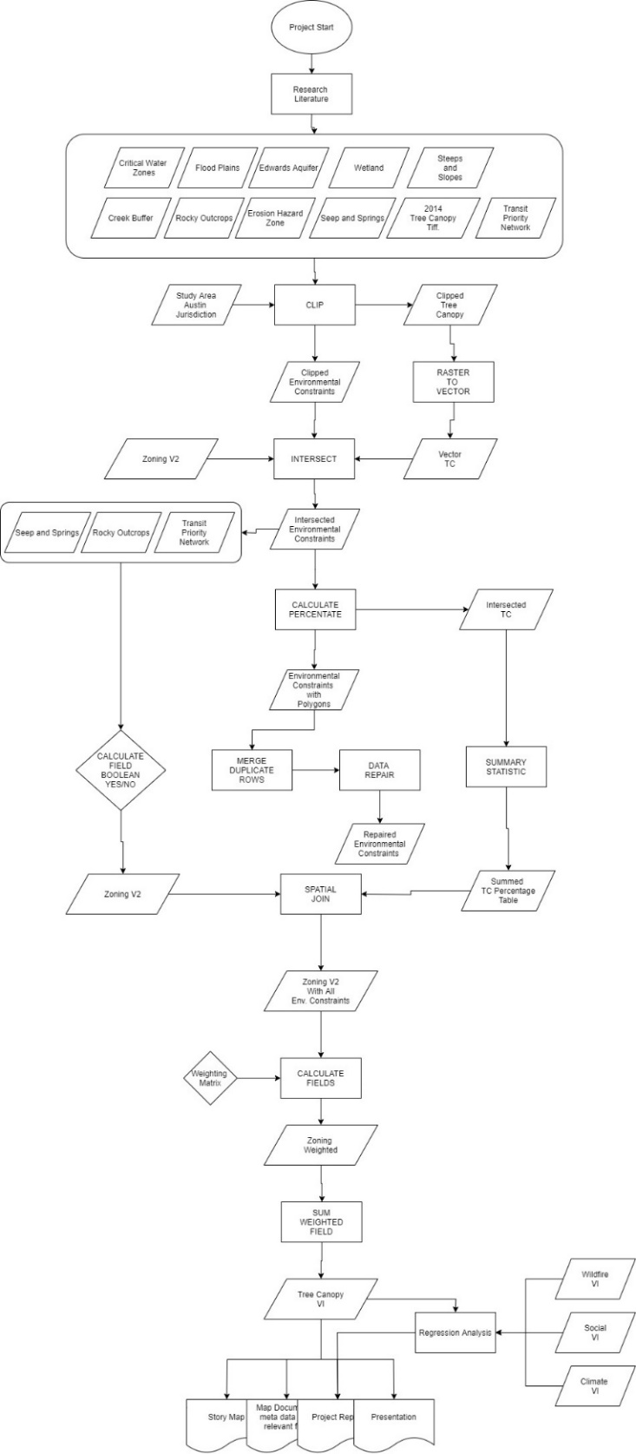
Figure 2. Final Flow Chart with Deliverables

- Findings and Discussion
4.1 Standard Deviation
Standard deviation was used to define how even our data was. A low standard deviation score generally means the data is more reliable and clustered together compared to higher standard deviations, which indicate a wider spread of a dataset. After processing our data, we found to have a standard deviation of four, meaning our data was statistically significant and closely related. We also found that our data had a bimodal distribution peaking within our lower and higher values. The two peaks presented represented our local minimum and maximum with our dataset and where most values fell. (Refer to Figure 3)
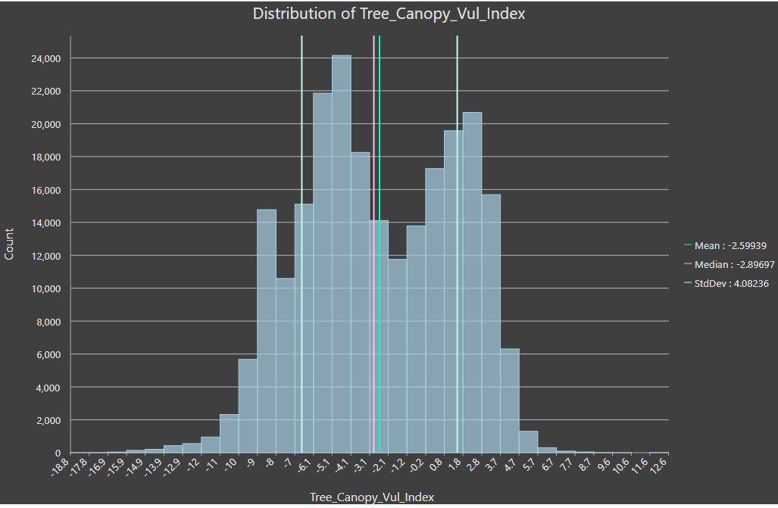
Figure 3. Distribution of Tree Canopy Vulnerability

4.2 Regression Analysis
To further analyze our data, we ran linear regression analysis between our tree canopy index and our environmental constraints. One of the main aspects of our project was to analyze impervious cover and how it affects tree canopy. Our regression analysis gave us an R squared value of 0.31. This indicates that impervious cover is loosely correlated with our vulnerability index.
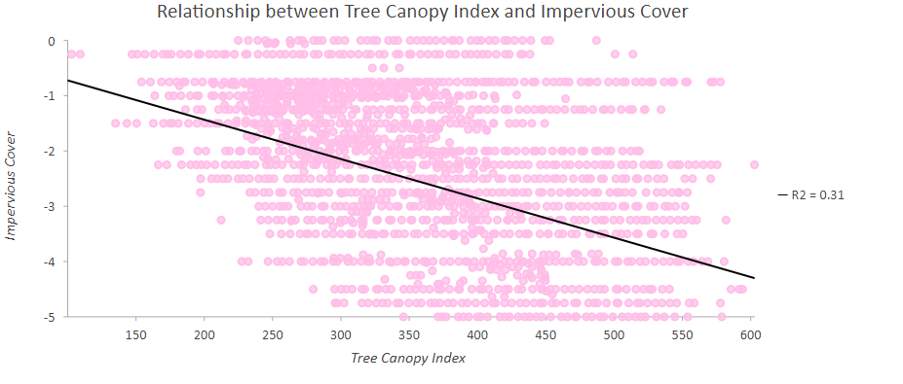
Figure 4. Relationship between Tree Canopy Index and Impervious Cover
After running a linear regression on the impervious cover, we ran linear regressions on our environmental constraints. One of these environmental constraints was the Edwards Aquifer. Our results showed a R squared value of 0.36. This also indicated a loosely correlated value between the constraint and our vulnerability index.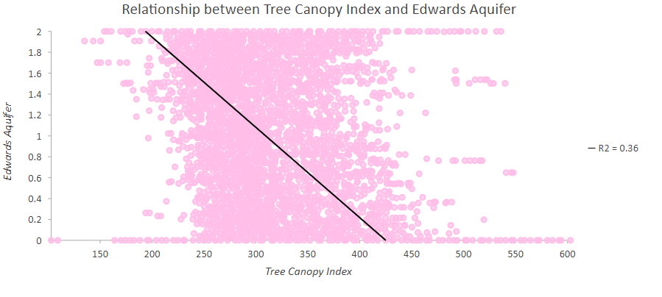Figure 5. Relationship between Tree Canopy Index and Edwards Aquifer
We also used a Boolean yes/no weight for the transit priority zones weighting that value a negative five (-5). We ran a linear regression analysis to find the impact a singular weighted value would have on our regression analysis. We were presented an R squared value of 0.67. This was found to have a stronger correlation between the vulnerability index compared to the impervious cover and the environmental constraints.
4.3 Implications
Few of the findings or results from the Tree Canopy Vulnerability Index were particularly surprising. The spatial distribution for the more vulnerable area were aggregated withing the Transit Priority Network and centered around Interstate Highway 35. The most vulnerable zone also was as expected with multi-unit residential, commercial and government owned sites ranking as generally the topmost-vulnerable. Additionally, the transit priority network was most likely weighed too low, but it is generally the area where most of the tree canopy for Austin is at risk.
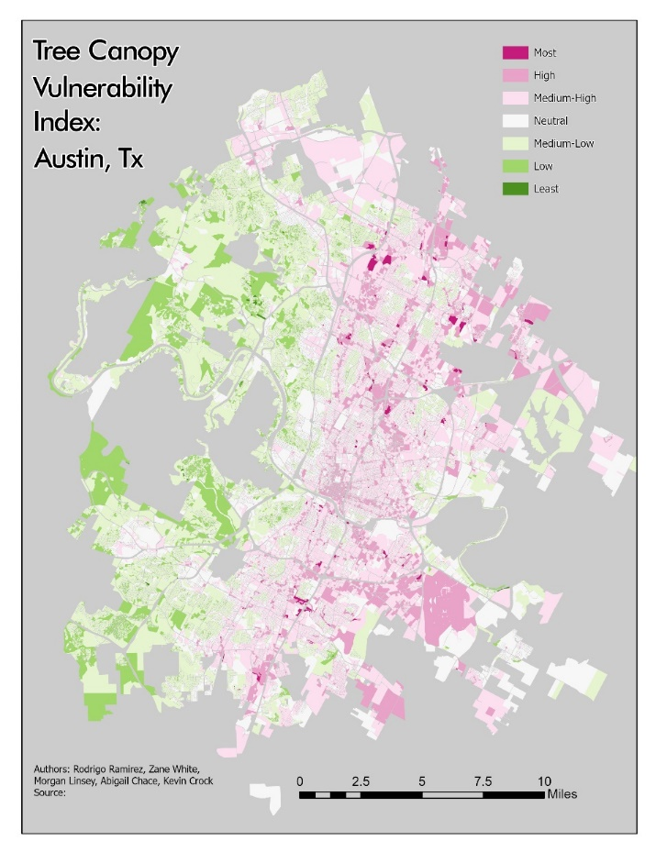
Figure 6. Final Tree Canopy Vulnerability Index of Austin, Texas
4.4 Data Challenges
The current tree canopy file that was used throughout the project was massive, comprised of over 1 million rows on its attribute table after it was intersected with the zones. This significantly limited the time to work on analysis as well as the types of processes that were able to be run. This was further exacerbated after the real-world events for quarantine were put into place, and team members had to do all calculations on their personal computers. Running any tool on the dataset would take an extremely long time to run just one file and would either, crash midway through, output something not beneficial to the project, or receive an error within the data. With the team being unable to come together, data management and sharing became problematic with different files being joined and feature layers being turn into layer packages to be shared. The majority of these challenges were mitigated to some degree by frequent synchronization meetings out of class and lab time periods. Additionally, when frequently joining the layers, some additional polygons were created. All the excess polygons that were manually detected by a visual inspection of the map and attribute table were deleted, but it was a reoccurring problem.
4.5 Data Limitations and Recommendations
The primary limitation to this data is set is that it is potentially temporal inconsistent and many of the layers were created and developed from different years. The tree canopy tiff was developed in 2014, and the data for processing some of the index were unknown. In terms of the analysis that was conducted regarding tree vulnerability, the use of remote sensing data on soil quality would have been beneficial to show where rich and poor soil quality was throughout the city. Also showing air pollutants, land cover types, and precipitation data may provide a more dynamic view of urban tree canopy. One of the benefits of using a GIS to address the vulnerability of tree canopy cover in Austin is that it gives an accurate representation spatially of how trees currently are and can be affected through zoning. If one were to not use a GIS to address a problem like this, possibly through just statistics and providing numbers on a trend line, it would not provide the visual representation critical to understanding the state of tree canopy cover within Austin. One of the constraints of using a GIS to address this problem can occur from the weighted numbers, calculations and the enormous amount of data used for this project. There is always a possibility of calculations in the future that may be done incorrectly and misinterpret the data. For example, due to technological constraints, the tree canopy layer was unable to be properly merged and repaired. Visually inspecting the attribute layer after the field calculations revealed that some of the tree canopy percentages were slightly over one hundred percent. The percentage as statistically null, but for complete accuracy those files would need to be repaired. The data can be standardized with the standard deviation, and is ultimately what the team decided to do, but it limited the ability to standardize the data with a square root and made the regression analysis more difficult that it should have been. We attempted to normalize the data using a minimum-maximum range of values, as shown in the opportunity index methodology, and produced a range numbers that were positive with the higher values representing more vulnerability. However, it was not readily apparent to the team how this would be beneficial, and interpretation from a data scientist may yield a more useful analysis.
- Conclusion
In conclusion, this project presented an opportunity to assist the City of Austin in planning future zoning parcels. This project allowed for an analysis of multiple layers and constraints that were then properly weighted and applied to create a Tree Canopy Vulnerability Index. We hope that this project will be insightful and provide assistance when determining future zoning plans for Austin, Texas. We all believe that this was a good opportunity to learn and work together as a team. Other GIS analyst can take our work a step further by implementing different geospatial analysis such as radial base function or area to area kriging. Overall, this project’s intent is to assist in the decision of updated zoning for the city of Austin, Texas.
- References
Armson, D., et al. “The Effect of Street Trees and Amenity Grass on Urban Surface Water Runoff in Manchester, UK.” Urban Forestry & Urban Greening, Urban & Fischer, 17 May 2013, www.sciencedirect.com/science/article/pii/S1618866713000460.
Greene, Christopher S., and Peter J. Kedron. “Beyond Fractional Coverage: A Multilevel Approach to Analyzing the Impact of Urban Tree Canopy Structure on Surface Urban Heat Islands.” Applied Geography, Pergamon, 19 Apr. 2018, www.sciencedirect.com/science/article/pii/S0143622817301935.
Halter, Alan Dale. “Determining Existing, Possible, and Preferable Urban Tree Canopy for Austin, Texas.” TexasScholarWorks, University of Texas at Austin, 1 May 2013, hdl.handle.net/2152/22682.
Hill, Elizabeth, et al. “Evaluating the Impact of Government Land Use Policies on Tree Canopy Coverage.” Land Use Policy, Pergamon, 2 July 2009, www.sciencedirect.com/science/article/pii/S0264837709000647.
Weissmann, Jordan. “Austin, Texas, Is Blowing Away Every Other Big City in Population Growth.” Slate Magazine, Slate, 21 May 2015, slate.com/business/2015/05/population-growth-in-u-s-cities-austin-is-blowing-away-the-competition.html.
“Urban Population Growth.” World Health Organization, World Health Organization, 16 Mar. 2015, www.who.int/gho/urban_health/situation_trends/urban_population_growth_text/en/.

Appendix I: Group Members Contribution
Overall general tasks were broken down according to the response to the proposal, progress report and final report requirement as stated by the professor. The project manager broke down the tasks in a word document and team member completed their assigned task. The presentations were broken down in the same manner with the written portion and slide correlating with each other in terms of who was responsible for what. All members researched literature regarding tree canopies and provided sources. Every member generated questions for the RFP and provided input for brainstorming for the project. The overall workflow followed the methodology that was original proposed with changes as the occasion called for it. Each team member was generally assigned tasks according to their title within the group and individual strengths. These tasks were broken up into sections during the data processing. However, many of the tasks required multiple participants, and sometime required the entire team’s full effort. Many steps such as merging, data repairs, intersects, and spatial joins took multiple team members trying to process the data. For example, the difficulty in converting the tree canopy polygon tiff file required the entire team to use their home computer to convert the file from a raster to a polygon, which the resulting files was approximately 2.2 million polygons.

Abigail (GIS Specialist & Researcher) -
Abigail was assigned a researching and GIS specialist role in the project. Throughout the project she has reviewed, written, and managed the data files provided by the client. She initially reviewed the data, made the master data list, and did the initial cleaning up of the data sets. This follows with the proposal, as she made the list and comments for the data. Abigail also constructed the simplified workflow process in the proposal. During the progress report, she completed the task section outlining the future tasks in the methodology. She clipped the tree canopy to the study and was ultimately responsible for the raster to polygon conversion. Many of the files concerning the environmental constraints were merged, had the data repaired and spatial joined to the master zoning file by Abigail. For the end product she was responsible for generating charts for the distribution of the data and running a regression analysis on the data set compared to other vulnerability indexes provided by the client. This required taking the data table and exporting them into an excel spreadsheet, organizing and generating the charts for analysis. For the final report, she was responsible for the data section and the meta data appendix.

Kevin (Editor & Researcher) -
Kevin was responsible for collecting and editing most of the project reports and files. All reports and presentations were reviewed by him and the project manager before submission, by rewriting certain sections and correcting typographical errors for coherency and consistency. He was responsible for researching, collecting the references for the literature review, and creating the reference section used in the proposal and final report. He wrote a summary for three of sources used in the literature review. For the progress report, he wrote the completed tasks and present work section. Computationally, he clipped, intersected and spatial join the seeps, springs and rock outcrop file to the zoning file. He also attributed all tables regarding the environmental constraints percentages as well as Boolean yes/no with Tito. He also was integral to correctly spatially joining the tree canopy to the main zoning file. The meta data was jointly created and collected by Kevin and Morgan. He imported the final map into ArcGIS online, edited the symbology and created the story map online. During the final reports he was responsible for the conclusion and references section.

Rodrigo Ramirez (Tito) (Graphic Designer & Assistant Manager) -
Throughout the project, Tito acted as the assistant manager and GIS Technician. At the beginning of the project, he created and edited the logo for the Canopy Cats in Adobe Photoshop and Illustrator. He collected the literature sources from the other team members and wrote the literature review in the proposal. For the progress report he created the introduction, purpose and scope section. He spent an inordinate amount of time researching dasymetric mapping for our geostatistical methods and looked into the weighting methodology based on the literature review. For the data files, he took the intersected environmental fields and calculated the environmental percentages of the parcels, and then multiplied them by their weighted values with Kevin. During the final report he created the methods, results and discussion sections. He was responsible for the construction of the final flow chart that was required in the deliverables. Additionally, Tito conducted the zoom meetings whenever the project manager was unavailable, helped synchronize the project and was the official recorder for the meeting notes.

Morgan (Graphic Designer & Researcher)-
Morgan’s role was as a GIS Technician and Researcher. He researched some of the key literature for the project, such as papers concerning the land use for zoning and tree vulnerability. He wrote up a summary on each article for use in the literature review section. For the proposal, he created the budget tables and project timelines for the paper and presentation. In ArcPro he clipped creek buffers, wetlands, transit priority network and intersected them with the zoning files. He created the updated timetable for the progress report. Morgan was also responsible for the research into different geostatistical methods, such as radial base function that was explained during the progress report. The weighting matrix write up and excel table were generated by Morgan to be used by Tito in the final report. He and Tito applied the matrix to the environmental percentages for the parcels. The map generated to demonstrate the change in impervious cover due to the proposed zoning was by Morgan. He was responsible assisting Kevin with updating the meta data for the final deliverables. During the final report he wrote the introduction and problem statement.

Zane (Project Manager)-
Overall, Zane’s role within the group was that of a general project manager. He was responsible for the assigning of tasks, the breakdown who wrote what section in the reports, and the general weekly tasks. Zane was responsible for responding to the client and maintaining an open line of communication. Specifically, he generated the questions to the request for proposal, and communicated the client’s intent with the rest of the team. He wrote the participation, deliverables and conclusion section of the proposal report. After spring break, he conducted bi-weekly synchronization meetings, posted the assigned tasks to the group’s resource page in TRACS. Zane also wrote the conclusion portion of the progress report. For most of the processing of the data in ArcPro, he took on the role of the trouble shooting whenever one of the many issues arose and checking the files for obvious errors. For example, when the intersected tree canopy file would not merge with their adjacent polygons within their parcels, he devised the solution to just create a summary statistic and joined the summed parcels with main zoning file. Zane created the main coordinated tasks list to keep the team members on track for the final turn in. Then for the final report he assisted Tito with the results, discussion and appendix I sections. He created the poster’s template in Adobe indesign and constructed the final poster. Additionally, he presented the progress report and final presentation to the class and client.

Appendix II: Meta Data
File Name | Description
Metadata.pdf | Metadata description of vulnerability index and environmental constraints.

