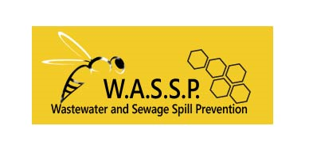

Wastewater and Sewage Spill Prevention

Consultants:

Haylea Elliff: Project Manager

Alexandra Thompson: Water Resource Specialist

Jasi Mitchell: GIS Analyst & Editor

Joseph Berenji: GIS Specialist

Justin Williams: GIS Analyst & Web Developer

**March 26th, 2018**

**Vulnerability Analysis and Visualization of Sewage Spills in Edwards Aquifer TCEQ Regions 11 and 13 from 2012 to 2017**

**Progress Report**

**Prepared for:** 

**Prepared by: Wastewater and Sewage Spill Prevention (W.A.S.S.P)**



**I**

**TABLE OF CONTENTS**

**1. INTRODUCTION**

1.1 Summary…………………………………….1

1.2 Purpose………………………….…………...1

1.3 Scope…………………………….…………..1

**2. TASKS**……………………………………………….1

2.1 Completed Work…………………..………………...1

2.2 Present Work………………………………..……….2

2.3 Projected Work………………….…….…..…………3

2.4 Findings in Data……………………..……….…..….3

**3. REVISED TIME TABLE**……………………………4

**4. PROBLEMS AND CONCERNS**…………………….4

4.1 Data Issues……………………………………5

4.2 Recommendations…………..………………..5

**6. PARTICIPATION**………………………………..…..5

**II**

**1. Introduction**

1.1 Summary

This report is dedicated to informing our client, Annalisa Peace of the Greater Edwards Aquifer Alliance (GEAA) of the completed and projected work for the project of “Vulnerability Analysis and Visualization of Sewage Spills in Edwards Aquifer TCEQ Regions 11 and 13 from 2012 to 2017.” The project is well underway, without any anticipated change in scope or expected outcomes. The timeline has changed slightly to provide more time cleaning data to project sewage spill and create the interactive story map.

1.2 Purpose

This project will update previous maps of sewage spills located in the Texas Commission on Environmental Quality (TCEQ) regions 11 and 13 in the Edwards Aquifer after 2012 until 2017. There will also be a vulnerability analysis conducted to represent the sensitive areas of the Edwards Aquifer. With our analyses we hope to provide an accurate visualization of the condition of the Edwards Aquifer and sewage spill over the last 5 years. The representation of this data can provide valuable information to environmental scientists, municipalities, the Edwards Aquifer Groundwater District, and the public to better protect the aquifer. The follow is the basic tasks to complete this project:

Task 01: Clean and geocode data.

Task 02: Project the spill data into ArcMap with appropriate layers.

Task 03: Development of DRASTIC model.

Task 04: Create an interactive story map with ArcGIS Online with spill map and attribute data.

1.3 Scope

The scope and study area of the project has remained consistent with the proposal of February 26, 2018. While there are many records to clean and document, we have divided the work between group members to cover each year and county completely.

**2. Tasks**

2.1 Work Completed

The acquisition of applicable layers for sewage spill data is complete, while acquisition for layers for the DRASTIC model are near complete. As of March 3, 2018, we have obtained the requested data from TCEQ that will allow us to update the previous spill maps of the Edwards Recharge Zone. We have completed approximately 1/4th of cleaning the data to be projected. The records have been sorted by priority counties and start dates of the incidents. Incident start dates have been selected to have consistency of when the spill happen, since some end dates carried on to the next year due to longer clean up procedures.

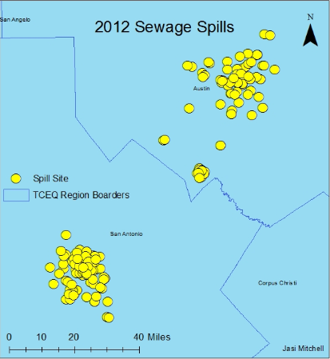

Fig.1. 2012 map of geocoded and projected sewage spills.

Regarding our efforts to model groundwater pollution potential, being able to work with associated data foreach of the hydrogeologic settings has granted us a much deeper understanding of how these various parts of the environment work together so intricately and harmoniously. Because our method determines relative pollution potential and not absolute, the bulk of our time and effort has been, and will be dedicated to the development of an effective and accurate system to group similar features into categories. For qualitative data, lithological descriptions of vertical well cross sections, we have devised a scale for porosity and permeability ranging from 1-10 based on associated rock and soil types reported such as clay, shale, limestone etc. For our quantitative data, we will analyze the statistical distribution of our data, specifically the range of distribution, from which we will apply a best fit model with which will be classified through equal interval means, thus standardizing our various datasets.

2.2 Present Work

Currently, we are cleaning and geocoding all the data by editing the records for typos and consistency and inserting latitude and longitude coordinates. We have deleted the entities of ___ to better produce a public friendly interactive story map, since we will be using the attribute table as the incident descriptions. The deleted fields, while not useful to general public information will still be available in the metadata of this project. There has also been the elimination of some information due to containing the names supervisions and persons recording the incidents, we feel it would be a violation of privacy to keep this information that would be displayed to the public. We will also be condensing the fields for incident description, action, and comments due to duplicate information. After the data is cleaned and coordinates are accompanying each record we can easily create points on a map for each spill location, like that of figure 1. The data layers for the DRASTIC model are being gathered and separated to provide and easier manipulation of various statistics. Then, surfaces will be interpolated and analyzed to provide for visualization of the sensitive areas of the Edwards Aquifer.

2.3 Projected Work

The final month of the project is dedicated to finish cleaning the data, creating the spill maps for each year, and finishing the analysis of vulnerable areas with the DRASTIC method. The interactive story map will be created via ArcGIS Online with the spill maps and their attribute tables. The final step of the project will be to create a professional poster.

2.4 Findings in Data

The initial expectations of data quality were poor, however after receiving the data and sorting there is somewhat more information concerning spill amount and comments than expected. Within the excel spreadsheet data there was a total of 3093 records, with 2662 applicable to the counties for our scope. Approximately 0.016% of the records did not record spill amount or were less than 1 gallon, or 51 records, with the majority (21) of those records recorded by Bexar county. Figure 2 displays a pie chart to visually represent the amount of records received for each county over the 5-year period. We received 102 pages of miscellaneous data in PDF format. The pages are scanned documents of various forms such as, Water Quality Non-Compliance Notifications, Sanitary Sewer Overflow notifications, Texas Oil or Hazardous substance discharge reports, and handwritten journal notes. These pages were poorly documented and hard to use, mostly useless for the project due to quality issues.

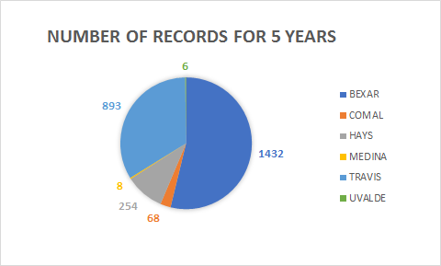

Fig.2 Chart of number of records received for all 5 years.

**3. Revised Time Table**

There are few changes made to the previous timetable. Extra time has been added to cleaning and sorting the data and creating the story map. We have shrunk the composition of the writing the final report to a week to focus more on creating the interactive story map and other applicable maps.

Table 1. Revised Timeline

|  |  |
| --- | --- |
| **Week 1** | **RFB Receival and Initial Project Concepts** |
| **Week 2 & 3** | Data Acquisition |
| **Week 4 & 5** | Proposal |
| **Feb 21** | Proposal Presentation rehearsal |
| **Feb 26** | Proposal Presentation, 2nd client meeting |
| **Week 6 & 7 & 9** | Data cleaning and projection & Vulnerability Analysis |
| **Week 10** | Progress Presentation, 3rd client meeting |
| **March 26th** | Progress Report |
| **Week 11 & 13 & 14** | Final data analysis & Story Map |
| **Week 15** | Final Report and Completion |
| **April 25** | Final Report Presentation Rehearsal |
| **April 30** | Final Presentation |

**4. Problems and concerns**

4.1 Data Issues

There is not consistency between regions and years of the corresponding entities for the records. For example, the Source_Name entity of 2017 Travis county contained the address of incident compared to Bexar county that contained a description. There are relative locations such as “400 Ft. South East of Cullen Blvd in Buda,” that are not accurate for locations or some records did not contain location at all. There are also multiple entries for some spill events for the same addresses within the same week, however it is not specified whether it is different incidents or different locations. We have had difficulty projecting the spills due to the addresses recorded, so we have chosen to project them with latitude and longitude coordinates, yet this is very time consuming. There are some concerns with access and this discontinuity of dataset and layers for the vulnerability analysis using the DRASTIC method. The most applicable data for this portion of the project is governmental, which is difficult or not able to access, however there are some open source information that can be substituted with less accurate details.

4.2 Recommendations

* Have incidents recorded with a GPS Unit to create waypoints.
* Delineation of all sewage lines throughout the service area which include depths of pipes to record depths of spills for records and remediation.
* Diligent when recording gallons, incidents, and clean up. For example, 43 records contained end date as year 3000 or were recorded as “Act of God.”
* Use a standard spill event category system with provided parameters to create consistency in records and remediation.

**5. Conclusion**

There has been progress made in cleaning the data, preparing for sewage spill projections, and collecting information for the DRASTIC model of the vulnerability analysis. There are some changes in the timeline to provide more time for cleaning the data and creating the interactive story map. We are currently on track for completion of the project on time without changing scope or any major tasks of the project.

**6. Participation**

Haylea Elliff: Project Manager: Introduction, Tasks, Revised Timetable, Conclusion

Alexandra Thompson: Water Resource Specialist: Data Issues and Recommendations

Jasi Mitchell: GIS Analyst & Editor. Tasks: Data Issues

Joseph Berenji: GIS Specialist: Present Work, Projected Work

Justin Williams: GIS Analyst & Web Developer