

Geo-Technical Consultants LLC

For

City of San Marcos Planning and Development Services

Temporal Analysis of Occupancy Characteristics and Land to Improvement Ratio of Heritage Neighborhoods

Wyatt Ellison

Hunter Harrison

James Corson

Spencer Cardwell

Filing Date: February 25, 2018

Table of Contents

1.  Introduction 1

1.1 Summary 1

1.2 Purpose 1

1.3 Scope 2

Figure 1 2

2.   Literature Review 3

3. Dataset 4

Table 1 4

4.Methodology 5

4.1 Overview 5

4.2 Preprocessing 5

4.3 Statistical Analysis 5

4.4 Visualizing the Data 6

Figure 2 7

5. Implications 7

6.Budget 8

Table 2 8

7.Timetable 9

8. Final Deliverables 11

9. Conclusion 11

10. References 13

I

# 1.  Introduction

## 1.1 Summary

                San Marcos, Texas is a city experiencing massive growth. From April of 2010 to July 2016 the population swelled from approximately 45,145 to 61,980 people; a whopping 37.3 % increase.[1] Amid rapid development, locals are stirred to preserve the structural and aesthetic integrity of the city’s historic Heritage neighborhoods.

Over the course of this project we aim to process 10 years of data from the Hays County Central Appraisal District to create a map visually describing susceptibility to change within our study area.

## 1.2 Purpose

                Map products and statistical evidence delineating susceptibility to change would be an effective aid to the city’s Planning and Development Services in their efforts to better tailor San Marcos’ Land Development Code to the public’s design. To this end, PIGS will analyze occupancy trends and improvement to land ratio of residential properties within the Heritage neighborhoods over the last decade, identifying at-risk historic areas in need of safeguard, and areas where development should be encouraged.

1

## 1.3 Scope

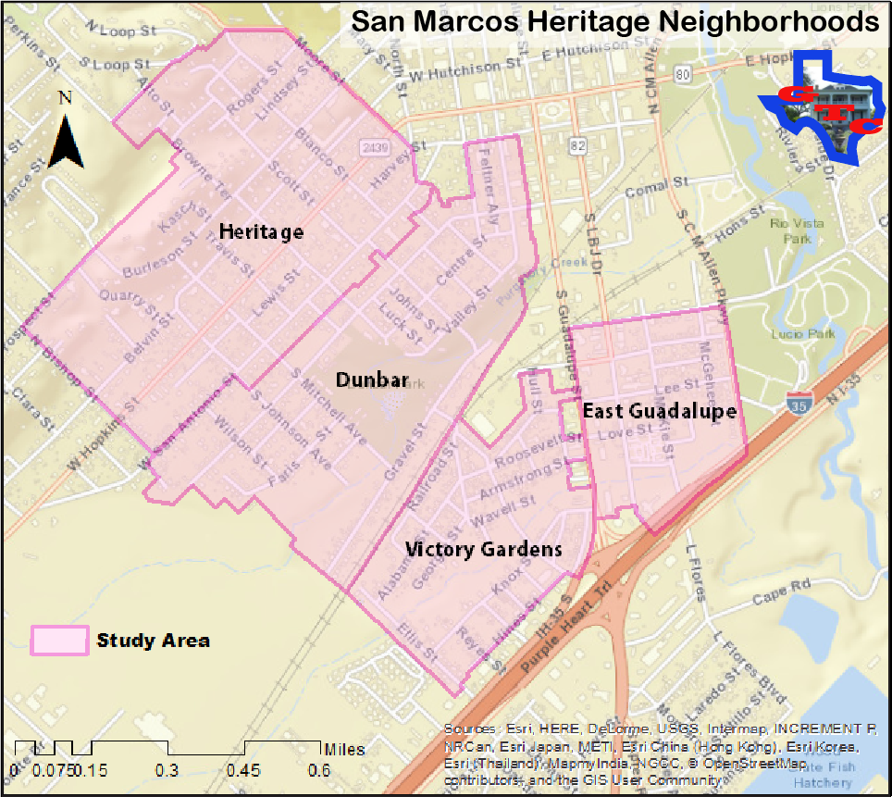

### Figure 1

                The data we are working with spans the ten-year period between 2007 to 2017. We will process and analyze each year's data individually, then perform statistical analyses and create story maps to present any findings regarding temporal trends and/or patterns.

Our area of primary interest is within the boundaries of four historic San Marcos neighborhoods: Dunbar, East Guadalupe, Heritage, and Victory Gardens.[Fig. 1] While we expect to restrict our processing and analysis to parcel data that fall inside of these neighborhoods, we may broaden the extent of our study area to include adjacent neighborhoods if we find that we have ample time and resources.

2

# 2.   Literature Review

For the purposes of this study, we focus on historic neighborhoods in the San Marcos, Texas area and their susceptibility to change. In particular, we aim to provide statistical data from temporal analysis and land to improvement ratios (LIR) of San Marcos’ historic neighborhoods. In conjunction with the city of San Marcos planning and development services, we hope to provide a basis, rooted in quantitative analysis, for the construction of future city development codes.

A responsible land development code is crucial for preserving cities desired characteristics and culture. The implication of a GIS system by urban planners can greatly improve the accuracy and comprehensiveness of a land development plan. In fact, urban planners are some of the most common appliers of GIS systems.[2] Applying GIS data and analysis to urban planners' decision making allows for a systematized management of land-use decisions based on maps that is easily viewed by all parties in the permitting process. [3]

The city of San Marcos has undergone tremendous growth throughout the last decade, consistently ranking as one of the United States fastest growing small cities. However, with this increase in population comes a myriad of previously unseen problems. Gentrification, for the purpose of our study, is defined as an influx of middle-class residents and capital flows into downtown districts of urban centers.[4] Gentrification has the potential to displace historic residents of an area by raising property taxes to a point no longer affordable by the traditional residents of that area. The causes and effects of gentrification are a highly debated topic in both political and scholarly arenas. Population growth, economic growth, infrastructure improvements and a demand for urban housing have all been linked to possible causes of gentrification.[5] While some researchers view gentrification as a potential remedy for decades old problems of declining urban areas, a happy medium must be reached to protect our vulnerable urban populations.[6] With our study, we intend to identify areas that are at the most risk of gentrification so that we may protect San Marcos’ heritage neighborhoods.

To accomplish this, we will employ a series of GIS based analysis. We know from previous studies that current prices, price changes, public regulation, competition from other forms of residence, demographic of the population, socioeconomic status and congestion are all factors that play into a change in homeownership over time.[7] Along with occupancy characteristics, a LIR study will also be employed. However, outside of calculating depreciation of real estate for accounting purposes, the scholarly research on LIR studies over time is extremely limited. We look forward to this exciting opportunity to study what we feel is a widely under-researched and under-valued factor in the identification of areas susceptible to gentrification. Through our research, we aim to provide city officials, not only in San Marcos, but also around the world with a better way of identifying and responsibly controlling re-development of our historic urban areas.

3

# 3. Dataset

The core Data to be used for this project will consist of land parcel and ownership information provided by the Hays County Appraisal District. The data covers the years between 2007 and 2017 and will be processed largely using Microsoft Excel. GIS data provided by the City of San Marcos will be used in conjunction with the parcel data to create maps of our results in ArcMap. The Hays County Appraisal District Tabular Data is missing data from the years 2008 and 2010, so data from the end of year 2007 and beginning of 2011 will be used instead.

Table 1

4

|  |  |  |  |  |
| --- | --- | --- | --- | --- |
| **Entity** | **Attributes** | **Spatial Object** | **Status** | **Source** |
| **San Marcos GIS Shapefiles** | Land parcels, Neighborhoods, Buildings, Zoning | Polygons | Available | City of San Marcos |
| **Hays County Appraisal District Tabular Data** | Address of land plots, Address of owner, Total market value | Excel Worksheets | Available | Hays County Appraisal District |

# 4. Methodology

## 4.1 Overview

            For the temporal analysis of owner occupancy and land to improvement ratios (LIR) in the Heritage Neighborhood Area of San Marcos, we will focus on a ten-year period between 2007 and 2017. The result will be a feature class listing owner occupancy and land to improvement ratios for all parcels within the Heritage Neighborhood Areas; as well as maps to illustrate trends in occupancy and LIR while also displaying the susceptibility to development of each section of the Heritage Neighborhoods. Through our research, we wish to pinpoint areas of the Heritage Neighborhoods that possess changing occupancy and increasing LIR values and are therefore more susceptible to development. Our process is illustrated in figure 1.

## 4.2 Preprocessing

            We will begin by preprocessing the data. This will involve using Microsoft Excel in combination with the join function on ArcMap to sort the Hays County Parcel data down to entries which cover only the parcels within the Heritage Neighborhoods. Using GIS data for the City of San Marcos as a base, we will create new shapefiles to display the boundary of the Heritage Neighborhoods Area and each land parcel contained within.

## 4.3 Statistical Analysis

Owner occupancy can be determined by examining the hays county appraisal district data to observe whether or not the owner of a given property lives in that property. Once we have determined the number of owners who live at their properties, we can turn that number into a percentage by dividing absent owners from present owners and multiplying by 100. We will find the percentage of owner occupancy for each year between 2007 and 2017 and compare the change in occupancy over the years using a linear regression.

5

The land to improvement ratios for each parcel of property can be determined by dividing the total market value of improvements by the total land market value, which can be found in the hays county appraisal district data. When multiplied by 100 this value gives the percentage to which the land has gained in value. Using a Python script to automate part of the calculation process could be a useful tool considering the large number of parcels to evaluate. Increasing land values will indicate that the parcel has high susceptibility to development. We will calculate the Land to Improvement ratio for each parcel of land and compare how the value of each parcel has changed between 2007 and 2017.

## 4.4 Visualizing the Data

            Once owner occupancy and land to improvement ratios have been calculated for each parcel we will begin visualizing the data using Maps and Graphs. Using Microsoft excel we can create regression graphs to chart the change in each variable over time. Next, we will create a feature class in ArcMap listing the owner occupancy and LIR for all parcels in each year. Using this feature class in combination with shapefiles for the parcels within the Heritage Neighborhoods we can create maps to visualize our data spatially. Finally, we will create an online story map which will display the data year by year to show how patterns have developed into what they are today.

6

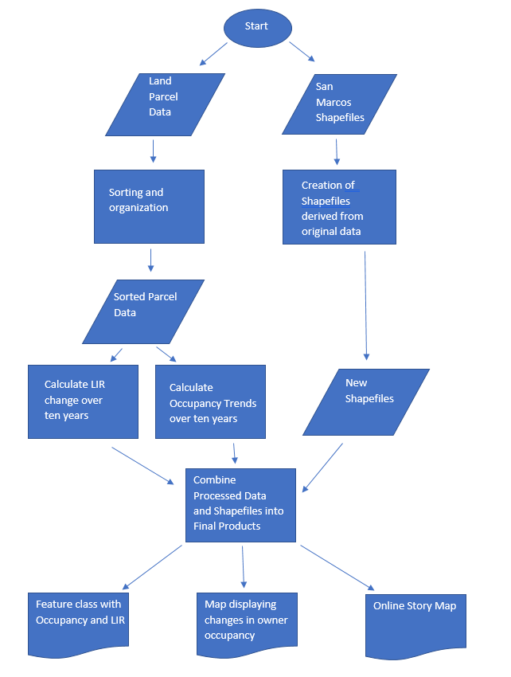

### Figure 2

# 5. Implications

            This research will be useful for planning responsible future development within each Heritage Neighborhood. The information we provide will help the City of San Marcos pinpoint the regions where development should take place, with the goal of diversifying housing options for citizens and students while maintaining the property values and unique characteristics of the Heritage Neighborhoods. Additionally, the products of our research can be used to inform current and future residents about the availability of housing and the potential for development in the Heritage Neighborhoods.

7

# 6. Budget

Table 2

Data Preprocessing

|  |  |  |
| --- | --- | --- |
| **Number of Consultants** | **4** |  |
| **Hourly Pay** | $20.00 |  |
| **Time Frame (weeks)** | 2 |  |
| **Weekly Hours Per Consultant** | 15 |  |
| **Overall Cost** |  | $2,400.00 |

Data Analysis

|  |  |  |
| --- | --- | --- |
| **Number of Consultants** | **4** |  |
| **Hourly Pay** | $20.00 |  |
| **Time Frame (weeks)** | 6 |  |
| **Weekly Hours Per Consultant** | 15 |  |
| **Overall Cost** |  | $7,200.00 |

Licensing Fees

|  |  |  |
| --- | --- | --- |
| **Software** | **Total time used (weeks)** | **Time Cost** |
| **ArcMap (advanced membership)** | 16 | $1,846.00 |
| **Microsoft Office (5 user License)** | 16 | $40.00 |
|  |  |  |
| **Total Cost** |  | $1,886.00 |

Web-Map

8

|  |  |  |
| --- | --- | --- |
| **Number of Consultants** | **4** |  |
| **Hourly Pay** | $20.00 |  |
| **Time Frame (weeks)** | 3 |  |
| **Weekly Hours Per Consultant** | 15 |  |
| **Overall Cost** |  | $3,600.00 |

Final Report

|  |  |  |
| --- | --- | --- |
| **Number of Consultants** | **4** |  |
| **Hourly Pay** | $20.00 |  |
| **Time Frame (weeks)** | 5 |  |
| **Weekly Hours Per Consultant** | 15 |  |
| **Overall Cost** |  | $6000.00 |

Totals

|  |  |
| --- | --- |
| **Total Time (weeks)** | **16** |
| **Total Costs** | $21,086.00 |

# 7. Timetable

**Data preprocessing:** Two weeks

During this time, we will thoroughly review the data given by the client.

Key components: familiarize, organize obtain the appropriate software for the data if needed.

**Start**: Wednesday, January 17, 2018

**Completion:** Wednesday, January 31, 2018

**Data Analysis:** Six weeks

9

Throughout this period, we will be working on the task the client has given us. There will be 2 progress reports given during this time.

Key components:  Determine and conduct appropriate spatial, temporal, and statistical analyses.

**Start**: Thursday, February 1, 2018

**Completion:** Thursday, March 15, 2018

**Web-Map Design:** Three weeks

Designing and creating the requested online story map.

Key components: Place the data in an orderly fashion to show a timeline story map.

**Start:** Friday, March 16, 2018

**Completion:** Friday, April 6, 2018

**Final Report:** Five weeks

Compile a report with all the data gathered from the Analysis.

Key Components: Disclose findings & provide explanation and discussion of deliverables.

**Start:** Wednesday, April 4, 2018

**Completion:** Wednesday, May 9, 2018

10

# 8. Final Deliverables

            Our final deliverables will include a feature class containing data for owner occupancy and land to improvement ratio for all parcels in the Heritage Neighborhoods area, a map showing areas where owner occupancy has significantly changed and an online story map to display the results of our analysis. As well as a final report, professional poster and CD containing all our data and final products.

Deliverables:

* Final Report
* Professional Poster
* CD containing
* All data
* Metadata
* Final Report
* Poster
* PowerPoint Presentation
* Instructions for use
* Occupancy and LIR feature class
* Map of Occupancy change
* Online Story Map

# 

# 9. Conclusion

Geo-Technical Consultants LLC wants to provide the city of San Marcos' planning and development services with hard data products describing the spatial distribution of susceptibility to change within the city's historic neighborhood district, and to provide metrics by which we may interpret the degree of said susceptibility. We will do this by processing raw ownership, land market value, and improvement market value data from each year of the last decade. By unmasking temporal trends within our data, we hope to glean a working understanding of what development patterns we can expect to see within our study area to aid our client in suggesting methods for curbing that development in a manner that will not hinder growth, but will preserve the nostalgic qualities of these neighborhoods.

11

12

# 10. References

[1] U.S. Census Bureau.  *United States Census Bureau, QuickFacts: San Marcos city, Texas.* <https://www.census.gov/quickfacts/fact/table/sanmarcoscitytexas/PST045217> (last accessed 24 February 2018).

[2] Yeh, A G-O. 1996. Urban Planning and GIS. *GISteac.*

[3] Kohasha, Hiroyuki. 2000. Applications of GIS to Urban Planning and Management: Problems Facing Japanese Local Governments. *GeoJournal.*

[4] Zukin, Sharon. 1987. Gentrification: Culture and Capital in the Urban Core. *Annual Review of Sociology.*

[5] Bhatta, B. 2010. Analysis of Urban Growth and Sprawl from Remote Sensing Data. *Advances in Geographic Information Sciences.*

[6] Fouch, Nakisha. 2012. A Geographic Analysis of Gentrification Susceptibility in the City of Asheville, N.C. *Tiger Prints, Clemson University.*

[7] Lauridsen, Jorgen, Nannerup, Niels, Skak, Morten. 2009. A Spatio-Temporal Analysis of Home Ownership. *Journal of Housing Research.*

13