Scott Christensen, Project Manager
Brad Dillashaw, Assistant Project Manager
Sam Ortega, GIS Specialist
Kelly McGauhey, GIS Analyst
Jacqueline Carrillo, GIS Technician

Proposal:
Construction of Geodatabase with Analysis of
New Braunfels’ Drainage System

Prepared by GenIuS, Inc.

February 22, 2012

Table of Contents

Introduction 1
Summary: 1
Purpose: 2
Scope 3
Proposal 4
Data 4
Methodology 4
Implications 6
Budget 7
Timeline 7
Final Deliverables 8
Conclusion 8
Participation 9
Appendices 10
Appendix A: Scope Map 10
Appendix B: Budget 11
Appendix C: Timeline 13

Introduction

Summary:
New Braunfels is a growing city. Between 2000 and 2010, New Braunfels grew by 14.6 square miles and 21,246 residents. As the city expands, it endeavors to ensure that its infrastructure keeps pace with its expanding needs. This has been particularly important in the case of drainage infrastructure; areas of New Braunfels have experienced problems with flooding, including the 1998 and 2002 floods of the area along Broadway and the 2009 flooding which left the Gruene Crossing neighborhood marooned with all exits blocked by waters. This problem is compounded by a dispersed filing system of drainage records as well as by existing problems with drainage infrastructure and records from recently-annexed areas to New Braunfels.
New Braunfels is not the only city to have grappled with issues surrounding drainage infrastructure and drainage record management techniques. The City of Houston, Texas, the City of Springfield, Missouri, and the County of Franklin, Ohio are among several local governments that have turned to Geographic Information Systems (GIS) to help them manage, maintain, and make decisions regarding their local drainage infrastructure. These local governments have all made successful use of geodatabases in managing records in a centralized manner, demonstrating at-risk areas, and making sound financial decisions regarding infrastructure repairs and upgrades. Thus, in order to support the growth and health of the City of New Braunfels, a geodatabase that inventories drainage and right-of-way structures and their conditions is needed.

Purpose:
The purpose of this proposal is to detail the benefits, methodology, and costs involved in the creation of a drainage geodatabase for the City of New Braunfels. The geodatabase will be designed to relate to existing databases as needed and to record and maintain drainage information in a centralized, streamlined manner that will allow for data clarity and decision making. The collection of pilot data will be used to test the functionality and design of the geodatabase to ensure that it will work according to current and future Public Works professional needs and standards. After this project, the City of New Braunfels Public Works Department will be able to easily maintain and grow this database according to their changing needs.

Scope
The geographic extent of this project will be 5 blocks down W. San Antonio St. at the intersections with S. Castell Ave, N. Hill Ave, S. Academy Ave, Clemens Ave, and S. Guenther Ave. For a more visual idea of our selected area please refer to our map on Appendix A. This geographic scope will be the primary area for data collection of drainage and right-of-way infrastructure information, which we will conduct within the area of these block segments. The selection was made after reviewing your RFP carefully, conducting a walk-through of the area of focus, and great deliberation; Genius Inc. Staff felt confident in our selected geographic scope area. The selected area is a reasonable size for our time-frame; it includes blocks of commercial and residential streets, and appears to have moderate traffic flow. All three aspects stand important during our estimated time of data collection.
In addition, we have also reviewed and will carefully consider a Secondary Scope if necessary and the time permits. If Genius Inc. can carry out the task, we will request a meeting at that time so that a secondary geographic area can be added to the project scope at the discretion of the project team and will be defined with input from the clients.

Proposal

Data
The data needed to complete the New Braunfels Public Works Drainage project will include multiple shapefiles and a Digital Elevation Model, which will be provided by the client in order to preserve data conventions required by the New Braunfels Department of Public Works. Aerial imagery, including Pictometry, will also be made available by the client if the project requires use of them.

Data Sources
New Braunfels centerline shapefile – Client supplied
New Braunfels city limit shapefile – Client supplied
New Braunfels parcels shapefile – Client supplied
Digital Elevation Model (need more info) – Client supplied
2009 Pictometry of New Braunfels (as needed) – Client supplied
Street rating database – Client supplied

Software Requirements
ESRI ArcGIS 10 (ArcMap, ArcCatalog)
Adobe Dreamweaver CS5.5
Microsoft Office 2010 (Word, Excel, Powerpoint, Access)

Methodology
Database Design
To meet the GIS needs of New Braunfels Public Works, our first priority with this project is to create a preliminary structure for the geodatabase in ArcGIS as well as a data input form of the drainage infrastructure for New Braunfels.
The basic framework in ArcGIS will include relevant information on several drainage and right-of-way infrastructure features, including, but not limited to: sidewalks, crosswalks, curbs, ditches, gutters, and storm drains. Desired data on key characteristics of each feature-- such as sidewalks’ width, curb attachment, and Americans with Disabilities Act compliance-- will be recorded as unique attributes associated with the features within the database. We will create drop-down menus and fields for data entry in order to record data in a uniform method according to the specific needs of the New Braunfels Public Works Department. A notes field will also be included for technicians to record specific information about features that does not match to any strict dropdown or attribute options.
Some attributes will be added to the database and input form but will not be populated in the collection of pilot data in this project. Such examples include the build date or conditions of given features. If the client wishes, they may collect this data to be used along with pilot data we will be collecting in order to test for the functionality of the geodatabase.
. The features’ geographic locations will be recorded using both State Plane South Central Texas coordinates, commonly used by predominate government organizations, as well as a relationship to the street centerline database currently in use by the city of New Braunfels.
Once we have created a preliminary file geodatabase structure and database input form, we will arrange to meet with representatives from the New Braunfels Public Works Department to review the geodatabase design and feature and attribute data we plan to collect; we will incorporate appropriate and necessary changes as recommended through such a meeting into the geodatabase design.

Data Collection
Once we have finalized the preliminary database structure design, we will begin with the data collection. Most of the data collection will come from field work using GPS and other instruments to collect specific attribute data. The first day of field work we will meet with engineers and GPS technicians from New Braunfels Public Works in the field to go over data collection methods in order to ensure quality and consistency of the data. We will go over each feature class listed in the geodatabase and all corresponding attributes to verify the format is acceptable for data collection as well as implementation and analysis. We will explore other data collection options presented by using aerial photography and pictometry image analysis through evaluation of their efficiency and accuracy.
We will meet engineers and GPS technicians from New Braunfels Public Works during the data collection and database population periods of the project to determine if we will have time to expand past the primary geographic scope of this project. Throughout the project we will maintain a website to keep our clients informed on the progress of this project as well as to share any finalized documents we have created for the project.

Implications
The geodatabase that we will create will help the City of New Braunfels in several ways. Most importantly, it will allow the Department of Public Works to better assess what drainage and right-of-way infrastructure must be built to keep pace new city growth. It will also make clear what old infrastructure needs to be repaired to accommodate the city’s growing population In short, this geodatabase will allow New Braunfels to strategically plan their future in an efficient and streamlined manner.

Budget
The total cost of the project is $ 21,297.00. This total includes hourly pay rates for each task, pay rate for managers, equipment costs, software costs, and costs for travel expenses. The total hours required for this project is 420 labor hours. Management will require 80 man hours for system management. Equipment costs covers supplies, maintenance of hardware, and the depreciation of the hardware while it is in exclusive use for this project. Software expenses include the cost of licensing for ESRI software that will be in exclusive use for this project as well as the purchase of software packages that will be needed to complete this project and develop all deliverables. Travel expenses only include the mileage from our office in San Marcos, Texas to the public works department office in New Braunfels, Texas. For a table detailing all budgeted expenses, please refer to Appendix B.

Timeline
The conduction of the project will last ten weeks, with one additional week for the presentation of the project, for a total of eleven weeks. The project will begin during the week of 20 February – 24 February 2012 and will end the last full week of April, 23 April – 27 April 2012. During this time there will be three mandatory dates that we will need to meet with representatives from New Braunfels Department of Public Works: 22 February will be the project proposal, 2 April will be a mandatory meeting with the client to present our progress of the project, and 4 May will be the presentation of the project to the client.
The project is broken down into two main parts. The first part, design of the geodatabase and Access database will last for four weeks (weeks 1 – 4). The second part, data collection and population of the database will take five weeks (weeks 5 – 9). The last week will be designated for finalization and the preparation of deliverables. For a complete timeline please refer to Appendix C.

Final Deliverables
At the completion of the project, we will provide the following:
- File geodatabase
- Detailed final report
- Poster depicting relevant project details
- Website detailing project progress
- CD containing:
- All Related/Used Data
- Metadata
- Final Report
- Poster of End Results
- PowerPoint Presentation
- Instructions for CD- Readme file

Conclusion
The result of the project will be the creation of a geodatabase containing information about a number of drainage and right-of-way infrastructure features, including sidewalks, curbs, gutters, ditches, crosswalks, and inlets. The geodatabase can be used by the City of New Braunfels Public Works Department to identify future drainage issues, as well as giving the city an efficient way to keep records associated with drainage. The city will also have the opportunity to expand and continue development of the database to meet their evolving needs as their city grows.

Participation
Cover Page Jacqueline Carrillo
Table of Contents Kelly McGauhey
Summary Kelly McGauhey
Purpose Kelly McGauhey
Scope Jacqueline Carrillo
Data Samuel Ortega
Methodology Scott Christensen
Implications Scott Christensen
Budget Bradly Dillashaw
Timetable Bradly Dillashaw
Deliverables Jacqueline Carrillo
Conclusion Samuel Ortega
Participation Samuel Ortega
Logo Design Jacqueline Carrillo
Proposal Compilation, Editing, and Formatting Kelly McGauhey

Appendices

Appendix A: Scope Map
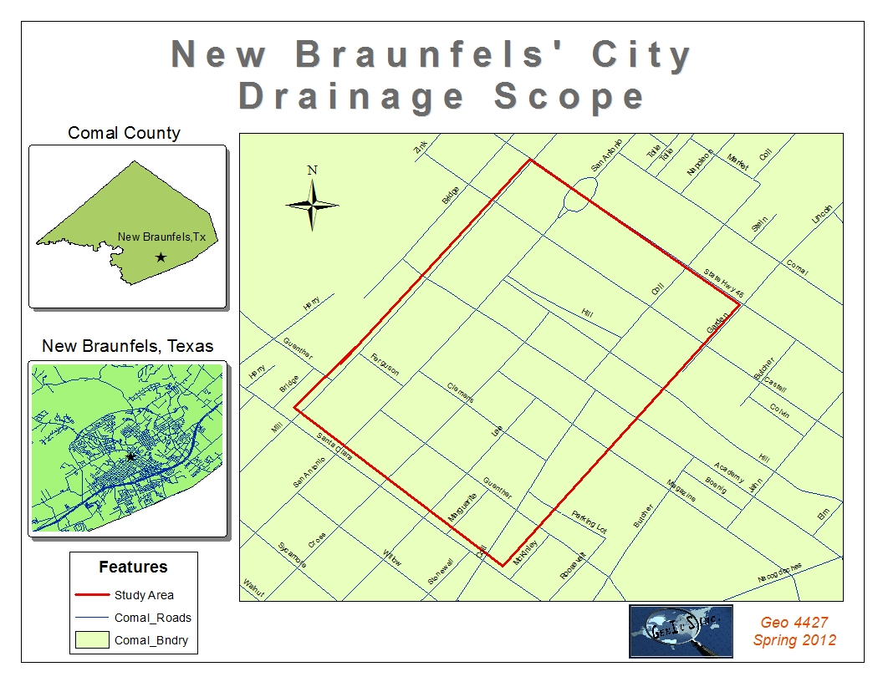

Appendix B: Budget
BUDGET
TASK | DESCRIPTION | HOURS | COST ($) | TOTAL COST ($)
Design Geodatabase & Access Database
 | Total Hours: [(10 hours/week * 4 weeks * 3 consultants) + (5 hours/week * 4 weeks * 1 consultant) + ( 7 hours/week * 4 weeks * 1 consultant)] | 168
 | Hourly Pay |  | 25
 | TOTAL COST: (Total Hours * Hourly Pay) |  |  | 4200
Data Collection
 | Total Hours: [(5 hours/week * 4 weeks * 3 consultants) + (2.5 hours/week * 5 weeks * 1 consultant) + (3.5 hours/week * 5 weeks * 1 consultant) + (5 hours/week * 1 week * 2 consultants)] | 100
 | Hourly Pay |  | 20
 | TOTAL COST: (Total Hours * Hourly Pay) |  |  | 2000
Analyze Pictometry & Aerial Photography
 | Total Hours: [(5 hours/week * 1 week * 2 consultants)] | 10
 | Hourly Pay |  | 25
 | TOTAL COST: (Total Hours * Hourly Pay) |  |  | 250
Populate Geodatabase
 | Total Hours: [(5 hours/week * 4 weeks * 3 consultants) + (2.5 hours/week * 5 weeks * 1 consultant) + (3.5 hours/week * 5 weeks * 1 consultant) +(5 hours/week * 1 week * 2 consultant] | 100
 | Hourly Pay |  | 25
 | TOTAL COST: (Total Hours * Hourly Pay) |  |  | 2500
Finalize & Prepare Deliverables
 | Total Hours: [(10 hours/week * 1 week * 3 consultants) + (5 hours/week * 1 week * 1 consultant) + (7 hours/week * 1 week * 1 consultant)] | 42
 | Hourly Pay |  | 20
 | TOTAL COST: (Total Hours * Hourly Pay) |  |  | 840
System Management
 | Project Manager
 | Total Hours: (5 hours/week * 10 weeks * 1 Project Manager) | 50
 | Hourly Pay |  | 50
 | Total: (Total Hours * Hourly Pay) |  | 2500
 | Assistant Project Manager
 | Total Hours: (3 hours/week * 10 weeks * 1 Assistant Project Manager) | 30
 | Hourly Pay |  | 40
 | Total: (Total Hours * Hourly Pay) |  | 1200
 | TOTAL COST: (Project Manager Total + Assistant Project Manager Total) |  |  | 3700
Equipment Cost
 | Supplies ($150/workstation * 5 workstations) |  | 750
 | Maintenance ($200/workstation * 5 workstations) |  | 1000
 | Depreciation [(($9000 [value of computers]/36 equipment life in months) + ($450 [value of GPS units ($150/unit * 3 units)]/36 equipment life in months)) * 2.5 (months equipment will be in exclusive use for project)] |  | 656
 | TOTAL COAST: (Supplies + Maintenance + Depreciation) |  |  | 2406
Software Costs
 | ESRI License Fee ($25,000/12 months * 2.5 months) |  | 5208
 | Purchase of Adobe Dreamweaver CS5.5 |  | 119
 | TOTAL SOFTWARE COST: (Lincense Fee + Dreamweaver) |  |  | 5328
Travel Expenses
 | 29 Miles @ $0.50/mile * 5 trips (1/week during Data Collection) |  | 72.5
 | TOTAL TRAVEL EXPENSES |  |  | 73
TOTAL COSTS |  |  |  | 21297

Appendix C: Timeline
TIMELINE
TASKS | WEEKS
 | 1 | 2 | 3 | 4 | 5 | 6 | 7 | 8 | 9 | 10 | 11
 | 2/20 - 2/24 | 2/27 - 3/02 | 3/05 - 3/09 | 3/12 - 3/16 | 3/19 - 3/23 | 3/26 - 3/30 | 4/02 - 4/06 | 4/09 - 4/13 | 4/16 - 4/20 | 4/23 - 4/27 | 4/30 - 5/04
Project Proposal | 22-Feb
Data Collection
Analyze Pictomety & Aerial Photography
Progress Report |  |  |  |  |  |  | 2-Apr
Design Geodatabase & Access Database
Populate Geodatabase
Finalize and Prepare Deliverables
Project Presentation |  |  |  |  |  |  |  |  |  |  | 4-May

U.S. Census Bureau. American Factfinder. http://factfinder2.census.gov/ (accessed February 2012).
Gonzales, Eric. "Residents' Opposition becomes a Drain on County Flood Project." KENS 5 San Antonio. January 25, 2012. http://www.kens5.com/news/Local-Residents-become-a-drain-on-county-flood-projects-138088268.html (accessed February 2012). "Gruene Crossing Drainage Project Begins Today." KGNB New Braunfels, Texas. January 30, 2012. http://kgnb.am/news/gruene-crossing-drainage-project-begins-today (accessed February 2012).
ESRI. White Papers: GIS Library. http://www.esri.com/library/index.html (accessed February 2012).

