S.M.A.R.T.
Spatial Management of Aquatic Resources in Texas

John Daneri (Project Manager)
Jacob Powell (Assistant Project Manager)
Kathleen Callahan (GIS Analyst)
Leah Gibson (GIS Analyst)



Final Report For:
Water Resources Vulnerable to Expanding Urban Development in the Texas Hill Country

Prepared by S.M.A.R.T.

- Introduction
  - Introduction and Problem Statement ……………………………1
  - Scope ……………………………………………………....…….1
- Literature Review …………………………………………………….……..2
- Data ………………………………………………………………………….5
  - Soil Data Set …………………………………………………….5
  - Vegetation Data Set ……………………………………………..6
  - Slope Data Set…………………………….……………….…….7
  - Cave Density Data Set …………………………….…...………..7
  - Floodplain Data Set ……………………………………………..8
- Methodology ..………………………………………………………………8
  - Groundwater Vulnerability …………………………………..…8
  - Surface Water Vulnerability…………………….………………9
  - Equal Weight Model ………………………………………...…9
  - Weighted Model ……………………………………………….10
  - Sensitivity Analysis ……………………………………………11
- Results ……..………………………………………………………………11
- Discussion ………………………..……………………………………......12
- Conclusion …...……………………………………………………………15
- References………………………………………………………………....16
- Figures …………………………………………………………………….17
- Maps ………………………………………………………………………23
Appendix I (Metadata)………………………………………………………...29
Appendix II (Contribution of each team member)...…………………...……...89
  - Introduction and Problem Statement
The Texas Hill Country is facing exponential growth during a time when preserving natural resources is critical. The increasing number of developments in the region poses an immediate risk to water resources in an area with unique geographic features. In order for the Hill Country to grow in a responsible and sustainable manner, it is necessary to identify and preserve the areas that are most sensitive to development and other land use changes. The Hill Country Alliance (HCA) is a non-profit organization committed to raising public awareness on the delicate nature of natural resources in the Texas Hill Country. The HCA works cooperatively with landowners, ranchers, developers, conservationists, and elected officials to preserve water quality, water supply, and natural beauty in the seventeen county Hill Country area.
The HCA hired S.M.A.R.T. to identify areas where groundwater and surface water are the most sensitive to development using Geographic Information Systems. The use of GIS allows the various hydro-geologic and geographic criteria to be analyzed and spatially correlated in a way that would be difficult using traditional paper maps. Each criterion evaluated for this study was analyzed for relative vulnerability and then combined to produce static maps and interactive web maps that identify the most vulnerable areas. The vulnerability maps produced will serve as a valuable tool for citizens, landowners, planners, developers, and public officials to aid them in making more informed decisions when deciding where new developments should be located.
1.2 Scope
The study’s geographic extent includes seventeen counties located in Central Texas: Mason, Llano, Burnet, Kimble, Gillespie, Blanco, Travis, Hays, Comal, Kendall, Kerr, Real, Edwards, Uvalde, Bandera, Medina, and Bexar.

2. Literature Review
Research in mapping groundwater vulnerability with GIS has been conducted for many years and has been improved upon since the EPA developed the DRASTIC model for groundwater vulnerability mapping in 1987. DRASTIC is an acronym for the categories examined using the model. It uses a subjective point rating system based on the professional judgment of the original developers (Aller et al. 1987).
D – Depth to water – 5
R – Net Recharge - 4
A – Aquifer Media - 3
S – Soil Media - 2
T – Topography - 1
I – Impact of vadose zone media - 5
C – Hydraulic Conductivity of the aquifer - 3
One study (Rupert. 2001) improved on the DRASTIC model by calibrating the point rating scheme to measure nitrite plus nitrate as nitrogen concentrations in ground water. In this study, 3 of the 7 original DRASTIC factors believed to be the most important were used: Depth to groundwater, Net recharge, and soil media. Land use data was used as a surrogate for net recharge. The study showed that “the effectiveness of vulnerability maps could be improved by calibrating the point ratings on the basis of the results of statistical correlations between groundwater quality and hydrogeologic and anthropogenic variables” (Rupert. 2001). Although our study did not include these calibrations, it was useful to know what parts of the DRASTIC model were considered to be the most important in the study. The use of land use data to determine net recharge is applicable to our study because we used land cover data in much the same way. Our study did not include data about contaminant concentrations, but it would be an interesting way to further increase the accuracy of a vulnerability assessment in the future.
Another study (Yıldırım and Topkaya. 2007) conducted in Antalya, Turkey evaluated four different methods, including the DRASTIC model, for analyzing groundwater vulnerability. The other models used were SINTACS, PI, and COP. The goal of this study was to assess the intrinsic vulnerability of groundwater resources which are in karst limestone formations. The DRASTIC model was computed through multiplication of rating values assigned to each factor by its relative weight and then adding the seven products. The SINTACS model used is basically the same as DRASTIC except that effective filtration is substituted for the net recharge factor used in the DRASTIC model, and the weights vary significantly according to the hydrogeologic conditions of the study area. The PI method developed specifically for karst areas is based on the product of two factors: Protective cover, and Infiltration conditions. The protective cover data included topsoil, subsoil, lithology, and fracture properties. The Infiltration data included conductivity, swallow holes, sinking streams, and vegetation properties. The COP model was calculated by multiplying three factors: Concentration of flows, Overlying layers, and Precipitation. The results of the study showed that the SINTACS model worked better than the DRASTIC model for the specific study area, and the COP method worked the best overall. It is suggested that a study area be divided into sections and then different methods be used for each region based on its geological characteristics. Future studies for our study area should compare the effectiveness of the different methods described in this article.
In yet another study (Atkinson and Thomlinson. 1994) the DRASTIC model and GIS was used to map groundwater vulnerability for the entire state of Texas. The document states that groundwater is one of the most important natural resources in Texas and their goal is to indicate where the most susceptible and least susceptible areas are located. Another goal of the study was to generate a database for each of the seven criteria that are analyzed using the DRASTIC model that could be updated as better data becomes available. As in the other studies, the DRASTIC map was created by multiplying each one of the factors analyzed by its relative weight and then summing the products to produce the DRASTIC Pollution Potential Index (DPPI). Two separate maps were created and two weighting schemes were employed, one for industrial and municipal pollutants, and one for agricultural pollutants. For the industrial and municipal model, depth to water and impact of the vadose zone were found to be the most important factors, and topography was the least important. For the agricultural pesticides model, soil media and topography were considered to be the most important, and impact of the vadose zone and hydraulic conductivity were considered the least important. The results of both models determined that the potential for pollution from agricultural pesticides was greater than pollution from industrial and municipal sources. Although this research is somewhat dated, it is useful because the scope of the study covers the same area we are focused on, and our results can be directly compared to the results of this analysis.
3. Data
The investigation into surface water and groundwater vulnerability used soil thickness, soil hydraulic conductivity (KSAT), vegetation, and slope data as criteria to put into a GIS analysis covering the Hill Country region. The groundwater vulnerability investigation used an additional cave density data set in its GIS analysis. In addition to the previously mentioned data, there was an overlay of all recorded floodplains within the scope, which were used as reference for both static maps. All data used was secondary data, no original data was created for this project.
3.1 Soil Data Set
The soil data set was provided by the HCA and covers the entire study area with the exception of Mason County for which soil data is not available. The data was originally obtained from soil surveys available on the SSURGO soil survey database website. The data includes information that we utilized on soil thickness and soil hydraulic conductivity (KSAT).
The soil thickness information is important in determining groundwater vulnerability because the thickness of the soil determines how much filtration occurs as water percolates through the ground. For surface water vulnerability, soil thickness is important because it determines the amount of water that can be absorbed by the soil before running off into drainage areas. The data was originally in vector format and was converted to a raster grid based on depth values in order for the data to be comparable to other data layers. Before raster conversion was performed, we created a new field for depth values in the attribute table. The original attribute for soil depth was expressed as a range from zero to the maximum soil depth. The new depth field created was composed of a single value expressing the maximum soil depth. Additionally, fields with no data originally contained a double hyphen, and those fields were changed to “NoData.” The new soil depth raster was then converted to vulnerability values in which thin soils were considered most vulnerable and thick soil were least vulnerable (Figure 3).
The soil hydraulic conductivity (KSAT) was used to determine how easily water flows through the soil. This data was originally in vector format and was converted to a raster grid based on KSAT value. Prior to conversion, a new field containing KSAT values was created and values originally consisting of two hyphens to represent missing data were changed to “NoData”. The KSAT raster created was then converted into two vulnerability rasters, one for surface water and one for groundwater. For groundwater vulnerability, the highest KSAT values were considered most vulnerable, and the lowest values least vulnerable. For surface water, the lowest KSAT values were considered most vulnerable, and the highest KSAT values least vulnerable (Figure 3).

3.2 Vegetation Data Set
For determining vulnerability it is necessary to know the amount of ground cover vegetation throughout the study area, because it determines how much water will runoff, and how much will be impeded by vegetative cover. Data originally provided by the HCA contained LANDSAT satellite data for vegetation that did not cover the entire study area, so we obtained a more complete dataset from the USGS seamless data distribution server. The different types of vegetation provided in the data were analyzed and scored for vulnerability based on how much of each category consisted of ground cover. Tree canopy, for example, was not considered a fully vegetated area because it usually indicates a lack of ground cover vegetation. Once all categories of vegetation were examined, we consulted with our client to determine final vegetation categories and scores for vulnerability (Figure 4).
3.3 Slope Data Set
The slope data, provided by the HCA, consisted of a single raster expressing the percent rise of slope across the study region. The original data was obtained as a digital elevation model from the USGS. Slope is an important component in the analysis of groundwater and surface water vulnerability because the steeper the slope, the more likely water is to run off into creeks and streams. For this analysis steep slopes were considered most vulnerable for both groundwater and surface water, and a new raster was created for slope in which the steepest slopes had the highest vulnerability scores (Figure 3).
3.4 Cave Density Data Set
The cave density data illustrates the concentration of caves as they exist within a one square kilometer area throughout the study region. This is the coarsest layer, at one square kilometer resolution, and establishes the precision of the overall analysis. The cave data was provided by the HCA and was originally obtained from the Texas Speleological Society. Cave density data is important in calculating groundwater vulnerability because it indicates locations where recharge of an aquifer is occurring with little or no filtration. The dataset was in vector format and was converted to a raster grid based on number of caves per each square kilometer cell. The cave raster was then converted to vulnerability scores in which areas with the highest concentration of caves were considered to be the most vulnerable (Figure 3).

3.5 Floodplain Data Set
The floodplain data highlights areas where development is at an increased risk for flooding during times of high water, based on adjacency to water bodies and flat slopes. These records were not used as a criterion in the actual GIS analysis, but are displayed on the maps for reference. The data was provided by the HCA and was originally obtained from FEMA. The floodplain data set was lacking records for Kimble, Gillespie, and Mason counties, as well as parts of Blanco County.
- Methodology
The analysis was performed by determining vulnerability for each data layer being evaluated and combining the results using GIS. In order to facilitate the flow of operations being performed with the data, a cartographic model was developed to visually represent the entire process (Figure 5). In addition to providing a visual representation, the cartographic model provided a template that could be easily modified when refining the analysis. Two models were used to calculate the results, one in which all criteria were considered equally important, and one in which some criteria were weighed more heavily than others. A sensitivity analysis comparing both models was then conducted to test the robustness of the results.
4.1 Groundwater Vulnerability
To determine groundwater vulnerability, we evaluated soil thickness, soil hydraulic conductivity (KSAT), slope, ground cover vegetation, and cave density. For Mason County, only slope, ground cover vegetation, and cave density were used because no soil data was available. Each item was analyzed for vulnerability criteria and assigned a value from 0 to 100; 0 indicating least vulnerable, and 100 indicating most vulnerable areas. For the soil data, areas with decreased soil thickness and increased soil KSAT values were considered to be the most vulnerable. For slope, areas of high relief were considered to be the most vulnerable, and flat areas or areas with a slight slope were considered least vulnerable. For ground cover vegetation, areas with no ground vegetation were classified as most vulnerable and areas with abundant ground vegetation were classified as least vulnerable. For cave density, areas with the highest density of caves per square kilometer were considered most vulnerable, and areas with no caves were considered least vulnerable.
4.2 Surface Water Vulnerability
To calculate surface water vulnerability we evaluated soil thickness, soil hydraulic conductivity (KSAT), slope, and ground cover vegetation. Mason County was evaluated using only slope and ground cover vegetation because no soil data was available. Each item was analyzed for vulnerability criteria and assigned a value from 0 to 100; 0 indicating least vulnerable, and 100 indicating most vulnerable areas. For the soil data, areas with thin soils and low values for soil KSAT were considered most vulnerable. For slope data, areas of high relief were considered most vulnerable, and flat areas or areas with a slight slope were considered least vulnerable. For ground cover vegetation, areas with abundant ground vegetation were classified as least vulnerable, and areas with no ground vegetation cover were classified as most vulnerable.
4.3 Equal Weight Model
For the equal weight calculation, the vulnerability of each layer was summed and then divided by the total number of layers. Dividing the sum by the number of layers normalizes the results to a common scale from 0 to 100, where 0 is the least vulnerable and 100 is the most vulnerable. The following formulas were used to perform the calculation:
Groundwater:
[(Soil Thickness) + (Soil KSAT) + (Slope) + (Vegetation) + (Cave Density)] / 5
Groundwater Mason County:
[(Slope) + (Vegetation) + (Cave Density)] / 3
Surface Water:
[(Soil Thickness) + (Soil KSAT) + (Slope) + (Vegetation)] / 4
Surface Water Mason County:
[(Slope) + (Vegetation)] / 2
4.4 Weighted Model
The weighted vulnerability calculation attributed a weight to each criterion being evaluated based on its perceived level of importance. The weight is used as a factor by which each vulnerability layer is multiplied when performing the analysis. A weight factor of (3) would indicate that the layer is considered to be three times as important as other layers being analyzed. The weight for each criterion was determined by the expert opinions of Dr. Richard A. Earl, and Dr. Laura Stroup of Texas State University. The following formulas were used to perform the calculation:
Groundwater:
[(Soil Thickness*3) + (Soil KSAT*3) + (Cave Density*3) + (Slope*1) + (Vegetation*1)] / 11
Groundwater Mason County:
[(Cave Density*3) + (Slope*1) + (Vegetation*1)] / 5
Surface Water:
[(Slope*3) + (Vegetation*3) + (Soil KSAT*2) + (Soil Thickness*1)] / 9
Surface Water Mason County:
[(Slope*3) + (Vegetation*3)] / 6
4.5 Sensitivity Analysis
To test the robustness of the results, we conducted a sensitivity analysis comparing the equal weight model and the weighted vulnerability model. We created an algorithm in which the equal weight model was subtracted from the results of the weighted model. The results were represented in a map expressing the amount of change in vulnerability. This change map provides both a visual and a quantitative representation of the difference between the two models. Positive values indicate areas where the vulnerability has increased from the equal weight model to the weighted model. Negative values indicate areas where vulnerability has decreased from the equal weight model to the weighted model.
- Results
Figure 1 and 2 display the distribution of the data in their respective categories; least vulnerability (0-23%), medium vulnerability (23%-40%), moderate vulnerability (40%-57%), and highest vulnerability (57%-100%). The range of values for each category was chosen to highlight the most vulnerable areas in all maps while making the maps comparable to one another. The change maps show the difference between the equal weight and the weighted vulnerability models and display where vulnerability has increased, decreased, or remained the same.
For the groundwater analysis, the results of the equal weighted model were more evenly distributed than the weighted one, with 27% of the data in the least vulnerable category, 39% for medium, 20% for moderate; and 14% in the highest category. The weighted model had 25% of the data within the least vulnerable range, 42% in the medium category, 28% in the moderate category, and 6% in the highest category. The weighted groundwater model produced 44% less vulnerability, 38% more vulnerability and 18% no change in values when compared to the equal weight model (Figure 1).
Both surface water maps showed more equal distribution, with the weighted model being the most evenly distributed out of all the maps. The equal weighted model displayed 14% of the results in the least vulnerable category, 22% in the medium range, 30% in the moderate, and 33% in the highest. The weighted model had 22% of the results at least vulnerable, 29% for medium, 22% for moderate, and 27% in the highest range. When compared to the equal weight model, the weighted model produced 52% less vulnerability, 29% more vulnerability, and 18% no change (Figure 2).
- Discussion
After completing a full analysis, we discovered that the bulk of locations most sensitive to development for surface and groundwater follow a general geographic trend from the northeast to the southwest of the study region. This trend follows areas of high relief in the Balcones Escarpment, along the Edwards and Trinity aquifers. The surface water maps contain more vulnerable areas than the groundwater maps, with the equal weighted model showing the greatest concentration of vulnerable areas. This difference is caused by the inclusion of the cave data in the groundwater maps. Caves only exist in 2% of the study area, which increases the vulnerability in 2% of the area, and decreases it in 98% of the area.
The sensitivity analysis tested the robustness of our findings by comparing the equal weight maps to the weighted maps. The groundwater maps changed more evenly than the surface water maps with only a 6% difference between the positive and negative change values. The surface water maps changed more unevenly with a 24% difference between positive and negative change values. Overall, both maps were equally robust with only 18% of the data remaining unchanged.
Although there is a great deal of variability between the surface water and groundwater results, the concentration of the most vulnerable and least vulnerable areas is fairly consistent. The maps could be useful in identifying general areas of concern, but they do not indicate precise locations. They can serve as a reference tool to show broad areas of increased vulnerability where large scale developments pose the greatest risk. Generally the results indicate what is already known: the Texas Hill Country is overall a highly sensitive area, and the continued development in any part of the region can have negative impacts on the environment.
While working on this project we were faced with some limitations. One of the first limitations was the coarseness of the cave data that we were provided with. The resolution of the cave data was in one kilometer cells, while the rest of the data was provided at thirty meter resolution. This was a precautionary measure by the providers of the cave data to avoid identifying their precise locations in an effort to protect the natural state of the caves. As a result, all of our maps are presented in one kilometer resolution.
Another limitation was the absence of soil data for Mason County, and the inconsistency of the soil data across county boundaries. There were problems with the soil data along the county lines of Edwards, Bandera, and Real counties. There is a drastic change in the soil depth information between these counties, and the counties bordering them. The difference in depth values are attributed to the soil surveys from which the data was collected. Edwards, Bandera, and Real counties share the same soil survey, which was conducted at a different time than the surrounding counties. Although this did not have a large impact on the outcome of the overall analysis, having more accurate soil depth data in these areas would provide more consistent vulnerability scores.
The accuracy of the ground cover vegetation data was another limiting factor of our analysis. The data originally provided by the HCA consisted of LANDSAT satellite data that included a detailed classification for vegetation. The data was incomplete and only covered about 80% of the study area. To overcome this, we obtained land cover data from the USGS seamless data distribution server which was available for the entire area. The data obtained from the USGS was more generalized than the original information that was provided in that it contained fewer classifications for vegetation. The lack of detail made it more challenging to accurately determine which land cover types consisted of ground cover vegetation.
There are many advantages of using GIS to map the vulnerability of surface water and groundwater in the Texas Hill Country. The greatest advantage of using a GIS is that it allowed us to provide a visual representation as well as a quantitative analysis of surface water and groundwater vulnerability. GIS also allowed us to conduct a sensitivity analysis to test the robustness of our results. In the analysis we were able to compare the weighted results to the equal weight results, which displayed the impact on the overall vulnerability of the study area. Without the use of GIS, it would only have been possible to make a visual comparison which would not have provided as much information.
Although we feel that we have delivered an excellent product, there are several improvements that could be made given more time. It would be possible to obtain more detailed land cover data to derive a more accurate representation of ground cover vegetation. We could also include more criteria that could improve the accuracy of our analysis, such as depth to groundwater data, and aquifer media. Improvements could be made to the criterion weighing process by obtaining the opinion of a greater variety of experts. This would allow for the creation of additional models that could be used for comparison. Our final deliverables could have been more detailed as well. Given more time, we could have included additional interactive maps on our website (such as the change maps). The final poster displaying our results could also have included the change maps as well as statistical tables and information.
- Conclusion
The groundwater and surface water vulnerability mapping project was a very useful learning experience for all members of the SMART team. It taught us the dynamics of working in a small group as well as the processes involved in multi-criteria analysis using GIS. It was also beneficial to gain the experience of working with a client on an extended project. In addition we all learned a great deal about the Texas Hill Country and the unique geographic and environmental aspects of the region.
We hope that the HCA will be able to use our product as a tool to influence responsible growth in the Hill Country. At the very least we have laid down the groundwork and identified the data that is necessary to conduct a more thorough analysis in the future. The HCA should continue to pursue their goals and we are proud to have made a positive contribution to the preservation of our unique environment.
- References
Aller, L., T. Bennett, JH Lehr, RJ Petty, and G. Hackett. "DRASTIC: A Standardized System for Evaluating Ground Water Pollution Potential using Hydrogeologic Settings. US Environmental Protection Agency EPA." Washington, DC 455 (1987)
Atkinson, S. F., and J. R. Thomlinson. "AN EXAMINATION OF GROUND WATER POLLUTION POTENTIAL THROUGH GIS MODELING." (1994): 71.
Malczewski, J. GIS and Multicriteria Decision Analysis. Wiley, 1999.
Rupert, M. G. "Calibration of the DRASTIC Ground Water Vulnerability Mapping Method." Ground Water 39, no. 4 (Jul-Aug 2001): 625-630. PMID: 11447862.
Yıldırım, Mustafa, and Bülent Topkaya. "Groundwater Protection: A Comparative Study of Four Vulnerability Mapping Methods." CLEAN: Soil, Air, Water 35, no. 6 (12 2007): 594-600.

Figure 1
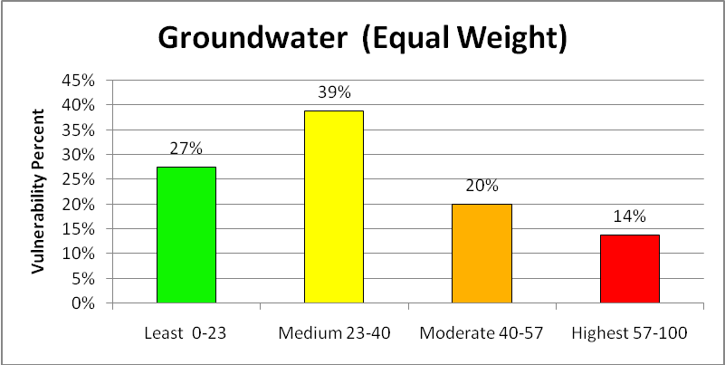
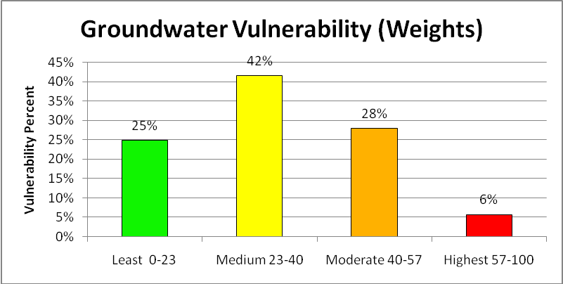
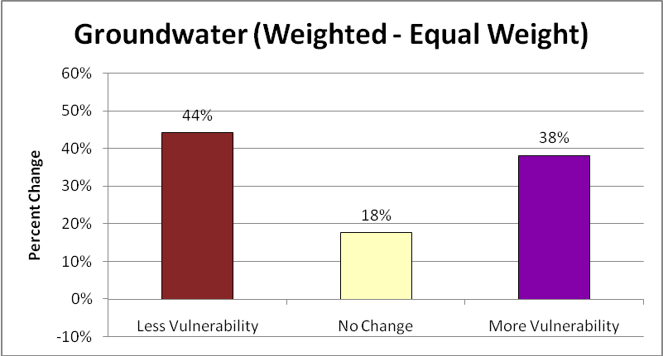
Figure 2
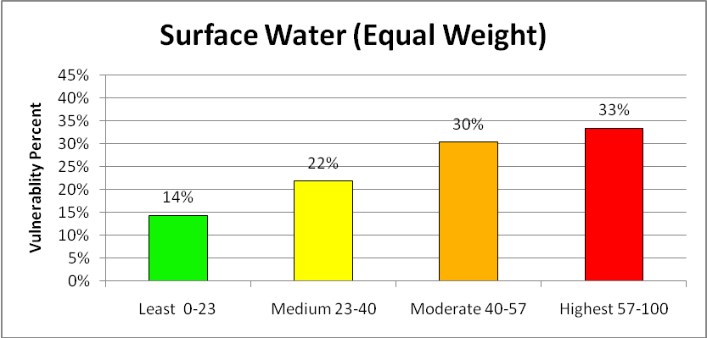
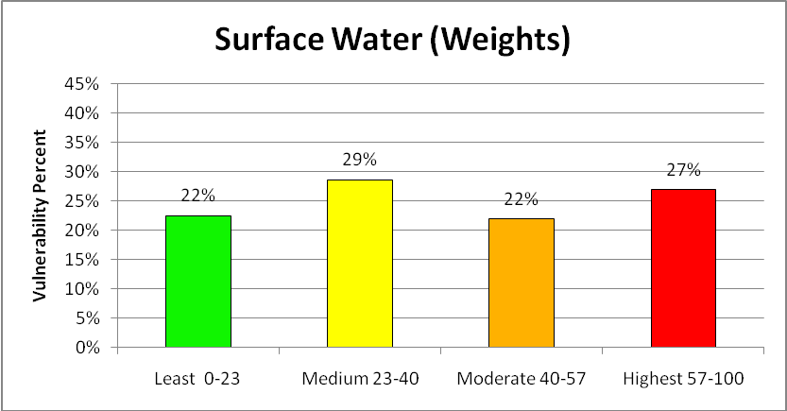
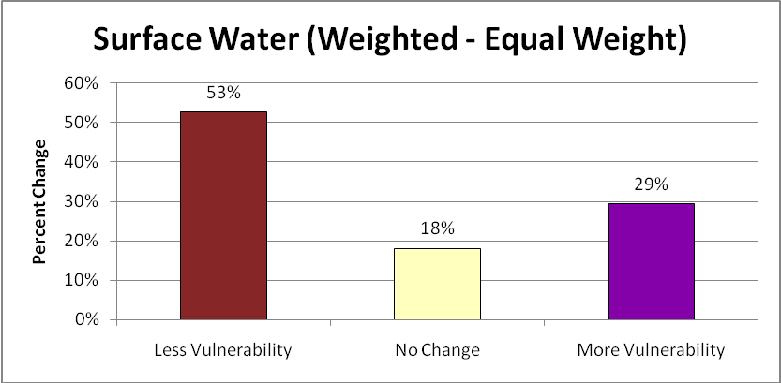
Figure 3
Least Vulnerable=0 Most Vulnerable=1
Slope Range (Percent Rise) | % of area in data range | Vulnerability Score
0 – 2.3 | 25% | 0
2.4 – 4.7 | 26% | .33
4.8 – 9.4 | 25% | .66
9.4 – 210 | 24% | 1

Cave Density per | % of area in data range | Vulnerability Score
0* | n/a* | 0
1 | 60% | .33
2 – 3 | 25% | .66
4 – 51 | 15% | 1
*98% of the total study area for this layer has no caves and is not covered by the cave data; areas with no caves will be given a vulnerability score of 0. The percentage of area within each data range for this table represents the percent of area within each range that does have caves and is covered by the cave data.
Soil Depth* | % of area in data range | Vulnerability Score
15 – 80 | 20% | 0
9 – 15 | 25% | .33
6 – 9 | 28% | .66
3 – 6 | 27% | 1
*The data provided does not specify units for soil depth
Soil KSAT* (Groundwater) | % of area in data range | Vulnerability Score
.42, 1.4 | 10% | 0
4 | 46% | .33
14 | 35% | .66
42, 141 | 9% | 1
*The data for soil KSAT provided consists of 6 discrete values (.42, 1.4, 4, 14, 42, 141), grouping the first 2 values and the last 2 values gives the best distribution of data within each range.
Soil KSAT (Surface Water) | % of area in data range | Vulnerability Score
42, 141 | 9% | 0
14 | 35% | .33
4 | 46% | .66
.42, 1.4 | 10% | 1

Figure 4
The table below gives the description of the types of land cover in the USGS Land Cover dataset that we are using to determine ground vegetation. Areas that have no ground vegetation will be classified as most vulnerable (100) and areas with ground vegetation will be classified as least vulnerable (0). If an area has 50% ground vegetation (such as low intensity development), then it will be given a partial score and classified as 50% vulnerable or (50).
Code | Description | % of  total area | Least Vulnerable=0 Most Vulnerable=100
11 | Open Water - All areas of open water, generally with less than 25% cover or vegetation or soil | 0.77% | 100
21 | Developed, Open Space - Includes areas with a mixture of some constructed materials, but mostly vegetation in the form of lawn grasses. Impervious surfaces account for less than 20 percent of total cover. These areas most commonly include large-lot single-family housing units, parks, golf courses, and vegetation planted in developed settings for recreation, erosion control, or aesthetic purposes | 2.73% | 20
22 | Developed, Low Intensity -Includes areas with a mixture of constructed materials and vegetation. Impervious surfaces account for 20-49 percent of total cover. These areas most commonly include single-family housing units. | 1.47% | 50
23 | Developed, Medium Intensity - Includes areas with a mixture of constructed materials and vegetation. Impervious surfaces account for 50-79 percent of the total cover. These areas most commonly include single-family housing units | 0.75% | 80
24 | Developed, High Intensity - Includes highly developed areas where people reside or work in high numbers. Examples include apartment complexes, row houses and commercial/industrial. Impervious surfaces account for 80 to100 percent of the total cover. | 0.40% | 100
31 | Barren Land (Rock/Sand/Clay) - Barren areas of bedrock, desert pavement, scarps, talus, slides, volcanic material, glacial debris, sand dunes, strip mines, gravel pits and other accumulations of earthen material. Generally, vegetation accounts for less than 15% of total cover. | 0.01% | 100
41 | Deciduous Forest - Areas dominated by trees generally greater than 5 meters tall, and greater than 20% of total vegetation cover. More than 75 percent of the tree species shed foliage simultaneously in response to seasonal change. | 6.55% | 100
42 | Evergreen Forest - Areas dominated by trees generally greater than 5 meters tall, and greater than 20% of total vegetation cover. More than 75 percent of the tree species maintain their leaves all year. Canopy is never without green foliage. | 21.08% | 100
43 | Mixed Forest - Areas dominated by trees generally greater than 5 meters tall, and greater than 20% of total vegetation cover. Neither deciduous nor evergreen species are greater than 75 percent of total tree cover. | 0.01% | 100
52 | Shrub/Scrub - Areas dominated by shrubs; less than 5 meters tall with shrub canopy typically greater than 20% of total vegetation. This class includes true shrubs, young trees in an early successional stage or trees stunted from environmental conditions. | 50.73% | 0
71 | Grassland/Herbaceous - Areas dominated by grammanoid or herbaceous vegetation, generally greater than 80% of total vegetation. These areas are not subject to intensive management such as tilling, but can be utilized for grazing. | 11.01% | 0
81 | Pasture/Hay - Areas of grasses, legumes, or grass-legume mixtures planted for livestock grazing or the production of seed or hay crops, typically on a perennial cycle. Pasture/hay vegetation accounts for greater than 20 percent of total vegetation. | 1.42% | 0
82 | Cultivated Crops - Areas used for the production of annual crops, such as corn, soybeans, vegetables, tobacco, and cotton, and also perennial woody crops such as orchards and vineyards. Crop vegetation accounts for greater than 20 percent of total vegetation. This class also includes all land being actively tilled. | 2.45% | 0
90 | Woody Wetlands - Areas where forest or shrub land vegetation accounts for greater than 20 percent of vegetative cover and the soil or substrate is periodically saturated with or covered with water. | 0.44% | 0
95 | Emergent Herbaceous Wetlands - Areas where perennial herbaceous vegetation accounts for greater than 80 percent of vegetative cover and the soil or substrate is periodically saturated with or covered with water. | 0.01% | 0

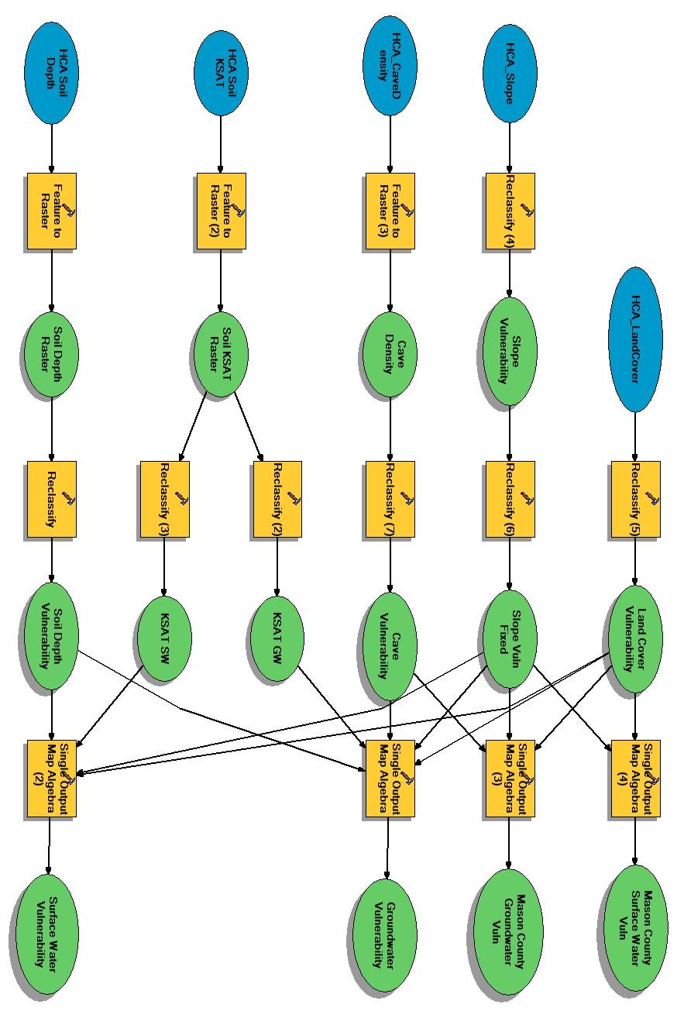
Figure 5

Maps

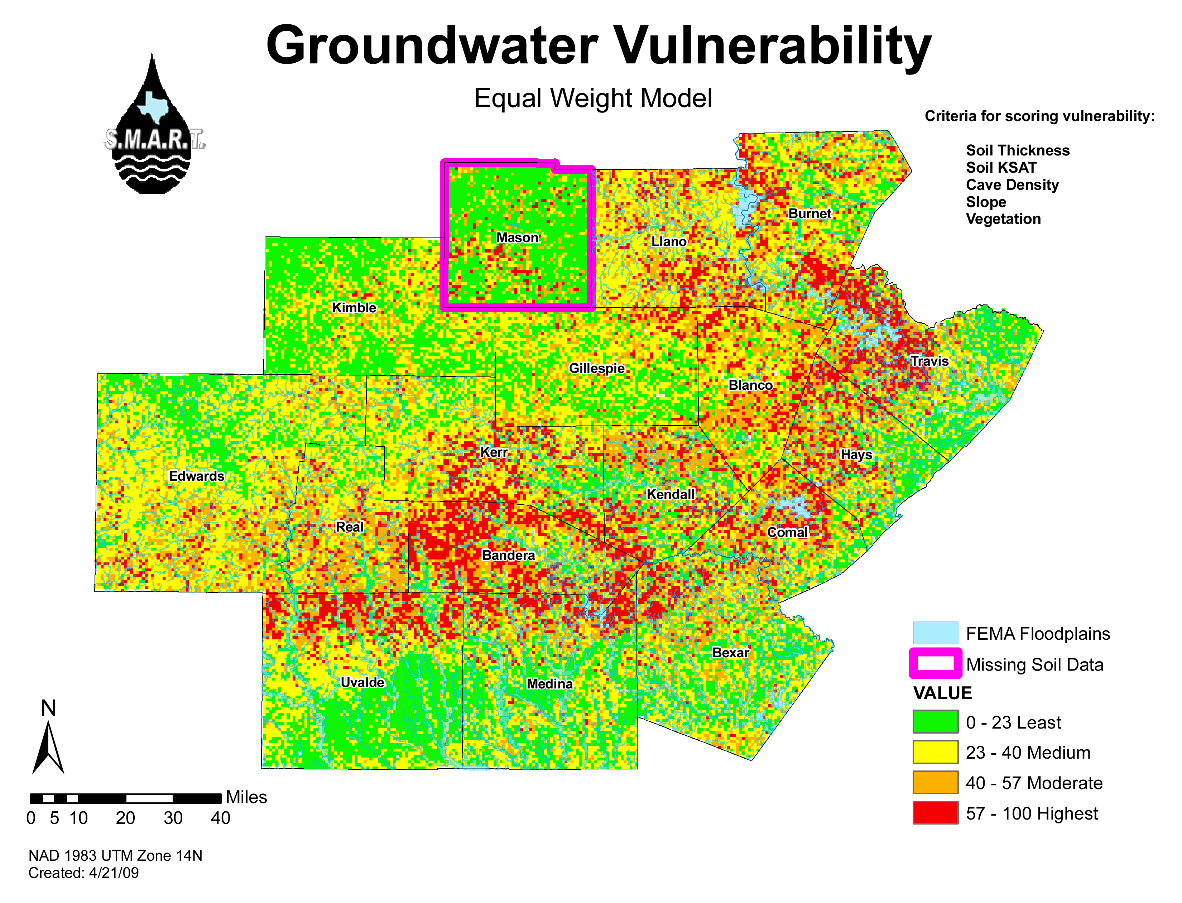

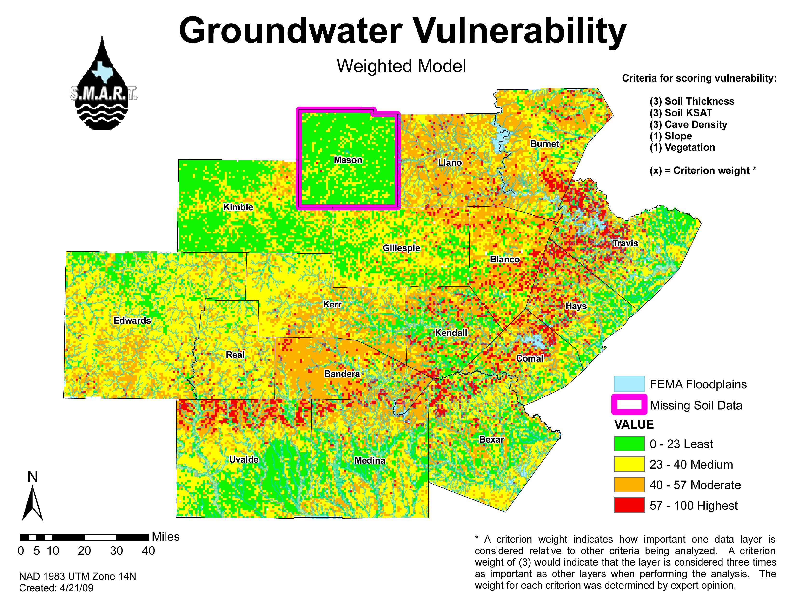

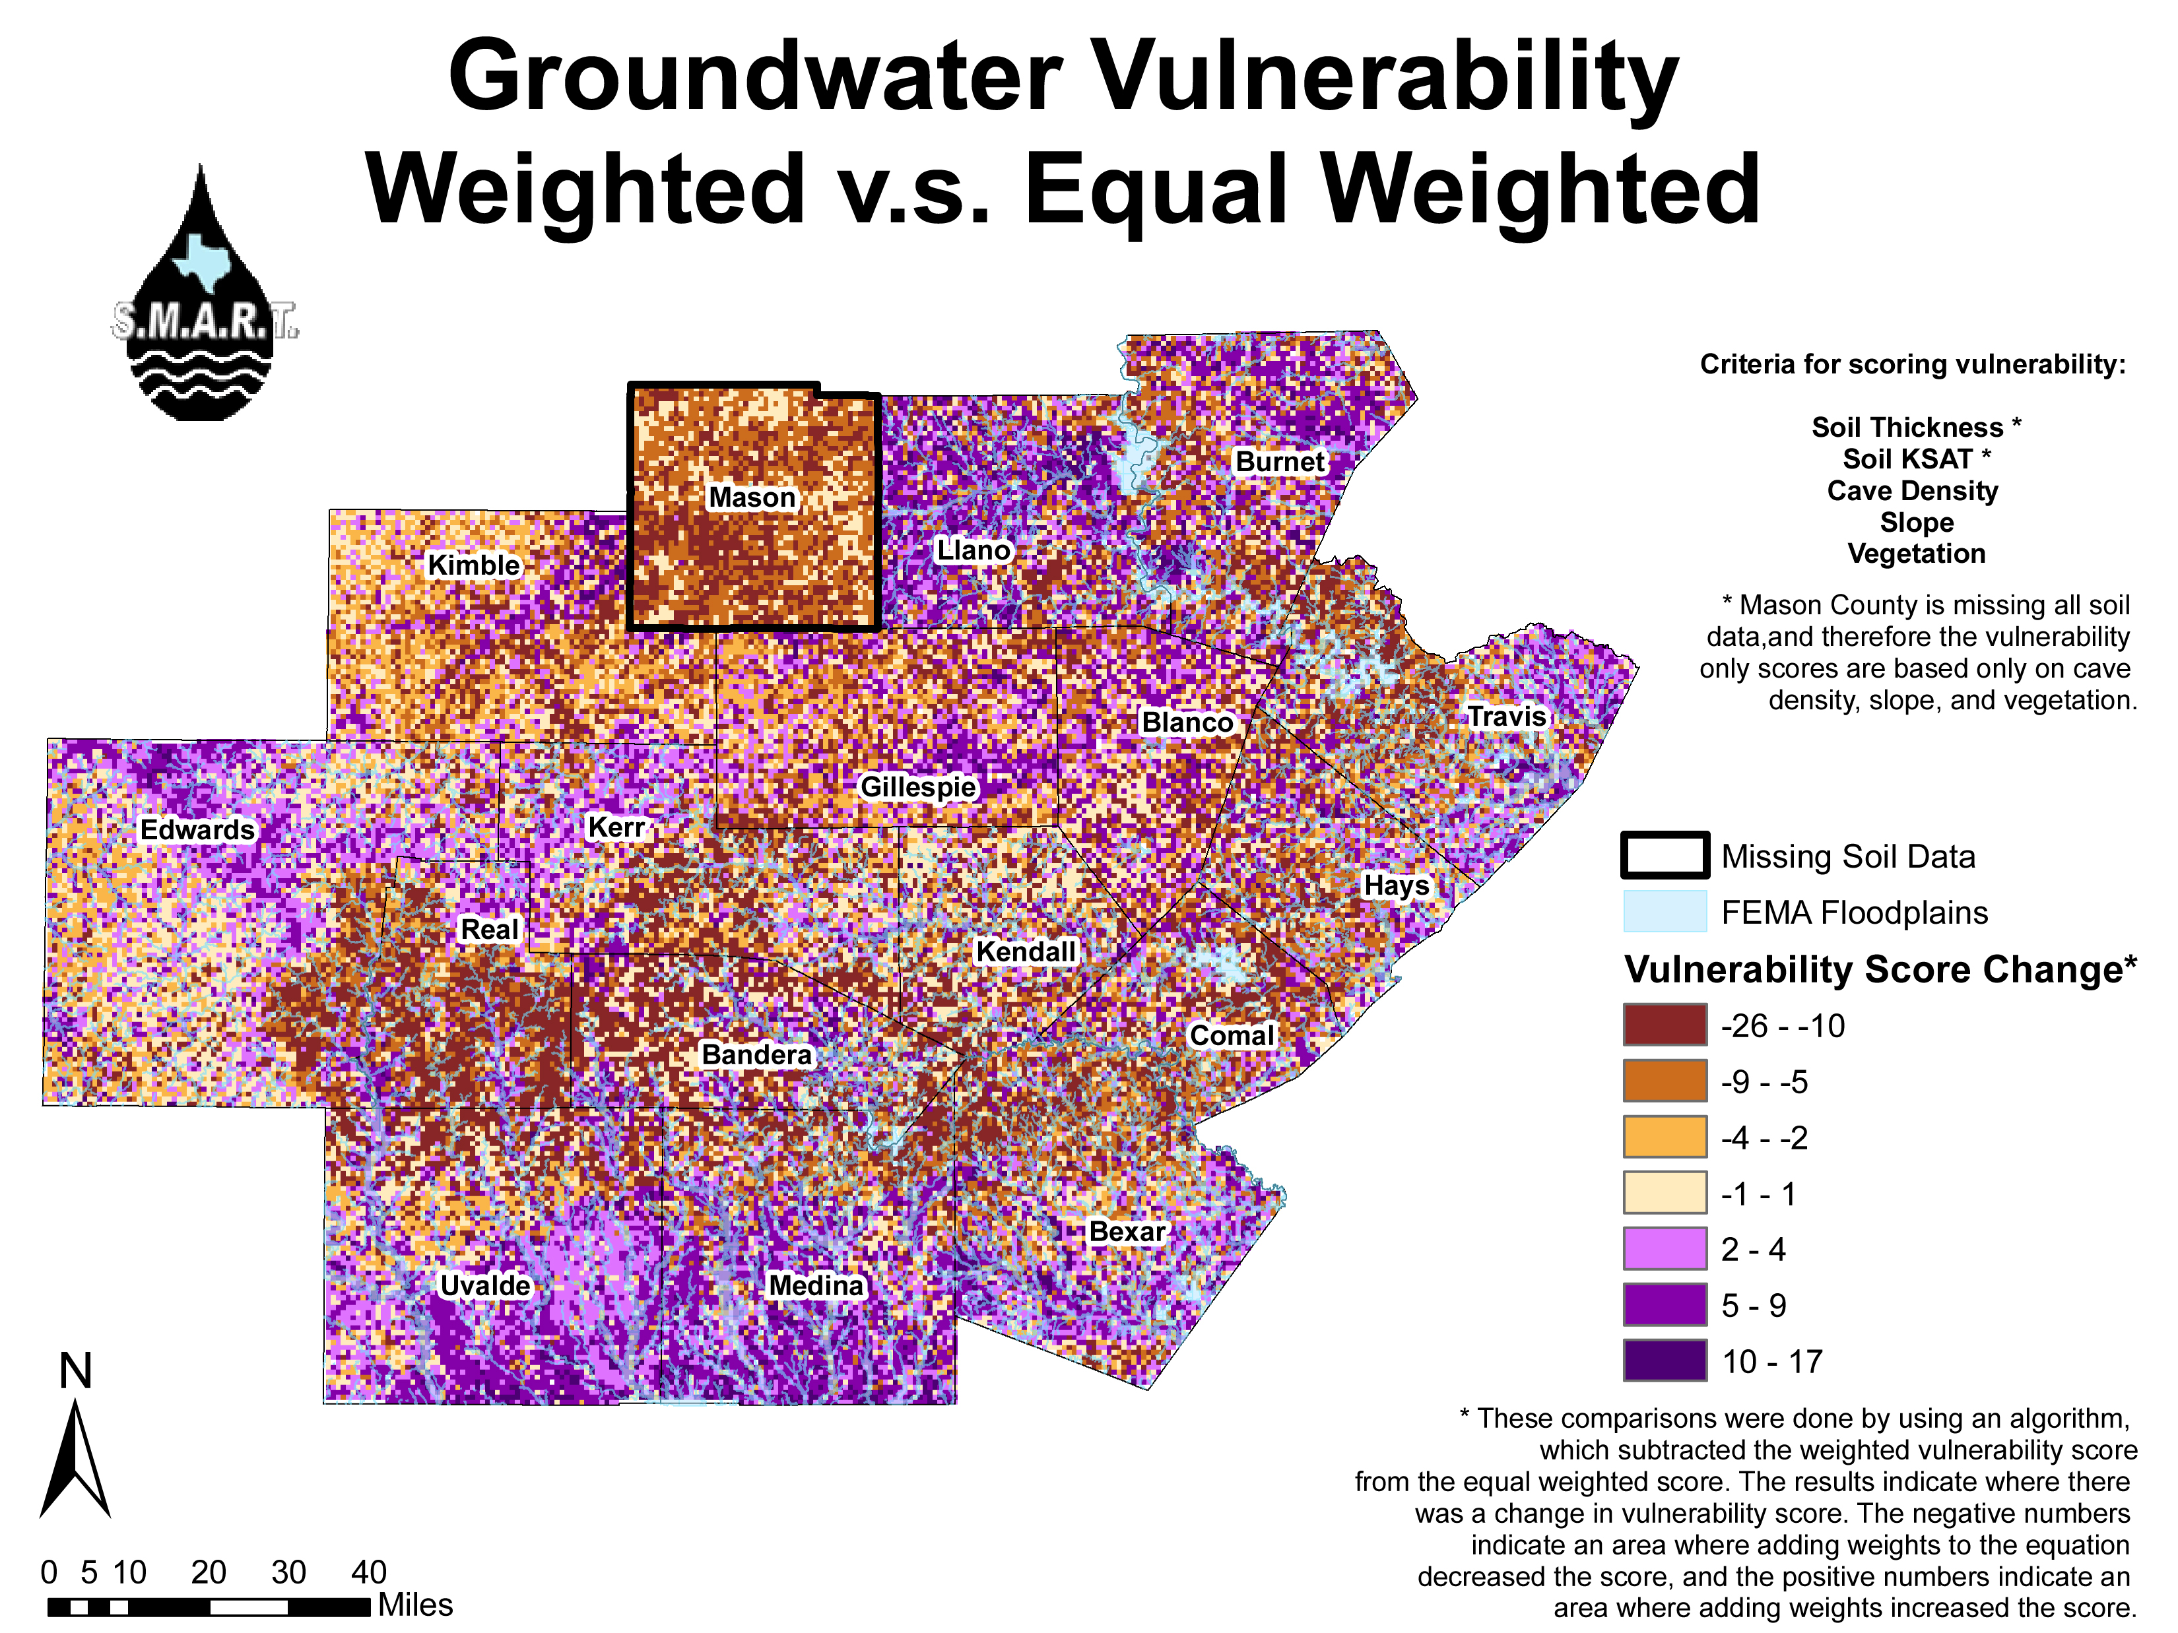

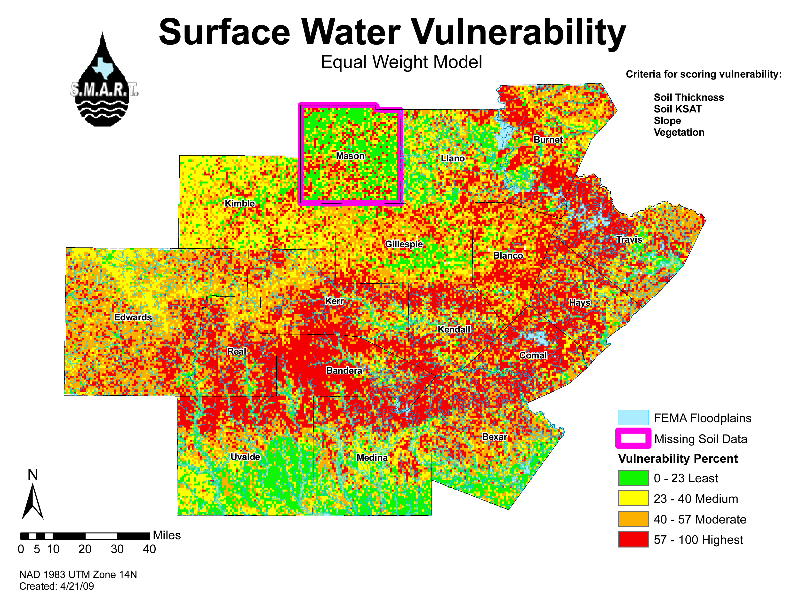

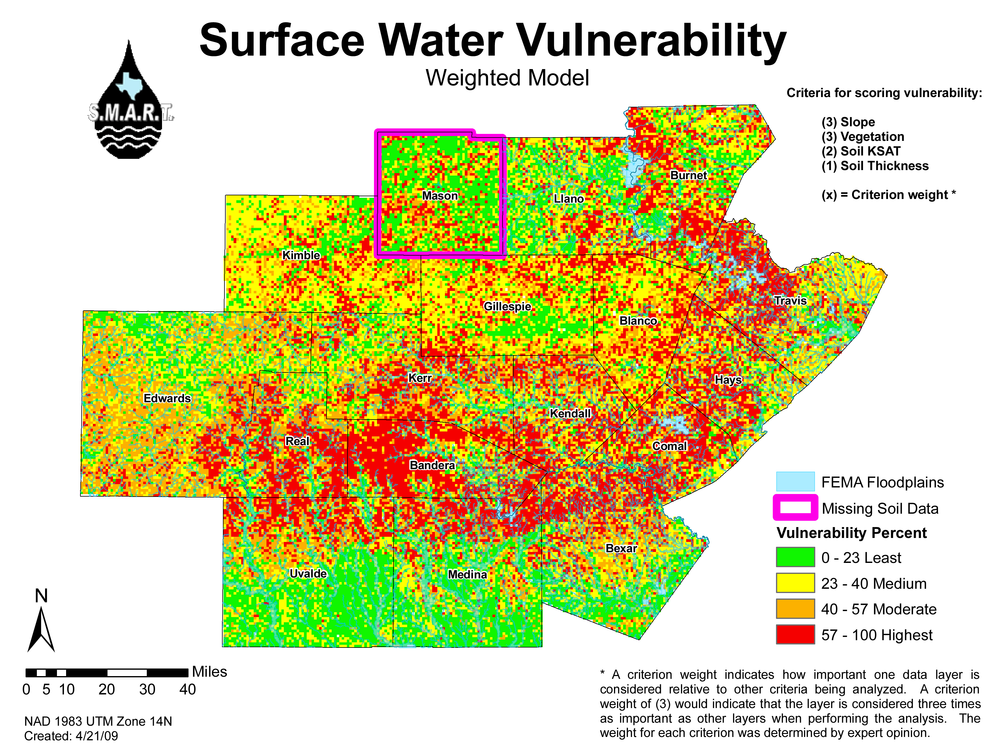

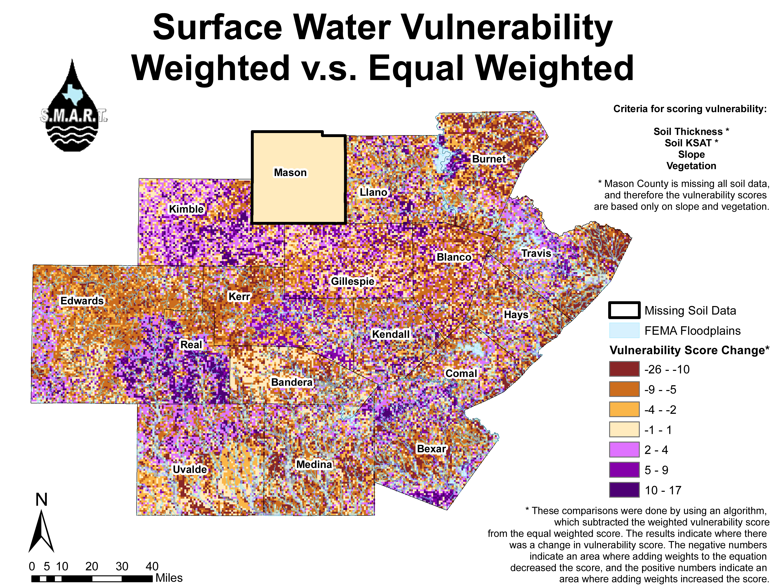

Appendix I
(Metadata)
Texas Hill Country Equal Weighted Groundwater Vulnerability
*Metadata language: English
*Metadata character set: utf8 - 8 bit UCS Transfer Format
*Last update: 20090509
Metadata contact:
Individual's name: Kathleen Callahan
Organization's name: Texas State University (Geo 4427)
Contact's position: GIS student and metadata manager for the project.
Contact's role: originator
Contact information:
Address:
e-mail address: kmc1229@gmail.com

*Scope of the data described by the metadata: dataset
*Scope name: dataset
*Name of the metadata standard used: ISO 19115 Geographic Information - Metadata
*Version of the metadata standard: DIS_ESRI1.0
Resource Identification Information:
Citation:
Title: Texas Hill Country Groundwater Vulnerability (Equal Weighted)
Alternate titles: Equal Weighted Groundwater Vulnerability
Reference date:
Date: 200903
Type of date: creation

Reference date:
Date: 200905
Type of date: publication

*Presentation format: digital map
Party responsible for the resource:
Individual's name: Christy Muse
Organization's name: Hill Country Alliance (HCA)
Contact's position: Executive Director
Contact's role: point of contact
Contact information:
Phone:
Voice: 512-263-9147

Address:
Delivery point:
15315 W. Hwy. 71
City: Austin
Administrative area: Texas
Postal code: 78738
Country: United States
e-mail address: christy@hillcountryalliance.org

Party responsible for the resource:
Individual's name: Alberto Giordano P.H.D
Organization's name: Texas State University
Contact's position: Professor of Geo 4427
Contact's role: point of contact
Contact information:
Phone:
Voice: 512-245-6581

Address:
e-mail address: ag22@txstate.edu

Party responsible for the resource:
Individual's name: Giancarlo Daneri
Organization's name: Texas State University
Contact's position: Geo 4427 Student (Project Manager)
Contact's role: point of contact
Contact information:
Address:
e-mail address: jondaneri@txstate.edu

Themes or categories of the resource: environment, inlandWaters, oceans
Theme keywords:
Keywords: groundwater, water, soil KSAT, vegetation, cave density, soil depth
Place keywords:
Keywords: Texas, Hill Country, Texas Hill Country, Central Texas
Abstract:
This data was created to extract the vulnerability of groundwater in the 17 county Texas Hill Country region to urban development. The analysis uses slope, vegetation, soil thickness, soil KSAT, and cave density as criteria to determine the vulnerability score for groundwater. There was an additional sensitivity analysis preformed to determine the robustness of the results.

This data was created by the Texas State University Geo 4427 class of 2009, for a GIS investigation into groundwater and surface water vulnerability to urban development in the Texas Hill Country. The project was prepared for the Hill Country Alliance. The final products, which employed this data, are used by the Hill Country Alliance to contribute to the debate on planning and development in the Texas Hill Country region.

*Dataset language: English
Resource constraints:
Constraints:
Limitations of use: The soil KSAT and soil depth data was missing for Mason County. The vulnerability score for Mason County was therefore calculated without these criteria and created as a separate raster file. This data set reflects this fact through the absence of any data in Mason County.
Limitations of use: The coarsest layer used to create this data set is cave density and it is at a 1km resolution, therefore all results are limited to 1km accuracy.
*Spatial representation type: grid
*Processing environment: Microsoft Windows XP Version 5.1 (Build 2600) Service Pack 3; ESRI ArcCatalog 9.3.1.1850
Spatial resolution:
Ground sample distance:
Precision of spatial data: 1
Units of measure, scale:
Units: Kilometers
Conversion to metric: 1 Kilometer = 1 km

Resource's bounding rectangle:
*Extent type: Full extent in decimal degrees
*Extent contains the resource: Yes
*West longitude: -100.724525
*East longitude: -97.361336
*North latitude: 31.038466
*South latitude: 29.078512

Other extent information:
Geographic extent:
Bounding rectangle:
*Extent type: Full extent in the data's coordinate system
*Extent contains the resource: Yes
*West longitude: 335401.0044
*East longitude: 656401.0044
*North latitude: 3433864.9018
*South latitude: 3217864.9018

Point of contact:
Individual's name: Christy Muse
Organization's name: Hill Country Alliance (HCA)
Contact's position: Executive Director
Contact's role: point of contact
Contact information:
Phone:
Voice: 512-263-9147

Address:
Delivery point:
15315 W. Hwy. 71
City: Austin
Administrative area: Texas
Postal code: 78738
Country: United States
e-mail address: christy@hillcountryalliance.org

Point of contact:
Individual's name: Alberto Giordano P.H.D
Organization's name: Texas State University
Contact's position: Professor of Geo 4427
Contact's role: point of contact
Contact information:
Phone:
Voice: 512-245-6581

Address:
e-mail address: ag22@txstate.edu

Point of contact:
Individual's name: Giancarlo Daneri
Organization's name: Texas State University
Contact's position: Geo 4427 Student (Project Manager)
Contact's role: point of contact
Contact information:
Address:
e-mail address: jondaneri@txstate.edu
Spatial Representation - Grid:
Number of dimensions: 2
Axis dimensions properties:
Dimension:
*Dimension name: column (x-axis)
*Dimension size: 321
Resolution:
*Distance: 1000
*Units of measure: Meter
*Conversion to ISO units: 1 Meter = 1 Meter(s)

Dimension:
*Dimension name: row (y-axis)
*Dimension size: 216
Resolution:
*Distance: 1000
*Units of measure: Meter
*Conversion to ISO units: 1 Meter = 1 Meter(s)

*Cell geometry: area
*Transformation parameters are available: Yes
Reference System Information:
Reference system identifier:
*Value: NAD_1983_UTM_Zone_14N
Data Quality Information:
Scope of quality information:
Level of the data: dataset
Lineage:
Lineage statement:
The data assembled to make this vulnerability layer (cave density, vegetation, soil KSAT, soil depth, and slope) were with the exception of vegetation all provided by HCA. The vegetation layer was acquired from the publically available GIS data on the USGS website.

The following formula was input in ArcGIS to obtain vulnerability scores found in this data set:
[(Soil Thickness) + (Soil KSAT) + (Slope) + (Vegetation) + (Cave Density)] / 5
Distribution Information:
Distributor:
Contact information:
Individual's name: Christy Muse
Organization's name: Hill Country Alliance
Contact's position: Executive Director
Contact's role: distributor
Available format:
*Format name: Raster Dataset
Format version: ArcGIS 9.3
Ordering process:
Instructions:
Contact Hill Country Alliance for further instruction on obtaining access to this data.

Transfer options:
*Transfer size: 0.169
Online source:
Online location (URL): http://geo'305577.evans.txstate.edu
*Connection protocol: Local Area Network
Function performed: information
Description: Static Map Images

Medium of distribution:
Medium name: CD-ROM
Geoprocessing History:
Process:
*Process name: Single Output Map Algebra
*Date: 20090404
*Time: 111102
*Tool location: C:\Program Files (x86)\ArcGIS\ArcToolbox\Toolboxes\Spatial Analyst Tools.tbx\SingleOutputMapAlgebra
*Command issued: SingleOutputMapAlgebra "((Ksat GW)+(Soil Depth Vulnerability)+(Land Cover Vulnerability)+(Slope Vuln Fixed)+(Cave Vulnerability)) / 5"

Mason County Equal Weighted Groundwater Vulnerability
*Metadata language: English
*Metadata character set: utf8 - 8 bit UCS Transfer Format
*Last update: 20090509
Metadata contact:
Individual's name: Kathleen Callahan
Organization's name: Texas State University (Geo 4427)
Contact's position: GIS student and metadata manager for the project.
Contact's role: originator
Contact information:
Address:
e-mail address: kmc1229@gmail.com

*Scope of the data described by the metadata: dataset
*Scope name: dataset
*Name of the metadata standard used: ISO 19115 Geographic Information - Metadata
*Version of the metadata standard: DIS_ESRI1.0
Resource Identification Information:
Citation:
Title: Mason County Groundwater Vulnerability (Equal Weighted)
Alternate titles: Equal Weighted Groundwater Vulnerability
Reference date:
Date: 200903
Type of date: creation

Reference date:
Date: 200905
Type of date: publication

*Presentation format: digital map
Party responsible for the resource:
Individual's name: Christy Muse
Organization's name: Hill Country Alliance (HCA)
Contact's position: Executive Director
Contact's role: point of contact
Contact information:
Phone:
Voice: 512-263-9147

Address:
Delivery point:
15315 W. Hwy. 71
City: Austin
Administrative area: Texas
Postal code: 78738
Country: United States
e-mail address: christy@hillcountryalliance.org

Party responsible for the resource:
Individual's name: Alberto Giordano P.H.D
Organization's name: Texas State University
Contact's position: Professor of Geo 4427
Contact's role: point of contact
Contact information:
Phone:
Voice: 512-245-6581
Address:
e-mail address: ag22@txstate.edu
Party responsible for the resource:
Individual's name: Giancarlo Daneri
Organization's name: Texas State University
Contact's position: Geo 4427 Student (Project Manager)
Contact's role: point of contact
Contact information:
Address:
e-mail address: jondaneri@txstate.edu

Themes or categories of the resource: environment, inlandWaters, oceans
Theme keywords:
Keywords: groundwater, water, urban development, vegetation, cave density
Place keywords:
Keywords: Texas, Hill Country, Texas Hill Country, Central Texas, Mason County, Mason
Abstract:
This data was created to extract the vulnerability of groundwater in Mason County, Texas, to urban development. The analysis uses slope, vegetation, and cave density as criteria to determine the vulnerability score for groundwater. There was an additional sensitivity analysis preformed to determine the robustness of the results.

This data was created by the Texas State University Geo 4427 class of 2009, for a GIS investigation into groundwater and surface water vulnerability to urban development in the Texas Hill Country. The project was prepared for the Hill Country Alliance. The final products, which employed this data, are used by the Hill Country Alliance to contribute to the debate on planning and development in the Texas Hill Country region.

*Dataset language: English
Resource constraints:
Constraints:
Limitations of use: The soil KSAT and soil depth data was missing for Mason County. The vulnerability score for Mason County was therefore calculated without these criteria. This data set reflects this fact with vulnerability scores based on three criteria instead of five.
Limitations of use: The coarsest layer used to create this data set is cave density and it is at a 1km resolution, therefore all results are limited to 1km accuracy.
*Spatial representation type: grid
*Processing environment: Microsoft Windows Vista Version 6.0 (Build 6001) Service Pack 1; ESRI ArcCatalog 9.3.0.1770
Spatial resolution:
Ground sample distance:
Precision of spatial data: 1
Units of measure, scale:
Units: Kilometers
Conversion to metric: 1 Kilometer = 1 km

Resource's bounding rectangle:
*Extent type: Full extent in decimal degrees
*Extent contains the resource: Yes
*West longitude: -100.724782
*East longitude: -97.361625
*North latitude: 31.037581
*South latitude: 29.077625

Other extent information:
Geographic extent:
Bounding rectangle:
*Extent type: Full extent in the data's coordinate system
*Extent contains the resource: Yes
*West longitude: 335374.870907
*East longitude: 656374.870907
*North latitude: 3433766.914231
*South latitude: 3217766.914231

Point of contact:
Individual's name: Christy Muse
Organization's name: Hill Country Alliance (HCA)
Contact's position: Executive Director
Contact's role: point of contact
Contact information:
Phone:
Voice: 512-263-9147

Address:
Delivery point:
15315 W. Hwy. 71
City: Austin
Administrative area: Texas
Postal code: 78738
Country: United States
e-mail address: christy@hillcountryalliance.org

Point of contact:
Individual's name: Alberto Giordano P.H.D
Organization's name: Texas State University
Contact's position: Professor of Geo 4427
Contact's role: point of contact
Contact information:
Phone:
Voice: 512-245-6581

Address:
e-mail address: ag22@txstate.edu

Point of contact:
Individual's name: Giancarlo Daneri
Organization's name: Texas State University
Contact's position: Geo 4427 Student (Project Manager)
Contact's role: point of contact
Contact information:
Address:
e-mail address: jondaneri@txstate.edu

Spatial Representation - Grid:
Number of dimensions: 2
Axis dimensions properties:
Dimension:
*Dimension name: column (x-axis)
*Dimension size: 321
Resolution:
*Distance: 1000
*Units of measure: Meter
*Conversion to ISO units: 1 Meter = 1 Meter(s)

Dimension:
*Dimension name: row (y-axis)
*Dimension size: 216
Resolution:
*Distance: 1000
*Units of measure: Meter
*Conversion to ISO units: 1 Meter = 1 Meter(s)

*Cell geometry: area
*Transformation parameters are available: Yes
Reference System Information:
Reference system identifier:
*Value: NAD_1983_UTM_Zone_14N
Data Quality Information:
Scope of quality information:
Level of the data: dataset
Lineage:
Lineage statement:
The data assembled to make this vulnerability layer (cave density, vegetation, and slope) were with the exception of vegetation all provided by HCA. The vegetation layer was acquired from the publically available GIS data on the USGS website.

The following formula was input in ArcGIS to obtain vulnerability scores found in this data set:
[(Slope) + (Vegetation) + (Cave Density)] / 3

Distribution Information:
Distributor:
Contact information:
Individual's name: Christy Muse
Organization's name: Hill Country Alliance
Contact's position: Executive Director
Contact's role: distributor
Available format:
*Format name: Raster Dataset
Format version: ArcGIS 9.3
Ordering process:
Instructions:
Contact Hill Country Alliance for further instruction on obtaining access to this data.
Transfer options:
*Transfer size: 0.129
Online source:
*Online location (URL): file://\\SPECIALK\E\HCA GIS PROJECT\Metadata Layers\ma_gw_equal
*Connection protocol: Local Area Network
Function performed: information
Description: Downloadable Data

Medium of distribution:
Medium name: CD-ROM
Geoprocessing History:
Process:
*Process name: Single Output Map Algebra
*Date: 20090404
*Time: 111102
*Tool location: C:\Program Files (x86)\ArcGIS\ArcToolbox\Toolboxes\Spatial Analyst Tools.tbx\SingleOutputMapAlgebra
*Command issued: SingleOutputMapAlgebra "((Ksat GW)+(Soil Depth Vulnerability)+(Land Cover Vulnerability)+(Slope Vuln Fixed)+(Cave Vulnerability)) / 5"

Texas Hill Country Equal Weighted Surface Water Vulnerability

*Metadata language: English
*Metadata character set: utf8 - 8 bit UCS Transfer Format
*Last update: 20090509
Metadata contact:
Individual's name: Kathleen Callahan
Organization's name: Texas State University (Geo 4427)
Contact's position: GIS student and metadata manager for the project.
Contact's role: originator
Contact information:
Address:
e-mail address: kmc1229@gmail.com

*Scope of the data described by the metadata: dataset
*Scope name: dataset
*Name of the metadata standard used: ISO 19115 Geographic Information - Metadata
*Version of the metadata standard: DIS_ESRI1.0

Resource Identification Information:
Citation:
Title: Texas Hill Country Equal Weighted Surface Water Vulnerability
Alternate titles: Equal Weighted Surface Water Vulnerability
Reference date:
Date: 200903
Type of date: creation

Reference date:
Date: 200905
Type of date: publication

*Presentation format: digital map
Party responsible for the resource:
Individual's name: Christy Muse
Organization's name: Hill Country Alliance (HCA)
Contact's position: Executive Director
Contact's role: point of contact
Contact information:
Phone:
Voice: 512-263-9147

Address:
Delivery point:
15315 W. Hwy. 71
City: Austin
Administrative area: Texas
Postal code: 78738
Country: United States
e-mail address: christy@hillcountryalliance.org

Party responsible for the resource:
Individual's name: Alberto Giordano P.H.D
Organization's name: Texas State University
Contact's position: Professor of Geo 4427
Contact's role: point of contact
Contact information:
Phone:
Voice: 512-245-6581

Address:
e-mail address: ag22@txstate.edu

Party responsible for the resource:
Individual's name: Giancarlo Daneri
Organization's name: Texas State University
Contact's position: Geo 4427 Student (Project Manager)
Contact's role: point of contact
Contact information:
Address:
e-mail address: jondaneri@txstate.edu

Themes or categories of the resource: environment, inlandWaters, oceans
Theme keywords:
Keywords: surface water, water, soil KSAT, vegetation, river, soil thickness
Place keywords:
Keywords: Texas, Hill Country, Texas Hill Country, Central Texas
Abstract:
This data was created to extract the vulnerability of surface water in the 17 county Texas Hill Country region to urban development. The analysis uses slope, vegetation, soil thickness, and soil KSAT as criteria to determine the vulnerability score for surface water. There was an additional sensitivity analysis preformed to determine the robustness of the results.

This data was created by the Texas State University Geo 4427 class of 2009, for a GIS investigation into groundwater and surface water vulnerability to urban development in the Texas Hill Country. The project was prepared for the Hill Country Alliance. The final products, which employed this data, are used by the Hill Country Alliance to contribute to the debate on planning and development in the Texas Hill Country region.

*Dataset language: English
Resource constraints:
Constraints:
Limitations of use: The soil KSAT and soil thickness data were missing for Mason County. The vulnerability score for Mason County was therefore calculated without these criteria and created as a separate raster file. This data set reflects this fact through the absence of any data in Mason County.
Limitations of use: The coarsest layer used int this vulnerability project was cave density and it is at a 1km resolution, therefore all results are limited to 1km accuracy.
*Spatial representation type: grid
*Processing environment: Microsoft Windows Vista Version 6.0 (Build 6001) Service Pack 1; ESRI ArcCatalog 9.3.0.1770
Spatial resolution:
Ground sample distance:
Precision of spatial data: 1
Units of measure, scale:
Units: Kilometers
Conversion to metric: 1 Kilometer = 1 km

Resource's bounding rectangle:
*Extent type: Full extent in decimal degrees
*Extent contains the resource: Yes
*West longitude: -100.724525
*East longitude: -97.361336
*North latitude: 31.038466
*South latitude: 29.078512

Other extent information:
Geographic extent:
Bounding rectangle:
*Extent type: Full extent in the data's coordinate system
*Extent contains the resource: Yes
*West longitude: 335401.0044
*East longitude: 656401.0044
*North latitude: 3433864.9018
*South latitude: 3217864.9018

Point of contact:
Individual's name: Christy Muse
Organization's name: Hill Country Alliance (HCA)
Contact's position: Executive Director
Contact's role: point of contact
Contact information:
Phone:
Voice: 512-263-9147

Address:
Delivery point:
15315 W. Hwy. 71
City: Austin
Administrative area: Texas
Postal code: 78738
Country: United States
e-mail address: christy@hillcountryalliance.org

Point of contact:
Individual's name: Alberto Giordano P.H.D
Organization's name: Texas State University
Contact's position: Professor of Geo 4427
Contact's role: point of contact
Contact information:
Phone:
Voice: 512-245-6581

Address:
e-mail address: ag22@txstate.edu

Point of contact:
Individual's name: Giancarlo Daneri
Organization's name: Texas State University
Contact's position: Geo 4427 Student (Project Manager)
Contact's role: point of contact
Contact information:
Address:
e-mail address: jondaneri@txstate.edu

Spatial Representation - Grid:
Number of dimensions: 2
Axis dimensions properties:
Dimension:
*Dimension name: column (x-axis)
*Dimension size: 321
Resolution:
*Distance: 1000
*Units of measure: Meter
*Conversion to ISO units: 1 Meter = 1 Meter(s)

Dimension:
*Dimension name: row (y-axis)
*Dimension size: 216
Resolution:
*Distance: 1000
*Units of measure: Meter
*Conversion to ISO units: 1 Meter = 1 Meter(s)

*Cell geometry: area
*Transformation parameters are available: Yes
Reference System Information:
Reference system identifier:
*Value: NAD_1983_UTM_Zone_14N
Data Quality Information:
Scope of quality information:
Level of the data: dataset
Lineage:
Lineage statement:
The data assembled to make this vulnerability layer (vegetation, soil KSAT, soil thickness, and slope) were with the exception of vegetation all provided by HCA. The vegetation layer was acquired from the publically available GIS data on the USGS website.

The following formula was input in ArcGIS to obtain vulnerability scores found in this data set:
[(Soil Thickness) + (Soil KSAT) + (Slope) + (Vegetation)] / 4

Distribution Information:
Distributor:
Contact information:
Individual's name: Christy Muse
Organization's name: Hill Country Alliance
Contact's position: Executive Director
Contact's role: distributor
Available format:
*Format name: Raster Dataset
Format version: ArcGIS 9.3
Ordering process:
Instructions:
Contact Hill Country Alliance for further instruction on obtaining access to this data.

Transfer options:
*Transfer size: 0.169
Online source:
*Online location (URL): file://\\SPECIALK\E\HCA GIS PROJECT\Metadata Layers\sw_vul_equal
*Connection protocol: Local Area Network
Function performed: information
Description: Downloadable Data

Medium of distribution:
Medium name: CD-ROM
Geoprocessing History:
Process:
*Process name: Single Output Map Algebra
*Date: 20090404
*Time: 111102
*Tool location: C:\Program Files (x86)\ArcGIS\ArcToolbox\Toolboxes\Spatial Analyst Tools.tbx\SingleOutputMapAlgebra
*Command issued: SingleOutputMapAlgebra "((Ksat GW)+(Soil Depth Vulnerability)+(Land Cover Vulnerability)+(Slope Vuln Fixed)+(Cave Vulnerability)) / 5"

Mason County Equal Weighted Surface Water Vulnerability
*Metadata language: English
*Metadata character set: utf8 - 8 bit UCS Transfer Format
*Last update: 20090509
Metadata contact:
Individual's name: Kathleen Callahan
Organization's name: Texas State University (Geo 4427)
Contact's position: GIS student and metadata manager for the project.
Contact's role: originator
Contact information:
Address:
e-mail address: kmc1229@gmail.com

*Scope of the data described by the metadata: dataset
*Scope name: dataset
*Name of the metadata standard used: ISO 19115 Geographic Information - Metadata
*Version of the metadata standard: DIS_ESRI1.0
Resource Identification Information:
Citation:
Title: Mason County Surface Water Vulnerability (Equal Weighted)
Alternate titles: Equal Weighted Surface Water Vulnerability
Reference date:
Date: 200903
Type of date: creation

Reference date:
Date: 200905
Type of date: publication

*Presentation format: digital map
Party responsible for the resource:
Individual's name: Christy Muse
Organization's name: Hill Country Alliance (HCA)
Contact's position: Executive Director
Contact's role: point of contact
Contact information:
Phone:
Voice: 512-263-9147

Address:
Delivery point:
15315 W. Hwy. 71
City: Austin
Administrative area: Texas
Postal code: 78738
Country: United States
e-mail address: christy@hillcountryalliance.org

Party responsible for the resource:
Individual's name: Alberto Giordano P.H.D
Organization's name: Texas State University
Contact's position: Professor of Geo 4427
Contact's role: point of contact
Contact information:
Phone:
Voice: 512-245-6581

Address:
e-mail address: ag22@txstate.edu

Party responsible for the resource:
Individual's name: Giancarlo Daneri
Organization's name: Texas State University
Contact's position: Geo 4427 Student (Project Manager)
Contact's role: point of contact
Contact information:
Address:
e-mail address: jondaneri@txstate.edu

Themes or categories of the resource: environment, inlandWaters, oceans
Theme keywords:
Keywords: surface water, water, urban development, vegetation, river
Place keywords:
Keywords: Texas, Hill Country, Texas Hill Country, Central Texas, Mason County, Mason
Abstract:
This data was created to extract the vulnerability of surface water in Mason County, Texas to urban development. The analysis uses slope, and vegetation as criteria to determine the vulnerability score for surface water. There was an additional sensitivity analysis preformed to determine the robustness of the results.

This data was created by the Texas State University Geo 4427 class of 2009, for a GIS investigation into groundwater and surface water vulnerability to urban development in the Texas Hill Country. The project was prepared for the Hill Country Alliance. The final products, which employed this data, are used by the Hill Country Alliance to contribute to the debate on planning and development in the Texas Hill Country region.

*Dataset language: English
Resource constraints:
Constraints:
Limitations of use: The soil KSAT and soil thickness data were missing for Mason County. The vulnerability score of Mason County was therefore calculated without these criteria . This data set reflects this fact through vulnerability scores only based on two criteria.
Limitations of use: The coarsest layer used int this vulnerability project was cave density and it is at a 1km resolution, therefore all results are limited to 1km accuracy.
*Spatial representation type: grid
*Processing environment: Microsoft Windows Vista Version 6.0 (Build 6001) Service Pack 1; ESRI ArcCatalog 9.3.0.1770
Spatial resolution:
Ground sample distance:
Precision of spatial data: 1
Units of measure, scale:
Units: Kilometers
Conversion to metric: 1 Kilometer = 1 km

Resource's bounding rectangle:
*Extent type: Full extent in decimal degrees
*Extent contains the resource: Yes
*West longitude: -100.724782
*East longitude: -97.361625
*North latitude: 31.037581
*South latitude: 29.077625

Other extent information:
Geographic extent:
Bounding rectangle:
*Extent type: Full extent in the data's coordinate system
*Extent contains the resource: Yes
*West longitude: 335374.870907
*East longitude: 656374.870907
*North latitude: 3433766.914231
*South latitude: 3217766.914231

Point of contact:
Individual's name: Christy Muse
Organization's name: Hill Country Alliance (HCA)
Contact's position: Executive Director
Contact's role: point of contact
Contact information:
Phone:
Voice: 512-263-9147

Address:
Delivery point:
15315 W. Hwy. 71
City: Austin
Administrative area: Texas
Postal code: 78738
Country: United States
e-mail address: christy@hillcountryalliance.org

Point of contact:
Individual's name: Alberto Giordano P.H.D
Organization's name: Texas State University
Contact's position: Professor of Geo 4427
Contact's role: point of contact
Contact information:
Phone:
Voice: 512-245-6581

Address:
e-mail address: ag22@txstate.edu

Point of contact:
Individual's name: Giancarlo Daneri
Organization's name: Texas State University
Contact's position: Geo 4427 Student (Project Manager)
Contact's role: point of contact
Contact information:
Address:
e-mail address: jondaneri@txstate.edu

Spatial Representation - Grid:
Number of dimensions: 2
Axis dimensions properties:
Dimension:
*Dimension name: column (x-axis)
*Dimension size: 321
Resolution:
*Distance: 1000
*Units of measure: Meter
*Conversion to ISO units: 1 Meter = 1 Meter(s)

Dimension:
*Dimension name: row (y-axis)
*Dimension size: 216
Resolution:
*Distance: 1000
*Units of measure: Meter
*Conversion to ISO units: 1 Meter = 1 Meter(s)

*Cell geometry: area
*Transformation parameters are available: Yes
Reference System Information:
Reference system identifier:
*Value: NAD_1983_UTM_Zone_14N
Data Quality Information:
Scope of quality information:
Level of the data: dataset
Lineage:
Lineage statement:
The data assembled to make this vulnerability layer (vegetation, soil KSAT, soil thickness, and slope) were with the exception of vegetation all provided by HCA. The vegetation layer was aquired from the publically available GIS data on the USGS website.

The following formula was input in ArcGIS to obtain vulnerability scores found in this data set:
[(Slope) + (Vegetation)] / 2

Distribution Information:
Distributor:
Contact information:
Individual's name: Christy Muse
Organization's name: Hill Country Alliance
Contact's position: Executive Director
Contact's role: distributor
Available format:
*Format name: Raster Dataset
Format version: ArcGIS 9.3
Ordering process:
Instructions:
Contact Hill Country Alliance for further instruction on obtaining access to this data.

Transfer options:
*Transfer size: 0.129
Online source:
*Online location (URL): file://\\SPECIALK\E\HCA GIS PROJECT\Metadata Layers\ma_sw_equal
*Connection protocol: Local Area Network
Function performed: information
Description: Downloadable Data

Medium of distribution:
Medium name: CD-ROM
Geoprocessing History:
Process:
*Process name: Single Output Map Algebra
*Date: 20090404
*Time: 111102
*Tool location: C:\Program Files (x86)\ArcGIS\ArcToolbox\Toolboxes\Spatial Analyst Tools.tbx\SingleOutputMapAlgebra
*Command issued: SingleOutputMapAlgebra "((Ksat GW)+(Soil Depth Vulnerability)+(Land Cover Vulnerability)+(Slope Vuln Fixed)+(Cave Vulnerability)) / 5"

Texas Hill Country Weighted Groundwater Vulnerability

*Metadata language: English
*Metadata character set: utf8 - 8 bit UCS Transfer Format
*Last update: 20090509
Metadata contact:
Individual's name: Kathleen Callahan
Organization's name: Texas State University (Geo 4427)
Contact's position: GIS student and metadata manager for the project.
Contact's role: originator
Contact information:
Address:
e-mail address: kmc1229@gmail.com

*Scope of the data described by the metadata: dataset
*Scope name: dataset
*Name of the metadata standard used: ISO 19115 Geographic Information - Metadata
*Version of the metadata standard: DIS_ESRI1.0
Resource Identification Information:
Citation:
Title: Texas Hill Country Groundwater Vulnerability (Weighted)
Alternate titles: Weighted Groundwater Vulnerability
Reference date:
Date: 200912
Type of date: creation

Reference date:
Date: 200905
Type of date: publication

*Presentation format: digital map
Party responsible for the resource:
Individual's name: Christy Muse
Organization's name: Hill Country Alliance (HCA)
Contact's position: Executive Director
Contact's role: point of contact
Contact information:
Phone:
Voice: 512-263-9147

Address:
Delivery point:
15315 W. Hwy. 71
City: Austin
Administrative area: Texas
Postal code: 78738
Country: United States
e-mail address: christy@hillcountryalliance.org

Party responsible for the resource:
Individual's name: Alberto Giordano P.H.D
Organization's name: Texas State University
Contact's position: Professor of Geo 4427
Contact's role: point of contact
Contact information:
Phone:
Voice: 512-245-6581

Address:
e-mail address: ag22@txstate.edu

Party responsible for the resource:
Individual's name: Giancarlo Daneri
Organization's name: Texas State University
Contact's position: Geo 4427 Student (Project Manager)
Contact's role: point of contact
Contact information:
Address:
e-mail address: jondaneri@txstate.edu

Themes or categories of the resource: environment, inlandWaters, oceans
Theme keywords:
Keywords: groundwater, water, soil KSAT, vegetation, cave density, soil depth
Place keywords:
Keywords: Texas, Hill Country, Texas Hill Country, Central Texas
Abstract:
This data was created to extract the vulnerability of groundwater in the 17 county Texas Hill Country region to urban development. The analysis uses slope, vegetation, soil thickness, soil KSAT, and cave density as criteria to determine the vulnerability score for groundwater. Each criterion was weighted based on its level of significance to groundwater vulnerability. There was an additional sensitivity analysis preformed to determine the robustness of the results.

This data was created by the Texas State University Geo 4427 class of 2009, for a GIS investigation into groundwater and surface water vulnerability to urban development in the Texas Hill Country. The project was prepared for the Hill Country Alliance. The final products, which employed this data, are used by the Hill Country Alliance to contribute to the debate on planning and development in the Texas Hill Country region.

*Dataset language: English
Resource constraints:
Constraints:
Limitations of use: The soil KSAT and soil depth data was missing for Mason County. The vulnerability score for Mason County was therefore calculated without these criteria and created as a separate raster file. This data set reflects this fact through the absence of any data in Mason County.
Limitations of use: The coarsest layer used to create this data set is cave density and it is at a 1km resolution, therefore all results are limited to 1km accuracy.
*Spatial representation type: grid
*Processing environment: Microsoft Windows Vista Version 6.0 (Build 6001) Service Pack 1; ESRI ArcCatalog 9.3.0.1770
Spatial resolution:
Ground sample distance:
Precision of spatial data: 1
Units of measure, scale:
Units: Kilometers
Conversion to metric: 1 Kilometer = 1 km

Resource's bounding rectangle:
*Extent type: Full extent in decimal degrees
*Extent contains the resource: Yes
*West longitude: -100.724525
*East longitude: -97.361336
*North latitude: 31.038466
*South latitude: 29.078512

Other extent information:
Geographic extent:
Bounding rectangle:
*Extent type: Full extent in the data's coordinate system
*Extent contains the resource: Yes
*West longitude: 335401.0044
*East longitude: 656401.0044
*North latitude: 3433864.9018
*South latitude: 3217864.9018

Point of contact:
Individual's name: Christy Muse
Organization's name: Hill Country Alliance (HCA)
Contact's position: Executive Director
Contact's role: point of contact
Contact information:
Phone:
Voice: 512-263-9147

Address:
Delivery point:
15315 W. Hwy. 71
City: Austin
Administrative area: Texas
Postal code: 78738
Country: United States
e-mail address: christy@hillcountryalliance.org

Point of contact:
Individual's name: Alberto Giordano P.H.D
Organization's name: Texas State University
Contact's position: Professor of Geo 4427
Contact's role: point of contact
Contact information:
Phone:
Voice: 512-245-6581

Address:
e-mail address: ag22@txstate.edu

Point of contact:
Individual's name: Giancarlo Daneri
Organization's name: Texas State University
Contact's position: Geo 4427 Student (Project Manager)
Contact's role: point of contact
Contact information:
Address:
e-mail address: jondaneri@txstate.edu

Spatial Representation - Grid:
Number of dimensions: 2
Axis dimensions properties:
Dimension:
*Dimension name: column (x-axis)
*Dimension size: 321
Resolution:
*Distance: 1000
*Units of measure: Meter
*Conversion to ISO units: 1 Meter = 1 Meter(s)

Dimension:
*Dimension name: row (y-axis)
*Dimension size: 216
Resolution:
*Distance: 1000
*Units of measure: Meter
*Conversion to ISO units: 1 Meter = 1 Meter(s)

*Cell geometry: area
*Transformation parameters are available: Yes

Reference System Information:
Reference system identifier:
*Value: NAD_1983_UTM_Zone_14N

Data Quality Information:
Scope of quality information:
Level of the data: dataset
Lineage:
Lineage statement:
The data assembled to make this vulnerability layer (cave density, vegetation, soil KSAT, soil depth, and slope) were with the exception of vegetation all provided by HCA. The vegetation layer was aquired from the publically available GIS data on the USGS website.

The following formula was input into ArcGIS to obtain the vulnerability scores: [(Soil Thickness*3) + (Soil KSAT*3) + (Cave Density*3) + (Slope*1) + (Vegetation*1)] / 11

Distribution Information:
Distributor:
Contact information:
Individual's name: Christy Muse
Organization's name: Hill Country Alliance
Contact's position: Executive Director
Contact's role: distributor
Available format:
*Format name: Raster Dataset
Format version: ArcGIS 9.3
Ordering process:
Instructions:
Contact Hill Country Alliance for further instruction on obtaining access to this data.

Transfer options:
*Transfer size: 0.169
Online source:
*Online location (URL): file://\\SPECIALK\E\HCA GIS PROJECT\Metadata Layers\gw_vul_weight
*Connection protocol: Local Area Network
Function performed: information
Description: Downloadable Data

Medium of distribution:
Medium name: CD-ROM
Geoprocessing History:
Process:
*Process name: Single Output Map Algebra
*Date: 20090404
*Time: 111102
*Tool location: C:\Program Files (x86)\ArcGIS\ArcToolbox\Toolboxes\Spatial Analyst Tools.tbx\SingleOutputMapAlgebra
*Command issued: SingleOutputMapAlgebra "((Ksat GW)+(Soil Depth Vulnerability)+(Land Cover Vulnerability)+(Slope Vuln Fixed)+(Cave Vulnerability)) / 5"
*Metadata language: English
*Metadata character set: utf8 - 8 bit UCS Transfer Format
*Last update: 20090509
Metadata contact:
Individual's name: Kathleen Callahan
Organization's name: Texas State University (Geo 4427)
Contact's position: GIS student and metadata manager for the project.
Contact's role: originator
Contact information:
Address:
e-mail address: kmc1229@gmail.com

*Scope of the data described by the metadata: dataset
*Scope name: dataset
*Name of the metadata standard used: ISO 19115 Geographic Information - Metadata
*Version of the metadata standard: DIS_ESRI1.0
Resource Identification Information:
Citation:
Title: Mason County Groundwater Vulnerability (Weighted)
Alternate titles: Weighted Groundwater Vulnerability
Reference date:
Date: 200904
Type of date: creation

Reference date:
Date: 200905
Type of date: publication

*Presentation format: digital map
Party responsible for the resource:
Individual's name: Christy Muse
Organization's name: Hill Country Alliance (HCA)
Contact's position: Executive Director
Contact's role: point of contact
Contact information:
Phone:
Voice: 512-263-9147

Address:
Delivery point:
15315 W. Hwy. 71
City: Austin
Administrative area: Texas
Postal code: 78738
Country: United States
e-mail address: christy@hillcountryalliance.org

Party responsible for the resource:
Individual's name: Alberto Giordano P.H.D
Organization's name: Texas State University
Contact's position: Professor of Geo 4427
Contact's role: point of contact
Contact information:
Phone:
Voice: 512-245-6581

Address:
e-mail address: ag22@txstate.edu

Party responsible for the resource:
Individual's name: Giancarlo Daneri
Organization's name: Texas State University
Contact's position: Geo 4427 Student (Project Manager)
Contact's role: point of contact
Contact information:
Address:
e-mail address: jondaneri@txstate.edu

Themes or categories of the resource: environment, inlandWaters, oceans
Theme keywords:
Keywords: groundwater, water, urban development, vegetation, cave density
Place keywords:
Keywords: Texas, Hill Country, Texas Hill Country, Central Texas, Mason County, Mason
Abstract:
This data was created to extract the vulnerability of groundwater in Mason County, Texas, to urban development. The analysis uses slope, vegetation, and cave density as criteria to determine the vulnerability score for groundwater.
Each criterion was weighted based on its level of significance to surface water vulnerability. There was an additional sensitivity analysis preformed to determine the robustness of the results.

This data was created by the Texas State University Geo 4427 class of 2009, for a GIS investigation into groundwater and surface water vulnerability to urban development in the Texas Hill Country. The project was prepared for the Hill Country Alliance. The final products, which employed this data, are used by the Hill Country Alliance to contribute to the debate on planning and development in the Texas Hill Country region.

*Dataset language: English
Resource constraints:
Constraints:
Limitations of use: The soil KSAT and soil depth data was missing for Mason County. The vulnerability score for Mason County was therefore calculated without these criteria. This data set reflects this fact with vulnerability scores based on three criteria instead of five.
Limitations of use: The coarsest layer used to create this data set is cave density and it is at a 1km resolution, therefore all results are limited to 1km accuracy.
*Spatial representation type: grid
*Processing environment: Microsoft Windows Vista Version 6.0 (Build 6001) Service Pack 1; ESRI ArcCatalog 9.3.0.1770
Spatial resolution:
Ground sample distance:
Precision of spatial data: 1
Units of measure, scale:
Units: Kilometers
Conversion to metric: 1 Kilometer = 1 km

Resource's bounding rectangle:
*Extent type: Full extent in decimal degrees
*Extent contains the resource: Yes
*West longitude: -100.724782
*East longitude: -97.361625
*North latitude: 31.037581
*South latitude: 29.077625

Other extent information:
Geographic extent:
Bounding rectangle:
*Extent type: Full extent in the data's coordinate system
*Extent contains the resource: Yes
*West longitude: 335374.870907
*East longitude: 656374.870907
*North latitude: 3433766.914231
*South latitude: 3217766.914231

Point of contact:
Individual's name: Christy Muse
Organization's name: Hill Country Alliance (HCA)
Contact's position: Executive Director
Contact's role: point of contact
Contact information:
Phone:
Voice: 512-263-9147

Address:
Delivery point:
15315 W. Hwy. 71
City: Austin
Administrative area: Texas
Postal code: 78738
Country: United States
e-mail address: christy@hillcountryalliance.org

Point of contact:
Individual's name: Alberto Giordano P.H.D
Organization's name: Texas State University
Contact's position: Professor of Geo 4427
Contact's role: point of contact
Contact information:
Phone:
Voice: 512-245-6581

Address:
e-mail address: ag22@txstate.edu

Point of contact:
Individual's name: Giancarlo Daneri
Organization's name: Texas State University
Contact's position: Geo 4427 Student (Project Manager)
Contact's role: point of contact
Contact information:
Address:
e-mail address: jondaneri@txstate.edu

Spatial Representation - Grid:
Number of dimensions: 2
Axis dimensions properties:
Dimension:
*Dimension name: column (x-axis)
*Dimension size: 321
Resolution:
*Distance: 1000
*Units of measure: Meter
*Conversion to ISO units: 1 Meter = 1 Meter(s)

Dimension:
*Dimension name: row (y-axis)
*Dimension size: 216
Resolution:
*Distance: 1000
*Units of measure: Meter
*Conversion to ISO units: 1 Meter = 1 Meter(s)

*Cell geometry: area
*Transformation parameters are available: Yes

Reference System Information:
Reference system identifier:
*Value: NAD_1983_UTM_Zone_14N
Data Quality Information:
Scope of quality information:
Level of the data: dataset
Lineage:
Lineage statement:
The data assembled to make this vulnerability layer (cave density, vegetation, and slope) were with the exception of vegetation all provided by HCA. The vegetation layer was acquired from the publically available GIS data on the USGS website.

The following formula was input in ArcGIS to obtain vulnerability scores found in this data set:
[(Cave Density*3) + (Slope*1) + (Vegetation*1)] / 5

Distribution Information:
Distributor:
Contact information:
Individual's name: Christy Muse
Organization's name: Hill Country Alliance
Contact's position: Executive Director
Contact's role: distributor
Available format:
*Format name: Raster Dataset
Format version: ArcGIS 9.3
Ordering process:
Instructions:
Contact Hill Country Alliance for further instruction on obtaining access to this data.

Transfer options:
*Transfer size: 0.129
Online source:
*Online location (URL): file://\\SPECIALK\E\HCA GIS PROJECT\Metadata Layers\ma_gw_weight
*Connection protocol: Local Area Network
Function performed: information
Description: Downloadable Data

Medium of distribution:
Medium name: CD-ROM
Geoprocessing History:
Process:
*Process name: Single Output Map Algebra
*Date: 20090404
*Time: 111102
*Tool location: C:\Program Files (x86)\ArcGIS\ArcToolbox\Toolboxes\Spatial Analyst Tools.tbx\SingleOutputMapAlgebra
*Command issued: SingleOutputMapAlgebra "((Ksat GW)+(Soil Depth Vulnerability)+(Land Cover Vulnerability)+(Slope Vuln Fixed)+(Cave Vulnerability)) / 5"
Texas Hill Country Weighted Surface Water Vulnerability
*Metadata language: English
*Metadata character set: utf8 - 8 bit UCS Transfer Format
*Last update: 20090509
Metadata contact:
Individual's name: Kathleen Callahan
Organization's name: Texas State University (Geo 4427)
Contact's position: GIS student and metadata manager for the project.
Contact's role: originator
Contact information:
Address:
e-mail address: kmc1229@gmail.com

*Scope of the data described by the metadata: dataset
*Scope name: dataset
*Name of the metadata standard used: ISO 19115 Geographic Information - Metadata
*Version of the metadata standard: DIS_ESRI1.0
Resource Identification Information:
Citation:
Title: Texas Hill Country Weighted Surface Water Vulnerability
Alternate titles: Weighted Surface Water Vulnerability
Reference date:
Date: 200904
Type of date: creation

Reference date:
Date: 200905
Type of date: publication

*Presentation format: digital map
Party responsible for the resource:
Individual's name: Christy Muse
Organization's name: Hill Country Alliance (HCA)
Contact's position: Executive Director
Contact's role: point of contact
Contact information:
Phone:
Voice: 512-263-9147

Address:
Delivery point:
15315 W. Hwy. 71
City: Austin
Administrative area: Texas
Postal code: 78738
Country: United States
e-mail address: christy@hillcountryalliance.org

Party responsible for the resource:
Individual's name: Alberto Giordano P.H.D
Organization's name: Texas State University
Contact's position: Professor of Geo 4427
Contact's role: point of contact
Contact information:
Phone:
Voice: 512-245-6581

Address:
e-mail address: ag22@txstate.edu

Party responsible for the resource:
Individual's name: Giancarlo Daneri
Organization's name: Texas State University
Contact's position: Geo 4427 Student (Project Manager)
Contact's role: point of contact
Contact information:
Address:
e-mail address: jondaneri@txstate.edu

Themes or categories of the resource: environment, inlandWaters, oceans
Theme keywords:
Keywords: surface water, water, soil KSAT, vegetation, river, soil thickness
Place keywords:
Keywords: Texas, Hill Country, Texas Hill Country, Central Texas
Abstract:
This data was created to extract the vulnerability of surface water in the 17 county Texas Hill Country region to urban development. The analysis uses slope, vegetation, soil thickness, and soil KSAT as criteria to determine the vulnerability score for surface water. Each criterion was weighted based on its level of significance to surface water vulnerability. There was an additional sensitivity analysis preformed to determine the robustness of the results.

This data was created by the Texas State University Geo 4427 class of 2009, for a GIS investigation into groundwater and surface water vulnerability to urban development in the Texas Hill Country. The project was prepared for the Hill Country Alliance. The final products, which employed this data, are used by the Hill Country Alliance to contribute to the debate on planning and development in the Texas Hill Country region.

*Dataset language: English
Resource constraints:
Constraints:
Limitations of use: The soil KSAT and soil thickness data were missing for Mason County. The vulnerability score for Mason County was therefore calculated without these criteria and created as a separate raster file. This data set reflects this fact through the absence of any data in Mason County.
Limitations of use: The coarsest layer used int this vulnerability project was cave density and it is at a 1km resolution, therefore all results are limited to 1km accuracy.
*Spatial representation type: grid
*Processing environment: Microsoft Windows Vista Version 6.0 (Build 6001) Service Pack 1; ESRI ArcCatalog 9.3.0.1770
Spatial resolution:
Ground sample distance:
Precision of spatial data: 1
Units of measure, scale:
Units: Kilometers
Conversion to metric: 1 Kilometer = 1 km

Resource's bounding rectangle:
*Extent type: Full extent in decimal degrees
*Extent contains the resource: Yes
*West longitude: -100.724525
*East longitude: -97.361336
*North latitude: 31.038466
*South latitude: 29.078512

Other extent information:
Geographic extent:
Bounding rectangle:
*Extent type: Full extent in the data's coordinate system
*Extent contains the resource: Yes
*West longitude: 335401.0044
*East longitude: 656401.0044
*North latitude: 3433864.9018
*South latitude: 3217864.9018

Point of contact:
Individual's name: Christy Muse
Organization's name: Hill Country Alliance (HCA)
Contact's position: Executive Director
Contact's role: point of contact
Contact information:
Phone:
Voice: 512-263-9147

Address:
Delivery point:
15315 W. Hwy. 71
City: Austin
Administrative area: Texas
Postal code: 78738
Country: United States
e-mail address: christy@hillcountryalliance.org

Point of contact:
Individual's name: Alberto Giordano P.H.D
Organization's name: Texas State University
Contact's position: Professor of Geo 4427
Contact's role: point of contact
Contact information:
Phone:
Voice: 512-245-6581

Address:
e-mail address: ag22@txstate.edu

Point of contact:
Individual's name: Giancarlo Daneri
Organization's name: Texas State University
Contact's position: Geo 4427 Student (Project Manager)
Contact's role: point of contact
Contact information:
Address:
e-mail address: jondaneri@txstate.edu

Spatial Representation - Grid:
Number of dimensions: 2
Axis dimensions properties:
Dimension:
*Dimension name: column (x-axis)
*Dimension size: 321
Resolution:
*Distance: 1000
*Units of measure: Meter
*Conversion to ISO units: 1 Meter = 1 Meter(s)

Dimension:
*Dimension name: row (y-axis)
*Dimension size: 216
Resolution:
*Distance: 1000
*Units of measure: Meter
*Conversion to ISO units: 1 Meter = 1 Meter(s)

*Cell geometry: area
*Transformation parameters are available: Yes

Reference System Information:
Reference system identifier:
*Value: NAD_1983_UTM_Zone_14N
Data Quality Information:
Scope of quality information:
Level of the data: dataset
Lineage:
Lineage statement:
The data assembled to make this vulnerability layer (vegetation, soil KSAT, soil thickness, and slope) were with the exception of vegetation all provided by HCA. The vegetation layer was aquired from the publically available GIS data on the USGS website.

The following formula was input in ArcGIS to obtain vulnerability scores found in this data set:
[(Slope*3) + (Vegetation*3) + (Soil KSAT*2) + (Soil Thickness*1)] / 9

Distribution Information:
Distributor:
Contact information:
Individual's name: Christy Muse
Organization's name: Hill Country Alliance
Contact's position: Executive Director
Contact's role: distributor
Available format:
*Format name: Raster Dataset
Format version: ArcGIS 9.3
Ordering process:
Instructions:
Contact Hill Country Alliance for further instruction on obtaining access to this data.
Transfer options:
*Transfer size: 0.170
Online source:
*Online location (URL): file://\\SPECIALK\E\HCA GIS PROJECT\Metadata Layers\sw_vul_weight
*Connection protocol: Local Area Network
Function performed: information
Description: Downloadable Data

Medium of distribution:
Medium name: CD-ROM
Geoprocessing History:
Process:
*Process name: Single Output Map Algebra
*Date: 20090404
*Time: 111102
*Tool location: C:\Program Files (x86)\ArcGIS\ArcToolbox\Toolboxes\Spatial Analyst Tools.tbx\SingleOutputMapAlgebra
*Command issued: SingleOutputMapAlgebra "((Ksat GW)+(Soil Depth Vulnerability)+(Land Cover Vulnerability)+(Slope Vuln Fixed)+(Cave Vulnerability)) / 5"

Mason County Weighted Surface Water Vulnerability
*Metadata language: English
*Metadata character set: utf8 - 8 bit UCS Transfer Format
*Last update: 20090509
Metadata contact:
Individual's name: Kathleen Callahan
Organization's name: Texas State University (Geo 4427)
Contact's position: GIS student and metadata manager for the project.
Contact's role: originator
Contact information:
Address:
e-mail address: kmc1229@gmail.com

*Scope of the data described by the metadata: dataset
*Scope name: dataset
*Name of the metadata standard used: ISO 19115 Geographic Information - Metadata
*Version of the metadata standard: DIS_ESRI1.0
Resource Identification Information:
Citation:
Title: Mason County Surface Water Vulnerability (Weighted)
Alternate titles: Weighted Surface Water Vulnerability
Reference date:
Date: 200904
Type of date: creation

Reference date:
Date: 200905
Type of date: publication

*Presentation format: digital map
Party responsible for the resource:
Individual's name: Christy Muse
Organization's name: Hill Country Alliance (HCA)
Contact's position: Executive Director
Contact's role: point of contact
Contact information:
Phone:
Voice: 512-263-9147

Address:
Delivery point:
15315 W. Hwy. 71
City: Austin
Administrative area: Texas
Postal code: 78738
Country: United States
e-mail address: christy@hillcountryalliance.org

Party responsible for the resource:
Individual's name: Alberto Giordano P.H.D
Organization's name: Texas State University
Contact's position: Professor of Geo 4427
Contact's role: point of contact
Contact information:
Phone:
Voice: 512-245-6581

Address:
e-mail address: ag22@txstate.edu

Party responsible for the resource:
Individual's name: Giancarlo Daneri
Organization's name: Texas State University
Contact's position: Geo 4427 Student (Project Manager)
Contact's role: point of contact
Contact information:
Address:
e-mail address: jondaneri@txstate.edu

Themes or categories of the resource: environment, inlandWaters, oceans
Theme keywords:
Keywords: surface water, water, urban development, vegetation, river
Place keywords:
Keywords: Texas, Hill Country, Texas Hill Country, Central Texas, Mason County, Mason
Abstract:
This data was created to extract the vulnerability of surface water in Mason County, Texas to urban development. The analysis uses slope and vegetation as criteria to determine the vulnerability score for surface water.
Each criterion was weighted based on its level of significance to surface water vulnerability. There was an additional sensitivity analysis preformed to determine the robustness of the results.

This data was created by the Texas State University Geo 4427 class of 2009, for a GIS investigation into groundwater and surface water vulnerability to urban development in the Texas Hill Country. The project was prepared for the Hill Country Alliance. The final products, which employed this data, are used by the Hill Country Alliance to contribute to the debate on planning and development in the Texas Hill Country region.

*Dataset language: English
Resource constraints:
Constraints:
Limitations of use: The soil KSAT and soil thickness data were missing for Mason County. The vulnerability score of Mason County was therefore calculated without these criteria . This data set reflects this fact through vulnerability scores only based on two criteria.
Limitations of use: The coarsest layer used in this vulnerability project was cave density and it is at a 1km resolution, therefore all results are limited to 1km accuracy.
*Spatial representation type: grid
*Processing environment: Microsoft Windows Vista Version 6.0 (Build 6001) Service Pack 1; ESRI ArcCatalog 9.3.0.1770
Spatial resolution:
Ground sample distance:
Precision of spatial data: 1
Units of measure, scale:
Units: Kilometers
Conversion to metric: 1 Kilometer = 1 km

Resource's bounding rectangle:
*Extent type: Full extent in decimal degrees
*Extent contains the resource: Yes
*West longitude: -100.724782
*East longitude: -97.361625
*North latitude: 31.037581
*South latitude: 29.077625

Other extent information:
Geographic extent:
Bounding rectangle:
*Extent type: Full extent in the data's coordinate system
*Extent contains the resource: Yes
*West longitude: 335374.870907
*East longitude: 656374.870907
*North latitude: 3433766.914231
*South latitude: 3217766.914231

Point of contact:
Individual's name: Christy Muse
Organization's name: Hill Country Alliance (HCA)
Contact's position: Executive Director
Contact's role: point of contact
Contact information:
Phone:
Voice: 512-263-9147

Address:
Delivery point:
15315 W. Hwy. 71
City: Austin
Administrative area: Texas
Postal code: 78738
Country: United States
e-mail address: christy@hillcountryalliance.org

Point of contact:
Individual's name: Alberto Giordano P.H.D
Organization's name: Texas State University
Contact's position: Professor of Geo 4427
Contact's role: point of contact
Contact information:
Phone:
Voice: 512-245-6581

Address:
e-mail address: ag22@txstate.edu

Point of contact:
Individual's name: Giancarlo Daneri
Organization's name: Texas State University
Contact's position: Geo 4427 Student (Project Manager)
Contact's role: point of contact
Contact information:
Address:
e-mail address: jondaneri@txstate.edu

Spatial Representation - Grid:
Number of dimensions: 2
Axis dimensions properties:
Dimension:
*Dimension name: column (x-axis)
*Dimension size: 321
Resolution:
*Distance: 1000
*Units of measure: Meter
*Conversion to ISO units: 1 Meter = 1 Meter(s)

Dimension:
*Dimension name: row (y-axis)
*Dimension size: 216
Resolution:
*Distance: 1000
*Units of measure: Meter
*Conversion to ISO units: 1 Meter = 1 Meter(s)

*Cell geometry: area
*Transformation parameters are available: Yes
Reference System Information:
Reference system identifier:
*Value: NAD_1983_UTM_Zone_14N
Data Quality Information:
Scope of quality information:
Level of the data: dataset
Lineage:
Lineage statement:
The data assembled to make this vulnerability layer (vegetation, soil KSAT, soil thickness, and slope) were with the exception of vegetation all provided by HCA. The vegetation layer was aquired from the publically available GIS data on the USGS website.

The following formula was input in ArcGIS to obtain vulnerability scores found in this data set:
[(Slope*3) + (Vegetation*3)] / 6

Distribution Information:
Distributor:
Contact information:
Individual's name: Christy Muse
Organization's name: Hill Country Alliance
Contact's position: Executive Director
Contact's role: distributor
Available format:
*Format name: Raster Dataset
Format version: ArcGIS 9.3
Ordering process:
Instructions:
Contact Hill Country Alliance for further instruction on obtaining access to this data.

Transfer options:
*Transfer size: 0.129
Online source:
*Online location (URL): file://\\SPECIALK\E\HCA GIS PROJECT\Metadata Layers\ma_sw_weight
*Connection protocol: Local Area Network
Function performed: information
Description: Downloadable Data

Medium of distribution:
Medium name: CD-ROM
Geoprocessing History:
Process:
*Process name: Single Output Map Algebra
*Date: 20090404
*Time: 111102
*Tool location: C:\Program Files (x86)\ArcGIS\ArcToolbox\Toolboxes\Spatial Analyst Tools.tbx\SingleOutputMapAlgebra
*Command issued: SingleOutputMapAlgebra "((Ksat GW)+(Soil Depth Vulnerability)+(Land Cover Vulnerability)+(Slope Vuln Fixed)+(Cave Vulnerability)) / 5"

Comparison of Equal and Weighted Model for Groundwater Vulnerability in the Texas Hill Country
*Metadata language: English
*Metadata character set: utf8 - 8 bit UCS Transfer Format
*Last update: 20090509
Metadata contact:
Individual's name: Kathleen Callahan
Organization's name: Texas State University (Geo 4427)
Contact's position: GIS student and metadata manager for the project.
Contact's role: originator
Contact information:
Address:
e-mail address: kmc1229@gmail.com

*Scope of the data described by the metadata: dataset
*Scope name: dataset
*Name of the metadata standard used: ISO 19115 Geographic Information - Metadata
*Version of the metadata standard: DIS_ESRI1.0
Resource Identification Information:
Citation:
Title: Texas Hill Country Comparing Vulnerability Scores (Equal Weighted - Weighted)
Alternate titles: Equal Weighted - Weighted Groundwater Vulnerability
Reference date:
Date: 200905
Type of date: creation

Reference date:
Date: 200905
Type of date: publication

*Presentation format: digital map
Party responsible for the resource:
Individual's name: Christy Muse
Organization's name: Hill Country Alliance (HCA)
Contact's position: Executive Director
Contact's role: point of contact
Contact information:
Phone:
Voice: 512-263-9147

Address:
Delivery point:
15315 W. Hwy. 71
City: Austin
Administrative area: Texas
Postal code: 78738
Country: United States
e-mail address: christy@hillcountryalliance.org

Party responsible for the resource:
Individual's name: Alberto Giordano P.H.D
Organization's name: Texas State University
Contact's position: Professor of Geo 4427
Contact's role: point of contact
Contact information:
Phone:
Voice: 512-245-6581

Address:
e-mail address: ag22@txstate.edu

Party responsible for the resource:
Individual's name: Giancarlo Daneri
Organization's name: Texas State University
Contact's position: Geo 4427 Student (Project Manager)
Contact's role: point of contact
Contact information:
Address:
e-mail address: jondaneri@txstate.edu

Themes or categories of the resource: environment, inlandWaters, oceans
Theme keywords:
Keywords: groundwater, water, soil KSAT, vegetation, river, soil thickness, urban development
Place keywords:
Keywords: Texas, Hill Country, Texas Hill Country, Central Texas
Abstract:
This data was created to extract the difference in the equal weighted and the weighted model of groundwater vulnerability in the 17 county Texas Hill Country region to urban development. The analysis uses slope, vegetation, soil thickness, soil KSAT, and cave density as criteria. One model weighs each criterion, where as the other makes each criterion equally as important as the others.

This data was created by the Texas State University Geo 4427 class of 2009, for a GIS investigation into groundwater and surface water vulnerability to urban development in the Texas Hill Country. The project was prepared for the Hill Country Alliance. The final products, which employed this data, are used by the Hill Country Alliance to contribute to the debate on planning and development in the Texas Hill Country region.

*Dataset language: English
Resource constraints:
Constraints:
Limitations of use: The soil KSAT and soil thickness data were missing for Mason County. The vulnerability score for Mason County was therefore calculated without these criteria and created as a separate raster file. This data set reflects this fact through the absence of any data in Mason County.
Limitations of use: The coarsest layer used in this vulnerability project was cave density and it is at a 1km resolution, therefore all results are limited to 1km accuracy.
*Spatial representation type: grid
*Processing environment: Microsoft Windows Vista Version 6.0 (Build 6001) Service Pack 1; ESRI ArcCatalog 9.3.0.1770
Spatial resolution:
Ground sample distance:
Precision of spatial data: 1
Units of measure, scale:
Units: Kilometers
Conversion to metric: 1 Kilometer = 1 km

Resource's bounding rectangle:
*Extent type: Full extent in decimal degrees
*Extent contains the resource: Yes
*West longitude: -100.724525
*East longitude: -97.361336
*North latitude: 31.038466
*South latitude: 29.078512

Other extent information:
Geographic extent:
Bounding rectangle:
*Extent type: Full extent in the data's coordinate system
*Extent contains the resource: Yes
*West longitude: 335401.0044
*East longitude: 656401.0044
*North latitude: 3433864.9018
*South latitude: 3217864.9018

Point of contact:
Individual's name: Christy Muse
Organization's name: Hill Country Alliance (HCA)
Contact's position: Executive Director
Contact's role: point of contact
Contact information:
Phone:
Voice: 512-263-9147

Address:
Delivery point:
15315 W. Hwy. 71
City: Austin
Administrative area: Texas
Postal code: 78738
Country: United States
e-mail address: christy@hillcountryalliance.org

Point of contact:
Individual's name: Alberto Giordano P.H.D
Organization's name: Texas State University
Contact's position: Professor of Geo 4427
Contact's role: point of contact
Contact information:
Phone:
Voice: 512-245-6581

Address:
e-mail address: ag22@txstate.edu

Point of contact:
Individual's name: Giancarlo Daneri
Organization's name: Texas State University
Contact's position: Geo 4427 Student (Project Manager)
Contact's role: point of contact
Contact information:
Address:
e-mail address: jondaneri@txstate.edu

Spatial Representation - Grid:
Number of dimensions: 2
Axis dimensions properties:
Dimension:
*Dimension name: column (x-axis)
*Dimension size: 321
Resolution:
*Distance: 1000
*Units of measure: Meter
*Conversion to ISO units: 1 Meter = 1 Meter(s)

Dimension:
*Dimension name: row (y-axis)
*Dimension size: 216
Resolution:
*Distance: 1000
*Units of measure: Meter
*Conversion to ISO units: 1 Meter = 1 Meter(s)

*Cell geometry: area
*Transformation parameters are available: Yes
Reference System Information:
Reference system identifier:
*Value: NAD_1983_UTM_Zone_14N
Data Quality Information:
Scope of quality information:
Level of the data: dataset
Lineage:
Lineage statement:
The data assembled to make this layer (vegetation, soil KSAT, soil thickness, slope, and cave density) were with the exception of vegetation all provided by HCA. The vegetation layer was aquired from the publically available GIS data on the USGS website.

The following formula was input in ArcGIS to obtain the diffrence in vulnerability scores found in this data set:
[Weighted Maps] - [Equal Weight]

Distribution Information:
Distributor:
Contact information:
Individual's name: Christy Muse
Organization's name: Hill Country Alliance
Contact's position: Executive Director
Contact's role: distributor
Available format:
*Format name: Raster Dataset
Format version: ArcGIS 9.3
Ordering process:
Instructions:
Contact Hill Country Alliance for further instruction on obtaining access to this data.

Transfer options:
*Transfer size: 0.169
Online source:
*Online location (URL): file://\\SPECIALK\E\HCA GIS PROJECT\Metadata Layers\minus_gw
*Connection protocol: Local Area Network
Function performed: information
Description: Downloadable Data

Medium of distribution:
Medium name: CD-ROM
Geoprocessing History:
Process:
*Process name: Single Output Map Algebra
*Date: 20090404
*Time: 111102
*Tool location: C:\Program Files (x86)\ArcGIS\ArcToolbox\Toolboxes\Spatial Analyst Tools.tbx\SingleOutputMapAlgebra
*Command issued: SingleOutputMapAlgebra "((Ksat GW)+(Soil Depth Vulnerability)+(Land Cover Vulnerability)+(Slope Vuln Fixed)+(Cave Vulnerability)) / 5"

Comparison of Equal and Weighted Model for Groundwater Vulnerability in the Mason County
*Metadata language: English
*Metadata character set: utf8 - 8 bit UCS Transfer Format
*Last update: 20090509
Metadata contact:
Individual's name: Kathleen Callahan
Organization's name: Texas State University (Geo 4427)
Contact's position: GIS student and metadata manager for the project.
Contact's role: originator
Contact information:
Address:
e-mail address: kmc1229@gmail.com

*Scope of the data described by the metadata: dataset
*Scope name: dataset
*Name of the metadata standard used: ISO 19115 Geographic Information - Metadata
*Version of the metadata standard: DIS_ESRI1.0
Resource Identification Information:
Citation:
Title: Mason County Groundwater Vulnerability Comparison (Equal Weighted - Weighted)
Alternate titles: Equal Weighted - Weighted Groundwater Vulnerability
Reference date:
Date: 200905
Type of date: creation

Reference date:
Date: 200905
Type of date: publication

*Presentation format: digital map
Party responsible for the resource:
Individual's name: Christy Muse
Organization's name: Hill Country Alliance (HCA)
Contact's position: Executive Director
Contact's role: point of contact
Contact information:
Phone:
Voice: 512-263-9147

Address:
Delivery point:
15315 W. Hwy. 71
City: Austin
Administrative area: Texas
Postal code: 78738
Country: United States
e-mail address: christy@hillcountryalliance.org

Party responsible for the resource:
Individual's name: Alberto Giordano P.H.D
Organization's name: Texas State University
Contact's position: Professor of Geo 4427
Contact's role: point of contact
Contact information:
Phone:
Voice: 512-245-6581

Address:
e-mail address: ag22@txstate.edu

Party responsible for the resource:
Individual's name: Giancarlo Daneri
Organization's name: Texas State University
Contact's position: Geo 4427 Student (Project Manager)
Contact's role: point of contact
Contact information:
Address:
e-mail address: jondaneri@txstate.edu

Themes or categories of the resource: environment, inlandWaters, oceans
Theme keywords:
Keywords: groundwater, water, vegetation, river, cave density, urban development
Place keywords:
Keywords: Texas, Hill Country, Texas Hill Country, Central Texas, Mason County, Mason
Abstract:
This data was created to extract the difference in the equal weighted and the weighted model of groundwater vulnerability in the Mason County to urban development. The analysis uses slope, vegetation, and cave density as criteria. One model weighs each criterion, where as the other makes each criterion equally as important as the others.

This data was created by the Texas State University Geo 4427 class of 2009, for a GIS investigation into groundwater and surface water vulnerability to urban development in the Texas Hill Country . The project was prepared for the Hill Country Alliance. The final products, which employed this data, are used by the Hill Country Alliance to contribute to the debate on planning and development in the Texas Hill Country region.

*Dataset language: English
Resource constraints:
Constraints:
Limitations of use: The soil KSAT and soil thickness data were missing for Mason County. The vulnerability score for Mason County was therefore calculated without these criteria. This data set reflects this fact through a vulnerability scores based on only 3 criteria.
Limitations of use: The coarsest layer used in this vulnerability project was cave density and it is at a 1km resolution, therefore all results are limited to 1km accuracy.
*Spatial representation type: grid
*Processing environment: Microsoft Windows Vista Version 6.0 (Build 6001) Service Pack 1; ESRI ArcCatalog 9.3.0.1770
Spatial resolution:
Ground sample distance:
Precision of spatial data: 1
Units of measure, scale:
Units: Kilometers
Conversion to metric: 1 Kilometer = 1 km

Resource's bounding rectangle:
*Extent type: Full extent in decimal degrees
*Extent contains the resource: Yes
*West longitude: -100.724782
*East longitude: -97.361625
*North latitude: 31.037581
*South latitude: 29.077625

Other extent information:
Geographic extent:
Bounding rectangle:
*Extent type: Full extent in the data's coordinate system
*Extent contains the resource: Yes
*West longitude: 335374.870907
*East longitude: 656374.870907
*North latitude: 3433766.914231
*South latitude: 3217766.914231

Point of contact:
Individual's name: Christy Muse
Organization's name: Hill Country Alliance (HCA)
Contact's position: Executive Director
Contact's role: point of contact
Contact information:
Phone:
Voice: 512-263-9147

Address:
Delivery point:
15315 W. Hwy. 71
City: Austin
Administrative area: Texas
Postal code: 78738
Country: United States
e-mail address: christy@hillcountryalliance.org

Point of contact:
Individual's name: Alberto Giordano P.H.D
Organization's name: Texas State University
Contact's position: Professor of Geo 4427
Contact's role: point of contact
Contact information:
Phone:
Voice: 512-245-6581

Address:
e-mail address: ag22@txstate.edu

Point of contact:
Individual's name: Giancarlo Daneri
Organization's name: Texas State University
Contact's position: Geo 4427 Student (Project Manager)
Contact's role: point of contact
Contact information:
Address:
e-mail address: jondaneri@txstate.edu

Spatial Representation - Grid:
Number of dimensions: 2
Axis dimensions properties:
Dimension:
*Dimension name: column (x-axis)
*Dimension size: 321
Resolution:
*Distance: 1000
*Units of measure: Meter
*Conversion to ISO units: 1 Meter = 1 Meter(s)

Dimension:
*Dimension name: row (y-axis)
*Dimension size: 216
Resolution:
*Distance: 1000
*Units of measure: Meter
*Conversion to ISO units: 1 Meter = 1 Meter(s)

*Cell geometry: area
*Transformation parameters are available: Yes
Reference System Information:
Reference system identifier:
*Value: NAD_1983_UTM_Zone_14N

Data Quality Information:
Scope of quality information:
Level of the data: dataset
Lineage:
Lineage statement:
The data assembled to make this layer (vegetation, soil KSAT, soil thickness, slope, and cave density) were with the exception of vegetation all provided by HCA. The vegetation layer was acquired from the publically available GIS data on the USGS website.

The following formula was input in ArcGIS to obtain the difference in vulnerability scores found in this data set:
[Weighted Maps] - [Equal Weight]

Distribution Information:
Distributor:
Contact information:
Individual's name: Christy Muse
Organization's name: Hill Country Alliance
Contact's position: Executive Director
Contact's role: distributor
Available format:
*Format name: Raster Dataset
Format version: ArcGIS 9.3
Ordering process:
Instructions:
Contact Hill Country Alliance for further instruction on obtaining access to this data.

Transfer options:
*Transfer size: 0.130
Online source:
*Online location (URL): file://\\SPECIALK\E\HCA GIS PROJECT\Metadata Layers\minus_ma_gw
*Connection protocol: Local Area Network
Function performed: information
Description: Downloadable Data

Medium of distribution:
Medium name: CD-ROM
Geoprocessing History:
Process:
*Process name: Single Output Map Algebra
*Date: 20090404
*Time: 111102
*Tool location: C:\Program Files (x86)\ArcGIS\ArcToolbox\Toolboxes\Spatial Analyst Tools.tbx\SingleOutputMapAlgebra
*Command issued: SingleOutputMapAlgebra "((Ksat GW)+(Soil Depth Vulnerability)+(Land Cover Vulnerability)+(Slope Vuln Fixed)+(Cave Vulnerability)) / 5"

Comparison of Equal and Weighted Model for Surface Water Vulnerability in the Texas Hill Country
*Metadata language: English
*Metadata character set: utf8 - 8 bit UCS Transfer Format
*Last update: 20090509
Metadata contact:
Individual's name: Kathleen Callahan
Organization's name: Texas State University (Geo 4427)
Contact's position: GIS student and metadata manager for the project.
Contact's role: originator
Contact information:
Address:
e-mail address: kmc1229@gmail.com

*Scope of the data described by the metadata: dataset
*Scope name: dataset
*Name of the metadata standard used: ISO 19115 Geographic Information - Metadata
*Version of the metadata standard: DIS_ESRI1.0
Resource Identification Information:
Citation:
Title: Texas Hill Country Surface Water Vulnerability Comparison (Equal - Weighted)
Alternate titles: Equal Weighted - Weighted Surface Water Vulnerability
Reference date:
Date: 200905
Type of date: creation

Reference date:
Date: 200905
Type of date: publication

*Presentation format: digital map
Party responsible for the resource:
Individual's name: Christy Muse
Organization's name: Hill Country Alliance (HCA)
Contact's position: Executive Director
Contact's role: point of contact
Contact information:
Phone:
Voice: 512-263-9147

Address:
Delivery point:
15315 W. Hwy. 71
City: Austin
Administrative area: Texas
Postal code: 78738
Country: United States
e-mail address: christy@hillcountryalliance.org

Party responsible for the resource:
Individual's name: Alberto Giordano P.H.D
Organization's name: Texas State University
Contact's position: Professor of Geo 4427
Contact's role: point of contact
Contact information:
Phone:
Voice: 512-245-6581

Address:
e-mail address: ag22@txstate.edu

Party responsible for the resource:
Individual's name: Giancarlo Daneri
Organization's name: Texas State University
Contact's position: Geo 4427 Student (Project Manager)
Contact's role: point of contact
Contact information:
Address:
e-mail address: jondaneri@txstate.edu

Themes or categories of the resource: environment, inlandWaters, oceans
Theme keywords:
Keywords: surface water, water, soil KSAT, vegetation, river, soil thickness
Place keywords:
Keywords: Texas, Hill Country, Texas Hill Country, Central Texas
Abstract:
This data was created to extract the difference in the equal weighted and the weighted model of surface water vulnerability in the 17 county Texas Hill Country region to urban development. The analysis uses slope, vegetation, soil thickness, and soil KSAT as criteria. One model weighs each criterion where as the other makes each criterion equally as important as the others.

This data was created by the Texas State University Geo 4427 class of 2009, for a GIS investigation into groundwater and surface water vulnerability to urban development in the Texas Hill Country . The project was prepared for the Hill Country Alliance. The final products, which employed this data, are used by the Hill Country Alliance to contribute to the debate on planning and development in the Texas Hill Country region.

*Dataset language: English
Resource constraints:
Constraints:
Limitations of use: The soil KSAT and soil thickness data were missing for Mason County. The vulnerability score for Mason County was therefore calculated without these criteria and created as a separate raster file. This data set reflects this fact through the absence of any data in Mason County.
Limitations of use: The coarsest layer used int this vulnerability project was cave density and it is at a 1km resolution, therefore all results are limited to 1km accuracy.
*Spatial representation type: grid
*Processing environment: Microsoft Windows Vista Version 6.0 (Build 6001) Service Pack 1; ESRI ArcCatalog 9.3.0.1770
Spatial resolution:
Ground sample distance:
Precision of spatial data: 1
Units of measure, scale:
Units: Kilometers
Conversion to metric: 1 Kilometer = 1 km

Resource's bounding rectangle:
*Extent type: Full extent in decimal degrees
*Extent contains the resource: Yes
*West longitude: -100.724525
*East longitude: -97.361336
*North latitude: 31.038466
*South latitude: 29.078512

Other extent information:
Geographic extent:
Bounding rectangle:
*Extent type: Full extent in the data's coordinate system
*Extent contains the resource: Yes
*West longitude: 335401.0044
*East longitude: 656401.0044
*North latitude: 3433864.9018
*South latitude: 3217864.9018

Point of contact:
Individual's name: Christy Muse
Organization's name: Hill Country Alliance (HCA)
Contact's position: Executive Director
Contact's role: point of contact
Contact information:
Phone:
Voice: 512-263-9147

Address:
Delivery point:
15315 W. Hwy. 71
City: Austin
Administrative area: Texas
Postal code: 78738
Country: United States
e-mail address: christy@hillcountryalliance.org

Point of contact:
Individual's name: Alberto Giordano P.H.D
Organization's name: Texas State University
Contact's position: Professor of Geo 4427
Contact's role: point of contact
Contact information:
Phone:
Voice: 512-245-6581

Address:
e-mail address: ag22@txstate.edu

Point of contact:
Individual's name: Giancarlo Daneri
Organization's name: Texas State University
Contact's position: Geo 4427 Student (Project Manager)
Contact's role: point of contact
Contact information:
Address:
e-mail address: jondaneri@txstate.edu

Spatial Representation - Grid:
Number of dimensions: 2
Axis dimensions properties:
Dimension:
*Dimension name: column (x-axis)
*Dimension size: 321
Resolution:
*Distance: 1000
*Units of measure: Meter
*Conversion to ISO units: 1 Meter = 1 Meter(s)

Dimension:
*Dimension name: row (y-axis)
*Dimension size: 216
Resolution:
*Distance: 1000
*Units of measure: Meter
*Conversion to ISO units: 1 Meter = 1 Meter(s)

*Cell geometry: area
*Transformation parameters are available: Yes
Reference System Information:
Reference system identifier:
*Value: NAD_1983_UTM_Zone_14N
Data Quality Information:
Scope of quality information:
Level of the data: dataset
Lineage:
Lineage statement:
The data assembled to make this layer (vegetation, soil KSAT, soil thickness, and slope) were with the exception of vegetation all provided by HCA. The vegetation layer was acquired from the publically available GIS data on the USGS website.

The following formula was input in ArcGIS to obtain the difference in vulnerability scores found in this data set:
[Weighted Maps] - [Equal Weight]

Distribution Information:
Distributor:
Contact information:
Individual's name: Christy Muse
Organization's name: Hill Country Alliance
Contact's position: Executive Director
Contact's role: distributor
Available format:
*Format name: Raster Dataset
Format version: ArcGIS 9.3
Ordering process:
Instructions:
Contact Hill Country Alliance for further instruction on obtaining access to this data.

Transfer options:
*Transfer size: 0.169
Online source:
*Online location (URL): file://\\SPECIALK\E\HCA GIS PROJECT\Metadata Layers\minus_sw
*Connection protocol: Local Area Network
Function performed: information
Description: Downloadable Data

Medium of distribution:
Medium name: CD-ROM
Geoprocessing History:
Process:
*Process name: Single Output Map Algebra
*Date: 20090404
*Time: 111102
*Tool location: C:\Program Files (x86)\ArcGIS\ArcToolbox\Toolboxes\Spatial Analyst Tools.tbx\SingleOutputMapAlgebra
*Command issued: SingleOutputMapAlgebra "((Ksat GW)+(Soil Depth Vulnerability)+(Land Cover Vulnerability)+(Slope Vuln Fixed)+(Cave Vulnerability)) / 5"

Comparison of Equal and Weighted Model for Surface Water Vulnerability in Mason County
*Metadata language: English
*Metadata character set: utf8 - 8 bit UCS Transfer Format
*Last update: 20090509
Metadata contact:
Individual's name: Kathleen Callahan
Organization's name: Texas State University (Geo 4427)
Contact's position: GIS student and metadata manager for the project.
Contact's role: originator
Contact information:
Address:
e-mail address: kmc1229@gmail.com

*Scope of the data described by the metadata: dataset
*Scope name: dataset
*Name of the metadata standard used: ISO 19115 Geographic Information - Metadata
*Version of the metadata standard: DIS_ESRI1.0

Resource Identification Information:
Citation:
Title: Mason County Surface Water Vulnerability Comparison (Equal Weighted - Weighted)
Alternate titles: Equal Weighted - Weighted Surface Vulnerability
Reference date:
Date: 200905
Type of date: creation

Reference date:
Date: 200905
Type of date: publication

*Presentation format: digital map
Party responsible for the resource:
Individual's name: Christy Muse
Organization's name: Hill Country Alliance (HCA)
Contact's position: Executive Director
Contact's role: point of contact
Contact information:
Phone:
Voice: 512-263-9147

Address:
Delivery point:
15315 W. Hwy. 71
City: Austin
Administrative area: Texas
Postal code: 78738
Country: United States
e-mail address: christy@hillcountryalliance.org

Party responsible for the resource:
Individual's name: Alberto Giordano P.H.D
Organization's name: Texas State University
Contact's position: Professor of Geo 4427
Contact's role: point of contact
Contact information:
Phone:
Voice: 512-245-6581

Address:
e-mail address: ag22@txstate.edu

Party responsible for the resource:
Individual's name: Giancarlo Daneri
Organization's name: Texas State University
Contact's position: Geo 4427 Student (Project Manager)
Contact's role: point of contact
Contact information:
Address:
e-mail address: jondaneri@txstate.edu

Themes or categories of the resource: environment, inlandWaters, oceans
Theme keywords:
Keywords: surface water, water, vegetation, river, urban development
Place keywords:
Keywords: Texas, Hill Country, Texas Hill Country, Central Texas, Mason County, Mason
Abstract:
This data was created to extract the difference in the equal weighted and the weighted model of surface water vulnerability in the Mason County to urban development. The analysis uses slope, and vegetation criteria. One model weighs each criterion, where as the other makes each criterion equally as important as the others.

This data was created by the Texas State University Geo 4427 class of 2009, for a GIS investigation into groundwater and surface water vulnerability to urban development in the Texas Hill Country . The project was prepared for the Hill Country Alliance. The final products, which employed this data, are used by the Hill Country Alliance to contribute to the debate on planning and development in the Texas Hill Country region.

*Dataset language: English
Resource constraints:
Constraints:
Limitations of use: The soil KSAT and soil thickness data were missing for Mason County. The vulnerability score for Mason County was therefore calculated without these criteria. This data set reflects this fact through a vulnerability scores based on only 3 criteria.
Limitations of use: The coarsest layer used in this vulnerability project was cave density and it is at a 1km resolution, therefore all results are limited to 1km accuracy.
*Spatial representation type: grid
*Processing environment: Microsoft Windows Vista Version 6.0 (Build 6001) Service Pack 1; ESRI ArcCatalog 9.3.0.1770
Spatial resolution:
Ground sample distance:
Precision of spatial data: 1
Units of measure, scale:
Units: Kilometers
Conversion to metric: 1 Kilometer = 1 km

Resource's bounding rectangle:
*Extent type: Full extent in decimal degrees
*Extent contains the resource: Yes
*West longitude: -100.724782
*East longitude: -97.361625
*North latitude: 31.037581
*South latitude: 29.077625

Other extent information:
Geographic extent:
Bounding rectangle:
*Extent type: Full extent in the data's coordinate system
*Extent contains the resource: Yes
*West longitude: 335374.870907
*East longitude: 656374.870907
*North latitude: 3433766.914231
*South latitude: 3217766.914231

Point of contact:
Individual's name: Christy Muse
Organization's name: Hill Country Alliance (HCA)
Contact's position: Executive Director
Contact's role: point of contact
Contact information:
Phone:
Voice: 512-263-9147

Address:
Delivery point:
15315 W. Hwy. 71
City: Austin
Administrative area: Texas
Postal code: 78738
Country: United States
e-mail address: christy@hillcountryalliance.org

Point of contact:
Individual's name: Alberto Giordano P.H.D
Organization's name: Texas State University
Contact's position: Professor of Geo 4427
Contact's role: point of contact
Contact information:
Phone:
Voice: 512-245-6581

Address:
e-mail address: ag22@txstate.edu

Point of contact:
Individual's name: Giancarlo Daneri
Organization's name: Texas State University
Contact's position: Geo 4427 Student (Project Manager)
Contact's role: point of contact
Contact information:
Address:
e-mail address: jondaneri@txstate.edu

Spatial Representation - Grid:
Number of dimensions: 2
Axis dimensions properties:
Dimension:
*Dimension name: column (x-axis)
*Dimension size: 321
Resolution:
*Distance: 1000
*Units of measure: Meter
*Conversion to ISO units: 1 Meter = 1 Meter(s)

Dimension:
*Dimension name: row (y-axis)
*Dimension size: 216
Resolution:
*Distance: 1000
*Units of measure: Meter
*Conversion to ISO units: 1 Meter = 1 Meter(s)

*Cell geometry: area
*Transformation parameters are available: Yes
Reference System Information:
Reference system identifier:
*Value: NAD_1983_UTM_Zone_14N
Data Quality Information:
Scope of quality information:
Level of the data: dataset
Lineage:
Lineage statement:
The data assembled to make this layer (vegetation, soil KSAT, soil thickness, slope, and cave density) were with the exception of vegetation all provided by HCA. The vegetation layer was acquired from the publically available GIS data on the USGS website.

The following formula was input in ArcGIS to obtain the difference in vulnerability scores found in this data set:
[Weighted Maps] - [Equal Weight]

Distribution Information:
Distributor:
Contact information:
Individual's name: Christy Muse
Organization's name: Hill Country Alliance
Contact's position: Executive Director
Contact's role: distributor
Available format:
*Format name: Raster Dataset
Format version: ArcGIS 9.3
Ordering process:
Instructions:
Contact Hill Country Alliance for further instruction on obtaining access to this data.

Transfer options:
*Transfer size: 0.127
Online source:
*Online location (URL): file://\\SPECIALK\E\HCA GIS PROJECT\Metadata Layers\minus_ma_sw
*Connection protocol: Local Area Network
Function performed: information
Description: Downloadable Data

Medium of distribution:
Medium name: CD-ROM

Geoprocessing History:
Process:
*Process name: Single Output Map Algebra
*Date: 20090404
*Time: 111102
*Tool location: C:\Program Files (x86)\ArcGIS\ArcToolbox\Toolboxes\Spatial Analyst Tools.tbx\SingleOutputMapAlgebra
*Command issued: SingleOutputMapAlgebra "((Ksat GW)+(Soil Depth Vulnerability)+(Land Cover Vulnerability)+(Slope Vuln Fixed)+(Cave Vulnerability)) / 5"
Appendix II
(Contribution of each team member)
- Proposal: During lab, all members contributed to writing the summary, purpose, and scope.
  - John – literature review, budget, methodology
  - Jacob – KSAT and soil thickness layers; timetable; powerpoint
  - Kathleen – slope and vegetation layers; participation; data; implications; power point map design
  - Leah – logo; cave density layer; compiling/typing report
- Progress Report:
  - John
- Website:
  - John – manifold; basic layout; updating server
  - Jacob – updated Manifold maps
  - Leah – editing and design
- Metadata:
  - Kathleen
- Final Report:
  - John – overall compilation, editing/approval, methodology, literature review, conclusion
  - Jacob – powerpoint, discussion
  - Kathleen – appendix, designed maps
  - Leah – results, appendix
- Poster :
  - John – editing and final preparation
  - Jacob – initial layout; reference map
  - Leah – layout
  - Kathleen – designed maps
John was responsible for overall communication with the client and final review of every product.
All oral presentations were divided equally amongst team members; while John answered client questions at the end.

