Progress Report:
GIS Analysis of Austin Fire Department’s Wildfire Incident Data
from January 2012 to July 2018

BOBCAT WILDFIRE CONSULTANTS
Consulting Team Members:
David Olguin: Manager
Thanh Nguyen: Schedule Coordinator/Analyst
Jorge Perdomo: Budget Coordinator/Analyst
Samuel Becker: Literature Reviewer/Analyst
Rhodes Smartt: Data Coordinator/Analyst
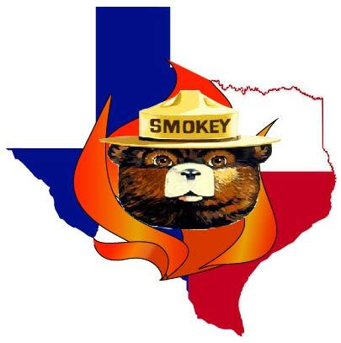
Filing Date: October 28th, 2018

Table of Contents

Introduction…………………………………………………………….……………….…….2
Summary……………………………………………………………………………….2
Purpose Statement…………………………………………………………………....2
Scope…………………………………………………………………………………...2
Tasks…………………..………………………………………………………………..……...2
Work Completed……………………………………………………………………….2
Work Ongoing………………………………………………………………………….8
Project Revisions……………………………………………………………………....9
Conclusion………………………....………………………………...………………..….......9

1. Introduction
1.1 Summary
The City of Austin Fire Department’s Wildfire Division is interested in receiving an in-depth geographic analysis of a 6-1/2-year span of reported fire incidents within their municipal boundary. The wildfire division has requested a temporal and spatial analysis of ignitions, as well as an ignition-potential analysis to better understand where existing trends occur and where potential trends could occur. They are also interested in knowing the weather conditions when a wildfire occurred to better understand the correlation between these two variables.
1.2 Purpose Statement
This study aims to observe the trends and causes of wildfires within the Austin community, as well as develop predictive locations for possible future fires based on fuel type and population. The point data, vegetation model, and a fire rate-of-spread (ROS) model has been provided by the Austin Fire Department Wildfire Division. Bobcat Wildfire Consultants have gathered all supplemental data through open-source information.
1.3 Scope
We used the Austin city limit polygon for our study limit, including four smaller polygons within the Austin boundary. They represent Westlake Hills, Sunset Valley, San Leanna, and Rollingwood. We decided to include these communities in our analysis to have an all-inclusive Austin-area study. The data collected is from 2012 to July 2018, however, we will be doing analyses that attempt to look into future possibilities of potential wildfires.
2. Tasks
2.1 Work Completed
Our first task was to categorize the fire points by year, and the following graph shows the number of annual reported occurrences:
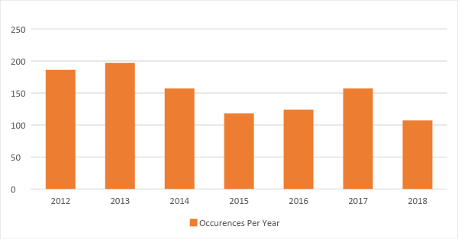
2012: 186 fires
2013: 197 fires
2014: 157 fires
2015: 118 fires
2016: 124 fires
2017: 157 fires
2018 (January to July): 107 fires

Our next task was to address the spatial analysis. We wanted to visually represent the number of wildfire occurrences per census tract and per council district in a map series by year. We accomplished this by aggregating the point data annually, then used the spatial join tool to run a count on the number of fires that were completely contained by a census tract or council district polygon. We then categorized the counted polygons into five classes using the Natural Breaks classification method. The following maps depict our results showing the yellow polygons with the fewest wildfires and the dark red polygons with the highest number of wildfires.

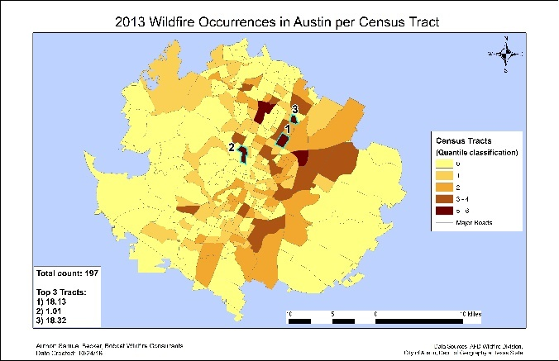
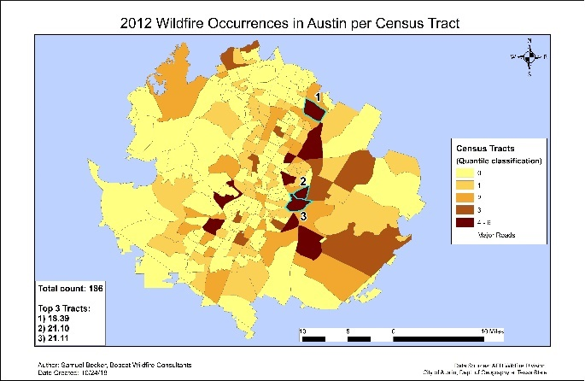
Wildfires Occurrences by Census Tracts

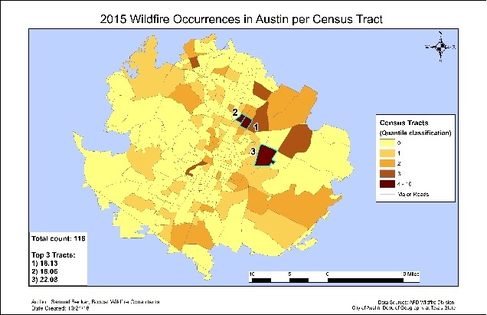
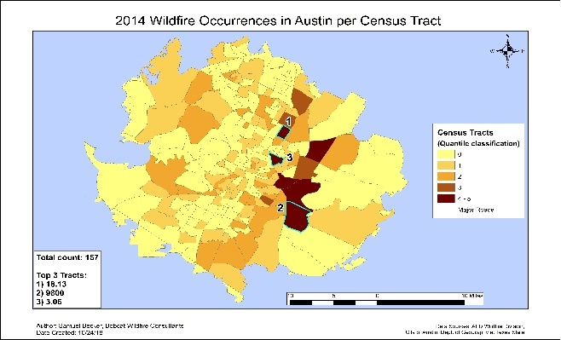

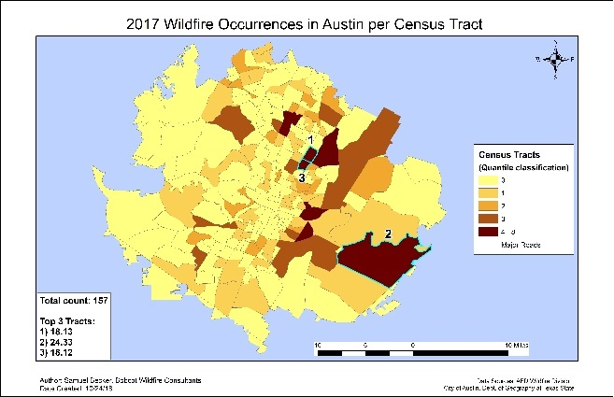
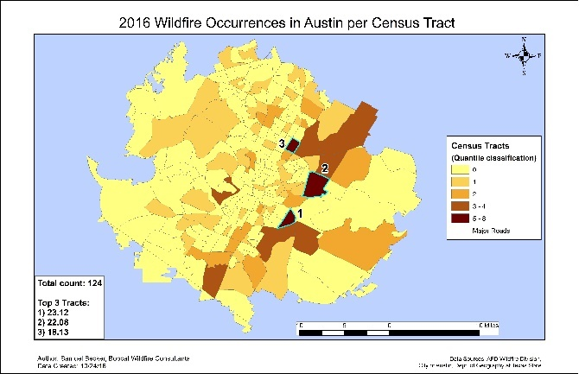

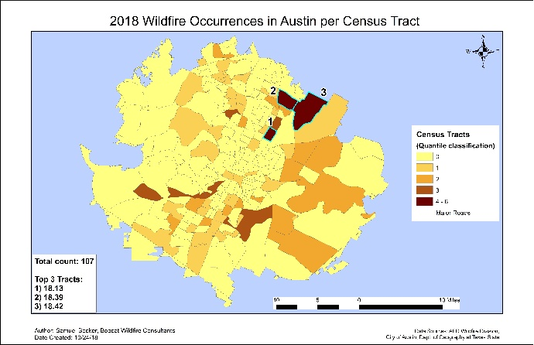

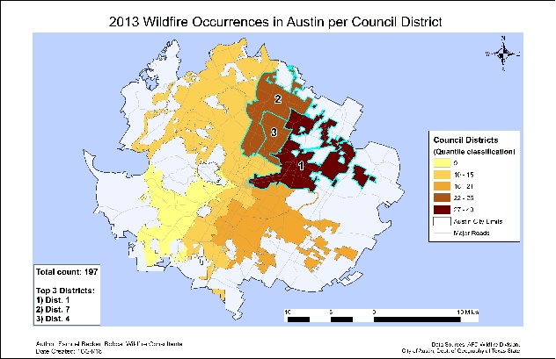
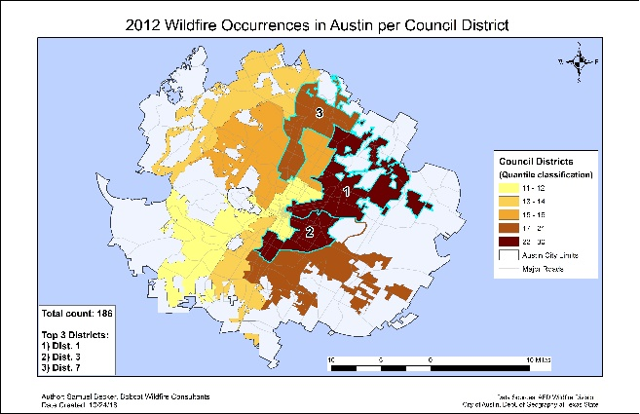
Wildfires Occurrences by Council Districts

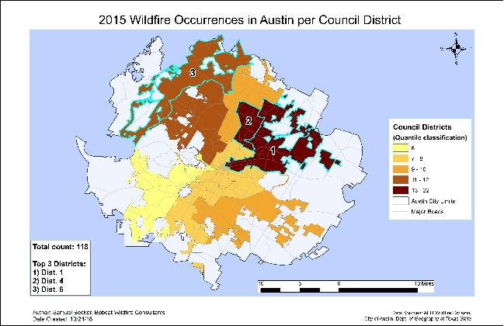
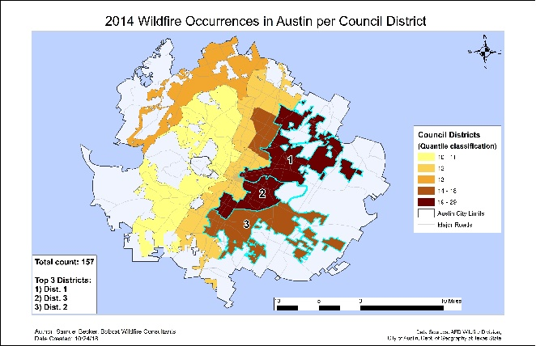

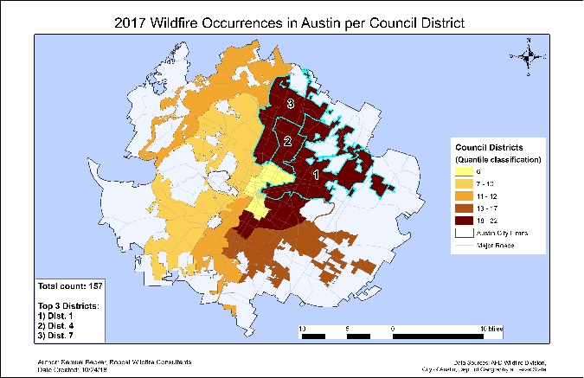
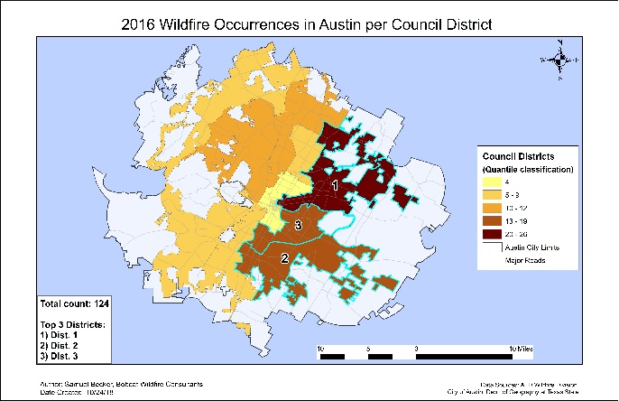

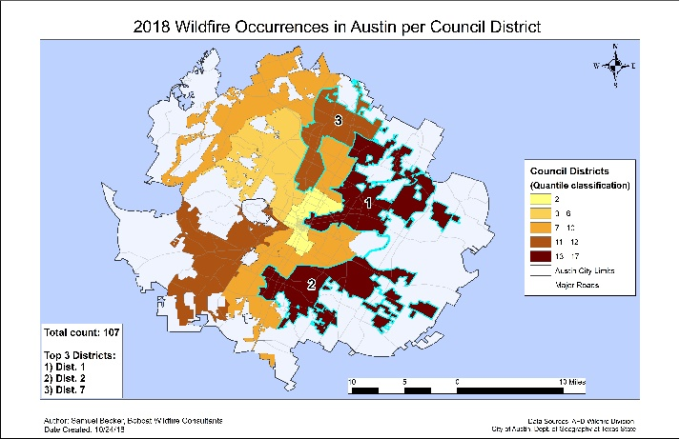
*If it becomes necessary to see the Census Tract maps and/or Council District maps at a higher quality than the above, download them from this document and view them in a photo-viewing application; they were all exported at 600 DPI, so there shouldn’t be an issue with attempting this*

These maps indicate some useful information. The census Tract that contained the highest number of recurring wildfires was Tract 18.13, and the Council District that contained the highest number of recurring wildfires was District 1. Additionally, the maps show that Austin’s eastern region (including northeast and southeast) sees a lot of wildfire activity. The question we want to answer is: how spatially significant is the wildfire activity? We can answer this question by setting out to reject the null hypothesis, which states: There is no clustering of wildfire occurrences in Austin.
To begin, we ran a hot-spot analysis using all wildfire points from 2012 to 2018. We had an option to run a general hot-spot analysis that looks at weighted point features or an optimized hot-spot analysis that counts the number of features within a specified cell size over the entire study area. Both of these options identify statistically significant hot and cold spots using the Getis-Ord Gi* statistic, which measures the intensity of clustering of high or low counts of wildfires in a cell relative to its neighboring cells (1). The output features between the two options differ in that the general hot-spot analysis produced a graduated point symbol and the optimized analysis resulted in a grid of fishnet polygons. We preferred the output as polygons to represent a continuous, more visually appealing hot spot area, especially when considering adjacent polygons. We also didn’t need to consider weighted values associated with the wildfire points, as required when running the general hot-spot analysis - we were merely concerned with their locations.
By counting the number of wildfire points within each cell the resulting output features depict the concentration of wildfires. The polygons are represented as a cell area measuring one thousand feet squared (22.96 acres). Looking at the attribute table, we identified the spatial significance. The returned hot-spot polygons are characterized with high z-scores and low p-values. The highest z-score was 17.99, revealing the number of standard deviations outside of a normally distributed dataset. Additionally, there were several low p-values of zero, indicating that the probability of randomness among the wildfire points in unlikely. When considered together, these scores confirm to us that it’s unlikely that the spatial pattern of the wildfires is completely random and allows us to reject the null hypothesis. The following maps show our hot-spot results, aggregated annually, where the red polygons represent those areas where fire incidents are highly concentrated:

Optimized Hot-Spot Analysis
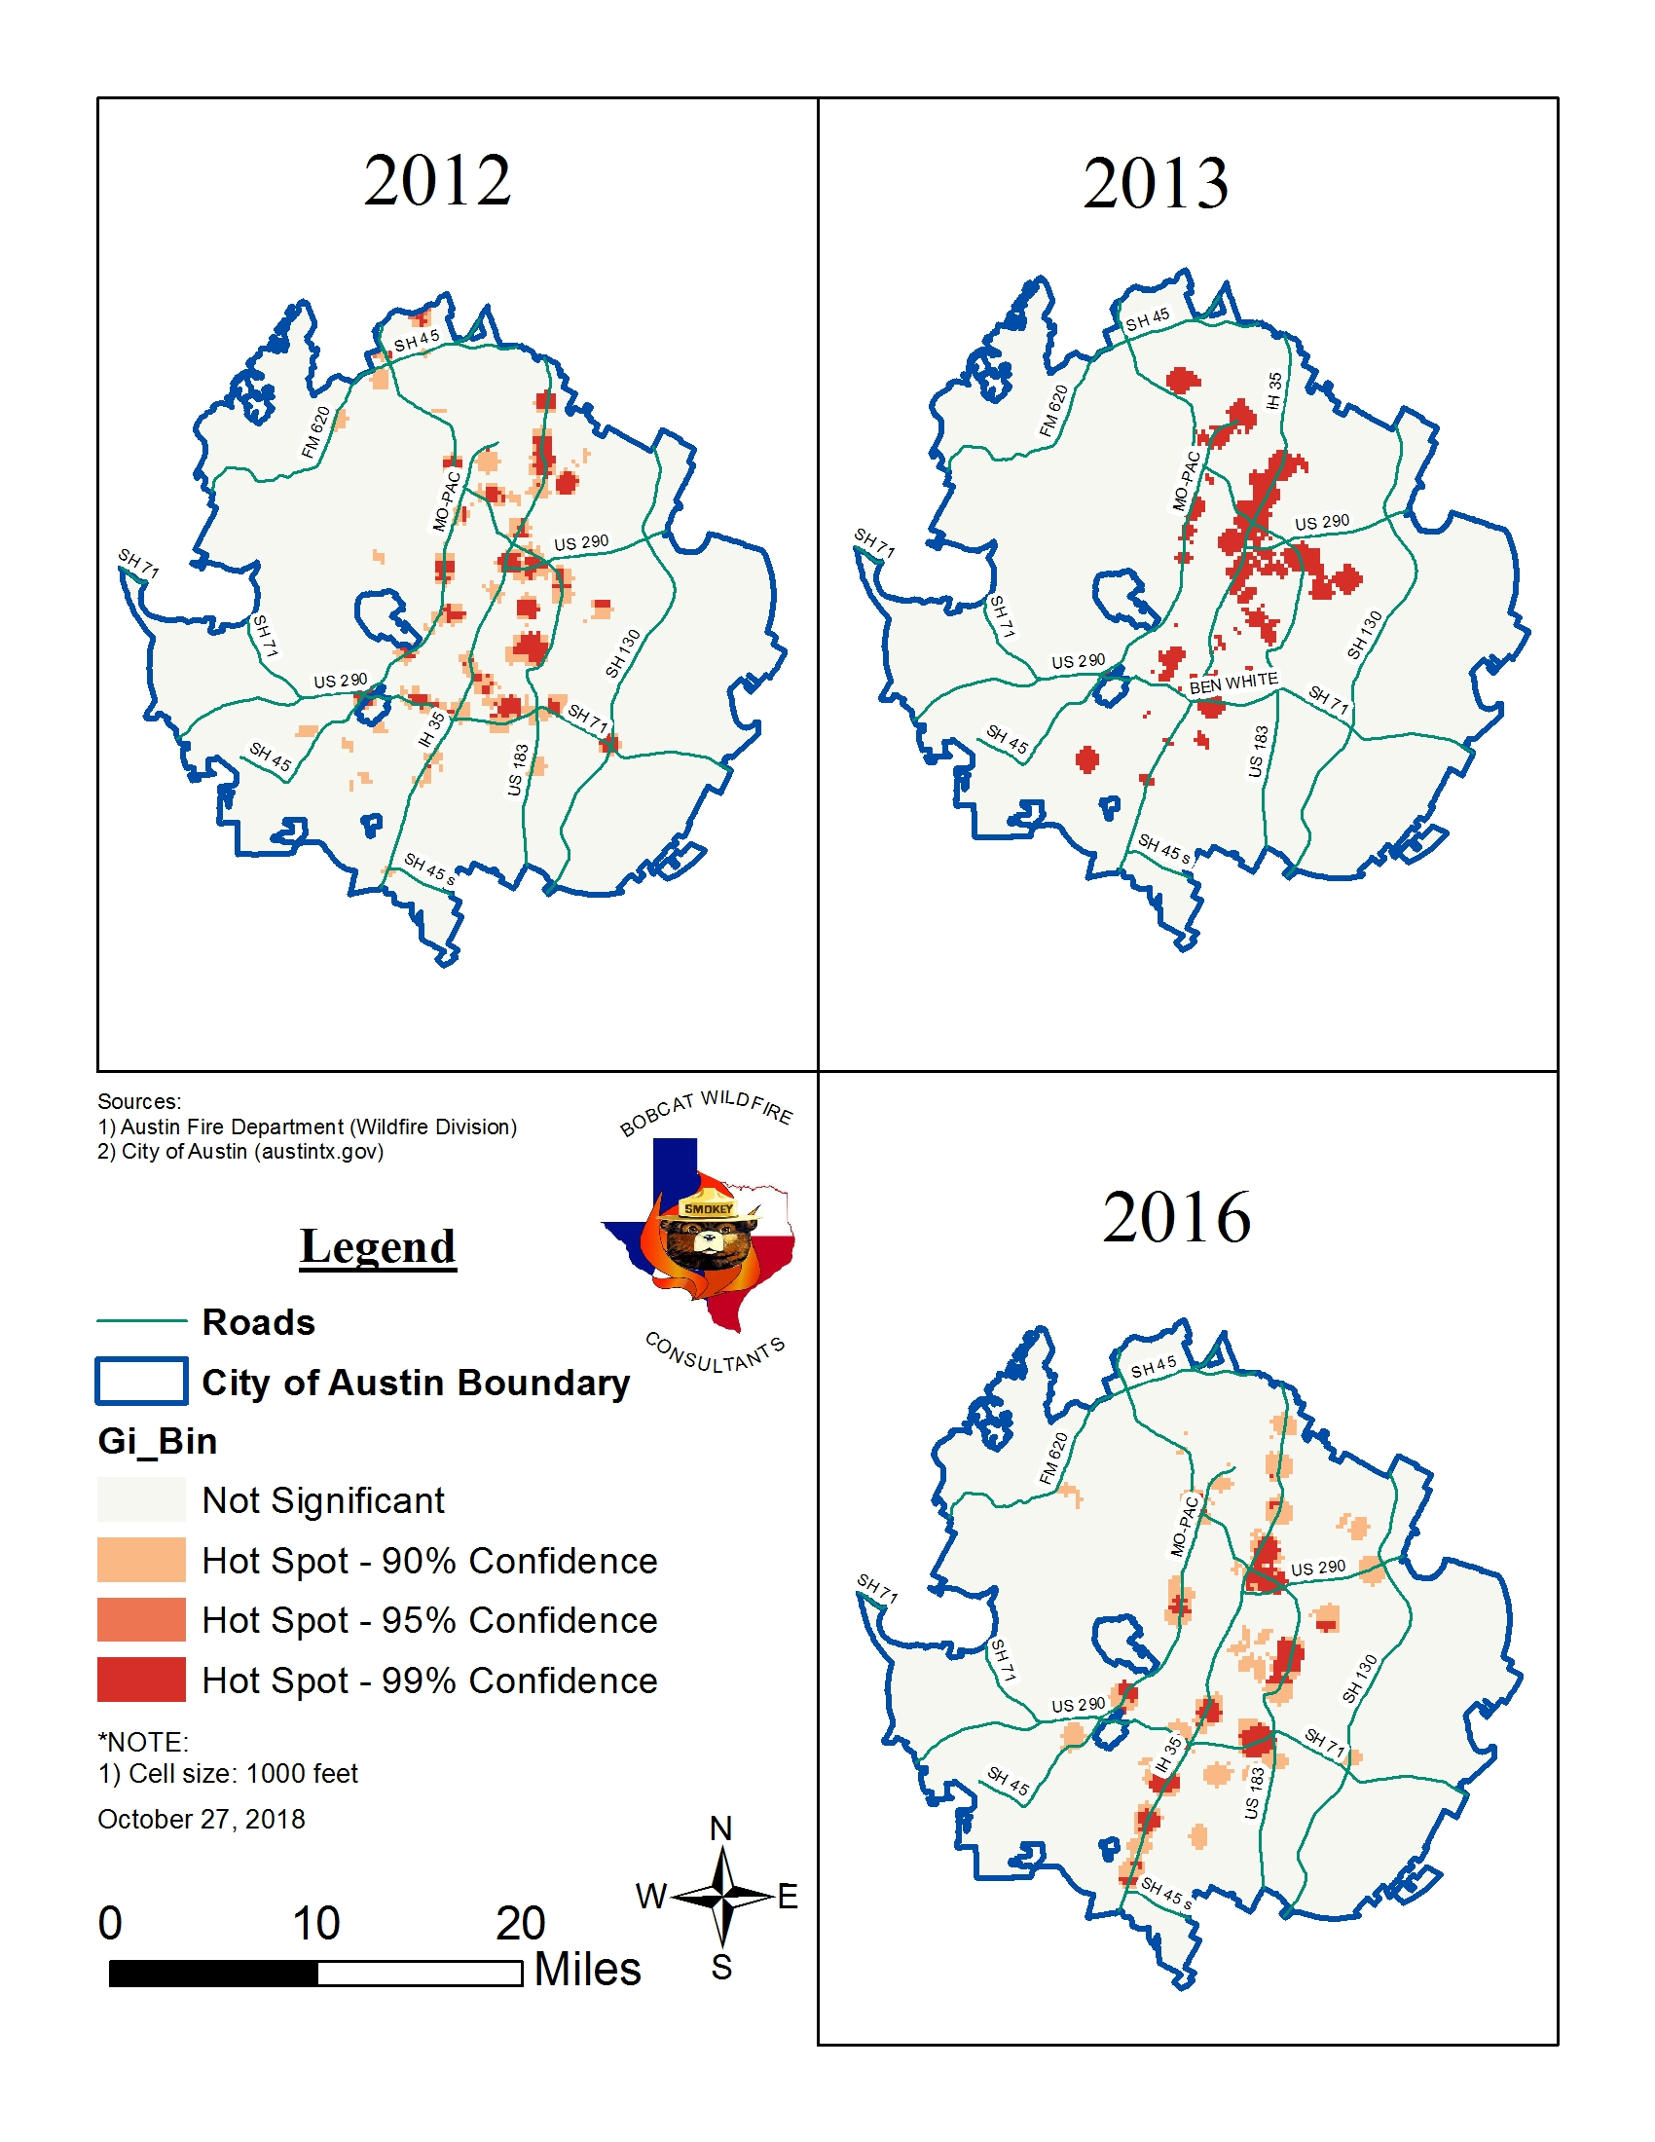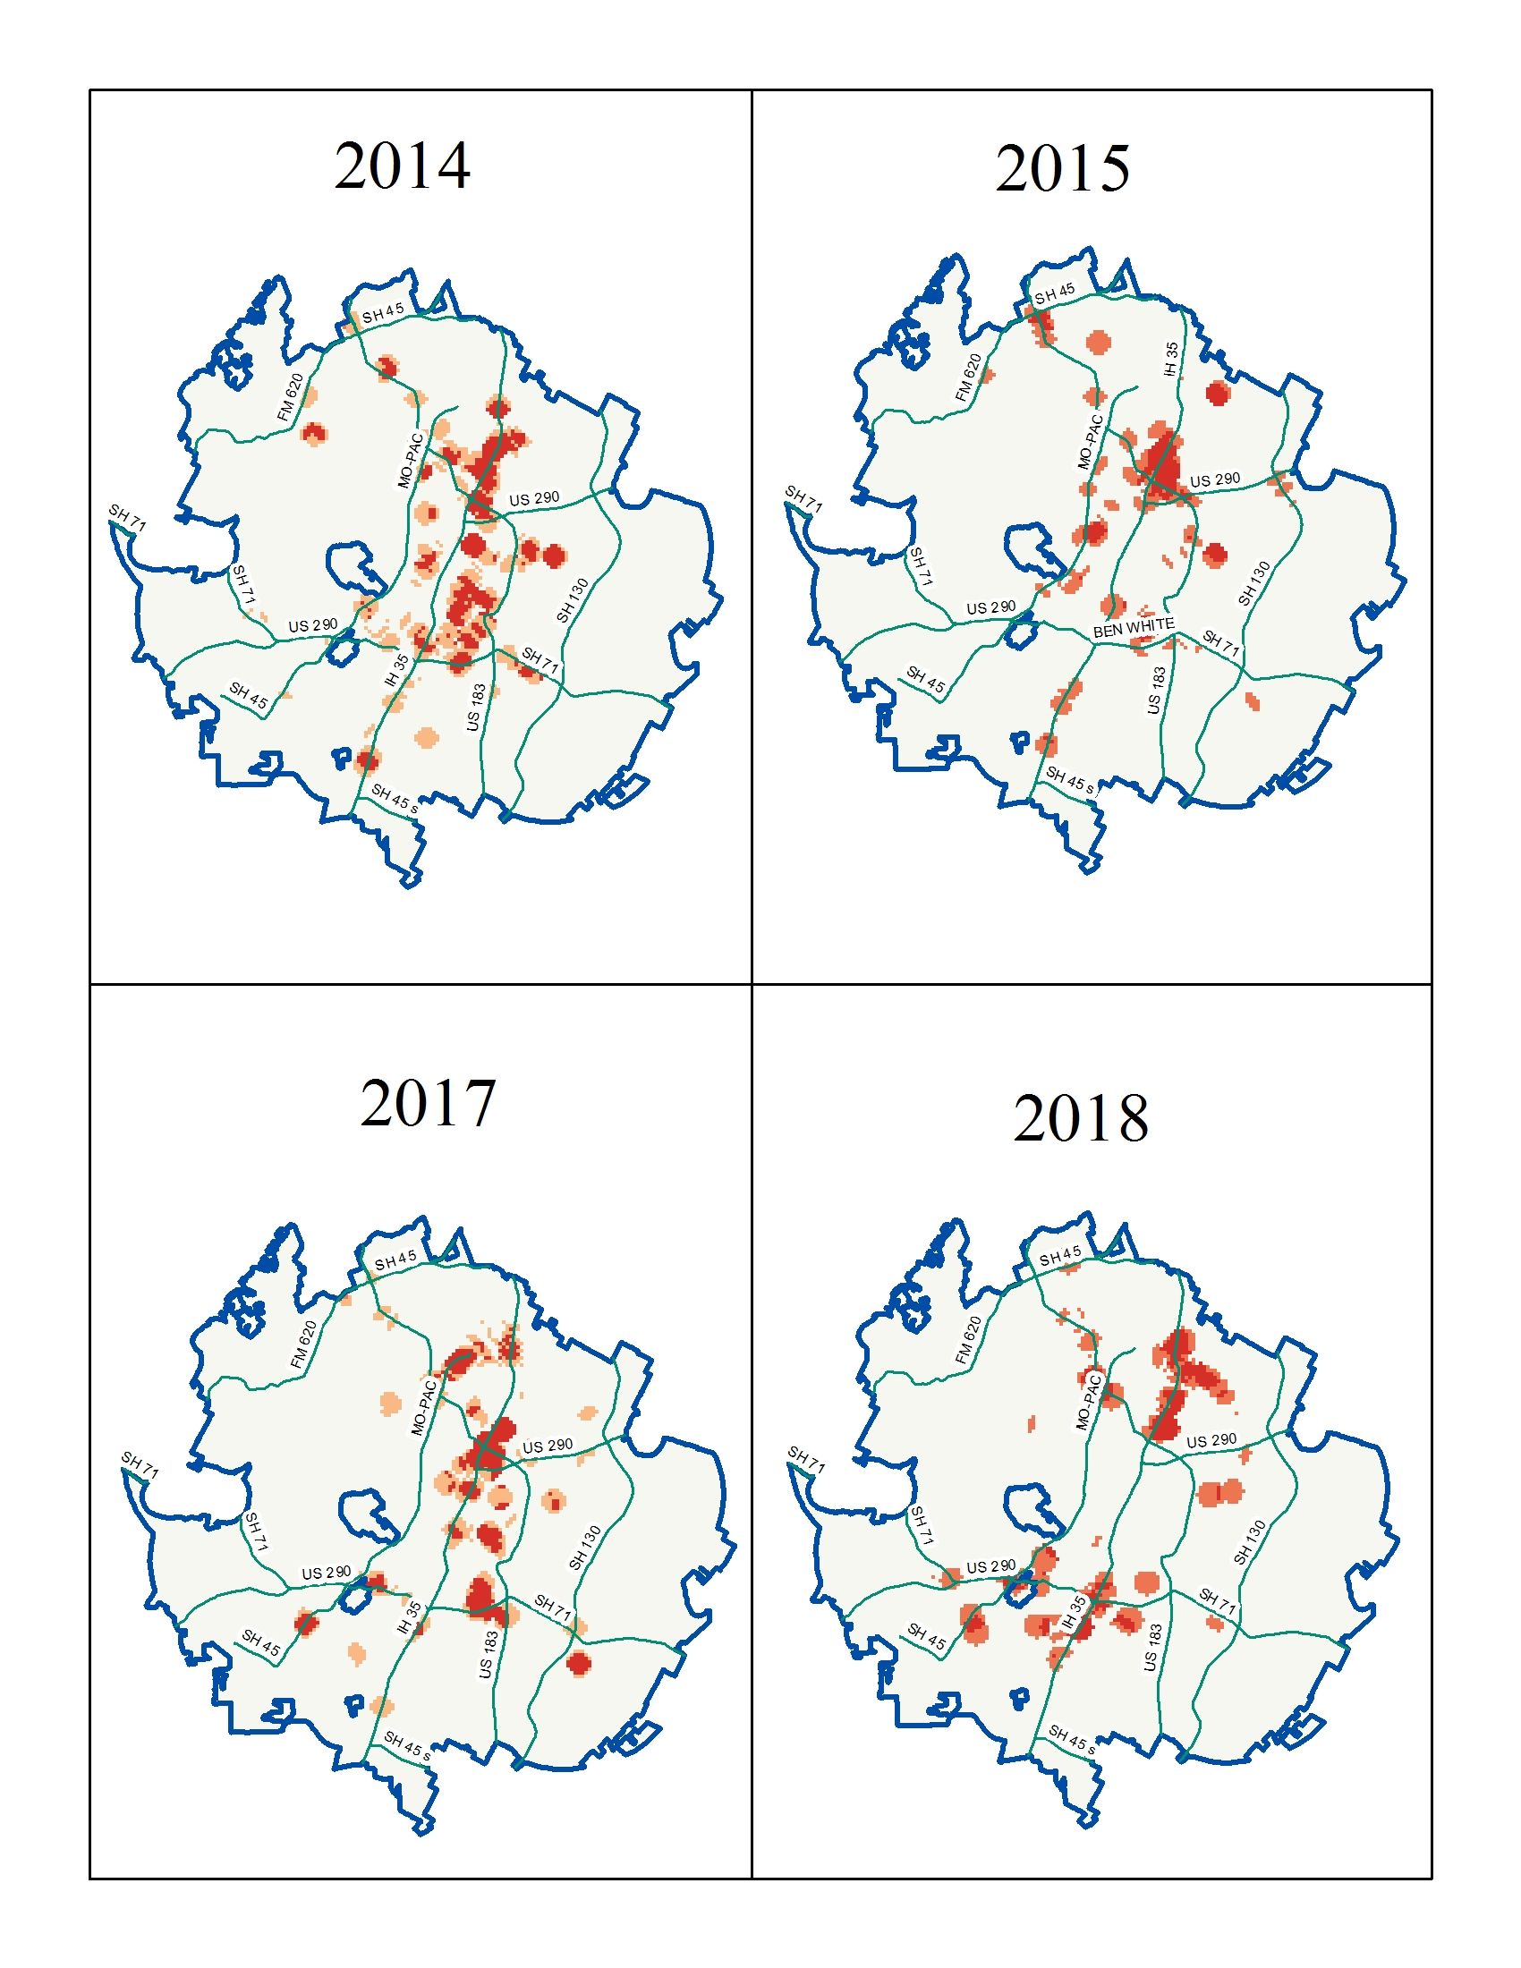
The hot-spot results revealed, not only the spatial significance of the fire locations, but also the directional distribution of the fires coinciding with major roads. There’s an implication here that most fires are a result of human activity (i.e. cigarettes or sparks from a vehicle). We plan to report more information on the cause and location relationship.

For our temporal analysis we graphed the entire 6-1/2 year dataset by hour of the day to reveal what time of the day most wildfires occur. Representing midnight as zero and 11 p.m. as 23 along the x-axis, the graph reveals that the most active time of the day for wildfires is between 9 a.m. and 7 p.m. The 1 p.m. hour returned the most fires with 145. This coincides with busy travel times, especially during and after the lunch hour. The graph below shows our results:
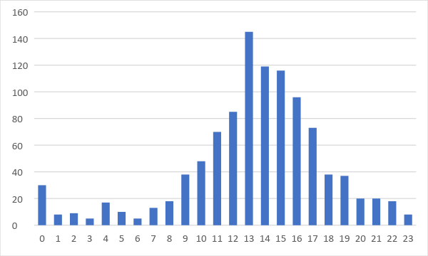

Graphing the wildfires by quarter (season) as seen in the graph below, revealed that most fires occur during Summer, specifically between July and September. This is usually the time when hotter weather produces dry vegetation, rainfall is less frequent, and prevailing south winds are most present, thereby increasing the perfect conditions for a fire.
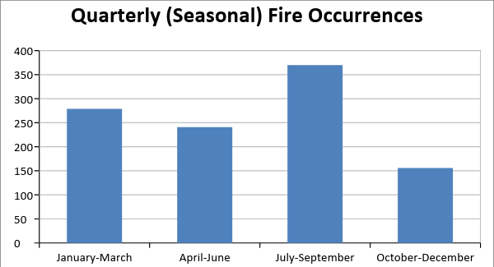

2.2 Work Ongoing
We are still planning to look at the most active day of the week for wildfire activity. We’re researching a method for extracting the day of the week based on a mm/dd/yyyy format in Excel. Once we pin down a solution to achieve this we’ll be able to show the most likely day for a wildfire occurrence, in graph form. Other ongoing work includes a regression analysis and an ignition potential analysis. More information to come on this.

2.3 Project Revisions
No major revisions have taken place. We’ve added one additional source to the literature review that discusses the hot-spot analysis in detail regarding the usefulness of the Getis-Ord Gi* statistic. This source is listed below:
- Using spatial statistics to identify emerging hot spots of forest loss, by Nancy L Harris, Elizabeth Goldman, Christopher Gabris, Jon Nordling, Susan Minnemeyer, Stephen Ansari, Michael Lippmann, Lauren Bennett, Mansour Raad, Matthew Hansen and Peter Potapov., Published 7 February 2017, ©2017 IOP Publishing Ltd., Environmental Research Letters, Volume 12, Number 2, iopscience.iop.org/article/10.1088/1748-9326/aa5a2f

3. Conclusion
By identifying where and when wildfires occur most often plus the areas with the highest ignition potential, we can not only help educate the general public, but also assist important decision makers in determining if the city has a sufficient number of resources to control to the occurrences. We’re on task to meet the final deliverable date of December 3rd.

