Final Report:
Geographical Analysis of Austin Fire Department’s Wildfire Ignitions
from January 2012 to July 2018

Prepared by Bobcat Wildfire Consultants:
David Olguin - Manager
Thanh Nguyen - Schedule Coordinator/Analyst
Jorge Perdomo - Budget Coordinator/Analyst
Samuel Becker - Literature Reviewer/Analyst
Rhodes Smartt - Data Coordinator/Analyst
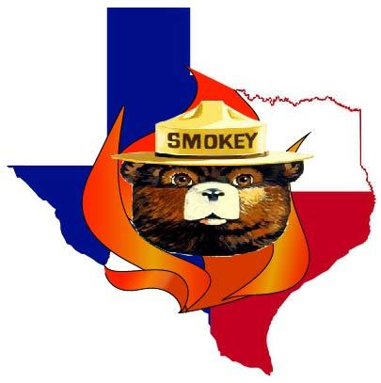
Filing Date: December 3, 2018

Table of Contents
Abstract……………………………………………………………...………………………….....2
1.Introduction………….…………………………………………………………………………..2
2.Data……………………………………………………………………………………………...3
3.Methods…………………………………………………………………………………………5
3.1 Spatial Analysis……………………………………………………………………….8
3.2 Temporal Analysis……………………………………………...……………………10
3.3 Regression Analysis………………………………………………………………….11
4. Results and Discussion……………………………..………………………………………....11
4.1 Spatial Analysis…………………………………………………………………..….14
4.2 Temporal Analysis…………………………………………………………………...19
4.3 Regression Analysis………………………………………………………………….21
5.Conclusion………………………………………………………………………..……………24
6.References…........………….………………………………………………..……………....…25
7.Appendix I: Group Members Contribution…….………………….......……..………………..27
8.Appendix II: Metadata……….……………………………………………..………………….28

Abstract
The Austin Fire Department Wildfire Division (AFDWD) documents hundreds of reported fire ignitions a year. Because of this there’s an imminent need to geographically analyze the factors involved in the creation of these human-induced incidents. This study was completed by Bobcat Wildfire Consultants (BWC), and looks at a 6-1/2 year window of 1,046 reported ignitions that occurred within Austin’s municipal boundary from January 2012 to July 2018. The spatial analysis will show a quantitative report of ignitions by administrative boundaries as well as a hot-spot analysis that shows where ignitions are concentrated based on their nearest neighbor clustering. A temporal analysis tracks and graphs the number of reported ignitions per year, the highest number of ignitions by hour of the day, the number of ignitions by day of the week, and a fire count categorized by seasons. We wrap up the report with an ordinary least squares (OLS) and geographically-weighted regression (GWR) to produce an ignition potential model for fire density by using fuel data (i.e. vegetation) as our explanatory variable. With this report we intend to aid decision makers in understanding where current wildfire threats pose a risk to people and property and where to effectively manage resources to help control these threats.
- Introduction
Austin, Texas has a population of over one million people and is growing every day. With around 450,000 residents living within the wildland urban interface (WUI), which is the area where housing and burnable vegetation meet, it is imperative to report where the threat is and what potential hazards could arise for citizens living within these areas. Due to extensive droughts and high levels of vegetation density, one of the largest threats we have here in Central Texas is wildfires. Cases of these wildfires can be seen all over Central Texas, with the Bastrop Complex fire of 2011 being a prime example, which destroyed 1,700 homes and consumed more than 340,000 acres (Headwaters). The benefits of a geographical analysis will help reveal hidden patterns in the data. In order to accomplish this, BWC will work with the AFDWD to provide a geographical analysis of their reported wildfire ignitions. As such, we’ve set out to provide a comprehensive perspective of AFDWD’s reported ignitions in terms of spatial distribution, temporal relationships, and predictive modeling. By following thorough steps in our analysis, we’ll attempt to answer the question we asked ourselves: Do wildfires most commonly occur in forested areas, where vegetation is most dense?
2. Data
All of our data was secondary-level and obtained from valid sources. Table 1 shows a list of the data we used for this study.
Table 1. Bobcat Wildfire Consultants Master Data List.
Name: | Type: | Source:
Wildfires_All.shp | Ignition Points Shapefile | Austin Fire Department Wildfire Division
CWPP_for_Portal.gdb | Geodatabase | Austin Fire Department Wildfire Division
FlamMap_Input_fuel | Fuel Raster Surface | Austin Fire Department Wildfire Division
ROS_CWPP | Fire Rate-of-SpreadRaster Surface | Austin Fire Department Wildfire Division
FlamMap_Output_N30_risk_spot_n30 | Fire Risk Raster Surface | Austin Fire Department Wildfire Division
FlamMap_Output_N30_flamelength_N30 | Flame Length Raster Surface | Austin Fire Department Wildfire Division
Points_FireDangerRatings.xlsx | Fire Danger Ratings Spreadsheet | Texas A&M Texas Weather Connection
tracts | Census Tracts Polygon Feature Class | Texas State University G.I.S. Data Repository
austinbnd | City of Austin Boundary Polygon Feature Class | Texas State University G.I.S. Data Repository
streets | Roads Polyline Feature Class | Texas State University G.I.S. Data Repository
Arteries_ATXbnd_clip | Roads Polyline  Feature Class | Texas State University G.I.S. Data Repository
CouncilDistricts_Projected.shp | Council Districts Polygon Shapefile | City of Austin
AustinRainfall.xlsx | Historic Rainfall Spreadsheet | Weather Underground

The reported fire ignition points were provided by AFDWD, as was a geodatabase that contained fuels, fire rate-of-spread, fire risk, and flame length datasets. There was some incompleteness with the fire rate-of-spread data as it did not extend to the limits of the Austin boundary, so we decided to use it for map display purposes in the report. BWC also used various open-source data portals for our other data needs. Texas A&M University’s Texas Weather Connection (twc.tamu.edu) was our source for retrieving daily weather conditions based on a fire danger rating. They were divided into five different classes (low, moderate, high, very high, and extreme). Texas State University’s Geographic Information Science data repository (W:\ Drive) was the source for our census tracts with 2010 populations, Austin boundary, and roads layer. The City of Austin (austintx.gov) provided council district boundaries via shapefile. The district boundaries required a reprojection. We gathered Austin’s historic rainfall data from Weather Underground (wunderground.com).

3. Methods
Our methods were completed using spatial analyst tools in ArcMap, version 10.6.1, and Microsoft Excel. The flowchart diagrams in Figure 1 show a general set of decisions, inputs, and processes we followed for our analyses. We reprojected the ignition points and council districts to North American Datum 1983 Texas State Plane Central Zone, U.S. feet, to stay consistent with our client-provided data. In order to provide a comprehensive report on the wildfires, we used three different analyses which all required varying methodologies.

a)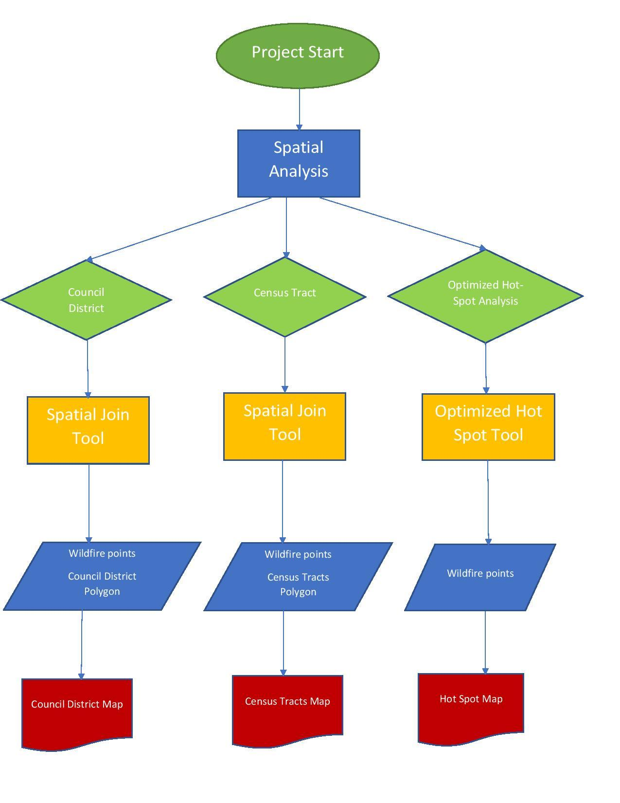
b)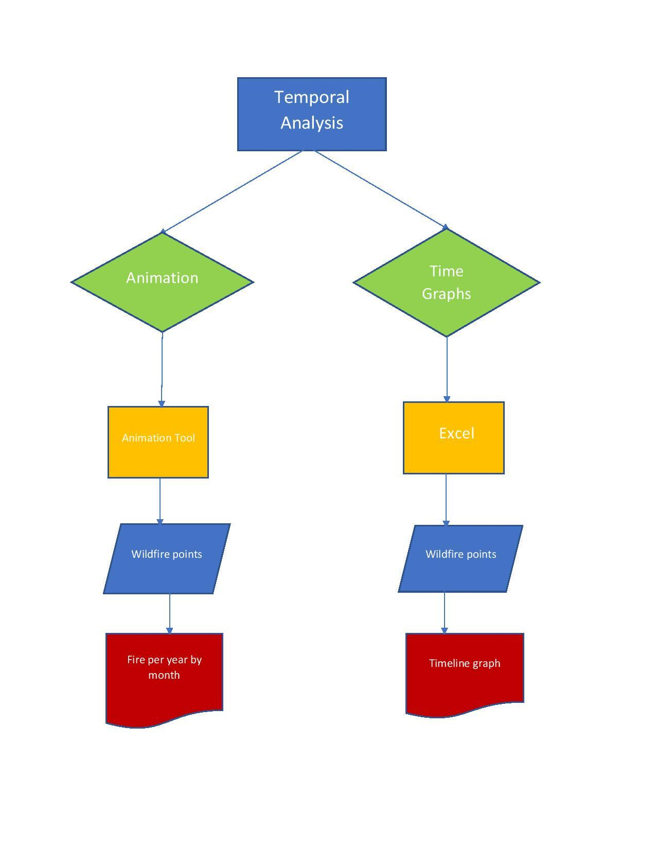
c)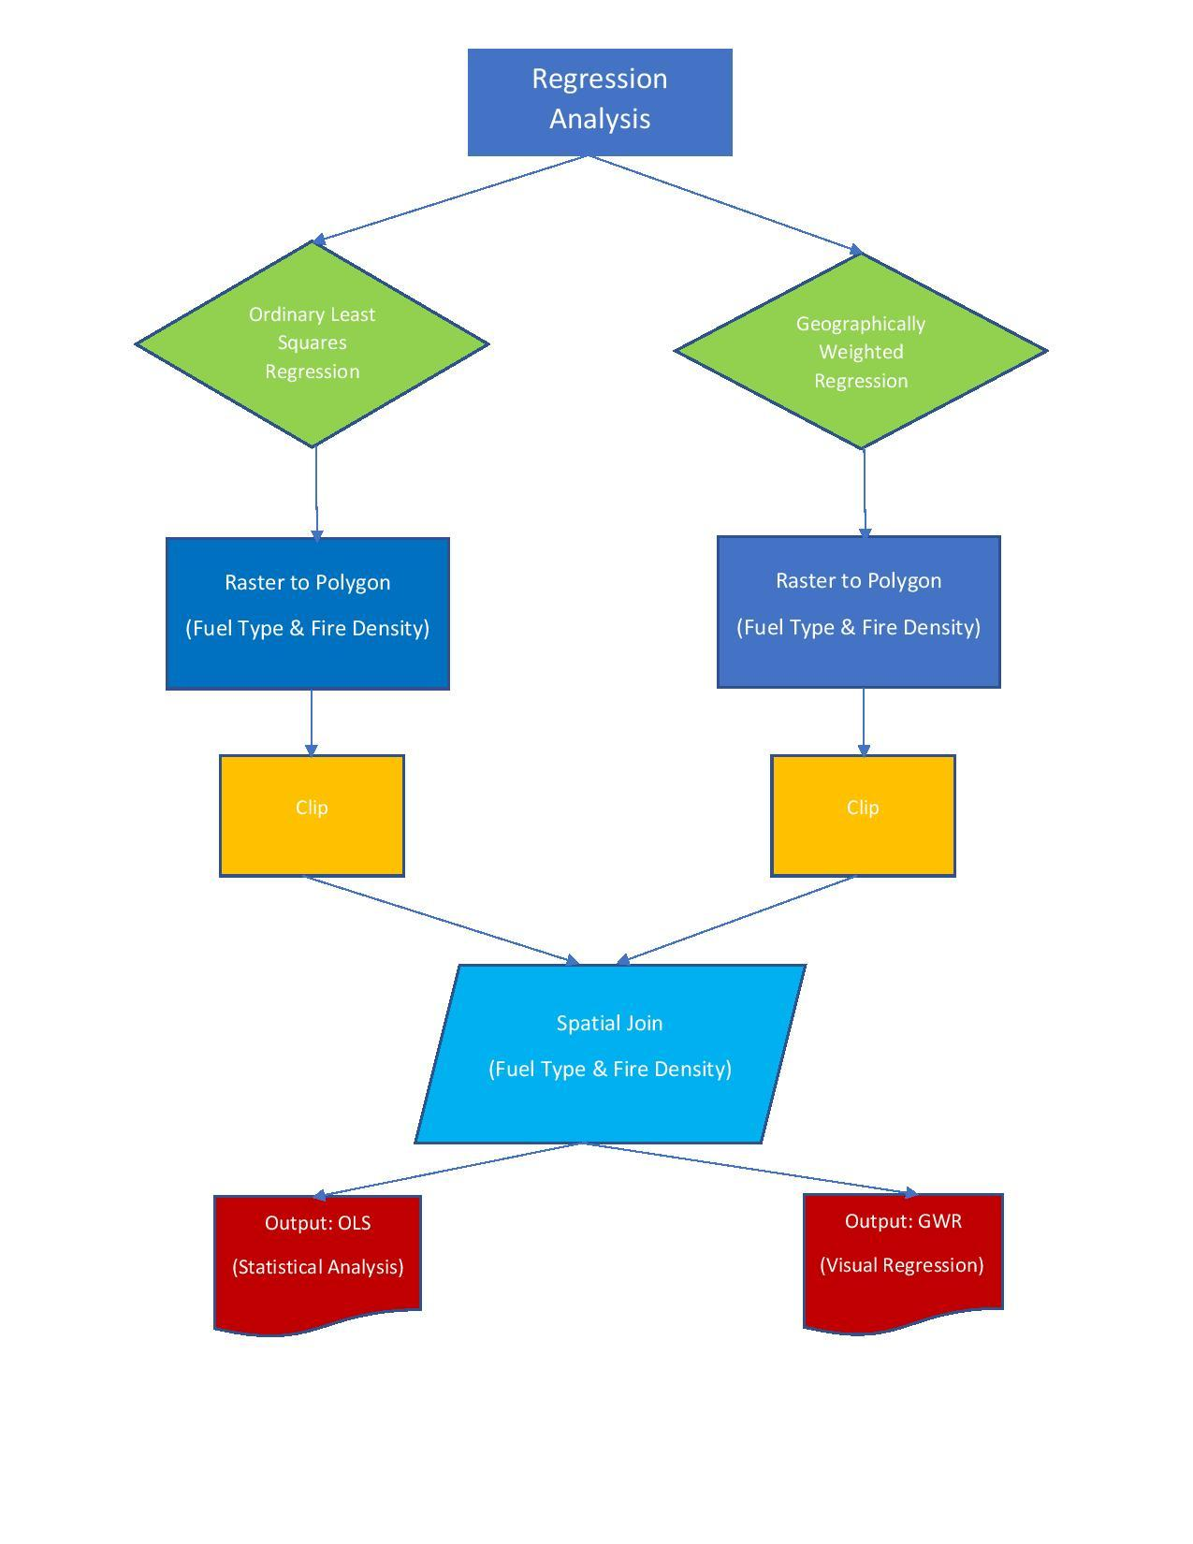
Figure 1. Methodology flowchart for our different analyses. Figure 1a. Spatial analysis workflow. Figure 1b. Temporal analysis workflow. Figure 1c. Regression analysis workflow.
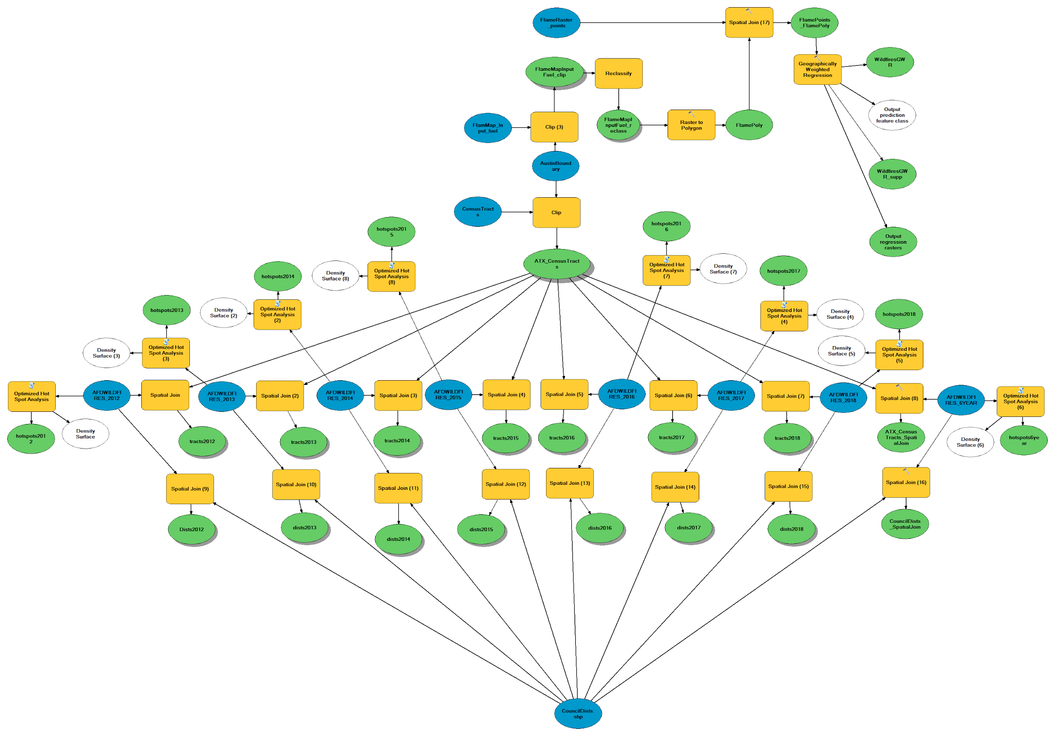
Figure 2. Model builder diagram generated in ArcMap 10.6.1.

We utilized the model builder tool in ArcMap to automate our routines and help reduce the time it took to run certain tools. Figure 2 shows the output diagram and its various components.
3.1 Spatial Analysis
3.1.1 Council Districts and Census Tracts
In order to report on incidents by administrative boundaries we decided to first map the distribution of wildfires by council districts and then by census tracts. To do this we used the spatial join tool to run a count of points that were totally contained by the district polygons. We then categorized the data into 5 classes using the Quantile classification method that displays increasing degrees of wildfire occurrence as the class number increases. There was no way to normalize this occurrence density by council districts because we were unable to find any meaningful population by council district dataset, so this lack of data will be seen as a limitation to our project’s spatial analysis. Continuing on, we analyzed the entire 6-1/2 year dataset and also ran the tool for each year separately. For the occurrence density by census tracts, we decided to again use the Quantile classification method but this time include 6 classes, with the 1st displaying areas that had no occurrences and then the next 5 displaying increasing degrees of occurrences as the classes progress. We were able to normalize this data by the 2010 census’ population figures for the locality to more accurately represent the number of fires as a percentage of each tract’s population.
3.1.2 Hot-Spot Analysis
We ran a hot-spot analysis for all 1,046 wildfire points, then we ran an annual analysis for each year, 2012 to 2018 separately. We ran an optimized hot-spot analysis tool that measures the intensity of clustering of high or low counts of wildfires in a cell relative to its neighboring cells (Nancy). We chose the resulting output fishnet polygons at 1,000 feet squared (∼23 acres) because we wanted an area that was an approximate multiple of our other input datasets that have a cell size of 98.425 feet.
3.1.3 Fire Danger Ratings and Weather Conditions
One of the largest contributing factors to wildfire cause is the weather conditions for the area. To take this into account for our analysis we first went to the Texas A&M Forestry Service website to look at the weather conditions for all the dates for our wildfires from 2012 to 2018. The weather conditions are defined on the website, 5 different classes, as a risk for wildfire ignition starting at low and moving to extreme. We converted the low to extreme system from the website to a numeric 1-5 system with 1 being low and 5 being extreme, and put these values into an Excel spreadsheet that had been exported from the wildfire vector data. We assigned a 1-5 value to all 1,046 wildfires and then joined the Excel spreadsheet back in ArcGIS.
The next step was actually running an analysis on the data and because the data is weighted and spread spatially we decided an inverse distance weighting would be a proper analysis of the data. In the inverse distance weighted (IDW) model, 5 was considered to have the highest weight due to the fact this would be when fires were most likely to occur due to the conditions.
3.2 Temporal Analysis
For our temporal analysis we graphed the entire 6-1/2 year dataset looking at three different parameters. Our data points included date and time stamps associated with their location so we were able to extract these values and create new fields. The new fields we created showed the hour, month, and year of the ignition. We also formatted the dates into a day of the week value. With these values extracted, this allowed us to report and graph various relationships that included the most active hour of the day, the most active day of the week, and the most active season of the entire 6-1/2 year timeframe. All our graphing methods were completed using the tools in Microsoft Excel.
To show an animated progression of the annual count of reported wildfires we used the animate tool in ArcMap. We used the entire 6-1/2 year data and created a new layer for all wildfire points that occured in every month for every year. Shortly after we enabled the “Time” features for the layers to allow the animation to run. The animation tool needed month and year attributes in a certain format (YYYYMM...etc). We chose to arrange the format of the attributes based on the year. Having the monthly data divided in their own layers allowed us to display monthly data on a yearly basis. This made it possible to discern yearly differences between months. However, when it came down to exporting the animation into a deliverable format we ran into difficulties. We could not directly extract the animations due to an unsupported output format but we did extract JPEG or sequential images of the animations. The ability to extract images into a JPEG format from certain years and months was possible because of the animation tool and the enabling of the time function on the layers. We used the sequential images and created GIF files to produce deliverable animations. As a result, we have culminated three time-series animations showing yearly totals, monthly wildfire points and monthly wildfire points between the years to allow comparison. We’ve also created an animated progression of reported wildfires for the months of the year. To accomplish this we accumulated a count for all fires for the entire 6-1/2 years from January to December. Please note, the displays for August to December does not include any 2018 fires because our dataset ended in July.
3.3 Regression Analysis
The regression analysis requires several steps on multiple datasets. In reviewing the literature, we recognized that in order to run a thorough regression analysis we needed to look at two different regression types, namely OLS and GWR. The ultimate purpose for these regressions was to be able to confidently predict where a variable, in our case fire density, would occur based on an explanatory, or independent variable. For our independent variable we chose to use fuels.
4. Results and Discussion
One important and obvious factor with wildfires is available fuel as it relates to vegetation. This takes us back to our first question we had when we started the project. Do wildfires most commonly occur in forested areas, where vegetation is most dense? Initially, we considered densely forested areas to pose the highest risk in terms of available fuel. Upon further research, however, we discovered that fine fuels can ignite easily and burn rapidly because they have more surface area available for contact with oxygen. Large fuels, on the other hand require more heat to ignite (Bowman). Due to this distinction with grass and small brush, we focused our interest in available fuels as they related to grass and shrubland; we considered areas with grass/shrublands to be a big factor in wildfire ignition and spread. This is not to say that people living in Austin’s western region, where forested areas are more prevalent, should be less concerned with the threat of wildfire because we believe that all citizens, regardless of region should be equally aware. Figure 3 shows the distribution of grass and shrub cover based on fuels data provided by AFDWD.
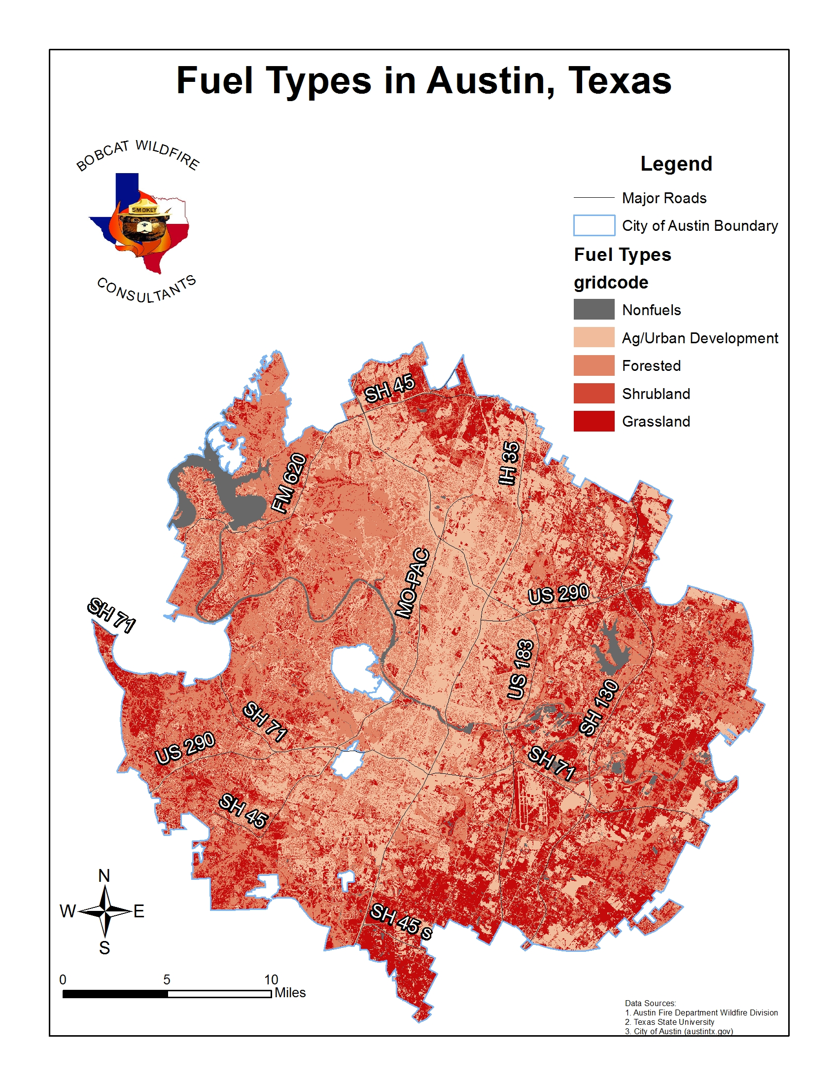
Figure 3. Available fuel distribution in Austin, Texas, showing the abundance of grass and shrub cover in Austin’s eastern areas.

From the fuel map, you can see the abundant distribution of grass and shrub vegetation in Austin’s eastern region, including a portion near the northern boundary that experienced several wildfires in 2013. The literature we reviewed discussed the comparison between forest fires and grass fires and indicates that these areas are just as susceptible to wildfire ignition, especially during hot and dry summers, as those areas with heavily forested vegetation.
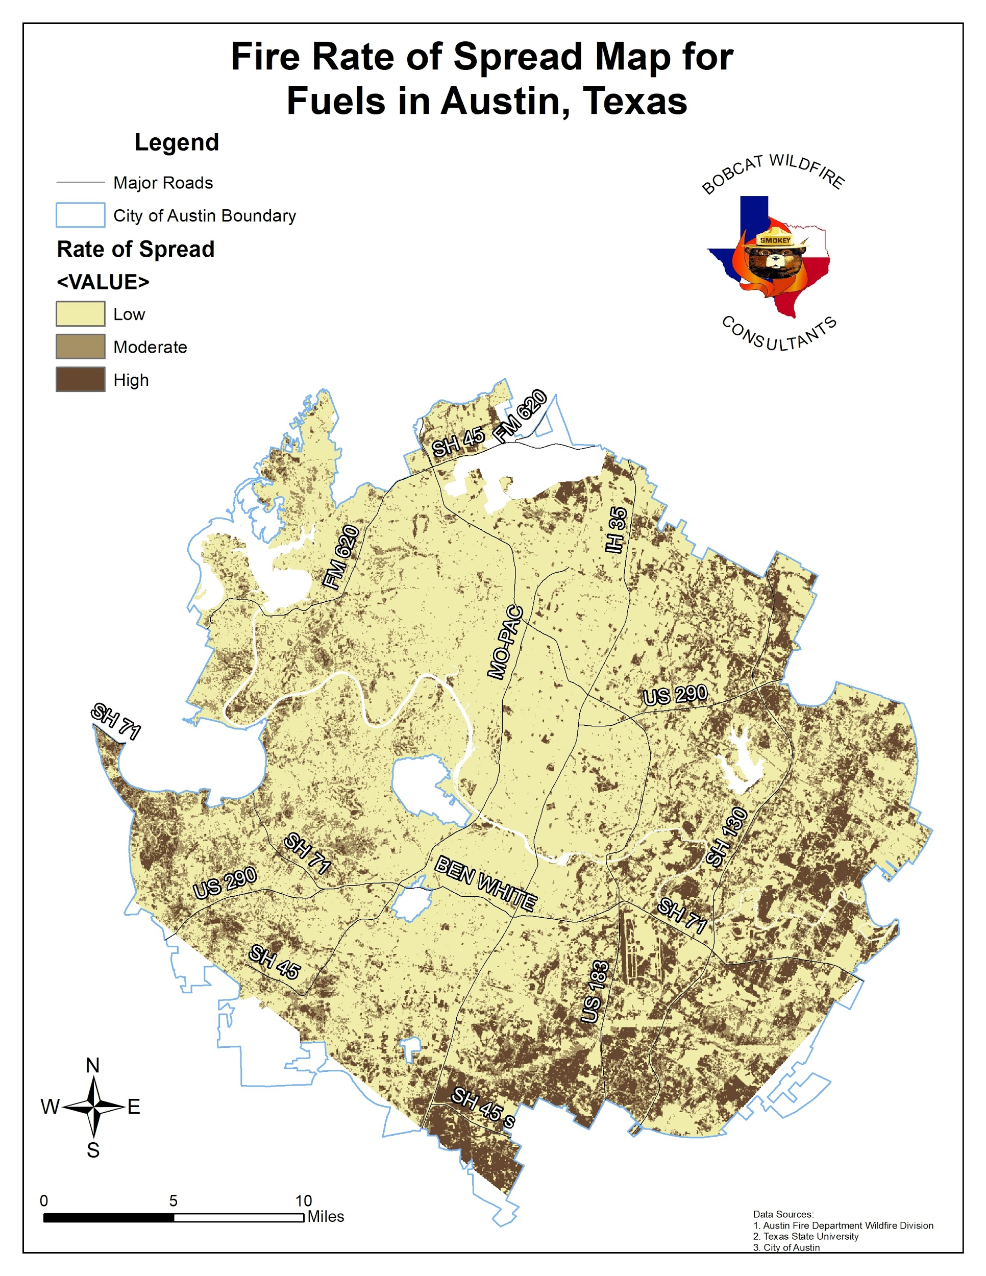
Figure 4. Fire rate of spread map showing where wildfires have the highest potential to move quickly. Austin’s eastern areas have the highest rates due to grasses, crops, and low-lying brush.

Grass and shrub fires have much faster rates of spread and under dry, windy conditions can be extremely difficult to control (Headwaters). Figure 4 shows a fire rate of spread map, and depicts how a lot of Austin’s eastern areas have some of the highest rates of spread. This area of Austin falls in the Blackland Prairie subregion, which is rich in native grasses, crops, and low-lying brush, making the threat of wildfire omnipresent. Similarly, Austin’s western region, located on the edge of the Edward’s Plateau, and straddling the Balcones Escarpment is rich in dense stands of oak, mesquite and juniper woodlands and is no less at risk for a wildfire event. It’s imperative for the general public to understand that the threat of wildfire danger is equally important, no matter where you live in Austin.
4.1 Spatial Analysis
We used two different sets boundaries for our analysis. They were council boundaries, of which Austin has 10 districts, and census boundaries, of which there are 199 tracts within Austin’s municipality. Although we’ve only shown boundary level data further research into different demographic behaviors could help provide a better understanding of wildfire awareness.
4.1.1 Council Districts
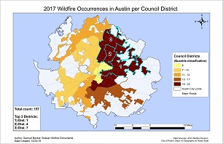
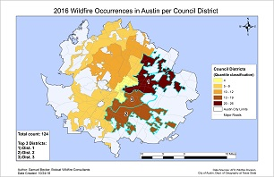
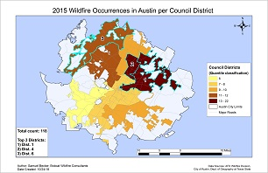
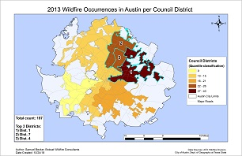
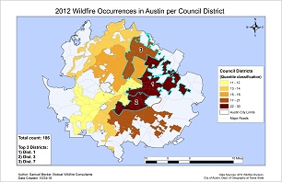
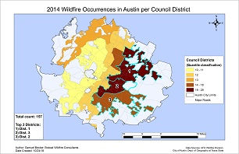
The council district that contained the highest number of recurring wildfires was District 1, and the districts located to the east of I-35 repeatedly reached the 2nd and 3rd spots for districts that have the most wildfires for every year studied. There were some years where the north districts had a high enough incident rate to appear in the top 3, however, the norm of this 6-1/2 year study is that most wildfires occur to the east of IH-35, particularly in the Rundberg-Cameron area that lines up with District 1, which can be seen in the district maps in Figure 6.
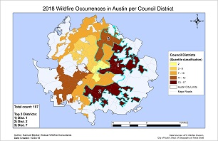

Figure 6. Council district maps showing annual concentrations.

4.1.2 Census Tracts
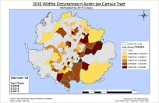
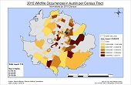
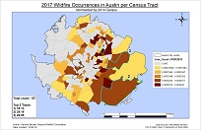
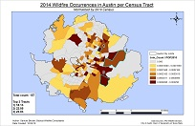
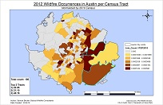
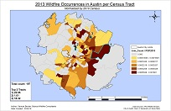
The census tracts that contained the highest number of recurring wildfires were Tracts 22.05 and 18.13, both of which are located in the northeast Austin area just east of IH-35. This Rundberg Lane to Pflugerville stretch near IH-35 was revealed to be the persistent area of most wildfire occurrences each year and for the whole 6-1/2 year study, with some deviational occurrences being dispersed all throughout the Austin city limits for some of the study years. The overall rule is that, much like the council districts’ spatial pattern of wildfire occurrences, fires are repeatedly occurring just east and along IH-35, predominantly in the Rundberg Lane area. Figure 7 reveals this clustered pattern in greater detail.
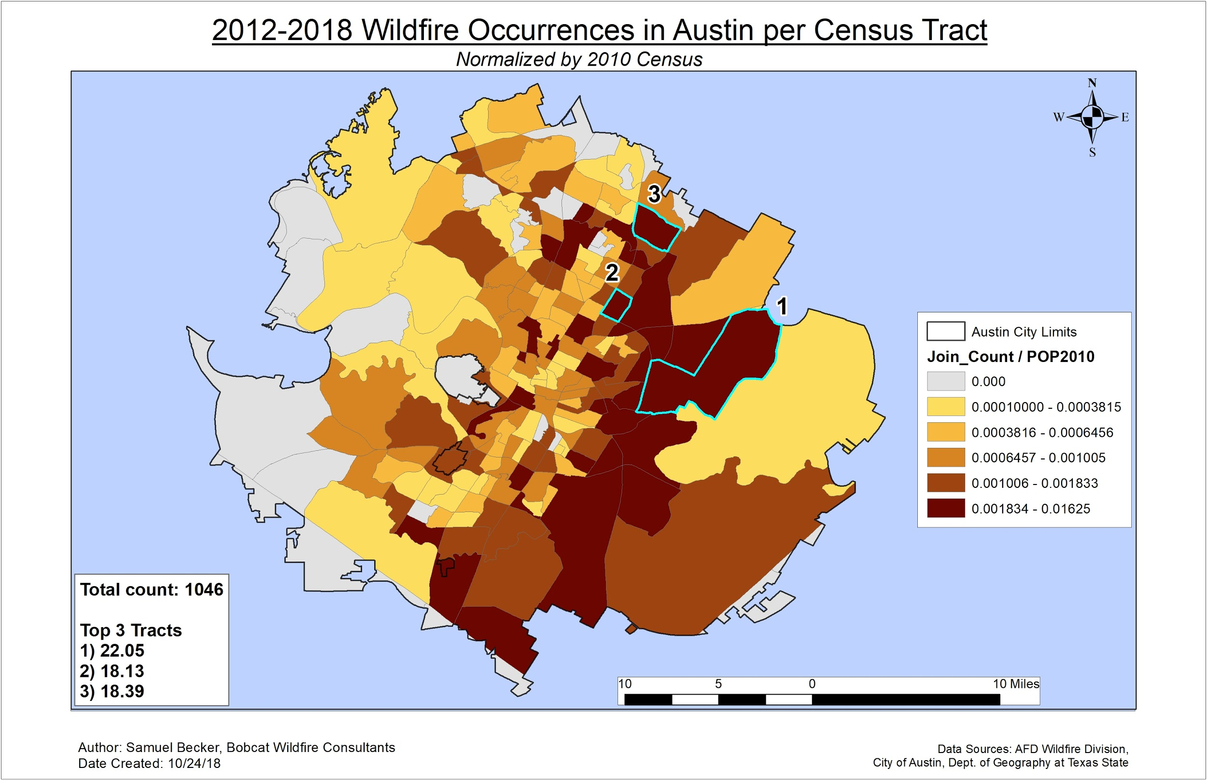
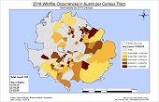

Figure 7. Census tract maps showing annual fire concentrations as well as an overall 6-1/2 year concentration.

4.1.3 Optimized Hot Spot Analysis
Our hot spot analysis indicated some interesting results that showed a high concentration of reported wildfires consistently along major roads as seen in Figure 8. Figure 8a shows our yearly results from the analysis and the clusters in relation to the roads. Austin experienced the most fires in 2012 to 2014 and can be attributed to low rainfall during those years, before a spike in 2015. Taking a closer look at 2013, we see the concentration of fires along IH-35 and US 183. Not only are these highways lined with grass that ignites easily during dry conditions, but they’re also heavily traveled arteries carrying thousands of commuters daily. Figure 8b shows the hot-spots when we ran all 6-1/2 years.
a)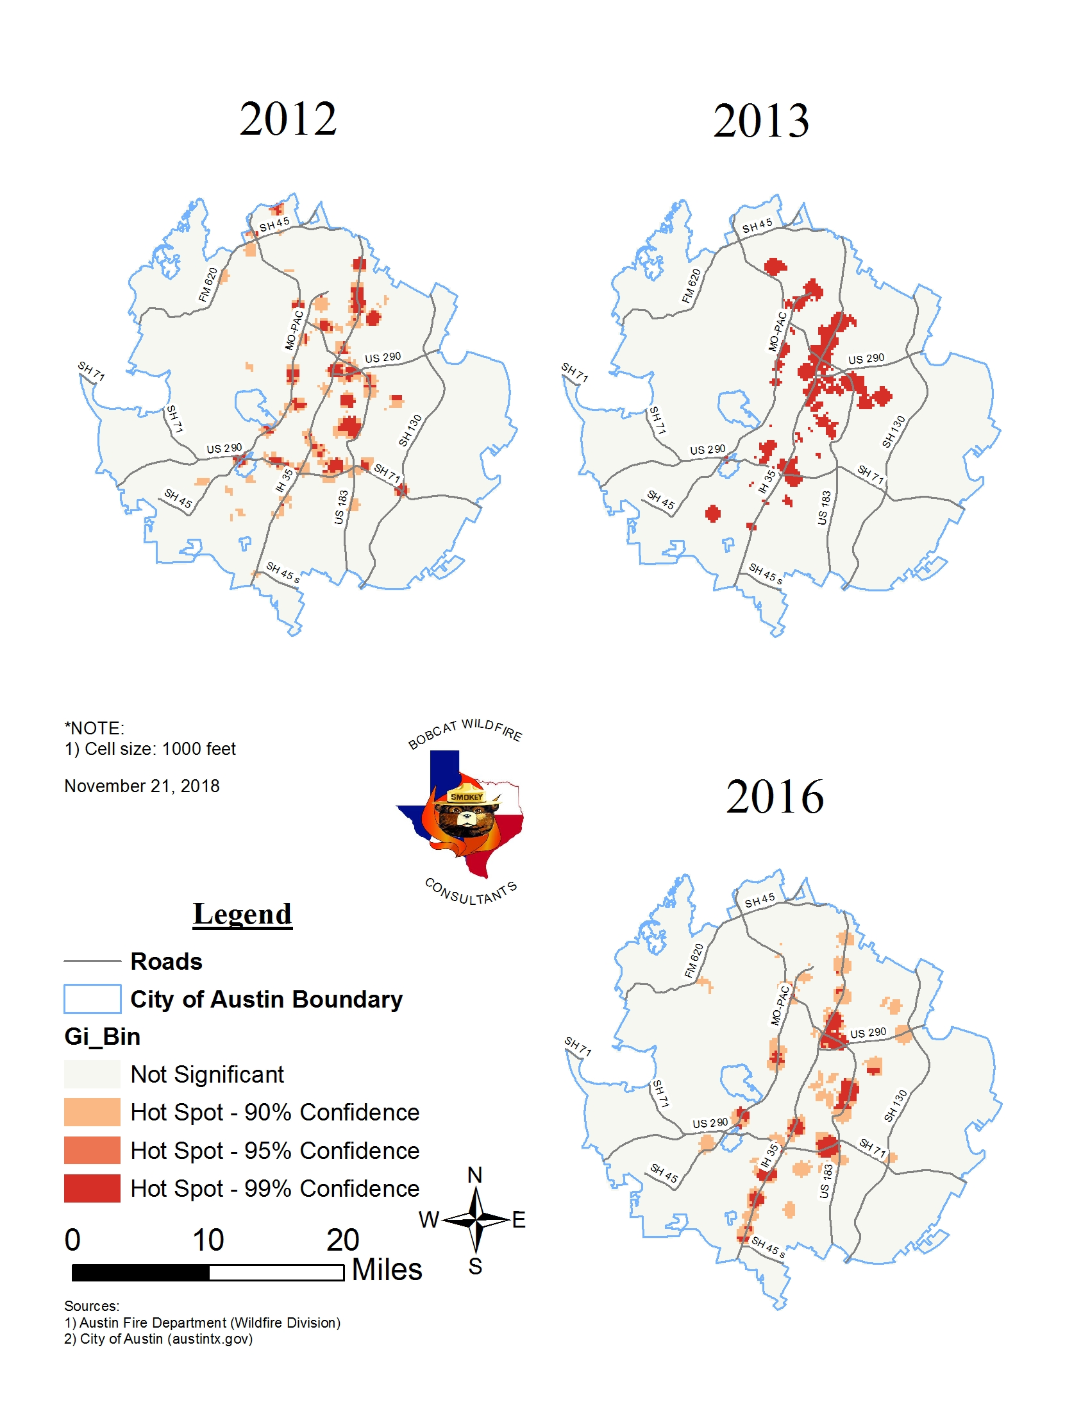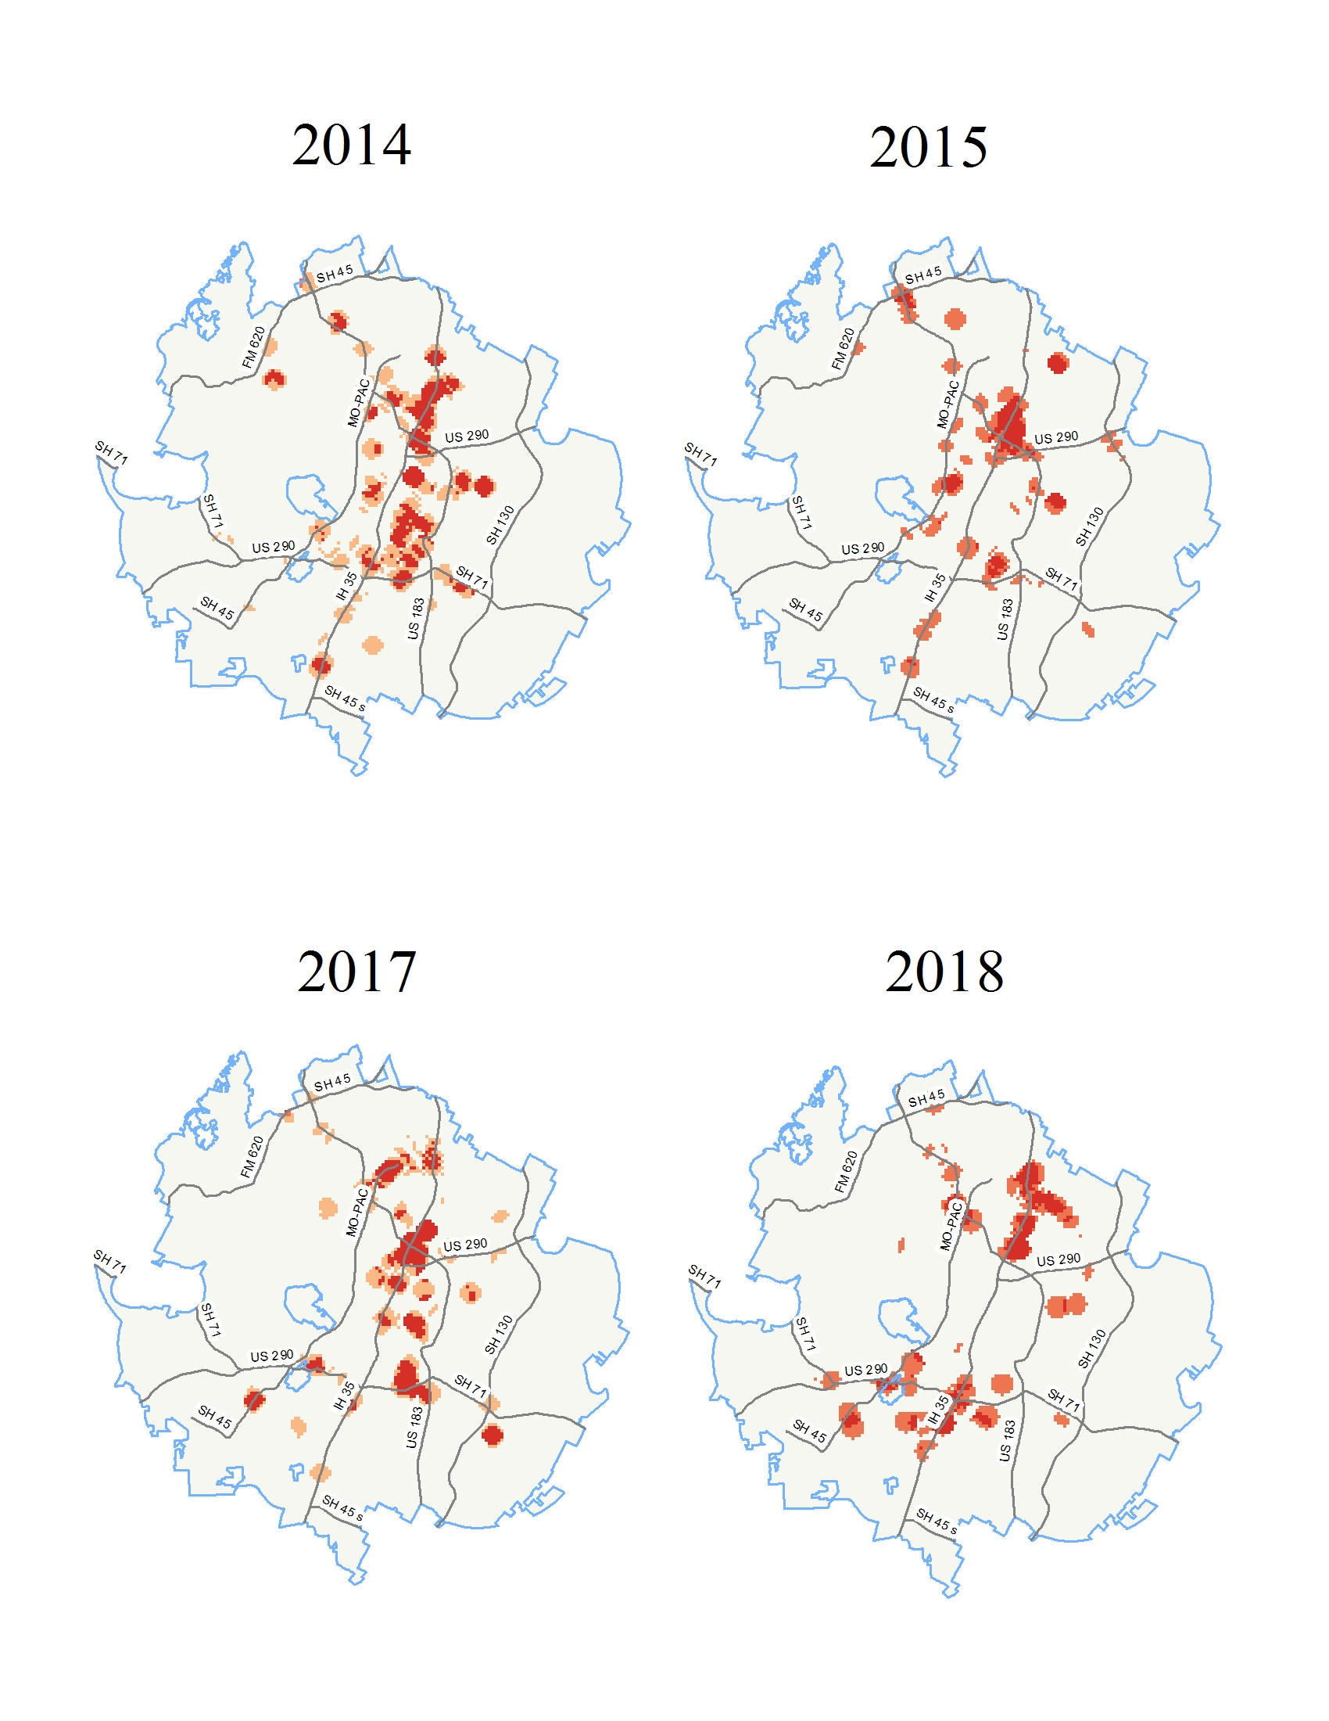
b)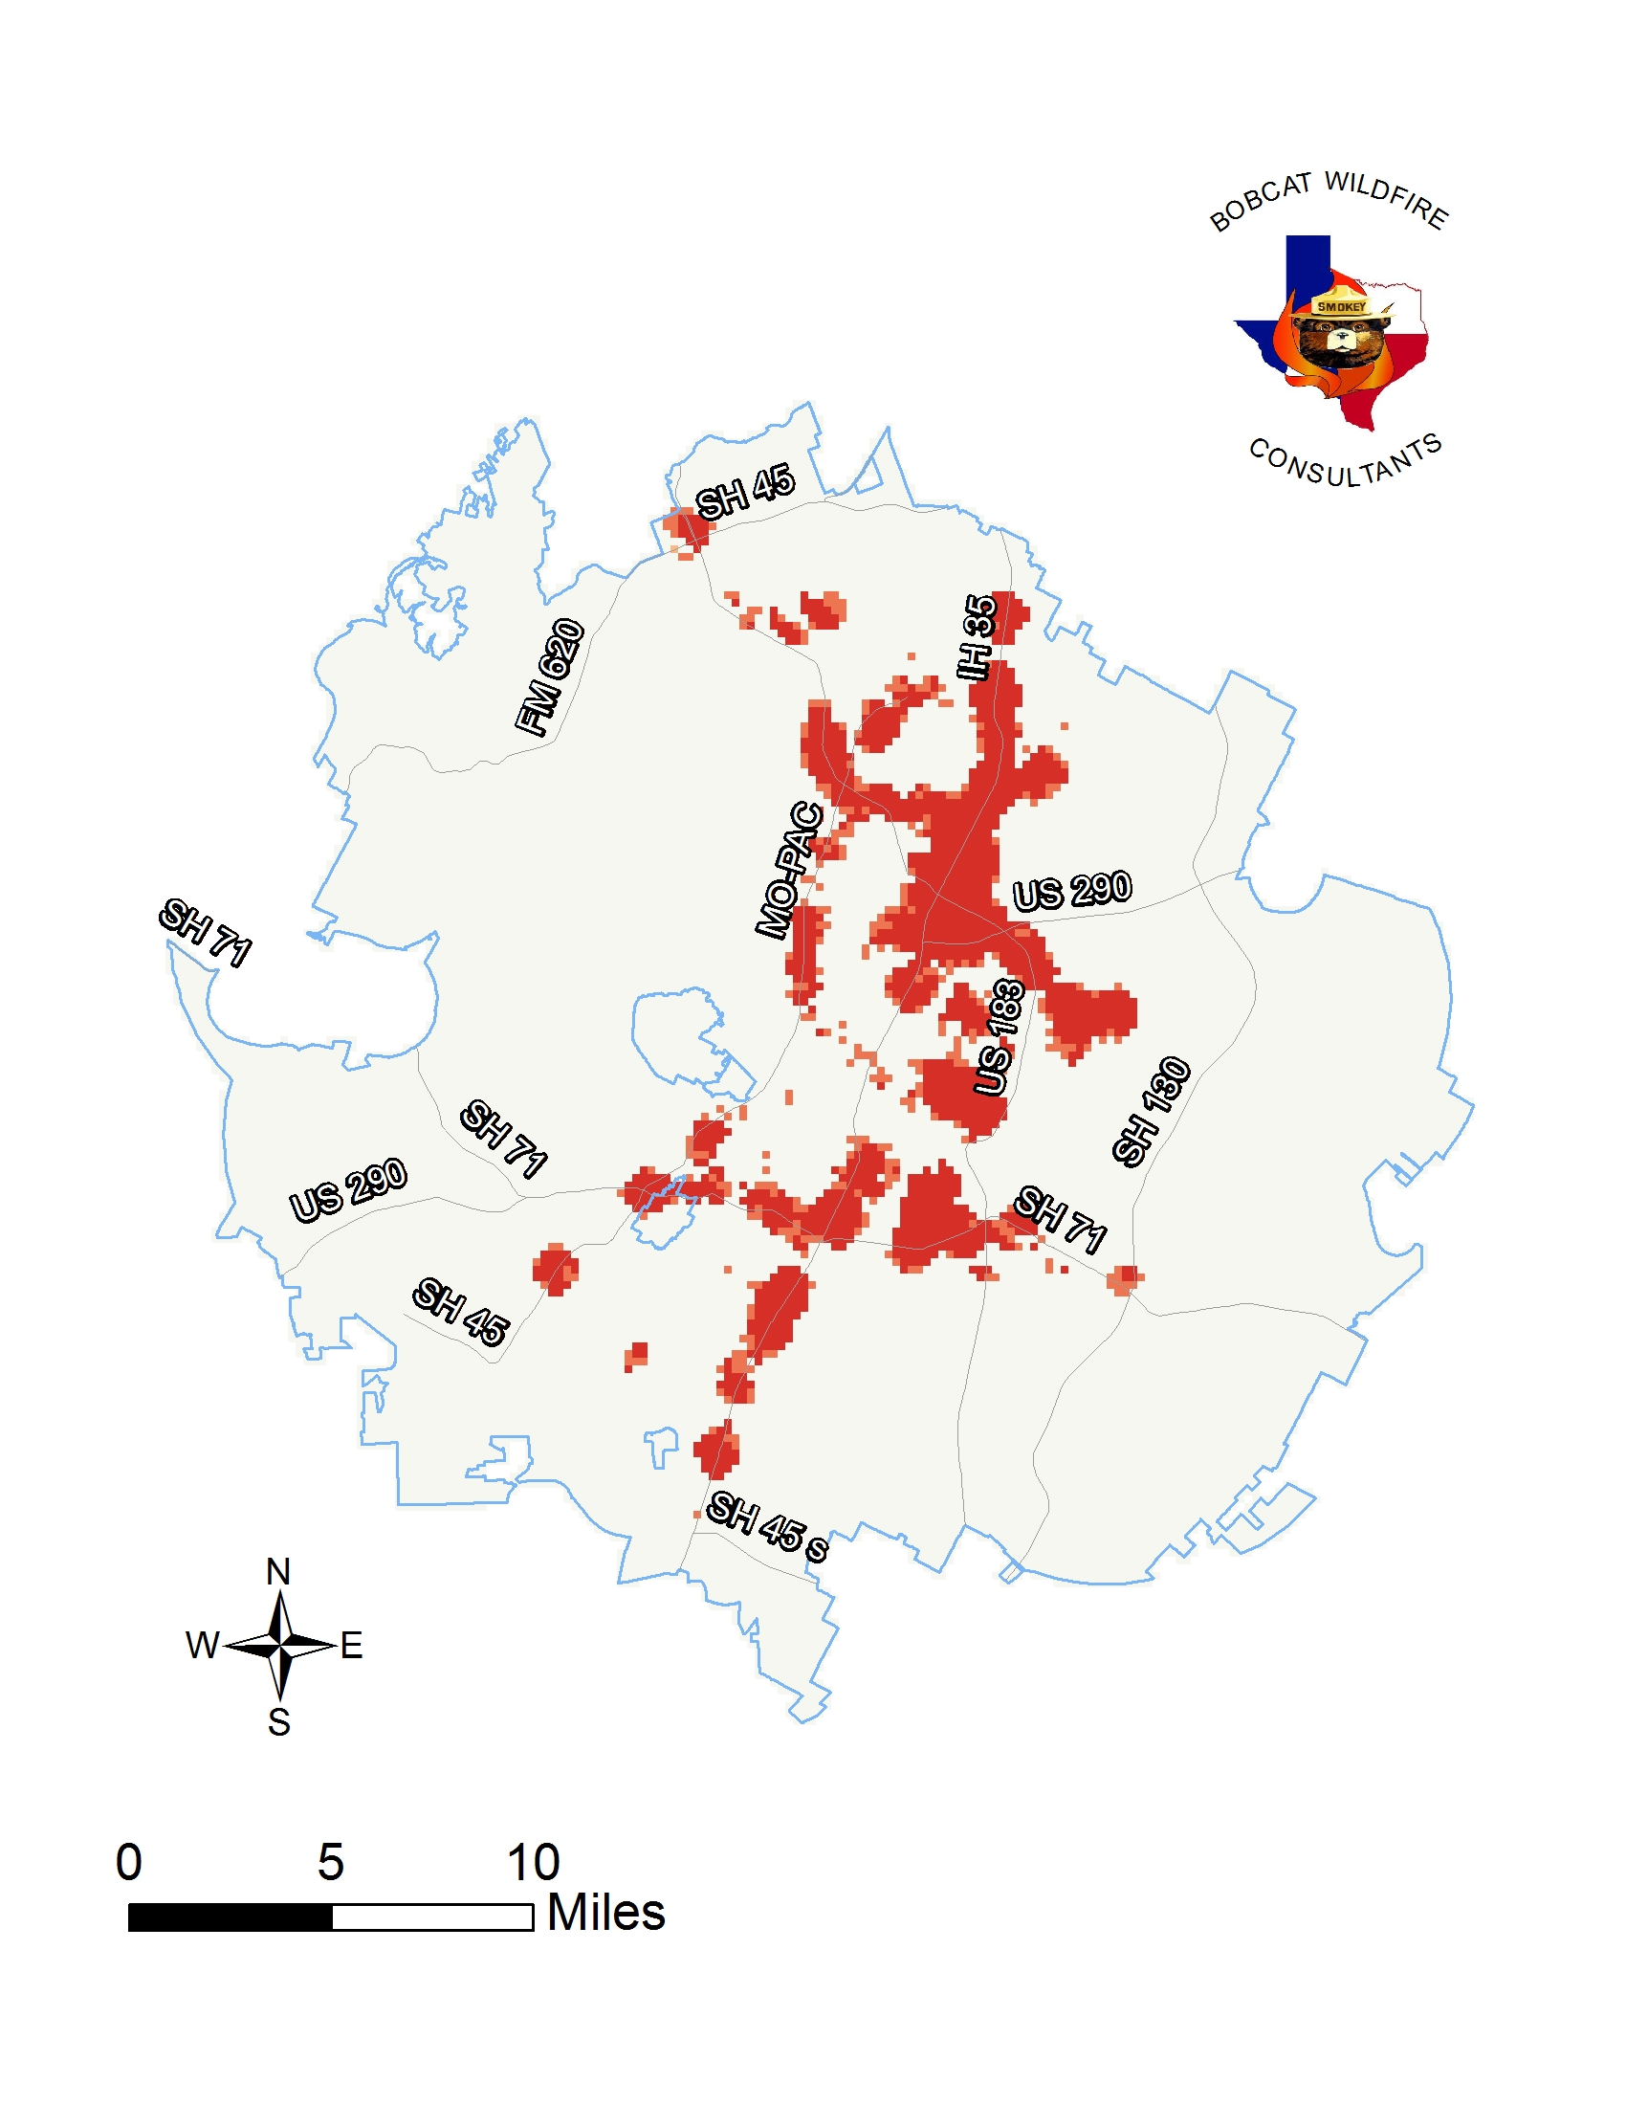
Figure 8. Optimized hot-spot results showing annual concentrations and their relationship along major roads. Figure 8a. These maps reveal significant hot-spots annually. Figure 8b. This maps shows the resulting hot-spots when analyzing all 6-1/2 years combined.
By counting the number of wildfire points within each cell the resulting output features depict the concentration of wildfires. The polygons are represented as a cell area measuring one thousand feet squared (～23 acres). Looking at the attribute table, we identified the spatial significance. The returned hot-spot polygons are characterized with high z-scores and low p-values. The highest z-score was 17.99, revealing the number of standard deviations outside of a normally distributed dataset. Additionally, there were several low p-values of 0.01, giving us a 99% confidence level for these hot spots.
4.1.4 Fire Danger Ratings and Weather Conditions
Our weather conditions maps show the weather conditions for all 1,046 fires. Figure 9 below shows the result of the Inverse Distance-Weighted raster for points and weather conditions. The dark red areas represent areas of fires that occurred on days with an extreme fire danger rating.
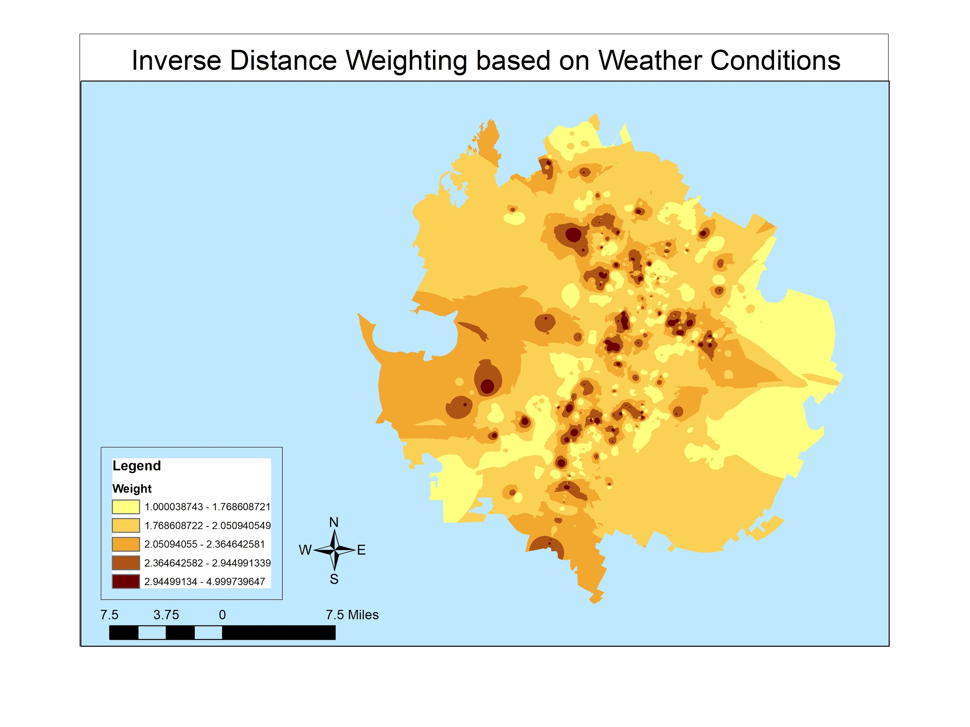Figure 9. Weather conditions for all reported ignitions showing where fires occurred on days with an extreme fire danger rating.

4.2 Temporal Analysis
Looking at the number of reported wildfires per year in Figure 10, we found that 2013 experienced the most fires and 2015 reported the fewest. These figures appear to be linked to Austin’s annual rainfall amounts. Figure 10a shows the locations and quantities of reported wildfires for each year of our study and the annual rainfall amounts can be compared in the graph in Figure 10b.
a)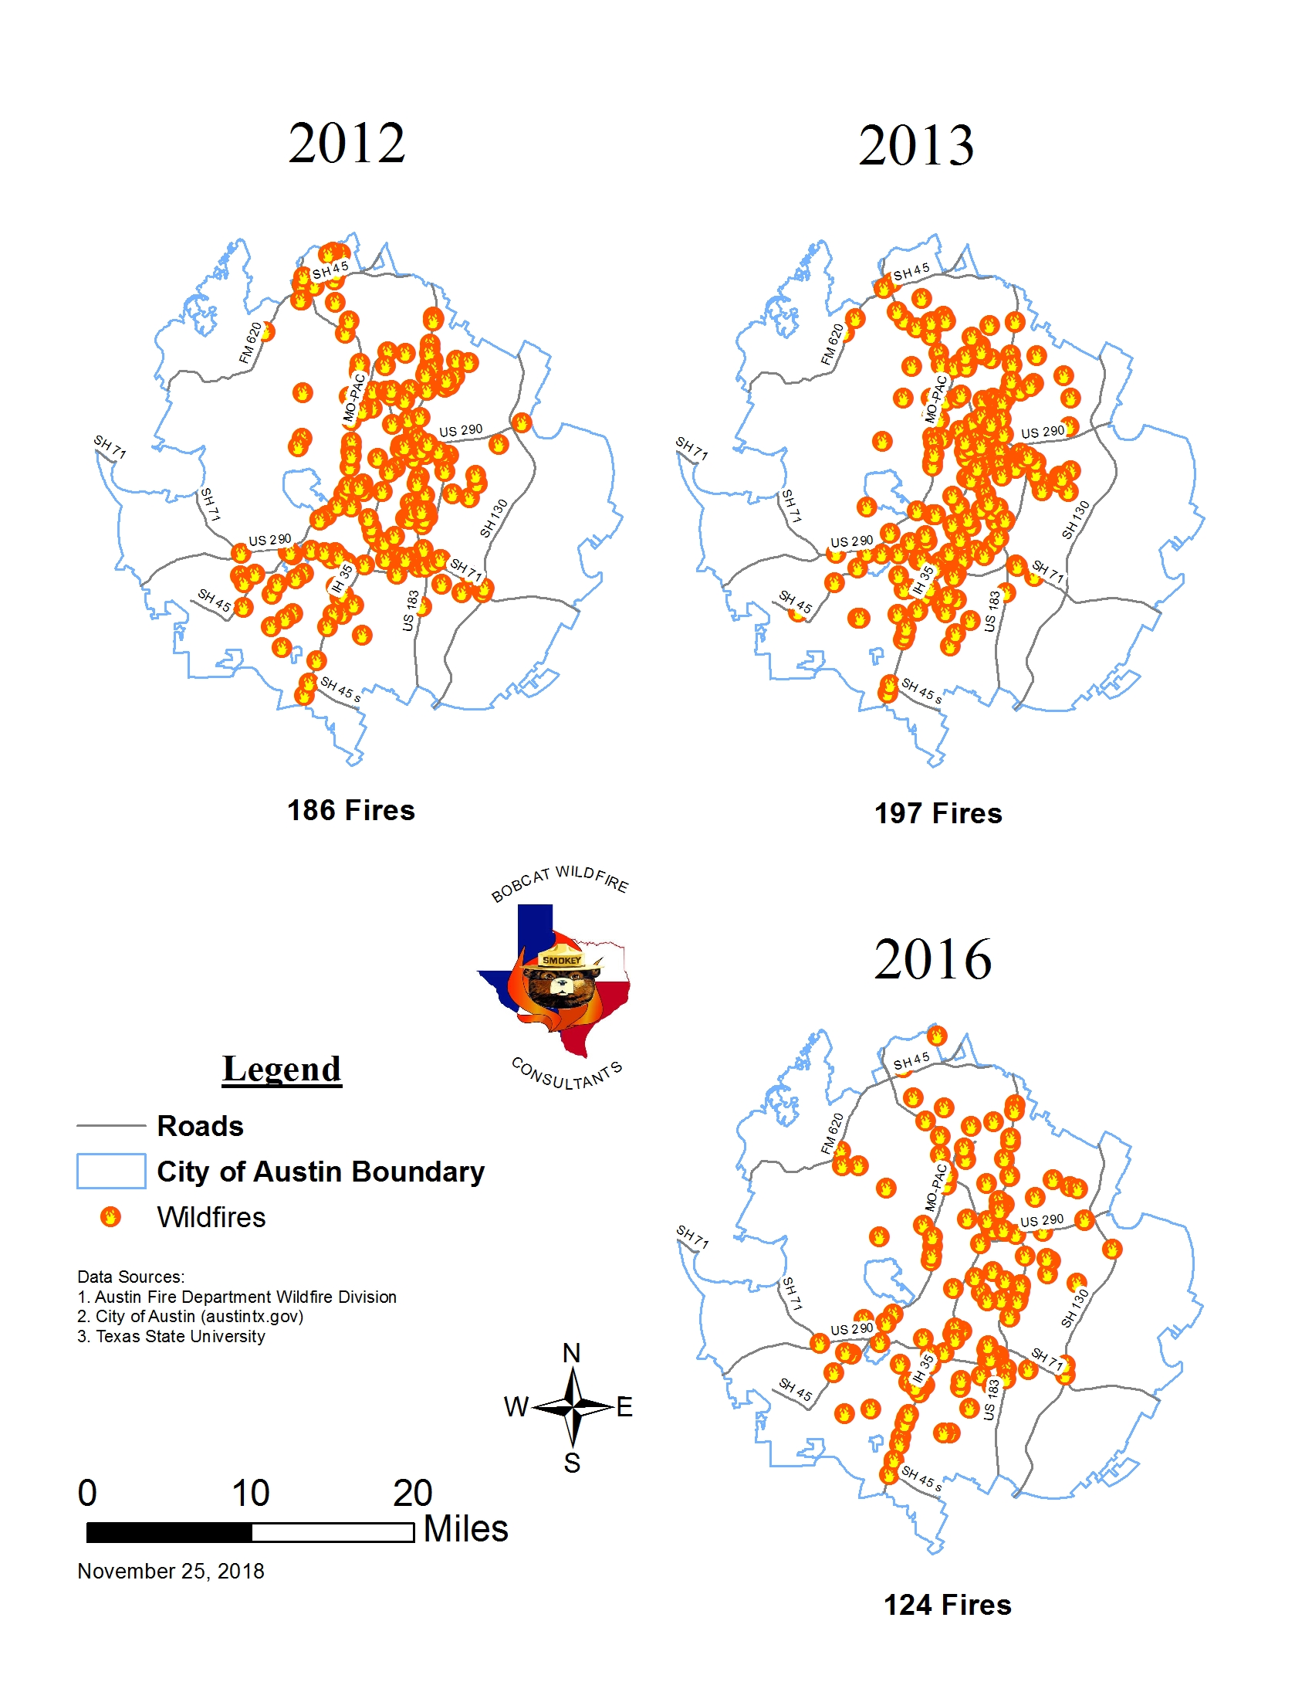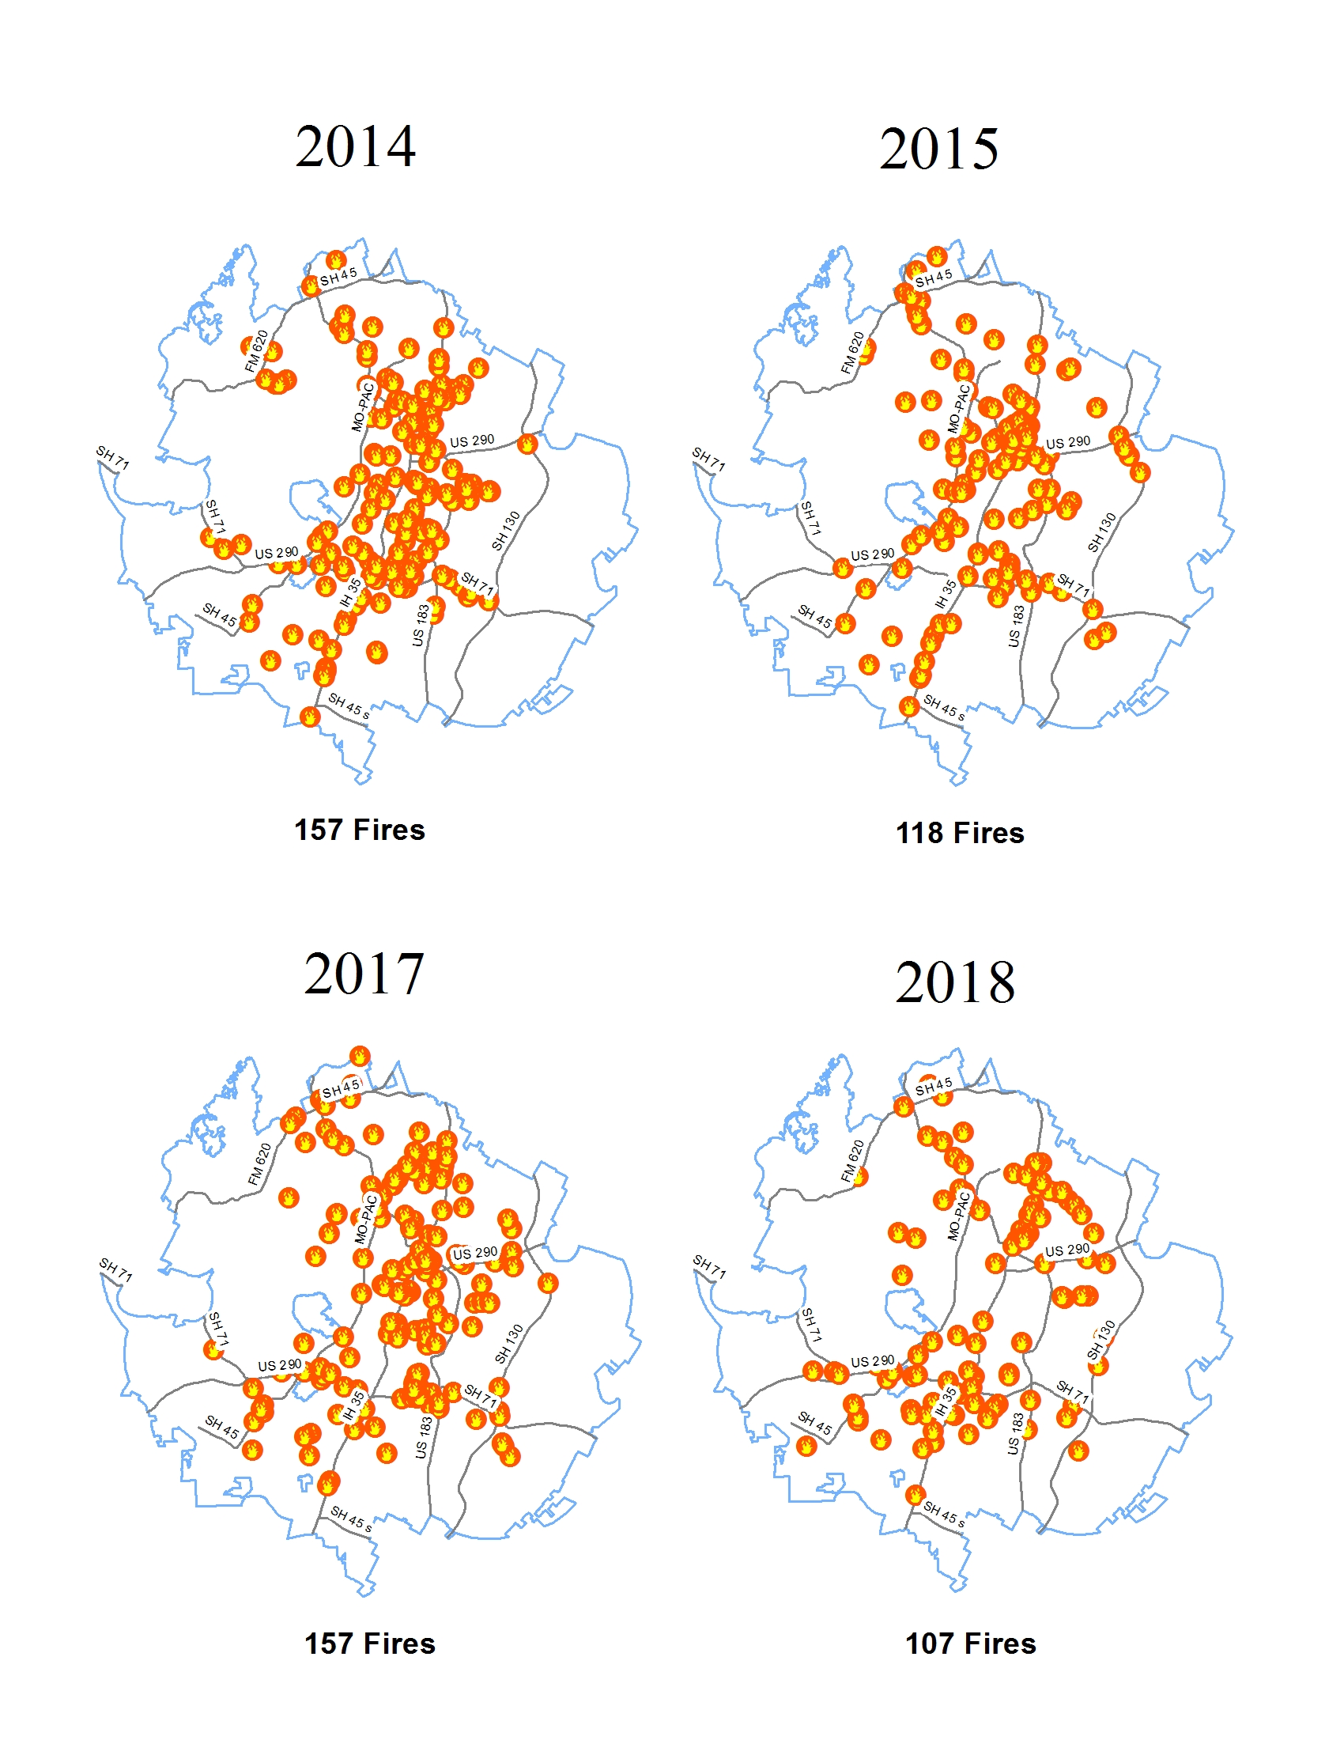
b)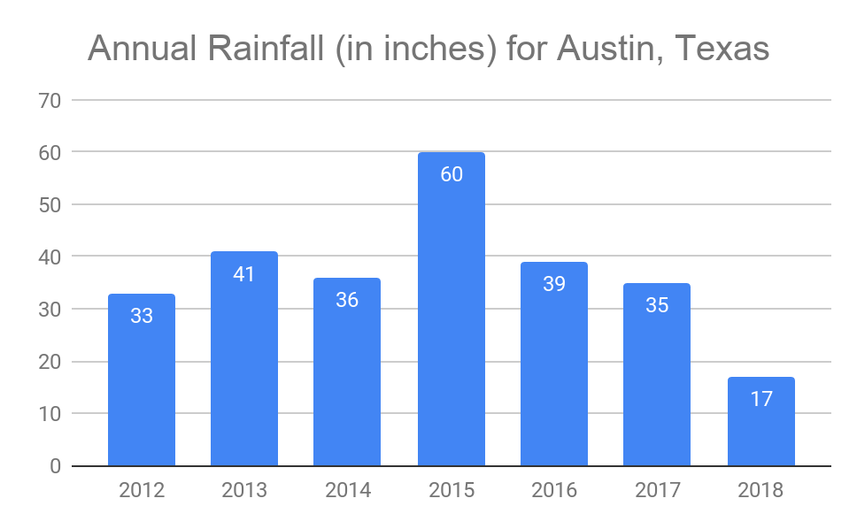
Figure 10. Low ignition count in 2015 could be attributed to high annual rainfall that same year. Figure 10a. Yearly reported ignitions from 2012 to 2018. Figure 10b. Austin’s annual rainfall totals for same date range.

Our hourly graph results show us the hour of the day that is most active for wildfire activity. Figure 11 shows the resulting data when we categorized the points by hour. Using zero to represent midnight and 22 to represent 10pm, the graph reveals that the most active time of the day for wildfires is between 9am and 7pm. More revealing than that is that between 1 and 2 o’clock in the afternoon the most ignitions occurred with 145 reported wildfires. This coincides with busy travel times, especially during and after the lunch hour.

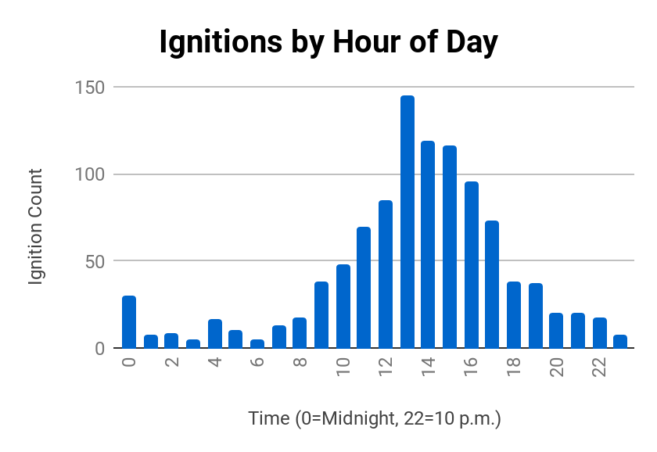
Figure 11. Reported ignitions by hour of the day from January 2012 to July 2018. Austin wildfire activity is busy between 9am and 7pm, with 145 reported ignitions between 1pm and 2pm.

Figure 12 shows the relationships of fires based on two other temporal factors. Our temporal analysis also revealed that the most active day of the week for reported ignitions was on a Monday, accounting for over 17% of the total fires as seen in Figure 12a. The most active season of the year was Summer, which accounted for over 35% of total fires as seen in Figure 12b. When we categorized the wildfire dates by season, we named January through March as Winter, and each three month batch after that was assigned each sequential season. Even though technically Winter starts in December, our wildfire date stamps began in January, and we didn’t have available data to fulfill the previous season.
a) 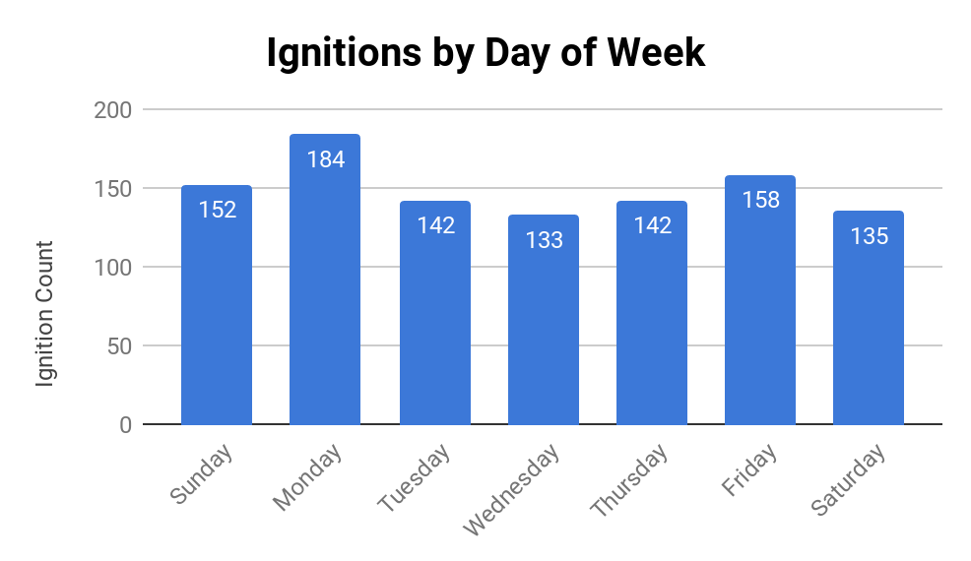
b)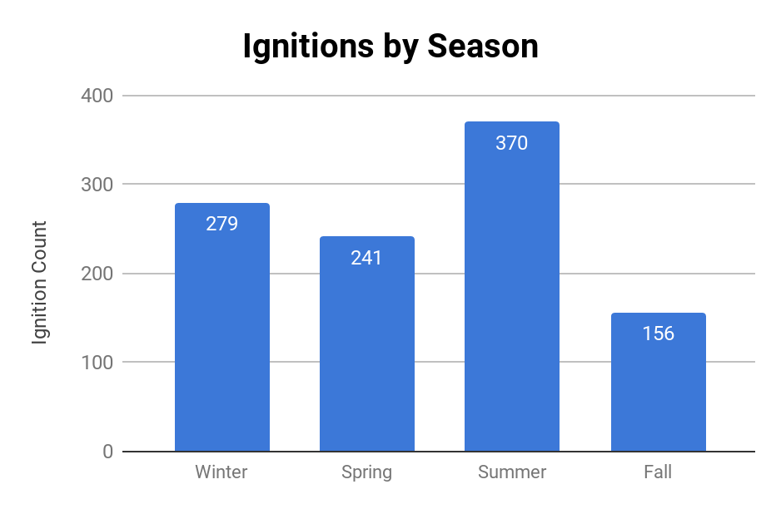
Figure 12. Temporal graphs of 1,046 reported wildfires. Figure 12a. Over 17% of fires occurred on a Monday. Figure 12b. Over 35% of fires occurred during Summer, specifically between July to September.

4.3 Regression Analysis
4.3.1 Variables
In order to begin our regression analysis we needed to decide what variables needed to actually be used to show our regression. When looking at what variables we needed for the regression to show us data we actually needed to use explanatory factors that caused or affected wildfires. One of the major variables we looked at was fuel type which is how flammable the vegetation is. We included road density in the Ordinary Least Squares analysis however, we encountered errors actually running the GWR with this variable, so we excluded it.
4.3.2 Ordinary Least Squares Regression
We ran an ordinary least squares analysis in order to look at severity of multi collineation between variables as well as see how statistically significant the data was. This was a key preliminary action we needed to take before running the geographic-weighted regression. We used the kernel fire density map as the dependent variable and the fuel type and road density as our explanatory. After running the ordinary least squares analysis we also ran a spatial autocorrelation (Moran’s I) to test whether the data is clustered or not received. Figure 13 shows the regression output reports. Figure 13a shows the spatial autocorrelation report. Figure 13b shows both the OLS and Moran’s I output.
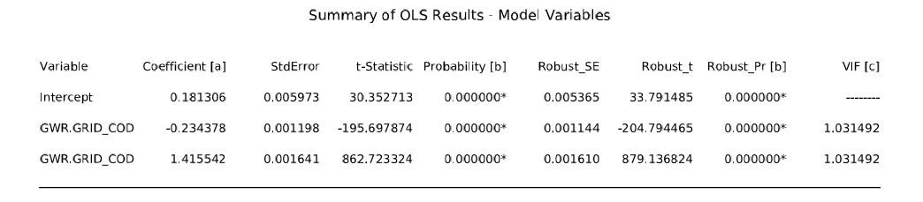
- 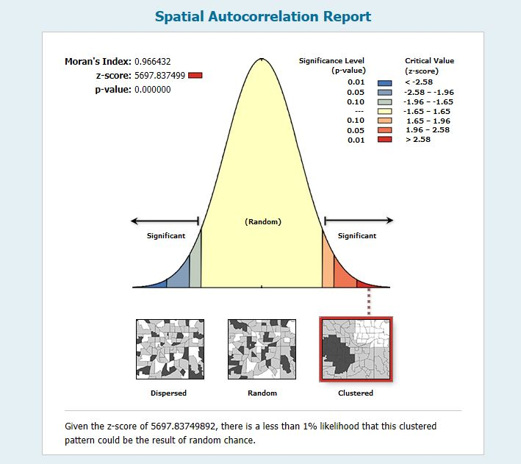

b)
Figure 13. Regression results for ordinary least squares (OLS). Figure 13a. The Moran’s I spatial autocorrelation results showing a high z-score with a low p-value, meaning clustering is significant. Figure 13b. The table shows the results of the OLS with a positive coefficient for fuel types and a negative coefficient for road density.

The results of the OLS showed that a coefficient of 1.41 for the fuel type variable meaning that there is a positive correlation between the two. On the other hand the road density coefficient shows a -0.23 meaning that they are not linear to each other. The VIF (variance inflation factor) was another value we looked at from the OLS. The VIF shows the severity of multi collineation between the different variables. Anything over a 7.5 would mean that the variables are severely collineated and the model will not run. Both values were around 1.03 which means that the regression model should run.
4.3.3 Geographically Weighted Regression
For the second component to our regression analysis we decided to go with the Geographic Weighted Regression (GWR). To begin doing this we needed to create a kernel density map of wildfire occurrences. When doing this we made sure to keep the cell size of the raster at 98.425 feet which was the same as the vegetation layer we’d be comparing it to. Once we had the raster completed for both the fuel type layer and kernel fire density, we converted those into vector data (polygons) because the GWR would not accept raster files. Once both were converted we did a spatial join between the two variables and created one final output. Finally we ran the GWR with the kernel fire density as our dependent variable and fuel type as our explanatory variable. Figure 14 shows the output of the geographic-weighted regression.
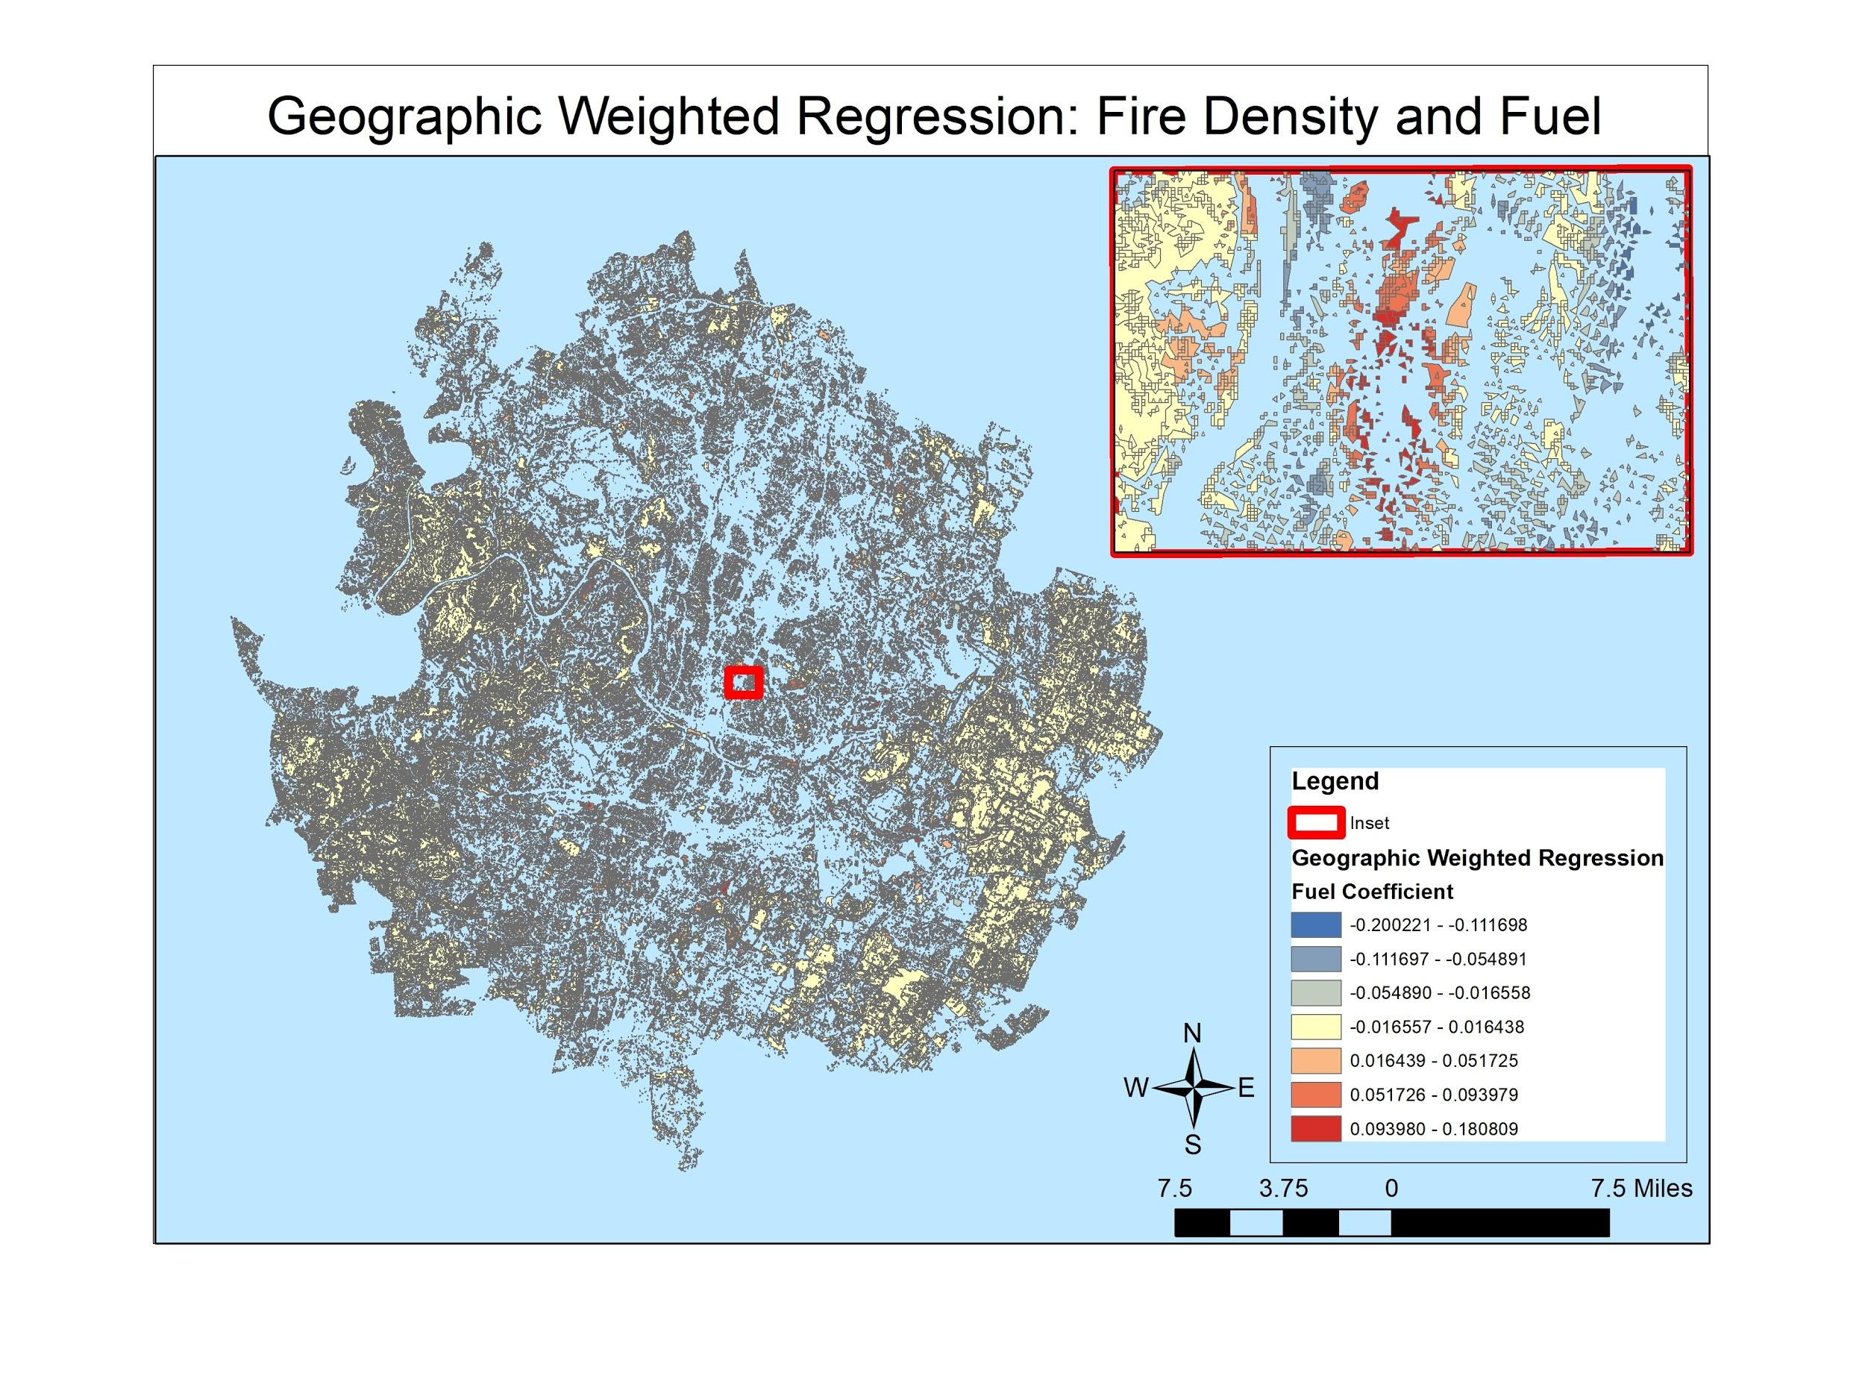Figure 14. A geographic-weighted regression based on fire density and fuel type.

5. Conclusions
In conclusion, we’ve answered our initial question We found that wildfires more commonly occur where easily ignitable fuels such as grass and brush are distributed, but have come to understand that forested areas are equally susceptible. We’ve provided a set of usable facts to help all of Austin’s stakeholders, young or old, rich or poor, Democrat or Republican. When wildfire presents itself it doesn’t discriminate against any group, so everybody should be aware. Our interpretation of the data will hopefully bring awareness to the forefront of people’s minds not just at one o’clock in the afternoon, or on Mondays, or during the Summer, but at all times. The threat of wildfires is a never-ending serious concern to people and property, so the better we can understand the factors that play a role in their occurrence the more informed our decisions and behaviors in controlling them will be.
6. References
Bowman Consulting Group, Ltd. 2014, June 30. Austin/Travis County Community Wildfire Protection Plan. United States, City of Austin, Office of Homeland Security and Emergency Management. Retrieved September 1, 2018, from http://www.austintexas.gov/wildfireprotectionplan

Busenberg, G. 2004. Wildfire Management in the United States: The Evolution of a Policy Failure. Review of Policy Research, 21: 145-156.

Filipe Xavier Catry, Francisco Rego, Fernando Bação, Francisco Moreira. January 2009. Modeling and Mapping Wildfire Ignition Risk in Portugal. International Journal of Wildland Fire, 2009, 18, 921-931. CSIRO Publishing.

Headwaters Economics. September 2018. Wildfire & Vulnerable Populations in Austin, Texas. https://headwaterseconomics.org/wildfire/homes-risk/austin-
wildfire-population-risk.

Lu Y., Carter L., Showalter P.S. 2009. Wildfire Risk Analysis at the Wildland Urban Interface in Travis County, Texas. In: Showalter P., Lu Y. (eds) Geospatial Techniques in Urban Hazard and Disaster Analysis. Geotechnologies and the Environment, Vol 2. Springer, Dordrecht.

J. Martínez-Fernández, E. Chuvieco, and N. Koutsias. May 16, 2012. Modelling Long-Term Fire Occurrence Factors in Spain By Accounting for Local Variations With Geographically Weighted Regression. Natural Hazards and Earth Systems Sciences, 13, 311-327, 2013. Copernicus Publications on behalf of the European Geosciences Union.

Mark A. Finney, Jack D. Cohen, Jason M. Forthofer, Sara S. McAllister, Michael J. Gollner, Daniel J. Gorham, Kozo Saito, Nelson K. Akafuah, Brittany A. Adam, and Justin D. English. 2015. Role of buoyant flame dynamics in wildfire spread. Proceedings of the National Academy of Sciences 112 (32) 9833-9838.

M. P. North, S. L. Stephens, B. M. Collins, J. K. Agee, G. Aplet, J. F. Franklin, and P. Z. Fulé. 2015. Reform forest fire management, Science 349 (6254), 1280-1281.

Nancy L Harris, Elizabeth Goldman, Christopher Gabris, Jon Nordling, Susan Minnemeyer, Stephen Ansari, Michael Lippmann, Lauren Bennett, Mansour Raad, Matthew Hansen and Peter Potapov., Using Spatial Statistics to Identify Emerging Hot Spots of Forest Loss, published 7 February 2017, ©2017 IOP Publishing Ltd., Environmental Research Letters, Volume 12, Number 2, iopscience.iop.org/article/10.1088/1748-9326/aa5a2f

Rain Nox. 2015. Wildfire Mitigation Behavior on Residential Properties near Balcones Canyonlands Preserve in Austin, Texas. Texas State University, Dept. of Geography.

Roger B. Hammer, Susan I. Stewart, and Volker C. Radeloff. 2009. Demographic Trends, the Wildland–Urban Interface, and Wildfire Management, Society & Natural Resources, 22:8, 777-782.

Stewart, S.I., V.C. Radeloff, R.B. Hammer, and T.J. Hawbaker. 2007. Defining the Wildland Urban Interface. Journal of Forestry 105:201-207.

Susan Combs. 2011. The Impact of the 2011 Drought and Beyond. United States, Texas Comptroller of Public Accounts. TX: State of Texas.

Uddhab Bhandary. 2009. Land use planning and wildfire risk mitigation: an analysis of wildfire-burned subdivisions using high-resolution remote sensing imagery and GIS data. Journal of Environmental Planning and Management 52 (7) 939-955.

Vilar del Hoyo, L., Martín Isabel, M.P., and Martínez Vega. 2011. F.J. Eur J Forest Res 130: 983.
7. Appendix I: Group Members Contribution
David Olguin managed the team members’ contributions and aligned team tasks with the dates created in the timeline. He ensured that the reports, presentations, and poster board were finalized according to teams tasks and client expectations. He contributed some reporting on the literature review. He worked with Rhodes on the optimized hot-spot analysis and reported on those methodologies. He assisted Sam and Rhodes with the preliminary fire count by council district and census tract maps. He also created some of the graphs in Excel that show the temporal relationships. He communicated with all group members over the course of the semester, and participated in all group meetings outside lab and lecture hours.
Thanh Nguyen created the methodology flow chart and timeline for the project. He also created the team logo using Adobe Illustrator. He and Jorge worked together on the temporal analysis component, specifically creating the animation maps that show the monthly and annual occurrence of wildfires . He communicated with all group members over the course of the semester, and participated in all group meetings outside lab and lecture hours.
Jorge Perdomo worked with Thanh on creating additional animation maps that show reported ignitions for each month of the year, accumulated over the 6-1/2 year data window. He also created the team’s budget report and retrieved the Austin council district boundaries for Austin, which he reprojected into state plane NAD83 Texas central zone, which was our desired projection for all our analyses. He communicated with all group members over the course of the semester, and participated in all group meetings outside lab and lecture hours.
Sam Becker compiled and reported on the literature review. He created the reference list which the group relied on throughout the project. He and Rhodes retrieved most all of the team’s data through the City of Austin’s website and Texas State University’s GIS data repository. He also completed the model builder diagram and the spatial analysis maps showing the wildfire occurrences by administrative boundaries. He communicated with all group members over the course of the semester, and participated in all group meetings outside lab and lecture hours.
Rhodes Smartt worked alongside Sam in retrieving the necessary data including the city boundary, roads, and census tracts. He worked in Excel to extract the timestamps into individual columns to enable us to graph the different temporal relationships. He worked on the optimized hot spot analysis, assisted by David. He completed the ordinary least squares and geographically weighted regression analyses. He communicated with all group members over the course of the semester, and participated in all group meetings outside lab and lecture hours.
8. Appendix II: Metadata
The metadata files for this project are included in the data DVD:
File name: | Description
AFD by Year | Annual reported ignitions (2012-2018).
AFD Census Tract | Ignition count by census tracts (separated annually and combined years).
AFD Census Tracts by Time | Wildfire ignitions by census tracts with temporal relationships.
AFD Council Districts | Ignition count by council districts (separated annually and combined years).
AFD Weather Conditions | Fire danger ratings for all ignition points. 1 = low, 2 = moderate, 3 = high, 4 = very high, 5 = extreme.
Austin Wildfire Points | All reported ignition points.
Optimized Hot Spot | Hot-spot results for all years and separated years (2012-2018).
Regression Model and Components | Ordinary least squares and geographically weighted regression variables. Dependent variable = fire density, Independent variable = fuels.

