Examining the Relationship Between Urban Heat Islands and the Tree Canopy in Austin, TX

Bobcat Urban Foresters

For
City of Austin Urban Forestry Department

Prepared by:
Zachary Mayer: Project Manager / GIS Specialist
Rance Parker: GIS Specialist
Kallie Hallmark: GIS Specialist
Gabrielle Allen: Remote Sensing Specialist
Alexis Ramirez: Remote Sensing Specialist

DATE: 30 September 2018

Table of Contents
- Introduction Page 2
1.1 Summary Page 2
1.2 Purpose Page 2
1.3 Scope Page 2
- Literature Review Page 3
- Proposal Page 5
3.1 Data Page 5
3.2 Methodology Page 5
3.3 Implications Page 8
3.4 Budget Page 9
3.5 Timetable Page 9
3.6 Final Deliverables (results) Page 10
- Conclusion Page 10
- Participation Page 11
- Bibliography Page 11

- Introduction

1.1 Summary
The urban tree canopy can have many benefits including shading the city’s landscape and reducing thermal radiation. When there is not enough canopy to shade the urban surface area, thermal heating can increase city wide creating heat islands where the temperature of the city is warmer than the surrounding rural region. Heat islands can impact the local weather by decreasing wind and precipitation. Specific parts of the urban area may also be hotter than others. These hot spots may not be as covered by the urban tree canopy as other parts of the city. The relationship between the Austin urban tree canopy and the heat islands of the city of Austin is what will be analyzed and measured.

1.2 Purpose
The purpose of this project is to analyze and map the relation between the urban tree canopy and the thermal radiation of the Austin area (or Travis County). Landsat data of thermal imagery of Austin from 2014 and the surrounding area in Travis County would be processed and hot spots and cold spots will be identified. A urban tree canopy map of the greater Austin area would be clipped (or masked) with a shapefile layer of Travis County. Areas of the city (or the county) where there would be thermal hot spots and cold spots would be analyzed on a scale of 100m x100m squares, and the amount of urban canopy would then be measured.

1.3 Scope
The scope of the urban heat island analysis will consist mostly of Travis County. The thermal imagery includes all of Travis county. The urban tree canopy area of analysis will only include most of Travis, not all do to limitations of the data, but it does include all of the Austin city limits. Once we perform an analysis of the hot and cold spots, the area will be focused to the parts of Austin and surrounding communities which have far above or below the average temperature found for Travis County. Due to Austin being the largest contributor to the urban heat island effect, we will put particular emphasis on notable areas throughout Austin.
The timeframe we will be working in is the May-September of 2014. The tree canopy data supplied and Landsat 8 OLI/TIRS data used are both for this year.

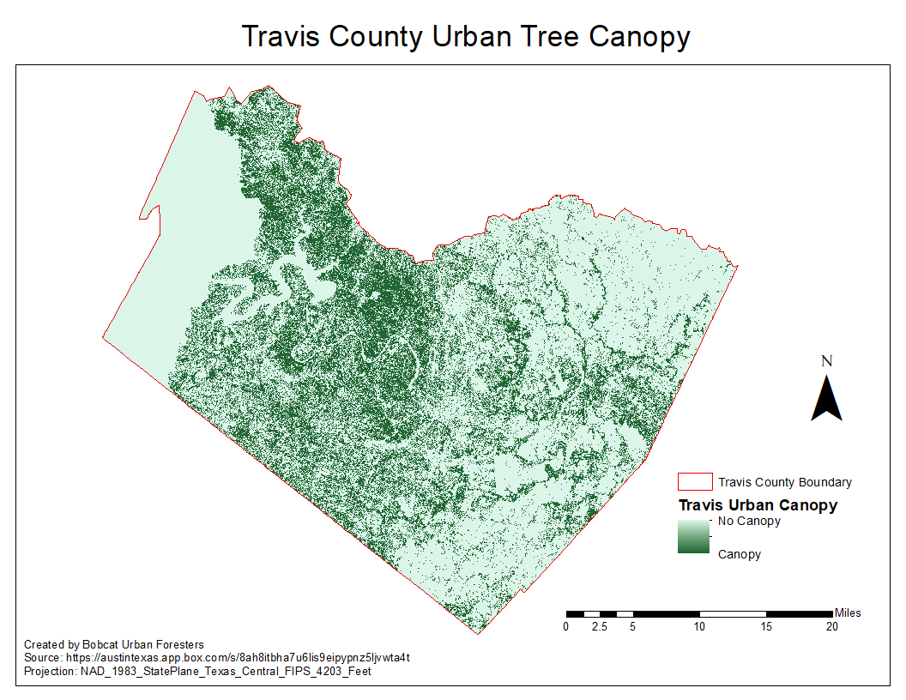

2. Literature Review
Modern cities are made up of dense concentrations of impermeable materials which absorb more thermal heat. This absorption creates heat islands. In order to measure and analyze heat islands across an urban area, remote sensing imagery should be acquired. In the article titled Mapping Micro-Urban Heat Islands Using Landsat TM And A GIS, by Aniello et al, show the effectiveness of using Landsat data and how to discern Urban Heat Islands (UHI). The best time of year to look for the images is during the summer and fall when there are minimal clouds and warm weather (Aniello et al., 1994). Satellite data is useful for showing the difference in temperature between rural and urban areas as well as water surface temperatures (Aniello et al., 1994). The journal Approaches to study Urban Heat Island – Abilities and Limitations, written by Mirzaei et al., describes the concerns and limitations of studying an UHI. Thermal remote sensing can cause a small variance in data because of the difference in surface temperature and ambient air temperature (Mirzaei et al., 2010). Much of the surface of an urban environment may not be seen because of three dimensional buildings which can cover the surface of an area (Mirzaei et al., 2010).

Loughner et al. describes, in the journal titled Roles of Urban Tree Canopy and Buildings in Urban Heat Island Effects: Parameterization and Preliminary Results, how the UTC effect in cities has been observed to increase the effects of heat waves and warm weather, which can cause health problems, and causes the effects of air pollution to intensify (Loughner et al., 2012). In the journal Mitigation of the heat island effect in urban New Jersey, the authors describe the urban heat islands (UHI), having similar effects of what Loughner describes, and in collaboration with summertime heat waves, engender ecological issues such as heat stress and an increase in concentrations of heat stress and secondary air pollutants (Solecki et al., 2005). Cities have tried many solutions to solve the problems of UHIs. An increased amount of brick, concrete, asphalt, stone and other comparable materials typically used in urban construction, absorb a disproportionate amount of short-wave solar radiation during the day. This amount of stored energy in typically urban areas is then less effectively reradiated as long wave radiation than would usually be seen in rural areas.(Solecki et al., 2005) This is especially problematic during the summer months because this phenomenon can potentially coincide with heat waves. This problem had been documented in the article Heat Wave, A Social Autopsy of Disaster in Chicago, which reported as the case in the Chicago heat wave of 1995, which resulted in the death of over 700 people (Klinenberg, 2002). In the article Approaches to study Urban Heat Island- Abilities and Limitations the author states the increase human migration into urban areas since the end of the second world war has exploded (Population Reference Bureau. 2005). The journal Urban Climates and Heat Islands: Albedo, Evapotranspiration, and Anthropogenic Heat stated this boom in human urbanization has had a noticeable effect on our city’s meteorology. It has affected everything from local wind patterns, increase in humidity and the rate of precipitation (Taha H., 1997). Feyisa et al. wrote Efficiency of parks in mitigating urban heat island effect: An example from Addis Ababa, and described how parks and green space can subdue the effects of an UHI. A small increase in the temperature of an urban environment can cause a big effect in energy usage of a city degree of change correlates with 5-10% increased energy usage (Feyisa et al., 2013). California and Florida have developed solutions to this problem by creating more white roofs and tree shades. Both states have demonstrated the ability to heavily reduce demand for cooling in the areas that implemented more trees and white roofs (Klinenberg, 2002) . A study in Los Angeles, title Painting the Town White and Green, has shown that the implementation of these programs has reduced cooling demand by as much as 18% (Rosenfeld et al., 1997). The result of this program is optimistic, especially when considering the demand for air conditioning in the United States accounts for one sixth of electrical energy demand, at an annual cost of $40 billion (Rosenfeld et al., 1997).

Loughner stated a healthy urban tree canopy can reduce the strength of UHI and its negative effects (Loughner et al., 2012). Trees provide shade and transpiration which causes cooling as much as four to six degrees farenheit difference from areas without trees, when they full grown (Loughner et al., 2012). Akbari came to a similar conclusion in the journal Cool Surfaces and Shade Trees to Reduce Energy Use and Improve Air Quality in Urban Areas ; by stating some of the most effective solutions have been increasing the amount of vegetation endemic to the most heavily affected areas and to try and decrease the amount of anthropogenic heat inside building tree canopies (Akbari, 2001). The journal An Urban Surface Exchange Parameterisation for Mesoscale Models described how trees have been shown to greatly reduce the amount of solar radiation and wind that reaches these heat islands. This can demonstrably prove that trees are as important as buildings in control volumes, and that tree canopies could reduce UHI effects on the local ecology (Martilli et al., 2002). The best two ways to reduce the UHI effects are to increase vegetation cover or use more reflective surface material (Solecki et al., 2005). Increasing vegetation in an area such as tree planting or plants on top of roofs can increase air quality as well as making it cooler and reducing energy use of a building (Solecki et al., 2005). Trees planted around a house are proven to reduce the cost of air conditioning by providing cover as the sun moves across the afternoon sky (Solecki et al 2005).
3. Proposal

3.1 Data
- Greater Austin area 2014 urban tree canopy TIFF file from AustinTexas.gov
- Travis County shapefile from CAPCOG Regional Open Data
- LANDSAT 8 OLI/TIRS scenes from Summer 2014 (May - September)
  - Bands 4 (red), 5 (near infrared), and 10 (thermal infrared 1)

3.2 Methodology
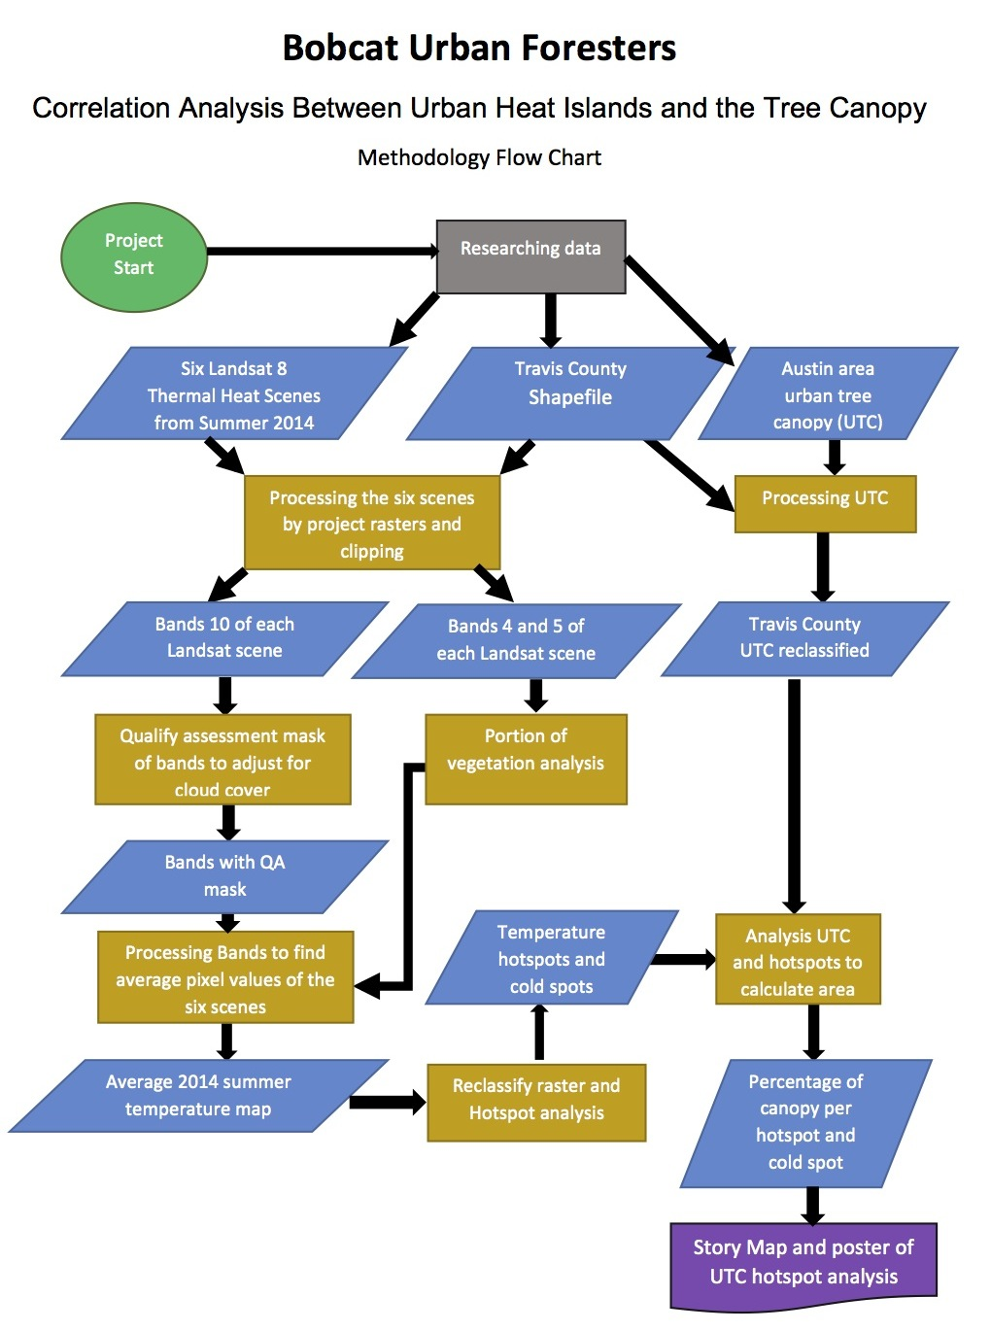
Landsat Methodology
Before visualizing how the urban heat island is mitigated by tree canopy cover in Travis county, we will need to first assess the quality of the Landsat scenes and perform a cloud cover mask to extract clouds, cirrus clouds, and shadows. This is essential for the correlation accuracy between the two attributes. We will be processing all Landsat 8 remote sensing scenes as well as the hotspot analysis in ArcMap.

We will download as many scenes that have minimal cloud cover if possible so we can find a reliable average of land surface temperatures. LANDSAT 8 has a temporal resolution of 16 days, which means there will be about two scenes available per month. The scenes available in the summer of 2014 varied in cloud cover and we were able to download six scenes that were viable for this project. Before any processing should occur, we made sure all files we work with are in the same projection and coordinates. We based our primary projection of this project to the tree canopy cover file which is NAD_1983_StatePlane_Texas_Central_FIPS_4203_Feet.

First, we clipped bands 4, 5 and 10 of each date to the Travis county shapefile. There are two thermal bands in the Landsat 8 OLI/TIRS sensor. We chose to use band 10 instead of band 11 in our research due to more uncertainty in the accuracy of land surface temperatures in band 11 (Lu et al. 2014). If there are clouds or shadows of clouds in the images, we will need to create a mask using the Quality Assessment band file (BQA.TIF) provided in the scene download folder. To perform this, we have to download a toolbox from GitHub that can be used within ArcMap. The Extract QA Bands tool will be able to extract the bit-packed values associated with each scene and remove the classes individually. It combines the classes into one single file with the true values being “1” and false values being “0”. Next, we will convert the raster with the true values (1) to polygons and extract them from the thermal band (10) scenes.

Once we have acquired images through USGS Earth Explorer, clipped to the area of interest, and masked the cloud cover and shadows, we will need to start the process of finding the LST. First, we will convert the thermal band to Top-of-Atmosphere (TOA) Radiance. This equation corrects the digital number (DN) assigned to each pixel to account for atmospheric scattering. To do so, we will use the map algebra tool with the equation:

L_{λ} = M_{L}*Q_{cal} + A_{L}
where:
L_{λ} = Spectral radiance (W/(m2 * sr * μm))
M_{L} = Radiance multiplicative scaling factor for the band (RADIANCE_MULT_BAND_10 from the metadata).
A_{L} = Radiance additive scaling factor for the band (RADIANCE_ADD_BAND_10 from the metadata).
Q_{cal} = L1 pixel value in DN (Digital Numbers)

Next, we will need to perform a conversion to TOA Brightness Temperature and conversion to Celsius. The digital number for each pixel are still not useful at this point for data analysis and will need to be converted to an actual temperature. We will use the equation:

TB=$(\frac{K_{2}}{ ln(\frac{K_{1}}{Lλ} +1)} )-273.15$
where:
TB = Top of atmosphere brightness temperature (in Kelvin)
L_{λ} = Spectral radiance (W/(m2 * sr * μm))
K₁ = Thermal conversion constant for the band (K₁_CONSTANT_BAND_10 from the metadata)
K₂ = Thermal conversion constant for the band (K₂_CONSTANT_BAND_10 from the metadata)

Lastly, we will perform a conversion from At-Satellite Temperature to Land Surface Temperature. The difference in kinetic temperature of the earth compared to what the sensor is capturing will be accounted for using the equation:

T= TB/[1+(λ*TB/c2)*ln(ε)]
where:
TB = Top of atmosphere brightness temperature (in Celsius)
λ = wavelength of emitted radiance (10.8 μm for Landsat 8 band 10)
c2 = h*c/s= 1.4388*10⁻² m K = 14388 μm K
h = Planck’s constant = 6.626*10⁻³⁴ J/s
s = Boltzmann constant = 1.38*10⁻²³ J/K
c = speed of light = 2.998*10⁸ m/s

ε = 0.004*Pv +0.986
Pv= ((NDVI - NDVI_{min})/(NDVI_{max} - NDVI_{min}))²

To find ε (emissivity), we will also need to find Pv (proportion of vegetation). We need to account for emissivity because not all objects on the earth's surface radiate the same temperatures. For example, water temperature is captured by the sensor differently than concrete. We can use the NDVI (normalized difference vegetation index) with bands 4 and 5.

After we have found the land surface temperature for each of the scenes and performed a layer stack, we will need to use the raster calculator function to average out each pixels temperature. We can then convert the pixels from Celsius to Fahrenheit and produce a single raster that will be ready for the next portion of our method, which is to perform and visualize a hotspot analysis.

Urban Tree Canopy Methodology
Processing of the canopy data will begin once the 2014 urban tree canopy (UTC) raster of the greater Austin area and the county shapefile of central Texas are acquired. First, both the polygon shapefile and raster must be aligned to the projection of NAD_1983_StatePlane_Texas_Central_FIPS_4203_Feet. Travis county will be selected from the central Texas country shapefile. A mask extraction will The UTC raster will be extracted by mask, by using the Travis County shapefile. This new raster, of only the UTC data in Travis county, will be reclassified. The UTC raster includes two values of one and three. Value one is the classification of canopy area. The reclassification will create a new raster of only the tree canopy or value one from the original UTC raster.

Hotspot Analysis Methodology
The averaged land surface temperature image will be categorized based on temperature ranges in order to show hot and cold spots. If the temperature value range goes from 75 degrees Fahrenheit to 95 degrees (for example), then the reclassification could be divided into five equal classes (equal break classification) of four degrees of temperature range. Each class would then be color coded and renamed into coolest, cool, average, warm, and warmest. Any raster pixel values within the top three degree class range (from around 91 to 95 degrees) would be the hotter areas on the thermal image raster. The lowest temperature classification would be around 75 to 71 degrees. In order to prevent skewing of the data and since tree canopy cover is not associated with open bodies of water, cooler water bodies will be masked out.

This reclassified thermal image raster can be compared and visualized with the reclassified UTC raster. The density of UTC in the area of the hottest pixels can be seen. The hottest and coolest pixels could be analyzed with a Getis-Ord Gi analysis to scientifically create the estimated area of the temperature hotspots and cold spots. The UTC within these hotspots and coldspots could be clipped with either the reclassified thermal image raster or the hotspot analysis raster. The clipped UTC raster’s pixel quantity within the hotspots could be measured, then the area calculated, along with the total pixel area of the hotspots. The percentage of canopy within the hotspots could then be measured.

Another analysis to measure the UTC area percentage within hotspots could include using a map algebra analysis to find the total number of UTC pixels within hotspots. The limitation with this analysis is the pixel sizes of the UTC and thermal image raster or significantly different sizes; the thermal image’s resolution is 100 meters wide and the UTC has a much finer resolution. If the UTC resolution size is increased the exact canopy area size could not be properly measured because much of its pixels could be lost in the simplifying process.

The UTC area percentage will be calculated with the use of the better analysis technique utilized, and measurements can be quantified, and visualized by creating a story map to show the areas of interests (hotspots and coldspots).

3.3 Implications
We would like to develop and implement an ArcGIS Model Tool to be used by the City of Austin that will help reduce the propensity of UHI. This tool will help Austin not only in the short term but also into the future. This tool will identify the hottest and coolest areas, the mean summertime surface temperatures, and the relationship between the surface temperature and the canopy as new data becomes available. This will be intuitive, easy-to-use, and will drastically cut down on the time required to analyze the data. This will help Austin retain a viable system to reduce the UHI that is endemic in larger, growing, urban areas. We believe that with global temperatures currently on the rise, and likely to remain on the rise for the foreseeable future, that this tool will be integral to the continued comfort and safety of Austin’s rapidly growing population and the environment alike. In addition, we would like to create a online story map, and educational poster to bring this project to the public eye. We believe that this transparency will engender public support.

3.4 Budget
The budget consists of the aggregate costs of wages, equipment, and personnel. Wage and software information is based on data gathered from Glassdoor, Adobe, and Esri. Overhead costs are not included in the proposed budget.

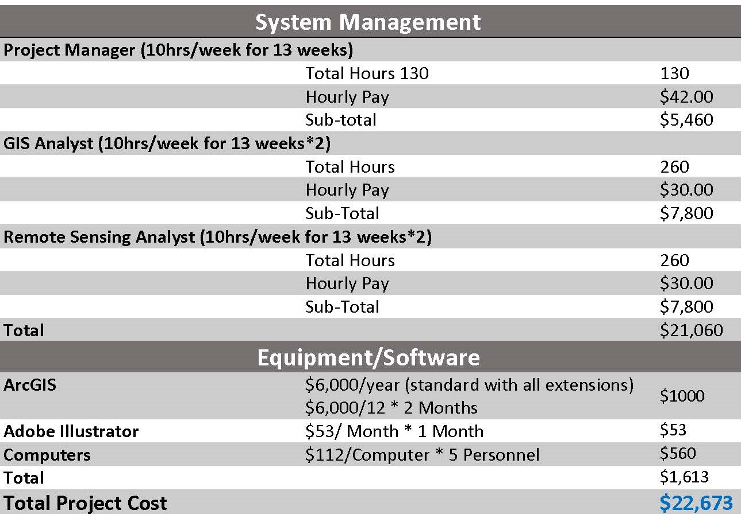

3.5 Timetable
- Data Collection: Landsat 8 OLI/TIRS and Travis county data collected
- Methodology and Analysis: All GIS and remote sensing analysis and processes performed. Maps created.
- Assemble Deliverables: All deliverables including Maps, Powerpoint, Web presentations collected and finished.
- Final Corrections: Any final alterations to the deliverables performed.

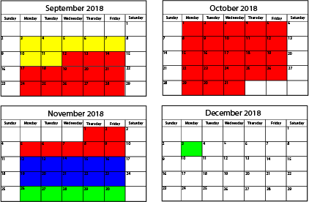

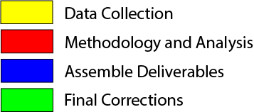

3.6 Final Deliverables
Once the urban thermal radiation hot spots and cold spots have been identified and the thermal radiation measurement has been quantified and classified, the spatial area of these spots will be measured and the percentage of canopy in these hotspot and cold spot locations will be quantified. We will be producing a model for the City of Austin to recreate this project in the future with an updated tree canopy TIFF as well as an instruction manual on downloading and correcting LANDSAT images.

4. Conclusion
The urban tree canopy has been shown to mitigate the city’s radiating thermal heating. Our analysis is expected to show where hotspots are located within Travis county, including where the urban canopy is weakest and where expansion opportunities exist. This would identify areas where tree placement would be most effective. The urban foresters of the city of Austin will be provided a tool to assist them in identifying hotspot locations and to construct urban forestry projects accordly. The analysis of the data could have hurdles and technical issues, and mitigating the limitations and margins of error could be a challenge, but one our team feels confident in overcoming.
5. Participation
Methodology Flow Chart - Zachary Mayer
Methodology of Remote Sensing - Alexis Ramirez and Gabrielle Allen
Methodology of Urban Tree Canopy - Zachary Mayer
Literature review - Kallie Hallmark, Zachary Mayer, Rance Parker
Budget- Kallie Hallmark
Time Table - Rance Parker
Implications - Kallie Hallmark

6. Bibliography

Akbari, H., S. Konopacki, H. Taha. 2001. Cool Surfaces and Shade Trees to Reduce Energy Use and Improve Air Quality in Urban Areas. Solar Energy 2001;70;295-310.

Aniello, C., Morgan, K. Morgan, A. Busbey, and L. Newland. 1994. Mapping Micro-Urban Heat Islands Using Landsat ™ and a GIS. Pergamon 21(8): 965-968.

AustinTexas.gov. tree_canopy_2014.zip. 2017. Geospatial Data Dev. City of Austin. www.austintexas.gov. (Last accessed 26 September 2018).

CAPCOG Region Open Data. 2017. Counties, Administrative Boundaries Capital Area Council of Governments. http://regional-open-data-capcog.opendata.arcgis.com/datasets/counties. (Last Accessed 26 September 2018).

Feyisa, G.L., K. Dons, and H. Meilby. 2014. Efficiency of parks in mitigating urban heat island effect: An example from Addis Ababa. Elsevier B. V. 123:87-94.

Klinenberg, E. 2002. Heat Wave, A Social Autopsy of Disaster in Chicago. University of Chicago Press, Chicago.

Loughner, C. P., D.J. Allen, D. Zhang, K.E. Pickering, R.R. Dickerson, and L. Landry. 2012. Roles of Urban Tree Canopy and Buildings in Urban Heat Island Effects: Parameterization and Preliminary Results. American Meteorological Society Journal of Applied Meteorology and Climatology 51: 1775-1784. (Last accessed 26 September 2018).

Martilli A., A.Clappier, Rotach. 2002. An Urban Surface Exchange Parameterisation for Mesoscale Models. Boundary-Layer Meteorology 2002; 104:261-304

Mirzaei, P. A., and F. Haghighat. 2010. Approaches to Study Urban Heat Island Abilities and Limitations. Elsevier B.V. 45(2010): 2192-2201.

Population Reference Bureau. 2005. World Population Data Sheet. Population Reference Bureau; 2005.

Rosenfeld, A.H., J.J. Rome, H. Akbari, A.C. Lloyd. 1997. Painting the Town White and Green. Technology Review 100 (2), 52-59.

Solecki, W. D., C. Rosenzweig, L. Parshall, G. Pope, M. Clark, J. Cox, and M. Wiencke. 2005. Mitigation of the heat island effect in urban New Jersey. Elsevier B.V. 6(1): 39-49.

Taha, H. Urban Climates and Heat Islands: Albedo, Evapotranspiration, and Anthropogenic Heat. 1997. Energy and Buildings 1997;25:99-103.

U.S. Geological Survey (USGS). 2014. Landsat Collection 1 Level-1 Quality Assessment Band Landsat Missions. https://landsat.usgs.gov/collectionqualityband. (Last accessed 26 September 2018).

U.S. Geological Survey (USGS). 2014. Landsat 8 Pre-Collection Quality Assessment Band Landsat Missions. https://landsat.usgs.gov/qualityband. (Last accessed 26 September 2018).

U.S. Geological Survey (USGS). 2014. Landsat Quality Assessment (QA) Tools Landsat Missions. https://landsat.usgs.gov/landsat-qa-tools. (Last accessed 26 September 2018).

U.S. Geological Survey (USGS). 2017. Landsat Quality Assurance ArcGIS Toolbox. U.S. Geological Survey software release. https://github.com/USGS-EROS/landsat-qa-arcgis-toolbox/blob/master/README.m
d.

Yu, X., X. Guo., and Z. Wu. 2014. Land Surface Temperature Retrieval from Landsat 8 TIRS—Comparison between Radiative Transfer Equation-Based Method, Split Window Algorithm and Single Channel Method. Remote Sensing 2014 (6): 9845. (Last Accessed 12 September 2018).

