Examining the Relationship Between Urban Heat Islands and the Tree Canopy in Austin, TX

Bobcat Urban Foresters

For
City of Austin Urban Forestry Department

Prepared by:
Zachary Mayer: Project Manager / GIS Specialist
Rance Parker: GIS Specialist
Kallie Hallmark: GIS Specialist
Gabrielle Allen: Remote Sensing Specialist
Alexis Ramirez: Remote Sensing Specialist

DATE: 29 October 2018
Table of Contents
- Introduction Page 3
1.1 Summary Page 3
1.2 Purpose Page 3
1.3 Scope Page 3
2. Project Tasks Page 3
2.1 Work Completed Page 3
2.2 Present Work Page 4
2.3 Work Scheduled Page 5
2.4 Problems Page 5
3. Time Table Page 6
3.1 Time Table Changes Page 6
4. Conclusion Page 7

- Introduction
1.1 Summary
Our group has created maps and analyzed data about the relationship between the Urban Heat Island (UHI) effect and the Urban Tree Canopy (UTC). After speaking with Alan Halter of the Urban Forestry Department in Austin, TX in our initial meeting, we began working on the project. This report shows our progress and any variables and data that have changed since our last report.

1.2 Purpose
This project will provide maps, data, and a methodology manual concerning the relationship between the UTC and the UHI. We will create and provide a working GIS model in which the processes and results we acquire can be replicated by the City of Austin in the future.

Major tasks of this project include:
- Task 1: Gathering and extracting thermal bands from LANDSAT scenes to find Land Surface Temperature (LST)

- Task 2: Processing UTC raster

- Task 3: Hot Spot analysis

- Task 4: Creating GIS models for future replication

1.3 Scope
The scope for the project hasn’t changed since our last report. The greater Austin area within Travis County is still our focus for the UHI effect as we plan to continue to home in on areas of extreme values relative to the study area to further explore the relationship to tree canopy cover.

2. Project Tasks
2.1 Work Completed
- Remote Sensing Task:
  - LANDSAT 8 data gathered and bands 4, 5, and 10 extracted from files.
  - Successfully masked clouds and cloud shadows from all scenes.
  - Two models created to extract clouds and convert LANDSAT raw images into LST.
  - Landsat bands processed and averaged into a single image (see Figure 1).
- Tree Canopy Task:
  - Travis county shapefile gathered from CAPCOG.
  - Tree canopy gathered from AustinTexas.gov.
  - UTC raster reclassified, clipped and processed by zonal analysis is sync to Landsat resolution (see figure 2)
- Hotspot Analysis Task:
  - See present work.

2.2 Present Work
- Remote Sensing Task:
  - All data has been gathered and extracted. Will clip water bodies out of the scene using National Land Cover Database 2011 data to avoid skewing of the hotspot analysis.
- Tree Canopy Task:
  - UTC prepared and ready for analysis.
- Hotspot Task:
  - Researching methods for hotspot analysis to determine proper parameters and methodology.

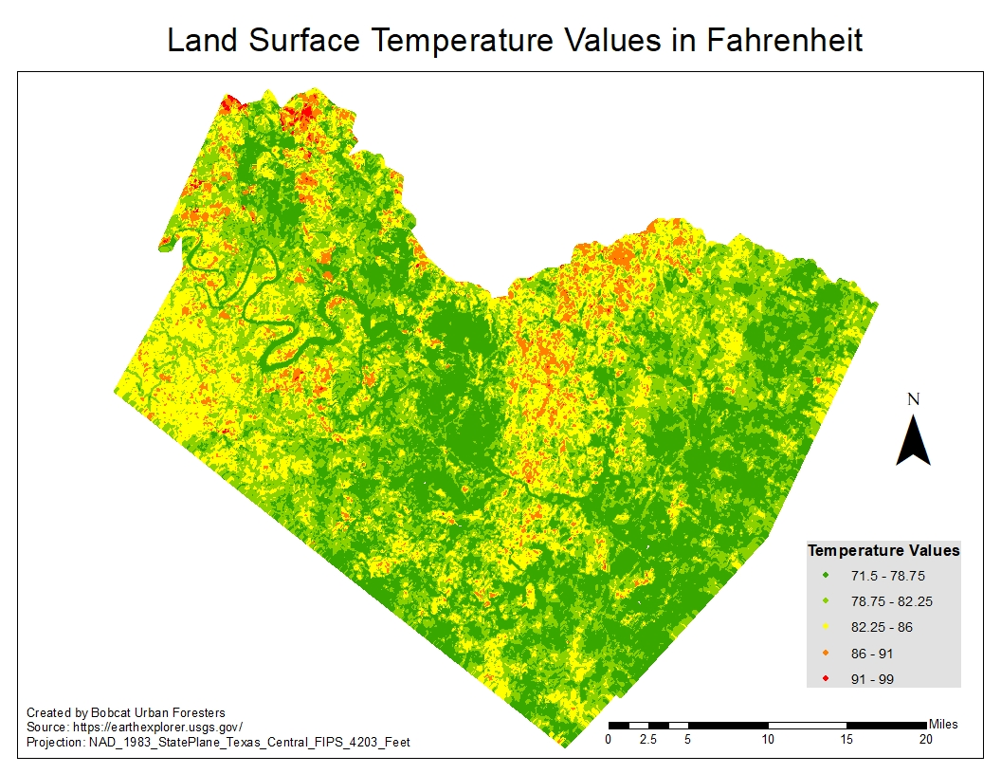
Figure 1
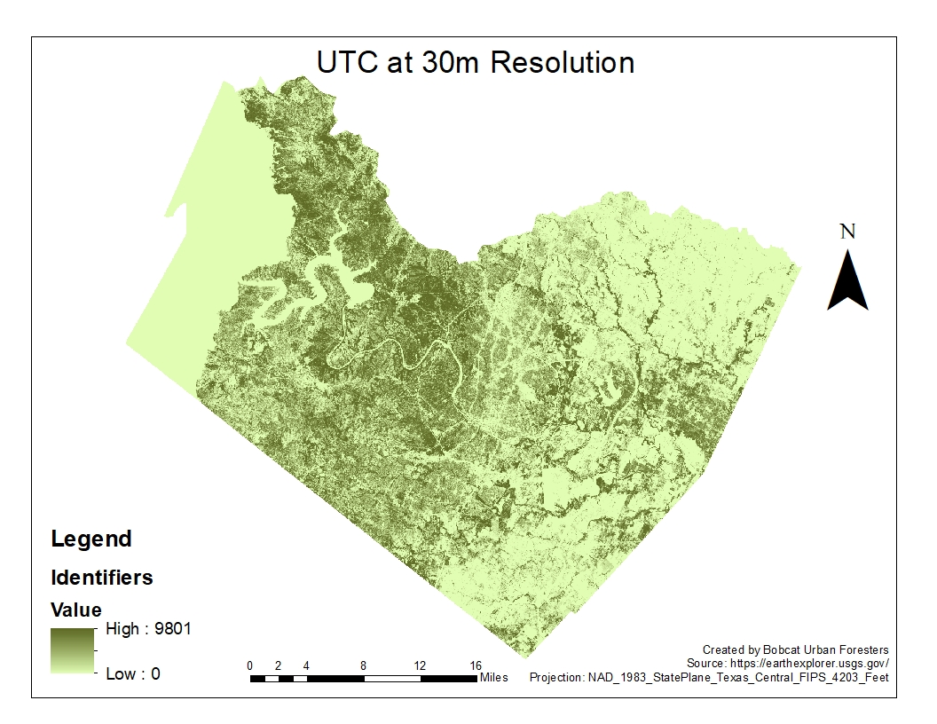
Figure 2
2.3 Work Scheduled
- Remote Sensing Task:
  - Will be creating an instruction manual for City of Austin to replicate this project in the future.
- Hotspot Task:
  - Complete the hot spot analysis on the extracted and clipped data.
  - Determine areas of interest within Hotspot Analysis results.
- Final Deliverables:
  - Create single manual of all methodologies used.
  - Publish an online story map of our data and results.
  - Share a geodatabase of all data/outputs used and created.
2.4 Problems
There have been a few problems concerning the project’s tasks, which include the tree canopy task, remote sensing task and the hotspot task. The UTC reclassification, clipping and zonal analysis had been problematic with a process of trial and error due to file sizes and computer processing limitations. The final mean LST raster contained spots of “No Data” values due to cloud cover being present in particular areas for each scene. Hot Spot analysis has been attempted but it has not yet worked yet.

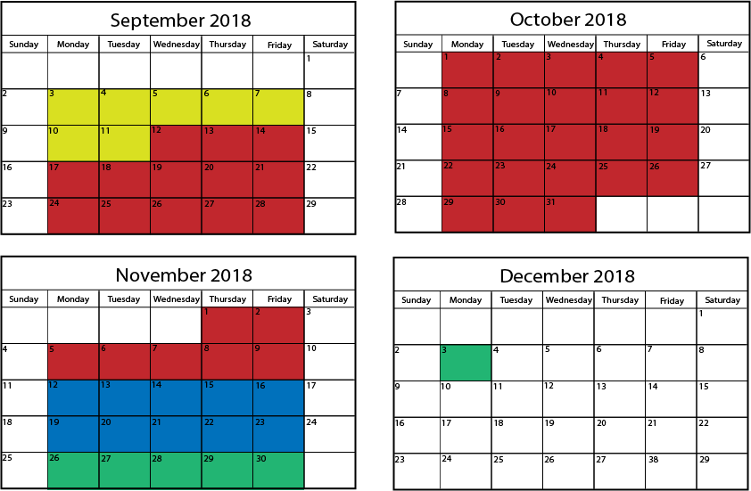
3. Time Table
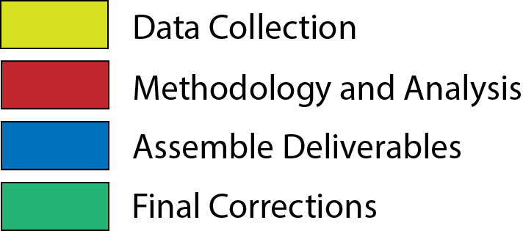

Figure 3

3.1 Time Table Changes
The time table for our project hasn’t changed since our last report. We are on schedule to finish our data analysis on November 9 and will begin creating our model and assembling deliverables on November 12. See Figure 3 for details.

4. Conclusion
In conclusion, the Bobcat Urban Foresters are working on a project dedicated to the relationship between the Urban Tree Canopy and the Urban Heat Island in Travis county. Our scope remains focused on the greater Austin area and our purpose is to create a GIS model that can replicate our methodology for updated data in the future, create an online story map that can be easily understood by the general public, and create a presentation for the Williamson County GIS day.

We have completed our data gathering and extracting of the correct bands from the LANDSAT 8 imagery. We are currently preparing our extracted data in order to perform a hot spot analysis to determine the hottest and coldest areas relative to canopy cover. We are scheduled to complete our hot spot analysis and then to create our GIS model, story map, and GIS day presentation.

The end goal for our team is to have effectively verify that the tree canopy can lower the temperatures of urban areas and to be able to communicate this data to the City of Austin as well as the general public. We also will include a model so that when updated data becomes available these methodologies can be easily performed.

