Examining the Relationship Between Urban Heat Islands and the Tree Canopy in Austin, TX

Bobcat Urban Foresters

For
City of Austin Urban Forestry Department

Prepared by:
Zachary Mayer: Project Manager / GIS Specialist
Rance Parker: GIS Specialist
Kallie Hallmark: GIS Specialist
Gabrielle Allen: Remote Sensing Specialist
Alexis Ramirez: Remote Sensing Specialist

DATE: 3 December 2018

Table of Contents

Abstract 3
- Introduction and Problem Statement 3
- Data 5
3. Methods 8
3.1 Landsat Methodology 9
3.2 Urban Tree Canopy Methodology 12
3.3 (Relate Analysis) Methodology 13
4. Results and Discussion 15
4.1 Implications 17
4.2 Data Quality Issues 18
4.3 Data Limitations and Recommendations 19
5. Conclusion 19
6. References 20
Appendix I: Contributions 22
Appendix II: Metadata 24

Abstract
This project analyzed the relationship between the Austin tree canopy density and the land surface temperature of Travis County. For decades scientists have observed the problems caused from the environment around dense urban areas called urban heat islands (UHI) and has shown how the urban tree canopy (UTC) can help mitigate the problem. This project is meant to find areas in the city center of Austin where the UHI is the strongest and where the UTC lessens the urban heating effects. Canopy data from the city and land surface data from Landsat was processed, then each of the values were compared to measure the impact the urban tree canopy (UTC) has on the urban heat island (UHI) in the city of Austin during the summer of 2014. The results showed that where there were more trees the ground was usually cooler, and where there were less trees the ground was warmer. The warmer ground included denser urbanized areas with roads, pavement, parking lots, and buildings, where there is not high density of tree canopy space.

Introduction
This project is about measuring and analyzing the relationship between the Austin urban tree canopy (UTC) and the urban heat islands (UHI) of the city. The UHI effect is when the impermeable materials that make up buildings such as pavement, concrete, parking lots, and roads, absorb and radiate more heat than in surrounding rural country areas. This causes dense urban areas to be unnaturally warmer. The UTC is composed of the tree coverage in an urban area.
This project’s focus is on finding exact locations were the tree canopy is the least dense and has the hottest temperatures on the parcel level. The UHI effect in cities has been observed to increase the effects of heat waves and warm weather, which can cause health problems like heat stress and heat stroke, or air pollution to intensify (Loughner et al., 2012). This is especially problematic during the summer months because this phenomenon can potentially coincide with heat waves. This problem was highlighted in the case in the Chicago heat wave of 1995, which resulted in the death of over 700 people (Klinenberg, 2002). A small increase in the temperature of an urban environment can cause a huge effect in energy usage with a 5-10% increase. (Feyisa et al., 2013).
The science behind urban heat islands and the impact of the urban tree canopy has been observed and studied for decades across the globe. In California and Florida, some solutions to UHIs were implemented including increasing tree shade around buildings, and the shaded buildings’ cooling utility demand was heavily reduced (Klinenberg, 2002). Trees provide shade and transpiration which causes cooling as much as four to six degrees Fahrenheit difference from areas without trees, when they are fully grown (Loughner et al., 2012).
UHIs are a public health risk and a utility burden on cities, therefore mitigating them is in the best interest of the general public. A great way to possibly reduce the phenomena is by planting trees in hotter locations to shade the area and potentially reduce the temperature. (Loughner et al., 2012). The combination of Geospatial Modeling Environment software, such as ArcGIS, and remote sensing techniques can be applied to locate the most intense heat islands where more trees can be planted.
The land surface temperatures and the canopy density values needed to be compared using GIS software (ESRI’s ArcMap) to find the Austin’s warmest areas where the canopy is less dense. The exact parcels needed to be identified in order for urban foresters and city planners to propose where improvements can be made. The Landsat images and UTC were processed to find the exact details of the least dense canopy locations and where exactly the average land surface temperature of the summer of 2014 was the warmest within the parcels (see figure 1).
Our analysis was expected to show heat islands in denser urban areas with low canopy density, which has been observed in many modern cities for decades. The hypothesis for this project was that the downtown area, major shopping centers, and areas around major roads and highways would have the highest land surface temperature and the least dense tree canopy.

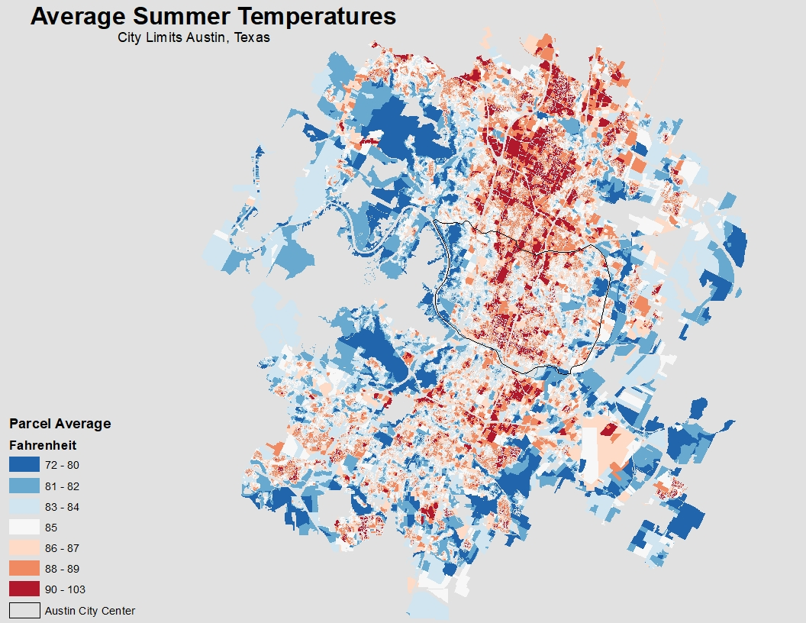
Figure 1: Average summer temperature per parcel with warmer
temperatures as red and colder temperatures as blue.

2. Data
The Central Texas Counties shapefile was downloaded from CAPCOG Regional Open Data website. This shapefile included multiple central Texas Counties around the greater Austin metropolitan area. Only Travis County was necessary for the project, and it was selected and exported as a new shapefile. The shape of Travis County was defined the geospatial scope of the project and was used to clip the UTC raster and all Landsat imagery. The original CAPCOG file had the coordinate system of GCS_WGS_1984, but the new Travis County shapefile was reprojected to NAD_1983_StatePlane_Texas_Central_FIPS_4203_Feet.

The Landsat 8 OLI/TIRS raster scenes were downloaded from U.S. Geological Survey. These images were all taken in the summer of 2014, from April to September. These seven scenes were essential to find the urban heat islands. Bands 4 (red), 5 (near infrared), and 10 (thermal infrared 1) were taken from the Landsat scenes and processed. These scenes originally had the coordinate system of WGS84_UTM14 and were reprojected to NAD_1983_StatePlane_Texas_Central_FIPS_4203_Feet.

The raster TIFF file of the Greater Austin Area urban tree canopy in 2014, came from AustinTexas.gov. The project necessitates the use of urban tree canopy 2014 data. The TIFF file was downloaded from the City of Austin website. This file included much of the greater Austin area which includes areas outside of Travis County, but the canopy class of the data did not span the entirety of Travis County. The data had the NAD_1983_StatePlane_Texas_Central_FIPS_4203_Feet coordinate system, with a one-foot by one-foot resolution. This data was altered by clipping the file by the Travis County layer then reclassifying the raster to show only the canopy. This raster was so large that it required a computer with a large enough processing power to complete the clipping and reclassification.

The Travis County Parcels 2016 shapefile was downloaded from the CAPCOG Regional Open Data website. This shapefile included all the land parcels in Travis County. This data was used to measure the relative value data on a scale per property. The parcels in the city limits and city center were selected and made as new layers from the original shapefile. The original coordinate system was NAD_1983_StatePlane_Texas_Central_FIPS_4203_Feet.

The 2011 Land Cover raster data was downloaded online through the Multi-Resolution Land Characteristics (MRLC) consortium and was used to mask out the water bodies in the Land Surface Temperature analysis. Without this data, the cooler water bodies could potentially skew the LST values. The original coordinate system was Albers_Conical_Equal_Area, so we projected it to NAD_1983_StatePlane_Texas_Central_FIPS_4203_Feet, clipped it to Travis County, and only selected the water feature pixels for analysis.

The Austin City Limits boundary was downloaded from the CAPCOG Regional Open Data website. The Austin city limits had to be selected from the original layer. This file once processed would help select sections of the parcel and pavement shapefiles that were located within the Austin city limits. This shapefile originally had the coordinate system of NAD_1983_StatePlane_Texas_Central_FIPS_4203_Feet.

The Austin City Center shapefile originated from the Dr. Nathan Currit at Texas State University Geography department. This shapefile used to focus the scope of the relational analysis and the coordinate system was originally NAD_1983_StatePlane_Texas_Central_FIPS_4203_Feet.

The Parks and Open Spaces, Building Footprints, and the Paved Areas 2013 shapefiles all came from AustinTexas.gov. The parks and paved areas were used to analyze the results of the relational analysis. The Building Footprint shapefile was used to give localized land surface temperature data context. The Parks shapefile originally had a coordinate system of WGS84(DD), and the Paved Area and the Building Footprint shapefile had a coordinate system of NAD_1983_StatePlane_Texas_Central_FIPS_4203_Feet.

3. Methods
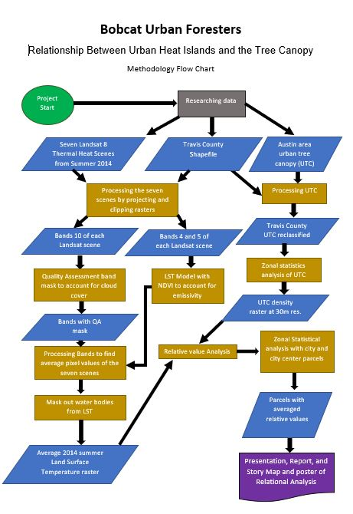
Figure 2: Methods and workflow table of the various conversions, algorithms, and analysis used for final products.

3.1 Landsat Methodology
Before we started our project, our group sat down and created our methodology (See Figure 2). Seven scenes from April to September of 2014 were ordered from earthexplorer.usgs.gov. These scenes were first visually assessed to have as minimal cloud cover as possible to find a reliable average of land surface temperatures. LANDSAT 8 has a temporal resolution of 16 days, meaning there are about two scenes available per month to choose from. However, many scenes from the summer of 2014 were completely covered with clouds, rendering them unusable. We were able to select seven scenes that were viable for this project that ranged from completely cloudless to cloud coverage in about half of the scene. A cloud cover mask procedure was later done to extract clouds and shadows. This was essential for the future accuracy of the Land Surface Temperature (LST) conversions.

Before processing or analyzing could occur, all Landsat 8 remote sensing scenes were projected to the same coordinate system as the City of Austin UTC layer. Bands 4, 5 and 10 of each scene were then clipped to the Travis County shapefile. There are two thermal bands in the Landsat 8 OLI/TIRS sensor. Band 10 was used instead of Band 11 in our research due to more uncertainty in the accuracy of land surface temperatures in Band 11 (Yu et al. 2014).

The Land Surface Temperature (LST) model was created using instructions from various resources such as YouTube tutorials and ESRI forums. First, the thermal band was converted to Top-of-Atmosphere (TOA) Radiance. This equation corrects the digital number (DN) assigned to each pixel to account for atmospheric scattering. The map algebra tool used the following equation:

L_{λ} = M_{L}*Q_{cal} + A_{L}
where:
L_{λ} = Spectral radiance (W/(m2 * sr * μm))
M_{L} = Radiance multiplicative scaling factor for the band (RADIANCE_MULT_BAND_10 from the metadata).
A_{L} = Radiance additive scaling factor for the band (RADIANCE_ADD_BAND_10 from the metadata).
Q_{cal} = L1 pixel value in DN (Digital Numbers)

The data was converted to TOA Brightness Temperature and converted to Celsius. The digital number for each pixel was not useful for data analysis until each were converted to a temperature value. The following equation was used:
TB=$(\frac{K_{2}}{ ln(\frac{K_{1}}{Lλ} +1)} )-273.15$
where:
TB = Top of atmosphere brightness temperature (in Kelvin)
L_{λ} = Spectral radiance (W/(m2 * sr * μm))
K₁ = Thermal conversion constant for the band (K₁_CONSTANT_BAND_10 from the metadata)
K₂ = Thermal conversion constant for the band (K₂_CONSTANT_BAND_10 from the metadata)

The last step in the Landsat data analysis was converting the At-Satellite Temperature into Land Surface Temperature. The difference in kinetic temperature of the earth compared to what the sensor was capturing was accounted for using the equation:
T= TB/[1+(λ*TB/c2)*ln(ε)]
where:
TB = Top of atmosphere brightness temperature (in Celsius)
λ = wavelength of emitted radiance (10.8 μm for Landsat 8 band 10)
c2 = h*c/s= 1.4388*10⁻² m K = 14388 μm K
h = Planck’s constant = 6.626*10⁻³⁴ J/s
s = Boltzmann constant = 1.38*10⁻²³ J/K
c = speed of light = 2.998*10⁸ m/s

ε = 0.004*Pv +0.986
Pv= ((NDVI - NDVI_{min})/(NDVI_{max} - NDVI_{min}))²

To find ε (emissivity), Pv (proportion of vegetation) had to be found. It was necessary to account for emissivity, because not all objects on the earth's surface radiate the same temperatures. For example, water temperature is captured by the sensor differently than concrete. The NDVI (normalized difference vegetation index) was used with Bands 4 and 5.

We then converted that raster from Celsius to Fahrenheit which would be ready for the cloud extraction. The cloud extraction an essential part to the methodology because clouds affect the quality of the pixel values by scattering reflected light back to satellite sensor. This means that the values recorded from these areas are not true values of what the measured values should be recorded from the ground. With most of our scenes having a high presence of clouds, we needed to remove them to prevent any skewing of our mean temperatures. If there were clouds or shadows of clouds in the images, a mask was created using the Quality Assessment band file (BQA.TIF) provided in the scene download folder. To perform this task, a toolbox from GitHub that can be used within ArcMap was downloaded. The Extract QA Bands tool extracted the bit-packed values associated with each scene and removed the classes individually. It combined the specified classes into one single file with the true values being “1” and false values being “0”. This raster was used to convert the true values (1) and into LST values. All the false values (0) were assigned a NoData value. After we created the new LST layers of each date, we used the Raster Calculator tool to find the average of all the scenes pixel temperature value and combined them into one final raster.

Lastly, water bodies needed to be removed from the final LST layer because the tree canopy does not extend over it. Also, the water could affect a hot spot analysis by skewing the results of areas that have no trees. The water was removed by using the National Land Cover Dataset which was correctly projected and clipped down to Travis County. In the Raster Calculator tool, the water class was used in a Con query expression to output water values into NoData values. The final Travis LST layer was then ready for correlational analysis with the urban tree canopy.

3.2 Urban Tree Canopy Methodology
The 2014 urban tree canopy (UTC) raster of the greater Austin area was acquired from and the County shapefile of central Texas was acquired. The County shapefile and raster were aligned to the projection of NAD_1983_StatePlane_Texas_Central_FIPS_4203_Feet. Travis County was selected from the central Texas country shapefile. The UTC raster was extracted by mask, by using the Travis County shapefile. This new raster, of only the UTC data in Travis County, was reclassified. The UTC raster included two values of one and three. Value one was the classification of the canopy area. The reclassification created a new raster of only the tree canopy or value one from the original UTC raster (See Figure 3).

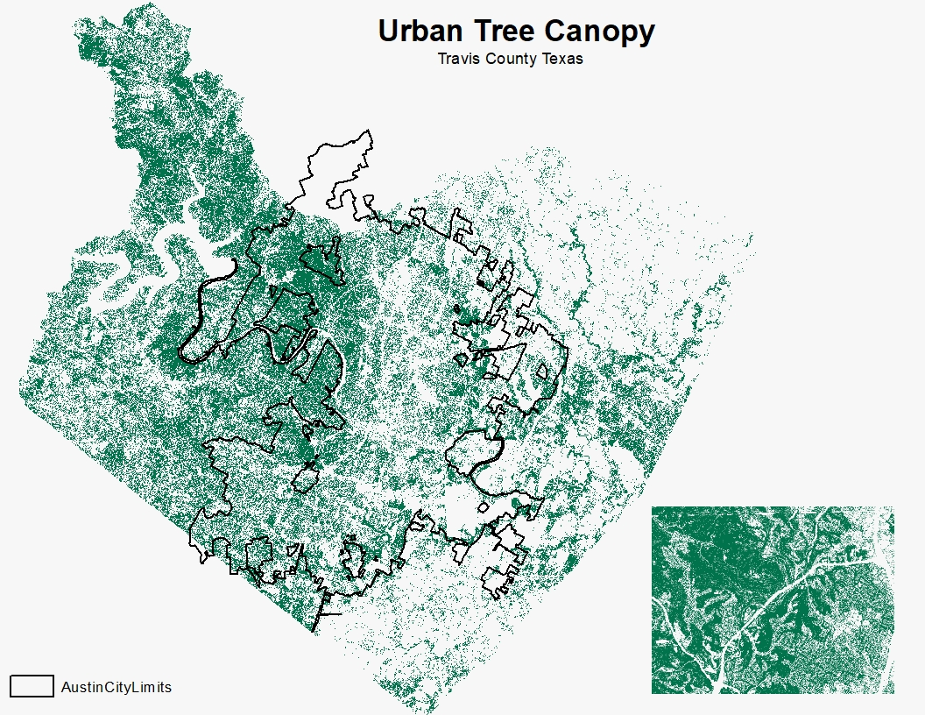
Figure 3: Visual of Austin’s urban tree canopy coverage and extent throughout Travis.

We also created a 30-meter spatial resolution of the UTC by first giving each pixel a unique identifier using the raster to point tool. We then converted these points to polygons to create a zone for each pixel. Using zonal statistics, we created a vector shapefile and then converted it into a raster to create the 30m resolution file.

Syncing the UTC data with the LST raster, and converting the UTC raster resolution, which give a sum of how many 1-foot by 1-foot canopy pixels were in the new resolution of 100 by 100 feet. This provided a spectrum of canopy density; the more canopy pixels in the larger resolution the denser the pixel (See Figure 4).

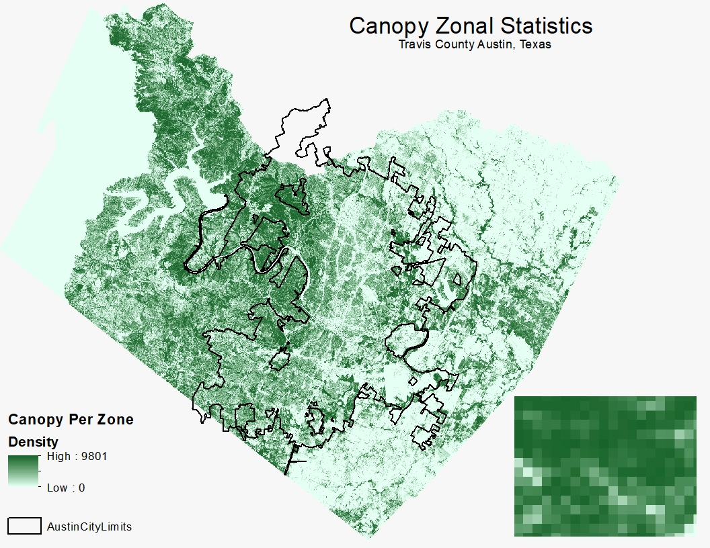
Figure 4: Calculated sum of UTC pixels within the larger LST resolution dataset.

3.3 Relational Analysis Methodology
The land surface temperature value ranged from 69 to 103 degrees Fahrenheit (See Figure 5). To simplify our results, we put our data through steps that would create a normalized value that represented both UTC density and average temperature.

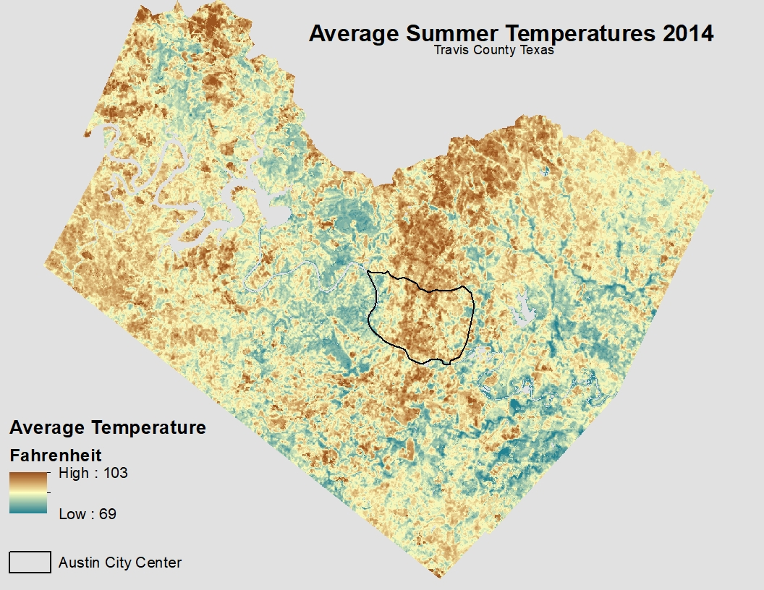
Figure 5: Calculated average Land Surface Temperature of seven Landsat scenes.

We first converted our two rasters (UTC and Temperature) to float so they could be put into the raster calculator. We then performed the following equation on each:
(“raster” - min. value) / (max. value - min. value)

After performing this equation on both the UTC and temperature rasters we subtracted the utc output from the temperature output:
(“tempoutput”) - (“UTCoutput”)

This equation would output our normalized relationship value. This showed the locations where the LST values were the highest and the tree canopy were the lowest, where LST values were low and UTC density was high, and all value ranges in between.

A zonal statistic analysis was performed with processed city parcel data to find the averaged relative value of each parcel. This would provide an output where each parcel could be given a measurement and value for Temperature and canopy density (See Figure 6).

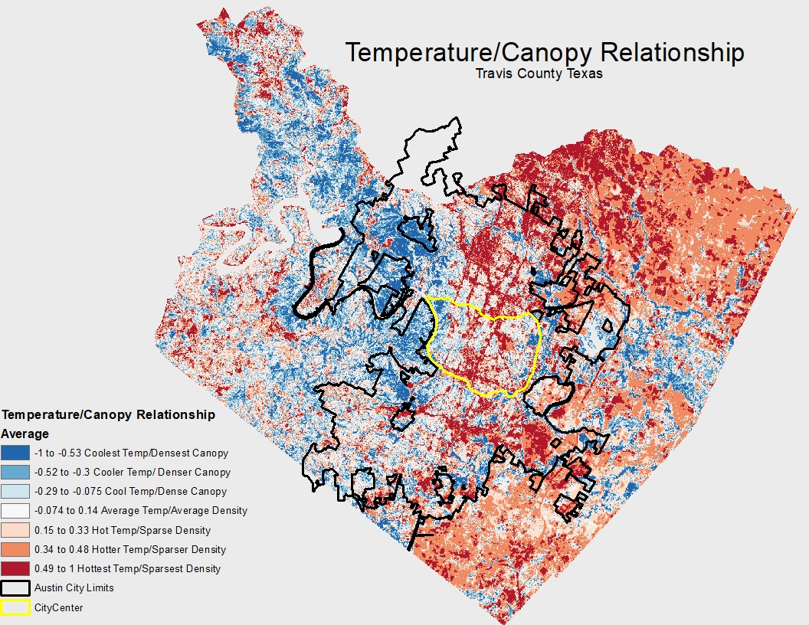
Figure 6: Relationship between the LST and UTC with positive correlations in red and negative correlations in blue.

4. Results and Discussion

Through the methodology used to create our normalized relationship raster there is a clear causation between the tree cover in Austin and the land surface temperatures. Throughout the city and suburbs there are areas of high temperatures with very sparse tree canopy as opposed to the parks and more rural areas of Austin where the temperatures are lower with a higher tree density.

We used our normalized data to evaluate the city parcels of Austin to see which parcels had extreme temperatures (See Figure 7). This allows us to be able to specifically identify where would need to consider increasing tree coverage to lower the temperatures to a more sustainable level. Many of the coolest parcels were parks and recreational areas and majority of the hottest were schools, offices, and city infrastructure such as the airport and parking spaces (See Figure 8 & 9).
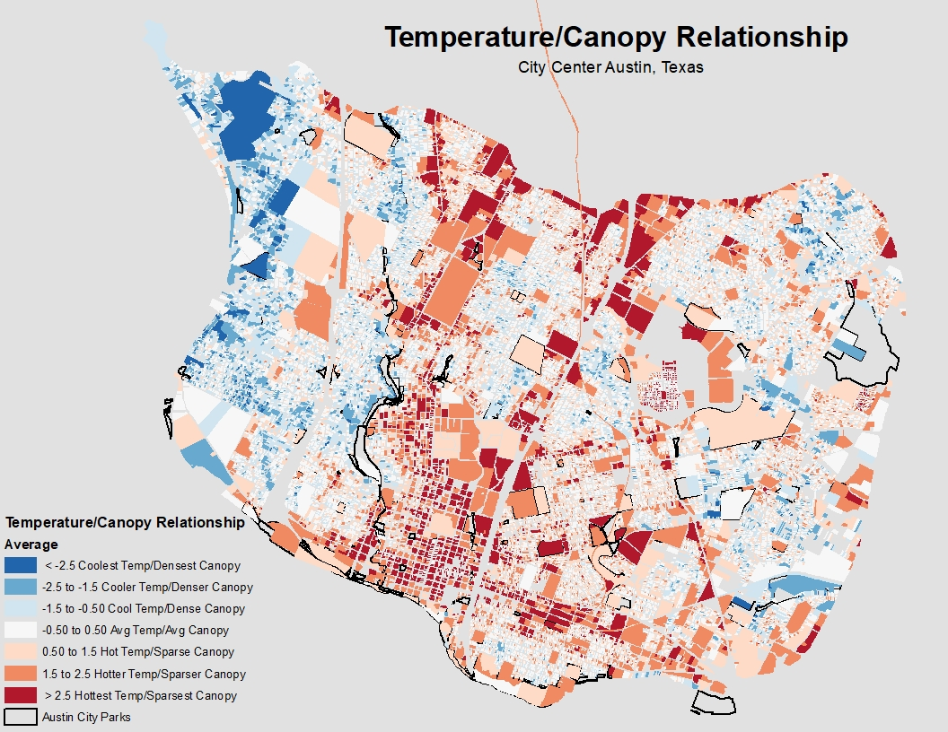
Figure 7: Parcels in the Austin city center that show relationship between UTC and LST.

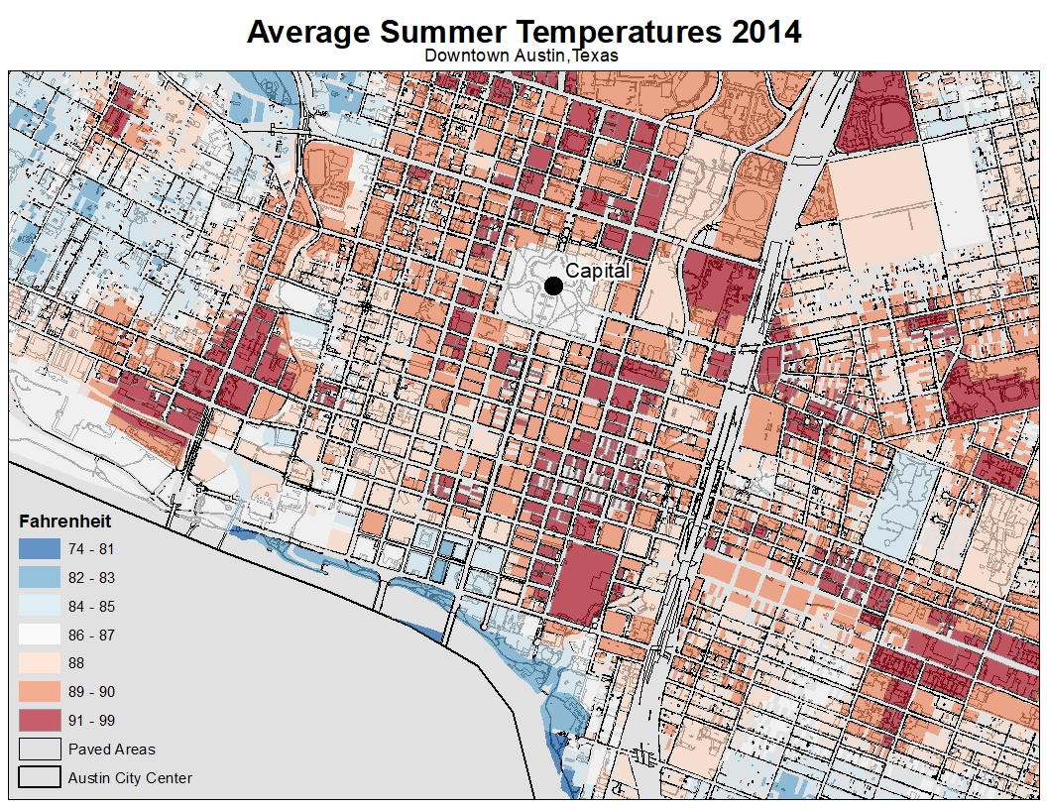
Figure 8: Average summer temperatures of Austin’s downtown city parcels and paved areas.
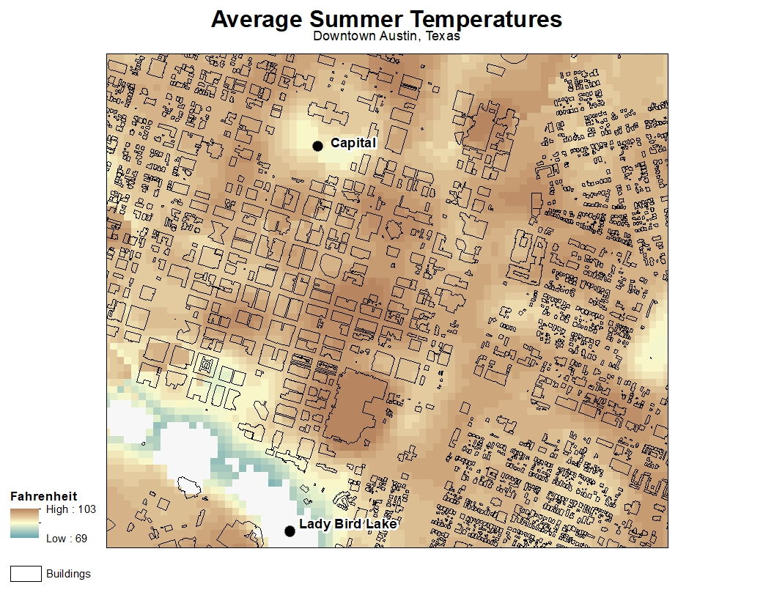
Figure 9: Average summer temperatures of Austin’s downtown area city buildings.

4.1 Implications

We have developed an ArcMap Tool in Model Builder that will help reduce the propensity of UHI and for the City of Austin to be implement in the future. This tool has identified the hottest and coolest areas, the mean summertime surface temperatures, and the relationship between the surface temperature. With global temperatures on the rise this tool will be integral to the lasting comfort and safety of Austin’s rapidly growing population and the environment. In addition, an online story map and an educational poster were created to bring this project to the public eye. We believe this transparency will engender public support. Bobcat Urban Foresters produced a model for the City of Austin to recreate this project in the future with an updated tree canopy TIFF as well as an instruction manual on downloading and correcting LANDSAT images.

The hypothesis for this project was that denser areas of impermeable urban material with less canopy density would have warmer land surface temperatures. The urban areas with the higher concentrations of impermeable materials and low canopy density were expected to be the urban core of Austin (roughly from Ben White freeway to 183 between Mopac and I35), including the downtown area, major highways, and shopping centers. The results were similar to the hypothesis, except there were more moderate temperatures in Austin’s urban core, the warmest LST in the town down area was not between the skyscrapers and high rises but was actually the convention center. The downtown area in relation to the rest of the study area was still significantly warmer. The moderate temperatures in the city’s core was thanks to health canopy in the residential neighborhoods, although not as cool as the neighborhoods under healthy canopy in west Austin. Shopping centers and parking lots along the major roads in the urban core were relatively warm and with low canopy density.

4.2 Data Quality Issues

To achieve positional accuracy, we made sure that all files used were projected into the same coordinate system. We also used Environment settings in ArcMap to assure rasters lined up to each other before analysis.

The UTC data came to us in a very fine resolution of 1 foot by 1 foot. This data resolution proved to be difficult for our machines to process, but we achieved the desired results via alternative methods, which are laid out in the manual, and a bit of creativity. The results of the zonal analysis would have been further skewed without the conversion as the zonal statistics would have been inflated.

Other quality issues that we mitigated were to remove water bodies out of the scene to avoid potential skewing of any hot spot analyses.

4.3 Data Limitations and Recommendations

There is an issue with completeness of the tree canopy layer provided to from the City of Austin, as it does not cover the entirety of Travis County. The correlation between the canopy density and temperature values could not be measured for a large part of West Travis County.

Gaps in the final Landsat LST raster caused us to alter our original methodology of only including scenes from May through September of 2014. We decided to include a scene with no cloud coverage from April 28, 2014 to fill the gaps of our averaged LST dataset.

The parks, city limits and city data were not from 2014 but were a updated a few years after the study period. The most recent National Land Cover Database file is from 2011 and was the only accurate water body resource found. We recommend using the most recent file provided to provide as much accuracy to the project as possible.

5. Conclusion
The final results of this project found the exact parcels in Austin that were the warmest, including the downtown area, around major roads within the urban core of Austin and around shopping centers. One of the warmest parcels in the downtown area was where the Austin convention center was located. This project’s results also showed grassy parks like Zilker may have fields with lower canopy density but had moderate land surface temperatures. These fields at Zilker park are often used for sports, recreation and even a space for concert festivals, and planting trees in the middle of these fields may be problematic. Planting around the parameter if there’s space could be a better idea. Austin Bergstrom International Airport was a location with a high LST values and low canopy density, however it may not be a good place to plant more trees. Trees at an airport could cause a few problems including attracting birds, which could increase the chances of bird strikes with aircraft.

The urban tree canopy has been shown to mitigate the city’s radiating thermal heating. Our analysis showed where the warmest locations are located within the Austin area, including where the urban canopy is weakest and where tree planting opportunities exist, and be the most effective. The urban foresters of the City of Austin now have access to this tool to assist them in identifying hotspot locations and to construct urban forestry projects accordingly.

6. References

AustinTexas.gov. Parks and Open Spaces. Geospatial Data Dev. City of Austin. www.austintexas.gov. (Last accessed 28 November 2018).

AustinTexas.gov. Paved Areas 2013. Geospatial Data Dev. City of Austin. www.austintexas.gov. (Last accessed 28 November 2018).

AustinTexas.gov. tree_canopy_2014.zip. 2017. Geospatial Data Dev. City of Austin. www.austintexas.gov. (Last accessed 26 September 2018).

AustinTexas.gov. Building Footprints. Geospatial Data Dev. City of Austin. www.austintexas.gov. (Last accessed 28 November 2018).

CAPCOG Region Open Data. 2017. Counties, Administrative Boundaries Capital Area Council of Governments. http://regional-open-data-capcog.opendata.arcgis.com/datasets/counties. (Last Accessed 26 September 2018).

CAPCOG Region Open Data. 2018. City Limits 2018, Administrative Boundaries Capital Area Council of Governments. http://regional-open-data-capcog.opendata.arcgis.com/datasets/citylimits-nov2018 . (Last Accessed 29 November 2018).

CAPCOG Region Open Data. 2017. Parcels Travis 2016, Property Capital Area Council of Governments. http://regional-open-data-capcog.opendata.arcgis.com/datasets/parcels-travis-2016-1 . (Last Accessed 29 November 2018).

Currit, N. Austin City Center. Texas State University Geography Department.

Feyisa, G.L., K. Dons, and H. Meilby. 2014. Efficiency of parks in mitigating urban heat island effect: An example from Addis Ababa. Elsevier B. V. 123:87-94.

Klinenberg, E. 2002. Heat Wave, A Social Autopsy of Disaster in Chicago. University of Chicago Press, Chicago.

Loughner, C. P., D.J. Allen, D. Zhang, K.E. Pickering, R.R. Dickerson, and L. Landry. 2012. Roles of Urban Tree Canopy and Buildings in Urban Heat Island Effects: Parameterization and Preliminary Results. American Meteorological Society Journal of Applied Meteorology and Climatology 51: 1775-1784. (Last accessed 26 September 2018).

U.S. Geological Survey (USGS). 2014. Data. Multi-Resolution Land Characteristics Consortium (MRLC). https://www.mrlc.gov/data?f%5B0%5D=category%3Aland%20cover. (Last accessed 2 December 2018).

U.S. Geological Survey (USGS). 2014. Landsat Collection 1 Level-1 Quality Assessment Band Landsat Missions. https://landsat.usgs.gov/collectionqualityband. (Last accessed 26 September 2018).

U.S. Geological Survey (USGS). 2014. Landsat 8 Pre-Collection Quality Assessment Band Landsat Missions. https://landsat.usgs.gov/qualityband. (Last accessed 26 September 2018).

U.S. Geological Survey (USGS). 2014. Landsat Quality Assessment (QA) Tools Landsat Missions. https://landsat.usgs.gov/landsat-qa-tools. (Last accessed 26 September 2018).

U.S. Geological Survey (USGS). 2017. Landsat Quality Assurance ArcGIS Toolbox. U.S. Geological Survey software release. https://github.com/USGS-EROS/landsat-qa-arcgis-toolbox/blob/master/README.md.

Yu, X., X. Guo., and Z. Wu. 2014. Land Surface Temperature Retrieval from Landsat 8 TIRS—Comparison between Radiative Transfer Equation-Based Method, Split Window Algorithm and Single Channel Method. Remote Sensing 2014 (6): 9845. (Last Accessed 12 September 2018).

Appendix I: Contributions
Zachary Mayer (Project Manager):
As project manager my primary role was to coordinate the Bobcat Urban Foresters team’s progress. I wrote up the literature review for the proposal and used parts of literature review for the final report. I worked on the Austin 2014 Urban Tree Canopy.tiff by reclassifying the raster then clipping it, before it was processed further by other team members. I did research and went through a process of trial and error with different ways of doing analysis. I worked on aggregating the UTC data to resize the raster’s resolution, but our team went with a better method to process the UTC data. I worked on a Getis-Ord Gi Hot Spot analysis for the LST data, but our team went with the relational analysis instead. I worked with the GIS services in Alkek to gain licensed access to the resource of ESRI’s ArcGIS online web map builder, for research to learn how to create a map series story map as a final deliverable. My group went with a shortlist story map instead. I downloaded Austin building data and processed the shapefile to be used as tool to analyze the results, and our team did use the processed building data. I worked on the proposal report and presentation, as well as working on the final report and final presentation.

Gabrielle Allen:
As a Remote Sensing specialist, I assisted in the conversion techniques used for the pre-processing of the Landsat scenes, land surface temperature equations, and extraction features. Pre-processing consisted of downloading raw Landsat scenes within the defined time period to acquire the satellite wavelength bands need for preparation of land surface temperature conversions. I provided some input for the format of the algorithms used for LST modifications. After the LST Fahrenheit files were provided to me, feature extractions were needed to prevent skewing of the data before it is passed on for zonal and hot-spot analysis. I downloaded the necessary tool boxes needed for the removal of the clouds through the use of the Band Quality Assessment (.BQA) file provided in the scene downloads. I performed many query expressions in Raster Calculator for the removal of clouds and water from each scene. Also, generated the final mean average LST temperature for Travis County. I added information within the final report and presentation. Lastly, I contributed to the overall aspect of the poster consisting of the purpose, methodology, results, design, and format.

Alexis Ramirez:
As a remote sensing specialist, most of my contributions were to the preparation and analysis of the Landsat scenes. Gabrielle and I researched and downloaded appropriate Landsat Scenes, created our methodology, and helped each other create the methodology. I built the LST Conversion model with input from Gabrielle. We also divided up work for all reports and presentations for the Landsat methodology portions. Contributed to the methodology of our poster, as well as proofreading and editing for grammar. I also proofread and edited the documents for our website. I created and organized geodatabase, prepared the README file for final CD deliverable, and burned CDs. Wrote portions of the Landsat Methodology in the CoA Instruction manual. Much of my time was spent making sure our group was on track, helping with assigning/allocating tasks, and editing/proofreading assignments.

Kallie Hallmark Bradley/GIS Analyst:
As a GIS specialist, I resolved the spatial resolution for UTC raster by converting the data into zones which allowed us to analyze the UTC against the LST. I analyzed geographic data to determine canopy density and evaluated normalized data results by seven classes on a scale of sparsest/densest and coldest/hottest. Also, I generated all final UTC and UHI maps including downtown, city limits, and County study areas displaying: paved areas, parks, building footprints, average temperatures, and parcel analyses. I contributed research, budget, literature reviews as well as analysis in the proposal, final report, as well as design input for the poster.

Rance Parker:
As a GIS specialist most of my contributions happened after we received the rasters from our remote sensing specialists. I specifically created our model to normalize and relate the UTC and LST rasters in order to display the relationship results seen. I also created our shortlist story map on the ESRI website allowing our data to be presented easily and clearly to the public. I helped in the creation of our preliminary maps which were handed off to Kallie for finalization. Apart from the GIS analysis I created our logo, contributed to the writing and presenting of the scope and timetable in the proposal and progress report, and worked on the initial literature review at the beginning of the project.

Appendix II: Metadata

File Name | Description
TravisNormal.pdf | Metadata description for the normalized UTC/LST relationship TIFF
UTC30mRes.pdf | Metadata description for the zonal UTC 30m resolution TIFF
Travis_without_water.pdf | Metadata description of final summer 2014 LST TIFF output

