Table of Contents
Kyle- San Marcos Regional Trail  September 30, 2017 | Development of a Transportation Greenbelt Trail from the City of Kyle to the City of San Marcos  Consultants  ●Lucas Chavez (Project Manager) ●Julian Emerson (GIS analyst) ●Emma Highberger (GIS analyst)

Introduction
- Summary ……………………………………….2
- Purpose …………………………………………2
- Scope …………………………………………...3
- Literature Review……………………………….4
Proposal
- Data……………………………………………..5
- Methodology……………………………………7
- Budget…………………………………………..10
- Timetable……………………………………….12
- Final Deliverables……………………………...13
Conclusion………………………………………….......14
Participation……………………………………………..14
References……………………………………………...14

1. Introduction
1.1 Summary:
The San Marcos Greenbelt Alliance (SMGA) is a non-profit organization founded in 1998 to provide non-motorized travel throughout San Marcos and other communities. Currently there is no direct access from San Marcos to Kyle for pedestrian traffic. Creating a passage between the two growing cities will allow citizens to hike safely between locations.
Trailblazers Consulting will implement a GIS that will provide the San Marcos Greenbelt Alliance (SMGA) with the most sustainable route for a connecting trail from San Marcos to Kyle. With this proposed route, the SMGA plans to connect with other communities such as the City of Buda and Austin. They intend to develop a route connection with Austin's Violet Crown trail that is proposed to link the cities involved between San Marcos and Austin.

1.2 Purpose: What is the purpose of the study you are undertaking? What are your goals and objectives?
- There are multiple reasons to increase the connectivity between municipalities but the main goal in developing this trail is for transportation purposes. Our project is to develop a trail utilizing GIS to support our methods of how and why this trail should be designed in the proposed site we designate. SMGA will be able to utilize the information we provide them to propose this development to future stakeholders that want to take part in the funding of this great project for their communities. Funding from local partners and stakeholders allow for the development of trails which provide communities the opportunity to promote health, recreation, transportation, ecology, economy, and education.
- This study will provide a GIS of a proposed greenbelt trail from San Marcos to Kyle based on the analysis of multiple criteria: property ownership, land usage, tree cover, established trails with possible connectivity, and potential crossings of major highways and rivers. We will classify our criteria as either desirable or undesirable and manipulate the trail route accordingly. This will create a spine trail with little to no difficulty to traverse so anybody can easily and efficiently travel between these cities without having to drive a motor-vehicle.
- This project will be produced using data from the stakeholders which are: the City of Kyle GIS department, San Marcos GIS department, and the City of Buda GIS department. Other data sources we will use will be from Texas Natural Resource Information Systems (TNRIS), Google Earth, and the United States Geological Survey (USGS) for the development of the trail.

1.3 Scope:
- The scope of the area we are mapping consists of the City of Kyle to the City of San Marcos. The area west of I-35 is the primary focus to connect the 2 cities with the development of our proposed trail. We plan to link the 2 communities with green spaces that are established in both areas for the development of this trail.
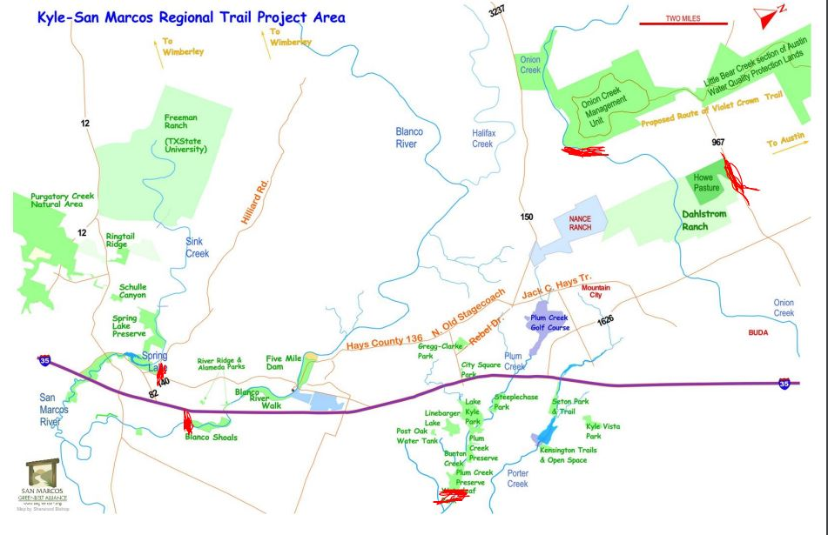

2. Literature review
This project will consist of creating a map of a proposed trail(s) utilized primarily for transportation. The scope we will be working which encompasses the San Marcos/Kyle area and end results will include and link existing trails. The goals provided by SMGA require us to examine and assemble least cost paths as well as multi-purpose use.
Carroll I. Courtenay and Todd R. Lookingbill conducted an analysis to design a regional trail network with a high conservation value using Green Infrastructure principles. Their scope encompassed the James River watershed. The authors determined potential locations of the trails within their study area through a series of spatial analysis methods while sustaining conservation and recreation goals. They first used two types of GI assessments to identify priority green spaces, a geospatial analysis to prioritize and link remaining natural lands and a morphological spatial pattern analysis to categorize the land cover into discrete classes. As well as incorporating protected areas, the authors generated a priority surface including perceived ecological value. Courtenay and Lookingbill demonstrated the possibility of combining recreational and transportation goals with conservation efforts to successfully produce a multi-purpose trail with least cost degradation of the environment.
In an article featured on AmericanTrails.org Mel Huie and Carrie Belding discuss the success in investing in regional trails. Creating a network of trails that go beyond county boundaries provides a valuable transportation option. The authors also discuss resource allocation and sustainability. These two important factors in building great trails starts with investors. And the return on investment comes in all types of forms: more jobs, tourism and new residents. In order to expand regional trail connection, it is important to be able to relay the significant benefits these trails can inflict on the community so that those interested in the vision may contribute.
The building and expansion of trail-making is repeatedly expressed as beneficial on multiple levels not only for connecting locations but for connecting people - together and with nature.

3. Proposal
3.1 Data: This section should be in the format of a master data list (refer to the lecture)
- Publicly accessible GIS data
Cities Data:  San Marcos, Tx | Attributes | Spatial Object | Status
Parks shapefile | Name of Parks; Dedication; Addresses; Acre Size | Polygon | Available
Trail Data Shapefile | Name of Trails; Source of Production; Length of Trail; Park Associated with Trail; Status of Trail | Polyline | Available
City Limit Shapefile | Created By; Acreage | Polygon | Available

Cities Data:  Kyle, TX | Attributes | Spatial Object | Status
Parks Shapefile | Name of Parks; Acreage; Type of Recreation Capabilities; Owner of Park; Addresses | Polygon | Available
Trail Data Shapefile | Park Associated with Trail; Length of Trail | Polyline | Available
City Limit Shapefile | Addresses; Subdivions | Polygon | Available

Entity | Data Collected | Attributes | Spatial Object | Status
Texas Natural Resource Information Systems (TNRIS) | 1) Aerial Imagery;  2) Soil Data | 1) Imagery provides basemap;  2) Type of Soil;  Farmable/Non-Farmable soils; Erodibility | 1) Raster Image;  2) Polygon | Available
United States Geological Survey (USGS) | Land Cover/ Land Use data; | Count; Value | Raster Dataset | Available
Texas State Geography Department | Digital Elevation Model | Elevation | Raster Dataset | Available
Texas Commission of Environmental Quality (TCEQ) | River Data | River Basin; Segment Name; Segment Description | Polyline | Available
Hays County | Low Water Crossings Data | Location of Low Water Crossing; Crossing Type;  Creek Associated | Point | Available

  - Texas Natural Resources Information Systems (TNRIS)
    - Aerial Imagery from source will allow for more precise visualization when developing the trail along the terrain.
    - Soil data from source will help with analyzing trail sustainability depending on the different soil types.
  - United States Geological Survey (USGS)
    - Land cover/ land use data to minimize the high cost of vegetation removal
  - Texas State University GIS Data
    - Collected a Digital Elevation Model (DEM) to mitigate areas with steep slopes that would increase risk and cause soil loss through erosion
  - Texas Commission of Environmental Quality (TCEQ)
    - Collected data on the rivers running through our AOI to incorporate for analysis.
- Software to be used: ArcGIS, ERDAS Imagine, Adobe Illustrator, Google Earth Pro

3.2 Methodology (You are required to include a flow chart for your methodology in this section)
- Create a base map of the Area of Interest (AOI) using aerial imagery, parks, and trail data provided by stakeholders
  - What will you do with the data? Aerial Imagery obtained through TNRIS to focus on the AOI
  - Overlay with existing park and trail shapefiles from their respected city GIS departments to analyze potential trail connectivity

- Gather all the variables through data acquisition to be able to develop a Least Cost Path
  - Acquisition of variables: Digital Elevation Model (DEM), National Landcover Dataset (NLCD), Trails, Soils, Water Features, and potential points of interests

- After the acquisition of data we need to figure how we want to process our different variables to produce our Least Cost Path
  - We want to convert our water features into points to allow us to reclassify into a water viewshed.
  - Acquire points of interests for potential rest stops along the trail as well as information boards along the way.
  - Once we have these variables processed we need to reclassify certain variables to allow us to run our least cost analysis.
    - Reclassification of multiple layers including: DEM, NLCD, Trails, Soils, Water Features, and Points of interests.
      - This will give the GIS the ability produce a weighted overlay of these layers based on how costly it will be to cross the pixel.
    - Once the variables have been reclassified we can figure the cost summation based on our valuation of the properties and relative weight estimates.
    - We develop a cost surface based on how each variable is weighed to develop a cost estimate raster of all the variables that were implemented into our analysis. This will give a cost estimate raster
    - Once the cost estimate raster is produced it will allow for the development of our trail based on the weights we put on our certain variables when figuring cost summation.

  - The hypothesis being tested with the analyses done is to provide a sustainable trail that will be of least cost to our client while producing a minimal risk of transportation difficulty from point A to point B as efficiently as possible.
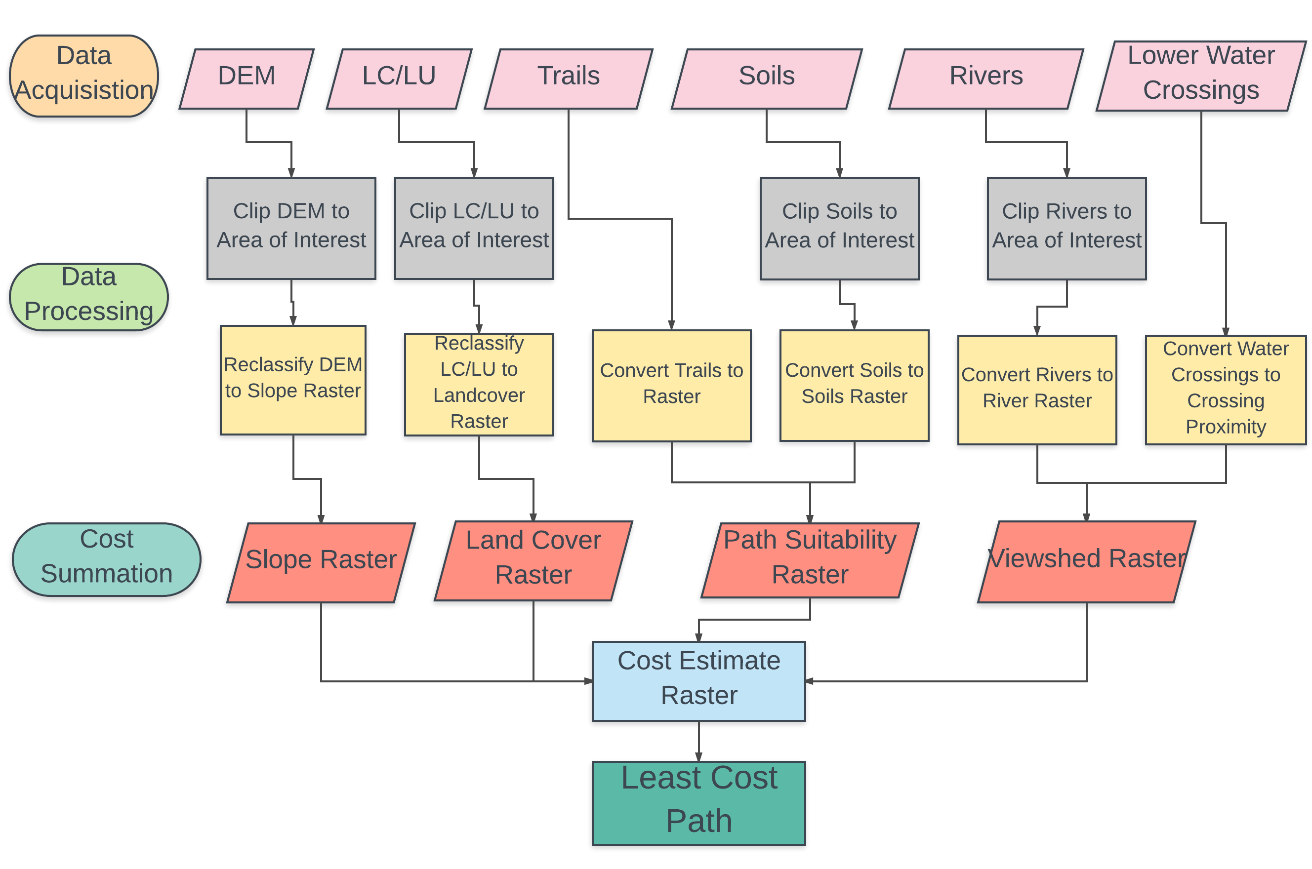

Referenced:
Kokkinidis, Ioannis & Stein, Beth & Surendrababu, Jayashree & Seigler, Taylor & Hwang, Won Hoi & Lorentz, Laura & Howey, Catherine. “A Least-Cost Algorithm Approach to Trail Design Using GIS.” Photogrammetric Engineering and Remote Sensing. Vol. 79. June 2013, p498-505.

3.3 Implications
- The data and results will be used for making a trail connecting San Marcos to Kyle Texas. In providing pedestrians direct access between locations citizens can travel safely and conveniently. This expansion of the San Marcos-Kyle network provides citizens with a non-motorized transportation option that also benefits the community in many ways.
  - Once we have presented the the potential trail this data and method we used to develop this trail can be implemented for other communities wanting to connect other cities with non-motorized travel.

3.4 Budget
Data Processing
Project Manager | 10 hours/week: 1 week
GIS Analyst | 15 hours/week: 2 analysts: 1 week
Total Hours | 40
Hourly Pay (Project Manager) | $30
Hourly Pay (GIS Analyst) | $20
Subtotal | $900

Data Analysis
Project Manager | 15 hours/week: 2 weeks
GIS Analyst | 10 hours/week: 2 analysts: 2 weeks
Total Hours | 70
Hourly Pay (Project Manager) | $30
Hourly Pay (GIS Analyst) | $20
Subtotal | $1,700

GIS and Map Development
Project Manager | 10 hours/week: 6 weeks
GIS Analyst | 10 hours/ week: 2 analysts: 6 weeks
Total Hours | 180
Hourly Pay (Project Manager) | $30
Hourly Pay (GIS Analyst) | $20
Subtotal | $4,200

Data Interpretation
Project Manager | 7 hours/week: 2 weeks
GIS Analyst | 7 hours/ week: 2 analysts: 2 weeks
Total Hours | 42
Hourly Pay (Project Manager) | $30
Hourly Pay (GIS Analyst) | $20
Subtotal | $980

Software
ArcGIS | $1,750 ($7,000 annual subscription)
ERDAS Imagine | $220
Adobe Illustrator | $599
Subtotal | $2,569

Total Cost
Data Processing Subtotal | $900
Data Analysis Subtotal | $1,700
GIS and Map Development Subtotal | $4,200
Data Interpretation Subtotal | $980
Software Subtotal | $2,569
Total Cost | $10,349

3.5 Timetable
We will spend no more than one week on the Data Processing phase. We are allocating such a small amount of time towards this phase of our project mainly because most of our data will be given to us by the affiliated cities and preprocessed. This phase of our project will include the collection and manipulation of our data which will result in a complete standardized collection of all of our data we will use for this project.
The Data Analysis phase of our project will be devoted two weeks. During these two weeks, our GIS analysts will examine our data, that are the criteria for the trail development, which include a Digital Elevation Model (DEM), National Landcover Dataset (NLCD), Trails, Soils, Water Features, and potential points of interests. With the results of our analysis, we will then begin our map development.
The GIS and Map Development phase will consist of 4 weeks of refining our GIS and generating the best map to display potential trails to SMGA and stakeholders. During this process, we will begin to reclassify our data to provide us with a cost surface that will aid in navigating a least cost path which will eventually produce the potential trail route.
Finally, we will spend two weeks on the Data Interpretation phase of our project. During this time, we will be performing a further analysis of what was produced in the previous phase and we will also be completing our Final Deliverables.

Table 1. Timetable
Project Phase | Starting | Ending
Data Processing | 9/11/2017 | 9/15/2017
Data Analysis | 9/18/2017 | 9/29/2017
GIS and Map Development | 10/2/2017 | 11/10/2017
Data Interpretation | 11/13/2017 | 11/24/2017
Presentation | 12/6/2017 | 12/6/2017

3.6 Final Deliverables
TrailBlazers Consulting will provide San Marcos Greenbelt Alliance with the following information
  - Detailed Final Report
  - Professional Poster
  - Data Files:
    - All data
    - Metadata
    - Report
  - PowerPoint Presentation
  - Map of Trails for specified Area of Interest
TrailBlazers Consulting will provide the San Marcos Greenbelt Alliance (SMGA) with a digital map that will display potential trails, based on the data collected. These trails will be developed through our analysis we run our data through to provide the best potential trail routes for the proposed area. This data will be given to SMGA to allow them to further their development of future greenways and trails in the San Marcos- Kyle region, and hopefully to neighboring cities.
4. Conclusion
- TrailBlazers Consulting will use the data provided by the San Marcos GreenBelt Alliance and other stakeholders, to develop a trail from the City of Kyle to San Marcos based on the analysis of spatial data. The functionality of the GIS will be to provide a path of least resistance based on the criteria set to develop a trail that will be suitable for pedestrian travel between these cities.

5. Participation
Emma Highberger (Graphic Designer/ GIS Analyst)
- Logo Designer, Team Name designer, formatted project proposal, wrote the literature review
Julian Emerson (GIS Analyst/ Planner)
- Developed a suitable timetable for our project, developed appropriate budget
Lucas Chavez (Project Manager)
- Compiled Master Dataset, Developed Methodology for executing project
6. References
Courtenay, Carroll I., and Todd R. Lookingbill. “Designing a Regional Trail Network of High Conservation Value Using Principles of Green Infrastructure.” Southeastern Geographer, vol. 54, no. 3, Jan 2014, pp 270-290., doi:10.1353/sgo2014.0023.
Belding, Carrie, and Mel Huie. “Building Portland’s network of trails.” AmericanTrails, vol. 44 Issue 2, Spring 2015, p22-24., 3p.
Kokkinidis, Ioannis & Stein, Beth & Surendrababu, Jayashree & Seigler, Taylor & Hwang, Won Hoi & Lorentz, Laura & Howey, Catherine. “A Least-Cost Algorithm Approach to Trail Design Using GIS.” Photogrammetric Engineering and Remote Sensing. Vol. 79. June 2013, p498-505.

