Emerald Crown Regional Trail
December 4, 2017

Consultants
- Lucas Chavez (Project manager)
- Julian Emerson (GIS analyst)
- Emma Highberger (GIS analyst)

Table of Contents

Abstract………………………………………………………...3

Introduction…………………………………………………….3

Problem Statement…………………………………....4

Purpose………………………………………………...4

Scope……………………………………………….…..5

Data…………………………………………………………..…6

Methodology…………………………………………………..10

Results………………………………………………………...13
Conceptual development of trails…………………..13
Statistics………………………………………………14
Parcel Count………………………………………….15
Data Quality…………………………………………..16
Implications…………………………………………...16
Conclusion…………………………………………………….17
References…………………………………………………....17
Appendix I……………………………………………………..18
Appendix II…………………………………………………….18
Appendix III……………………………………………………21

Abstract

Alleviating congestion in busy municipalities is a recognized issue almost everywhere. Increasing the diversity of connectivity is a start to mitigation. The San Marcos Greenbelt Alliance (SMGA) and other stakeholders want to implement a path network to connect the cities of San Marcos, Kyle and onward towards Buda in the development of the Emerald Crown Trail. This plan is to eventually connect to the Violet Crown Trail which is located in Austin, Texas.
By providing a regional trail accessible by foot or bike, roadway traffic could expect to be reduced. Trailblazers Consulting actualized this vision through applying GIScience by utilizing a weighted overlay, cost surface, and least cost path analysis. The results of this project produced multiple trails interconnecting the established area of interest. We were able to provide SMGA with sound statistical data in regards to parcel information and land cover data to allow them to assess whether or not to develop these trails in certain areas.

Introduction

1.1 Summary:
The San Marcos Greenbelt Alliance (SMGA) is a non-profit organization founded in 1998 to provide non-motorized travel throughout San Marcos and other communities. Currently Austin is developing the Violet Crown trail to extend to Buda, and the SMGA wants to be at the forefront in the development of the connecting trail, to be named the Emerald Crown Trail. The Emerald Crown Trail will extend from Buda into San Marcos, and will allow for recreational travel all the way to Austin once it is fully developed.
Trailblazers Consulting has been working in conjunction with SMGA throughout the semester, attending multiple group meetings. These meetings have allowed us to understand the needs of our client, and what it is that they expect us to provide them at the end of this project. This project wouldn’t be where it is without the cohesion of every member of SMGA and their input at these gatherings. Trailblazers Consulting has benefitted greatly from how proactive Mark Taylor and the rest of SMGA are about the development of the Emerald Crown Trail.
Trailblazers Consulting has worked countless hours to be able to provide SMGA with a multitude of potential routes for the development of these trails. By understanding the needs of our client, SMGA, we have conducted spatial analysis, which developed a cost surface through the application of a weighted overlay. The cost surface is based on certain variables, which were each weighed depending upon the importance of each factor to dictate the path of the most optimal trails. This will provide San Marcos Greenbelt Alliance (SMGA) with sustainable and suitable routes for connecting trails from within San Marcos to Kyle and onward towards Buda.
1.2 Problem Statement
Traffic in the Austin area is something that is always on the agenda to fix, but areas located around the metro area have started to see the ramifications of poor transportation planning. This has led to worsening traffic in cities located around the Austin area including Buda, Kyle and San Marcos. Austin is expected to continue to see growth and for city planners and developers in the area, there is a need to be proactive in their planning efforts.
San Marcos Greenbelt Alliance (SMGA) and the city of Austin have started to try and combat this issue through the development of alternate transportation through trails. The development of the Emerald Crown trail connecting with the Violet Crown Trail will allow their respective population a chance to avoid the hassle of their daily commuter traffic on I-35. This will give people the chance to incorporate recreation into their commute rather than the dread of waking up early to attempt to dodge traffic.
1.3 Purpose:
- There are multiple reasons to increase the connectivity between municipalities but the main goal in developing this trail is for transportation purposes. The development of a recreational transportation trail of this size, from Buda to San Marcos, will not only improve an area that has seen exponential growth over the past years, but also give value to that growth.
- San Marcos Greenbelt Alliance implementing this trail development and having sound GIScience to back it up will allow them to convey their message with confidence. Instilling a plan for the development of this trail will allow them to go to developers and ask them if they would be willing to incorporate their trail into these future developable lands. This will not only save SMGA the time it would take to build this trail, but also save them a considerable amount of money which can be used for other improvements to the trail.
- Our project was to develop trails utilizing GIS to support our methods of how and why these trails should be designed in the proposed site we designate. SMGA will be able to utilize the information we provide them to propose this development to future stakeholders that want to take part in the funding of this great project for their communities. Funding from local partners and stakeholders allows for the development of trails which provide communities the opportunity to promote health, recreation, transportation, ecology, economy, and education.
- This study will provide a GIS of a proposed trails from San Marcos to Kyle and onto Buda based on the analysis of multiple criteria: property ownership, land use/ land cover, and established trails with possible connectivity. We will classify our criteria as either desirable or undesirable and manipulate the trail route accordingly. This will create multiple trails with little to no difficulty to traverse, so anybody can easily and efficiently travel between these cities without having to drive a motor-vehicle.
- This project will be produced using data from the stakeholders which are: City of Kyle GIS department, San Marcos GIS department, City of Buda GIS department, and Hays County GIS Department. Other data sources we will use will be from Texas Natural Resource Information Systems (TNRIS), Google Earth, and the Texas Commission of Environmental Quality (TCEQ), for the development of the trail.

1.3 Scope:
- The scope of the area we are mapping extends from the City of Buda to the City of San Marcos (See Figure 1). The area west of I-35 is the primary focus to connect the three cities with the development of our proposed trails. Our findings were constructed through the manipulation of our cost surface.

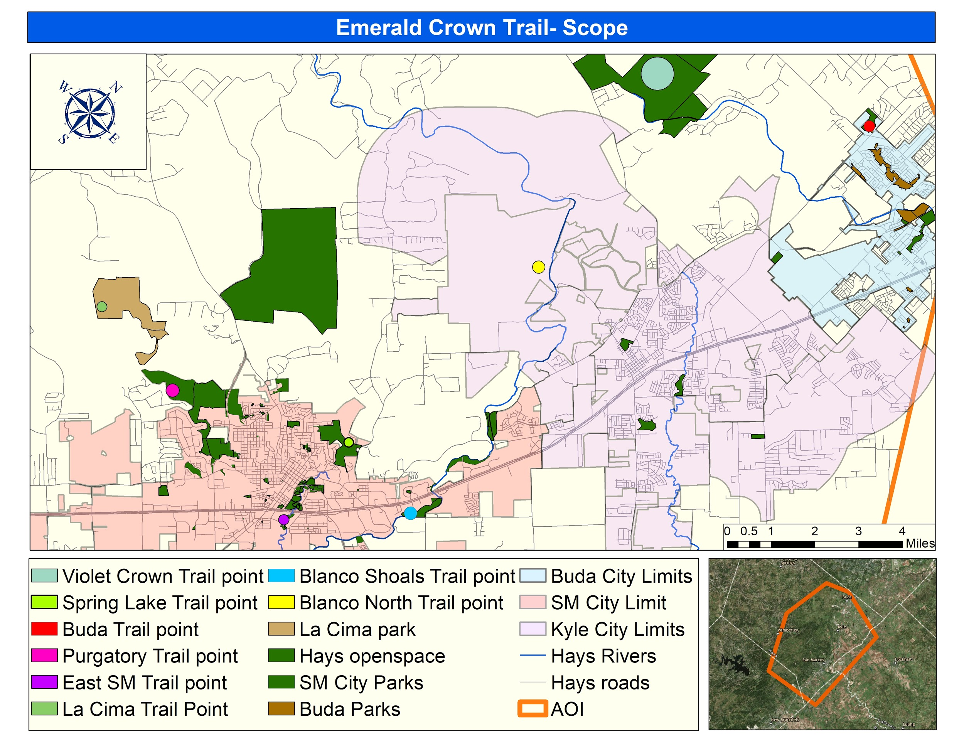
Figure 1: Emerald Crown Trail Scope

3.1 Data:
- Publicly accessible GIS data
Cities Data:  San Marcos, Tx | Attributes | Spatial Object | Status
Parks shapefile | Name of Parks; Dedication; Addresses; Acre Size | Polygon | Available
Trail Data Shapefile | Name of Trails; Source of Production; Length of Trail; Park Associated with Trail; Status of Trail | Polyline | Available
Parcel Shapefile | Address; Jurisdiction; Owner Name | Polygon | Available
City Limit Shapefile | Created By; Acreage | Polygon | Available

Cities Data:  Kyle, TX | Attributes | Spatial Object | Status
Parcel Shapefile | Address; Jurisdiction; Owner Name | Polygon | Available
Parks Shapefile | Name of Parks; Acreage; Type of Recreation Capabilities; Owner of Park; Addresses | Polygon | Available
Trail Data Shapefile | Park Associated with Trail; Length of Trail | Polyline | Available
City Limit Shapefile | Addresses; Subdivions | Polygon | Available

Entity | Data Collected | Attributes | Spatial Object | Status
Texas Natural Resource Information Systems (TNRIS) | 1) Aerial Imagery;  2) Soil Data | 1) Imagery provides basemap;  2) Type of Soil;  Farmable/Non-Farmable soils; Erodibility | 1) Raster Image;  2) Polygon | Available
United States Geological Survey (USGS) | Land Cover/ Land Use data | Count; Value | Raster Dataset | Available
Texas Commission of Environmental Quality (TCEQ) | 1) Land Cover/ Land Use data  2) River Data | 1) Type of Land cover  2) River Basin; Segment Name; Segment Description | 1) Polygon  2) Polyline | Available
Texas State Geography Department | Digital Elevation Model | Elevation | Raster Dataset | Available
Hays County | Low Water Crossings Data | Location of Low Water Crossing; Crossing Type;  Creek Associated | Point | Available

Data Poduced | Created By | Consists of which data | Spatial Object | Status
Weighted Overlay- Cost Surface | Trailblazers Consulting | Land use/ Land cover; Digital Elevation Model; Soils data | Raster | Available
Area of Interest | Trailblazers Consulting | A polygon used to specify the area we mapped | Polygon | Available
Trails- 12 in total | Trailblazers Consulting | Developed from the manipulation of our cost surface | Polyline | Available
Trails including parcel information | Trailblazers Consulting | We made a spatial join with our trails and the parcel data provided from stakeholders | Polyline | Available
Trails including Land use/ land cover data | Trailblazers Consulting | We made a spatial join with our trails and our land use/ land cover data | Polyline | Available

A. Texas Natural Resources Information Systems (TNRIS)
- Aerial Imagery from source will allow for more precise visualization when developing the trail along the terrain.
- Soil data from source will help with analyzing trail sustainability & suitability depending on the different soil types.
B. United States Geological Survey (USGS)
- Land cover/ land use data to minimize the high cost of vegetation removal. This data will be incorporated into our cost surface for our analysis
C. Texas State University GIS Data
- Collected a Digital Elevation Model (DEM) to mitigate areas with steep slopes that would increase risk and cause soil loss through erosion

D. Texas Commission of Environmental Quality (TCEQ)
- Land use/ Land Cover data to minimize the high cost of vegetation removal. This data will be incorporated into our cost surface for our analysis.
- Collected data on the rivers running through our AOI to incorporate for analysis.
E. Software to be used: ArcGIS, Adobe Illustrator

3.2 Methodology:
- Created a base map of the Area of Interest (AOI) using aerial imagery, parks, and trail data provided by stakeholders
  - Aerial Imagery obtained through TNRIS to focus on the AOI and inspect the area the trails go through
  - Overlay with existing park and trail shapefiles from their respected city GIS departments to analyze potential trail connectivity
- Gathered all the variables through data acquisition to be able to develop a cost surface
  - Acquisition of variables: Digital Elevation Model (DEM), Land Cover/ Land use data (LC/LU), and Soil Suitability data
- After the acquisition of data, we figured how we wanted to manipulate our different variables to produce our cost surface
  - Developed points for specific parks for potential trail connectivity.
    - Trail points created: Violet Crown Trail Point; Purgatory Trail Point; La Cima Trail Point; Spring Lake Trail Point; North Blanco Trail Point; Blanco Shoals Trail Point; East San Marcos Trail Point; Buda Trail Point
  - Once we had these variables processed we needed to reclassify certain variables to allow us to run our least cost analysis.
    - Reclassification of multiple layers including: DEM, Land Cover/ Land Use (LC/LU), Soils.
      - This will give the GIS the ability produce a weighted overlay of these layers based on how costly it will be to cross each pixel.
    - Once the variables were reclassified we calculated the cost summation based on our valuation of the properties and relative weight estimates.
    - We developed a cost surface based on how each variable was weighed. This developed a cost estimate raster of all the variables that were implemented into our analysis.
      - When producing the cost surface, we set certain parameters for each of the layers we were going to overlay. Each variable was given a certain percentage out of 100, by the recommendation of the San Marcos Greenbelt Alliance on the importance of each variable.
        - Reclassified LC/ LU was weighed at 55%, based on importance of tree cover and avoidance of urban areas.
        - Reclassified DEM based on slope percent rise was weighed at 40%, to allow smooth travel across such a large area and to avoid drastic elevation change.
        - Reclassified Soils weighed at 5%, to concentrate on areas where trail development would be less likely eroded due to certain soil types in the areas
    - Once the cost estimate raster was produced it allowed for the development of our trails based on the weights we put on our certain variables when figuring cost summation.
      - We set our starting point, from the trail points created to estimate the cost from that point across our area of interest.
      - After that we ran the least cost path tool in ArcGIS, which allowed us to set a destination point for our trail to travel to from the starting point. This allowed us to analyze the cost to get from one trail point to the next trail point based on the cost surface.
    - Once we produced a least cost path between two trail points, we then continued to run the least cost path tool. We connected different trail points, producing least cost paths throughout our area of interest, based on our cost surface.
Figure 2. Explains the methodology we followed.

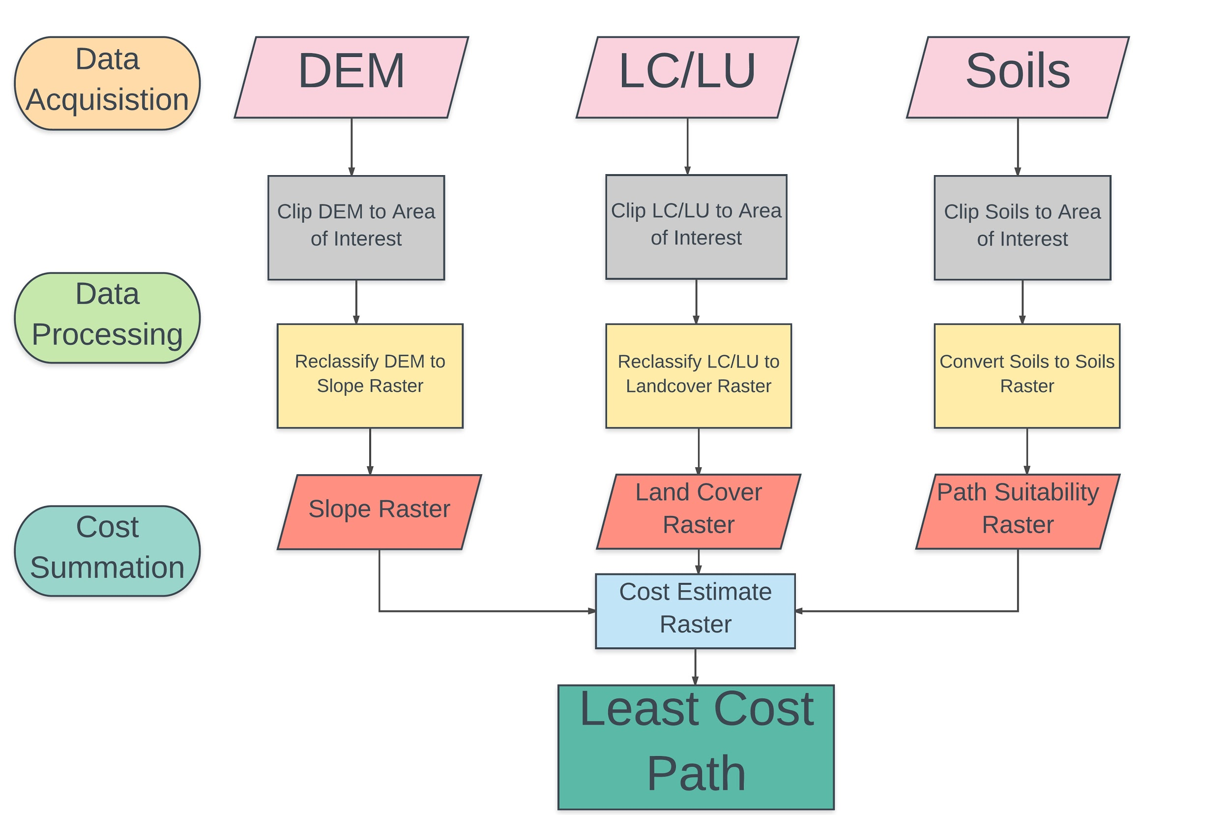
Figure 2. Methodology Flowchart
Referenced:
Kokkinidis, Ioannis & Stein, Beth & Surendrababu, Jayashree & Seigler, Taylor & Hwang, Won Hoi & Lorentz, Laura & Howey, Catherine. “A Least-Cost Algorithm Approach to Trail Design Using GIS.” Photogrammetric Engineering and Remote Sensing. Vol. 79. June 2013, p498-505

4. Results
4.1 Conceptual development of trails
After running the data through their respective operations several times with slight tweaks as needed, we discovered twelve interconnecting trails. There is a potential bias presented in the results to keep in mind. The weighted overlay was specified to what SMGA communicated to Trailblazers Consulting as their priorities. Seeing that this project is specific to SMGAs objectives, our cost surface was tailored to their requests. Figure 3 depicts the 12 trails developed with the interaction of the cost surface.
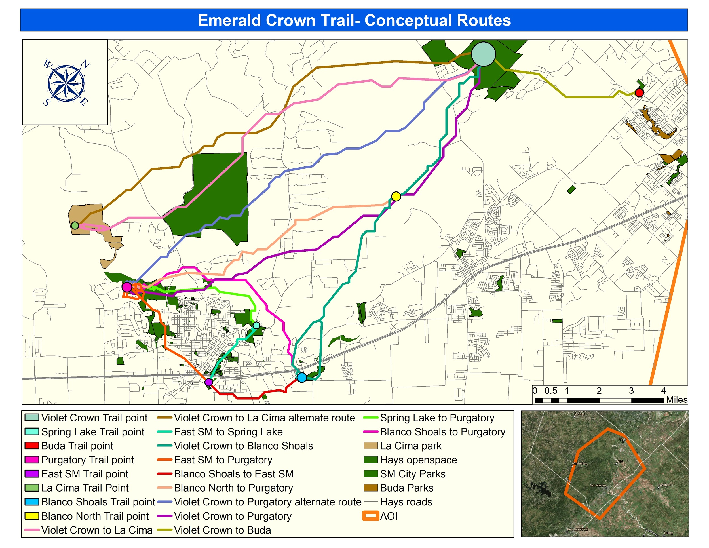
Figure 3- Map of conceptual trails developed

4.2 Statistics
As specified by the San Marcos Greenbelt Alliance, tree cover was the most desired criteria within the development of the trails, holding more importance than slope and the soil erodibility. To validate that the trails we created did follow the client's specifications, Trailblazers Consulting provided statistical charts showing the percentage of what land cover type each of the trails went through. There is still some error in this method due to some of the land cover types that were negated during the spatial join that was performed between the trails and the land cover types because of their insignificance to the trails interaction with the cost surface.
These statistics were calculated by determining the amount of times a trail crossed a reclassified land cover type out of the total number of land cover types the trail crossed and converted into a percentage out of 100%. We reclassified the land cover types, in order of most desireable to least desireable, into: Forested, Shrubland, Planted Woody, Urban, Planted Herbaceous, and Stream/River.
The Violet Crown to La Cima trai (Figure 4)l cuts through a very heavily forested area. It also cuts through more water than most of the other trails mainly because of Sink Creek by Freeman ranch and other streams in the area. The most important aspect of this trail is where is crosses Hilliard. The trail avoids the subdivision on Hilliard and cuts through Freeman Ranch to eventually get to La Cima.​
The alternate trail from Violet Crown to La Cima (Figure 5) crosses a few more urban areas, in this case being ranch roads and more rural neighborhoods. It also crosses even more water than the initial Violet Crown to La Cima trail. A fair amount of tree cover is still present within this trail.
The Violet Crown to Purgatory trail (Figure 6) is a great trail not only because of the amount of tree cover and vegetation interference, but also because of its proximity to the City of San Marcos without having to much urban interference.
​The alternate route from Violet Crown to Purgatory (Figure 7) is one of the most forested trails provided being that it stays clear from any current development.
The Violet Crown to Blanco Shoals trail (Figure 8) crosses just as much urban area as it does forested area, but is a great trail in terms of elevation because it stays relatively flat due to its proximity to the river.​
The Violet Crown to Buda trail (Figure 9) is mainly forested having to cross a few streets within its path towards the City of Buda.
The Blanco North to Purgatory trail (Figure 10) stays pretty consistent with the amount of tree cover it goes through. It also incorporates the already existing ringtail trail off of ranch road right before its destination at Purgatory.​
The Blanco Shoals to Purgatory (Figure 11) trail is a great example of how these trails can be close to city limits while staying mainly in a forested land cover type and maintaining a relatively low elevation change.​
The East San Marcos to Spring Lake trail (Figure 12) does a great job of staying in Forested areas within San Marcos City Parks while being surrounded by the heavily urban area of San Marcos.
The East San Marcos to Purgatory trail (Figure 13) also does a great job of sticking to the forested area of San Marcos City Parks on its way to Purgatory.
The Spring Lake to Purgatory trail (Figure 14) hugs the outer limits of the City of San Marcos and stays in mostly forested areas also going through the already existing Ringtail trails.

4.3 Parcel Count
Through multiple meetings Trailblazers Consulting attended, a thorough understanding of what the San Marcos Greenbelt Alliance (SMGA) wanted us to provide them was established. They spoke extensively about needing to know information regarding land ownership and potential property owners that they might have to come in contact with. This led to them to asking us if there was a way to incorporate that information into the development of these trails.
Trailblazers Consulting was able to run a spatial join with the developed trails and the merged parcel data of Kyle and San Marcos, which gave an accurate parcel count for each trail (Table 1).

Table 1- Table of each trail and the amount of parcels it crosses
Trail | Parcel Count | Trail | Parcel Count
Blanco North to Purgatory | 104 | Violet Crown to Blanco Shoals | 124
Blanco Shoals to East SM | 64 | Violet Crown to Buda | 69
Blanco Shoals to Purgatory | 73 | Violet Crown to La Cima | 22
East SM to Purgatory | 155 | Violet Crown to La Cima ALT | 21
East SM to Spring Lake | 35 | Violet Crown to Purgatory | 82
Spring Lake to Purgatory | 39 | Violet Crown to Purgatory ALT | 101
Total |  |  | 889

This data allowed for us not only to provide an accurate parcel count, but also will give SMGA specific addresses and property owner names associated with the parcel information. We provided SMGA excel sheets for each trail that will provide them the information they will need to see which property owners to contact or avoid when developing these trails.

4.4 Data Quality
Despite having to extract the land use/land cover data set from outside sources, the quality of data used in this project was relatively concise due to the fact that we received most of it from the respected city's GIS department. Land use/land cover data was collected from two sources, one coming from the Texas Commission of Environmental Quality (TCEQ) which only classified the western portion of I-35. Whereas the data collected from Texas Natural Resource Information Systems (TNRIS) was able to incorporate the eastern portion of I-35 pertaining to our scope.

4.5 Implications
A. The data and results will be used for making trails connecting San Marcos to Kyle, Texas and eventually connecting to the Violet Crown Trail in Austin, Texas.
B. In providing pedestrians direct access between locations, citizens can travel safely and conveniently without having to interact with hazardous roadways. This expansion of the San Marcos-Kyle-Buda network provides citizens with a non-motorized transportation option that also benefits the community in many ways.
- This trail development could bring increased real estate development into these areas that want to incorporate the trail into their designs. This will potentially increase the property value in these areas, possibly not seen as highly sought-after lands.
- These trails, once developed and interconnected with the Violet Crown trail out to Austin, will be a one of a kind type of recreation development. This will draw a certain tourist market of recreation seekers who want to experience a scenic trail spanning the hill country.
- Once we have presented the potential trails, this record of data and methodology used in the development can be implemented for other communities wanting to connect to other cities via non-motorized travel.

5. Conclusion
TrailBlazers Consulting used the data provided by the San Marcos GreenBelt Alliance (SMGA) and other stakeholders to develop 12 conceptual trails from the City of Buda to San Marcos based on the analysis of spatial data. The functionality of the GIS will be to provide a path of least resistance based on the criteria set to develop trails that will be suitable for pedestrian travel between these cities. SMGA wanted to be able to have sound GIScience behind their message for the development of the Emerald Crown Trail and our spatial analysis provides them with an ample amount of information going forward in the implementation of these trails.
Trailblazers Consulting has greatly benefitted from how proactive SMGA has been on the development of the Emerald Crown Trail, and we hope that our results speak for themselves. The cooperation that the SMGA provided us with has benefitted each of us at Trailblazers Consulting and we thank them for the opportunity to work on this project.

References
Kokkinidis, Ioannis & Stein, Beth & Surendrababu, Jayashree & Seigler, Taylor & Hwang, Won Hoi & Lorentz, Laura & Howey, Catherine. “A Least-Cost Algorithm Approach to Trail Design Using GIS.” Photogrammetric Engineering and Remote Sensing. Vol. 79. June 2013, p498-505.

Appendix I:

Project manager: Lucas Chavez
- Data analysis
- Poster Creation
- Methodology
- Metadata Compilation
- Map Developer

GIS Analyst: Julian Emerson
- Timetable production
- Budget production
- Land Cover/Land use stats developer
- PowerPoint Editor
- Results

GIS Analyst: Emma Highberger
- Logo Designer
- Parcel count developer
- Abstract
- Final Report Editor
- Data Quality

Appendix II: Metadata

Blanco_shoals_trailpoint.pdf | Trail point that is located by the Blanco Shoals greenbelt. This point is used to connect our least cost path.
BlancoNorth_trailpoint.pdf | Trail point that is located by the blanco river in between San Marcos and Kyle. This point is used to connect our least cost path.
Buda_trailhead.pdf | Trail point is located in Buda. This point is used to connect our least cost path.
EastSM_trailpoint.pdf | Trail point is located on the east side of San Marcos. This point is used to connect our least cost path.
LaCima_trailpoint.pdf | This point is located in the designated land for La Cima Park. This point is used to connect our least cost path.
Purgatory_trailpoint_meta.pdf | This point is located within the purgatory park land. This point is used to connect our least cost path.
Springlake_trailpoint_meta.pdf | This point is located within the spring lake park area. This point is used to connect our least cost path.
Violetcrown_trailpoint.pdf | This point is located in the area that is a proposed site where the Violet Crown will connect with the Emerald Crown near the onion creek preserve. This point is used to connect our least cost path.
costpath_blancoshoals_to_eastSM.pdf | This is a least cost path developed from the interaction with the cost surface. It connects the blanco shoals trail point to the East San Marcos trail point.
costpath_blancoshoals_to_purgatory.pdf | This is a least cost path developed from the interaction with the cost surface. It connects the blanco shoals trail point to the purgatory trail point.
costpath_eastSM_to_purgatory.pdf | This is a least cost path developed from the interaction with the cost surface. It connects the east San Marcos trail point to the Purgatory trail point.
costpath_eastSM_to_springlake.pdf | This is a least cost path developed from the interaction with the cost surface. It connects the east San Marcos trail point to the Spring lake trail point.
costpath_polyline_springlake_to_Purgatory.pdf | This is a least cost path developed from the interaction with the cost surface. It connects the Spring Lake trail point to the Purgatory Trail point.
costpath_polyline_VioletCrown_to_buda.pdf | This is a least cost path developed from the interaction with the cost surface. It connects the Violet Crown trail point to the Buda trail point.
costpath_springlake_to_purgatory.pdf | This is a least cost path developed from the interaction with the cost surface. It connects the Spring Lake trail point to the Purgatory trail point.
costpath_violetcrown_to_purgatory.pdf | This is a least cost path developed from the interaction with the cost surface. It connects the Violet Crown trail point to the purgatory trail point.
costpath_violetcrown_to_blancoshoals.pdf | This is a least cost path developed from the interaction with the cost surface. It connects the Violet crown trail point to the blanco shoals trail point.
costpath_violetcrown_to_buda.pdf | This is a least cost path developed from the interaction with the cost surface. It connects the violet crown trail point to the buda trail point.
costpath_violetcrown_to_purgatory_alternate.pdf | This is a least cost path developed from the interaction with the cost surface. It is an alternate cost path that connects the Violet Crown trail point to the Purgatory trail point.
costsurface_LULC_SLOPE_SOILS_meta.pdf | This is the cost surface that was developed from the weighted overlay of the LULC dataset, DEM Slope, and the soils dataset.
DEM_for_costsurface_meta.pdf | This is the Digital Elevation Model used to be able to represent slope in our cost surface.
parceldata_SM_kyle_merge_meta.pdf | This is the parcel data that was from both the city of San Marcos and Kyle and then merged. This was done to allow for an accurate parcel count when we ran a spatial join with specific trails.
Reclassified_LULC_meta.pdf | This is the land use land cover dataset that was used to account for land cover in our cost surface we developed.
Reclassified_soils_meta.pdf | This is the soils dataset that was used in the cost surface to account for erodibility of the soils.

Appendix III: Statistics
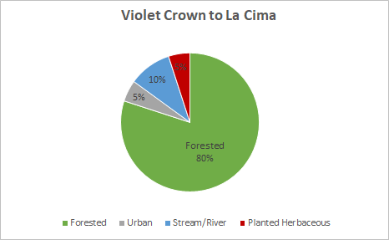
Figure 4
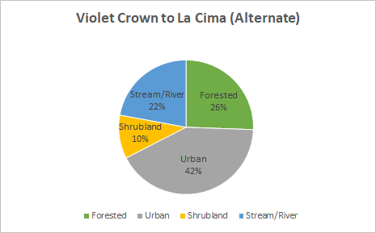
Figure 5
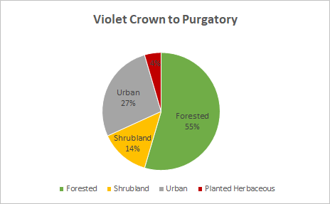
Figure 6
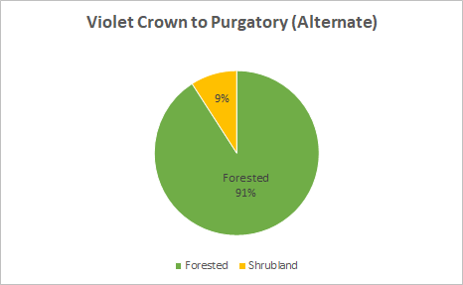
Figure 7
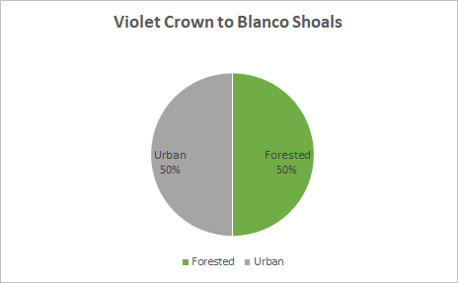
Figure 8
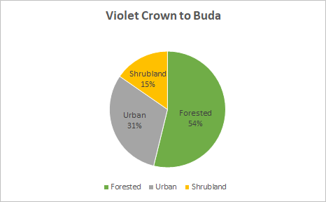
Figure 9
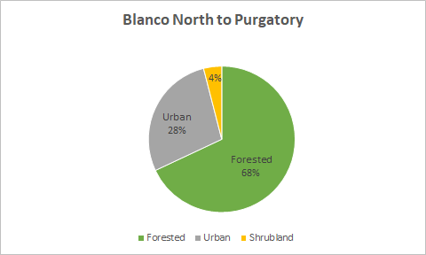
Figure 10
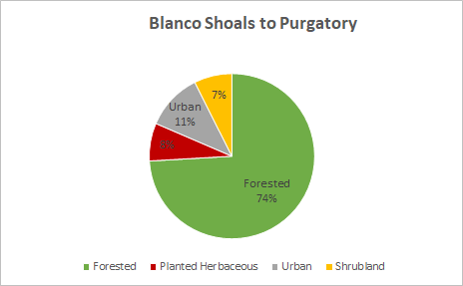
Figure 11
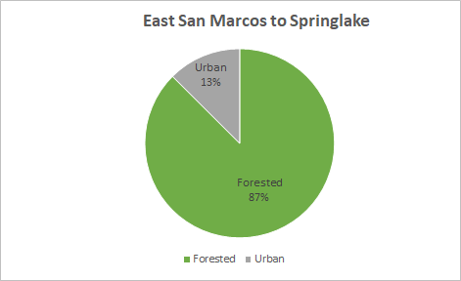
Figure 12
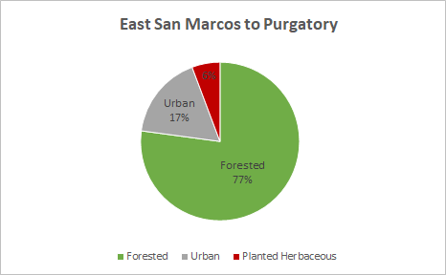
Figure 13

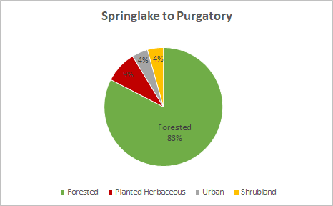
Figure 14

