Austin’s Urban Forest Canopy
Rand-Green-Sibley Consultants
Erin Rand, Project Manager
Curtis Green, GIS Analyst
Cory Sibley, GIS Analyst

Texas State University
10/1/2017

Table of Contents

1. Introduction……………………………………..….…3
1.1 Summary……………..…………………...…3
1.2 Purpose……………………….…………...…3
1.3 Scope…………………...……………………3
2. Literature Review………………………………….….4
3. Proposal……………………….………………………5
3.1 Data……………………………….…...…….5
3.2 Methodology………………....…...…………7
3.2.1 Data Processing...............................7
3.2.2 Analysis............................................7
3.2.3 Flow Chart.......................................9
3.3 Budget...........................................................10
3.4 Timetable......................................................11
3.5 Final Deliverables.........................................12
4. Conclusion..................................................................12
5. Participation................................................................13
Works Cited................................................................14

1. Introduction
1.1 Summary
The City of Austin Urban Forestry Program is a division of Austin Parks and Recreation that is dedicated to improving the quality of life for Austin residents by supporting the long term health and vitality of public urban forest resources, which provide environmental, social, and economic enrichment. This semester Texas State University will work with the City of Austin Urban Forestry Program to evaluate urban canopy change between the years 2006, 2010, and 2014 using aerial imagery of canopy cover. We will assess growth/loss through potential correlations between canopy change and geospatial variables such as political boundaries or land use.
1.2 Purpose
This study will use hotspot analysis of canopy coverage from 2006, 2010, and 2014 to correlate with features such as land use data, political boundaries, and watersheds. Using a statistical regression, the study will show if any relation is present between canopy change and the aforementioned features. After interpreting the results of our study we will recommend priority areas for tree planting and distribution programs. We will represent the study findings in standard map form, and will present the change in the tree canopy in a story map using ArcGIS Online, which will be used by the City of Austin for urban forestry advocacy.
1.3 Scope
Our scope includes the Greater Austin area including the ETJ as delineated in the extent of the data provided. The canopy datasets were recorded in 2006, 2010, and 2014, and will reflect the change during that period. The data will be processed and delivered between the time period of August 2017 through December 2017.

2. Literature Review

Widespread deforestation, particularly that in sensitive ecosystems such as the rainforest, is a well-known and extensively discussed topic. However, there is one lesser-known type of deforestation that is very sparsely studied, and yet, grows exponentially the with the spread of metropolitan sprawl: the phenomenon of urban canopy loss.
An urban forest, as defined by the Sustainable Urban Forest Coalition, is “the aggregate of all community vegetation and green spaces that provides a myriad of environmental, health, and economic benefits for a community” (SUFC, 2013). More specifically, for a green area to be classified as an urban forest, the metropolitan area in question should be a concentrated population of at least 50,000 residents, and although many urban canopy initiatives are focused on publically accessible areas such as parkland and pedestrian space, the urban forest includes both public and privately owned vegetated land (COA, 2013).
The economic, health, and social benefits of a thriving urban forest are numerous. Economically, urban forests both directly and indirectly contribute to the local area’s value. Due to the positive connotations associated with healthy greenery in residential and commercial areas, such as appealing aesthetics and potential for outdoor recreation activities, property values increase greatly; homes with trees on the property, on average, have a minimum 6% higher value than equivalent homes that do not (Sagers, 2005). Environmentally, the urban forest serves a multitude of beneficial purposes. Urban heat islands, which form due to the high albedo of the concrete, manmade terrain of the city, can be mitigated by increased tree cover, which shades and protects the structures and areas beneath (Akbari, 2001). Additionally, the canopy helps remove air pollution, mitigate flood damage, and provide a sanctuary for native wildlife (Rudd, 2002).
Due to the rapid advancement of GIS and digital remote sensing technologies, public works departments such as the City of Austin Urban Forestry Program are now able to record,
document, and analyze tree canopy trends over time. Environmental factors such as terrain, macroclimate, and location in regard to floodplains may impact the growth of the urban canopy.

Hot, very dry climates, as well as other environmentally-challenged areas such as steeply-sloped terrain, may struggle intensely to maintain a healthy canopy in the face of urban expansion. On the other hand, more temperate areas, particularly those close to sources of water and exposed to high levels of precipitation, may have an easier time maintaining this balance of vegetation (Heynen, 2003). Local land use, density of population, and proportion of residential areas to municipal ones may also affect canopy cover. Densely populated areas, which are often lower income and more structurally inefficient, tend to have significantly less canopy cover, whereas urban areas with a large proportion of residential, suburban properties, are more likely to have large expanses of green space (Heynen, 2003).
Although there are many statewide and nationwide advocacy programs for urban forest rehabilitation around the country, due to the newness of the technology, there has been some study on the trend of canopy loss during urban development, but there has minimal study conducted on the correlation of potential causes with these dramatic changes. It is essential, therefore, that further study be completed on these correlations, and organizations like the City of Austin Forestry Program use this information to further benefit the public health and environment.

3. Proposal

3.1 Data
This project will rely on the data provided by but not limited to the City of Austin GIS data portal on the City of Austin website. This secondary data will be examined and interpreted utilizing the ESRI ArcMap software. Both primary and secondary data information is shown in Table 1. on the following page.

Table 1. City of Austin Provided Data

Data Name | Category | Data Type | Software | Status | Provider
Tree Canopy 2006 | Spatial Data | Primary | ArcMap | Available | City Of Austin
Tree Canopy 2010 | Spatial Data | Primary | ArcMap | Available | City Of Austin
Tree Canopy 2014 | Spatial Data | Primary | ArcMap | Available | City Of Austin
Austin Jurisdictional | Map/Spatial Data | Secondary | ArcMap | Available | City Of Austin
Land Use 2014 | Spatial Data | Secondary | ArcMap | Available | City Of Austin
Land Use 2010 | Spatial Data | Secondary | ArcMap | Available | City Of Austin
City of Austin Parks | Spatial Data | Secondary | ArcMap | Available | City Of Austin
Watersheds | Spatial Data | Secondary | ArcMap | Available | City Of Austin
Council Districts | Spatial Data | Secondary | ArcMap | Available | City Of Austin
County Boundaries | Spatial Data | Secondary | ArcMap | Available | City Of Austin
Urban Roadways | Spatial Data | Secondary | ArcMap | Available | City Of Austin
Land Use 2006 | Spatial Data | Secondary | ArcMap | Available | City Of Austin

3.2 Methodology
The methodology process will be broken into two portions. The first portion will consist of data preparation and the second portion will consist of analysis tools and processes.

3.2.1 Data Preparation
The data sets used will be a combination of collected existing data and data composed from our own spatial analysis. In regards to acquisition and preparation, we must first collect the existing data from our sources and format them accordingly. The primary data of “canopy cover 2006, 2010, and 2014” is comprised of 2006 shapefiles and 2010/2014 aerial photography. We will need to convert 2010 and 2014 image files into compatible shape files using raster to vector conversions with ArcGIS software. Other primary data used will contain shapefiles consisting of urban land use, parks/green spaces, and tourist hotspots. Our secondary data will be consisting of premade shapefiles that will include roadways, jurisdictional boundaries, and name identifiers. We will then import the primary and secondary data into ArcGIS to georeference the data to a coordinate system to ensure consistency and accuracy of our analysis outputs. The coordinate system State Plane Texas Central will be used. Once we have all of the data in the same format and geospatially referenced, we must then approach the scope of our project. All of the primary data must be clipped to match the extent of the Austin jurisdictional boundary. This will decrease chances of skewed data while adhering to the scope of our project. One more preparation must be made to our data before we can continue to the analysis portion. We must identify key urban development projects specific to the years 2006, 2010, and 2014. We will use geospatially referenced polygons to mark the scope of the development and will use these shapefiles for spatial analysis later on. The project data is uploaded, formatted, and in proper scope. Our next step will be to use statistical tools to analyze the data.

3.2.2 Analysis
The analysis portion will discuss the processes and analyses used to achieve the statistical outcomes desired for interpretation. To better understand this portion, we must briefly revisit the desired outcome of the project. We are looking for a change of canopy over three data sets,
factors that may influence said change, and if a definable relationship can be established with the possible factors and the trend over the three data sets.
The first spatial analysis tool we will use will be “Hotspot Analysis”. This tool uses spatial statistics to identify clusters of high significance and low significance. This significance will be directly related to proximity of canopy cover with other canopy cover with parameters set to < and > 300 meters. The hot and cold spot outputs can be used to identify key areas of both high canopy cover and low canopy cover. We will use these spatial distribution outcomes in future analysis.
The second spatial analysis tool that will be used will be “Ordinary Least Squares Regression”. This tool uses statistics to generate an equation that interprets the relation between spatial data. The first relationship tested will be the canopy hotspot outputs (result from previous analysis) and the created key urban development projects (mentioned in above data preparation portion). The second relationship that will be analyzed using “OLS” will be the canopy hotspot outputs compared the green space location and development. The third relationship tested will be the canopy hotspot outputs in relation to tourist hotspot data. We will use the “OLS” outcomes to determine relationship statistics based on the data comparisons.
We will now have compiled the data, prepared the data, and analyzed the data. The next step will be to interpret the results.

3.2.3 Flow Chart
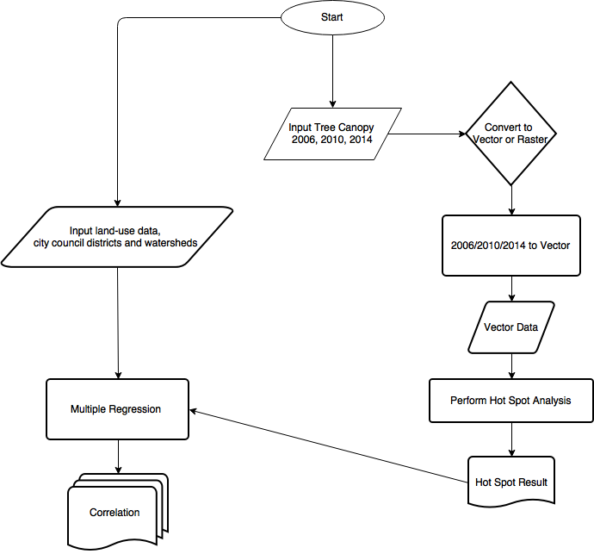

3.3 Budget

Work Category |  |  | Number of Consultants | Hourly Rate | Total Hours/  Wk/Employee | Period Length (Wk) | Category Total
Research |  |  | 2 | 30 | 5 | 2 | $600.00
Data Collection |  |  | 2 | 30 | 15 | 3 | $2,700.00
Data Preprocessing/  Formatting |  |  | 3 | 45 | 10 | 3 | $4,050.00
Data Analysis |  |  | 3 | 60 | 15 | 2 | $5,400.00
Interpretation and Compilation |  |  | 2 | 50 | 10 | 2 | $2,000.00
Dissemination and Presentation |  |  | 3 | 40 | 10 | 2 | $2,400.00
Project Management |  |  | 1 | 80 | 5 | 14 | $5,600.00
GIS Systems Management |  |  | 2 | 50 | 5 | 14 | $7,000.00
 |  |  |  |  |  | Direct Labor Total: | $29,750.00

Category | Workstations Used | Cost per Week | Weeks Used | Category Total
Supplies | 6 | 12 | 14 | $1,008.00
Maintenance | 6 | 15 | 14 | $1,260.00
Deprecation  (Equip. life=  36 months) | 6 | 150 | 14 | $12,600.00
 |  |  | Equipment Total: | $14,868.00

GRAND TOTAL: $44, 618

3.4 Timetable

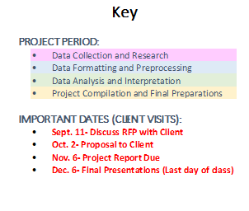

3.5 Final Deliverables
- Detailed Final Report (2 copies)
  - Professional Poster for display in the Geography Department?
  - CD (2 copies) containing: All data, Metadata, Report, Poster, PowerPoint Presentation, Instructions on how to use the CD
- Readme file
- Documentation of all processes and methodologies utilized for project, including a proposal, progress report, final report, poster, and presentation slides used in class.
- Summary and/or tabulation of findings, including implications for further research
- GIS Data (all ArcGIS shapefiles compiled and/or geodatabase with metadata) displaying the tree canopy change and any spatial or geostatistical analysis results from 2006, 2010, 2014.
- Story Map or equivalent ArcGIS Online web mapping application, along with access to all necessary files.

4. Conclusion

With the results from our analysis, we will highlight a number of critical areas for canopy lost, and suggest possible causes for this phenomenon. The results of this study will not only aid the City of Austin Forestry Program, but contribute to the study of the correlation between urban forests and anthropogenic actions. This knowledge will allow the City of Austin and other urban canopy advocates to take action more efficiently, as well as guide programs to mitigate issues that might contribute to the loss.

5. Participation

Erin Rand, Project Manager:
- Literature Review
- Conclusion
- Proposal Compilation, formatting, and editing

Curtis Green, GIS Analyst:
- Data
- Deliverables
- Logo

Cory Sibley, GIS Analyst:
- Methodology
- References
- Logo

Collaborative Effort:
- Introduction
- Timetable
- Budget

Article/Proposal Citations

Akbari, H. & S. Konopacki. (2005). Calculating energy-saving potentials of heat-island reduction strategies. Energy Policy, 33(6):721-756.
Heynen, Nik & Lindsey, Greg. (2003). Correlates of Urban Forest Canopy Cover: Implications for Local Public Works. Public Works Management & Policy. 8. 33-47. 10.1177/1087724X03008001004.
Parks and Recreation, Brewer et al., (2013). Austin's Urban Forest Plan: A Master Plan for Public Property. The City of Austin Urban Forestry Board. https://austintexas.gov/sites/default/files/files/Parks/Forestry/AUFP_Final_DRAFT_01-07-14_No_Appendices.pdf (last accessed 28 September 2017).
Rudd, H., J. Vala, & V. Schaefer. (2002). Importance of backyard habitat in a comprehensive biodiversity conservation strategy: A connectivity analysis of urban green spaces. Restoration Ecology, 10(2): 368-37
Sagers, Larry A., "The Value and Importance of Urban Forestry" (2005). All Archived Publications. Paper 1503. http://digitalcommons.usu.edu/extension_histall/1503
Sustainable Urban Forests Coalition. (2013). How does the SUFC define urban forests? Retrieved from Sustainable Urban Forests Coalition website: http://www.urbanforestcoalition.com/

Data Citations
Both Cited Portals for Austin.Gov URL’s
Open Data | City of Austin Texas | Open Data | City of Austin Texas. Austin. https://data.austintexas.gov/ (last accessed 28 September 2017).
GIS and Maps. Home. http://www.austintexas.gov/department/gis-and-maps (last accessed 28 September 2017).

