Austin’s Urban Forest Canopy
Rand-Green-Sibley Consultants
Erin Rand, Project Manager
Curtis Green, GIS Analyst
Cory Sibley, GIS Analyst

Texas State University
10/1/2017

TABLE OF CONTENTS
1. Introduction……………………………………...….…3
1.1 Summary……………..…………………...…...........3
1.2 Purpose Statement………...….………….....….........3
1.3 Scope…………………...………………….…..........3
2. Tasks………………………….……………………….4
2.1 Work Completed…….…...……................................4
2.2 Present Work………………....…...………...........…5
2.3 Work Scheduled.........................................................5
2.4 Problems....................................................................7
3. Conclusion.....................................................................7
4. Participation...................................................................8

1. Introduction
1.1 Summary
The City of Austin Urban Forestry Program is a division of Austin Parks and Recreation that is dedicated to improving the quality of life for Austin residents by supporting the long term health and vitality of public urban forest resources, which provide environmental, social, and economic enrichment. This semester Texas State University will work with the City of Austin Urban Forestry Program to evaluate urban canopy change between the years 2006, 2010, and 2014 using aerial imagery of canopy cover. We will assess growth/loss through potential correlations between canopy change and geospatial variables such as political boundaries or land use.
1.2 Purpose
This study will use hotspot analysis of canopy coverage from 2006, 2010, and 2014 to correlate with features such as land use data, political boundaries, and watersheds. Using a statistical regression, the study will show if any relation is present between canopy change and the aforementioned features. After interpreting the results of our study we will recommend priority areas for tree planting and distribution programs. We will represent the study findings in standard map form, and will present the change in the tree canopy in a story map using ArcGIS Online, which will be used by the City of Austin for urban forestry advocacy.
1.3 Scope
Our scope includes the Greater Austin area including the ETJ as delineated in the extent of the data provided. The canopy datasets were recorded in 2006, 2010, and 2014, and will reflect the change during that period. The data will be processed and delivered between the time periods of August 2017 through December 2017.

2. Tasks

2.1 Work Completed
Over the past month we have worked towards achieving the goals set in our project proposal. Our main completed objective was the compilation and formatting of all the data needed to complete the project. The following is a preview of our completed work.
Through the open source portal website, data.austintexas.gov, we obtained all the necessary data needed to complete the project. After collecting the data, the next task was converting the data to a specific format. All of the project data formatting was done using the geographic information system software ArcMap. When first obtained, the three primary canopy data sets were incompatible with the desired analysis tools, in both scope and format. The desired scope noted in the project proposal consisted of the City of Austin extraterritorial jurisdiction boundary.
The extraneous area of all three canopy data sets were removed using the “clip” data management tool in ArcMap. The next step to creating the desired scope was to identify the intersecting areas of all three data sets that is required for proper analysis. Polygon outlines were created of all three data sets. The three polygons were then overlapped to find the area where all three data sets intersected. Figure 1 below shows the extent of shared intersections with an overlay of the desired city boundary.

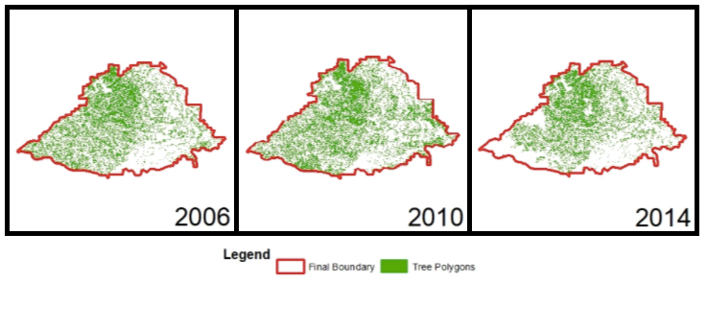
Figure 1: Clipped Data
After the scope was finalized, the next task was to reformat the data sets into vector shapefiles. The format of the 2010 and 2014 data sets were raster aerial image TIFF files, while the 2006 data set was already the preferred vector aerial image Shapefile. The following data manipulation will only be describing the two TIFF data files. The internal data of each file was reclassified into two represented features, canopy data and null data. Once these two categories were classified the null data was deleted as to simplify future analysis and speed future processing. The raster output data of this method contained only pixels from canopy data. The canopy raster files were then modified using the “raster to polygon” conversion tool. The output of the conversion tool produced the 2010 and 2014 data sets into the vector shapefiles desired for analysis. All of the primary canopy data has been formatted into geographically significant polygons that are awaiting future analysis.

2.2 Present Work
Currently there are a few tasks that need to be completed that we are performing before we are able to move into the correlation maps. The first being that we intend to acquire the median income and population density datasets, to use as variables for the correlation analysis. Secondly, we are overlaying the three datasets: 2006, 2010, and 2014. This will allow us to find the common area as well as see the change in canopy over time. Finally we are performing the hotspot analysis that will allow us to see the spatial clustering of the canopy over the given area.

2.3 Scheduled Work
As per the timeline provided below in Figure 2, we will be completing a series of tasks for the completion of our project over the next month. For the first given week following the presentation of the progress report we will be beginning the production of our correlation maps. We will be completing this utilizing ArcMap to display the correlation between the canopy data from 2006, 2010, and 2014 to our collected variables such as Land Use, Watersheds, and Political Boundaries.
Next we will be performing our statistical report in the week of November 13th – 17th. This will be a report where we will use the statistical output in ArcMap generated from our hotspot and regression analysis to form a hypothesis and check if the statistics match the correlations. This will help determine the accuracy of our analysis and help us form a useful hypothesis for future tree planting and distribution programs.
The following week of November 20th – 24th we will be conducting our full analysis for the future research of tree planting and distribution programs within the Austin area. During this time, we will take all of the data we have gathered and the analysis we have performed thus far and use it to project the effects of the canopy change in Austin and how these programs can continue to combat the receding canopy.
Finally, we will be creating an ArcMap Online story map while we continue to produce our final report. The purpose of the online story map is make our research results open to anyone who would like to view them in a user friendly format. This will assist in the continuation of our research.

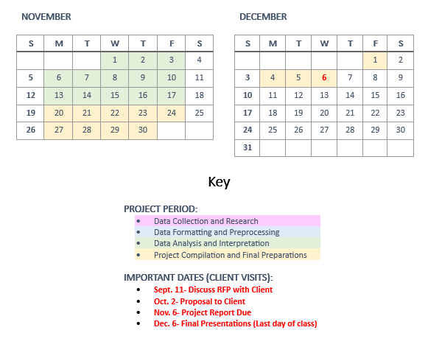
Figure 2: Updated Schedule

2.4 Problems
The main issues that we have had so far have revolved around the process of preformatting data for analysis. Firstly, the datasets were not all in shapefile format, so we needed to convert the 2010 and 2014 rasters to vector. However, the files were very large, and the process was slowed significantly by the computer processing power we had access to. We experienced many crashes and program failures, and when we were able to successfully convert and trim these files, the processes on each dataset often took upwards of twelve hours.
Additionally, we had an incongruence between dataset sizes and extents, which created the need for a lengthy boundary digitizing and clipping process to create a common boundary that had data for all three years. Because this data was very large, the loading time was slow, and made most processes, even panning or selecting, much more time-consuming than usual.
We were able to overcome these obstacles by dividing the data to run on several computers at once, as not to overload the machine, and running them overnight on our personal computers. Additionally, because ArcMap handled the manual digitizing process so poorly due to the long loading time, we used another spatial software called Global Mapper, which handles large raster files much more smoothly, to create a common boundary to clip the polygons to.

3. Conclusion
Although several large problems may have slowed us at the time, now that we have correctly preformatted our data for analysis, which was the lengthiest step, the process of beginning our spatial and statistical analysis should run smoothly and very much on schedule.

(Participation Continued On Next Page)
4. Participation
Erin Rand, Project Manager:
- Problems
- Conclusion
- Progress Report Document Compilation

Curtis Green, GIS Analyst:
- Work Scheduled
- Present Work

Cory Sibley, GIS Analyst:
- Work Completed
- Progress Report Document Editing and Final Review

Collaborative Effort: PowerPoint

