Austin’s Urban Forest Canopy
Rand-Green-Sibley Consultants
Erin Rand, Project Manager
Curtis Green, GIS Analyst
Cory Sibley, GIS Analyst

Texas State University
12/04/2017

TABLE OF CONTENTS
Abstract…………………………………………………..3
1. Introduction……………………………………...….…3
1.1 Problem Statement………………………...…...........3
1.2 Project Background and Nature..….…….....….........3
2. Data..………………………….……………………….5
3. Methodology………………………………………….6
3.1 ArcMap Methodology……………………………..6
3.2 Story Map Methodology…………………………..6
3.3 Original Plan and Process………………….……..7
4. Results and Discussion……………………………….8
4.1 Results…………………………………….……….8
4.2 Story Map Discussion…………………………….10
4.3 Project Complications…………………………….10
5. Conclusion....................................................................11
6. References....................................................................12
Appendix I Illustrations and Documents……………......13
Appendix II Group Member Contribution ……..……....19
Appendix III Metadata………………………………….20

Abstract
Widespread deforestation, particularly in sensitive ecosystems such as the rainforest, is a well-known and extensively discussed topic. However, there is one lesser-known type of deforestation that is very sparsely studied, and yet, grows exponentially with the spread of metropolitan sprawl: the phenomenon of urban canopy loss. This semester, Rand-Green-Sibley Consultants has worked with the City of Austin Urban Forestry Program to evaluate urban canopy change between the years of 2010 and 2014 using aerial imagery of canopy cover. This study uses raster overlay of canopy cover between 2010 and 2014 to compare the change with features such as land use data, political boundaries, and watersheds. This study discusses the potential relationship between canopy change and the aforementioned features. Using this information, we recommend priority areas for tree planting and distribution programs. We represent the study findings in standard map form, and additionally we have created a story map using ArcGIS Online to demonstrate this change interactively, which is intended to be used by the City of Austin for urban forestry advocacy.
1. Introduction

1.1 Problem Statement
The aim of this project is to highlight areas of greatest canopy loss and gain, and use this information to tell a meaningful story of the canopy of Austin over the past decade.

1.2 Project Background and Nature
The City of Austin Urban Forestry Program is a division of Austin Parks and Recreation that is dedicated to improving the quality of life for Austin residents by supporting the long term health and vitality of public urban forest resources, which provide environmental, social, and economic enrichment. An urban forest, as defined by the Sustainable Urban Forest Coalition, is “the aggregate of all community vegetation and green spaces that provides a myriad of environmental, health, and economic benefits for a community” (SUFC, 2013). More specifically, for a green area to be classified as an urban forest, the metropolitan area in question should be a concentrated population of at least 50,000 residents, and although many urban canopy initiatives are focused on publically accessible areas such as parkland and pedestrian space, the urban forest includes both public and privately owned vegetated land (COA, 2013).
The economic, health, and social benefits of a thriving urban forest are numerous. Economically, urban forests both directly and indirectly contribute to the local area’s value. Due to the positive connotations associated with healthy greenery in residential and commercial areas, such as appealing aesthetics and potential for outdoor recreation activities, property values increase greatly; homes with trees on the property, on average, have a minimum 6% higher value than equivalent homes that do not (Sagers, 2005). Environmentally, the urban forest serves a multitude of beneficial purposes. Urban heat islands, which form due to the high albedo of the concrete, manmade terrain of the city, can be mitigated by increased tree cover, which shades and protects the structures and areas beneath (Akbari, 2001). Additionally, the canopy helps remove air pollution, mitigate flood damage, and provide a sanctuary for native wildlife (Rudd, 2002).
Due to the rapid advancement of GIS and digital remote sensing technologies, public works departments such as the City of Austin Urban Forestry Program are now able to record, document, and analyze tree canopy trends over time. Environmental factors such as terrain, macroclimate, and location in regard to floodplains may impact the growth of the urban canopy.
Hot, very dry climates, as well as other environmentally-challenged areas such as steeply-sloped terrain, may struggle intensely to maintain a healthy canopy in the face of urban expansion. On the other hand, more temperate areas, particularly those close to sources of water and exposed to high levels of precipitation, may have an easier time maintaining this balance of vegetation (Heynen, 2003). Local land use, density of population, and proportion of residential areas to municipal ones may also affect canopy cover. Densely populated areas, which are often lower income and more structurally inefficient, tend to have significantly less canopy cover, whereas urban areas with a large proportion of residential, suburban properties, are more likely to have large expanses of green space (Heynen, 2003).
Although there are many statewide and nationwide advocacy programs for urban forest rehabilitation around the country, due to the newness of the technology, there has been some study on the trend of canopy loss during urban development, but there has minimal study conducted on the correlation of potential causes with these dramatic changes. It is essential, therefore, that further study be completed on these potential correlations, and organizations like the City of Austin Forestry Program use this information to further benefit the public health and environment.

2. Data
The data used in our project was obtained through the City of Austin’s GIS data portal on the City of Austin’s website. The specific data we acquired from the City of Austin were the Tree Canopy Raster files for the years 2010 and 2014, the City of Austin Jurisdictional boundary shapefile, the Land Use shapefile from 2010, a shapefile of the Watershed/Floodplain, and the City Council Districts shapefile. This would be the most credible source for the data obtained for our project because it is the data of the City of Austin provided by the City of Austin themselves. We also used an aerial image provided by the Department of Agriculture alongside the State of Texas. We needed this data in order to analyze the gain and loss of the tree canopy of the City of Austin over time and how variables such as land use, watersheds, and city council districts affected this data. Our data was modified many times from the original dataset to fit the needs of our study. First the data was imported and reclassified, then projected to the Texas State Plane coordinate system using ArcMap to ensure consistency in our data. Then it was clipped to the common boundary we created of our total scope of our project to display our data in one common area. The Land Use files were condensed into common categories that way we had a more general sense of the factors in land use affecting the tree canopy. This data was found to be fairly accurate for the size of the dataset and area covered.

Table 1: Data Sources
Data Name | Category | Data Type | Software | Status | Provider
Tree Canopy 2010 | Spatial Data | Secondary | ArcMap | Available | City of Austin
Tree Canopy 2014 | Spatial Data | Secondary | ArcMap | Available | City of Austin
Austin Jurisdictional | Map/Spatial Data | Secondary | ArcMap | Available | City of Austin
Land Use 2010 | Spatial Data | Secondary | ArcMap | Available | City of Austin
Watershed/Floodplain | Spatial Data | Secondary | ArcMap | Available | City of Austin
Aerial Imagery | Spatial Data | Secondary | ArcMap | Available | Department of Agriculture/ State of Texas
City Council Districts | Spatial Data | Secondary | ArcMap | Available | City of Austin

3. Methodology

3.1 ArcMap Methodology (see Appendix A for process flowchart)
To begin our analysis, we downloaded shapefiles for land use data, city council districts, and watershed floodplain areas, as well as raster files from 2010 and 2014 representing the canopy cover in a raster format, from the City of Austin GIS data portal. We additionally received vector data for the 2006 canopy cover. However, we were not able to use this data and format due to file corruption and availability issues and our tactic and process changed to the one described in this report.
Our analysis was performed by using the ArcMap “Diff” tool, a geoprocessing tool used to determine which values from the first input are logically different from that of the second, to overlay the 2010 and 2014 canopy cover rasters. We then cropped this data to the common extent of both datasets, and created a descriptive map. We also formatted the watershed, land use, and city council district shapefiles into descriptive maps, which we then used for visual comparison and interpretation of potential relationships between the variables and the canopy change data.

3.2 Story Map Methodology
The Story Map portion of the project is made by placing the maps we have created into an online media used for interactive displays and storytelling. The process consists of first gathering all of the desired data that will be displayed. The export function in ArcMap allows the data to be stored onto a computer drive for later dissemination. There are two tools used when creating an online Story Map. The first is the ArcMap Online website application that is located on the ESRI servers that is accessed through their website. The second tool is an online media file upload storage server such as Flickr, Google Drive, or YouTube. Both of these two tools will need an account to access their functions in regards to creating a Story Map. The next step in the process was to create a general basemap that our presentation will be using as a geographical and visual reference. This is done by using the ArcMap Online service and URL accessed content creator. An ESRI template was used to upload an aerial image of the greater Austin area. Upon this template was uploaded two ArcMap exported layers; the scope area extent border and the sample area inlet borders. Once this basic background reference map was created we continued in the process by applying the key sample data images we desired to represent from our findings. These data images represent the visual canopy loss/gain that our calculations produced. The data was exported from ArcMap into PNG image files. These PNG files were then uploaded onto the previously mentioned media file server Flickr. Once uploaded to the online server the images could then be imported into the Story Map. The Story Map application creator had a very easy input interface that allowed for quick import and formatting. At this portion of the creation of the Story Map we have uploaded a reference base map and the chosen images that will represent our findings. The next step was to change the format of the template to suit our needs such as written caption descriptions, titles, and URL links. The Story Map was then saved onto the ESRI servers and shared for public online viewing.

3.3 Original Plan and Process
Initially, when we began our study on Austin tree canopy change, we approached the project with a different tactic than the one we utilized to create the final deliverables. The format of the 2010 and 2014 data sets were raster aerial image TIFF files, while the 2006 data set was already the preferred vector aerial image shapefile. The raster output data of this method contained only pixels from canopy data. The canopy raster files were then modified using the “raster to polygon” conversion tool. The output of the conversion tool produced the 2010 and 2014 data sets into the vector shapefiles desired for analysis. However, due to the corruption of data for the year of 2006, incompatibility between file types for overlay, and time constraints that did not allow the extremely lengthy processing time required to perform the spatial analysis we had intended, we refocused our efforts to a visual comparison of the three shapefile variables- watersheds, city council districts, and land use- to the overlaid rasters of 2010 and 2014. We could then interpret and form these analyses into a useful story map, the ultimate goal of our project.

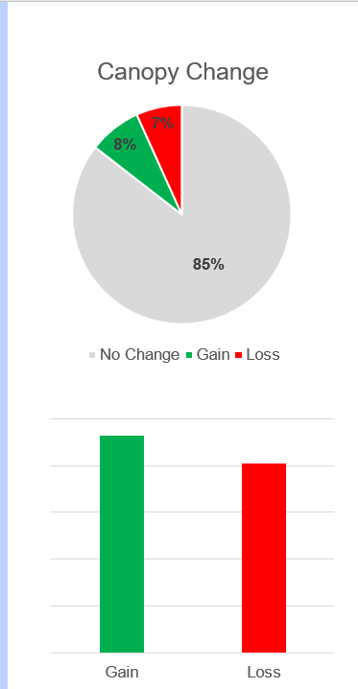
4. Results and Discussion

4.1 Results
As a result of the raster overlay that we performed, we found that statistically there was a net gain in tree canopy cover: 8% of the land area showed net gain, and 7% showed net loss. However, it is not appropriate to assume that this is an actual reflection of how the canopy changed overall across the time period. Consideration must be given to seasonality, yearly events such as flood and drought, and the presence of agricultural areas, which may appear as either loss OR gain areas depending on the time of year that the survey is taken, in accordance with the harvest. To demonstrate this, we have isolated a few key areas on our story map to explore.
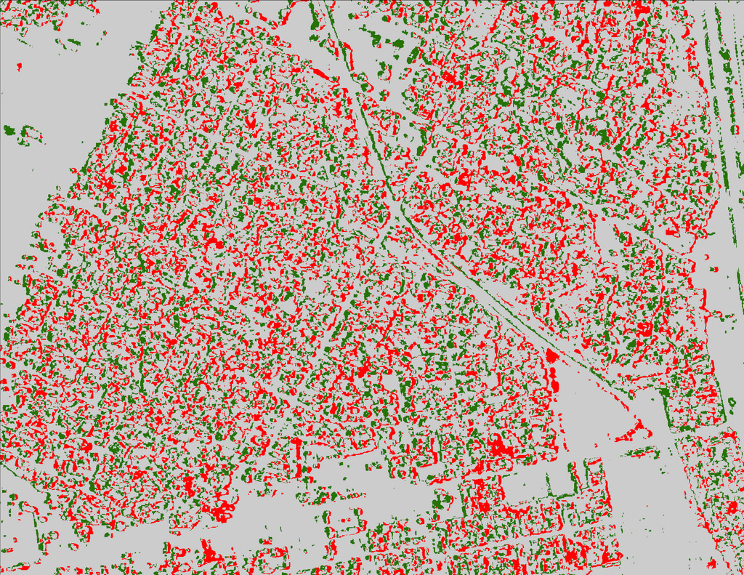
Figure 1: Canopy Change Chart
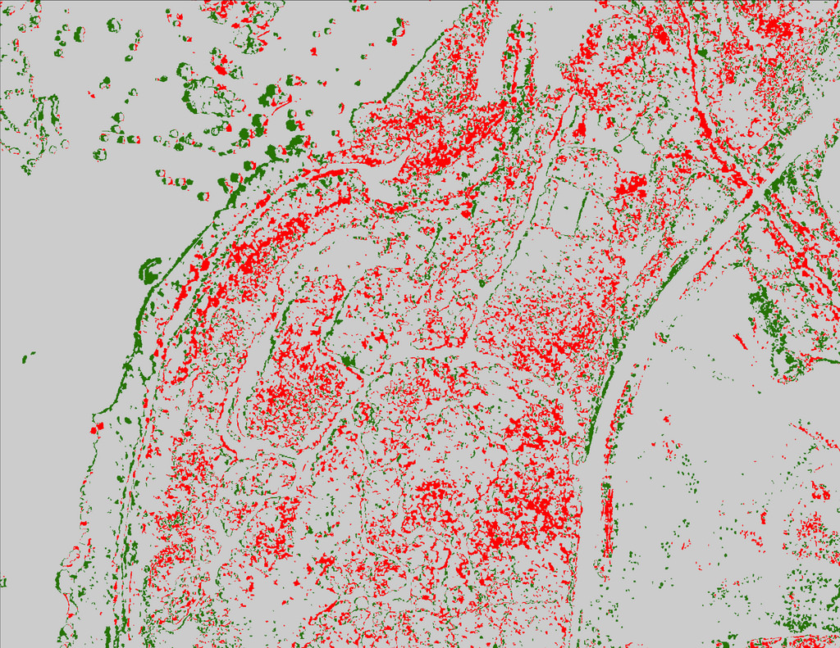
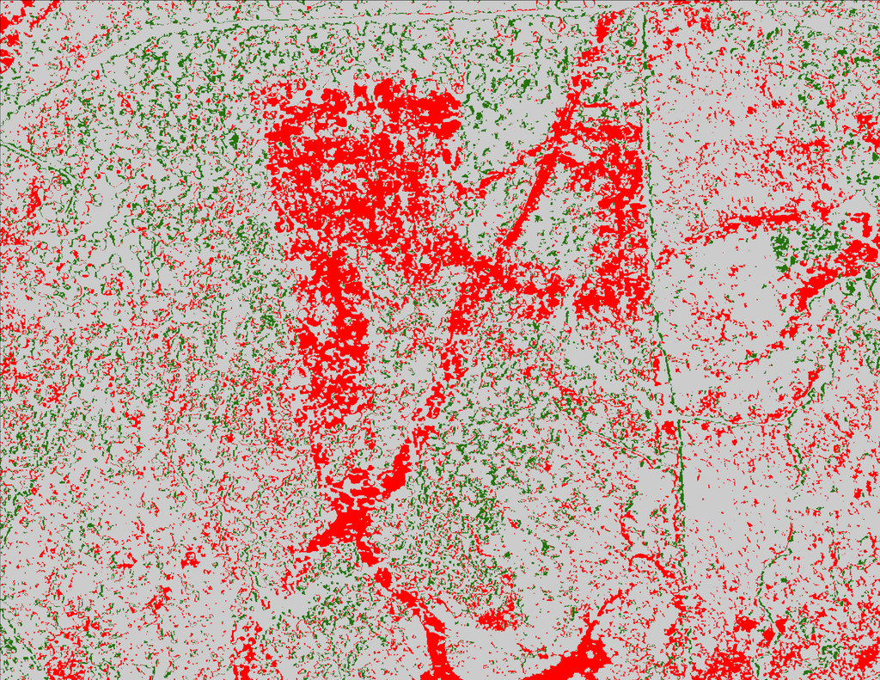
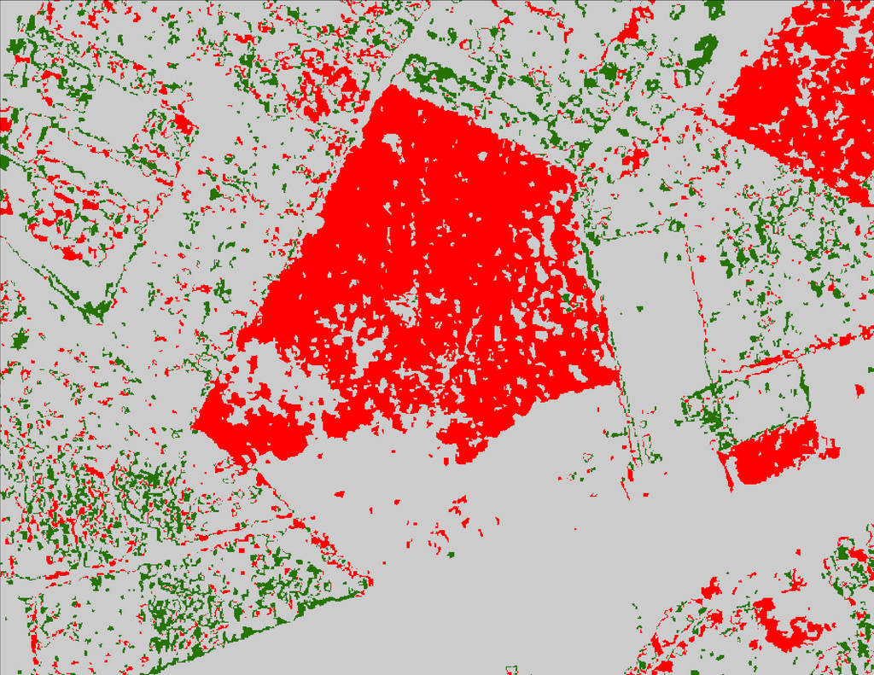
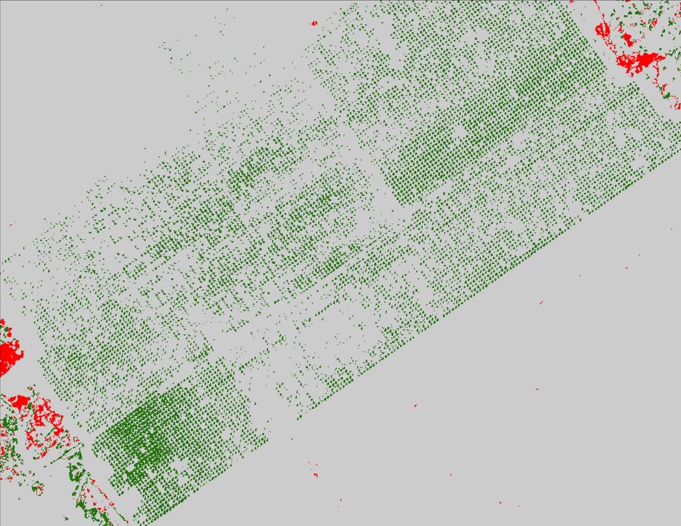
The Cherrywood community, for example, shows a dense mixture of loss and gain areas. This can be contributed to typical seasonal variance, as it is clear by the aerial imagery that very little vegetation change has taken place (see Fig. 2). As an example of clear canopy loss, the Avana-Esquel subdivision experienced a land use change from an agricultural area to a residential area, which resulted in clear cutting (see Fig. 3). Similarly, “The Point” apartment complex shows a lot-shaped loss of canopy due to the development of the complex during the four year period (see Fig. 4). An example of significantly misrepresented loss is evident in McKinney Falls State Park, which appears to show a large block of deforestation in a section of the park that is clearly forested. This can likely be attributed to either seasonal variation, or flood damage (see Fig. 5). An example of significantly misrepresented gain can be found in a section of the Lower Elgin road agricultural area, which appears to show a large swath of growth. However, given the photographic context of the area (which is evidently agricultural) and the geometric output of the canopy vector, it is safe to assume that this does not represent a real canopy change, and is simply resultant of the agricultural season (see Fig. 6).
Figure 2: Cherrywood Community
Figure 3: Avana-Esquel subdivision
Figure 4: “The Point” apartment complex
Figure 5: McKinney Falls State Park
These examples and more are illustrated in our story map, which can be located on our project website.

Figure 6: Lower Elgin Agricultural Area

4.2 Story Map Discussion
The Story Map Tour application is used as a presentation media. Our Story Map contains images exported from specific regions of the “Rast_Diff_Final” dataset. The regions shown represent areas with a dense singular trend of either canopy loss or gain. The Story Map progresses through these regional slides while transitioning the basemap view to allow for a comparison of the canopy data and the aerial image basemap. Each canopy trend image is accompanied with a brief description of the visual data represented. With this process we can present the findings in a simple and interactive manner that is publicly shared over the internet and housed on the ESRI servers. The ESRI online community is extensive and can critique openly shared Story Maps, answer any questions about processes they used, and ultimately strengthen your ArcGIS mapping understanding. This to be a very effective platform in a world of growing social media and geographic connectivity.

4.3 Project Complications
During the course of our study we ran into quite a bit of data quality issues as well as data processing issues. The first problem our study faced was the data available to us was inconsistent in the fact that the 2006 tree canopy data was in vector format rather than raster format as the other two datasets for 2010 and 2014 were available in. This made it difficult because we had to convert the files in order to keep consistency and perform the original analytical processes we wanted to perform and this took many hours and in some cases even a couple days with many failed attempts. With that we also had a few other inconsistencies in the datasets such as different projections, different resolutions, as well as different overall shape. The data also seemed to be incomplete in some datasets versus others with some areas just completely missing in a sort of fragmented coverage. This may be an error in the collection of the data or just inconsistencies in data collection over time through an almost ten year period. This could also be an error in just the converting of raster to vector or vice versa causing a loss or merge of data in certain areas. We also found conflict of data in our aerial images through a use of two different companies taking the images at different levels causing a shift in the image as you zoom in. Our aerial image we used to show the tree canopy itself displayed differences the further you zoomed in and we found that the Department of Agriculture took the largest extent down to about 10 meters and from 10 meters down to 1 meter was taken by an imaging program by the State of Texas. This caused a shift in the image due to the images being taken at different times throughout the year.

5. Conclusion
The results from our analysis highlighted a number of critical areas for canopy loss, and suggest explanations for these phenomenon. The results of this study will not only aid the City of Austin Forestry Program, but contribute to the study of the correlation between urban forests and anthropogenic actions. This knowledge will allow the City of Austin and other urban canopy advocates to take action more efficiently, as well as guide programs to mitigate issues that might contribute to the loss. In addition, our story map can now be utilized by the City of Austin as a visual and educational aid.

References

Article/Proposal Citations
Akbari, H. & S. Konopacki. (2005). Calculating energy-saving potentials of heat-island reduction strategies. Energy Policy, 33(6):721-756.
Heynen, Nik & Lindsey, Greg. (2003). Correlates of Urban Forest Canopy Cover: Implications for Local Public Works. Public Works Management & Policy. 8. 33-47. 10.1177/1087724X03008001004.
Parks and Recreation, Brewer et al., (2013). Austin's Urban Forest Plan: A Master Plan for Public Property. The City of Austin Urban Forestry Board. https://austintexas.gov/sites/default/files/files/Parks/Forestry/AUFP_Final_DRAFT_01-07-14_No_Appendices.pdf (last accessed 28 September 2017).
Rudd, H., J. Vala, & V. Schaefer. (2002). Importance of backyard habitat in a comprehensive biodiversity conservation strategy: A connectivity analysis of urban green spaces. Restoration Ecology, 10(2): 368-37
Sagers, Larry A., "The Value and Importance of Urban Forestry" (2005). All Archived Publications. Paper 1503. http://digitalcommons.usu.edu/extension_histall/1503
Sustainable Urban Forests Coalition. (2013). How does the SUFC define urban forests? Retrieved from Sustainable Urban Forests Coalition website: http://www.urbanforestcoalition.com/

Data Citations
Both Cited Portals for Austin.Gov URLs
Open Data | City of Austin Texas | Open Data | City of Austin Texas. Austin. https://data.austintexas.gov/ (last accessed 28 September 2017).
GIS and Maps. Home. http://www.austintexas.gov/department/gis-and-maps (last accessed 28 September 2017).

Appendix I - Illustrations and Documents
Appendix I.A: Methodology Flowchart

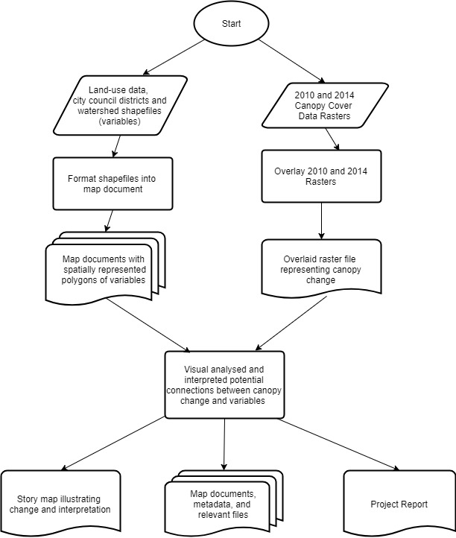

Appendix I.B: Austin Area Canopy Change 2010 - 2014

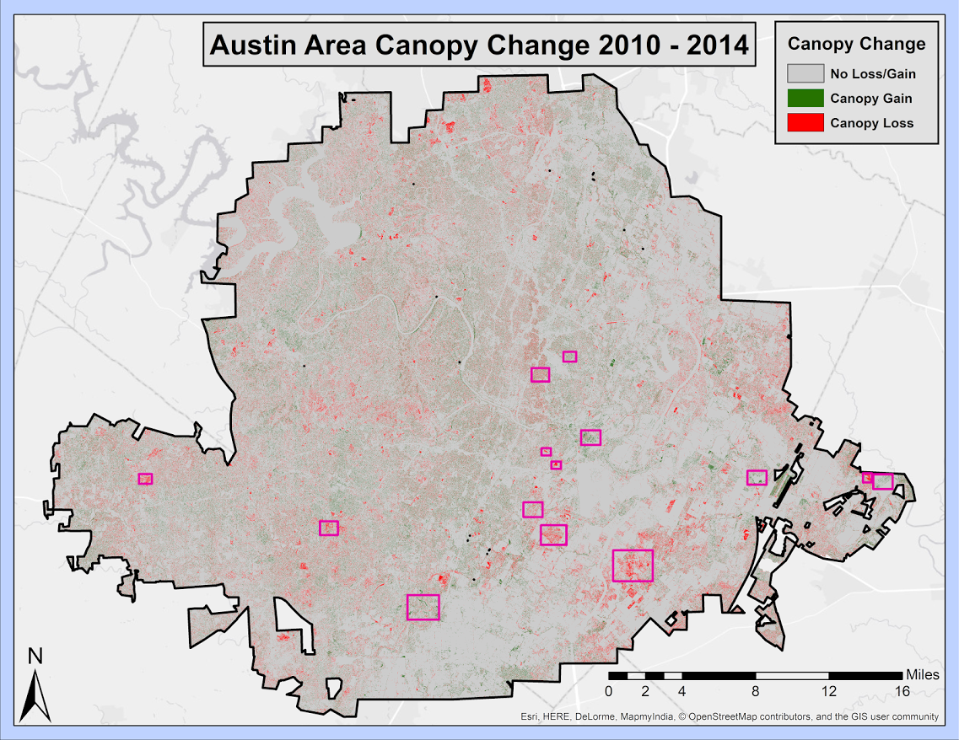

Appendix 1.C: City Council Boundaries

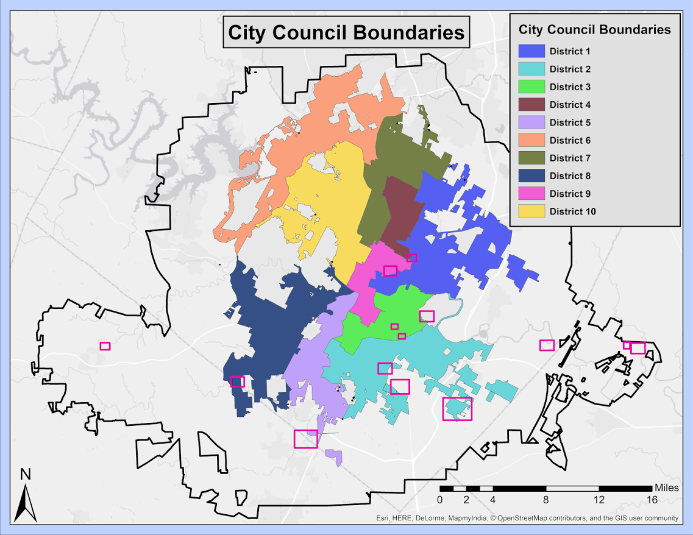

Appendix I.D: City Council Boundaries

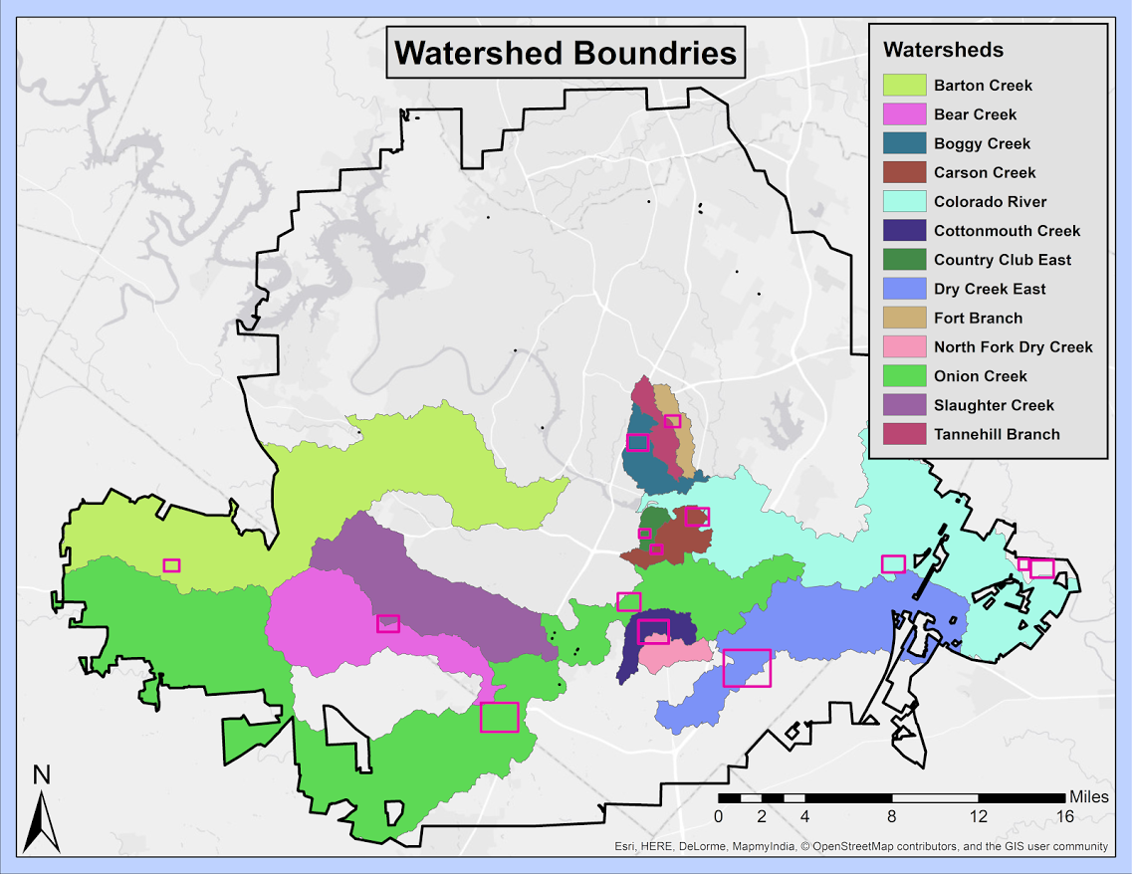

Appendix I.E: Land Use Inventory 2010 Map

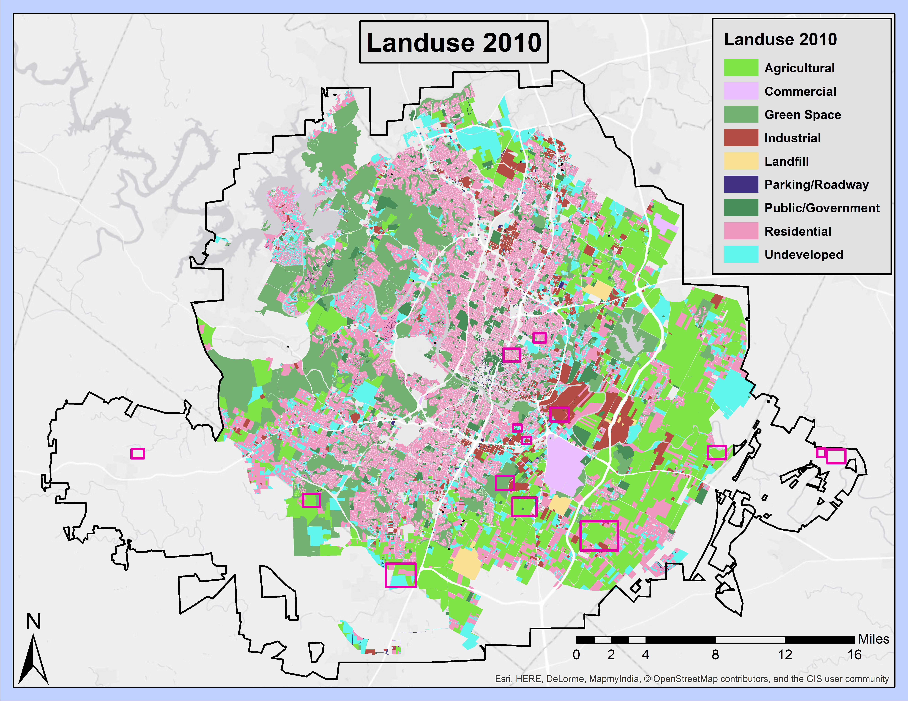

Appendix I.F: Land Use Allocation Pie Chart

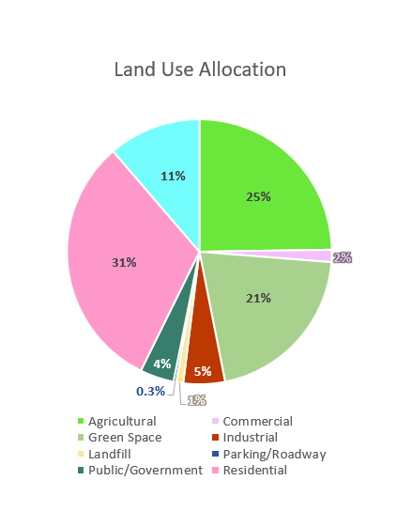

Appendix II: Group Member Contribution

Erin Rand, Project Manager:
- Report Compilation and Coordination
- Task Assignment
- Abstract
- Introduction
- Methodology (3.1 and 3.3)
- Results and Discussion (4.1)
- Conclusion
- Appendix I Compilation
- Appendix II

Curtis Green, GIS Analyst:
- Data section (2)
- Poster creation
- Results (4.3)
- Powerpoint

Cory Sibley, GIS Analyst:
- Story Map creation and development
- Final Maps creation and formatting
- Methodology (3.2)
- Discussion (4.2)
- Progress Report Document Editing and Final Review
- Appendix III- Metadata

Appendix III: Metadata

File Name | Description
Aerial_Boundbox_Final | The polygons that reference the sample areas chosen in our analysis.
Scope_Area_Final | The polygon reference that delineates the boundary of the scope of our project.
Watershed_Final | The shapefile that contains the information regarding watersheds in the Austin area.
Landuse2010_Final | The shapefile that contains the information regarding Landuse 2010 in the Austin area.
City_Council_Final | The shapefile that contains the information regarding City Council Districts in the Austin Area.
Rast_Diff_Final | The created raster file that contains the canopy data difference between the year 2010 and 2014.
Rast14_FinalClip | The raster file that contains the canopy data for 2014 in the Austin area.
Rast10_FinalClip | The raster file that contains the canopy data for 2010 in the Austin area.
Overlap_Clip_Final | The shapefile that was used to clip the raster and vector files into the desired scope.

See Section 3.3 for our initial process, and Section 4.4 for a detail of the data quality issues mentioned.

