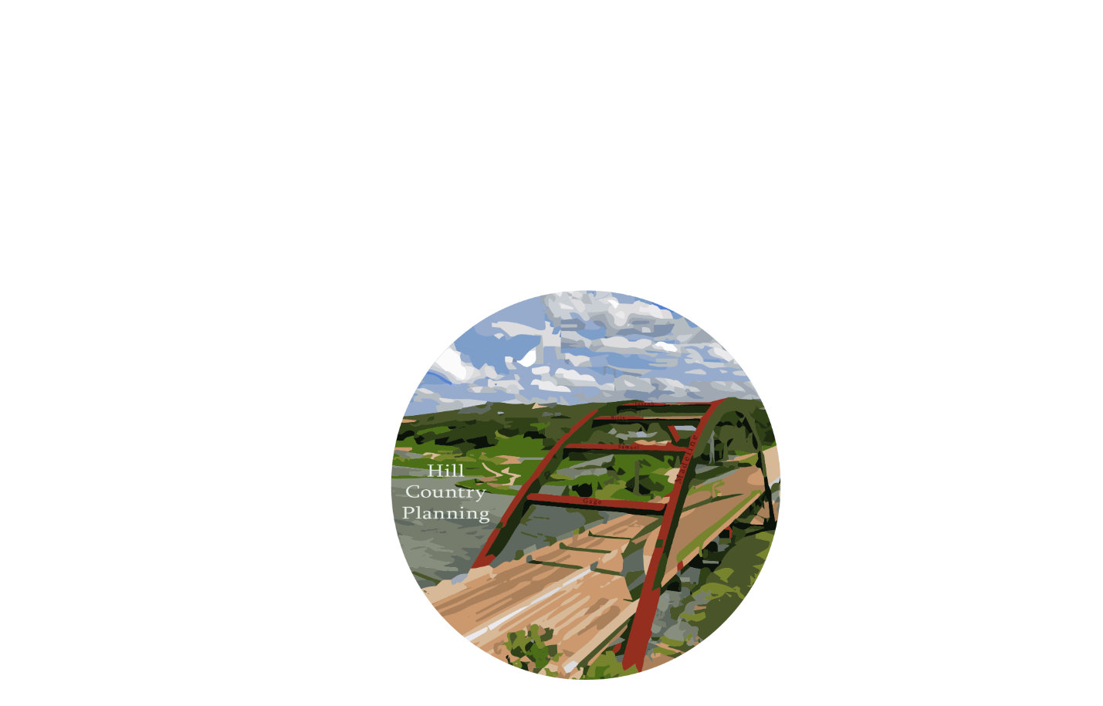

Madeline Covarrubias- Project Manager, GIS Analyst
Samuel Delafuente- GIS Analyst
Joseph Frombaugh- GIS Analyst
Billy Rodriguez- Graphic Designer, GIS Analyst
Gage Sears- GIS Analyst

Digitization of Safety Barriers in the City of Austin’s Council District 8 and Their Effects on Traffic Accidents

Prepared for:

Prepared by: Hill Country Planning
February 24, 2017
TABLE OF CONTENTS

1. INTRODUCTION 1
1.1 SUMMARY 1
1.2 PURPOSE 1
1.3 SCOPE 1
2. LITERATURE REVIEW 4
3. PROPOSAL 5
3.1 DATA 5
3.2 METHODOLOGY 5
3.3 IMPLICATIONS 8
3.4 BUDGET 9
3.5 TIMETABLE 9
3.6 FINAL DELIVERABLES 11
4. CONCLUSION 11
5. PARTICIPATION 11
6. REFERENCES 12

1. INTRODUCTION

1.1 SUMMARY
Austin, Texas is one of the fastest growing cities in the United States, located in South Central Texas. With large growth and a wealth of natural resources, there is a large strain on the city’s Public Works Department. While they implement GIS in many forms to help maintain the 4,000+ miles of right-of-way, there simply isn’t enough time, money, or man power to complete necessary projects that could increase efficiency within the department. Hill Country Planning has decided to step in to help with the project of digitizing the safety barriers to create a digital catalog for maintenance purposes. Recordation in a digital format allows the department to easily query their assets based on location and barrier/material type. The digital format also offers an opportunity for statistical analysis of barrier effectiveness related to traffic accidents.

1.2 PURPOSE
The purpose of this project is to catalog all of the safety barriers in Council District 8 of Austin, Texas through the process of GIS digitization, with a focus on barriers in proximity to stream crossings. The process will be carried out using a combination of aerial data provided by the city of Austin (COA) and Google street view. Barriers will be identified and queried by material type and end type. By digitizing the safety barriers, the Public Works Department, Transportation Department and Parks and Recreation Department can easily track and log maintenance records on the safety barriers throughout the city. This would allow work orders to be easily logged with the precise locations of safety barriers so workers knew exactly where to go when needing to perform maintenance on safety barriers. Moreover, Hill Country Planning will then overlay traffic accidents with the safety guard rail information in order to analyze whether the type of safety barrier impacted the result of the traffic accident through a hot spot analysis.

1.3 SCOPE
Hill Country Planning will digitize approximately 160 safety barriers and SETS in Council District 8 of Austin, Texas. This work space covers a little more than 45 square miles. Figure 1 located below shows the extent of the area Hill Country Planning will be analyzing. Once this initial digitization is done, Hill Country Planning will perform geo-spatial analyses to assess the effectiveness of safety barriers on traffic accidents in Austin, Texas. The scope can be adjusted if Hill Country Planning achieves benchmarks sooner than outlined. This will take place over a four month period, from January 30, 2017 to May 1, 2017. All final methods and processes will be executed during this time, with the final project and presentation being submitted no later than May 1, 2017.
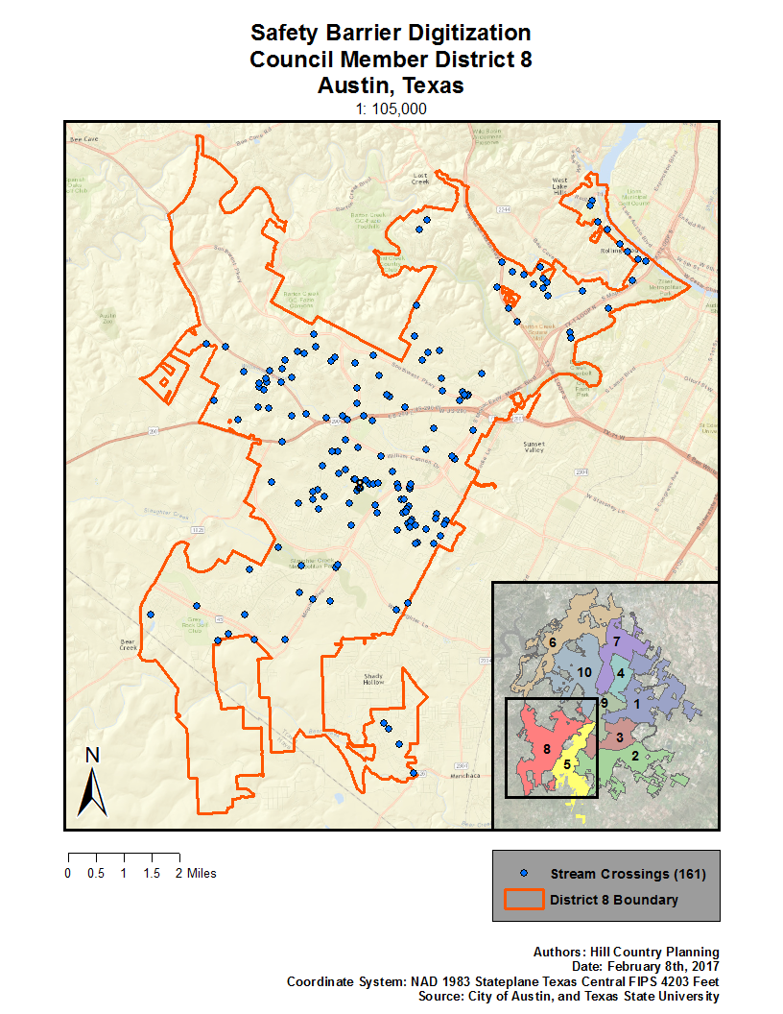
Figure 1: Map of District 8 Austin, Texas showing study area and safety barriers.

2. LITERATURE REVIEW
Accident frequencies related to safety barriers is studied in an article from Park et al. The results revealed that the severity of crashes and run-off roadway crashes are reduced but the total number of crashes increases. Results also revealed that guardrails are more effective at keeping older and middle age drivers safer than younger drivers. The effectiveness of guardrails in the event of a run off road crash is higher at night time than during day time.
An article from Zou and Tarko focuses less on the types of people involved in crashes but more on the different types of crashes related to the median barriers and roadside barriers. They found that although barriers reduced the frequency of high-risk crashes and run off road crashes like the article above, the barriers also introduced new types of crashes. For instance, a car could crash into a barrier but bounce back into the roadway into other traffic or a heavy vehicle could topple over the barrier into oncoming traffic.
In a study from Soltani et al., controlled tests are carried out on various types of vehicle barriers. The speed, angle of collision, angle of deflection, vehicle damage and occupant risk factors are all recorded for each barrier type. The list of barriers could possibly help identify which are susceptible to rollovers. The authors recommended the barrier used in test 13 which proved the most successful in mitigating vehicle damage and reducing the deflection angle of vehicles which in turn, reduces the chance of bounce back collusion with other vehicles.
Study based on fatal, injury, and property damage by Goubel, Martin, and Mintsa-Eya, took.data from 1996 to 2010 on an unknown French toll road. As they described what their different safety barriers, I understood how their goal in terms of having a safety barrier was to contain or absorb the crash from a vehicle so it does not rebound onto other cars travelling at their relative speed. They found that other than two wheel vehicles (motorcycles / moped), single sided and ‘W’ beam guardrail were more than likely to absorb car crashes and there appear on faster traveling cars such as highways. This relates to our work because it can determine what kind of safety barrier is needed to be in place as part of our analysis. We do not know the exact number of metal or metal-and-wood safety barriers in our scope, but we can assume there won’t be to many due to the fact there are not many stream crossings that intersect highways.

3. PROPOSAL

3.1 DATA
Table 1. Master data table for this project.
Source: City of Austin (CoA)
Layer | Attributes | Purpose
CoA Council Districts | Polygon data showing all 10 city council districts of Austin | Shows the area of the project, which is Council District 8, in relation to the entire city.
Stream Crossings | Point data displaying 160 stream crossings in district 8 | Focusing on stream crossings allows the scope of the project to be narrowed down to safety barriers that prevent cars from driving into water.
Safety Barriers | Line features showing previously digitized safety barriers | This feature class will be used to add on the newly digitized barriers while serving as an example/base for the process.
6 in. Aerial Imagery | High resolution imagery showing detailed map of study area | Aerial imagery will be used to be compared with Google Earth imagery to find the absolute locations of the safety barriers and to determine safety end treatments.

3.2 METHODOLOGY
First we will need to know what kind of data we are working with. The client has provided us with .shp, or shape, files and .mxd, or map document, files that are process through Esri’s worldwide leading GIS software, ArcMap. Everyone in Hill Country Planning has utilized a form of ArcMap document and their other files. Since we are focusing only on District 8 of Austin, Texas, we needed the client to provide us already files of Austin divided up in their districts. The client has already provided stream crossing intersection they digitized through a six-inch aerial imagery. The City of Austin hired a temporary worker to do digitize stream crossing barriers so the data within the map’s attributes has been organized. There are a few examples of how it needs to be done in each corner of District 8.
We divided up the one hundred and sixty stream crossing by the five people in our group and gave us our own layer within the map document. Then we will need to spatially join our assign points to safety barriers of Austin already created. Doing this will save the integrity of data organized by the City of Austin. We then need to select by location with the safety barrier of Austin as our target and our assigned stream crossing points source layer. This will be selected intersecting the points within 200 feet. We decided 200 feet because it would not overlap into someone else’s assigned points and be close enough for the barriers to find their stream crossings. Next, we will create a layer from the selection and this is where our we will create or edit our work. The last thing step to set up our work space is adding three fields in our layer and naming them; URL_1, URL_2, and URL_3. They will all be text type field with five-hundred characters in length. We will go back to the purpose of these three fields.
Then we will be digitizing the barriers with our client’s aerial photo by exactly how long each side is by making a line segment in map document’s editing session. If there is a tree or other object hovering over the crossing, we will open Google Maps and try to measure out the walking distance of the barrier. Next we will need to identify where the stream crossing is by using a Google Maps. We will identify the stream crossing point and in its location area we will change it from the default feet to degrees’ minute’s seconds. We will then copy those coordinates to Google Maps. After the image matches with our map, we can click on the little yellow icon to view the street view and easily record Then we will need to click “View on Google Maps” to copy the URLs of the three best images of the barrier used for referenced. Each link will be pasted into the URL_1, URL_2, and URL_3 fields.
After we assess the barrier we need to categorize it in Safety End Treatment (SET). This is what is at the end of guardrail or railing to hinder the force of a vehicle crashing into the end of the safety barrier. There are different SETs used in different kinds of traffic speed limits. The client provided us with a “SET and Barrier Material Type Guide” to help us classify the barrier type that we will inset in attribute table in our map document. A domain was created by the client to organize the ten types that can be selected from the drop box. Next we will need to edit what kind of material the barrier is made out of. This can be five different types; concrete, concrete-and-metal, metal, metal-and-wood, and wood.
We will do this for each our points and then send a progress report to our client. They will review our work and give suggestions. Once our final project is complete, need to analyze: total number of barriers and the percentage of how many different barriers types are in place. We will a Hot-Spot analysis to try and find out where more likely do accidents occur in our area. This will help us try and find potentially new safety barriers need to be placed. Maybe even in between sidewalks or bicycle lanes for their safety. Then try to compare past accidents with current crashes from this year or last year which ever has complete data. If the client has available, try and find out when their safety barriers were placed and find whether or not their assets have helped lower accidents. And finally report and map out the metal-and-wood because most common crash barrier use due to their high effectiveness and inexpensive production costs (Southern Guard Rail Company).
If all deliverables have been processed before the end of the semester, the client did suggest scope creep for our group. If possible, we can go back to our points and record how much damage their assets have taken so their maintenance program can run into full effect immediately.
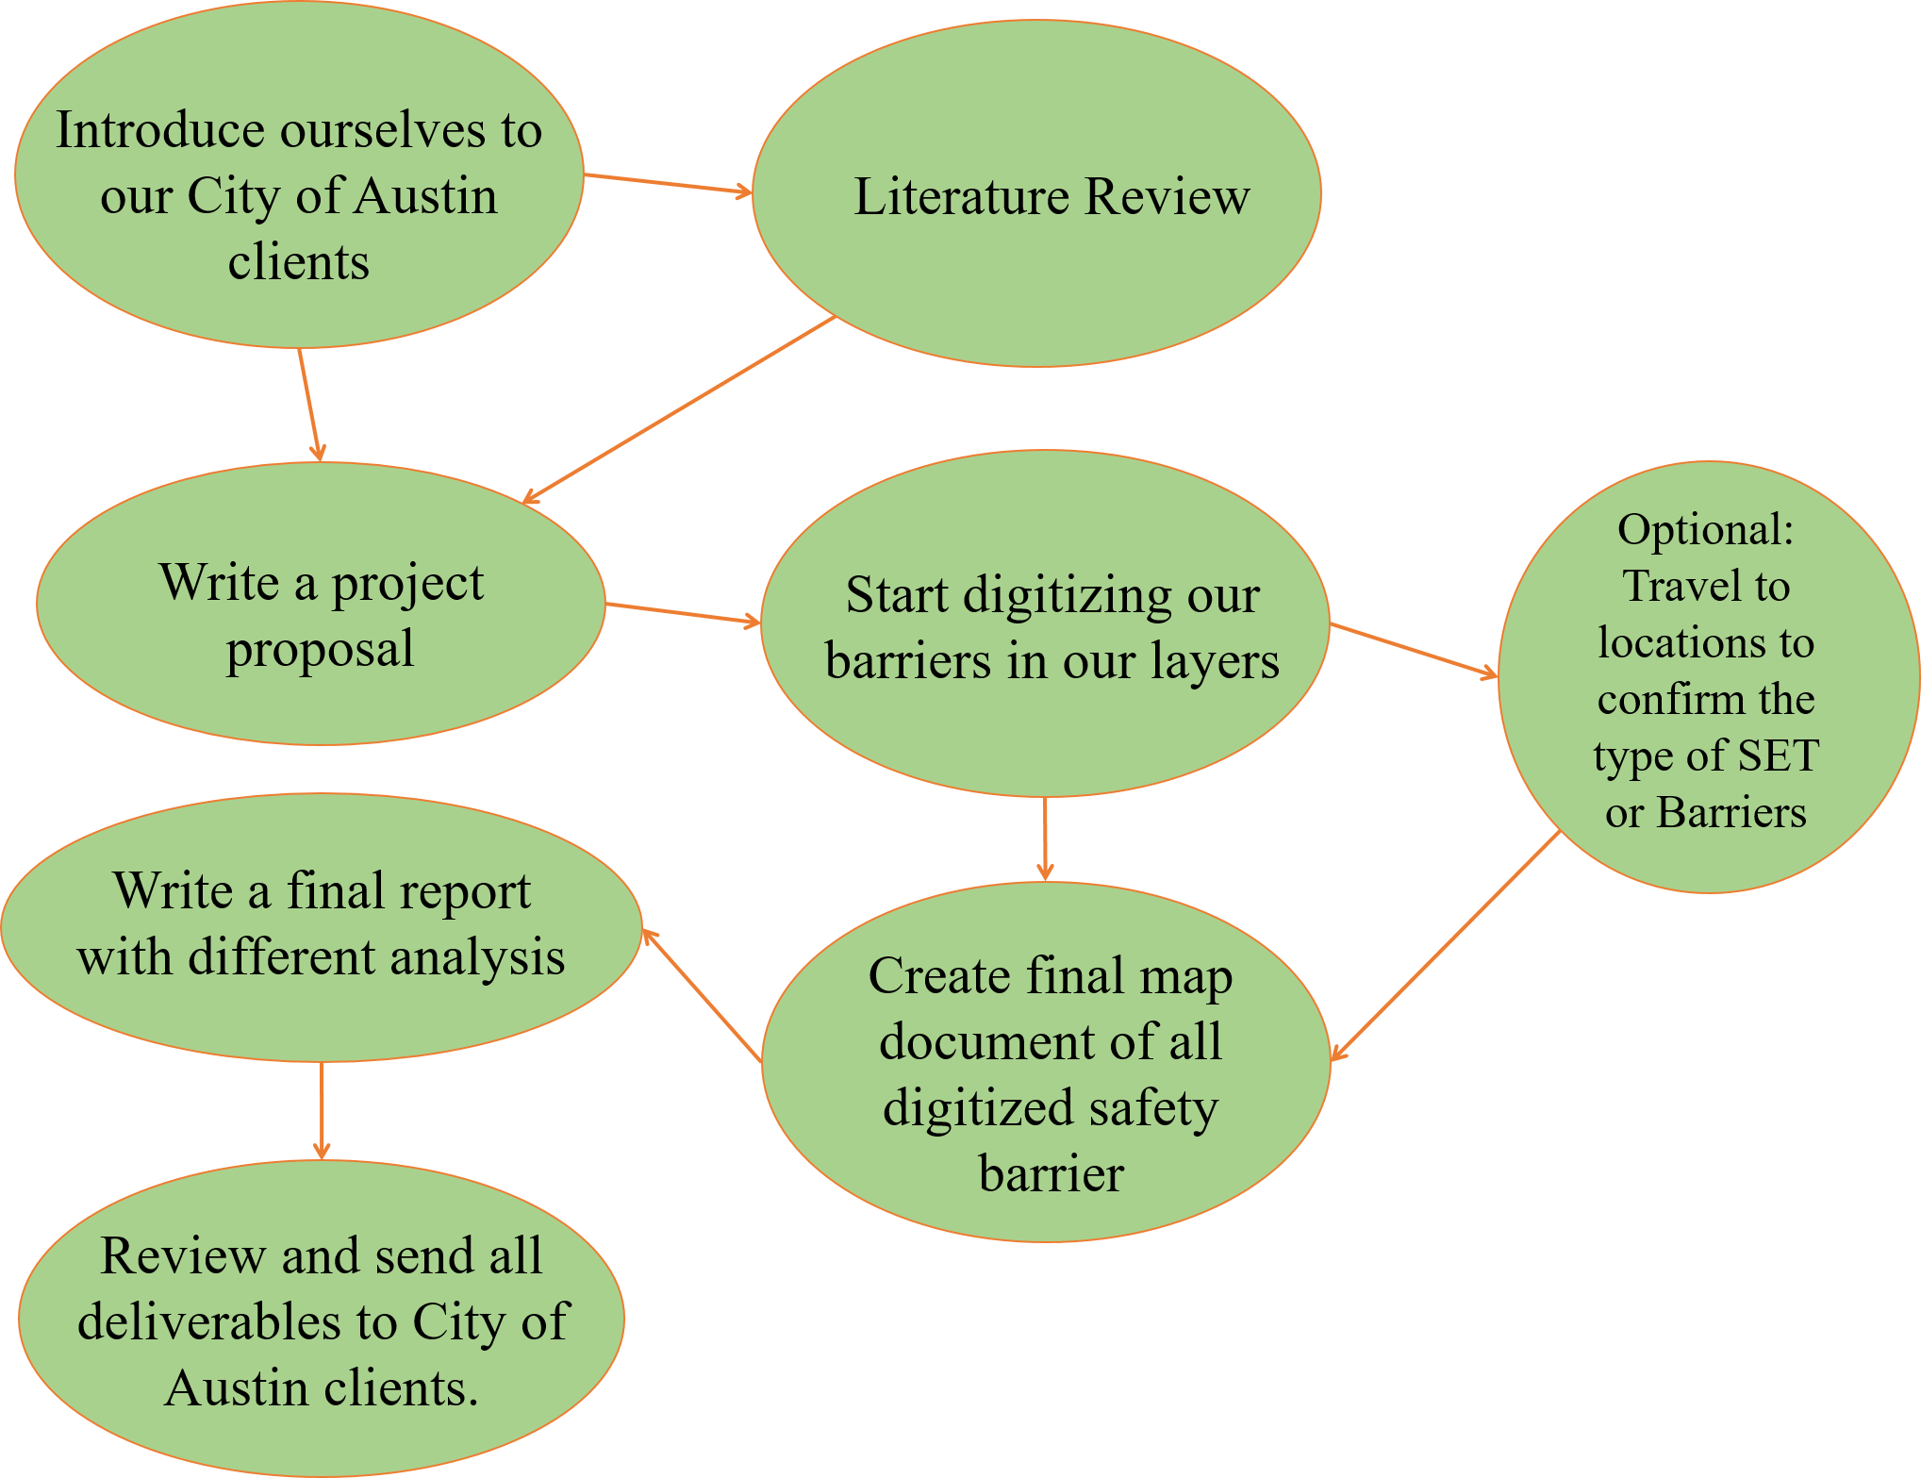

Figure 2. Overview of the project methodology.

3.3 IMPLICATIONS
Digitizing the safety barriers and safety end treatments allows multiple departments in the City of Austin who utilize GIS software to track these barriers. The City of Austin identifies safety barriers and safety end treatments as important assets. By digitizing these assets to acquire an online inventory of all the safety barriers in Council-Member District 8, it sets a standard and a base for future asset digitization for the City of Austin. The City of Austin will continue to digitize safety barriers throughout its city limits. Using Hill Country Planning’s Map Package and metadata will allow future GIS analysts to more efficiently digitize assets for the City of Austin. With the demand on public infrastructure, physical and labor, increasing as Austin continues to grow, tracking the quality of assets for an entire city can be difficult. Digitizing these assets allows the City to keep a real time log of asset statuses allowing City of Austin employees to work more efficiently.

3.4 BUDGET
Table 2. Budget breakdown by direct and indirect costs.
System Management
Project Manager (10 hrs/week for 13 weeks)
 | Total Hours | 130
 | Hourly Pay | $35.00
 | Sub-total | $4,550
GIS Analyst (10 hrs/week for 13 weeks)
 | Total Hours | 130
 | Hourly Pay | $27.50
 | Sub-total | $3,575
Total |  | $8,125
Equipment/Software
Workstation | $150/workstation * 5 workstations | $750
ArcGIS | $4,800/year (Standard w/ all extensions) $4,800/12 * 2 months | $800
Adobe Illustrator | $50/ month * 1 month | $50
Computers | $250/computer * 5 computers | $1,250
Total |  | $2,850
Total Project Cost
$10,975

3.5 TIMETABLE
Phase 1: Introduction to project (January 23rd – February 1st)
The initial phase of this project will involve having our first meeting with our clients from the City of Austin. They will explain to us what they want in terms of our final report, and what we need to do in the process of digitizing the safety barriers in Council District 8.
Phase 2: GIS Data collection and processing (February 6th – April 5th)
The second phase will begin in February. We will write a project proposal to be submitted to our clients no later than March 1st. Afterward, we will start editing the GIS files using ArcMap and add a point file to each safety barrier in Council District 8, and we will edit the metadata to provide accurate information. We will start editing the GIS files using ArcMap and add a point file to each safety barrier in Council District 8, and we will edit the metadata to provide accurate information.
Phase 3: Summarization and interpretation of data (April 12th - April 30th)
The final phase will involve drawing conclusions about our data. Using the final completed map we have made, we will look for other data that the clients did not provide if possible, such as data on traffic accidents in Austin.

Table 3. A visual of our project timeline.
Week 1 (Jan 23) | Introduction to the project concept
Week 2 (Jan 30) | First client meeting
Weeks 3-4 (Feb 6-18) | Begin writing our  Project Proposal
Week 5 (Feb 20) | Rehearse presentation to clients
Week 6 (Feb 27) | Second client meeting and initial presentation
Week 7 (Mar 6-31) | Begin actual GIS digitization
Week 11 (Apr 3) | Finish putting together our map
Week 12 (Apr 10) | Begin analysis of data
Week 13 (Apr 17) | Put together final report and deliverables
Week 14 (Apr 24) | Submission of final deliverables
Week 15 (May 1) | Final presentation

3.6 FINAL DELIVERABLES
At the end of this project, Hill Country Planning will provide the City of Austin with the following final deliverables:
  - Project Proposal, in response to the RFP from the city
  - Progress report, to keep our clients updated
  - Final report, with all of our collected data and analysis
  - Presentation slides, for the three different stages
  - Visual representation, in the form of a poster
  - Updated safety barrier feature class/shapefile

4. CONCLUSION
The City of Austin sent out a Request for Proposal for the digitization of assets. Particularly, safety barrier crossings and safety end treatments in Council-Member District 8. Hill Country Planning plans to digitize the safety barrier crossings and safety end treatments in District 8 (approximately 161 safety barriers). Digitizing assets will help curate a database that the City of Austin can use to digitize more safety barrier assets throughout the other 9 Council-Member Districts. If there is time left in the semester once the digitization is finished, Hill Country Planning will analyze safety barrier metadata and traffic accident data to see if the type of safety barrier impacts the type of accident that occurs.

5. PARTICIPATION
Madeline Covarrubias- Group manager, master data table, introduction, budget, final deliverables
Samuel Delafuente- Literature review, introduction
Joseph Frombaugh- Flow chart, timetable, introduction
Billy Rodriguez- Logo design, introduction, methodology, literature review
Gage Sears- Introduction, map creation, conclusion

6. REFERENCES
Jean-Louis. M, Mintsa-Eya, C., and Goubel C. 2013. Long-term analysis of the impact of longitudinal barriers on motorway safety. Accident Analysis & Prevention 59:443-451.
Juneyoung Park, Mohamed Abdel-Aty, Jaeyoung Lee. Use of empirical and full Bayes before–after approaches to estimate the safety effects of roadside barriers with different crash conditions. Journal of Safety Research 58:31-40.
Mehrtash Soltani, Taher Baghaee Moghaddam, Mohamed Rehan Karim, N.H. Ramli Sulong, Analysis of developed transition road safety barrier systems. Accident Analysis & Prevention 59:240-252.
SGRC. 2016. W-Beam Guardrails. Southern Guard Rail Company. http://www.southernguardrail.com/GalvanizedGuardrails/WBeamGuardrails/tabid/58/Default.aspx. Last accessed 20 February 2017.
Yaotian Zou, Andrew P. Tarko, An insight into the performance of road barriers − redistribution of barrier-relevant crashes. Accident Analysis & Prevention 96:152-161.

