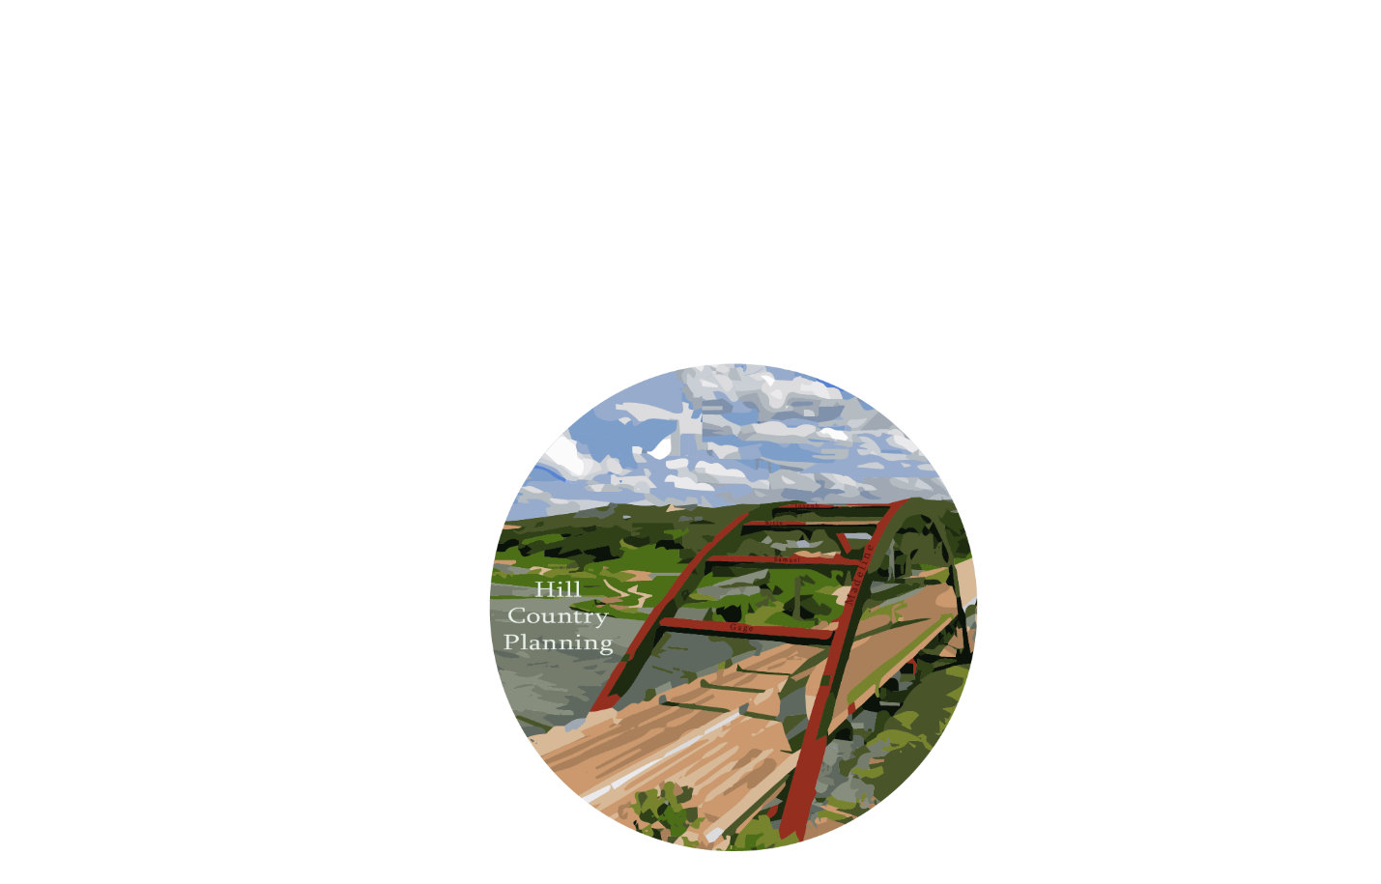

Madeline Covarrubias- Project Manager, GIS Analyst
Samuel Delafuente- GIS Analyst
Joseph Frombaugh- GIS Analyst
Billy Rodriguez- Graphic Designer, GIS Analyst
Gage Sears- GIS Analyst
Digitization of Safety Barriers in the City of Austin’s Council District 8 and Their Effects on Traffic Accidents

Prepared for:

Prepared by: Hill Country Planning
March 26, 2017
Contents
1. INTRODUCTION 4
1.1 SUMMARY 4
1.2 PURPOSE 4
1.3 SCOPE 4
2. TASKS 4
2.1 TASK 1: DIGITIZE SAFETY BARRIERS AND END TREATMENTS 4
2.2 TASK 2: DATA ANALYSIS 4
2.3 TASK 3: ADDITIONAL CAPACITY FOR TRAFFIC ANALYSIS 4
3. CHALLENGES & CONCERNS 5

4. CONCLUSION 5

5. PARTICIPATION 5

1. INTRODUCTION

1.1 SUMMARY
Hill Country Planning is digitizing approximately 162 safety barriers and safety end treatments in Council Member District 8 for the City of Austin, Texas Public Works Department. The Public Works Department could utilize this data to track maintenance logs remotely as well as provide information to their work crews such as precise location information what material are the barriers built out of. This project is apart of the greater project of digitizing all of Austin's infrastructure assets. Hill Country Planning has digitized approximately 70 out of 162 stream crossings and is on target for scheduled completion of the project by May 1, 2017.

1.2 PURPOSE
The purpose of this project is to catalog all of the safety barriers in Council District 8 of Austin, Texas. Hill Country Planning (HCP) will use the process of GIS digitization, with a focus on barriers in proximity to stream crossings. A high resolution aerial photography provided by City of Austin (COA) and a web based Google service that allows us to view panoramic images from the position on the street called, Google Street view, will assist our approach. Our goal is identifying safety barriers so when queried, the user will be able to see the material and safety end type. In the end, we will report the different types of barriers are in the District in percentage form.
Once the safety barriers in District 8 of Austin are digitized, the Public Works Department, Texas Transportation Department, and Parks and Recreation Department will be able to keep track and log maintenance records of their assets. Additionally, Hill Country Planning will then overlay traffic accidents with the safety guard rail information in order to analyze whether the type of safety barrier impacted the result of the traffic accident through a hot spot analysis and other analysis if needed. Hill Country Planning's final project can serve as a template for future GIS analysts to finish digitizing the rest of the City of Austin's stream crossing safety barriers.

1.3 SCOPE
Hill Country Planning will digitize approximately 160 safety barriers and safety end treatments (SET) in Council District 8 of Austin, Texas. Shown in Figure 1, this area is the South-Western part of Austin that is roughly 45 square miles. Austin’s water outflow does come from there area into Lady Bird Lake in forms of small ditches and the handful of creeks. Our project will take place over a four-month period, from January 30, 2017 to May 1, 2017. So far Hill Country Planning is on track to fulfil all deliverables by May 1, 2017.
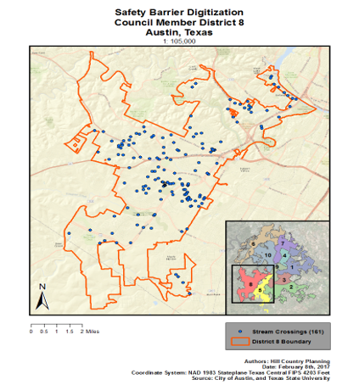
Figure 1: Map showing the extent of the study area.

2. TASKS

2.1 TASK 1: DIGITIZE SAFETY BARRIERS AND END TREATMENTS
Work Completed: Out of the 162 stream crossings within district eight, about 70 stream crossings have been completed. Out of those completed, about 12 stream crossings did not have any safety barriers. Only 1 barrier encountered so far has sustained any form of damage.
Present Work: The stream crossings have been split among the group, with about 32 stream crossings assigned to each member. Barriers that are difficult to be classified have been noted for reclarification with the client before the final deadline.
Work Scheduled: Work on digitization is expected to continue on schedule and be completed by the end of March.

2.2 TASK 2: DATA ANALYSIS
Work Completed: There is currently no work completed for Task 2. Before data analysis can begin, Hill Country Planning must complete the digitization of the 160 stream crossings (Task 1) so that we can analyze the statistics of the barriers we have digitized.
Present Work: Once all stream crossings have been digitized, we will present a final summary on the report of our findings. We will analyze statistics such as the number of stream crossings that do not have barriers, how frequently each type of barrier has been used, etc.
Work Scheduled: Analysis is expected to begin by April 3rd. Dr. Yuan will provide further information on the formatting expected for this section of our final deliverable report.

2.3 TASK 3: ADDITIONAL CAPACITY FOR TRAFFIC ANALYSIS
Work Completed: There is currently no work completed for Task 3. As it stands now, running spatial data traffic analyses is the task to follow once Hill Country Planning successfully digitizes the stream crossings and data analysis.
Present Work: There has been brainstorming with Daniel Haverlah, Dr. Yihang Yuan along with Hill Country Planning as well as research on other case studies of safety barrier traffic and accident analyses.
Work Scheduled: Following the completion of Tasks 1 & 2 as well as the preparation of the Final Deliverables, Task 3 will be worked on by further researching effective techniques and data needed for proper data analysis.

3. CHALLENGES & CONCERNS
Initially, Hill Country Planning had some problems with obtaining aerial imagery for the digitization portion of our project. After our first client meeting, we discovered that the 6in. aerial imagery would not load properly. Our client was patient with us as we worked together to find an alternative, until we finally decided on using a shapefile that is a URL map service that provided imagery that would suit our needs. HCP was able to focus most of our energy on our proposal, so no real time was lost.
Once digitization began, a few of the HCP members had trouble with setting up a work environment in ArcMap that did not alter the original data. The X: drive is where all original data that COA provided is located. All members have been instructed to work out of the personal drives that the university has provided for us. However, we had some minor difficulty moving data over so as to not alter the original because we had created our project in the X: drive. Our solution was to simply create a new project using the data that we had copied into our personal drives. This was practical for us, since no one had begun the digitization process yet.
As of right now, there have not been any new challenges we have encountered. In regards to any concerns, it is possible that HCP may not be able to complete a traffic analysis using a time-series analysis. For us to complete a time-series, we would need data for installation dates of all safety barriers in District 8 of Austin. Unfortunately, this is not feasible with the allotted time of this project. We hope to complete every other aspect of this project in such an efficient manner that would allow the COA to complete the traffic analysis well after HCP is finished, and apply their methods to other council districts as well.

4. CONCLUSION
Hill Country Planning will continue the digitization process for our clients. With no major changes to our scope or methodology, HCP has only had small bumps in the road. We have remained on schedule, with a little under half of the stream crossings already done. After task 1 is complete, we will move on to our analysis of the barriers, and begin the process of creating our final deliverables. Task 3 is still in the air, dependent on what information we can gather of barrier installation dates, and whether or not we will have the necessary time to complete a time-series analysis.

5. PARTICIPATION
Group Member | Position | Task
Madeline Covarrubias | Project Manager, GIS Analyst | Challenges & Concerns, Conclusion
Samuel Delafuente | GIS Analyst | Task 1
Joseph Frombaugh | GIS Analyst | Task 2, Presentation
Billy Rodriguez | Graphic Designer, GIS Analyst | Purpose, Scope
Gage Sears | GIS Analyst | Summary, Task 3

