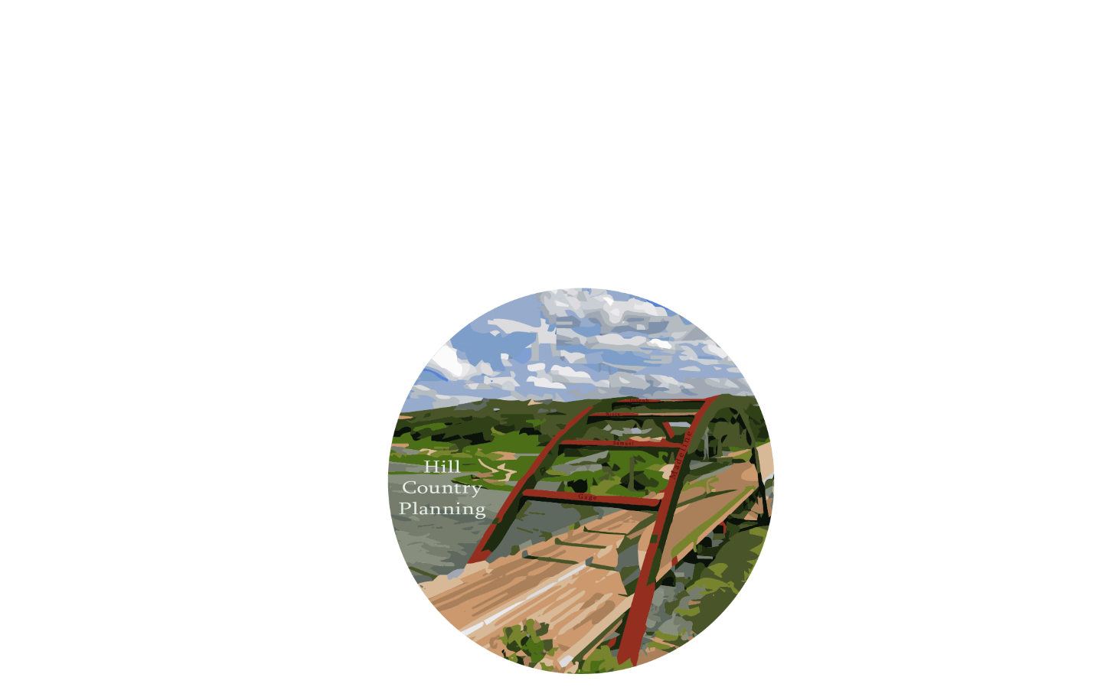

Madeline Covarrubias- Project Manager, GIS Analyst
Samuel Delafuente- GIS Analyst
Joseph Frombaugh- GIS Analyst
Billy Rodriguez- Graphic Designer, GIS Analyst
Gage Sears- GIS Analyst
Digitization of Safety Barriers in the City of Austin’s Council District 8 and Their Effects on Traffic Accidents

Prepared for:

Prepared by: Hill Country Planning
April 26, 2017
TABLE OF CONTENTS

1. INTRODUCTION AND PROBLEM STATEMENT 1
1.1 SUMMARY 1
1.2 PROBLEM STATEMENT AND PURPOSE 1
1.3 SCOPE 2
2. DATA 4
3. METHODOLOGY 5
3.1 DATA PREPARATION…………………………………………………………………..5
3.2 DIGITIZATION……………………………………………………………………………6
3.3 ESTABLISHING AND ACCESSING DATA………………………………………...…6
3.4 MERGE…………………………………………………………………………………...8
4. RESULTS AND DISCUSSION 9
4.1 SAFETY BARRIER ANALYSIS 9
4.2 DATA QUERY 9
4.3 LIMITATIONS 10
5. CONCLUSION 11
6. REFERENCES……………………………………………………………………………...13
7. APPENDIX I: GROUP MEMBER CONTRIBUTIONS………………………………….14
8. APPENDIX II: METADATA………………………………………………………………..15

1. INTRODUCTION AND PROBLEM STATEMENT

1.1 SUMMARY

Hill Country Planning digitized 164 safety barriers and Safety End Treatments (SETs) in Council Member District 8 for the City of Austin, Texas Public Works Department. This resulted in 522 new features created for the City of Austin. The Public Works Department could utilize this data to track maintenance logs remotely as well as provide information to their work crews such as precise location information what material are the barriers and safety end treatments are built out of. This project is a part of the greater project of digitizing all of Austin's infrastructure assets.

1.2 PROBLEM STATEMENT AND PURPOSE
Austin continues to grow and densify. As a result, the roads will become more travelled, more congested, creating more risk for accidents to occur. This means it is important for the City of Austin to have a digitized archive and inventory for all their safety barriers and SETs so the Public Works Department can more efficiently track metadata of the safety barriers and SETs such as location (relative and actual), maintenance records, and material information. The City of Austin would like to digitize all their assets or objects of value to the city (safety barriers, public road medians, street lights, etc.). However, being a public operation, the City of Austin cannot hire on a full time GIS-Technician to digitize all their assets for them. The City of Austin over the past 4 years has hired a couple of temporary GIS-Technicians to tackle this challenge for them. However, the work is not formatted the same across the years nor is it complete. The scope of work is also sporadic due to inconsistent employment working on digitizing the various assets for the City of Austin. This is where Hill Country Planning steps in.
Hill Country Planning digitized approximately 528 Safety Barriers and SETs for the Council Member District 8 of Austin, Texas with a focus on barriers and SETs associated with stream crossings. The Public Works Department is the main department utilizing the results of this project. However, the Transportation Department as well as the Parks and Recreation Department will be able to use the methodology in future digitization efforts for their ass

1.3 SCOPE
Hill Country Planning digitized approximately 162 safety barriers and SETs in Council Member District 8 of Austin, Texas. This area is the South-Western part of Austin that is roughly 45 square miles. Austin’s water outflow does come from there area into Lady Bird Lake in forms of small ditches and a handful of creeks. Our project will take place over a four-month period, from January 30, 2017 to May 1, 2017. Figure 1 displays all the safety barriers and SETs digitized within the project boundary.
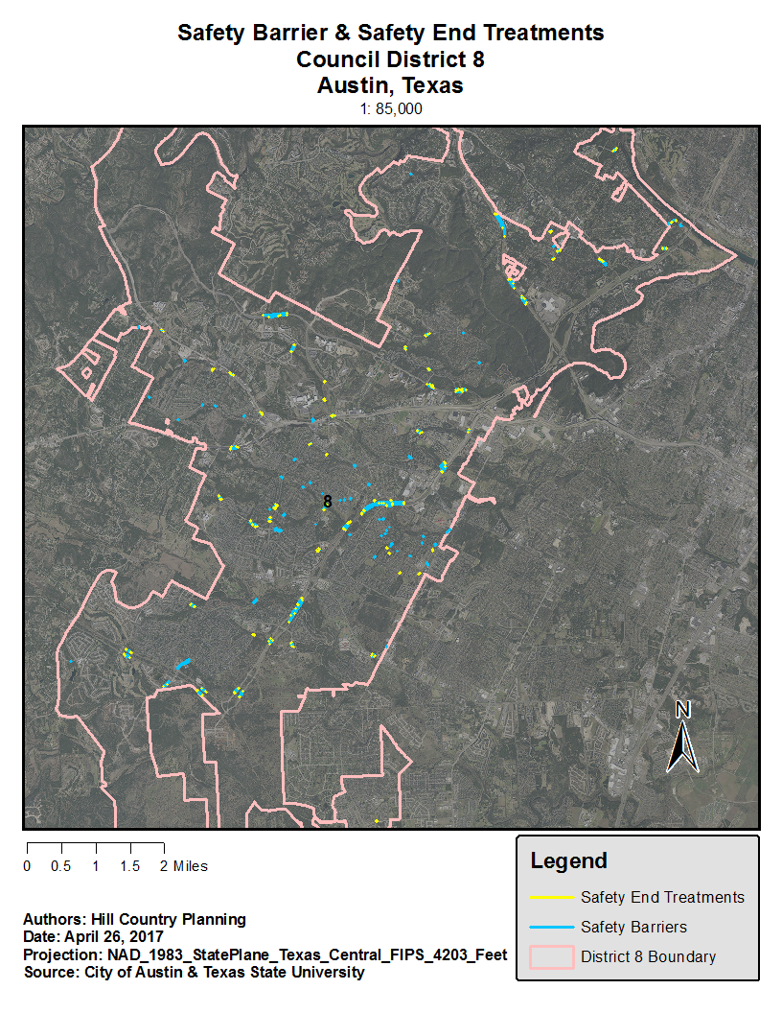
Figure 1. Map depicting the study area, with the digitized safety barriers and safety end treatments.

2. DATA
The majority of data obtained for use during the projected was provided by the City of Austin with the exception of Google Street View. The data sets provided include:
- City Council Districts – The extent of the project was restricted to council district 8, the southwest district of Austin. The vector data was used determine the scope of the project area. Before any data management or analysis began, a clip tool was used on the aerial imagery, stream crossings and previously digitized barriers to ensure work was completely within council district 8.
- Stream crossings – Stream crossings provided covered all districts of Austin, however when clipped, 162 stream crossings were located within district 8 to be included in analysis. Due to the data being provided by the client, it is unknown what processes were used to create the crossings but it is possible that streams were previously mapped already. A new layer could be created from selections of intersections between roads and streams.
- Aerial imagery – 12 inch aerials were taken in 2015 covered the CAPCOG area and were clipped to district 8. The resolution of the images was clear enough to create new line features on top of the barriers. Resolution is not clear enough to determine the types of attributes associated with the barrier such as material, barrier type and set end treatment.
- Previously digitized barriers – About 15% of stream crossings had previously digitized barriers by the City of Austin. Barriers already digitized within council district 8 were reviewed and altered if needed.
- Safety Barrier and Safety End Treatment Guide – A word document provided by the client contained images with descriptions to allow the group to identify the types of barriers needed. Types of materials defined were metal and wood, wood, concrete and metal, metal and concrete. Many barrier types were listed, however not all barrier types were used in the digitization.
- Google Street View – Street view was used as reference alongside aerial imagery to accurately digitize barriers correctly. Links were provided to barriers for quick viewing of barriers up close. Occasionally line of sight is broken by passing cars, vegetation or small bugs that prevent viewing of certain features. In these cases, the rewind tool often solved issues by showing new angles and reversing vegetation growth.
Barriers and safety end treatments were created using the create line feature tool. The lines were created on top of the aerial imagery photos. Attributes of the barriers such as material and barrier type were determined using Google Street View. Google Street View images of each barrier are also provided through URL’s that are listed in the attributes. Anything of note relating to the barriers such as damage or barriers covered in foliage are mentioned in the comments for each feature.
A total of 290 barriers and 218 safety end treatments were digitized in the final product.
- 141 barriers are made of metal and wood.
- 56 barriers are made of concrete.
- 55 barriers are made of metal.
- 34 barriers are made of concrete and metal.
- 4 barriers are made of wood.

3. METHODOLOGY
Hill Country Planning was presented with data already created by the City of Austin to further assist us on how the output of digitization will look like. Digitization was done through using Esri’s software ArcMap 10.4.1 and reference for the area was done with Google Map’s street view. Our job was to make the best judgment to sort whether a safety barrier’s material was concrete, metal, wood, or their other combinations. While using the Google’s street view we identified where and what Safety End Treatment (SET) to be added at the ends of the safety barrier.
3.1 DATA PREPARATION
After the contents of our client’s data was successfully transferred over. The roughly 160 stream crossings fell into District 8 were divided to about 32 crossings each to work on. The City of Austin already partially digitized different areas and this helped us with retain the fields created by our client. These domains contained the barrier’s material and helped us identify whether it was a safety end treatment or safety barrier. The next field we needed to create and fill was the URL_1, URL_2, and URL_3. We will come back to the importance of these fields in our report. The remainder of the fields were open to option such as modified or created by text field. The stream crossings became a point placed on the map to help us find the same area on Google Maps.
3.2 DIGITIZATION
Our client’s focus was the digitized safety barrier of District 8. To make this possible and legible to our clients, they asked us to use ArcMap 10.x. All members in Hill Country Planning have extensively used this mapping platform for previous projects and were ready for our task. Our client wanted for the digitized barriers to be accurate and mirror the correct length and size. If a long safety barrier breaks by any means, such as an entrance to resident, that barrier should be split as well. Safety end treatments will be defined and digitized along the ends of the barriers if applicable. Our client asked us to make a line segment starting from the safety barrier to the opposite side of the road.
The digitization process was executed by making an editing session and creating a feature. Safety barriers are typically straight running along the side of the different types of roads and the curve of the barrier can still be created by using small straight lines. Segments all connect each other and can finish the sketch from the editing sessions thus creating a feature of the layer. There have been a few assigned stream crossings that had no safety barrier, these were compiled in an excel sheet with the problem, the object ID number, the DEM coordinate, and brief notes. Digitization was a success for all group members and all 64 stream crossings were digitized and sorted accordingly.
3.3 ESTABLISHING AND ACCESSING DATA
Now we need to fill in the fields to define what the safety barrier is. There is a designated barrier type field in the attribute data where we will classify the safety end treatment or the safety barrier. The difference of barriers had a dash on it followed by its distinction from which you chose in the type of safety barrier. In the same field, there were uncategorized safety end treatments and one safety barrier called guard railing. Guard railing is the most common type of safety barrier due to its durability and low cost.
The next field to fill is to determine what is the safety barrier’s material. The domain already created helped us define the materials. For example, if it were a guard railing as seen in Figure 2, we would change the drop-down box from <Null> to METAL_AND_WOOD.
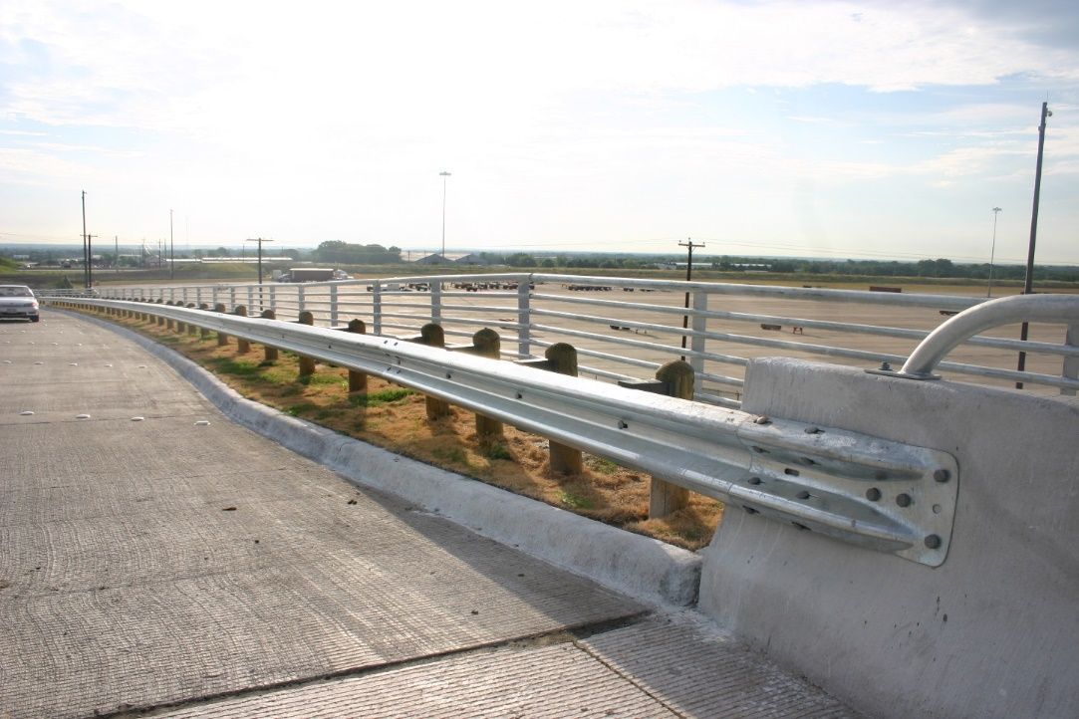
Figure 2. Guard railing connected to a Jersey barrier.
There have been cases where we need to make special consideration as well of the barriers so we created a Notes field to write out anything odd about the barrier, damage, or covering brush.
The last objective to finish the barrier or end treatment feature is to fill in the URL field. This was a pictorial reference through Google Maps and the URL address was copied to the text field in the map document. Three fields were created and able to hold the large amount of characters that make up a URL street view address. It was mandatory that we have at least one photo for each barrier and end treatment. The field is complete when we find the best picture to represent the barrier and then when the barrier is identified it will show the URL field and website and easily accessible when clicked will open automatically to your default browser. Everything that we populated will show up and can be referenced for our client’s maintenance program such as ­­Figure 3.
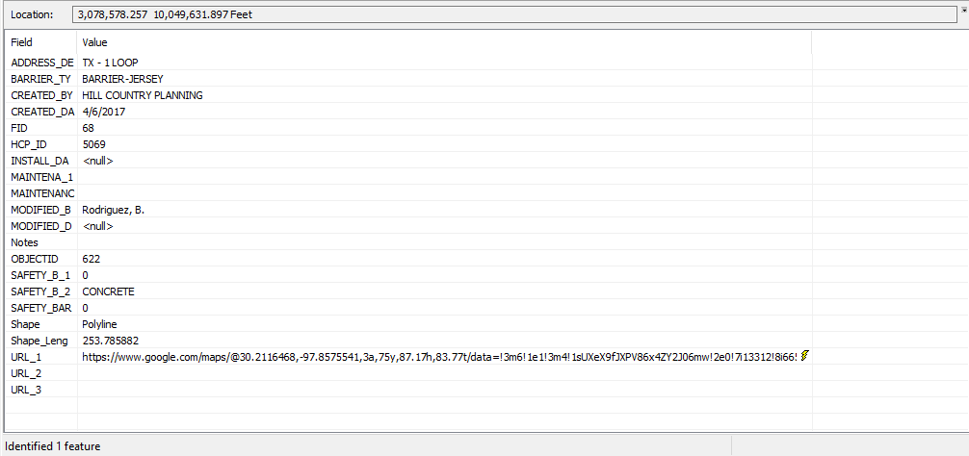
Figure 3. Using the Identify tool in ArcMap 10.4.1 to view the barrier’s attributes.

3.4 MERGE
We needed to join our own feature classes together once we were finished. Our group had concerns how to bring our data together without stepping on other’s work. We created our own object identification number field by our last and sorted by the thousands. For example, the first group member started with 0 to 999, the next member 1000 to 1999, etc. This was done in case when we joined our data it wouldn’t overlap and delete some created barriers because of the automatically Object ID number created once digitized. We tried to spatially join our data, but it would not show everyone’s data only the original data. Instead we used the Merge tool that ArcMap has available. This forced our individual feature classes to come together as one feature class for our deliverables. The outcome was positive and no data was lost thanks to the tool. Our primary objective was a success and if there were a larger time frame, we would be able to finish the rest of Austin’s districts.

4. RESULTS AND DISCUSSION

4.1 SAFETY BARRIER ANALYSIS
As we worked on the process of digitization, we discovered that there were actually several stream crossings that did not have any safety barrier at all. Instead, a small concrete inlet below the street had been created which would suffice given that most of such crossings existed in residential neighborhoods. This was also the case at crossings which were described as being a part of a floodplain rather than an actual stream crossing. Even the stream crossings in neighborhoods which did have safety barriers generally did not have much more than a simple short and metal railing, with no safety end treatment.
On the other hand, stream crossings on major highways, such as Highway 71 and Capital of Texas Highway, generally had metal and wood guardrails which were much longer in length overall, and included distinct safety end treatments (SETs). Most of these SETs seemed to be of either the highway class or turn-down type, although all of them existed in some configuration.

4.2 DATA QUERY
Our clients asked us to find out which barriers, out of those we digitized, were made of metal and wood, and where they are located in Council District 8. Our analysis of the safety barriers digitized showed that 53 safety barriers in Council District 8 were made of metal and wood, all of which are of the "Guardrailing" type of barrier.

Table 1: Location and number of safety barriers made of metal and wood
Street | No. of barriers
Mopac Expressway | 14
Davis Ln | 4
Latta Dr | 4
US Highway 71 | 3
Escarpment Blvd | 3
South Capital of Texas Highway | 3
Convict Hill | 3
Republic of Texas Boulevard | 2
Stratford Dr | 2
Mauai Dr | 2
La Cresada | 2
Beckett Rd | 2
Buena Suerte Dr | 2
Highway 290 | 1
Ridge Oak Rd | 1
Silvermine Dr | 1
Sanderling Trail | 1
Walsh Tarlton Lane | 1
Chatelaine Dr | 1
Rollingwood Dr | 1
Redbud Trail | 1
La Naranja | 1

In addition to using Google Earth imagery to find and digitize safety barriers where present, we discovered that out of the 164 stream crossings provided, 58 (or 35%) actually did not have any visible safety barrier present. For these stream crossings, we updated the Notes section of the Stream Crossings Data Attribute table accordingly to note this for our clients. (“No safety barrier present”).
4.3 LIMITATIONS
The main limitation Hill Country Planning encountered was not having enough time to complete everything we wanted to. Because we only had a few months to work with, in which time we also needed to write various deliverables and put together presentations for our clients (including a request for proposal and progress report), we did not actually get around to our secondary objectives of traffic analysis and hotspot correlation.

In addition, the process of compiling our final data file containing all digitized barriers was complicated and delayed by a number of unforeseen problems involving organization of the data such that each person could work on the digitization individually. Although our clients initially downloaded the data to our X:\ drive, we quickly discovered that we could not all work together off of said drive – ArcMap would show an error message "Cannot start editing" if more than one person had the file open at the same time. We were able to fix this problem by splitting the stream crossings into five separate layers, one for each person, and copying that data to each person's individual N:\ drive.

After all of the 164 stream crossings had digitized safety barriers (or were, in some cases, marked as not containing any form of safety barrier in the Notes field), we had some issues combining each person's digitized safety barrier data into one final ArcMap file. We had to create an ID field based on each person using a 4-digit number for each barrier (1001, 1002, 1003, etc. for one person, 2001, 2002, 2003... for the second, and so forth) in order to successfully combine the safety barrier layers Attribute tables based on a Join. Once we figured this out we were very limited on time to write our final report, let alone download data of traffic accidents in Austin and make additional analysis on any possible correlations with safety barrier types and accident frequency.

5. CONCLUSION
By digitizing safety barriers in Council District 8, the Public Works Department of the City of Austin can respond to maintenance issues with traffic accidents, damaged barriers, and locate places for new safety barriers to be placed in a faster and efficient manner. This will lead to a better rapport with the citizens in this area, increasing positive relations with local government. Hill Country Planning worked closely with our two contacts in order to deliver a project that could be used as a template to further digitize the rest of the city’s assets.
While there was no opportunity for field work to gather data, this project allowed our group to gain experience with the digitization process. Editing vector data is something that must be done in the workforce, we were able to figure out simple little kinks, such as how to draw straight/perpendicular lines, add proper fields, and edit domains. Initially, there was some concern about how to join all of our individual data together without compromising any information. We were able to just join all of our data using the join tool, and we used a field that was created for that express purpose, since we learned the object_id field is unreliable.
There is a considerable amount of opportunities for our project to be applied to different aspects of GIS usage. Most notably, other local municipalities can begin digitizing their assets in able to market themselves as eco-friendly, and to decrease the use of paper. The practice of digitization can also be used as a tool for research in the academic world. A wide range of academic fields can also use this process, such as biology for mapping out a species’ range.

6. REFERENCES
Jean-Louis. M, Mintsa-Eya, C., and Goubel C. 2013. Long-term analysis of the impact of longitudinal barriers on motorway safety. Accident Analysis & Prevention 59:443-451.
John Williams. (2016). GSI Highway Products. [Online Image]. "Highway Guard Rail Products." Retrieved from http://gsihighway.com/images/slide-2.jpg
Juneyoung Park, Mohamed Abdel-Aty, Jaeyoung Lee. Use of empirical and full Bayes before–after approaches to estimate the safety effects of roadside barriers with different crash conditions. Journal of Safety Research 58:31-40.
Mehrtash Soltani, Taher Baghaee Moghaddam, Mohamed Rehan Karim, N.H. Ramli Sulong, Analysis of developed transition road safety barrier systems. Accident Analysis & Prevention 59:240-252.
SGRC. 2016. W-Beam Guardrails. Southern Guard Rail Company. http://www.southernguardrail.com/GalvanizedGuardrails/WBeamGuardrails/tabid/58/Default.aspx. Last accessed 20 February 2017.
Yaotian Zou, Andrew P. Tarko, An insight into the performance of road barriers − redistribution of barrier-relevant crashes. Accident Analysis & Prevention 96:152-161.

7. APPENDIX I: GROUP MEMBER CONTRIBUTIONS
Madeline Covarrubias As the Project Manager for Hill Country Planning, I was in charge of being in direct contact with our clients and our instructors. For each individual stage of the project, I made sure to allocate different sections to each group member. For the proposal, I created the master data table along, as well as wrote the introduction, budget, and final deliverables. In regards to the proposal PowerPoint, I made sure to fill in the slides that corresponded to the sections that I wrote in the Proposal Report. For the progress report, I allocated the different sections equally among the group, and wrote the challenges & concerns, along with the conclusion. Once again, for the PowerPoint, I simply filled in all the sections that I was responsible for. At this point in the project, we began our data analysis, so I digitized all the stream crossings that were appointed to me by Gage. For the final report, presentation, and project map, I was in charge of formatting the deliverables and writing the conclusion.
Joseph Frombaugh designed the three Power Point presentations. For the Project Proposal, he designed the original flow chart, organized the timetable, and worked on the introduction. For our Progress Report, he worked on explaining Task 2 (Data Analysis) in detail. In the final report, he summarized the final results of our project.
Gage Sears designed all the maps, worked on the introduction in the proposal, progress and final report. Gage presented the scope and conclusion in the proposal and progress report presentation and presented the summary, purpose and scope in the final presentation. Gage worked on the methodology and divided up all the stream crossings for the group to work on individually and worked on merging them together with Sam. Gage created the pie charts for data analysis and presentations. Gage digitized 178 new features of safety barriers and SETs from his 32 stream crossings.
Billy Rodriguez Wrote methodology, a third of the introduction, contributed to original flow chart graphically, helped contribute with Literature Review, and created Hill Country Planning Logo all in the Project Proposal. Wrote and presented the methodology in the Project Proposal Presentation. Wrote purpose and scope in the Progress Report. Presented the purpose and scope for the Progress Report Presentation, but did not write it. Wrote the Methodology section for the Project Poster. And all sections in the Methodology in the Final Report and Final Presentation. Contributed to the Final Report's number guard rails section 4.2. Digitized 32 stream crossing and created 121 safety barriers and safety end treatments.
Samuel Delafuente Contributed to the introduction in the proposal, as well as conducted the literature review. Filled in and presented part of the proposal introduction and literature review. Contributed to the progress report by writing about task 1, and presenting task 1, challenges & concerns, as well as the conclusion. For the final report, wrote about the data used for the project, as well as designed the final poster for display.

8. APPENDIX II: METADATA
Table 2. A table describing all of the metadata used for this project.
File Name | Description
AustinAerialMetadata.pdf | Metadata description of the aerial imagery for Austin, Texas.
CouncilDistrict8Metadata.pdf | Metadata description of the council district 8 for Austin, Texas.
SafetyBarriersDistrict8Metadata.pdf | Metadata description of digitized safety barriers for Austin, Texas.
StreamCrossingsMetadata.pdf | Metadata description of the provided stream crossings for council district 8 of Austin, Texas.

