G.O.A.T.
Geographers of Austin Texas

Group Members
Elizabeth Garcia - Project Manager
Max Higgins - Assistant Manager
George Sanchez - GIS Analyst
Jacqueline Lara- Environmental Consultant
Austin Holman- Chief Technology Officer (CTO)

Filing Date
February 24th

Risk-Based Prioritization for Investigating Illicit Discharges

Prepared by Geographers of Austin Texas

Table of Contents
Cover Page…………………...I
Title Page………………….....II
Table of contents………….. III
Introduction
Summary……………..1
Purpose…………...….1
Scope….……………...1
Literature Review……….…2-3
Proposal
Data…………………..4
Methodology...…….5-6
Implications.…….……7
Budget….…………….8
Timetable.…...….…....9
Final Deliverables.....10
Conclusion……….....11
Reference………......12
Participation………....…..…13

INTRODUCTION

Summary
The City of San Marcos is a growing community and trying to expand. The 2010 Census data classified this location as an urbanized area. As it expands, concerns for illicit discharges are becoming greater. The Texas Department of Transportation is in charge of maintaining and reporting on illicit discharges in their Right of Ways. This semester TxDOT will be working with Geographers of Austin Texas to develop a new Risk Based Prioritization for Investigating Illicit Discharges. We will examine outfall locations and Identify potential pollution outliers, as to reduce pollution along the ROW in the new Urbanized San Marcos.

Purpose
This study will analyze the flow of illicit discharge to the ROW in San Marcos, indicated by MS4 to best manage pollution. Priority locations include areas with the highest susceptibility to pollution from the expansion and maintenances of the city, like the Edwards Aquifer Recharge Zone and Spring Lake. By using San Marcos GIS data, as well as the 2010 census data, we can evaluate areas of high traffic and automotive inlets such as gas stations and car washes. We might use slope data to analyze the flow direction of pollutants or areas of illicit discharges along the ROW in San Marcos. Reason being to better identify and define the parameters and specifics of more spatial data at a later date.

Scope
The study area will cover the entirety of old and new San Marcos urban area - specifically the ROW along the San Marcos streets and highways. Our client Adrienne Boer has stated that Illicit discharges along ROW in San Marcos will focus around city streets and highways, where outfalls (identified by MS4 data) are located. All processes and deliverables will be executed during the spring 2017 semester, January 2017 - April 2017, with the final submitted by the 26th of April by 4:00pm.

LITERATURE REVIEW

The project focuses on TxDOTs outfall locations, and how runoff from illicit discharge can leak into the outfalls and potentially harm our environment and surroundings. As review material our group chose articles from various organizations, educational facilities, and environmental agencies. Much of our review material is information on Municipal Separate Storm Sewer Systems (MS4’s) and how they are related to the outfall locations and illicit discharge areas.
One of the article reviews was over the Indiana Department of Transportation (INDOT) and their goal to limit potential pollutants to the Highway system and ROW. While choosing acceptable locations and monitoring criteria we noticed similarities in most articles reviewed. Highlighted topics included sensitive water locations, how to protect and preserve, educating the public over illicit discharges, keeping knowledge of potential pollutants, and programs for water quality control and clean up (INDOT, 2003). Although we had similarities, INDOT focused on protection and preservation instead of a methodology on which outlets to prioritize (IDOT, 2003).
Washington’s Department of Transportation (WSDOT) conducted the same project in the highways located in Snohomish, King, Pierce, Clark, and Spokane counties as well as cities of Seattle and Tacoma (Schaftlein, 1995). Their project inventory included identifying storm water sources and impact to develop a pollution prevention plan of illicit discharge connections in the WSDOT drainage system. By sampling outfalls with water quality and quantity suspicions they found most illicit connections in urbanized communities of commercial or residential areas (Schaftlein, 2015). This information does not give us a detailed list of methodology but it helps us prioritize our zoning.
For this project we would need to find locations where illicit discharge would most likely occur. Illicit Discharge Detection and Elimination: A Guidance Manual for Program Development and Technical Assessments, was written to help identify land uses and the impacts they can have on local water quality (Brown, Caraco, 2004).
To identify these potentially harmful industries, a three phase approach is suggested to find the maximum amount of information on these generating sites within outfalls. The first phase consists of consulting publically available databases. The Federal Government and Environmental Protection Agency both operate databases that contain historic locations of facilities and their potential for discharge. They also have databases containing Toxic Release Inventory facilities, as well as regulated facilities that may affect water anywhere in the United States. The second phase is to consult state and local agencies. Most states have programs that track permits industries acquire to gain access to storm drains. The final phase is reviewing local permits. Most permit databases have SIC codes that can be matched and traced to different facilities. Using these three phases, we can locate generating sites and determine if the discharge they emit is either illicit or authorized (Bender,2016). Although toxic release inventory facilities are facilities that should be monitored, the areas in San Marcos such as the waste facility are not close enough to the ROWs we are studying.
Focusing on cost aspect of the project and keeping it as low as possible really focuses on the priorities. In the article on IDDE done in Buffalo, NY from Buffalo State, zones in on keeping cost options low. There are 6 minimum control measurements (MCMs) the MS4s must include in their programs. Based on the New York State’s IDDE regulations, it suggests “Pitt’s (2004) illicit discharge Detection and Elimination: A Guidance Manual for Program Development and Technical Assessment” and its Outfall Reconnaissance Inventory tool for classification of outfalls. Our project with TXDOT, however suggest us to use the MS4 permit guide from the Environmental Protection Agency. Unlike the New York State program who had to map and geocode the 5000 outfalls, our outfalls have already been mapped out and geocoded. Similarly, they will be observed after a 72-hour dry period for analysis. This article’s methodology included protocol for the New York state. Since we are following the EPA MS4, this study was a bit too different for what we need.
As part of the Rouge Project, Wayne County in Michigan conducted a study that studied illicit connections and discharges that emptied out of the outfalls (Barry, 1998). They created a prioritization method that first eliminated businesses on combined sewer systems and next focused on previous areas of pollution. They then took into consideration land use and businesses were placed higher than non-commercial land use. Of the business land use, automobile related facilities were prioritized. When they completed their testing they noted that almost half of their illicit discharge was coming from floor drains. This was one of the closest studies to ours. It helped us prioritize zoning areas but it would not help with the analysis that we are performing (Johnson, 1998).

DATA

Data acquired to complete analysis
We will not need to go out and collect any field data for our project, we will collect available data from the San Marcos GIS Website. We also have previously acquired data given to us by our client.

Data sources
We will obtain it from the City San Marcos GIS data website, and our clients previously collected data. We did not collect it ourselves.

Source for each data layer
City limit and ETJ/ San Marcos GIS Website
City streets/ San Marcos GIS Website
Neighborhoods and sectors/ San Marcos GIS Website
Floodplain/ San Marcos GIS Website
Contours - atlas/ San Marcos GIS Website
Zoning - atlas/ San Marcos GIS Website
Outfall Locations/ TxDOT Acquired Data

Software used
We will use ArcGIS Online to produce our maps and data.

METHODOLOGY

What will you do with the data?

We will combine the outfall data given to multiple layers displaying different attributes such as population density, city land use zones, outfalls with historical illicit discharge, Edwards aquifer recharge zone, and distance from outfalls. This will help us determine the risk of illicit discharge for each outfall. We will also use an elevation model to determine where a pollutant may be coming from once it is established that an outfall has illicit discharge.

What processing of the data will be required?

We will take the outfall locations and assess their surrounding areas. We have determined what constitutes as high risk for illicit discharge based on industry and population density. The data will need to be run through an analysis process in the Arc Program.

Programming needed?

There will be little to no programming that we will have to write to complete this project.

What analyses will you undertake?

Our most intensive analysis will be determining what zoning layers will constitute high, medium, and low pollution probability. After we have determined our grading scale for illicit discharge and created zones for each risk level, we will overlay that layer with our outfall layer to label ROWs.

What hypotheses are you testing?

We believe that probability for illicit discharge can be directly correlated to population density, and the distance from the populated areas.

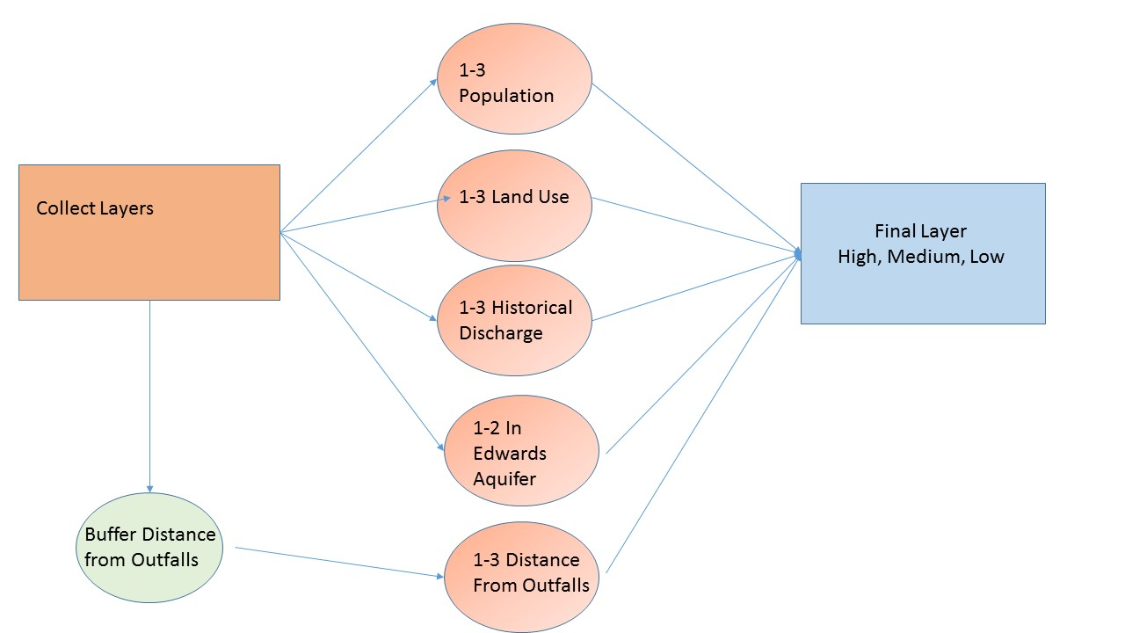
Figure 1 This flow chart shows the simplified step by step methodology of our project.

IMPLICATIONS

By implementing GIS data and research we can provide TxDOT with information regarding illicit discharge in their MS4 boundary. The pollution causing sites can be determined by applying tools like slope to the outfalls in the MS4 data. Further, TxDOT will be able to connect the outfalls to actual locations. If the pollution is caused by non-natural reasons, then TxDOT will be able to better regulate those with and without discharge permits.

Budget

How much would this cost if consultants were actually being paid for the job?

The average salary of a GIS Analyst is about 50 thousand dollars as a starting technician and around 80 for a Manager in the field. The client would only need to cover expenses of the employee and some equipment. Maybe minor expenses for gas or transportation in terms of needing to collect more data. Thirteen-week possible project run time.

Salaries

Project Manager $103,632
Assistant Project Manager $58,875
GIS Analyst $53,701
Environmental Consultant $52,859
Chief Technical Officer $136,579

Salaries expenses through the months of March - May 2017

Project Manager $25,908.00
Assistant Project Manager $14,718.75
GIS Analyst $13,425.25
Environmental Consultant $13,214.75
Chief Technical Officer $34,144.75

Total Salary Cost $101,411.50

Rental Equipment:
Computers: $160 / month per computer
ArcGIS Pro $4,200.00 / yr
Adobe Illustrator $29.99 / month
Office 365 Suite Business Pro $12.50 / month per user (5 users)

Rental Equipment through the months of March - May 2017
Computers $2,400.00
ArcGIS Pro $1,050.00
Adobe Illustrator $89.97
Office 365 Suite Business Pro $187.00

Total Equipment Cost $3,726.97

Timetable

Data Collection, all data provided by client upon RFP. Review of current data, and literature will take about one week to summarize. The amount of data provided and available online allows our team to continue after 2/8. We then move into the processing stage of the data. Our team will divide tasks and begin adding data into an ARC File. This entails us formatting all information and getting ready to start the analysis.

Phase 1 Data: Collection and processing (weeks 3-4)

The first phase will be the first 3-4 weeks primarily focused on collecting RFP and data from TxDOT. Once all data is collected we will be reviewing scholarly articles or literature for background information on our project.

Phase 2: Data analysis (weeks 5-7)

The second phase will consist of any possible revisions to satisfy clients input after the second meeting. The first phase will to add data analysis of the base layer provided by TxDOT. We’ll be creating map layers for possible overlay in ArcGIS desktop to analyze the study area and creating buffer zones for areas of interest.

Phase 3: Further analysis methodology creation (weeks 8 - 12)

In this phase, based on the information analysis, we will create a methodology to assess target fields based on risk level that would elicit an investigation. We will determine a scale for risk and what qualifies for each level (low, med, high). Further analysis of the study is to create a guideline that determines which areas are more prone to different types of illicit discharges. Also after briefing the client on our progression during the third meeting will be implementing any changes deemed necessary.

Phase 4: Map Development (weeks 13 - 14)

The final phase will allow us to create maps to display visuals to aid the methodology. We will provide graphics of the study area and the risk surrounding each outfall producing the final output for the project presentation.

Final Deliverables

What the client receive at the end of the semester:
A Detailed Final Report (2 copies)
Professional Poster for display in the Geography Department
CD (2 copies) containing:
All data
Metadata
Report
Poster
PowerPoint Presentation
GIS Layer with complete prioritized areas (feature class format, attribution, and projected coordinates
Possible extra layers to better understand how and why we used our methodology

CONCLUSION

In this proposal, we highlight the importance of information over outfall locations in San Marcos, Texas as to reduce the illicit discharges’ into the ROW. This is important to the city as to reduce pollution to the surrounding environment which includes endangered species and sensitive water locations. We created this document as a pre- plan to attack illicit discharges along the ROW in Texas. This project is aimed at all ROW in all DOTS system and attempts to create a methodology that can be implemented across the United States. It has references from literature reviews, methodology, implications, budget, timetable, and deliverables.

REFERENCE

Johnson B. 1998. From theory to Implementation-Finding illicit connections.

Bender P.R. 2016. Development of Effective Procedures for Illicit Discharge Risk Mapping.

Brown E., Caraco D., Pitt R. 2004. Illicit Discharge Detection and Elimination: A Guidance Manual for Program Development and Technical Assessment. Center for Watershed Protection.

Johnson B. 1998. From theory to Implementation-Finding illicit connections.

Lien C.Y. 2013. Storm water TMDL Compliance - A Case Study of Implementation Strategies Used in Two Coasts.

Gates, L. (2016). Enhancing MS4 illicit discharge detection & elimination (IDDE) programs. IECA 2016 - International Erosion Control Association's Environmental Connection Conference, (IECA 2016 - International Erosion Control Association's Environmental Connection Conference).

Irvine, K., Rossi, M. C., Vermette, S., Bakert, J., & Kleinfelder, K. 2011. Illicit Discharge Detection and Elimination: Low cost options for source identification and track down in storm water systems. Urban Water Journal, 8(6), 379-396.

Schaftlein S. 2015. Washington State’s Storm water Management Program.

Indiana Department of Transportation. National Pollutant Discharge Elimination System (NPDES) Individual Storm Water Discharge Permit. 2003.
http://docs.lib.purdue.edu/cgi/viewcontent.cgi?article=1615&context=roadschool. Last accessed 20 February 2017.

PARTICIPATION

Max, I worked on the over layout and format of the project, as-well as the reference citation, part of the conclusion, final deliverables, worked on methodology, data, and literature review.

Jacqueline, I worked on finding articles and reports for the literature review, I also read and summarized one of the articles. I partially helped with the reference citation and I worked on the data and methodology.

Elizabeth, I worked on finding and revising articles for the literature review section, helped with logo designing, writing out the implications, parts of the introduction, gave my input to other sections of the proposal, as well as revised and edited grammar, punctuation, and format of the final proposal. I also created the Prezi presentation for our client, and made the extra power point to turn into TRACS.

Austin, I worked on the budget, make charts for the budget, helped create the logo/name, helped with the timetable-line, and helped find and revise articles for the literature review.

George, I worked on the methodology, the current layer information, and created the logo using Photo Shop. I also found and summarized articles for the literature review as well as created the maps that were used for the Prezi/Powerpoint presentation.

