G.O.A.T.
Geographers of Austin Texas

Group Members
Elizabeth Garcia - Project Manager
Max Higgins - Assistant Manager
George Sanchez - GIS Analyst
Jacqueline Lara- Environmental Consultant
Austin Holman- Chief Technology Officer (CTO)

Filing Date
March 27

Risk-Based Prioritization for Investigating Illicit Discharges

Prepared by: Geographers of Austin Texas

INTRODUCTION
Summary
The development of a methodology and analysis investigating illicit discharges in the San Marcos Right of Way (ROW) is advancing well. We have several map options to present that we can focus on once approved.

BACKGROUND
Purpose
This study has begun to analyze the flow of illicit discharge to the ROW in San Marcos, indicated by Municipal Separate Storm Sewage System (MS4) to best manage pollution. The San Marcos MS4 is a conveyance system owned by the state of Texas to control pollution discharges. Priority locations include areas with the highest susceptibility to pollution from the expansion and maintenances of the city, like the Edwards Aquifer Recharge Zone and Spring Lake. By using San Marcos GIS data, as well as the 2010 census data, we have evaluated areas of high traffic and automotive inlets such as gas stations and car washes. We have not used slope data to analyze the flow direction of pollutants as of yet.
Scope
The study area covers the entirety of old and new San Marcos urban area, specifically the ROW along the San Marcos streets and highways. We are still on schedule to have all processes and deliverables completed by the 26th of April by 4:00pm. Figure 1 in the appendix shows a map of the study area. Maps with deeper detail will be provided in the near future.

TASKS
Work Completed
Work completed within the first three weeks included collecting the RFP and data from TxDOT. The TxDOT data composed of the San Marcos MS4 data and outfall locations. We reviewed multiple scholarly articles and journals to gain background information as well as find cost efficient ways to advance the project. We also investigated other illicit discharge projects in other cities around the nation so we know what worked and what did not work for the state’s DOT.
The fourth week consisted of presenting all information collected to Adrienne. The information presented was a summary of what the project was ab
out, what type of data was going to be included in the project, and the scope area that we are focusing on. A run-down of the literature we reviewed was discussed, as well as a list of extra data and software we found would be useful. Next we spoke of the methodology of the project which combined the data given, the processing required, programming needed, the analysis we plan to undertake, and the assumptions we would make for the final report. Lastly, we briefly mentioned the budget and an estimated timetable for the completion of the project.
The following 2 weeks we created maps to categorize the pollution severity of each building in the MS4 boundary. This process included assigning priority to buildings on a scale of 1-3 with 3 being the highest level of priority. We also created buffer zones around the outfalls and ROW (Figure 2) to determine potential levels of illicit discharge.
As of now we have created a map of the Southwest region of the San Marcos urbanized area showing pollution danger in a color scale (Figure 3). We can show a larger area of San Marcos if approved by Adrienne.
Present Work
We are finishing up our prioritization levels for the zoning locations. We are also still working on analyzing our slope layers and creating an elevation model. This would allow us to see where the illicit discharge will end up and help discover where it is coming from. Once we have all of our prioritization completed we will superimpose them so we can account for several variables of pollution.

TIMETABLE
We have completed phases 1 and 2 of our timetable. Dates for phases 3 and 4 are below.

March 27-April 17 Phase 3: Further analysis methodology creation
We will continue creating a methodology to assess target fields based on risk level that would elicit an investigation and categorize them as low, medium, and high. This includes determining which areas are more prone to different types of illicit discharges. We will be implementing any changes our client deems necessary.
April 17- April 26 Phase 4: Map Development
The final phase will allow us to finish creating and editing our maps to display our analysis and methodology. We will provide graphics of the study area and the risk surrounding each outfall producing the final output for the project presentation.

PROBLEMS
There were a few buildings that were not categorized or did not have a subcategory. These buildings were considered ‘other’. This required us to go to google maps to discover what the building actually was. This also required some local knowledge of the neighborhood the building was in. Since there were many buildings that were not categorized we prioritized re-categorizing the larger buildings and left the smaller ones as ‘unknown’.

CONCLUSION
In conclusion, we are well on schedule and our deliverables are close to completing. We will have several options that we have made headway on that will be completed once approved by Adrienne Boer.

APPENDEX

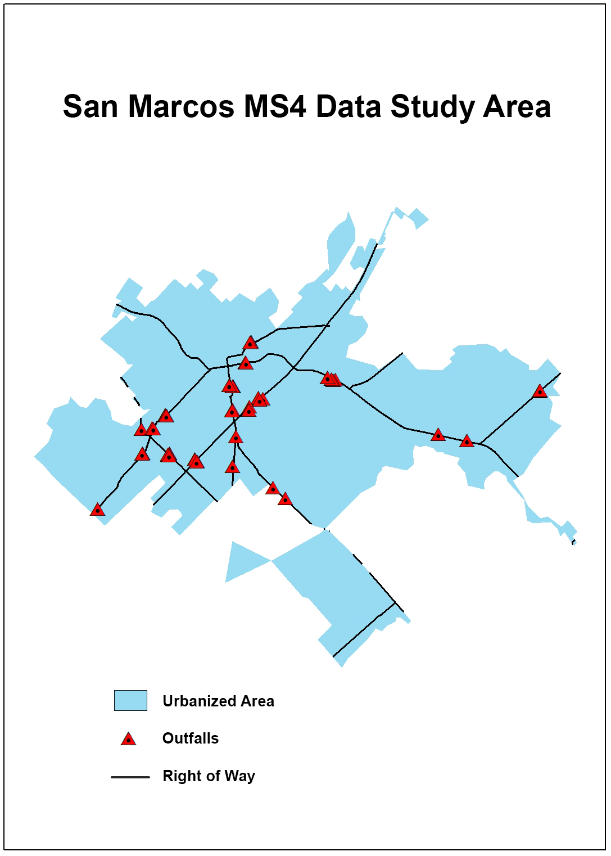
Figure 1 Map of the San Marcos study area: MS4 data, outfall locations, and the ROW.

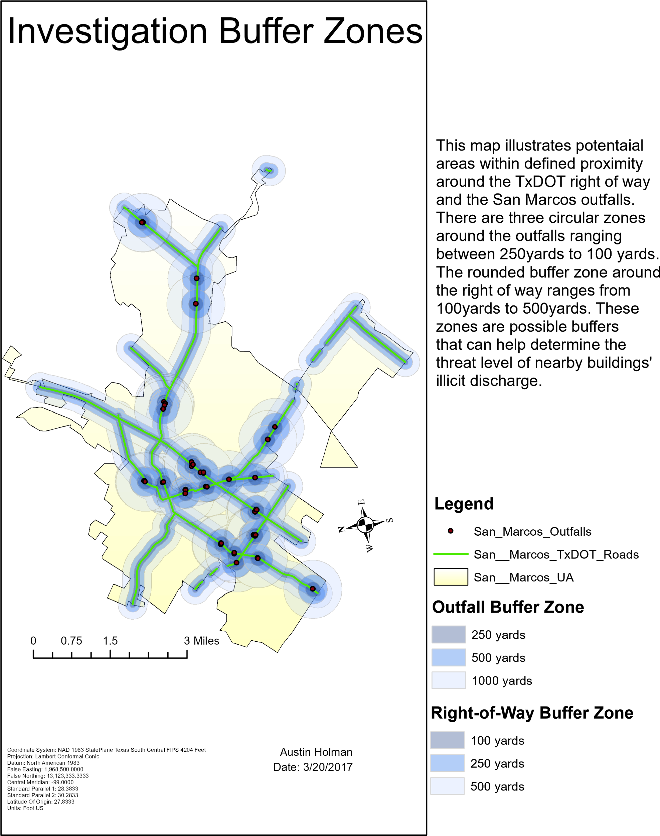
Figure 2 Buffer zones of potential illicit discharge areas around outfall locations.

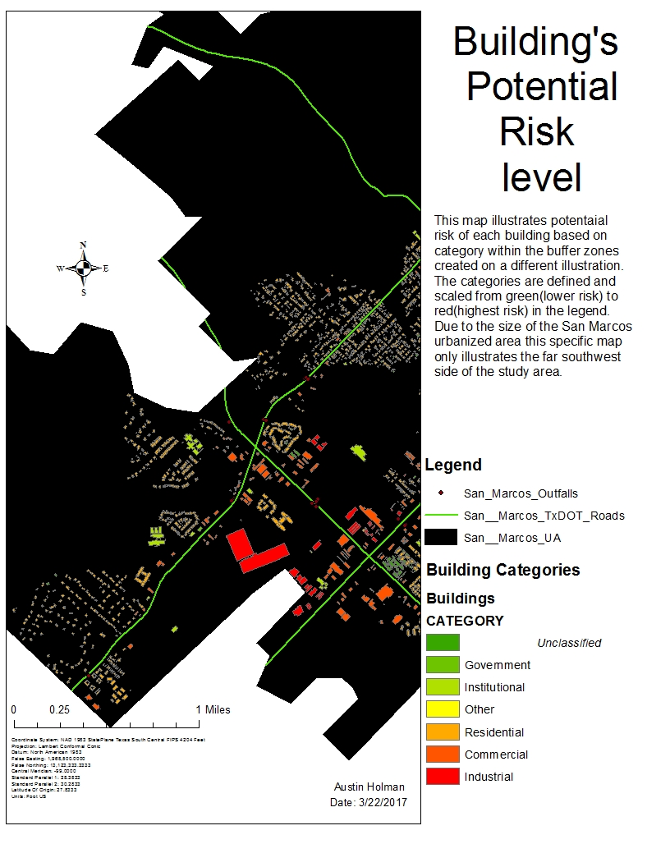
Figure 3 Categorized pollution risk of buildings in the Southwest region of San Marcos.

