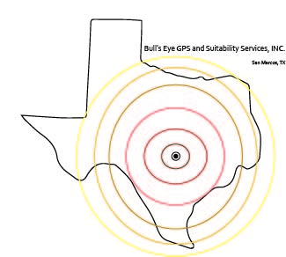

Bull’s Eye GPS and Suitability Services, INC

GPS Inventory and Telecommunication Tower Locational Analysis

Prepared for:
The City of San Marcos

Prepared By:
Molly Coryell, Project Manager
&
Andres Segovia, William van den Boom, John Dayton

Table of Contents

- Introduction ………………………………………………….. 1
- Summary ………………………………………………… 1
- Purpose ………………………………………………… 1
- Scope ………………………………………………… 1
- Literature Review ………………………………………………… 2
- Proposal ………………………………………………… 5
  - Data ………………………………………………… 5
  - Methodology ………………………………………………… 5
  - Budget ………………………………………………… 7
  - Timetable ………………………………………………… 7
  - Final Deliverables ………………………………………… 8
- Conclusions ………………………………………………… 9
- Participation ………………………………………………… 10
- References ………………………………………………… 11

1. Introduction

  - Summary

The San Marcos City Cemetery is a public cemetery that has existed in the City of San Marcos since 1874. Some of the earliest settlers are marked buried since 1876 as well and slaves before then for many years prior. This semester, the City of San Marcos will be working with Bull’s Eye GPS and Suitability Services, INC. in order to create a GPS inventory of the grave sites in Tower Addition section of the cemetery as well as finding a new location for the new telecommunications tower.

  - Purpose

The purpose of this project is to create a GPS inventory of the San Marcos Cemetery, Tower Addition section, and to find a new location for a telecommunications tower within the Cemetery. By creating a GPS inventory using a handheld Trimble unit and digitizing the data, the City of San Marcos will be able to create software for the public to use in which they can locate the grave sites of their loved ones. The new telecommunications tower, which will serve San Marcos as well as other cities in Hays County such as Buda, Kyle, and Wimberley for emergency services, will have improved aesthetics compared to the old one, and create more space that the Community Services Department may use to create more space for gravesites or a structure to hold over 15,000 urns.

  - Scope

The study area will cover the west boundary of the San Marcos City Cemetery also known as the Tower Addition section. The cemetery is located off of Old Ranch Road 12 across the street from the Blanco parking garage on the Texas State University campus. All processes and deliverables will be executed during the Spring of 2017 semester, February 2017 - May 2017, with the final recommendations for the study being submitted no later than May 1st, 2017.
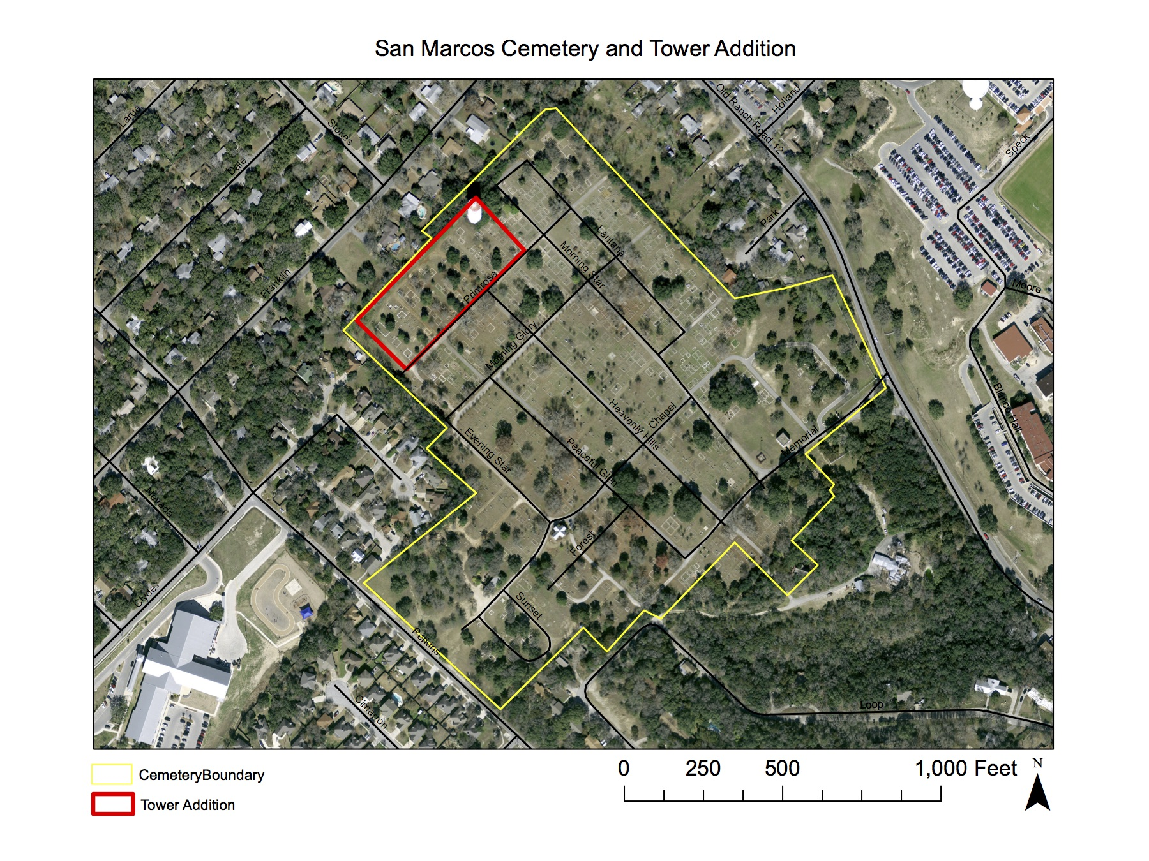
Figure 1 San Marcos Cemetery and Tower Addition

- Literature Review

The primary focus of this study is to find a more ideal location for the telecommunications tower in the Tower Addition of the San Marcos City Cemetery. Components to consider when relocating the telecommunications tower within the Tower Addition is the fall space of the tower and the path loss of the towers signal. The secondary focus of this project is to map the layout of the grave blocks in the Tower Addition, while keeping in mind the factors affecting the layout of this portion of the cemetery. These factors would include the history of the cemetery and any laws that pertain to the layout of the cemetery.
The Tower Addition of the San Marcos City Cemetery currently has the telecommunication tower on top of the water tower, the city of San Marcos is looking to relocate this tower to another location in this section, as they will be tearing down the no longer operational water tower. This telecommunication tower is of big importance as it is responsible for helping the emergency response teams of the cities of Buda, Kyle, San Marcos, and Wimberley. Without the proper installation of this tower these cities will have great difficulty responding to the emergencies that occur on a daily basis. To have a proper installation the tower, which is of monopole construction with no guy wires it must be located in an area where the fall space is around 130 feet, meaning that it will not land on any residential homes. Another key component for a proper installation will take in consideration of the signal path loss of the telecommunications tower. Factors that may affect the path loss of the telecommunications tower would include the terrain, buildings or vegetation, and diffraction losses. The terrain of the San Marcos City Cemetery can affect the path loss if the telecommunications tower is located in a low lying area which may allow areas of higher elevation to obstruct the path of the signal. Vegetation and buildings also play a role in the path loss due to buildings being able to reflect as well as absorb the radio signals. The vegetation around the tower will also need to be significantly below the antenna due to the attenuation of the radio signals it can have especially when wet. Diffraction losses can occur if an object appears in the path of the signal causing it to diffract around the object and even possibly lose the signal. The more rounded the object is the greater the chance the signal can be lost, radio signals diffract better around sharp edged objects.
The San Marcos City Cemetery is a 45 acre plot located off of Ranch Road 12 and was founded in 1874. The cemetery was originally part of a Mexican land grant that was acquired by Thomas J. Chambers in 1834. After his death his wife sold 3,000 acres in 1867 which included this site to H.N. Duble at an estate sale and a portion of the cemetery was later purchased by Freedman Peter Roberts. Stories suggest that slaves of the earliest settlers in this area were buried prior to the cemetery’s first recorded burial of Major C. Rogers in 1876. In 1876 the San Marcos Cemetery Association was organized and later that year the association purchased 10 acres from Judy Covington Dixon. Acquired through land acquisitions the cemetery acreage had increased to more than 20 acres by 1924 and in that same year the city of San Marcos acquired the cemetery. By the year of 1964 private citizens set up a perpetual care trust fund in order to help maintain the necessary care of individual lots and graves such as the maintenance and repair of these grave sites. This cemetery has many pioneer settlers, War of 1812 veterans, and veterans of other conflicts from the Texas Revolution to the Vietnam War.
This project's final outcome is to help provide a digitalization of the tower section of the City of San Marcos Cemetery to the city of San Marcos in order to help them create a digital map of the property that is similar to the Palm Cemetery's digital map in the City of Winter Park, Florida that is run by Pontem Software. Pontem software was founded in 1979 and provides flexible, full feature software for their clients and also pairs up with other companies to help provide the needs for their clients unique and ever changing needs. The company first started working with cemetery records in 1985 and by the mid 90’s introduced the first version to Windows that included image and document management as well as integrated mapping of cemeteries. The initial goal of this software in Pontem was to help cemeteries protect their records from loss from fire or floods, but now with advanced technologies including the integration of GIS mapping the company's clients are looking to leverage the data that is stored in order to serve not only them, but their communities as well in new ways. Some of these new developments are providing real time publishing of the data to online services, online burial search allowing families to locate their loved ones on up to date interactive maps, and also allowing them to see available properties near those loved ones.

- Data/Methodology

The data that will be collected will include the grave site sections that vary from 4-8 sections in a grid, new potential telecommunications tower locations, as well as possible fall out areas for the old tower to be knocked down, and tree canopies that are going to be in the study area. This is the data that will be acquired in order to incorporate it into the pontem cemetery software. Since there is already a geodatabase at our disposal from the prior group from last semester, we should just be having to do the final touches on the copying of polygons and GPS measurements to finish our part of the project.
This data is going to be obtained using a Trimble handheld GPS issued by Texas State University. The data for the project is going to be collected on site by the members of our group using the GPS. Then we are going to refer to the data given for us to use by the clients to copy and paste the rest of the sections in our study area in order to identify each grave site in our Tower addition section. The tree canopies and tower data will be collected on site by the members of our group as well as a few grave sections that require special methodology in the event of the GPS data being corrupted. The software we are using will be ArcMap 10.4.1
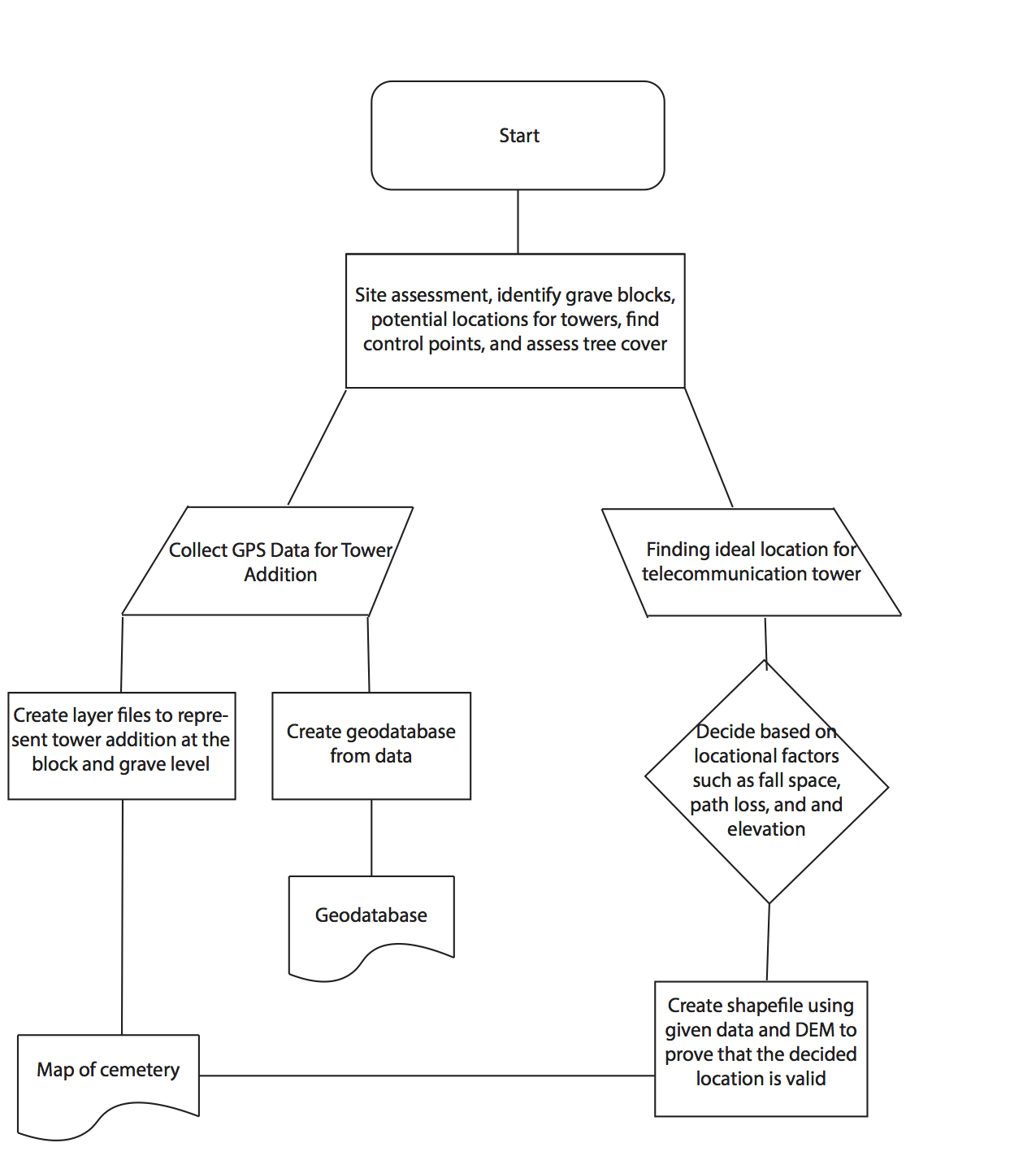
Figure 2 Flow chart of methodology

- Budget and timeline

4.1 Budget
SERVICES  GIS MANAGER: 1 manager  Hours: roughly 4-5 hours a week over a span of 11 weeks.  Hourly rate: $36/hr.  Subtotal: $1800  GIS ANALYST: 3 analysts  Hours: roughly 4-5 hours a week over a span of 11 weeks.  Hourly rate: $24/hr.  Subtotal: 1200 x 3 = 3600  SUB-SERVICES TOTAL: $5400  TOTAL COST: 12,612.43 | SUPPLIES AND SOFTWARE  ESRI ARC Catalog 10.4.1  Hours used: 2-3 hours a week for 11 weeks.  Hourly rate for subscription: $5.71  Subtotal: $188.43  TRANSPORTATION  4-mile roundtrip to graveyard.  Roughly 5-10 trips over a 11-week period.  60 cents per mile  Subtotal: $24 dollars on gasoline.  GPS DEVICE TRIMBLE  $7000  SUPPLIES AND SOFTWARE SUBTOTAL: $7212.43  Figure 3 Budget pie chart

4.2 Timeline
Phase 1: Receive project assignment, meet clients from the City of San Marcos, site assessment of the San Marcos Cemetery, review data and documents given to us, create a proposal

Phase 2: Begin digitizing the Tower Addition at the block and grave level, creating an accurate and correctly formatted attribute table, finding the best location for the new telecommunications tower
Phase 3: Begin creating our final report including deliverables and a presentation of our work by May 1st, 2017

 | Week 1 | Week 2 | Week 3 | Week 4 | Week 5 | Week 6 | Week 7 | Week 8 | Week 9 | Week 10 | Week 11
Phase 1
Phase 2
Phase 3
Table 1 Timetable

- Final Deliverables

By the end of the project, our client will be receiving:
- A detailed final report
- A professional poster which will include a map of the Tower Addition section marked at the block/grave level and a map showing the best location for the new telecommunications tower.
- CD [2 copies: one for Dr. Yuan and the second for the City of San Marcos] containing:
    - All data, Metadata, the final report, a professional poster, and the PowerPoint presentation.

- Conclusions

This project is very important to the citizens of San Marcos and people in the surrounding areas. People have been being buried at this gravesite for over a 150 years and there’s high demand currently to digitize the cemetery to bring it into the 21st century. This will be beneficial for family members wishing to find and locate their family members gravesites. We also hope to give them good advice in selecting a location for a telecommunications tower through our studies. It is very important to us as well as to the citizens of San Marcos as well as first responders that we see these things done thoroughly and properly.

- Participation

  - John Dayton - Budget, data/methodology, conclusions
  - Will van den Boom - Scope, literature review, references
  - Andres Segovia - Summary, purpose
  - Molly Coryell - Graphics, maps, logo, editing, formatting, final deliverables, timeline, touch-ups on: data/methodology, purpose, conclusions

- References

  - http://www.celltowerinfo.com/site-selection/
  - http://texascemeteries.org/hays/san-marcos-cemetery
  - http://www.ci.san-marcos.tx.us/index.aspx?page=222
  - https://support.pontem.com/hc/en-us/articles/214157043-Taking-Technology-to-the-Next-Level-Pontem-featured-In-American-Cemetery-And-Cremation-Magazine-July-2016

