Progress Report:
Five Mile Dam Soccer Complex

March 30th, 2015

Created By:
Matt Riggan, Danny Cohen, Sam Boesch
Introduction:
Summary:
Our team here at G.R.A.M. has spent previous weeks utilizing our GIS knowledge to come together to create a flexible and versatile method in order to present the City of San Marcos with a digital database that can be used to maintain the Five Mile Dam Soccer Complex. This will efficiently save the parks and recreation department time and money in the years to come. In this progress report contains the purpose and scope of our project, as well as the tasks timeline, problems, and concerns that we have endured thus far.
Purpose:
We hope that our time and efforts put into the project planning, data collection, data analysis, construction of the final product in ArcMap, and final adjustments and corrections will allow the department to handle more tasks in the most efficient way possible. In order for us to complete these tasks the data must first be collected in the field with a tremble unit that ensures excellent accuracy of every recorded amenity within the soccer complex.
Scope:
After speaking with the our employers, we have concluded that our initial idea of what we believed to be the scope of the project was very close to what we will use in our Final product, but with a few minor adjustments. We now realize that the bulk of the information desired for this project will be the irrigation system layout at the complex, and while we have acquired the data and geospatial locations of the many other amenities, the main focus of our scope will be largely focused on presenting a clear organized layout of the many soccer fields that contain valve boxes, sprinkler heads, and control boxes that make up the irrigation system. The Scope of the project will remain in the area of the complex that is located inside of the jogger’s trial that surrounds the soccer fields and the irrigation system.
Tasks:
Completed:
Our team has completed a sufficient amount of the tasks that we were assigned including determining a method and a plan to complete the project, and going out in the field and documenting any amenities relative to the project. Most importantly, we have accomplished perhaps the most time demanding task of the entire project which is the data collection process. We have successfully recorded accurate points of soccer fields, garbage cans, many valve boxes, recycling bins, sidewalks, and many other amenities within the study area. With the data we have collected we are now able to provide a rough map of the amenities of the Complex, but this obviously will need to be improved before completion.
Current:
Currently we are concentrating on converting all of our collected data to ArcMap with as much accuracy as possible. We are working to differentially correct all points to avoid any shifts in recorded GPS points. This process compares the date that all of our points were corrected to how much the satellites were off for that given day. This insures that all of our points will not be off a few more inches.

Remaining:
The remaining tasks include collecting remaining GPS points for the irrigation system, creating a hierarchy of the diameter of the irrigation pipes, analysis all of all final data, composing a final map in Arc, and finally putting the finishing touches on any and all of the final deliverables to ensure that they are ready for our client. We hope that we face minimal unplanned obstacles so that we can have as much time to review, correct, and adjust the final product as much as possible to ensure that it is in its optimal state and ready for use.
Current Timeline:
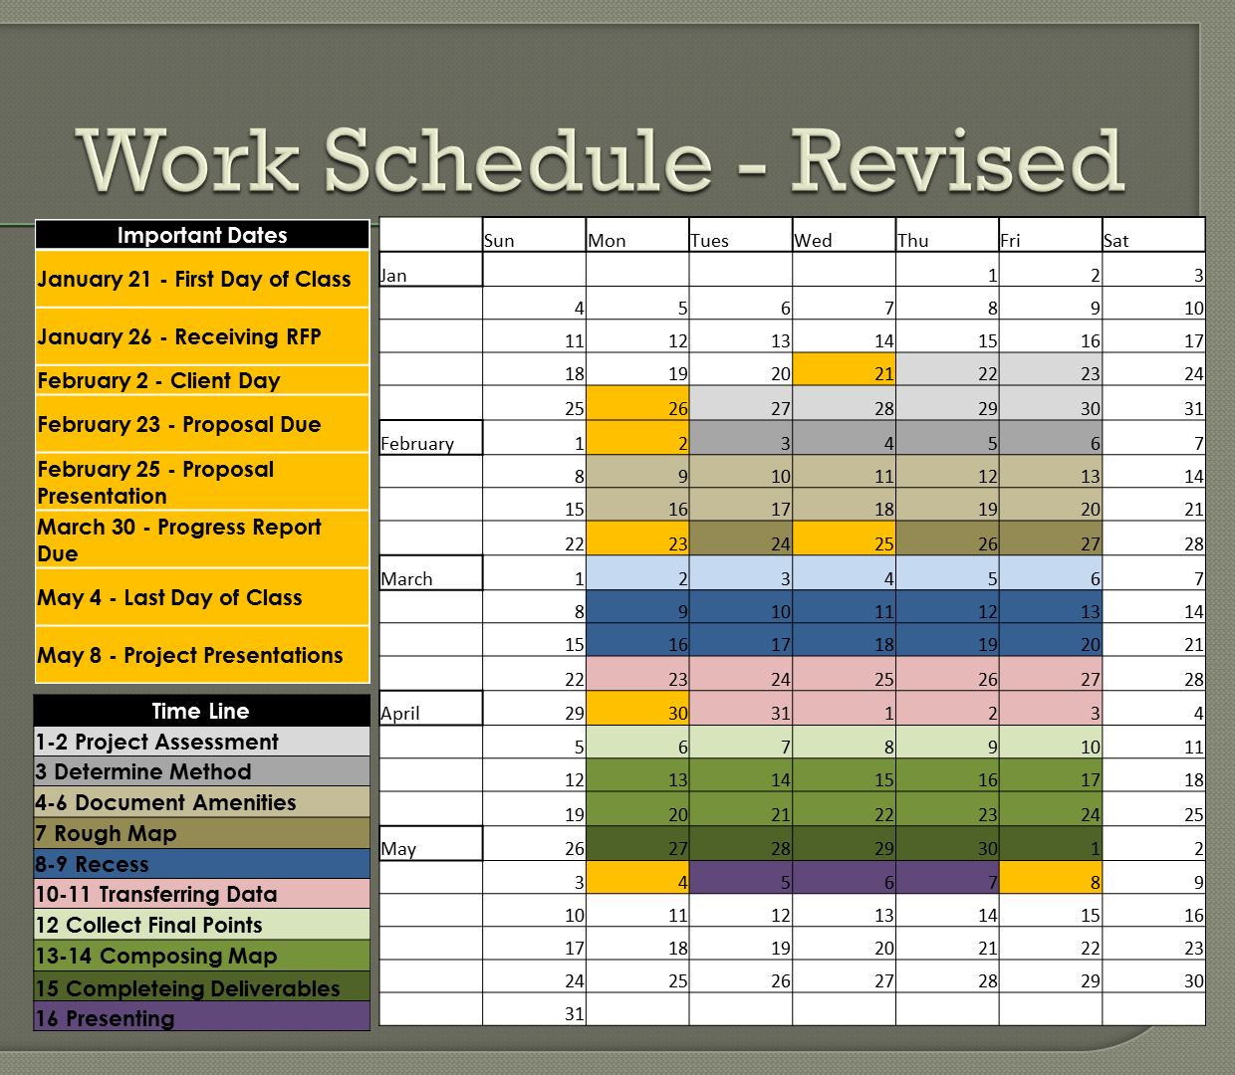
Problems and Concerns:
Through the past weeks we have been faced with a few speed bumps but none of them have completely stopped progress. We have seen a number of technical difficulties but have managed to overcome all so far. Perhaps the problem that has taken its tole on us most is the weather which prevented us from going out in the field and collecting GPS points for an entire week due to the rainy weather during that particular week.
Conclusion:
You will be pleased to know that our team is where we planned to be at this point in our time line and we are confident that we will be able to remain on course and completed all tasks as planned and on time. We have completed a large majority of the tedious portion of the project and are now nearing the downhill slope of organizing and completing all final deliverables for our client. We have completed all tasks on schedule as planned, and many tasks ahead of schedule.
After we complete our current task of collecting remaining geospatial data points to implement into our final ArcMap model we will be able to move to the final remaining tasks. We will spend the weeks to come making sure that all of our data is accurate as promised, completing the final database, and creating a visually pleasing map that will be available for the use of the Parks and Recreation department of the City of San Marcos. Our team is planning to finish these tasks as soon as we possibly can to ensure that we can present the best product that we possibly can that will be easily reused and implemented to other city owned parks and complexes without any difficulties.
We are excited to see where the remaining weeks will take us and to work to discover more helpful more ways to create more helpful qualities to include into the final product to hopefully ease the tasks of our clients even further. We will be working with the clients more than ever to comply with their needs and to provide them with a product that exceeds all expectations. Our team is open to any questions or concerns that the clients may have to ensure that we share the same goals, interests, and intensions for the final product that will be provided by the deadline of May 8th.

