Team Members:
Daniel Cohen
Sam Boesch
Matt Riggan
TABLE OF CONTENTS
Team Members:
Daniel Cohen
Sam Boesch
Matt Riggan

Introduction 1
Data 2
Table 1. 5
Table 2. 6
Table 3. 8
Table 4. 9
Image 1. 10
Methods 11
Image 2. 15
Results and Discussion 16
Image 3. . 17
Image 4. 17
Image 5. 17
Image 6. 19
Conclusion 20
References 21
Appendix I: Group Members Contribution 22
Appendix II: Metadata 23

Final Report

Introduction

The Soccer Complex at Five Mile Dam is a 43-acre property located in Hays County and maintained by the City of San Marcos. Providing many park goers with an area for recreational activities, the features and amenities receive a natural amount of wear and tear. This results in the necessity for a geographic database that assists the maintenance process for specified features within the complex. The city’s Parks and Recreation Department is currently creating geographic information system (GIS) inventories for its sports facilities in order for cheaper and more efficient amenity maintenance to be performed on a regular basis. Establishing the best method for data collection, processing, and portrayal is crucial to this project’s success, and that is exactly what Geographic Analysis and Maintenance (G.R.A.M.) aims to do. There are different methods of acquiring specific amenity’s spatial and attribute data in an area. There are also different procedures that can be put forth to correctly file that data within a geographic database for analysis and visual aids. Using global positioning systems (GPS) to provide accurate coordinates for each feature is much quicker and more precise than alternative methods of recording spatial data. Having many tools and functions, GPS units can be preset before collecting data, ultimately making the entire process simpler. “A GPS receiver is provided with an input/output port that retains any date and time stamp information often associated with position determinations, and therefore is more useful in archiving data for later analysis” (Woo and Sprague, 1995). With a high quality GPS unit spatial data can be recorded, saved, and shared with ease due to its compatibility with popular software. In comparison with other techniques of data processing, GIS methods are not only the quickest for feature database creation but also the most “frequently used in professional businesses around the globe” (Grimshaw, 2000). Although there are many, “ a few advantages to utilizing GIS includes improved communication, enhanced record keeping, cost saving, increased efficiency, and decision making” (AustinTexas.gov, 2015). Before starting this work we believed if we apply specific GPS and GIS methods to this project, then we will successfully provide a geodatabase consisting of the most accurate and efficiently collected data points while establishing a repeatable methodology for future use. During the process, visual aids will be created for better comprehension of the project.

Data
Creating this type of integrated geographic database involves capturing a large amount of spatial and attribute data. We aimed to collect coordinates for the specified features requested by the City as well as features that contributed in building an aesthetically pleasing layout for visual aids. This data was required and explicitly asked to be collected in regards for the creation of the geographic database and visual representations. Without the specifically requested data we collected, there would neither be a database and methodology to create, nor any maps to provide. All data collected was performed first hand by the members of our team making it primary data. Secondary data is data collected by people other than the members in our team. In only one aspect of the project did we incorporate secondary data, which originated from the City of San Marcos and was used as a reference for both the collection and creation of the complex’s irrigation structure. G.R.A.M. strived to collect the best primary data while refraining from the use of other data sources in order to insure optimal accuracy and reliability. Working at the complex also proved extremely helpful toward understanding how a geodatabase for the amenities there should be constructed. Acquiring the feature data needed within this large complex demanded an advanced GPS unit. Using Pathfinder Office G.R.A.M. and another group, Central Texas Geospatial Consulting, created and uploaded a data dictionary with similar GPS classification requirements appropriately named in accordance with the waypoints we needed to collect. We worked with the Trimble Geo XT GPS unit which provides accuracy under one meter during data collection. Our data dictionary allowed each collected point to be filed under a pre-described classification system.
Table 1. The menu classification options we used for our data dictionary is shown below.
Feature | Data Type | Primary Attributes | Secondary Attribute
Field | Polygon | Usage | Active, Inactive
 |  | Type | Small, Large
 | Point | Usage | Active, Inactive
 |  | Type | Small, Large
Irrigation System | Point | Usage | Active, Inactive
 |  | Type | Valve Box, Sprinkler Head
Stationary Garbage Receptacles | Point | Usage | Recycling
 |  |  | Non-Recycling
Trail | Line | Type | Running
Building | Polygon | Name | (Text Box) –  Concession Stand
Stationary Benches | Point | Type | Path Bench
Light Poles | Point | Type | Field Light Pole

This data dictionary is relatively basic and allows for quick data collection. During the database creation process we made changes for future specifications regarding features with multiple attributes. For unexpected features believed to have significance in this project, “generic” point, line, and polygon data classifications are programmed within the GPS unit. These generic features are primarily used when there is uncertainty in needing an amenities coordinates and it doesn’t have a designated place in the unit, or if there is a need to record the same amenity in a different data form. A text box option is provided and written in describing the generic feature’s attributes. We used the generic option in the beginning of our collection when failing to add a light pole class, and also when we wanted to take both line and point data for the fields to see which method was easier and more accurate. A data collection time table including leeway for disruptions such as poor weather conditions came in handy and kept the project on pace. The Trimble Geo XT unit is not water proof and is quite expensive, so we did not take any chances on collecting data in weather that was questionable. We used another time table for the irrigation points, which was the majority of the data collected, during the second business week of April to ensure an organized completion of work within a short amount of time.
Table 2. Data Collection Time Table for the second business week of April, 2015.
 | Monday | Tuesday | Wednesday | Thursday | Friday
10am – 11am | Class | Class | Class | Class | Class
11am – 12pm | Collect Data | Class | Collect Data | Class | Class
12pm – 1pm | Collect Data | Class | Collect Data | Class | Class
1pm – 2pm | Collect Data | Class | Collect Data | Class | Class
2pm – 3pm | Collect Data | Class | Collect Data | Class | Class
3pm or Later | Charge Trimble | Collect Data | Charge Trimble | Collect Data | Charge Trimble

For each GPS feature collected, between twenty and thirty points were taken to ensure a consistent level of accuracy. Satellite connection is crucial when utilizing GPS methods. The fewer the satellites, the tougher it is to find a signal and establish a point on the globe. Depending on the time of day, as few as two satellites and as many as nine were available to help pinpoint our data. In only one instance did we stop and come back another day to continue the particular area’s data collection, because there were not enough satellites connecting with our position at the time. The most difficult part of this data collection arose when attempting to locate sprinkler heads within the path surrounding the fields and concession building. The sprinklers were installed to project out of the ground from the irrigation pipelines below. This system results in water runoff accumulating and completely covering any signs of the sprinkler over time. After having trouble finding the majority of the sprinkler heads we turned to field methods and paced the distances between each sprinkler, dropped an irrigation flag once we located the head and proceeded to collect all the sprinkler data that way. Using provided PDF layouts of the irrigation given to us by the City, we were able to flag important sprinkler heads and pace in the direction the next head would be located according to the layouts. All together we ended up recording over seven hundred data points to use as features for our geographic database. Having only one GPS unit among the three project members allowed one to two of us to go in the field and collect points while the other(s) provided research and prepared the database for imminent use.
Once we finished collecting all of the needed coordinates, the locations and feature types were officially recorded within the data dictionary and were ready to be exported from the unit. This positioning system works using Terrasync and Pathfinder office version 5.40 to export the collected data onto the computer and ultimately the ArcGIS software version 10.2.2. In regards to the coordinate system applied, the Soccer Complex at Five Mile Dam is located within the State Plane Coordinate System 4204 and is based on the North American Datum 1983 (unit is in US feet). After uploading the data to Pathfinder, we strengthened its accuracy by differentially correcting it. All of our GPS data is based on the times it was taken and where the unit was when the satellites connected with it. In order to increase the overall accuracy of our data the differential correction method uses a nearest base station to compare timing and accuracy. These base stations are all over the world and contain exact times, intervals, and information regarding satellite placement. The base station used for this project was TxDOT, San Marcos. Comparing our unit’s data with the spatio-temporal accuracy of the base station ultimately provides better results for the project. After differentially correcting our data points, we receive a report of accuracy showing what percentage of our points were within a certain range of the points intended. Simply put, the correction shows how well our GPS unit performed, and how well we used it from a statistical standpoint.
Range | Percentage
0-5cm | -
5-15cm | 6.71%
15-30cm | 1.32%
30-50cm | 66.48%
0.5-1m | 24.24%
1-2m | 1.25%
2-5m | 0.01%
>5m | 0.01%
Table 3. Below are the calculated accuracies of all our data points collected with the Trimble.

After differentially correcting our data, we found that over seventy four percent was as accurate as fifty centimeters. After correcting our data we needed to properly export it into shapefile format so it can be applied and utilized within ArcGIS and Adobe Illustrator. In order to do this we manually formatted export setup properties to represent our data in an organized fashion. These properties include all of the feature types that will shape how the data is filed inside of our geographic database. Critical information is applied in this step such as the names for each group of data, the specific qualities of the data, and the general format to be exported. The setup properties are shown in a list of check boxes within the group of features it belongs. This made it very easy to pick which features we wanted to use and not use when exporting all of our extensively collected data.

Table 4. This table shows the feature options we chose during our export setup properties step.
Feature Type | Data File Name | Data Dictionary Name | Feature Name | Correction Status | Date Recorded
Point Features | Horizontal Precision | Point ID
Line Features | Length | Line ID | Arc ID | Area | Perimeter

When we look at our differentially corrected, and exported data in ArcMap we see all of the points we collected in a concise format. We can open up attribute tables for any data point and it will show that the location and attributes in correlation to all the other data points collected. By simply adding a base map of the Five Mile Dam Soccer Complex to the layers we created with our exported data, we can see how all of our data is mapped in a spatial frequency. At this point we were able to finally see all of the points we collected correctly integrated with the satellite imagery of the complex.

Image 1. This map shows every data point collected with its proper coordinates on the complex.
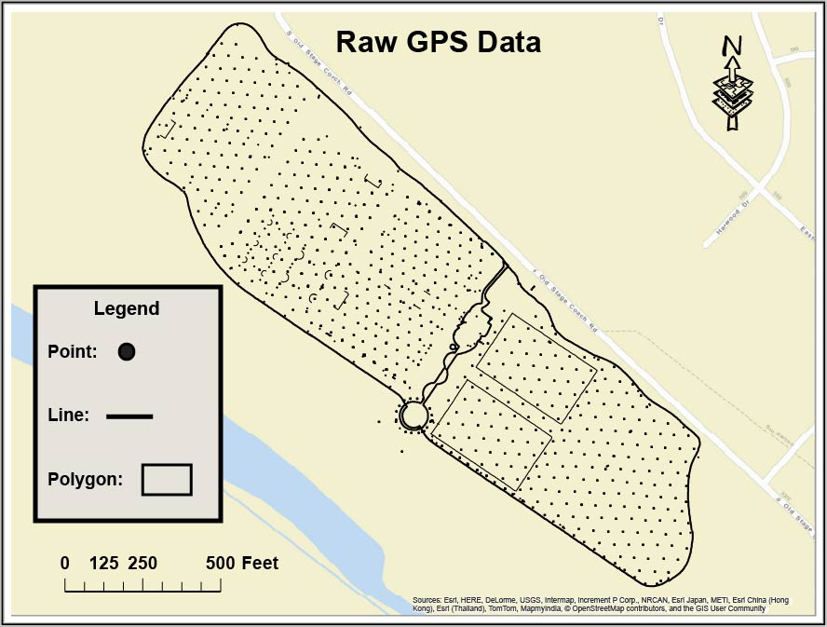
Methods
Providing a methodology focused on the creation of the complex’s geographic database is best comprehended when outlined in procedure descriptions. This methodology contains reiterations of previously explained project procedures. As one of the primary deliverables required for this project, this methodology is constructed to explain and the entirety of our methods from beginning to end. Planning the steps for this type of database involves full understanding of what the project assignment entailed. Our general method for success with this project was simply staying focused on exactly what our final deliverables were and what the best methods for providing each of those deliverables would be. Primary objectives included collecting GPS coordinates of specified amenities throughout the entire complex grounds, as well as the creation and organization of a geographic database focused around those specified amenities/feature attributes. Also, we needed to construct visually detailed maps showing the attribute data that was collected and exported. Upon completion of those objectives the task of providing a final report including this scientific methodology for this geodatabase design process was to be devised.
The methodology began with a team discussion covering the most effective ways to accomplish each task. We determined a plan and a number of agendas that would enforce the best possible product. We turned down many ideas, although they would satisfy our objective, we deemed them inefficient due to unnecessary obstacles involved. Time spent reviewing and researching similar projects allowed our team to compile ideas for a strong delivery product, which ultimately would be comprised of the best strategies for each step. After planning and researching we constructed a clear outline to show our clients what our plans were and how we intended to accomplish each step.
Once an outline was established we began the data acquisition portion of the project. A GPS unit capable of recording sub-meter accuracy was provided by our teacher assistant. Within this global positioning unit we created a data dictionary that provided menu options for when we actually collected the data. We labeled these menu options to organize and speed up the data collection process. Without the data dictionary we would have had to manually label each feature point collected, which ultimately elongates the duration of the project. After programming the unit’s data dictionary the group devised a time schedule to collect points. This schedule needed to be implemented around each of our class times as well as other interfering activities, such as work schedules and weekend travel plans to home cities. We followed this schedule for all of the collection of all data required except irrigation. For the irrigation data we ambitiously made a week long timetable for the second week of April (refer to Table 2) to collect all of the sprinkler heads and other water related features. The irrigation data eventually compiled to be the vast majority of all our collected data points.
At this point everything we needed to officially go out to the soccer complex and begin collecting points for our geodatabase had been accomplished. The first points we collected were non-irrigation points. This included features requested by our client that were not affiliated with the irrigation structures, such as stationary trash cans, light poles, and field dimensions. This took a decent amount of time due to how large the area is and how many fields there are out there. By the time we had collected those points it was the second week of April, which meant it was time to follow our irrigation data collecting schedule. We began by collecting valve boxes and main water source points, because they were much more visible than the embedded sprinkler heads. The hardest part of the data collection were the sprinkler heads. They were extremely hidden under the fields, and we found out the hard way that simply walking around and trying to spot every sprinkler head was not a sound method. This resulted in us using field methods and irrigation flags to find a consistent pattern and direction for the sprinkler irrigation dynamic. The City’s PDF documents showing the infrastructure and hierarchy of the irrigation were also used as references for our data collection techniques. The data collection process was lengthy and physically demanding, but it defined what this project’s GIS aspect would be focused on.
The uploading of all the Five Mile Dam’s requested data points were then ready to be imported from the GPS unit software Terrasync to the computer’s software Pathfinder. This simply requires the GPS unit’s charging cradle and USB connection cord. Within utilities in the Pathfinder software we transferred the data by choosing our labeled files containing the data we collected and adding it to the transfer area. We then chose to ‘transfer all’ files selected, and after the software processes it our data was provided in a spatially recorded format. The shown data points are the “raw” data from our collection which then needed to be differentially corrected. This process uses a nearest base station to where the points were collected that contains exact temporal satellite records. Differentially correcting our raw data shows how well our GPS unit worked in terms of accuracy, and ultimately corrects slight inaccuracies for every point collected at the soccer complex.
At this point we had corrected all of our data and were ready to export it as shapefiles in order for it to be compatible with ArcMap. We wanted to export the data into ArcMap because this software is where we will create a geographic database around the collected data. The export process requires an organization step labeled “Export Setup Properties.” Within this property window we selected features that organized the data for when it appears inside the ArcMap database. For the feature selections chosen refer to “Table 4.” After exporting the data, we organized the layers of each feature within the database. This involved selecting attributes for certain amenities and grouping them with similar data. For example, if we used the “general point” option within the data dictionary, we often misspelled the attributes of that point. We then would determine what the point represented and relocate it within the group layer it belonged. Once the data was organized and placed in their appropriate layers, we established the state plane coordinate system 4204 to ensure the data corresponds with its true location on the globe. From there we scaled a base map within our coordinate projection which showed the surrounding roads and rivers of the soccer complex. Adding the base map simply revealed the surroundings of our data for a more aesthetic perspective. At that point we officially had all of our corrected data in the correct coordinate system, and shown in the correct area of the world. The data is bland and basic looking at this point. Exporting the map as an Adobe Illustrator file (AI) was what we did next. By exporting the map as an AI file we were able to open it up inside of the Illustrator software and symbolize all of the features in much greater detail. This software also allowed us to create a visual layout of the irrigation pipe hierarchy between important points, such as sprinklers and valve boxes.
In order to make an impressive map, we spent hours of work in Adobe Illustrator rendering our data points into symbolic visuals that represented their attributes and functions. Creating a professional, effective visual aid to represent data collected by a GPS unit proved meticulous. When trying to represent data points through another software we strived to maintain data accuracy. Without the accuracy of the data a project of this caliber becomes unorganized and incredible. For areas not requested for the collection of data we used a TIFF image to find the features in those areas and then correctly modeled their location around the areas we collected data in. The types of maps we provided included our data’s feature classes within a clean representation of the complex’s layout all in the requested ANSI D format.
Image 2. Below is a flowchart representing this project’s methodology.
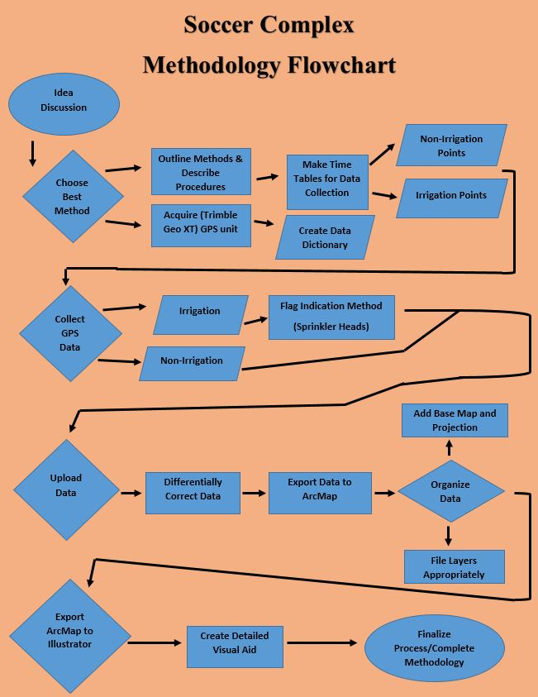
Results and Discussion
Successfully collecting and utilizing data for this project proved to be as time consuming and technically oriented as we anticipated. Results for each task were accomplished and accumulated to meet all the project’s needs. Our results also show that it is possible to collect specifically requested data points in an area with a GPS unit, and construct a method that turns that data into a functional geographic database. Using GPS and GIS methods to achieve a structural understanding of the requested amenities on the Five Mile Dam Soccer Complex worked phenomenally. Our team, G.R.A.M., learned how to use the specific GPS system required for this project, and after a few minutes of collecting data we were able to consistently and accurately record the rest of the points needed to facilitate a sound geographic database. Creating a data dictionary for the unit was complicated and confusing at first, because of the need to apply it for both my team’s project and another team’s as well, but after utilizing its purpose we found it quite convenient. Charging the Trimble was an issue in the beginning of this project, but our team made a point to remember and recharge the device after a lengthy day of data collection. At first, the GPS portion of this project was time consuming and unorganized, but as the semester progressed our team became very familiar and confident in our ways of collecting the data we needed. Finding the sprinkler heads were an issue until we established an irrigation-flag-line method to locate all the heads. By looking at irrigation blueprints and using field method techniques, we were able to understand a consistent spatial pattern for each of the fields for the entire irrigation system on the soccer complex. Originally finding the sprinkler heads in a timely fashion was the only issue that did not conform to our beginning hypothesis for this project.

Images 3, 4, and 5. Below images show our flag method of finding sprinkler heads.
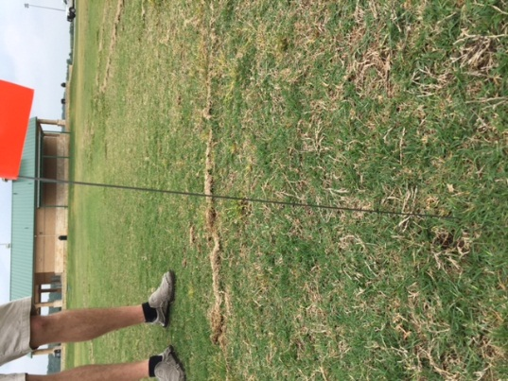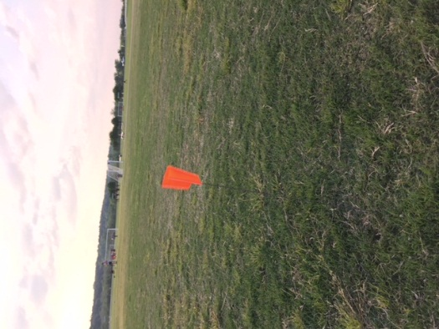
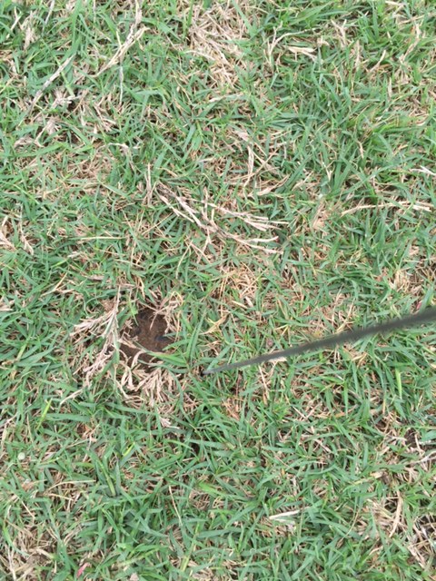
Some GIS portions of this project were fairly new to our team as well. The entire exporting of data from Pathfinder to ArcMap process was learned and applied multiple times. Knowing how to conform the points we collected to an organized and compatible format was not profoundly difficult, but definitely needed to be instructed for it to be properly preformed. Once the data was correctly displayed in the ArcGIS software, there were no more limitations to our process, and we were able to smoothly transition from collecting data to filing and utilizing the data. This gave us comfort knowing that the remaining portion of the project was attainable by spending time in the lab applying our GIS and map making knowledge to produce a desired outcome that meets the needs of our employer. If we were assigned this project again, we would approach very similarly to how we have, but with a more precise method for each and every task. We are very happy with our results, but if possible, cutting down the time it took to collect all of our data and create our database and visual aids would benefit our team in the long run. Knowing the procedures for every step during this project was crucial and informative. If we had used a less advanced GPS system we would not have been able to record such accurate data, therefore being uncertain and unhappy with the outcome of this project. Luckily, we were equipped with our unit were successfully able to collected excellent points all throughout our study area. Utilizing GIS to solve our geospatial problem worked very well. The knowledge our team used from previous GIS classes came in handy every step of the way. Knowing how satellites operate and are utilized in ArcMap supported our need to understand the GPS device we used so that it could be correctly applied upon completion of collecting data. The majority of our data was irrigation related, and using GIS methods to understand the spatial layout of the soccer complex’s water system became a huge part of this project, and helped our team keep a consistent accuracy of every amenity that we needed to record. The immensity and spatial determination of our collected data set became precisely organized and represented in our visual aids toward the end of this project. Creating a database focused around the data we collected and then establishing a methodology to repeat that process was proven obtainable and successful. Symbolizing requested amenities for the entirety of our subject area’s irrigation system was also a success, and our methods to obtain this goal proved to be both effective and efficient.
Image 6. This is our team’s map symbolizing our study area’s amenities and irrigation system.
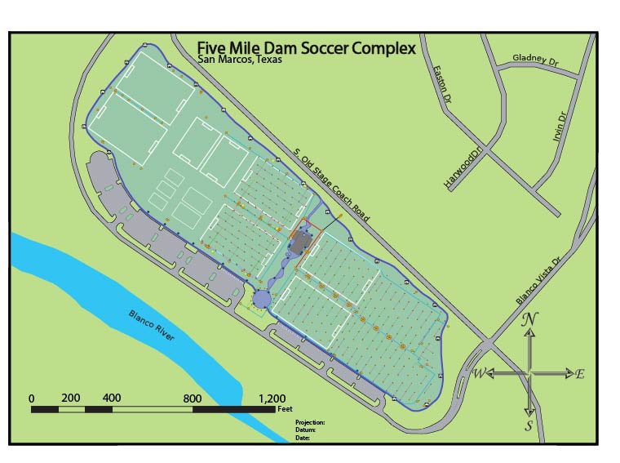
The map above was made using Adobe Illustrator, after data was accurately collected, transferred from a GPS unit to ArcMap through various procedures, and meticulously traced along the collected data points. This maps intention is to provide a clean visual aid that precisely symbolizes specifically requested amenities within the Soccer Complex at Five Mile Dam.
Conclusion
This project provided our team with real world tasks that needed to be completed as professionally and efficiently as possible. Interacting with clients from the City of San Marcos provided an aspect to our GIS education that had yet to be incorporated. This allowed our team to speak about information and directions with our employer regarding the successful completion of this assignment. The methods used to complete our procedures required a large amount of group communication and employer to employee communication. We gained a stronger insight on professional communication with clients, and achieved a unanimously desired outcome in the best way we all thought was possible. Understanding what kind of jobs are out there and how those jobs are completed is exactly what we got out of the project assigned in this course. What little uncertainty our team had during this project was quickly vanquished by the knowledge and guidance our professor, teacher assistant, and employer provided. By accumulating our team member’s skills to achieve the success of this project, we not only provided a professional outcome, but also gained individual experience for the careers that lie ahead of us. Our completion of this project ultimately allows the City of San Marcos to be better equipped when maintaining the Soccer Complex at Five Mile Dam’s original functionality and aesthetic beauty for decades to come.

References

David J. Grimshaw. Bringing geographical information systems into business. John Wiley & Sons, 2000.

“GIS and Maps AustinTexas.gov – The Official Website of the City of Austin.”GIS and Maps AustinTexas.gov – The Official Website of the City of Austin. N.p., n.d. Web. 24 Apr, 2015.

Woo, Arthur, and David S. Sprague. "GPS receivers with data ports for the uploading and downloading of absolute position information." U.S. Patent No. 5,450,344. 12 Sep. 1995.

Appendix I: Group Members Contribution

Matt:
Led the team through our planned outline for the duration of the project; scheduled data collection times for irrigation points; assisted in data dictionary construction; held responsibility for the GPS unit the second half of the semester; co-collected all data points; devised method to find sprinkler heads more efficiently; created detailed final map in adobe illustrator showing the complex and it’s irrigation hierarchy; created final poster.
Danny:
Idea discussion assistance; created tables regarding scheduling and budget; organized data for geodatabase creation and created the geodatabase; co-created presentations and previous reports; filed and analyzed all data for correct geographic database construction; formatted all materials to be applied within the website; created and specified entire metadata.
Sam:
co-scheduled data collection times for all data points (non-irrigation and irrigation); assisted in data dictionary construction; created dictionary table; created methodology flowchart; created April’s data collection time table; co-collected all data points; held responsibility of the GPS unit for the first half of the semester; uploaded data from unit to Pathfinder; differentially corrected the data; exported all data as shapefiles using export setup properties; Created final report.

