2/23/2015

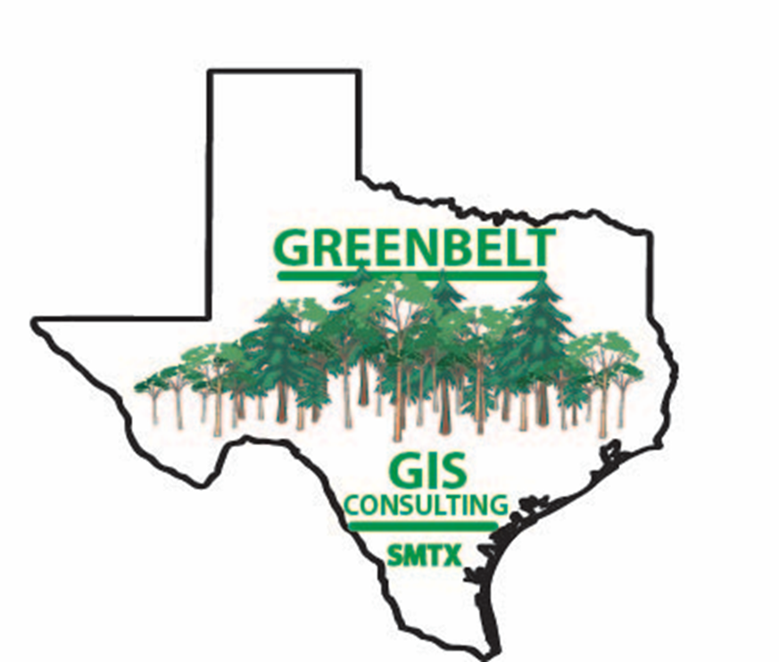

Clancy Taylor: Project Manager

Will Johnston: Assistant Manager

Megan Branam: Remote Sensing and GIS Analyst

Michael Amaral: Remote Sensing and GIS Analyst

GreenBelt GIS Consulting

Texas State University

The Efficacy of Residential Tree Plantings in Mitigating Urban Heat Island: An Analysis of the NeighborWoods Program in Austin, Texas

Prepared by: GreenBelt GIS Consulting

Table of Contents

**Introduction1**

Summary1

Purpose1

Scope1

**Literature Review2**

**Proposal3**

Data3

Methodology4

Budget6

Timeline7

Final Deliverables8

**Conclusion8**

**Participation9**

**Appendix10**

**Bibliography11**

**1.1 INTRODUCTION**

*1.2 Summary*

According to the Environmental Protection Agency (EPA), the Urban Heat Island effect explains the phenomena that developed areas are hotter than the surrounding rural areas. The heat from the urban areas negatively impacts cities, most specifically through increasing energy use and demand to cool down structures, air pollution, greenhouse gas emissions, human health issues relating to heat and pollution, as well as having a negative impact on water quality (Environmental Protection Agency, 2013). Many cities have implemented programs to mitigate the Urban Heat Island effect while still allowing development to occur, one of those being Austin, Texas.

Austin, Texas is a rapidly growing major city in central Texas, currently home to 885,000 people with an approximate population growth rate of 2.8%. With more people, comes more development. This development often means more concrete and other surfaces that contribute to the Urban Heat Island effect (UHI effect). In order to mitigate the UHI effect and reap other tree planting benefits, the City of Austin, Austin Energy, and the non-profit TreeFolks have implemented a tree planting program called NeighborWoods. In order to determine the effectiveness of the NeighborWoods program in UHI mitigation, the City of Austin has partnered with Greenbelt GIS Consulting. Greenbelt GIS Consulting will measure the effectiveness of the NeighborWoods program using ArcGIS, remote sensing, and statistical analysis, as well as make recommendations for future studies of this program.

*1.3 Purpose*

This study will analyze the effectiveness of the NeighborWoods program in mitigating the UHI effect. Using GIS to analyze tree planting locations, and ERDAS to analyze surface temperature, the study will help determine the cooling and other mitigating effects of trees. Furthermore, the study will analyze energy reduction benefits of NeighborWoods trees.

*1.4 Scope*

This study will analyze the city limits of Austin, Texas, with a special emphasis on locations with NeighborWoods Tree Plantings. These locations are shown in Figure 1. The NeighborWoods tree plantings began in 2002. The study will analyze surface temperature imagery over the 13 years since NeighborWoods began.

**2.1 LITERATURE REVIEW**

There is a large amount of research that has been conducted into studying what the urban heat island (UHI) effect is, its causes, and its impacts on the environment. In urban locations, much of the land that once contained vegetation is replaced by impervious surfaces like concrete and asphalt. The roads and buildings that are constructed in urban areas absorb more of the suns energy during the day and release that energy into the air at night (Gallo et al., 1993). Other attributing factors to the UHI effect are reduced airflow due to large buildings, as well as a reduced amount of moisture involved in evapotranspiration in the atmosphere located in these urban zones (Coutts, et al. 2007). With the replacement of the natural earth surface with impervious concrete, there is also a larger amount of runoff from rain water (Carlson, 1986). As temperatures rise in highly urbanized areas, the amount of energy used for air conditioning inside buildings further contributes and increases the UHI effect (Parks and Recreation Department).

Application of high-resolution thermal infrared remote sensing and GIS to assess urban heat island effect

According to the International Journal of Remote Sensing the urban heat island effect is “caused by deforestation and the replacement of the land surface by non-evaporating and non-porous materials such as asphalt and concrete.” With large buildings and pavement covering the landscape, the temperatures in heavily urbanized areas can rise by several degrees warmer than more rural outlying areas. In extreme cases, the urban heat island (UHI) may cause changes in precipitation and temperature that usually take nearly hundred years to take place.

The scope of this study in Huntsville, a medium sized city in northern Alabama. To collect the infrared data, an Advanced Thermal and Land Applications Sensor (ATLAS) attached to the bottom of a small jet. Landsat images were taken around solar noon and once again, later in the day roughly 3 hours after sunset, to highlight the warming and cooling of urban surfaces. While the plane was flying over the city recording infrared data, teams on the ground were collecting GPS ground control points and surface temperatures at the locations of different ground cover.

After the thermal data was collected, it was digitized, converted into a raster format, and then georeferenced using an aerial photo of Huntsville. Irradiance was used to calculate the heat differences in the cities by comparing the noon images with the images after the sunset. Once the daytime and nighttime irradiance values were graphically represented, it is seen that the most highly urbanized areas are the highest peaks during the day and the lowest troughs in the graphs at night.

The study concluded that highly urbanized commercial, industrial, and business areas possess the highest day time irradiance, while natural land cover types such as vegetation and water have the lowest day-night irradiance differences. However, residential areas have a highly variable amount of daylight irradiance because of varying amounts of tree cover. Another finding concluded that the “relationship between NDVI (as a surrogate of vegetation amount) and the irradiance of each category of land cover (as a surrogate of surface temperature) reveals that importance of vacant/ transition, residential, agricultural, and vegetation land cover types in contributing towards lowering their surface temperatures by virtue of their association with biomass. In conclusion, natural land cover types help cancel out the adverse effects of the urban heat island effect.

**3.1 PROPOSAL**

*3.2 Data*

To complete the analysis, we will use the locations of the NeighborWoods trees provided to us from the Urban Forestry Department at the City of Austin. Other data coming from the City of Austin includes city limits, Austin Energy service area, land cover information, and neighborhood information. Landsat 5 and Landsat 7 satellite imagines will be obtained from the USGS Earth Explorer database. The images will be at the same times of year from 2002 to 2014. The Landsat images will be looking specifically at the thermal data in band 6 and what change occurs as more trees are planted in neighborhoods. After all data is collected we will use programs ArcGIS and ERDAS Imagine to compile and study the effect NeighborWoods is having on the Urban Heat Island Effect in the Austin area.

*3.3 Methodology*

LANDSAT/ERDAS

Landsat imagery gathered from the USGS website Earth Explorer will be converted to TIFF files. The layer stacking tool will convert the separate band files into one Imagine file for each image. There will be three images used for analysis; one image from July 24th, 2002, one image from August 4th, 2009, and one image from July 1st, 2014.

Landsat imagery gathered from the USGS website Earth Explorer will be converted to TIFF files. The layer stacking tool will convert the separate band files into one Imagine file for each image. There will be three images used for analysis; one image from July 24th, 2002, using Landsat 7 ETM, one image from August 4th, 2009, using Landsat 4-5 TM, and one image from July 1st, 2014, using Landsat 8 OLI/TIRS. The purpose of using imagery during the summer is to highlight the peak potential effects of the UHI effect. The images derived from these dates display the best image quality available during the summer months. Once the files have been converted to Imagine file formats, the images will be opened with a grayscale, with the focus of the image on band six, which is the thermal band. The purpose of using grayscale for the images is to simply focus on the thermal band. The images will be re-projected into Texas State Plane Central (4203) to match the projections of the GIS data in ArcMap. Once this process has been implemented to all three images, the pixel sizes of the images will need to be resampled to all be the same size. From this point, we will be able to convert the pixel values into land surface temperature values, based off a particular conversion equation for each Landsat satellite. Landsat 4-5 and 7 data will be converted using equations from Chander et al. (2009), while Landsat 8 data will be converted using equations from Butler (2014). The images will then be converted into a raster file format to be exported to the ArcMap program. In ArcMap a more in-depth comparison of the different land surface temperatures will be produced.

ArcGIS

After the imagery is exported to ArcGIS from ERDAS imagine, further georeferencing will be unnecessary because the image will already be paired with a coordinate system. An NDVI, Normalized Difference Vegetation Index, function will be used to emphasize the “green” biomass and vegetation areas compared to the urbanized, impermeable areas of Austin. The change in green, vegetated areas on the map could be factored into the change in temperature over the NeighborWoods Project over its 14 years. The point data of planted tree locations, provided to us by the NeighborWoods Project, will be divided into three to four sections over the 14 year span. This is done for two reasons. The first reason being that a change in temperature over three or four years will be more apparent than the change in two consecutive years, also because there may be no change detected in the first year of the program. The second reason being that there are about 24,000 points in that layer with their respective metadata, and categorizing them into groups will make data management and analysis timely and less arduous. The main objective of the ArcGIS analysis is to visually analyze changes in temperature and land cover.

Statistical Analysis

Once the spatial analysis and surface temperature analysis of the data has been performed, a statistical analysis of the program will be performed. This analysis will be to understand the surface temperature from the years 2002 through 2014. Furthermore, the analysis will need to help understand the significance between the planting of the NeighborWoods Trees (independent variable) and the effect those trees have on surface temperature (dependent variable). Ideally, the statistical will be performed in accordance to the study years given by the remotely sensed images. This will be a formal statistical analysis of the observed spatial patterns seen in the data.

The final analysis for the study will be a quantification of the energy savings benefits of the NeighborWoods Tree Planting program. Using the information in the given Shapefile, and the National Tree Benefit Calculator, Greenbelt GIS Consulting will be able to view the number of kilowatts per hour saved by the different types of trees planted through the program.

*3.4 Budget*



*3.5 Timeline*

Phase 1: Data Collection and Processing

The first three weeks of the project will be collecting the required data from the City of Austin, and USGS. Then, we will work through with the data to ensure it is of consistent format and quality to be analyzed in the next phase of the project.

Phase 2: Data and Statistical Analysis

The second phase will involve overlaying the remote sensing and GIS data in ArcGIS. Furthermore, we will analyze the relationships between the NeighborWoods trees and surface temperatures both spatially and statistically.

Phase 3: Web and Map Development

|  |  |  |  |  |  |  |
| --- | --- | --- | --- | --- | --- | --- |
|  | **April 2015** | | | | |  |
| **S** | **M** | **T** | **W** | **Th** | **F** | **Sat** |
|  | Data and Statistical Analysis |  | 1 | 2 | 3 | 4 |
| 5 | 6 | 7  Web and Map Development | 8 | 9 | 10 | 11 |
| 12 | 13 | 14 | 15 | 16  Web and Map Development | 17 | 18 |
| 19 | 20 | 21 | 22 | 23  Web and Map Development | 24 | 25 |
| 26 | 27 | 28 | 29 | 30  Data Interpretation and Quality Control |  | |

This phase will see final products of the maps produced in phase 2. Additionally, the website for the project will become available and active.

Phase 4: Data Interpretation and Quality

Control

The final phase allows us two weeks to make final conclusions from our analysis and methods. This phase will ensure all data and work done has been held to standards set at the beginning of phase 1.

|  |  |  |  |  |  |  |
| --- | --- | --- | --- | --- | --- | --- |
|  | **February 2015** | | | | |  |
| **S** | **M** | **T** | **W** | **Th** | **F** | **Sat** |
| 1 | 2 | 3 | 4  Data Collection and Processing | 5 | 6 | 7 |
| 8 | 9  Data Collection and Processing | 10 | 11 | 12 | 13 | 14 |
| 15 | 16 | 17  Data Collection and Processing | 18 | 19 | 20 | 21 |
| 22 | 23  Data and Statistical Analysis | 24 | 25 | 26 | 27 | 28 |
|  |  |  |  |  |  |  |
|  | **March 2015** | | | | |  |
| **S** | **M** | **T** | **W** | **Th** | **F** | **Sat** |
| 1 | 2  Data and Statistical Analysis | 3 | 4 | 5 | 6 | 7 |
| 8  Data and Statistical Analysis | 9 | 10 | 11 | 12 | 13 | 14 |
| 15 | 16  Data and Statistical Analysis | 17 | 18 | 19 | 20 | 21 |
| 22 | 23  Data and Statistical Analysis | 24 | 25 | 26 | 27 | 28 |
| 29 | 30  Data and Statistical Analysis | 31 |  | | | |

|  |  |  |  |  |  |  |
| --- | --- | --- | --- | --- | --- | --- |
|  | **May 2015** | | | | |  |
| **S** | **M** | **T** | **W** | **Th** | **F** | **Sat** |
|  |  |  |  |  | 1  Data Interpretation and Quality Control | 2 |
| 3 | 4 | 5 | 6 | 7 | 8 | 9 |
| 10 | 11 | 12 | 13 | 14 | 15 | 16 |

*3.6 Final Deliverables*

When the project is completed the client can expect a final report that discusses: the comparison of tree planting locations and land surface temperature, an explanation of the methods used, the results of the analysis, and recommendations for future studies. A geodatabase of all data sets that were created during the analysis phase, including the completed metadata of the attributes, will be included. In addition to the report, a final map of the study and the class presentation slides will also be included in PowerPoint and PDF formats. A professional poster will be created to display the findings and results. Landsat images that were to be used for analysis will be converted to both raster and vector file formats. All of the data will be presented to the client via 2 CDs.

**4.1 CONCLUSION**

In conclusion, this project will produce a study on the mitigation of the urban heat island effect in Austin, Texas via the NeighborWoods Tree program. In order to analyze the NeighborWoods Trees, Greenbelt GIS Consulting will utilize the tools of ArcGIS to analyze spatial data and ERDAS images. In order to understand the statistical significance of the effectiveness of the program, a regression analysis will be performed. The last analysis performed by the team will be to understand the energy savings effect the planted trees of the program have had. This study should be used to understand the mitigation of the urban heat island effect in Austin, as well as assist in making future recommendations for the NeighborWoods Tree program.

**5.1 PARTICIPATION**

* **Clancy Taylor-Project Manager**
  + Introduction, Literature Review-Holes in Research and Review, Methodology-Statistical Analysis, Timeline, Conclusion, References, Participation, Presentation
* **Will Johnston-Web Development and GIS Analyst (Assistant Manager)**
  + Literature Review-Information on Using GIS to Study UHI, Methodology on ArcGIS, Budget, Presentation
* **Michael Amaral-Remote Sensing and GIS Analyst**
  + Cover Page, Title Page, Table of Contents, Literature Review-Information on General Heat Island Effect, Methodology on ERDAS/Remote Sensing, Deliverables
* **Megan Branam-Remote Sensing and GIS Analyst**
  + Literature Review-Mitigation of Urban Heat Island using Trees, Methodology in ArcGIS, Data, Methodology on ERDAS/Remote Sensing, Assistance on Putting Paper Together

**6.1 APPENDIX**

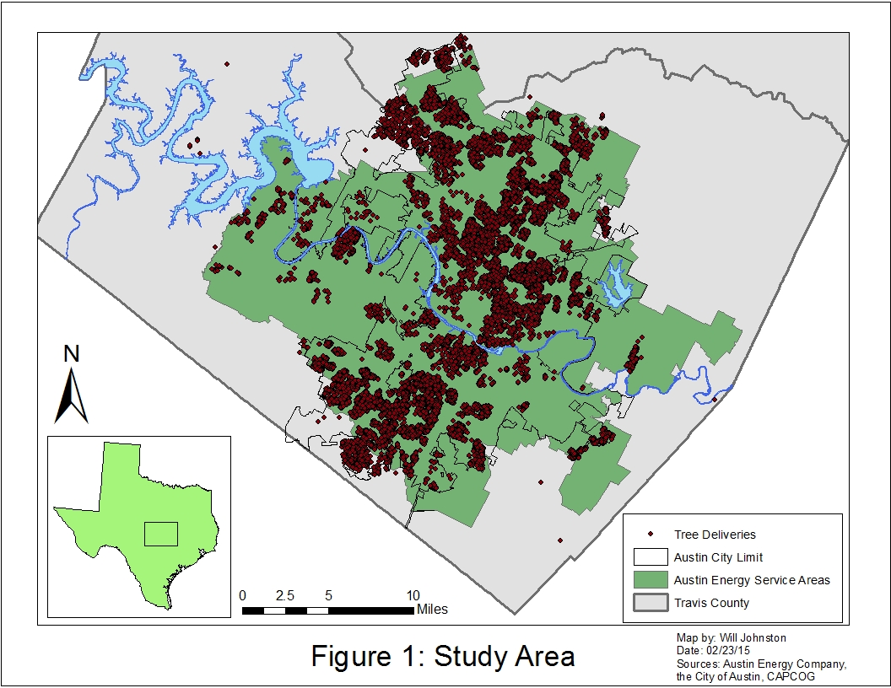**APPENDIX I.** Figure 1: Study Area

**7.1 BIBLOGRAPHY**

Carlson, T. N., 1986, Regional-scale estimates of surface moisture availability and thermal

inertia using remote thermal measurements. Remote Sensing Reviews, 1, 197± 247.

Coutts, A. M., J. Beringer and N.J. Tapper. 2007. Impact of Increasing Urban Density on Local Climate: Spatial and Temporal Variations in the Surface Energy Balance in Melbourne, Australia. Journal of Applied Meteorology and Climatology 46: 477-493.

Duvall, J.C., C.P. Lo, D.A. Quattrochi. 1997. Application of high resolution thermal infrared remote sensing and GIS to assess the urban heat island effect. The International Journal of Remote Sensing. 287-304.

K. P. Gallo, A. L. McNab, T. R. Karl, J. F. Brown, J. J. Hood, and J. D. Tarpley, 1993: The Use of NOAA AVHRR Data for Assessment of the Urban Heat Island Effect. J. Appl. Meteor., 32, 899–908.

Parks and Recreation Department. The Heat Island Effect: Cooling Strategies. City of Austin, n.d. Web. 17 Feb. 2015. <http://www.austintexas.gov/coolspaces>.