3/30/2015
Clancy Taylor: Project Manager
Will Johnston: Assistant Manager
Megan Branam: Remote Sensing and GIS Analyst
Michael Amaral: Remote Sensing and GIS Analyst
GreenBelt GIS Consulting
Texas State University

Progress Report
The Efficacy of Residential Tree Plantings in Mitigating Urban Heat Island: An Analysis of the NeighborWoods Program in Austin, Texas

Prepared by: GreenBelt GIS Consulting

Table of Contents

Introduction 1
Purpose 1
Scope 2
Tasks 2
Completed Work 2
Current Work 2
Planned Work 3

Conclusion 4

Appendix 5

1. Introduction
Progress on the NeighborWoods Program analysis has been going well since the proposal was accepted by the client, Alan Halter of the City of Austin Urban Forestry Department. This progress report is being submitted in order to assure Mr. Halter and the City that the project will be completed in compliance with the original proposal.
1.1 Purpose
In accordance with the proposal, this project strives to understand how the NeighborWoods Program helps mitigate the negative effects of the Urban Heat Island effect (UHI) in the City of Austin, specifically the area of implementation for the program. The City of Austin experiences higher temperatures as a result of the UHI, due to their metropolitan status. Concrete surfaces as well as increased amounts of pollution and automobile traffic increase temperatures in urban areas higher than they are in surrounding less populated areas. To mitigate this issue, the NeighborWoods Program, plants trees on residents’ lots to shade houses, thus decreasing air conditioning costs and to convert carbon dioxide to oxygen
Task 1: Remotely Sense temperature Landsat Images from USGS to TIFF Files for use in GIS
Task 2: Analyze surface temperatures and the locations to NeighborWoods trees in ArcGIS to visually analyze changes in temperature and land cover.
Task 3: Provide statistical analysis of the significance of the effect of NeighborWoods trees on surface temperature. Quantify the energy savings provided by the NeighborWoods trees.
Covered in this progress report will be the objectives of the project, the work already completed, the problems that have been encountered, and the work scheduled to be completed. The data collection phase is complete, currently we are working on some remaining data processing and analysis that will be further explained.

1.2 Scope
The scope of the project is the service area of Austin Energy, the main utility service provider in the City of Austin. While the UHI effect is not limited to the City of Austin, the service area of Austin Energy encompasses the limits of the NeighborWoods Program. The final goal of the project will to create a map comparing surface temperatures across Austin and featuring the locations of the trees planted via the NeighborWoods program. Furthermore, the final analysis will quantify the energy savings from the NeighborWoods program and provide an analysis of the effects of the program on surface temperatures.

2. Tasks
2.1 Completed Work
The three Landsat images have been pre-processed and are ready to be manipulated. The images have been re-projected to the Texas State Plane Central (4203) coordinate system. We have converted the thermal bands of the Landsat 4-5 and Landsat 7 images into useable surface temperature images. We completed this task by creating a model in ERDAS to convert the digital number values of the prepared images into spectral radiance values. From this point, the model converted the spectral radiance values into surface temperature values in Kelvin, which was then converted to Celsius. The two images have been given to our GIS team members to begin the analysis of the NeighborWoods tree program.
The GIS component has been going smoothly. Completed work includes base maps which have been created with data from the Capital Area Council of Governments (CAPCOG) GIS database, the City of Austin, and point data from the NeighborWoods Program, which was provided by the client. This data includes county boundaries, city limits, the service areas of Austin Energy, as well as road networks and water bodies for spatial orientation purposes. The data provided by NeighborWoods is metadata about the trees that have been planted during the program from 2002 to 2014 throughout the Austin area. To prepare the base map data for the actual remote sensing layer, some map editing was done to make the data more presentable to the client and easy to interpret. This included using a cut function on the road network layer to fit inside of Travis and Williamson Counties, as those are the two counties that Austin Energy operates in.
2.2 Current Work
We are currently working on creating a model that would convert the digital number values of the Landsat 8 image into surface temperature values. There is a difference in the way Landsat 8 images are processed when compared to earlier Landsat satellites. This different conversion factor has been more difficult for us to understand and execute. There are more steps involved with the Landsat 8 satellite due to the fact that there are two thermal bands present in the Landsat 8 satellite. The two bands are smaller wavelength intervals and we are figuring out the best way to include both of the bands accurately.
Currently, because of the technical difficulties encountered by the remote sensing team, any further GIS analysis has been halted. In the meantime, further research on GIS analysis techniques and web design has been conducted until the remote sensing data is converted into a compatible format for ArcMap.

2.3 Planned Work
Once we are able to understand and convert the Landsat 8 image into a surface temperature image, the remote sensing portion with ERDAS will be completed. After the remote sensing task is completed, Megan and Michael will join Will and Clancy with working on the GIS portion of the project.
Future work will consist of the actual GIS analysis once the remote sensing data is added to the base map. After analyses are complete, the data interpretation and quality control phase will begin. Once the maps are checked for quality and accuracy, they will be exported as both a .pdf and a .png file and then be added to a user-friendly website as one of the final deliverables. The website will contain all of the findings, final maps, and all documents produced throughout the project.
Once the GIS analysis is complete, then the statistical analysis and quantification of the energy savings of the NeighborWoods trees can be completed. The statistical analysis will show the significance of the effect the NeighborWoods trees on the surface temperature. We plan on using a spatial autocorrelation tool in ArcGIS to understand how the location of the tree plantings effect surface temperature at or near the location. The quantification of the energy savings will happen by using the National Tree Benefit Calculator and inputting the tree data given by the City of Austin.

3. Conclusion
While the project is still on track for completion on May 4, there have been some difficulties in adhering to the timeline put forth in the proposal. Most of the issues we have encountered are due to limited understandings of the ERDAS program. We have been able to refresh ourselves and understand most of the methods required to conduct this portion of the project, but we have had a couple issues with the program producing different results when the same inputs are used. We are using multiple sources to identify what our issue is and correcting it. Because of these difficulties, the timeline for the project has been adjusted accordingly. The updated timeline is shown in figure 2. The final deliverables for the project will still be complete on May 4, 2015, with the final presentation being held on May 8, 2015.
This project and report will ideally be for use in the City of Austin Urban Forestry Department, as well as those interested in urban forestry programs. The final report should be used to understand the mitigation of the urban heat island effect in Austin, as well as assist in making future recommendations for the NeighborWoods Tree program. This report can help further understand the benefits of urban tree plantings and how these trees assist in lowering temperature and other effects of the UHI.

4. Appendix
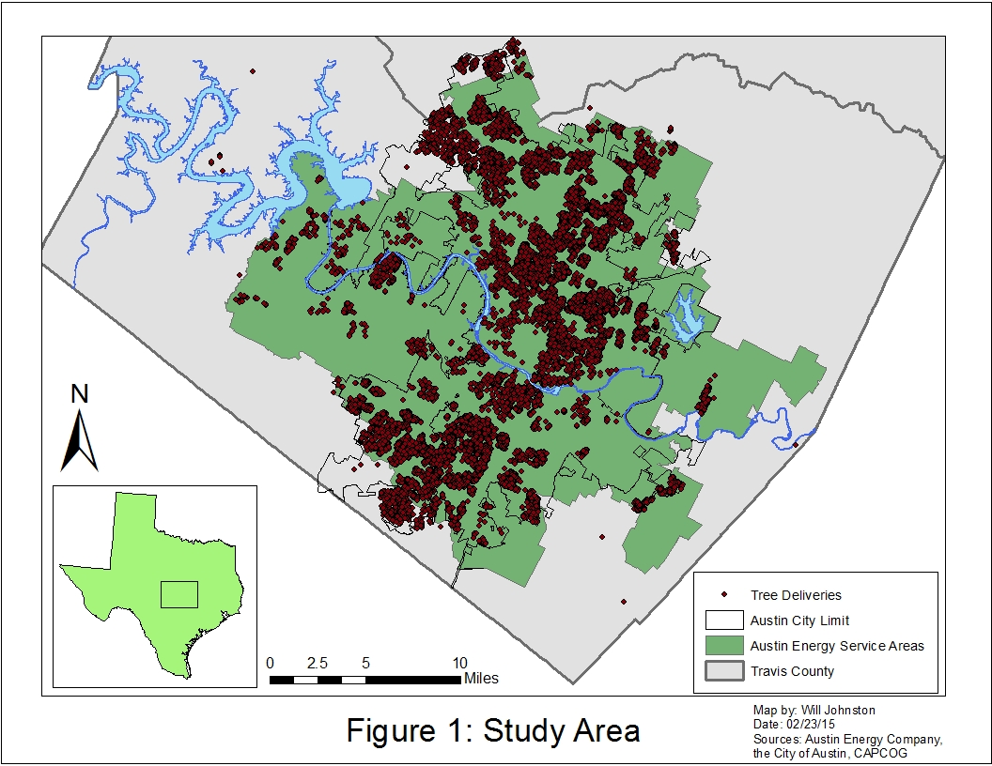
4.1 Figure 1: Study Area

4.2 Figure 2: Timeline
Phase 1: Data Collection and Processing
The first six weeks of the project will be collecting the required data from the City of Austin, and USGS. Then, we will work through with the data to ensure it is of consistent format and quality to be analyzed in the next phase of the project.
Phase 2: Data and Statistical Analysis
The second phase will involve overlaying the remote sensing and GIS data in ArcGIS. Furthermore, we will analyze the relationships between the NeighborWoods trees and surface temperatures both spatially and statistically. This phase will overlap with the data collection and processing phase during the week of March 16 and 23.
Phase 3: Web and Map Development
 | April 2015
S | M | T | W | Th | F | Sat
 | Data and Statistical Analysis |  | 1 | 2 | 3 | 4
5 | 6  Data and Statistical Analysis | 7 | 8 | 9 | 10 | 11
12 | 13 | 14 | 15 | 16  Web and Map Development | 17 | 18
19 | 20 | 21 | 22 | 23  Web and Map Development | 24 | 25
26 | 27 | 28 | 29 | 30  Data Interpretation and Quality Control
This phase will see final products of the maps produced in phase 2. Additionally, the website for the project will become available and active.
Phase 4: Data Interpretation and Quality
Control
The final phase allows us two weeks to make final conclusions from our analysis and methods. This phase will ensure all data and work done has been held to standards set at the beginning of phase 1.

 | February 2015
S | M | T | W | Th | F | Sat
1 | 2 | 3 | 4  Data Collection and Processing | 5 | 6 | 7
8 | 9  Data Collection and Processing | 10 | 11 | 12 | 13 | 14
15 | 16 | 17  Data Collection and Processing | 18 | 19 | 20 | 21
22 | 23 | 24 | 25 | 26  Data Collection and Processing | 27 | 28
 | March 2015
S | M | T | W | Th | F | Sat
1 | 2 | 3 | 4 | 5 | 6  Data Collection and Processing | 7
8 | 9 | 10 | 11 | 12 | 13  Data Collection and Processing | 14
15 | 16  Data and Statistical Analysis | 17 | 18 | 19 | 20 | 21
22 | 23  Data and Statistical Analysis | 24 | 25 | 26 | 27 | 28
29 | 30  Data and Statistical Analysis | 31

 | May 2015
S | M | T | W | Th | F | Sat
 |  |  |  |  | 1  Data Interpretation and Quality Control | 2
3 | 4 | 5 | 6 | 7 | 8 | 9
10 | 11 | 12 | 13 | 14 | 15 | 16

