5/4/2015
Clancy Taylor: Project Manager
Will Johnston: Assistant Manager
Michael Amaral: Remote Sensing and GIS Analyst
Megan Branam: Remote Sensing and GIS Analyst

Final Report

The Efficacy of Residential Tree Plantings in Mitigating Urban Heat Island: An Analysis of the NeighborWoods Program in Austin, Texas

Prepared by: GreenBelt GIS Consulting, Texas State University
Prepared for: City of Austin Urban Forestry Program
May 4, 2015
Table of Contents

Introduction 1
Problem Statement 1
Summary 1
Scope 2
Background of Urban Heat Island Effect 3
Remote Sensing and UHI Effects 3

Data 4

Methods 5
Remote Sensing 5
ArcGIS 7
Statistical Analysis 8
Tree Benefit Calculator 9

Results 10
Remote Sensing 10
ArcGIS Analysis 11
Statistical Analysis 20
Tree Benefit Calculator 24

Conclusion 24

References 25

Appendix 26
Group Member’s Contribution 26
Metadata 28

1. INTRODUCTION
1.1 Problem Statement
Austin, Texas is the “place to be”, attracting many new visitors, businesses, and permanent residents due to its favorable economy, business climate, cultural attractions, and temperate climate. According to the City of Austin (CoA), the population of the city increased from 680,000 to 865,000 in just 12 years. With more people comes more development. Developed and urbanized land brings more economic vitality and opportunity to a city; however, development can have negative environmental effects. One of the negative environmental effects that is coupled with urban development is known as the Urban Heat Island effect (UHI). Many cities have implemented programs to mitigate the Urban Heat Island effect while still allowing development to occur.
In order to mitigate the UHI effect and reap other tree planting benefits, the City of Austin, Austin Energy, and the non-profit TreeFolks have implemented a tree planting program called NeighborWoods. In order to determine the effectiveness of the NeighborWoods program in UHI mitigation, the City of Austin has partnered with Greenbelt GIS Consulting. Greenbelt GIS Consulting will measure the effectiveness of the NeighborWoods program using ArcGIS, remote sensing, and statistical analysis, as well as make recommendations for future studies of this program.

1.2 Summary
This study will analyze the effectiveness of the NeighborWoods program in mitigating the UHI effect. Using ERDAS to remotely sense and analyze surface temperature, ArcGIS to analyze tree planting locations, and statistical analysis to analyze the impact of the UHI mitigation, the study will help determine the cooling and other mitigating effects of trees. The benefits of using GIS methods for this study is that GIS allows the CoA to see the spatial distribution of not only the NeighborWoods tree program, but also the effects across the space of Austin. Furthermore, the study will analyze energy reduction benefits of NeighborWoods trees using the National Tree Benefit Calculator developed by Casey Trees and Davey Tree Expert Company.
1.3 Scope
This study will analyze the city limits of Austin, Texas, with a special emphasis on locations with NeighborWoods Tree Plantings. These locations are shown in Figure 1. The NeighborWoods tree plantings began in 2002. The study will analyze surface temperature imagery over the 13 years since NeighborWoods began.

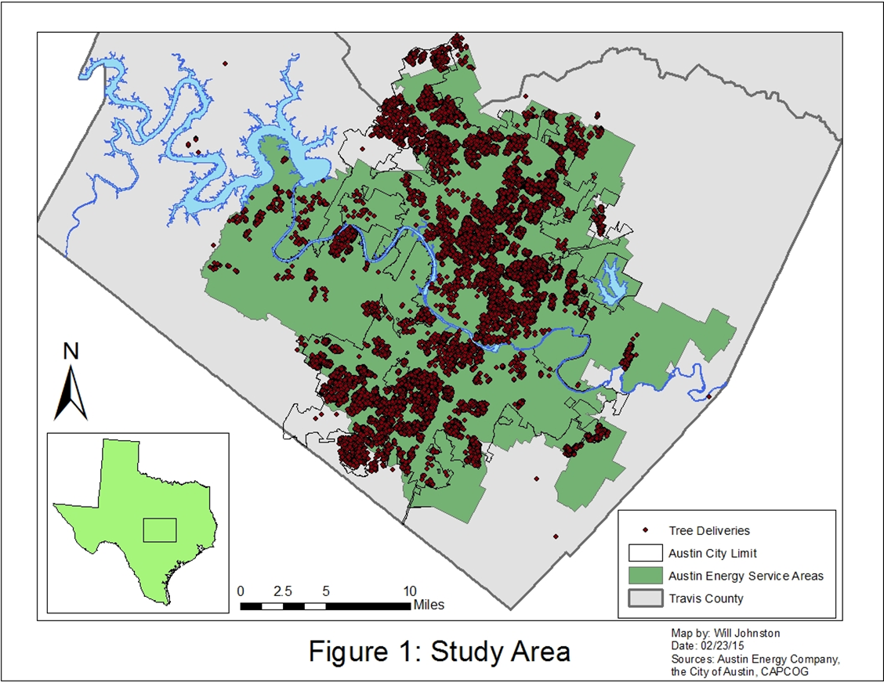

1.4 Background of Urban Heat Island Effect
According to the Environmental Protection Agency (EPA), the Urban Heat Island effect explains the phenomena that developed areas are hotter than the surrounding rural areas. The heat from the urban areas negatively impacts cities, most specifically through increasing energy use and demand to cool down structures, air pollution, greenhouse gas emissions, human health issues relating to heat and pollution, as well as having a negative impact on water quality (Environmental Protection Agency 2013).
There is a large amount of research that has been conducted into studying what the urban heat island (UHI) effect is, its causes, and its impacts on the environment. In urban locations, much of the land that once contained vegetation is replaced by impervious surfaces like concrete and asphalt. The roads and buildings that are constructed in urban areas absorb more of the suns energy during the day and release that energy into the air at night (Gallo et al., 1993). Other attributing factors to the UHI effect are reduced airflow due to large buildings, as well as a reduced amount of moisture involved in evapotranspiration in the atmosphere located in these urban zones (Coutts, et al. 2007). With the replacement of the natural earth surface with impervious concrete, there is also a larger amount of runoff from rain water (Carlson, 1986). As temperatures rise in highly urbanized areas, the amount of energy used for air conditioning inside buildings further contributes and increases the UHI effect.
1.4. Remote Sensing and UHI Effects
According to the International Journal of Remote Sensing the urban heat island effect is “caused by deforestation and the replacement of the land surface by non-evaporating and non-porous materials such as asphalt and concrete.” With large buildings and pavement covering the landscape, the temperatures in heavily urbanized areas can rise by several degrees warmer than more rural outlying areas. In extreme cases, the urban heat island (UHI) may cause changes in precipitation and temperature that usually take nearly hundred years to take place.
The scope of this study in Huntsville, a medium sized city in northern Alabama. To collect the infrared data, an Advanced Thermal and Land Applications Sensor (ATLAS) attached to the bottom of a small jet. Landsat images were taken around solar noon and once again, later in the day roughly 3 hours after sunset, to highlight the warming and cooling of urban surfaces. While the plane was flying over the city recording infrared data, teams on the ground were collecting GPS ground control points and surface temperatures at the locations of different ground cover.
After the thermal data was collected, it was digitized, converted into a raster format, then georeferenced using an aerial photo of Huntsville. Irradiance was used to calculate the heat differences in the cities by comparing the noon images with the images after the sunset. Once the daytime and nighttime irradiance values were graphically represented, it is seen that the most highly urbanized areas are the highest peaks during the day and the lowest troughs in the graphs at night.
The study concluded that highly urbanized commercial, industrial, and business areas possess the highest day time irradiance, while natural land cover types such as vegetation and water have the lowest day-night irradiance differences. Residential areas have a highly variable amount of daylight irradiance because of varying amounts of tree cover. Another finding concluded that the relationship between NDVI (Normalized Difference Vegetation Index-as a surrogate of vegetation amount) and the irradiance of each category of land cover (as a surrogate of surface temperature) reveals that importance of vacant/ transition, residential, agricultural, and vegetation land cover types in contributing towards lowering their surface temperatures by virtue of their association with biomass. In conclusion, natural land cover types help cancel out the adverse effects of the urban heat island effect.

2. DATA
The data used for this project were acquired from a variety of places to produce our final results. The location of the NeighborWoods trees where provided by the Urban Forestry Department at the City of Austin. Other data that came from the City of Austin included city limits, Austin Energy service area, land cover, zip codes, and neighborhood information. These where all used to make the base map in GIS and was useful in analyzing the effectiveness of the NeighborWoods program by providing an outline of the areas the program is targeting to make an overall difference in the Urban Heat Island Effect. This data was up to the quality standards for Austin, Texas data requirements.
For the remote sensing portion of our project, satellite imagines were obtained from the USGS Earth Explorer database. The dates for each image are close to the same time of year for the beginning point, middle and most recent year available. This was done to be able to look at the focus area with as near to the same weather and overall variables as possible. The three satellite imagines were re-projected into the Texas State Plane Central (4203) projection to match the GIS data in ArcMap. All three years were not available with good quality from a single satellite we used three different ones with the best quality data available. Landsat 7 was used for our beginning point of July 24, 2002 with 0.00% cloud cover, an image quality rating of 9 out of 10, and a pixel size of 100 feet. Landsat 4-5 was used for the middle point of August 4, 2009 with 1.00% could cover, a quality rating of 9 out of 10 and a pixel size of 50 feet. Lastly, Landsat 8 was used for our most recent point at July 1, 2014 with 3.62% cloud cover and a quality rating of 9 out of 10. Even though the cloud cover was not an issue for the Landsat 4-5 and Landsat 7 images, we ran into a bit a problem with the Landsat 8 image. The 3.62% cloud cover was visible enough that it obstructed the view of some of the focus area, which did effect the temperature readings of those areas once the data was converted to Celsius. The City of Austin is in the center of the image below, the grayish fuzziness around the city is cloud coverage that impacted some of the results of our analysis.

3. METHODS
3.1 Remote Sensing
The three Landsat images were first re-projected to the Texas State Plane Central (4203) projection. This projection is more suitable for the geographic location of the study area, and it reduces distortion in the image. After the images were re-projected to the preferred projection, the digital numbers of the images needed to be converted with various conversion factors to calculate the at-satellite brightness temperature. According to Chander et al. (2009), the digital numbers of an image must first be converted into spectral radiance values. Spectral radiance is the amount of light that is reflected off of an object. The following equations for converting digital numbers to at-sensor spectral radiance are as follows:

Landsat 4-5 and Landsat 7:
Lλ = (LMAXλ – LMINλ / Q_{calmax} – Q_{calmin}) * (Q_{cal} – Q_{calmin}) + LMINλ
- Definitions:
  - Lλ= Spectral radiance at the sensor's aperture [W/(m² sr μm)]
  - Qcal= Quantized calibrated pixel value [DN]
  - Qcalmin= Minimum quantized calibrated pixel value corresponding
  - to LMINλ [DN]
  - Qcalmax= Maximum quantized calibrated pixel value corresponding
  - to LMAXλ [DN]
  - LMINλ= Spectral at-sensor radiance that is scaled to Qcalmin [W/(m²
  - sr μm)]
  - LMAXλ= Spectral at-sensor radiance that is scaled to Qcalmax [W/(m²
  - sr μm)]

Landsat 8
Lλ = (R_{m}*Q_{cal}) + R_{a}
- Definitions
  - Lλ = Spectral radiance at the sensor's aperture [W/(m² sr μm)]
  - R_{m} = Radiance multiplier (provided in image metadata)
  - Q_{cal} = Calibrated digital number
  - R_{a} = Radiance additive value (provided in image metadata)
The conversion equations are different for Landsat 8 due to the fact that the instruments used on the satellite are different than the previous Landsat satellites. The values of the variables for Landsat 4-5 and 7 are found in the Chander et al. (2009) article, as well as the metadata for the images. The Landsat 8 variables are found in the metadata for the image. From this point, the radiance values of the pixels can be converted to the at-satellite brightness temperature.
To convert the spectral radiance values into at-satellite brightness temperature, the following equation is used:
$$T=\frac{K2}{(\ln\left(\frac{K1}{Lλ}\right)+1)}$$
- Definitions:
  - T = at-satellite brightness temperature (K)
  - K1 = Calibration constant 1 [W/(m² sr μm)]
  - K2 = Calibration constant 2 (K)
  - Lλ = Spectral radiance at the sensor's aperture [W/(m² sr μm)]
  - ln = Natural Logarithm
The output temperature units are in kelvin, so the image is converted one last time into degrees Celsius by subtracting 273.15. The three images are now ready for analysis in ArcMap.

3.2 ArcGIS
The main objective of the ArcGIS analysis is to visually analyze changes in temperature and tree cover. To create base maps for later analysis, data was downloaded from the Capital Area Council of Governments (CAPCOG), the City of Austin, and the NeighborWoods Program. Political boundaries, road networks, water bodies, and zip codes were downloaded from CAPCOG for spatial orientation purposes. The Austin Energy service area boundary was found on the City of Austin website. Tree data points containing metadata about the species planted as well as the location and dates of planting.
Since the scope of the project is the area of Austin Energy service, all tree points outside of the boundary were clipped out. The tree locations layer then was spatially joined to the zip code layer. It was concluded that the best way to display a change in temperature would be to divide the service area into sections and compare high tree population areas to low tree population areas. The low tree population areas that were established would be used as a control variable to measure how much the surface temperature changed without trees being planted there. Neighborhood planning areas were the first method investigated to split Austin up, but they did not cover the whole Austin Energy (AE) service area. Other ideas were brought up, but it was concluded that zip codes would be the most feasible method to divide up the service area. The zip codes of Austin were clipped to the shape of the AE service area. As soon as that was completed, using the attribute table, the top ten zip codes with the most trees planted were selected along with the top ten lowest density zip codes. To confirm this, a point density function was used to confirm where the high and low tree population areas were. After the high and low tree population zip codes were selected, they were converted into respective shape files. These newly created shapefiles will be the basis of the statistical analysis.
After the processing of the Landsat images was complete, the files were opened in ArcMap and fitted to the existing base map with the AE service area and the zip code layer. Small aesthetic changes were made to make the map easy to read, such as thickening border lines and creating the correct labels. Then three different maps were made with the current data from the years 2002, 2009, and 2014, with points representing the trees planted up to that year. These maps correspond with the Landsat images that were being used.
The final step of the GIS analysis was to find the mean temperature values in each of the zip codes that were being analyzed, which prepared the data for the statistical analysis. This was done by first using a Raster Clip function to cut out all unneeded Landsat imagery to create a manageable focus area, using the AE service area as the new output extent. Then, the clipped Landsat image was converted to a point vector shape file, employing a Raster to Point conversion tool. Then, the point layer was clipped to the shape of the zip code. The attribute table for the feature class was opened and the cell statistics option was selected to find the mean temperature of each individual zip code. This process was repeated until the mean temperature for all 20 zip codes was found for 2002, 2009, and 2014. Mean temperatures were recorded in an Excel spreadsheet to be used for the statistical analysis, concluding the GIS analysis component.

3.3 Statistical Analysis
In order to better understand the differences in the mean temperatures across Austin, Greenbelt GIS Consulting ran a statistical analysis of the mean temperatures per zip code. For the matter of analysis, Greenbelt GIS Consulting took the mean temperatures (in Celsius) per zip code for each year the Landsat imagery was analyzed-2002, 2009, 2014. These three data sets were then analyzed three different time periods-2002-2009, 2002-2014, and 2009-2014.
The statistical analysis performed on this data was a Wilcoxon Signed Rank Test. The Wilcoxon Signed Rank Test is a paired differences test. This test is used to find statistically significant differences in data that is non-normally distributed, and is used when comparing related samples of data. In order to run the test, we first calculated the mean temperature for the 10 zip codes with the densest NeighborWoods tree plantings, and the 10 zip codes with the least dense NeighborWoods tree plantings. Then, we analyzed the differences between the mean temperatures per zip code in 2014 and 2002, 2009 and 2002, and 2014 and 2009.
These differences were then compared against each other using the Wilcoxon Signed Rank test. This test was used to understand if these differences between the zip codes with the most dense NeighborWoods tree plantings and least dense NeighborWoods tree plantings were significant. The hypothesis that was tested under the Wilcoxon Signed Rank Test were developed in order to test the significance of the differences. The null and alternative hypothesis are as follows:
Null Hypothesis (H0): The median of differences between the temperature differences of the non-dense tree zip codes and the temperature differences of the dense zip codes is not statistically significant.
Alternative Hypothesis (H1): The median of differences between the temperature differences of the non-dense tree zip codes and the temperature differences of the dense zip codes is statistically significant.

3.4 Tree Benefit Calculator
With the use of the National Tree Benefit Calculator created by Casey Trees and Davey Tree Expert Company, a quantitative amount of energy savings and carbon reduction could be calculated. There are some assumptions to be used with the Tree Benefit Calculator; we assume that every tree is one inch in diameter when planted, and grows one inch every year. The growth rates are assumed to be similar for each year despite changes in precipitation, soil conditions, tree care and maintenance, local pest, and other external factors. When the trees are planted, we assume they are taken care of and are still standing alive to date. For all of the trees planted across the entirety of the program, they are categorized into 5 species types: large, medium, and small Broadleaf Deciduous trees, as well as large and small Broadleaf Evergreen trees. Trees are planted at the address provided by the tree recipient even though often trees are planted at different locations or not planted at all.
With these assumptions in mind, tables were created in Excel with information from the Tree Benefit Calculator for the different sizes of trees for the different species. Since each tree grew one inch every year, the total number of trees planted in one year would be multiplied many times with different coefficients to get the total amount of savings provided by trees planted in that year. This process was done for each year until reaching the end of the study’s timeframe, 2014.

4. RESULTS AND DISCUSSION
4.1 Remote Sensing
The products produced from the remote sensing portion of the project are upon which the rest of the project is focused on, the temperature on the ground. The creation of land surface temperature images were beyond the remote sensing grasps of this group, so the closest achievable goal was to generate at-satellite brightness temperature images. More specifically, at-satellite brightness temperature means the light that came from the sun, going through the atmosphere, reflects off of the ground and back into the atmosphere where the light is gathered by a satellite. There is “noise” in the atmosphere, like water vapor and other gases, which can disrupt readings and harm the quality of data. If areas of an image contain higher water vapor and the goal is to generate surface temperature, the water vapor will have a cooling effect on the gathered data, and can affect your results.
Some of the limitations associated with the remote sensing portion of the project are the images themselves. There are limited cloud coverages for the 2002 and 2009 images, but for the 2014 image, clouds impacted the southern area of the city of Austin. When there is cloud coverage over the study area, it interferes with the sensors data and can damage the integrity of the data. In addition to the cloud cover, the images were collected from the from the USGS Earth Explorer service. While the Landsat data available is good quality, it lacks high resolution. Two of the images having pixel sizes around 50 feet and one image having pixel sizes around 100 feet. Higher spatial resolution would have been more ideal with the study area being relatively small.
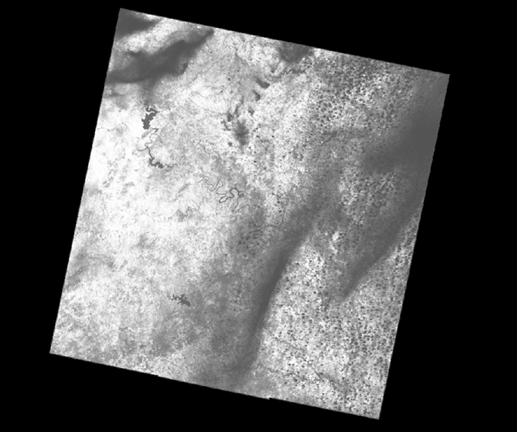
Figure 2: 2014 At-Satellite Brightness Temperature, Derived from Landsat 8. Note Cloud Cover in Southern Sections of the Image.
4.2 ArcGIS
The main results of the GIS analysis were mainly intermediate data that was made in preparation for the statistical analysis. The tree planting analysis of the zip codes was the first result that created the focus areas of the study into high population and low population areas. The second result was the surface temperature averages for each zip code, which would later be used as the input data for the Wilcoxon Signed Rank Test. After the statistical analysis was performed in SPSS, the surface temperature changes that were discovered were then visually represented in a graduated colors map as a final deliverable.
The main implication of this project is that the results can be used to test the effectiveness of other cities using similar tree planting programs, such as Los Angeles or New York. One of the main benefits of this type of research besides testing the mitigation of the UHI is that the data could be used to determine whether or not the tree planting programs are feasible from a budget and time point of view.
There were a few minor limitations to the data being used. The first being that the point data that represents the tree locations does not provide whether or not the tree is in good health. The tree could be dead but there is not a “check-up” process on the tree, as it would be very costly and time consuming, so that data is unknown. The analysis assumed that since the majority of the trees the NeighborWoods Program plants are native to the area, they have a high survival rating. The second limitation is that the point that represents the tree that was planted does not represent the actual location of the tree, but the center of the lot or property it was planted on. This would not make that much of a difference if the lot was an average residential sized lot, but if the lot was several acres in size that could skew the data.
In further research it would be helpful to have data about the status of the tree and whether or not it is in good health. This would be beneficial to future studies because it would make the study more accurate with less assumptions and considerations.
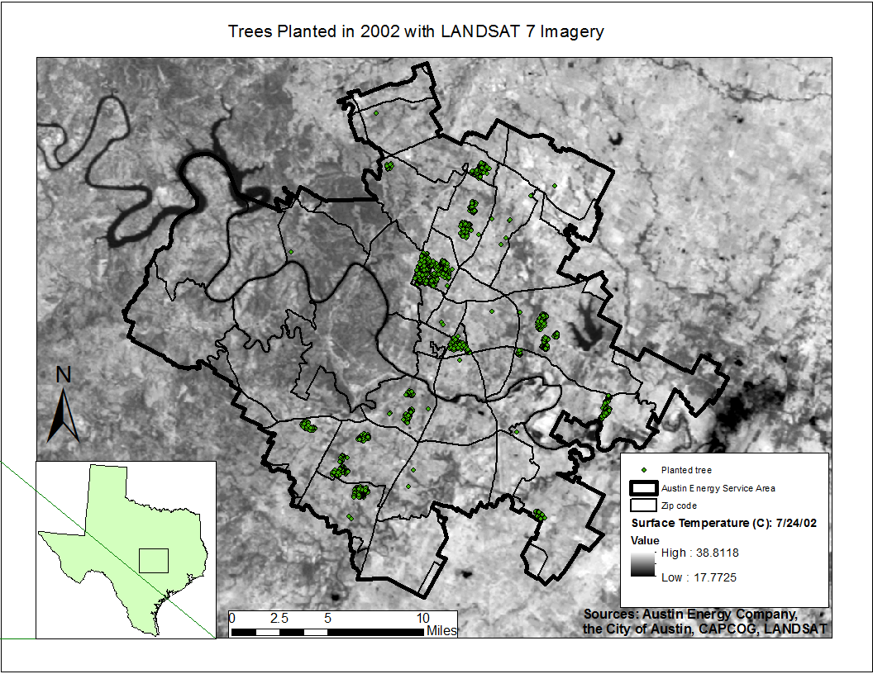Figure 3: NeighborWoods Tree Plantings, 2002. Shown with Surface Temperature Imagery
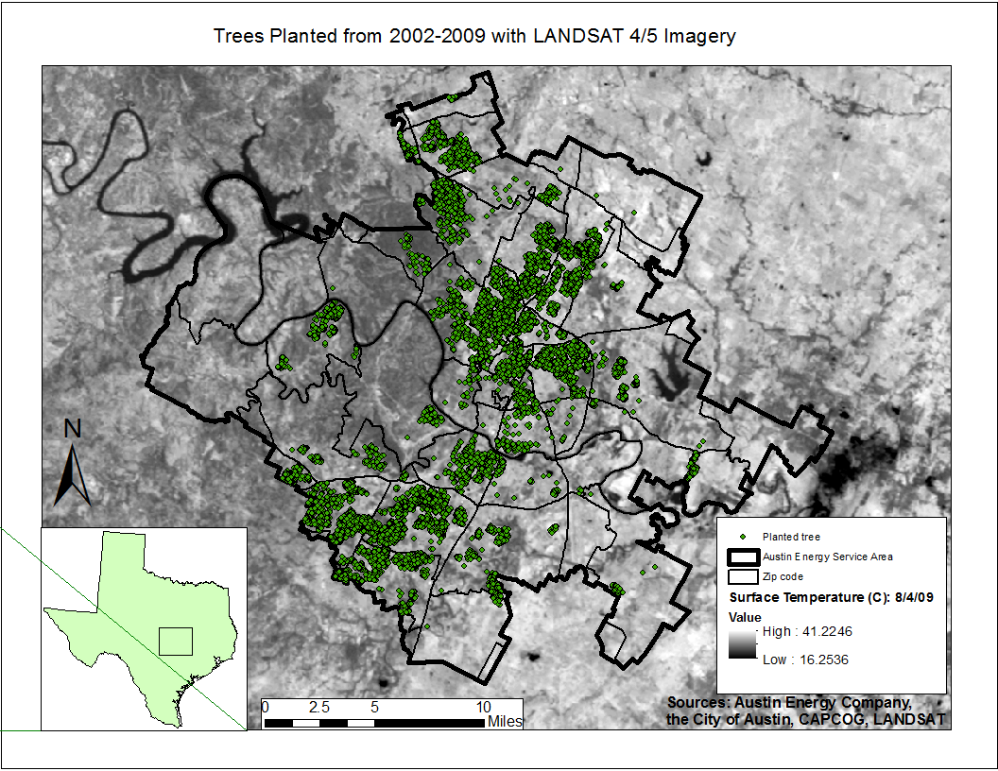Figure 4: NeighborWoods Tree Plantings, 2002-2009. Shown with Surface Temperature Imagery
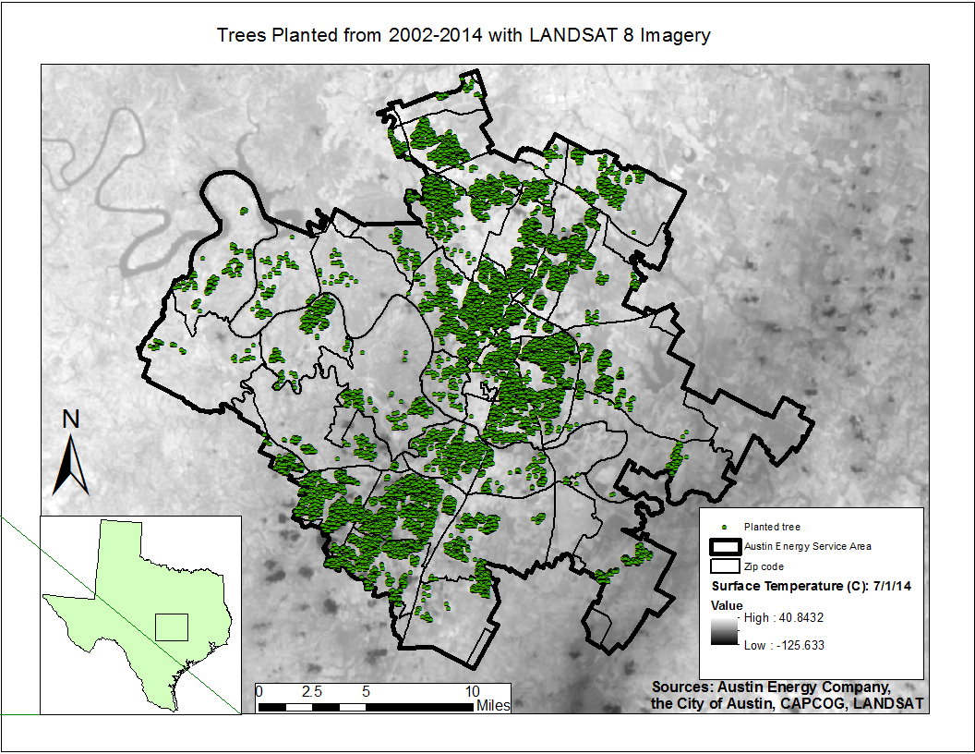Figure 5: NeighborWoods Tree Plantings, 2002-2014. Shown with Surface Temperature Imagery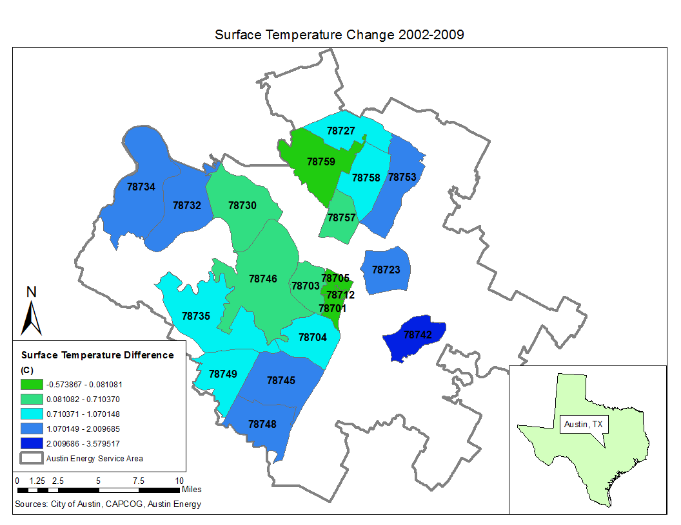Figure 6: Surface Temperature Change, 2002-2009 in the 10 Zip Codes with the Most and Least NeighborWoods Tree Plantings 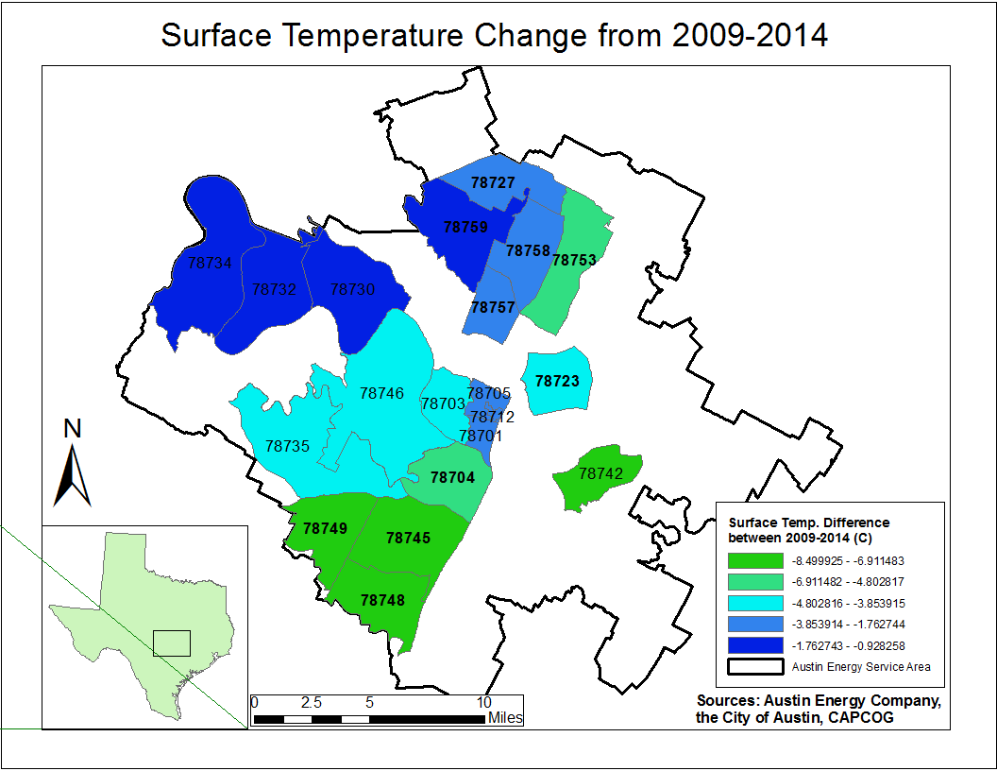 Figure 7: Surface Temperature Change, 2009-2014 in the 10 Zip Codes with the Most and Least NeighborWoods Tree Plantings 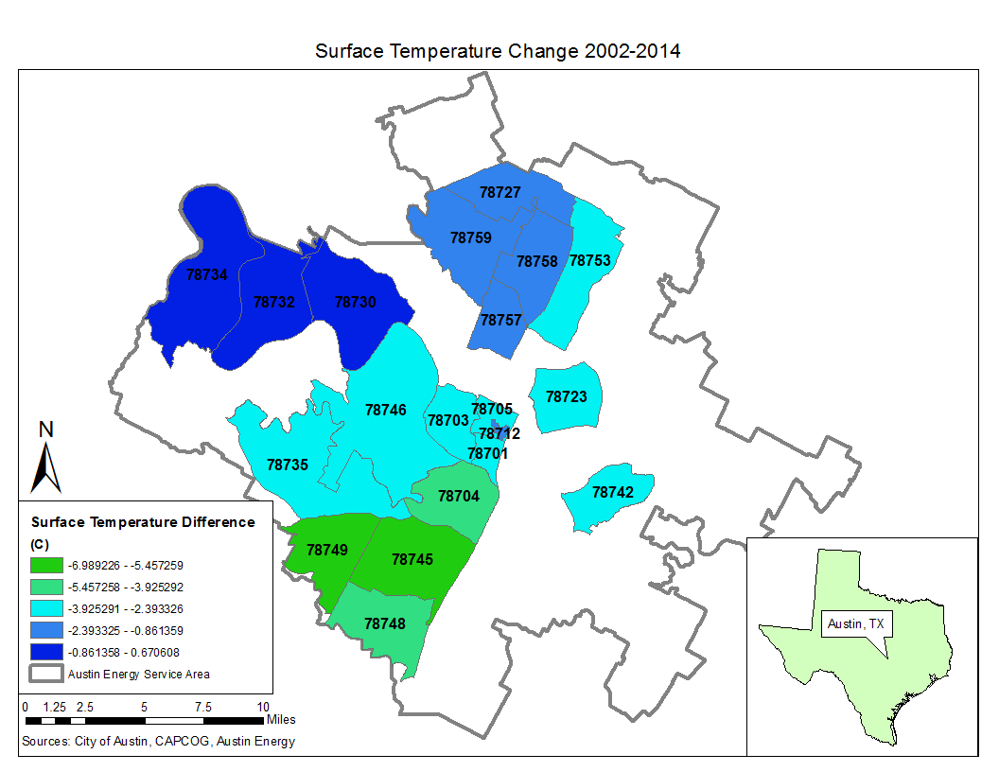 Figure 8: Surface Temperature Change, 2002-2009 in the 10 Zip Codes with the Most and Least NeighborWoods Tree Plantings
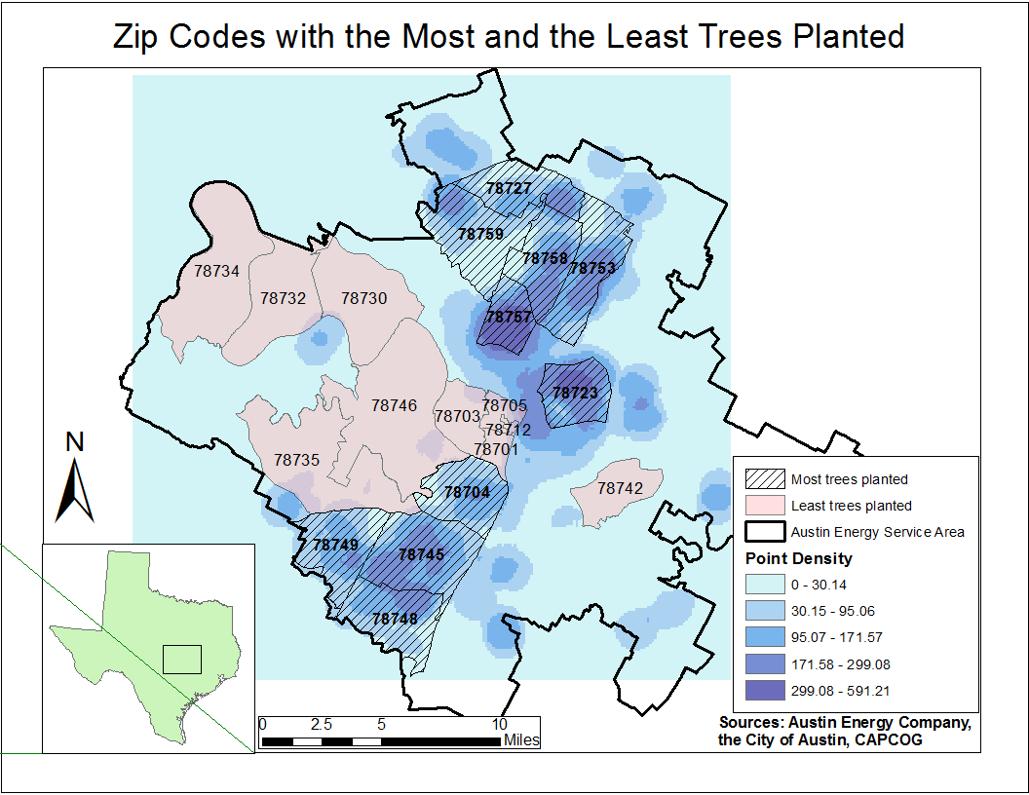
Figure 9: Surface Temperature Change, 2002-2014 in the 10 Zip Codes with the Most and Least NeighborWoods Tree Plantings

4.3 Statistical Analysis
This set of Wilcoxon Signed Tests examines the temperature differences between the areas with the densest NeighborWoods tree plantings and the least dense NeighborWoods tree plantings. The density of the tree plantings was determined in ArcGIS via a point density analysis (see section 3.2). The means between the two groups of trees was analyzed in 3 different sets, explained below. For an analysis to retain the null hypothesis would imply that the NeighborWoods do not have a significant effect on the temperatures. An alternative hypothesis (a rejection of the null hypothesis) implies that the NeighborWoods trees do have a significant effect on temperatures; however, a deeper look into the analysis is required to analyze whether the temperatures are lower.
The analysis for 2002 through 2014 showed a significant temperature difference. When looking further at the chart, most of the mean temperatures had been lowered. The zip codes with the most NeighborWoods tree plantings had cooler temperatures than those that did not. The analysis for 2002 through 2009 did not show a significant temperature difference. While pinpointing an exact cause of this, it could be due to the age of the trees or weather conditions for the time period. The analysis for 2009 through 2014 showed a significant temperature difference between the two groups of zip codes.
While this Wilcoxon Signed Ranks Test was run with many assumptions, this analysis showed that there are significant temperature differences in areas with NeighborWoods tree plantings than those without the trees. In order to better analyze the program in the future, a current health status of the tree plantings would be beneficial. While the test was run with many assumptions, such as tree health and location of the trees, two of the analyses proved significant with 95% confidence.

2002-2014:
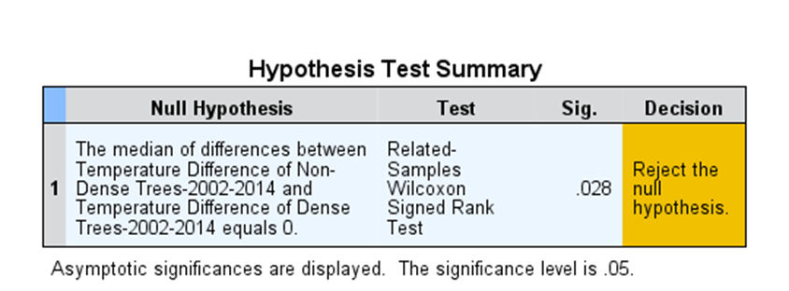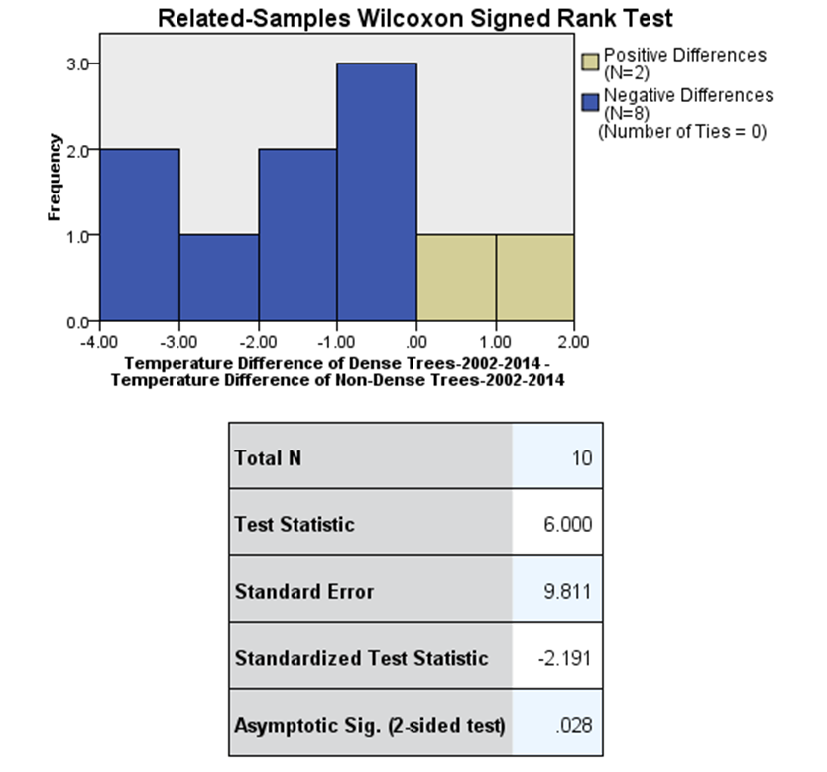

Figure 10: Results of Wilcoxon Signed-Rank Test, 2002-2014

2002-2009:
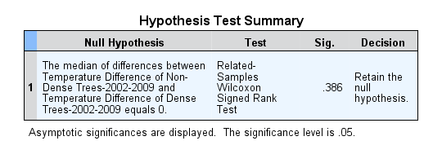
Figure 11: Results of Wilcoxon Signed-Rank Test, 2002-2009

2009-2014:
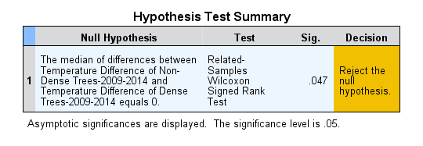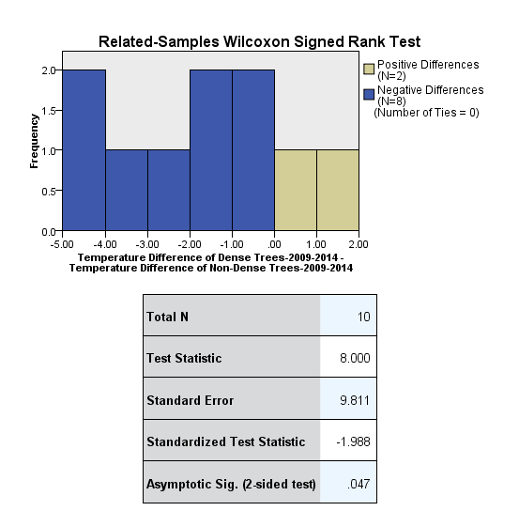

Figure 12: Results of Wilcoxon Signed-Rank Test, 2009-2014
4.4 Tree Benefit Calculator
After the calculations were completed, the NeighborWoods Tree Program provided the city of Austin with 43,563 trees. The 2,885 trees planted in 2002 were not included in the savings and reductions because the data on the species of those trees were unavailable. According to the National Tree Benefit Calculator, with the trees planted from 2003 to 2014 put all together, the savings provided is 5,798,479 kW/h. In addition to the energy savings provided by the trees, the Tree Benefit Calculator also estimates that 27,396,863 pounds of CO₂ were reduced from the atmosphere. With all of the savings and reductions provided just by trees alone, this indicates how beneficial it is to be planting more trees around our highly urbanized areas.

5. CONCLUSION
In conclusion, the NeighborWoods UHI mitigation project that was undertaken by Greenbelt GIS Consulting revealed new information about the NeighborWoods tree plantings and their environmental benefits to the City of Austin. By using many different types and tools of analysis-remote sensing, ArcGIS, statistics, and the energy savings calculations, a better understanding of the UHI in Austin is offered. This project required many different types of expertise and skill, and definitely served as a learning opportunity for all involved.
Overall, the NeighborWoods program is having a positive impact in the City of Austin. It is helping mitigate the UHI effect by lowering temperatures in areas with the tree plantings. These trees are also helping to save energy in individual’s homes (saving money and reducing energy demand), as well as taking carbon dioxide out of the atmosphere. This program should look for ways to continue and hopefully expand to positively impact more of the city. Future studies like this could be utilized in other cities with residential tree planting programs. As Austin continues to grow, so should the NeighborWoods tree program. The trees planted can help offset some of the negative environmental effects of development, helping keep Austin cooler, and mitigating the UHI effect for years to come.

6. REFERENCES

Chander, G., Markham, B., Helder, D., (2009). Summary of current radiometric calibration coefficients for Landsat MSS, TM, ETM+, and EO-1 ALI sensors. Remote Sensing of Environment 113, 893 – 903.

City of Austin. n.d. "Demographics." Planning and Development Review, City of Austin. Accessed April 15, 2015. https://austintexas.gov/demographics.

Carlson, T. N., 1986, Regional-scale estimates of surface moisture availability and thermal
inertia using remote thermal measurements. Remote Sensing Reviews, 1, 197± 247.

Coutts, A. M., J. Beringer and N.J. Tapper. 2007. Impact of Increasing Urban Density on Local Climate: Spatial and Temporal Variations in the Surface Energy Balance in Melbourne, Australia. Journal of Applied Meteorology and Climatology 46: 477-493.

Environmental Protection Agency. 2013. Heat Island Effect. August 29. http://www.epa.gov/heatislands/about/index.htm.

Gallo, K.P, A. L. McNab, T. R. Karl, J. F. Brown, J. J. Hood, and J. D. Tarpley, 1993: The Use of NOAA AVHRR Data for Assessment of the Urban Heat Island Effect. Journal of Applied Meteorology, 32, 899–908.

National Tree Benefit Calculator. Davey Tree Expert Co. and Casey Trees, n.d. Web. 10 April 2015. http://www.treebenefits.com/calculator/ Carlson, T. N., 1986, Regional-scale estimates of surface moisture availability and thermal

Parks and Recreation Department. The Heat Island Effect: Cooling Strategies. City of Austin, n.d. Web. 17 Feb. 2015. <http://www.austintexas.gov/coolspaces>.

7. APPENDIX
7.1 Group Member’s Contribution
Michael Amaral-
For this project, Megan and I mainly focused on handling the Remote Sensing tasks of the project. Images were gathered from the USGS Earth Explorer website. Extracting the data and compiling the layers for each image into one file was the first step, and re-projecting each image to the Texas State Plane Central projection to match our data in ArcGIS was completed first. After the data was prepared, Megan and I took to looking for previous studies to figure out how to determine land surface temperature. There was confusion along the way as to how to complete this task, due to the fact that both Megan and I were fairly rusty in our remote sensing knowledge. After discussing the project with a former professor, Nathan Currit. Dr. Currit informed us of the best method to achieve our goals. For the Tree Benefit Calculator task, Megan and I discussed our course of action to calculate the energy savings and carbon reductions, and split up the workload. For the final report, I prepared the remote sensing and Tree Benefit Calculator methodologies, as well as the results and discussions for both. For the deliverables, Megan and I created the tables of energy and CO2 savings.
Megan Branam-
For this report, I primarily worked alongside Michael to complete the Remote Sensing portion of the project. I found and downloaded the Landsat images used for the analysis as well as layer stacked and re-projected the images to get them ready to convert to a readable temperature output. I then conducted research in order to understand the best way to convert the temperature brightness values to a reading more commonly understood, like Celsius. For the Tree Calculator portion of our project Michael and I split up the work to calculate the atmospheric carbon reductions and energy conservations for all the trees delivered by the NeighboorWoods program. For the papers, I researched and contributed to the literary review portion of the project proposal. As well as wrote the data portion and contributing to the methodology for Remote Sensing and the Tree Calculator portion for all papers. Lastly, I helped put together the papers and headed putting together the final poster.

Will Johnston-
My role in the group involved mainly the ArcMap component. I was also a part of the web site development and created the logo for Greenbelt GIS Consulting in Adobe Illustrator. I downloaded the data from the City of Austin and CAPCOG sources and compiled it into a map on ArcMap to create a presentable map for the client. In the proposal, I created the budget for the project, along with writing the GIS methodology segment. I created maps of Austin with surface temperature, planting locations, and zip codes for the methodology part of the final report. Figuring out how to divide up the Austin Energy service area into control areas and focus areas was also my doing. The zip codes were found to be the most feasible method to divide the city up into dense and sparse locations. After the LANDSAT imagery was added to the base map, I processed the image with a raster to point function to calculate the average surface temperature per zip code and then prepared the data for the statistical analysis. For the final report, I wrote about all of the GIS components, including the GIS methodology and results. For the final deliverables I prepared the metadata, final data and compiled them into a geodatabase that would be given to the client. Finally, I developed the final maps and the website formatting.
Clancy Taylor-
As team manager, I spent time ensuring the group was staying on track to finish, as well as ensuring the work done was quality and in accordance to the RFP submitted. I developed, maintained, and adapted the timeline for the group, assuring we kept on track and on task. I created and updated to-do lists and delegated tasks to the appropriate members.
For the analysis component of the project, I researched, developed, and analyzed the statistical analysis for the project. I researched nonparametric methods and decided that the Wilcoxon Signed Ranks Test would be best for our analysis.
I also headed the writing component of the course. I edited and reviewed all information for all submitted information. I wrote the introduction and background, statistical analysis methods and results, and the conclusion for the final report. The components I wrote for the other submitted reports are listed in the appropriate papers. I also gathered and uploaded information for the website, as well as developed and organized the final presentation for the group.
7.2 Metadata
See attached files for full metadata.

