Kelly Blanton-Project Manager
William Weldon-Analyst
Paul Starkel-Analyst
Erica Tice-Analyst

An Analysis of Population Growth
and Land Use and Land Cover Changes
in the Pedernales River Basin
Prepared For:

Prepared By:

Table of Contents
1. INTRODUCTION 4
1.1 Summary 4
1.2 Problem Statement 4
1.3 Purpose 5
1.4 Scope 5
1. Data 6
2. METHODOLOGY 8
Methodology 3.1 Task 1 (shapefile creation and change detection maps) 8
Methodology 3.2 Task 2 (population trend projections) 9
Methodology 3.3 Task 3 (2014 update of LU/LC for the Pedernales) 9
3. RESULTS & DISCUSSION 9
4. CONCLUSION 19
5. REFERENCES 20
Appendix 1. Group Member Contribution PARTICIPATION 21
Appendix 2. Metadata 22

1. INTRODUCTION

1.1 Summary
The Pedernales River Basin is an area of approximately 815,000 acres located in the central Texas Hill Country. The watershed covers the counties of Blanco, Gillespie, Burnett, Hays, Kerr, Kendall, Kimble, and Travis. While the watershed overlays eight counties, Blanco and Gillespie are the counties with the majority of coverage by the Pedernales River Basin. The Pedernales, much like most rivers in central Texas, is prone to major fluctuation in water levels. For this reason, it is important to monitor the water quantity and quality of this area, as the river basin is an important resource to the Texas Hill Country providing a habitat for numerous fish and wildlife, supporting agricultural and ranching land, along with contributing to 23% of flow into Lake Travis, which is a critical source of drinking water for users downstream, such as the City of Austin (Texas Water Symposium, 2014).

1.2 Problem Statement
The problem this study attempts to address is how to discern land use and land change patterns within the study area over an extended period of time. The central Texas region is the fastest growing area in the United States. High levels of population growth affect habitat through increased water usage and loss of habitat through an increase in developed land. This information is specifically needed to ensure the environmental protection of the area. In addition to providing habitat for various wildlife, the river provides recreation and water for Austin, the capital of Texas. The project will help identify areas in need of preservation and care by providing maps of change from 1992 to 2014, helping to identify which specific class has been effected or stayed constant. With these maps the Hill Country Alliance will be informed and have data driven advocacy. To solve this problem it will be useful to create a GIS in which we can visualize and represent change in maps and tables. This will provide more concrete evidence to show land use and land change.

1.3 Purpose
The purpose of this study will be to analyze the indicators of land fragmentation, land use, development and population trends, along with other indicators of change in the Pedernales River Basin area. It is important to monitor these indicators in order to plan for the future of the Texas Hill Country and to protect its fragile natural resources, as the Pedernales River Basin is home to a plethora of fish and wildlife, who depend on the Pedernales for sustainability. The study will take populations of the eight counties the river basin covers from past, present and future years, along with past and present land use and land coverage data, in order to make create a map-set for The Hill Country Alliance which will track land use/land cover (LU/LC) over a temporal scale and will help to project a future outlook based on LU/LC and population trends for the Pedernales River Basin.

1.4 Scope
This study will cover the area of the Pedernales River Basin, which includes the counties of Blanco, Burnett, Gillespie, Hays, Kendall, Kerr, Kimble, and Travis (Fig. 1).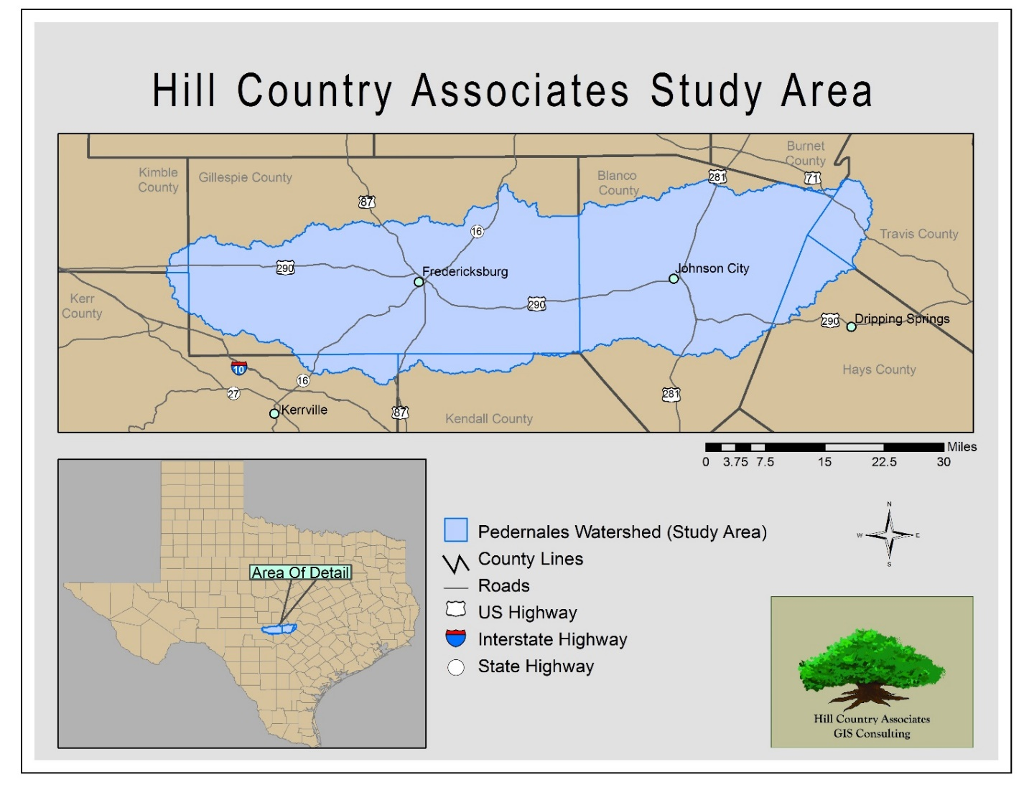
Figure 1. Pedernales River Watershed

Data
Population projection data was collected from the Texas Water Development Board 2016 Regional Water Plan County Population Projections for 2020-2070. This data is useful in looking at future population trends alongside LU/LC trends. Population data from our counties were then transferred and tables created in Microsoft Excel.
The Pedernales vector polygon was found and made into a separate layer using Hydro HUCs data from TNRIS. The data is projected into ArcMap using NAD 1983 UTM Zone 14N. The study area was isolated to the Pedernales sub basins within the huc_10_watershed shapefile. Once isolated, this polygon can be used to clip our LU/LC data to the extent of the study area.
Road data was collected for the state of Texas from TNRIS, this data was made via TX DOT road data. This was then clipped down to the study area and narrowed down to selected highways and major roads within ArcMap. This helps us give a relative spatial reference to our study area map.
LU/LC data was collected from the Multi-Resolution Land Characteristics Consortium (MRLC); we acquired the National Land Cover Database for the years of 1992, 2001, 2006 and 2011. This data was downloaded via the www.mrlc.gov website as Raster images for use in ArcGIS using the GCS North American 1983 coordinate system, we defined the projected coordinate system as NAD 1983 UTM Zone 14N in order to match the projection for the study area. These datasets are made from a combination of 30-meter resolution LANDSAT imager from the USGS and ancillary data. The NLCD’s (1992, 2001, 2006, & 2011) were clipped down to our study area in ArcMap and the Raster attribute tables were transferred over to excel to derive percentage of land use and land area covered to analyze LU/LC change in the Pedernales River Basin over time. Using Microsoft Excel and ArcMap we have created tables for LU/LC percentages, LU/LC maps, and change detection maps.
LANDSAT imagery was collected from the USGS Landsat 8 satellite for 2014 multispectral imagery. For our study area we collected four images (two summer images and two winter images) via the USGS Earth Explorer. The images collected were Row39Path27 (28_April_2014 and 22_January_2014) and Row39Path28 (05_May_2014 and 29_January_2014). These images were combined into multi-date images for each of the row and path pairs and then mosaicked within ERDAS Imagine. This new mosaicked image was then projected to fit the same projection as our other data NAD 1983 UTM Zone 14N. This data will be useful in getting an idea of current LU/LC information for the area in order to compare to the NLCD’s.

METHODOLOGY

Methodology 3.1 Task 1 (shapefile creation and change detection maps)
The first step in creating shapefiles of LU/LC datasets from the NLCD’s was to get the outline of our study area. To do this we performed a select by attribute in ArcMap of the huc_10_watershed layer downloaded from TNRIS to select the Pedernales river basin. After this layer was selected we created a new layer from the selection.
The next step in our analysis was to create shapefiles of LU/LC for each of the years from the NLCD’s downloaded. To do this we extracted by mask each one of the NLCD’s, using the huc_10_watershed selection for the Pedernales as the mask. This essentially clipped out the parts of the NLCD’s that did not fall within our study area. After this was completed we matched the symbology to match the color classification used by the MRLC allowing us to make maps of LU/LC for the years of 1992, 2001, 2006, and 2011. Attribute information for each one of the LU/LC rasters were then transferred to excel and percentage land coverage was calculated by dividing individual class cell counts by the total cell count of the raster. These tables help get a numerical sense of change in the Pedernales River Basin.
The next step was to get a visual representation of LU/LC changes in the area via creation of change detection maps. We did this using the 2001-2011 data because the 1992 data was classified using different methods and classes; therefore they were not suitable for creating change detection maps. To create these maps the cell statistics function was used to detect variety in pixel’s between different raster images. This will tell us which pixels remained unchanged and which pixels did change. Maps were then made to visually represent change between the years 2001-2006, 2006-2011, and a 2001-2011 to cover the entire 10 year period.

Methodology 3.2 Task 2 (population trend projections)
Population projections were pulled from the Texas Water Development Board and placed in Excel where we created a table showing projections through the year 2070 for each of the counties within the study area.

Methodology 3.3 Task 3 (2014 update of LU/LC for the Pedernales)
Our classification of the 2014 data used LANDSAT 8 imagery rather than NAIP imagery, this is because NAIP imagery is not multispectral and cannot be classified within ERDAS Imagine. After downloading and mosaicking all the necessary two date images from the USGS Earth Explorer the images were projected and clipped down in ERDAS in order to run a supervised classification. For this classification we selected “training” areas of known LU/LC and the computer ran the classification to find areas of similar spectral wavelengths. We combined classes into the major groups: Forest, Herbaceous, Shrubland, Barren, Developed, Agriculture, and Water/Wetland. After the supervised classification the image was then transferred back over to ArcMap and extracted to the study area in order to make an updated 2014 LU/LC map.

RESULTS & DISCUSSION
Overall, the Hill Country Associates team is satisfied with what has been accomplished with this project, it has been a learning process for everyone involved. However, Hill Country Associates feel that this analysis should only be taken for what it is. It is not an intensive analysis of what a funded project would yield, but we have provided a strong starting point for our client to locate important segments of land which are being threatened by urban development so they can better focus their efforts of conservation.
As seen throughout tables 2, 3, and 4, there has been a significant increase of developed land between the years of 2001 and 2011. Developed, High Intensity Land has seen almost a 50% increase over the ten year span. While this urban development has been occurring, there has also been a 14% decrease in overall forestland, this includes Deciduous and Evergreen Forest categories. Based on these tables and maps which were created by Hill Country Associates with collected Landsat data, we were able to create three maps illustrating land use and land coverage changes between the years of 2001 to 2006 (Figure 6), 2006 to 2011 (Figure 7), and 2001 to 2011 (Figure 8) in order to show these percent changes visually.
We have also created a 2014 LU/LC map for the Pedernales River Basin (Figure 5.) While this map shows the most recent uses of land, it is also somewhat less descriptive. Our 2014 LU/LC map only has seven land classes, which is half of what the other LU/LC maps have. Hill Country Associates needed to condense classification categories for this year’s data set because deciphering between smaller, similar land types (such as the four Developed classifications) was near impossible for us to do with unexperienced eyes and such a short timeframe to work with. Since we grouped similar categories together, the computer had a hard time deciphering between Developed land and areas that have built up limestone deposits. Because of this, the 2014 LU/LC map shows an overestimated amount of Developed land.
Initially, Hill Country Associates were under the impression that we would be able to collect past, present, and future population projections in order to create a future outlook of population for the Pedernales River Basin. However, after downloading the needed data we soon realized that this task was something way out of our level of expertise. Instead, we ended up using the population data collected from the Texas Water Development Board (Table 6) alongside the percent changes of LU/LC in the Pedernales River Basin. With this information, we were able to infer that these demographic variables are contributing factors to the increased urban development in the area.
The use of ESRI ArcMap and ERDAS Imagine were of great use to this project and helped to produce good results. We were able to create accurate GIS products for the LU/LC of the Pedernales River Basin by using Landsat data in both of these programs. While these programs were useful to us, they also caused limitations to our project. Hill Country Associates were unfamiliar with ERDAS Imagine prior to this project, as we had not extensively used the program before being assigned to this project, which was a steep learning curve and major setback.
Another issue we came across was the 1992 LU/LC data classification, data for this year was classified differently than the three other study years. As seen in Table 1, there are more classifications from 1992 than the following years, some of the classifications also have slightly different names. These differences can also be seen visually in Figure 1 by comparison to the following three figures.
If Hill Country Associates were to repeat the project, we would take the timeframe given for completion of this project into deeper consideration, as we did not realize how much time we would need for processing our results with ERDAS. Collaboration amongst our peers and educators would be another change next time and in future projects by Hill Country Associates.
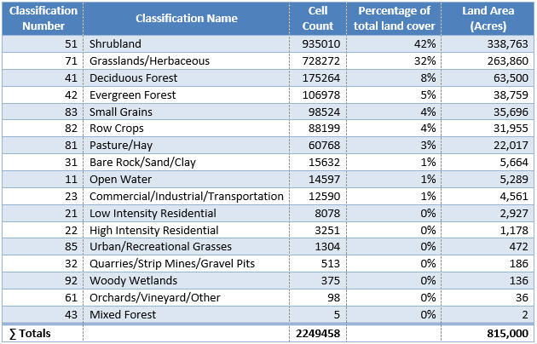
Table 1. 1992 Land Cover Statistics
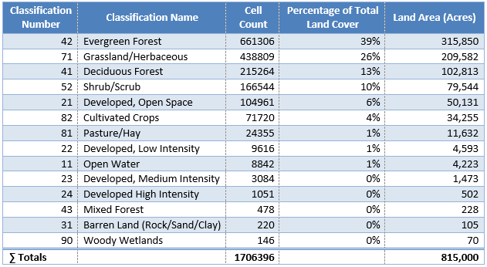
Table 2. 2001 Land Cover Statistics
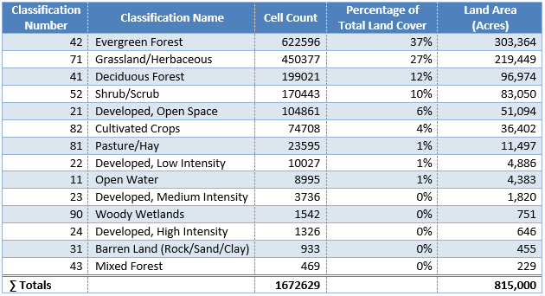
Table 3. 2006 Land Cover Statistics
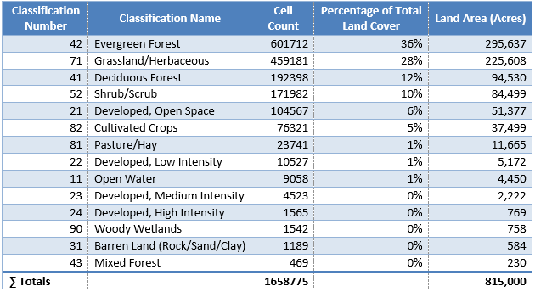
Table 4. 2011 Land Cover Statistics
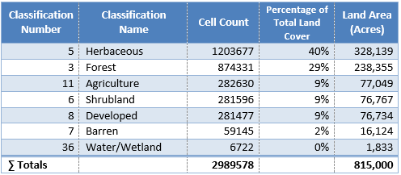
Table 5. 2014 Land Cover Statistics
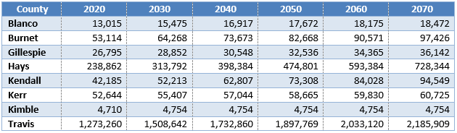
Table 6. Population Totals by County
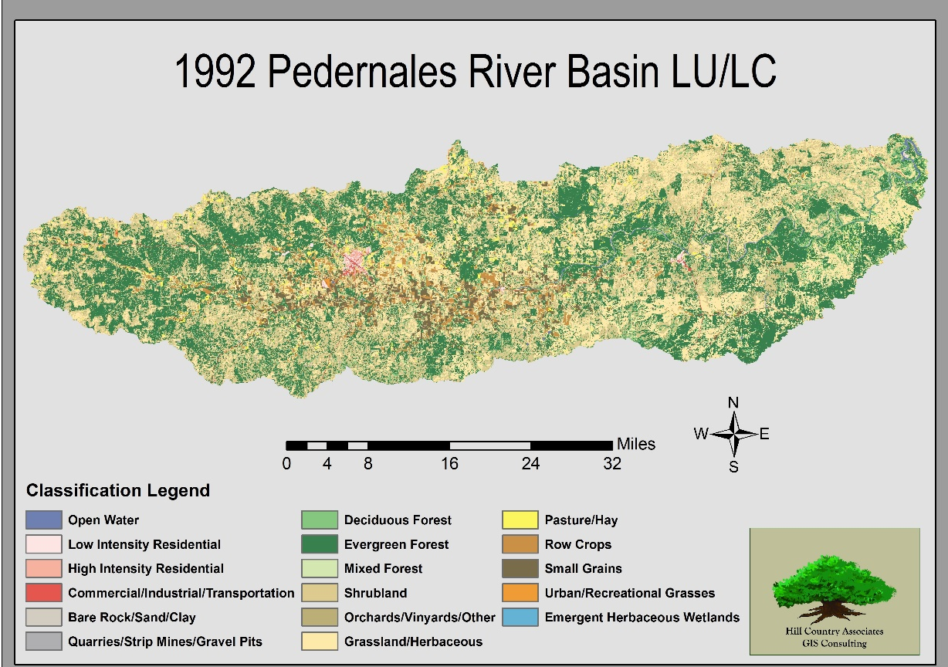
Figure 2. 1992 LULC Map
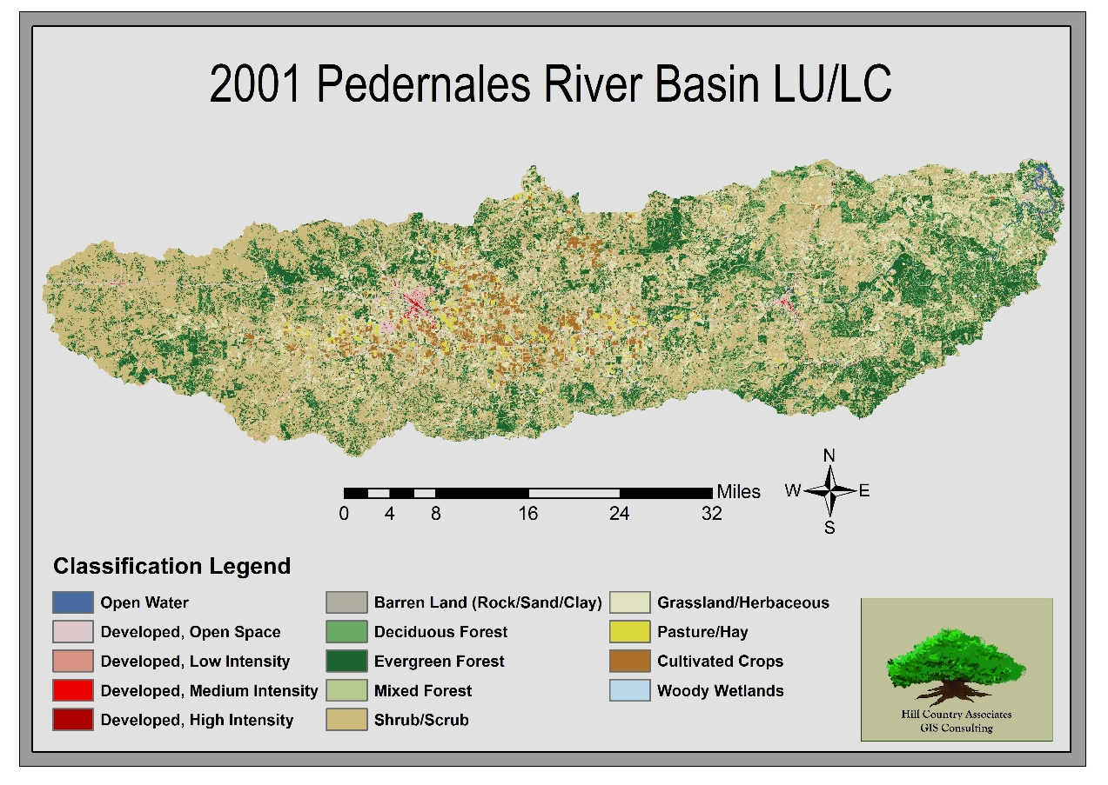
Figure 3. 2001 LULC Map
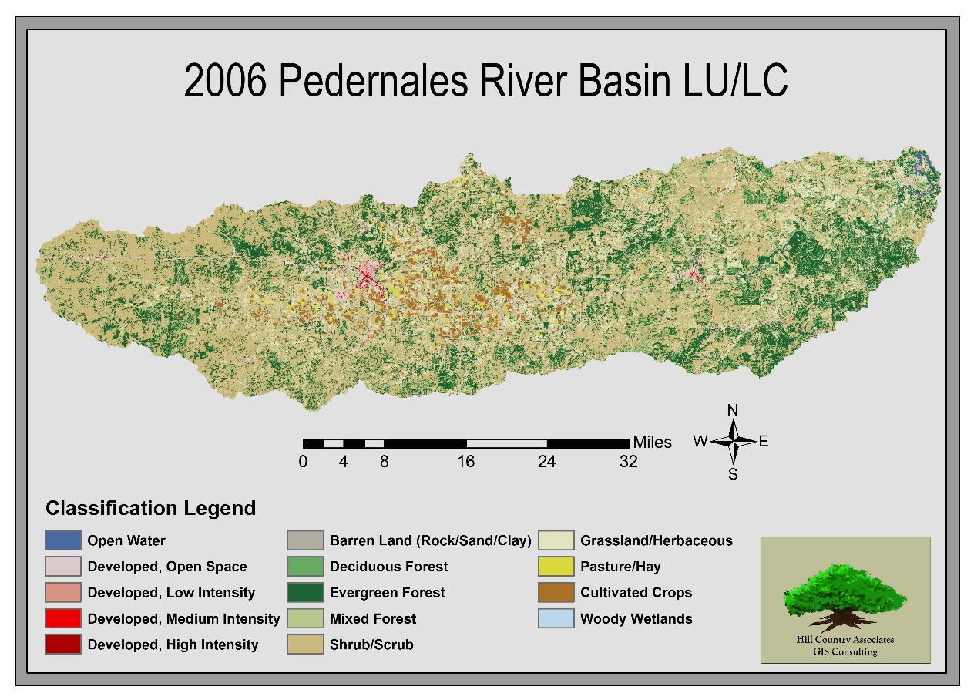
Figure 4. 2006 LULC Map
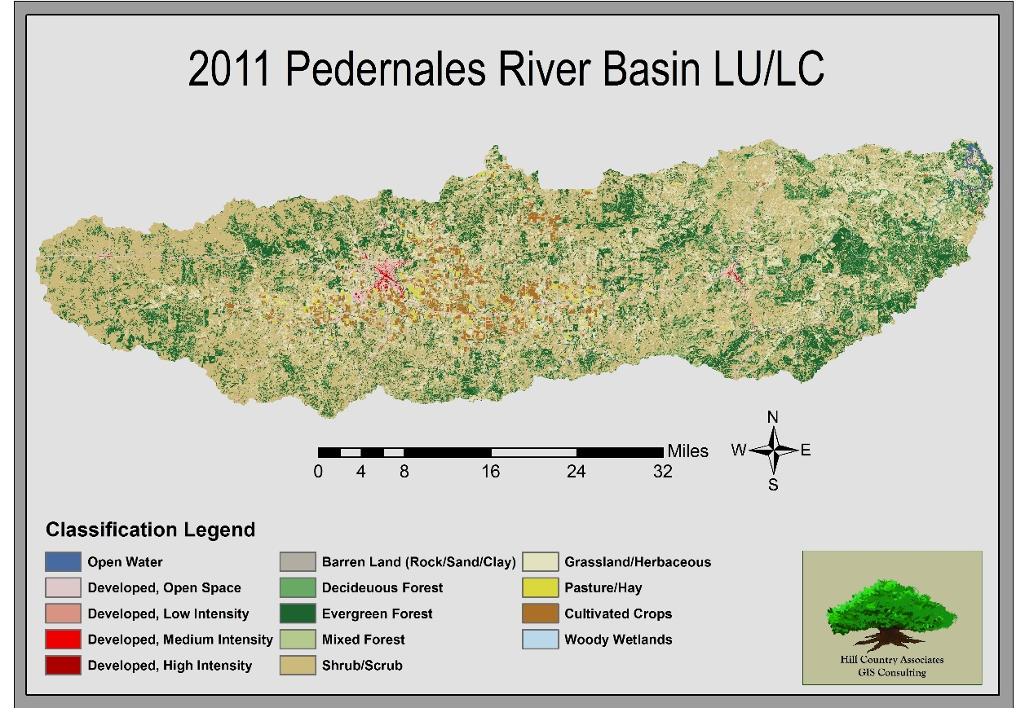
Figure 5. 2011 LULC Map
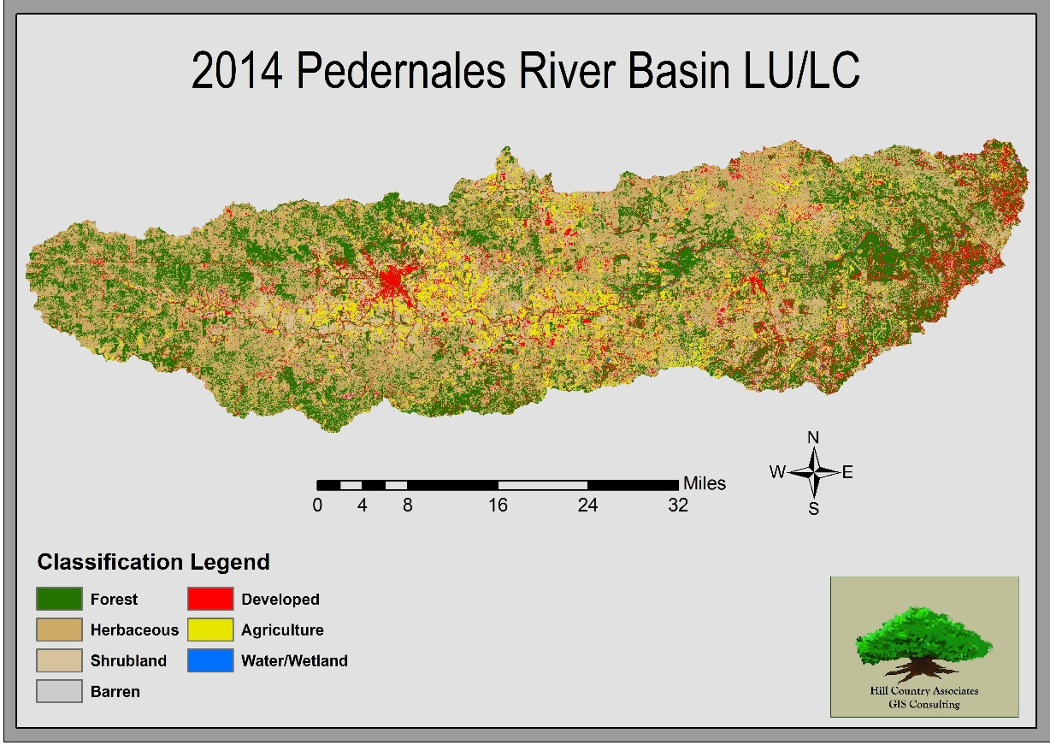
Figure 6. 2014 LULC Map
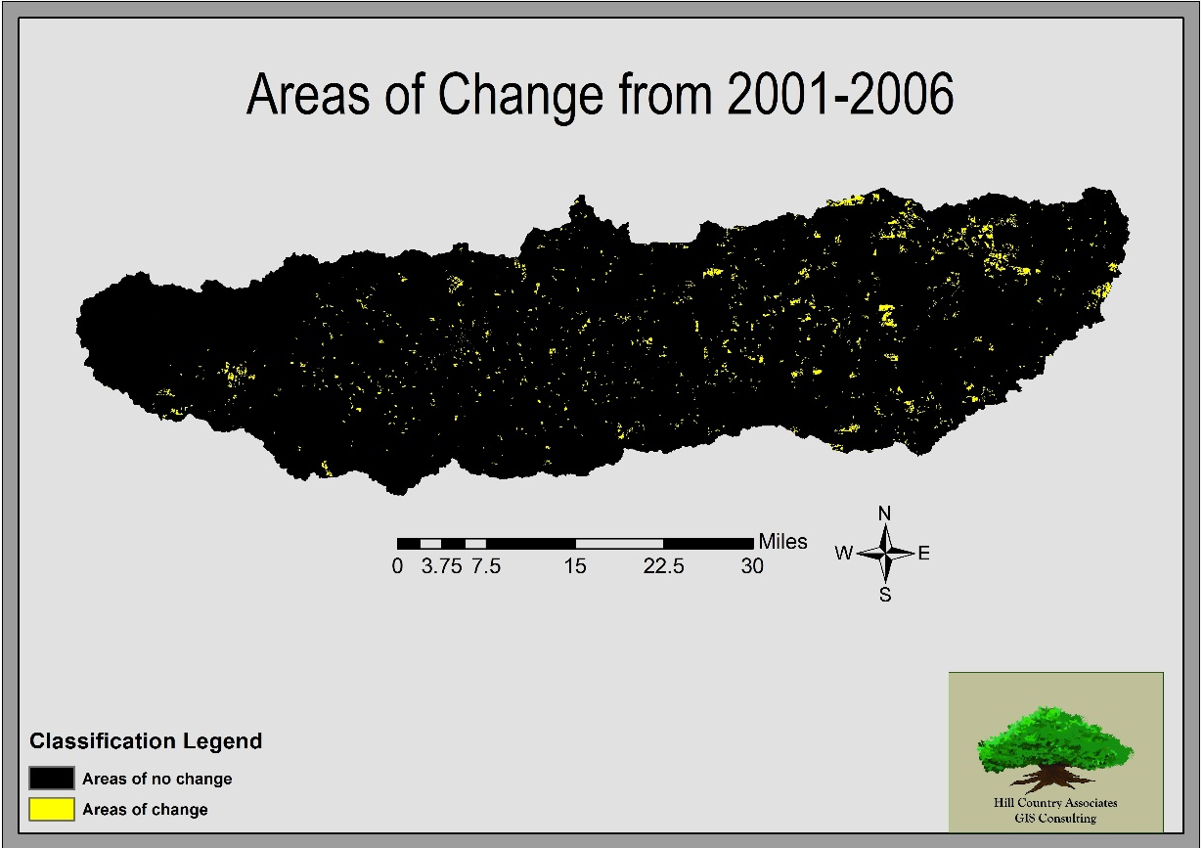
Figure 7. Change Detection Map (2001-2006)
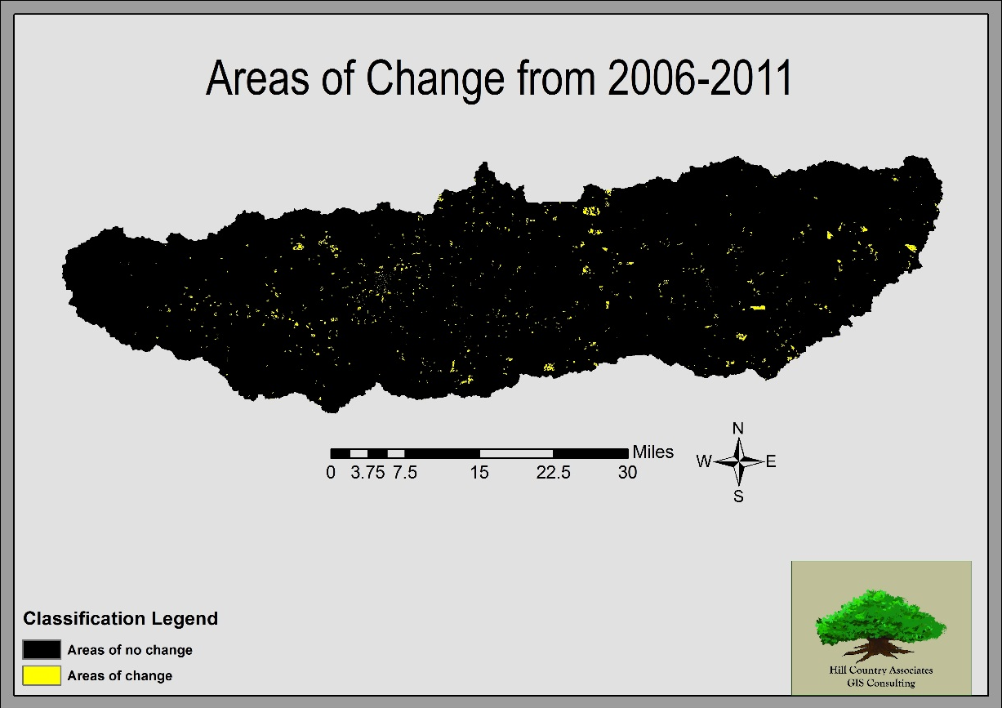
Figure 8. Change Detection Map (2006-2011)
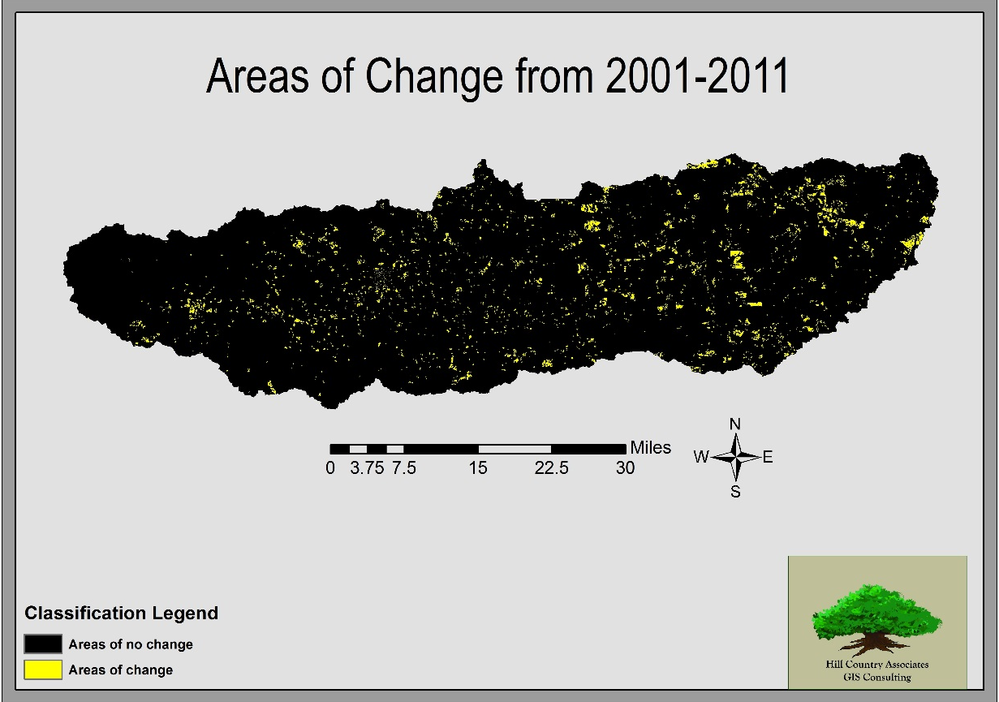
Figure 9. Change Detection Map (2001-2011)

CONCLUSION
The main pattern to take away from this study is a decrease in forested areas and an increase in developed land. This information was most easily and reliably extracted from 2001-2011 due to the available LU/LC data. This coincides with what one might expect from a growing population. This project had several challenges in creating a 2014 update of LU/LC and throughout the semester we have learned that LU/LC classification is a very difficult and time consuming process. To accurately produce a LU/LC classification takes a highly trained and skilled team of remote sensing experts to analyze patterns and differentiate spectrally similar classes. NAIP imagery due to its high 1-meter resolution is very visually appealing however it is not appropriate for actual classification because it is not a multispectral image, for this reason 30-meter resolution is the highest resolution we were able to work with. What we have created is not a perfect classification but an approximation of land use in the Pedernales and should be viewed as such.

REFERENCES
Multi-Resolution Land Characteristics Consortium (MRLC). 2011. National Land Cover Database (NLCD). Available from http://www.mrlc.gov/nlcd11_leg.php. Last accessed March 25th, 2015.
Texas Water Development Board (TWDB). 2015. Population and Water Demand Projections. Available from http://www.twdb.texas.gov/waterplanning/data/projections/index.asp. Last accessed March 25th, 2015.
Texas Water Symposium. 2014. Challenges Facing The Pedernales Basin. Challenges Facing The Pedernales Basin. Available from: http://tpr.org/post/challenges-facing-pedernales- basin Last accessed Feb. 12th, 2015.
Texas Natural Resources Information System (TNRIS). 2015. Data Search & Download. Available from http://tnris.org/data-download/#!/statewide. Last accessed April 8th, 2015.
United States Geological Survey (USGS). 2015. Earth Explorer. Available from http://earthexplorer.usgs.gov/. Last accessed March 25th, 2015.
Hill Country Alliance (HCA). 2015. Maps. Available from http://www.hillcountryalliance.org/maps/. Last accessed February 18th, 2015.

Appendix 1. Group Member Contribution PARTICIPATION
Kelly Blanton | - Responsible for group communication and coordination and analysis of 2014 LANDSAT imagery.  - Authored the Problem Statement, Conclusion, and References of the Final Report.
Paul Starkel | - Responsible for analysis of NLCD content and creation of 1992-2011 LU/LC shapefiles and maps.  - Authored the Data and parts of the Methodology sections of the Final Report.
Erica Tice | - Responsible for analysis of population trend and development, analysis of 2014 LANDSAT imagery and current land use conditions in the Pedernales.  - Authored the Introduction, and Results/Discussion sections of the Final Report.
William Weldon | - Responsible for analysis and interpretation of LANDSAT imagery and creation of an updated 2014 LU/LC classification shapefile and map.  - Authored parts of the Methodology and Metadata sections for the Final Report.

Appendix 2. Metadata
lulc1992
Raster Dataset
Tags
Hill County Associates

Summary
Land Use and Land Cover of the Pedernales River Basin
Description
Extracted to the study area of the Pedernales using the NLCD 1992 data downloaded from the MRLC.
Credits
Multi-Resolution Land Characteristics Consortium (MRLC) and TNRIS for the original NLCD and Watersheds files.
Use limitations
This data is for illustrative purposes. Hill Country Associates makes no warranties regarding this data accuracy or reliability and disclaims any and all liability associated with the use of this data. The user fully assumes the risk of use of this data.
Extent
There is no extent for this item.
Scale Range
There is no scale range for this item.
ArcGIS Metadata ►
Topics and Keywords ►
Theme keywords Hill County Associates

Hide Topics and Keywords ▲
Citation ►
Title lulc1992
Presentation formats digital map
FGDC geospatial presentation format raster digital data
Hide Citation ▲
Resource Details ►
Dataset languages English
Processing environment Microsoft Windows 7 Version 6.1 (Build 7601) Service Pack 1; Esri ArcGIS 10.2.2.3552
Credits
Multi-Resolution Land Characteristics Consortium (MRLC) and TNRIS for the original NLCD and Watersheds files.

Hide Resource Details ▲
Extents ►
Extent
Geographic extent
Bounding rectangle
West longitude -108.89041
East longitude -92.328456
South latitude 25.572904
North latitude 37.367613

Hide Extents ▲
Resource Constraints ►
Constraints
Limitations of use
This data is for illustrative purposes. Hill Country Associates makes no warranties regarding this data accuracy or reliability and disclaims any and all liability associated with the use of this data. The user fully assumes the risk of use of this data.

Hide Resource Constraints ▲
Spatial Data Properties ►

Georectified Grid ►
Number of dimensions 2
Axis dimensions properties
Dimension type row (y-axis)
Dimension size 38384

Axis dimensions properties
Dimension type column (x-axis)
Dimension size 44280

Cell geometry area
Hide Georectified Grid ▲

Hide Spatial Data Properties ▲
Fields ►

Details for object lulc1992.vat ►

Field Rowid ►
Field description
Internal feature number.

Description source
Esri

Description of values
Sequential unique whole numbers that are automatically generated.

Hide Field Rowid ▲

Field VALUE ►

Hide Field VALUE ▲

Field COUNT ►

Hide Field COUNT ▲

Field RED ►

Hide Field RED ▲

Field GREEN ►

Hide Field GREEN ▲

Field BLUE ►

Hide Field BLUE ▲

Hide Details for object lulc1992.vat ▲

Hide Fields ▲
Metadata Details ►
Metadata language English
Metadata character set utf8 - 8 bit UCS Transfer Format
Scope of the data described by the metadata dataset
Last update 2015-05-04
ArcGIS metadata properties
Metadata format ArcGIS 1.0
Created in ArcGIS for the item 2015-05-04 12:28:25

Hide Metadata Details ▲
Thumbnail and Enclosures ►
Enclosure
Enclosure type File
Description of enclosure original metadata
Original metadata document, which was translated yes
Source metadata format fgdc

Hide Thumbnail and Enclosures ▲
FGDC Metadata (read-only) ►
Identification ►
Citation
Citation Information
Title
lulc1992
Geospatial Data Presentation Form raster digital data

Description
Abstract
Extracted to the study area of the Pedernales using the NLCD 1992 data downloaded from the MRLC.
Purpose
Land Use and Land Cover of the Pedernales River Basin
Spatial Domain
Bounding Coordinates
West Bounding Coordinate -108.890410
East Bounding Coordinate -92.328456
North Bounding Coordinate 37.367613
South Bounding Coordinate 25.572904

Keywords
Theme
Theme Keyword Thesaurus None
Theme Keyword Hill County Associates

Access Constraints
None
Use Constraints
This data is for illustrative purposes. Hill Country Associates makes no warranties regarding this data accuracy or reliability and disclaims any and all liability associated with the use of this data. The user fully assumes the risk of use of this data.
Data Set Credit
Multi-Resolution Land Characteristics Consortium (MRLC) and TNRIS for the original NLCD and Watersheds files.
Native Data Set Environment
Microsoft Windows 7 Version 6.1 (Build 7601) Service Pack 1; Esri ArcGIS 10.2.2.3552

Hide Identification ▲
Spatial Data Organization ►
Direct Spatial Reference Method Raster
Raster Object Information
Raster Object Type Grid Cell
Row Count 38384
Column Count 44280

Hide Spatial Data Organization ▲
Spatial Reference ►
Horizontal Coordinate System Definition
Planar
Map Projection
Map Projection Name NAD 1983 UTM Zone 14N
Transverse Mercator
Scale Factor at Central Meridian 0.9996
Longitude of Central Meridian -99.0
Latitude of Projection Origin 0.0
False Easting 500000.0
False Northing 0.0

Planar Coordinate Information
Planar Coordinate Encoding Method coordinate pair
Coordinate Representation
Abscissa Resolution 0.000000002220024164500956
Ordinate Resolution 0.000000002220024164500956
Planar Distance Units meter

Geodetic Model
Horizontal Datum Name D North American 1983
Ellipsoid Name GRS 1980
Semi-major Axis 6378137.0
Denominator of Flattening Ratio 298.257222101

Hide Spatial Reference ▲
Entities and Attributes ►
Detailed Description
Entity Type
Entity Type Label lulc1992.vat

Attribute
Attribute Label Rowid
Attribute Definition
Internal feature number.
Attribute Definition Source Esri
Attribute Domain Values
Unrepresentable Domain
Sequential unique whole numbers that are automatically generated.

Attribute
Attribute Label VALUE

Attribute
Attribute Label COUNT

Attribute
Attribute Label RED

Attribute
Attribute Label GREEN

Attribute
Attribute Label BLUE

Hide Entities and Attributes ▲
Metadata Reference ►
Metadata Date 2015-05-04
Metadata Standard Name FGDC Content Standard for Digital Geospatial Metadata
Metadata Standard Version FGDC-STD-001-1998
Metadata Time Convention local time

lulc2001
Raster Dataset
Tags
Hill Country Associates

Summary
Land Use and Land Cover of the Pedernales River Basin
Description
Extracted to the study area of the Pedernales using the NLCD 2001 data downloaded from the MRLC.
Credits
Multi-Resolution Land Characteristics Consortium (MRLC) and TNRIS for the original NLCD and Watersheds files.
Use limitations
This data is for illustrative purposes. Hill Country Associates makes no warranties regarding this data accuracy or reliability and disclaims any and all liability associated with the use of this data. The user fully assumes the risk of use of this data.
Extent
West | -108.890415 | East | -92.328363
North | 37.367645 | South | 25.572891
Scale Range
Maximum (zoomed in) | 1:5,000
Minimum (zoomed out) | 1:150,000,000
ArcGIS Metadata ►
Topics and Keywords ►
* Content type Downloadable Data
Hide Topics and Keywords ▲
Citation ►
* Title lulc2001
Presentation formats * digital map
Hide Citation ▲
Resource Details ►
Dataset languages * English (UNITED STATES)
Spatial representation type * grid
* Processing environment Microsoft Windows 7 Version 6.1 (Build 7601) Service Pack 1; Esri ArcGIS 10.2.2.3552
Credits
Multi-Resolution Land Characteristics Consortium (MRLC) and TNRIS for the original NLCD and Watersheds files.

ArcGIS item properties
* Name lulc2001
* Location file://E:\Geo4427\project_gdb\lulc2001
* Access protocol Local Area Network

Hide Resource Details ▲
Extents ►
Extent
Geographic extent
Bounding rectangle
Extent type Extent used for searching
* West longitude -108.890415
* East longitude -92.328363
* North latitude 37.367645
* South latitude 25.572891
* Extent contains the resource Yes

Extent in the item's coordinate system
* West longitude -381764.043951
* East longitude 1092582.449857
* South latitude 2857626.403782
* North latitude 4135657.740160
* Extent contains the resource Yes

Hide Extents ▲
Resource Constraints ►
Constraints
Limitations of use
This data is for illustrative purposes. Hill Country Associates makes no warranties regarding this data accuracy or reliability and disclaims any and all liability associated with the use of this data. The user fully assumes the risk of use of this data.

Hide Resource Constraints ▲
Spatial Reference ►
ArcGIS coordinate system
* Type Projected
* Geographic coordinate reference GCS_North_American_1983
* Projection NAD_1983_UTM_Zone_14N
* Coordinate reference details
Projected coordinate system
Well-known identifier 26914
X origin -5120900
Y origin -9998100
XY scale 450445547.3910538
Z origin -100000
Z scale 10000
M origin -100000
M scale 10000
XY tolerance 0.001
Z tolerance 0.001
M tolerance 0.001
High precision true
Latest well-known identifier 26914
Well-known text PROJCS["NAD_1983_UTM_Zone_14N",GEOGCS["GCS_North_American_1983",DATUM["D_North_American_1983",SPHEROID["GRS_1980",6378137.0,298.257222101]],PRIMEM["Greenwich",0.0],UNIT["Degree",0.0174532925199433]],PROJECTION["Transverse_Mercator"],PARAMETER["False_Easting",500000.0],PARAMETER["False_Northing",0.0],PARAMETER["Central_Meridian",-99.0],PARAMETER["Scale_Factor",0.9996],PARAMETER["Latitude_Of_Origin",0.0],UNIT["Meter",1.0],AUTHORITY["EPSG",26914]]

Reference system identifier
* Value 26914
* Codespace EPSG
* Version 8.2.6
Hide Spatial Reference ▲
Spatial Data Properties ►

Georectified Grid ►
* Number of dimensions 2
Axis dimensions properties
Dimension type column (x-axis)
* Dimension size 44242
* Resolution 33.324590 Meter

Axis dimensions properties
Dimension type row (y-axis)
* Dimension size 38351
* Resolution 33.324590 Meter

* Cell geometry area
* Point in pixel center
* Transformation parameters are available Yes
* Check points are available No
Corner points
* Point -381764.043951 2857626.403782
* Point -381764.043951 4135657.740160
* Point 1092582.449857 4135657.740160
* Point 1092582.449857 2857626.403782

* Center point 355409.202953 3496642.071971
Hide Georectified Grid ▲

ArcGIS Raster Properties ►
General Information
* Pixel depth 8
* Compression type RLE
* Number of bands 1
* Raster format GRID
* Source type continuous
* Pixel type unsigned integer
* No data value 0
* Has colormap No
* Has pyramids Yes
Hide ArcGIS Raster Properties ▲

Hide Spatial Data Properties ▲
Spatial Data Content ►
Image Description
* Type of information physical measurement
Band information
* Description Band_1
* Maximum value 90.000000
* Minimum value 11.000000
* Number of bits per value 8
Hide Spatial Data Content ▲
Geoprocessing history ►
Process
Process name Extract by Mask (3)
Date 2015-02-04 11:58:45
Tool location c:\program files (x86)\arcgis\desktop10.2\ArcToolbox\Toolboxes\Spatial Analyst Tools.tbx\ExtractByMask
Command issued
ExtractByMask nlcd_2001_landcover_2011_edition_2014_10_10.img "huc_10_watershed selection" E:\Geo4427\project_gdb\LU_2001rs
Include in lineage when exporting metadata No
Hide Geoprocessing history ▲
Distribution ►
Distribution format
* Name Raster Dataset
Hide Distribution ▲
Fields ►

Details for object lulc2001.vat ►
* Type Table
* Row count 14
Field Rowid ►
* Alias Rowid
* Data type OID
* Width 4
* Precision 0
* Scale 0
* Field description
Internal feature number.

* Description source
Esri

* Description of values
Sequential unique whole numbers that are automatically generated.

Hide Field Rowid ▲

Field VALUE ►
* Alias VALUE
* Data type Integer
* Width 4
* Precision 0
* Scale 0
Hide Field VALUE ▲

Field COUNT ►
* Alias COUNT
* Data type Integer
* Width 4
* Precision 0
* Scale 0
Hide Field COUNT ▲

Hide Details for object lulc2001.vat ▲

Hide Fields ▲
Metadata Details ►
* Metadata language English (UNITED STATES)
* Metadata character set utf8 - 8 bit UCS Transfer Format
Scope of the data described by the metadata * dataset
Scope name * dataset
* Last update 2015-05-04
ArcGIS metadata properties
Metadata format ArcGIS 1.0
Standard or profile used to edit metadata ItemDescription
Created in ArcGIS for the item 2015-02-04 11:58:45
Last modified in ArcGIS for the item 2015-05-04 12:32:27
Automatic updates
Have been performed Yes
Last update 2015-05-04 12:32:27

Hide Metadata Details ▲
FGDC Metadata (read-only) ►
Entities and Attributes ►
Detailed Description
Entity Type
Entity Type Label lulc2001.vat

Attribute
Attribute Label Rowid
Attribute Definition
Internal feature number.
Attribute Definition Source Esri
Attribute Domain Values
Unrepresentable Domain
Sequential unique whole numbers that are automatically generated.

Attribute
Attribute Label VALUE

Attribute
Attribute Label COUNT

Hide Entities and Attributes ▲

lulc2006
Raster Dataset
Tags
Hill Country Associates

Summary
Land Use and Land Cover of the Pedernales River Basin.
Description
Extracted to the study area of the Pedernales using the NLCD 2006 data downloaded from the MRLC.
Credits
Multi-Resolution Land Characteristics Consortium (MRLC) and TNRIS for the original NLCD and Watersheds files.
Use limitations
This data is for illustrative purposes. Hill Country Associates makes no warranties regarding this data accuracy or reliability and disclaims any and all liability associated with the use of this data. The user fully assumes the risk of use of this data.
Extent
West | -108.890415 | East | -92.328363
North | 37.367645 | South | 25.572891
Scale Range
Maximum (zoomed in) | 1:5,000
Minimum (zoomed out) | 1:150,000,000
ArcGIS Metadata ►
Topics and Keywords ►
* Content type Downloadable Data
Hide Topics and Keywords ▲
Citation ►
* Title lulc2006
Presentation formats * digital map
Hide Citation ▲
Resource Details ►
Dataset languages * English (UNITED STATES)
Spatial representation type * grid
* Processing environment Microsoft Windows 7 Version 6.1 (Build 7601) Service Pack 1; Esri ArcGIS 10.2.2.3552
Credits
Multi-Resolution Land Characteristics Consortium (MRLC) and TNRIS for the original NLCD and Watersheds files.

ArcGIS item properties
* Name lulc2006
* Location file://E:\Geo4427\project_gdb\lulc2006
* Access protocol Local Area Network

Hide Resource Details ▲
Extents ►
Extent
Geographic extent
Bounding rectangle
Extent type Extent used for searching
* West longitude -108.890415
* East longitude -92.328363
* North latitude 37.367645
* South latitude 25.572891
* Extent contains the resource Yes

Extent in the item's coordinate system
* West longitude -381764.043951
* East longitude 1092582.449857
* South latitude 2857626.403782
* North latitude 4135657.740160
* Extent contains the resource Yes

Hide Extents ▲
Resource Constraints ►
Constraints
Limitations of use
This data is for illustrative purposes. Hill Country Associates makes no warranties regarding this data accuracy or reliability and disclaims any and all liability associated with the use of this data. The user fully assumes the risk of use of this data.

Hide Resource Constraints ▲
Spatial Reference ►
ArcGIS coordinate system
* Type Projected
* Geographic coordinate reference GCS_North_American_1983
* Projection NAD_1983_UTM_Zone_14N
* Coordinate reference details
Projected coordinate system
Well-known identifier 26914
X origin -5120900
Y origin -9998100
XY scale 450445547.3910538
Z origin -100000
Z scale 10000
M origin -100000
M scale 10000
XY tolerance 0.001
Z tolerance 0.001
M tolerance 0.001
High precision true
Latest well-known identifier 26914
Well-known text PROJCS["NAD_1983_UTM_Zone_14N",GEOGCS["GCS_North_American_1983",DATUM["D_North_American_1983",SPHEROID["GRS_1980",6378137.0,298.257222101]],PRIMEM["Greenwich",0.0],UNIT["Degree",0.0174532925199433]],PROJECTION["Transverse_Mercator"],PARAMETER["False_Easting",500000.0],PARAMETER["False_Northing",0.0],PARAMETER["Central_Meridian",-99.0],PARAMETER["Scale_Factor",0.9996],PARAMETER["Latitude_Of_Origin",0.0],UNIT["Meter",1.0],AUTHORITY["EPSG",26914]]

Reference system identifier
* Value 26914
* Codespace EPSG
* Version 8.2.6
Hide Spatial Reference ▲
Spatial Data Properties ►

Georectified Grid ►
* Number of dimensions 2
Axis dimensions properties
Dimension type column (x-axis)
* Dimension size 44242
* Resolution 33.324590 Meter

Axis dimensions properties
Dimension type row (y-axis)
* Dimension size 38351
* Resolution 33.324590 Meter

* Cell geometry area
* Point in pixel center
* Transformation parameters are available Yes
* Check points are available No
Corner points
* Point -381764.043951 2857626.403782
* Point -381764.043951 4135657.740160
* Point 1092582.449857 4135657.740160
* Point 1092582.449857 2857626.403782

* Center point 355409.202953 3496642.071971
Hide Georectified Grid ▲

ArcGIS Raster Properties ►
General Information
* Pixel depth 8
* Compression type RLE
* Number of bands 1
* Raster format GRID
* Source type continuous
* Pixel type unsigned integer
* No data value 0
* Has colormap No
* Has pyramids Yes
Hide ArcGIS Raster Properties ▲

Hide Spatial Data Properties ▲
Spatial Data Content ►
Image Description
* Type of information physical measurement
Band information
* Description Band_1
* Maximum value 90.000000
* Minimum value 11.000000
* Number of bits per value 8
Hide Spatial Data Content ▲
Geoprocessing history ►
Process
Process name Extract by Mask (2)
Date 2015-02-04 11:54:53
Tool location c:\program files (x86)\arcgis\desktop10.2\ArcToolbox\Toolboxes\Spatial Analyst Tools.tbx\ExtractByMask
Command issued
ExtractByMask nlcd_2006_landcover_2011_edition_2014_10_10.img "huc_10_watershed selection" E:\Geo4427\project_gdb\LU_2006rs
Include in lineage when exporting metadata No
Hide Geoprocessing history ▲
Distribution ►
Distribution format
* Name Raster Dataset
Hide Distribution ▲
Fields ►

Details for object lulc2006.vat ►
* Type Table
* Row count 14
Field Rowid ►
* Alias Rowid
* Data type OID
* Width 4
* Precision 0
* Scale 0
* Field description
Internal feature number.

* Description source
Esri

* Description of values
Sequential unique whole numbers that are automatically generated.

Hide Field Rowid ▲

Field VALUE ►
* Alias VALUE
* Data type Integer
* Width 4
* Precision 0
* Scale 0
Hide Field VALUE ▲

Field COUNT ►
* Alias COUNT
* Data type Integer
* Width 4
* Precision 0
* Scale 0
Hide Field COUNT ▲

Hide Details for object lulc2006.vat ▲

Hide Fields ▲
Metadata Details ►
* Metadata language English (UNITED STATES)
* Metadata character set utf8 - 8 bit UCS Transfer Format
Scope of the data described by the metadata * dataset
Scope name * dataset
* Last update 2015-05-04
ArcGIS metadata properties
Metadata format ArcGIS 1.0
Standard or profile used to edit metadata ItemDescription
Created in ArcGIS for the item 2015-02-04 11:54:53
Last modified in ArcGIS for the item 2015-05-04 12:34:04
Automatic updates
Have been performed Yes
Last update 2015-05-04 12:34:04

Hide Metadata Details ▲
FGDC Metadata (read-only) ►
Entities and Attributes ►
Detailed Description
Entity Type
Entity Type Label lulc2006.vat

Attribute
Attribute Label Rowid
Attribute Definition
Internal feature number.
Attribute Definition Source Esri
Attribute Domain Values
Unrepresentable Domain
Sequential unique whole numbers that are automatically generated.

Attribute
Attribute Label VALUE

Attribute
Attribute Label COUNT

Hide Entities and Attributes ▲

lulc2011
Raster Dataset
Tags
Hill Country Associates

Summary
Land Use and Land Cover of the Pedernales River Basin
Description
Extracted to the study area of the Pedernales using the NLCD 2011 data downloaded from the MRLC.
Credits
Multi-Resolution Land Characteristics Consortium (MRLC) and TNRIS for the original NLCD and Watersheds files.
Use limitations
This data is for illustrative purposes. Hill Country Associates makes no warranties regarding this data accuracy or reliability and disclaims any and all liability associated with the use of this data. The user fully assumes the risk of use of this data.
Extent
West | -108.890415 | East | -92.328363
North | 37.367645 | South | 25.572891
Scale Range
Maximum (zoomed in) | 1:5,000
Minimum (zoomed out) | 1:150,000,000
ArcGIS Metadata ►
Topics and Keywords ►
* Content type Downloadable Data
Hide Topics and Keywords ▲
Citation ►
* Title lulc2011
Presentation formats * digital map
Hide Citation ▲
Resource Details ►
Dataset languages * English (UNITED STATES)
Spatial representation type * grid
* Processing environment Microsoft Windows 7 Version 6.1 (Build 7601) Service Pack 1; Esri ArcGIS 10.2.2.3552
Credits
Multi-Resolution Land Characteristics Consortium (MRLC) and TNRIS for the original NLCD and Watersheds files.

ArcGIS item properties
* Name lulc2011
* Location file://E:\Geo4427\project_gdb\lulc2011
* Access protocol Local Area Network

Hide Resource Details ▲
Extents ►
Extent
Geographic extent
Bounding rectangle
Extent type Extent used for searching
* West longitude -108.890415
* East longitude -92.328363
* North latitude 37.367645
* South latitude 25.572891
* Extent contains the resource Yes

Extent in the item's coordinate system
* West longitude -381764.043951
* East longitude 1092582.449857
* South latitude 2857626.403782
* North latitude 4135657.740160
* Extent contains the resource Yes

Hide Extents ▲
Resource Constraints ►
Constraints
Limitations of use
This data is for illustrative purposes. Hill Country Associates makes no warranties regarding this data accuracy or reliability and disclaims any and all liability associated with the use of this data. The user fully assumes the risk of use of this data.

Hide Resource Constraints ▲
Spatial Reference ►
ArcGIS coordinate system
* Type Projected
* Geographic coordinate reference GCS_North_American_1983
* Projection NAD_1983_UTM_Zone_14N
* Coordinate reference details
Projected coordinate system
Well-known identifier 26914
X origin -5120900
Y origin -9998100
XY scale 450445547.3910538
Z origin -100000
Z scale 10000
M origin -100000
M scale 10000
XY tolerance 0.001
Z tolerance 0.001
M tolerance 0.001
High precision true
Latest well-known identifier 26914
Well-known text PROJCS["NAD_1983_UTM_Zone_14N",GEOGCS["GCS_North_American_1983",DATUM["D_North_American_1983",SPHEROID["GRS_1980",6378137.0,298.257222101]],PRIMEM["Greenwich",0.0],UNIT["Degree",0.0174532925199433]],PROJECTION["Transverse_Mercator"],PARAMETER["False_Easting",500000.0],PARAMETER["False_Northing",0.0],PARAMETER["Central_Meridian",-99.0],PARAMETER["Scale_Factor",0.9996],PARAMETER["Latitude_Of_Origin",0.0],UNIT["Meter",1.0],AUTHORITY["EPSG",26914]]

Reference system identifier
* Value 26914
* Codespace EPSG
* Version 8.2.6
Hide Spatial Reference ▲
Spatial Data Properties ►

Georectified Grid ►
* Number of dimensions 2
Axis dimensions properties
Dimension type column (x-axis)
* Dimension size 44242
* Resolution 33.324590 Meter

Axis dimensions properties
Dimension type row (y-axis)
* Dimension size 38351
* Resolution 33.324590 Meter

* Cell geometry area
* Point in pixel center
* Transformation parameters are available Yes
* Check points are available No
Corner points
* Point -381764.043951 2857626.403782
* Point -381764.043951 4135657.740160
* Point 1092582.449857 4135657.740160
* Point 1092582.449857 2857626.403782

* Center point 355409.202953 3496642.071971
Hide Georectified Grid ▲

ArcGIS Raster Properties ►
General Information
* Pixel depth 8
* Compression type RLE
* Number of bands 1
* Raster format GRID
* Source type continuous
* Pixel type unsigned integer
* No data value 0
* Has colormap No
* Has pyramids Yes
Hide ArcGIS Raster Properties ▲

Hide Spatial Data Properties ▲
Spatial Data Content ►
Image Description
* Type of information physical measurement
Band information
* Description Band_1
* Maximum value 90.000000
* Minimum value 11.000000
* Number of bits per value 8
Hide Spatial Data Content ▲
Geoprocessing history ►
Process
Process name Extract by Mask
Date 2015-02-04 11:49:47
Tool location c:\program files (x86)\arcgis\desktop10.2\ArcToolbox\Toolboxes\Spatial Analyst Tools.tbx\ExtractByMask
Command issued
ExtractByMask nlcd_2011_landcover_2011_edition_2014_10_10.img "huc_10_watershed selection" E:\Geo4427\project_gdb\LU_2011rs
Include in lineage when exporting metadata No
Hide Geoprocessing history ▲
Distribution ►
Distribution format
* Name Raster Dataset
Hide Distribution ▲
Fields ►

Details for object lulc2011.vat ►
* Type Table
* Row count 14
Field Rowid ►
* Alias Rowid
* Data type OID
* Width 4
* Precision 0
* Scale 0
* Field description
Internal feature number.

* Description source
Esri

* Description of values
Sequential unique whole numbers that are automatically generated.

Hide Field Rowid ▲

Field VALUE ►
* Alias VALUE
* Data type Integer
* Width 4
* Precision 0
* Scale 0
Hide Field VALUE ▲

Field COUNT ►
* Alias COUNT
* Data type Integer
* Width 4
* Precision 0
* Scale 0
Hide Field COUNT ▲

Hide Details for object lulc2011.vat ▲

Hide Fields ▲
Metadata Details ►
* Metadata language English (UNITED STATES)
* Metadata character set utf8 - 8 bit UCS Transfer Format
Scope of the data described by the metadata * dataset
Scope name * dataset
* Last update 2015-05-04
ArcGIS metadata properties
Metadata format ArcGIS 1.0
Standard or profile used to edit metadata ItemDescription
Created in ArcGIS for the item 2015-02-04 11:49:47
Last modified in ArcGIS for the item 2015-05-04 12:34:45
Automatic updates
Have been performed Yes
Last update 2015-05-04 12:34:45

Hide Metadata Details ▲
FGDC Metadata (read-only) ►
Entities and Attributes ►
Detailed Description
Entity Type
Entity Type Label lulc2011.vat

Attribute
Attribute Label Rowid
Attribute Definition
Internal feature number.
Attribute Definition Source Esri
Attribute Domain Values
Unrepresentable Domain
Sequential unique whole numbers that are automatically generated.

Attribute
Attribute Label VALUE

Attribute
Attribute Label COUNT

Hide Entities and Attributes ▲

change_06_11
Raster Dataset
Tags
Hill Country Associates

Summary
To detect changes in land use and land cover between specific sets of years.
Description
Change detection of LU/LC data in the Pedernales between the years 2006-2011
Credits
Multi-Resolution Land Characteristics Consortium (MRLC) and TNRIS for the original NLCD and Watersheds files.
Use limitations
This data is for illustrative purposes. Hill Country Associates makes no warranties regarding this data accuracy or reliability and disclaims any and all liability associated with the use of this data. The user fully assumes the risk of use of this data.
Extent
West | -108.890415 | East | -92.328363
North | 37.367645 | South | 25.572891
Scale Range
Maximum (zoomed in) | 1:5,000
Minimum (zoomed out) | 1:150,000,000
ArcGIS Metadata ►
Topics and Keywords ►
* Content type Downloadable Data
Hide Topics and Keywords ▲
Citation ►
* Title change_06_11
Presentation formats * digital map
Hide Citation ▲
Resource Details ►
Dataset languages * English (UNITED STATES)
Spatial representation type * grid
* Processing environment Microsoft Windows 7 Version 6.1 (Build 7601) Service Pack 1; Esri ArcGIS 10.2.2.3552
Credits
Multi-Resolution Land Characteristics Consortium (MRLC) and TNRIS for the original NLCD and Watersheds files.

ArcGIS item properties
* Name change_06_11
* Location file://E:\Geo4427\project_gdb\change_06_11
* Access protocol Local Area Network

Hide Resource Details ▲
Extents ►
Extent
Geographic extent
Bounding rectangle
Extent type Extent used for searching
* West longitude -108.890415
* East longitude -92.328363
* North latitude 37.367645
* South latitude 25.572891
* Extent contains the resource Yes

Extent in the item's coordinate system
* West longitude -381764.043989
* East longitude 1092582.449849
* South latitude 2857626.403186
* North latitude 4135657.739590
* Extent contains the resource Yes

Hide Extents ▲
Resource Constraints ►
Constraints
Limitations of use
This data is for illustrative purposes. Hill Country Associates makes no warranties regarding this data accuracy or reliability and disclaims any and all liability associated with the use of this data. The user fully assumes the risk of use of this data.

Hide Resource Constraints ▲
Spatial Reference ►
ArcGIS coordinate system
* Type Projected
* Geographic coordinate reference GCS_North_American_1983
* Projection NAD_1983_UTM_Zone_14N
* Coordinate reference details
Projected coordinate system
Well-known identifier 26914
X origin -5120900
Y origin -9998100
XY scale 450445547.3910538
Z origin -100000
Z scale 10000
M origin -100000
M scale 10000
XY tolerance 0.001
Z tolerance 0.001
M tolerance 0.001
High precision true
Latest well-known identifier 26914
Well-known text PROJCS["NAD_1983_UTM_Zone_14N",GEOGCS["GCS_North_American_1983",DATUM["D_North_American_1983",SPHEROID["GRS_1980",6378137.0,298.257222101]],PRIMEM["Greenwich",0.0],UNIT["Degree",0.0174532925199433]],PROJECTION["Transverse_Mercator"],PARAMETER["False_Easting",500000.0],PARAMETER["False_Northing",0.0],PARAMETER["Central_Meridian",-99.0],PARAMETER["Scale_Factor",0.9996],PARAMETER["Latitude_Of_Origin",0.0],UNIT["Meter",1.0],AUTHORITY["EPSG",26914]]

Reference system identifier
* Value 26914
* Codespace EPSG
* Version 8.2.6
Hide Spatial Reference ▲
Spatial Data Properties ►

Georectified Grid ►
* Number of dimensions 2
Axis dimensions properties
Dimension type column (x-axis)
* Dimension size 44242
* Resolution 33.324590 Meter

Axis dimensions properties
Dimension type row (y-axis)
* Dimension size 38351
* Resolution 33.324590 Meter

* Cell geometry area
* Point in pixel center
* Transformation parameters are available Yes
* Check points are available No
Corner points
* Point -381764.043989 2857626.403186
* Point -381764.043989 4135657.739590
* Point 1092582.449849 4135657.739590
* Point 1092582.449849 2857626.403186

* Center point 355409.202930 3496642.071388
Hide Georectified Grid ▲

ArcGIS Raster Properties ►
General Information
* Pixel depth 8
* Compression type RLE
* Number of bands 1
* Raster format GRID
* Source type continuous
* Pixel type unsigned integer
* No data value 0
* Has colormap No
* Has pyramids Yes
Hide ArcGIS Raster Properties ▲

Hide Spatial Data Properties ▲
Spatial Data Content ►
Image Description
* Type of information physical measurement
Band information
* Description Band_1
* Maximum value 2.000000
* Minimum value 1.000000
* Number of bits per value 8
Hide Spatial Data Content ▲
Geoprocessing history ►
Process
Process name
Date 2015-03-02 11:47:24
Tool location c:\program files (x86)\arcgis\desktop10.2\ArcToolbox\Toolboxes\Spatial Analyst Tools.tbx\CellStatistics
Command issued
CellStatistics LU_2011rs;LU_2006rs E:\Geo4427\project_gdb\CellSta_06_11 VARIETY DATA
Include in lineage when exporting metadata No
Hide Geoprocessing history ▲
Distribution ►
Distribution format
* Name Raster Dataset
Hide Distribution ▲
Fields ►

Details for object change_06_11.vat ►
* Type Table
* Row count 2
Field Rowid ►
* Alias Rowid
* Data type OID
* Width 4
* Precision 0
* Scale 0
* Field description
Internal feature number.

* Description source
Esri

* Description of values
Sequential unique whole numbers that are automatically generated.

Hide Field Rowid ▲

Field VALUE ►
* Alias VALUE
* Data type Integer
* Width 4
* Precision 0
* Scale 0
Hide Field VALUE ▲

Field COUNT ►
* Alias COUNT
* Data type Integer
* Width 4
* Precision 0
* Scale 0
Hide Field COUNT ▲

Hide Details for object change_06_11.vat ▲

Hide Fields ▲
Metadata Details ►
* Metadata language English (UNITED STATES)
* Metadata character set utf8 - 8 bit UCS Transfer Format
Scope of the data described by the metadata * dataset
Scope name * dataset
* Last update 2015-05-04
ArcGIS metadata properties
Metadata format ArcGIS 1.0
Standard or profile used to edit metadata FGDC
Created in ArcGIS for the item 2015-03-02 11:47:24
Last modified in ArcGIS for the item 2015-05-04 12:38:05
Automatic updates
Have been performed Yes
Last update 2015-05-04 12:37:39

Hide Metadata Details ▲
FGDC Metadata (read-only) ►
Entities and Attributes ►
Detailed Description
Entity Type
Entity Type Label change_06_11.vat

Attribute
Attribute Label Rowid
Attribute Definition
Internal feature number.
Attribute Definition Source Esri
Attribute Domain Values
Unrepresentable Domain
Sequential unique whole numbers that are automatically generated.

Attribute
Attribute Label VALUE

Attribute
Attribute Label COUNT

Hide Entities and Attributes ▲

change_01_11
Raster Dataset
Tags
Hill Country Associates

Summary
To detect changes in land use and land cover between specific sets of years.
Description
Change detection of LU/LC data in the Pedernales between the years 2001-2011
Credits
Multi-Resolution Land Characteristics Consortium (MRLC) and TNRIS for the original NLCD and Watersheds files.
Use limitations
This data is for illustrative purposes. Hill Country Associates makes no warranties regarding this data accuracy or reliability and disclaims any and all liability associated with the use of this data. The user fully assumes the risk of use of this data.
Extent
West | -108.890415 | East | -92.328363
North | 37.367645 | South | 25.572891
Scale Range
Maximum (zoomed in) | 1:5,000
Minimum (zoomed out) | 1:150,000,000
ArcGIS Metadata ►
Topics and Keywords ►
* Content type Downloadable Data
Hide Topics and Keywords ▲
Citation ►
* Title change_01_11
Presentation formats * digital map
Hide Citation ▲
Resource Details ►
Dataset languages * English (UNITED STATES)
Spatial representation type * grid
* Processing environment Microsoft Windows 7 Version 6.1 (Build 7601) Service Pack 1; Esri ArcGIS 10.2.2.3552
Credits
Multi-Resolution Land Characteristics Consortium (MRLC) and TNRIS for the original NLCD and Watersheds files.

ArcGIS item properties
* Name change_01_11
* Location file://E:\Geo4427\project_gdb\change_01_11
* Access protocol Local Area Network

Hide Resource Details ▲
Extents ►
Extent
Geographic extent
Bounding rectangle
Extent type Extent used for searching
* West longitude -108.890415
* East longitude -92.328363
* North latitude 37.367645
* South latitude 25.572891
* Extent contains the resource Yes

Extent in the item's coordinate system
* West longitude -381764.043989
* East longitude 1092582.449849
* South latitude 2857626.403186
* North latitude 4135657.739590
* Extent contains the resource Yes

Hide Extents ▲
Resource Constraints ►
Constraints
Limitations of use
This data is for illustrative purposes. Hill Country Associates makes no warranties regarding this data accuracy or reliability and disclaims any and all liability associated with the use of this data. The user fully assumes the risk of use of this data.

Hide Resource Constraints ▲
Spatial Reference ►
ArcGIS coordinate system
* Type Projected
* Geographic coordinate reference GCS_North_American_1983
* Projection NAD_1983_UTM_Zone_14N
* Coordinate reference details
Projected coordinate system
Well-known identifier 26914
X origin -5120900
Y origin -9998100
XY scale 450445547.3910538
Z origin -100000
Z scale 10000
M origin -100000
M scale 10000
XY tolerance 0.001
Z tolerance 0.001
M tolerance 0.001
High precision true
Latest well-known identifier 26914
Well-known text PROJCS["NAD_1983_UTM_Zone_14N",GEOGCS["GCS_North_American_1983",DATUM["D_North_American_1983",SPHEROID["GRS_1980",6378137.0,298.257222101]],PRIMEM["Greenwich",0.0],UNIT["Degree",0.0174532925199433]],PROJECTION["Transverse_Mercator"],PARAMETER["False_Easting",500000.0],PARAMETER["False_Northing",0.0],PARAMETER["Central_Meridian",-99.0],PARAMETER["Scale_Factor",0.9996],PARAMETER["Latitude_Of_Origin",0.0],UNIT["Meter",1.0],AUTHORITY["EPSG",26914]]

Reference system identifier
* Value 26914
* Codespace EPSG
* Version 8.2.6
Hide Spatial Reference ▲
Spatial Data Properties ►

Georectified Grid ►
* Number of dimensions 2
Axis dimensions properties
Dimension type column (x-axis)
* Dimension size 44242
* Resolution 33.324590 Meter

Axis dimensions properties
Dimension type row (y-axis)
* Dimension size 38351
* Resolution 33.324590 Meter

* Cell geometry area
* Point in pixel center
* Transformation parameters are available Yes
* Check points are available No
Corner points
* Point -381764.043989 2857626.403186
* Point -381764.043989 4135657.739590
* Point 1092582.449849 4135657.739590
* Point 1092582.449849 2857626.403186

* Center point 355409.202930 3496642.071388
Hide Georectified Grid ▲

ArcGIS Raster Properties ►
General Information
* Pixel depth 8
* Compression type RLE
* Number of bands 1
* Raster format GRID
* Source type continuous
* Pixel type unsigned integer
* No data value 0
* Has colormap No
* Has pyramids Yes
Hide ArcGIS Raster Properties ▲

Hide Spatial Data Properties ▲
Spatial Data Content ►
Image Description
* Type of information physical measurement
Band information
* Description Band_1
* Maximum value 2.000000
* Minimum value 1.000000
* Number of bits per value 8
Hide Spatial Data Content ▲
Distribution ►
Distribution format
* Name Raster Dataset
Hide Distribution ▲
Fields ►

Details for object change_01_11.vat ►
* Type Table
* Row count 2
Field Rowid ►
* Alias Rowid
* Data type OID
* Width 4
* Precision 0
* Scale 0
* Field description
Internal feature number.

* Description source
Esri

* Description of values
Sequential unique whole numbers that are automatically generated.

Hide Field Rowid ▲

Field VALUE ►
* Alias VALUE
* Data type Integer
* Width 4
* Precision 0
* Scale 0
Hide Field VALUE ▲

Field COUNT ►
* Alias COUNT
* Data type Integer
* Width 4
* Precision 0
* Scale 0
Hide Field COUNT ▲

Hide Details for object change_01_11.vat ▲

Hide Fields ▲
Metadata Details ►
* Metadata language English (UNITED STATES)
* Metadata character set utf8 - 8 bit UCS Transfer Format
Scope of the data described by the metadata * dataset
Scope name * dataset
* Last update 2015-05-04
ArcGIS metadata properties
Metadata format ArcGIS 1.0
Standard or profile used to edit metadata FGDC
Created in ArcGIS for the item 2015-05-01 13:46:40
Last modified in ArcGIS for the item 2015-05-04 12:40:38
Automatic updates
Have been performed Yes
Last update 2015-05-04 12:39:12

Hide Metadata Details ▲
FGDC Metadata (read-only) ►
Entities and Attributes ►
Detailed Description
Entity Type
Entity Type Label change_01_11.vat

Attribute
Attribute Label Rowid
Attribute Definition
Internal feature number.
Attribute Definition Source Esri
Attribute Domain Values
Unrepresentable Domain
Sequential unique whole numbers that are automatically generated.

Attribute
Attribute Label VALUE

Attribute
Attribute Label COUNT

Hide Entities and Attributes ▲

change_01_06
Raster Dataset
Tags
Hill Country Associates

Summary
To detect changes in land use and land cover between specific sets of years.
Description
Change detection of LU/LC data in the Pedernales between the years 2001-2006
Credits
Multi-Resolution Land Characteristics Consortium (MRLC) and TNRIS for the original NLCD and Watersheds files.
Use limitations
This data is for illustrative purposes. Hill Country Associates makes no warranties regarding this data accuracy or reliability and disclaims any and all liability associated with the use of this data. The user fully assumes the risk of use of this data.
Extent
West | -108.890415 | East | -92.328363
North | 37.367645 | South | 25.572891
Scale Range
Maximum (zoomed in) | 1:5,000
Minimum (zoomed out) | 1:150,000,000
ArcGIS Metadata ►
Topics and Keywords ►
* Content type Downloadable Data
Hide Topics and Keywords ▲
Citation ►
* Title change_01_06
Presentation formats * digital map
Hide Citation ▲
Resource Details ►
Dataset languages * English (UNITED STATES)
Spatial representation type * grid
* Processing environment Microsoft Windows 7 Version 6.1 (Build 7601) Service Pack 1; Esri ArcGIS 10.2.2.3552
Credits
Multi-Resolution Land Characteristics Consortium (MRLC) and TNRIS for the original NLCD and Watersheds files.

ArcGIS item properties
* Name change_01_06
* Location file://E:\Geo4427\project_gdb\change_01_06
* Access protocol Local Area Network

Hide Resource Details ▲
Extents ►
Extent
Geographic extent
Bounding rectangle
Extent type Extent used for searching
* West longitude -108.890415
* East longitude -92.328363
* North latitude 37.367645
* South latitude 25.572891
* Extent contains the resource Yes

Extent in the item's coordinate system
* West longitude -381764.043989
* East longitude 1092582.449849
* South latitude 2857626.403186
* North latitude 4135657.739590
* Extent contains the resource Yes

Hide Extents ▲
Resource Constraints ►
Constraints
Limitations of use
This data is for illustrative purposes. Hill Country Associates makes no warranties regarding this data accuracy or reliability and disclaims any and all liability associated with the use of this data. The user fully assumes the risk of use of this data.

Hide Resource Constraints ▲
Spatial Reference ►
ArcGIS coordinate system
* Type Projected
* Geographic coordinate reference GCS_North_American_1983
* Projection NAD_1983_UTM_Zone_14N
* Coordinate reference details
Projected coordinate system
Well-known identifier 26914
X origin -5120900
Y origin -9998100
XY scale 450445547.3910538
Z origin -100000
Z scale 10000
M origin -100000
M scale 10000
XY tolerance 0.001
Z tolerance 0.001
M tolerance 0.001
High precision true
Latest well-known identifier 26914
Well-known text PROJCS["NAD_1983_UTM_Zone_14N",GEOGCS["GCS_North_American_1983",DATUM["D_North_American_1983",SPHEROID["GRS_1980",6378137.0,298.257222101]],PRIMEM["Greenwich",0.0],UNIT["Degree",0.0174532925199433]],PROJECTION["Transverse_Mercator"],PARAMETER["False_Easting",500000.0],PARAMETER["False_Northing",0.0],PARAMETER["Central_Meridian",-99.0],PARAMETER["Scale_Factor",0.9996],PARAMETER["Latitude_Of_Origin",0.0],UNIT["Meter",1.0],AUTHORITY["EPSG",26914]]

Reference system identifier
* Value 26914
* Codespace EPSG
* Version 8.2.6
Hide Spatial Reference ▲
Spatial Data Properties ►

Georectified Grid ►
* Number of dimensions 2
Axis dimensions properties
Dimension type column (x-axis)
* Dimension size 44242
* Resolution 33.324590 Meter

Axis dimensions properties
Dimension type row (y-axis)
* Dimension size 38351
* Resolution 33.324590 Meter

* Cell geometry area
* Point in pixel center
* Transformation parameters are available Yes
* Check points are available No
Corner points
* Point -381764.043989 2857626.403186
* Point -381764.043989 4135657.739590
* Point 1092582.449849 4135657.739590
* Point 1092582.449849 2857626.403186

* Center point 355409.202930 3496642.071388
Hide Georectified Grid ▲

ArcGIS Raster Properties ►
General Information
* Pixel depth 8
* Compression type RLE
* Number of bands 1
* Raster format GRID
* Source type continuous
* Pixel type unsigned integer
* No data value 0
* Has colormap No
* Has pyramids Yes
Hide ArcGIS Raster Properties ▲

Hide Spatial Data Properties ▲
Spatial Data Content ►
Image Description
* Type of information physical measurement
Band information
* Description Band_1
* Maximum value 2.000000
* Minimum value 1.000000
* Number of bits per value 8
Hide Spatial Data Content ▲
Distribution ►
Distribution format
* Name Raster Dataset
Hide Distribution ▲
Fields ►

Details for object change_01_06.vat ►
* Type Table
* Row count 2
Field Rowid ►
* Alias Rowid
* Data type OID
* Width 4
* Precision 0
* Scale 0
* Field description
Internal feature number.

* Description source
Esri

* Description of values
Sequential unique whole numbers that are automatically generated.

Hide Field Rowid ▲

Field VALUE ►
* Alias VALUE
* Data type Integer
* Width 4
* Precision 0
* Scale 0
Hide Field VALUE ▲

Field COUNT ►
* Alias COUNT
* Data type Integer
* Width 4
* Precision 0
* Scale 0
Hide Field COUNT ▲

Hide Details for object change_01_06.vat ▲

Hide Fields ▲
Metadata Details ►
* Metadata language English (UNITED STATES)
* Metadata character set utf8 - 8 bit UCS Transfer Format
Scope of the data described by the metadata * dataset
Scope name * dataset
* Last update 2015-05-04
ArcGIS metadata properties
Metadata format ArcGIS 1.0
Standard or profile used to edit metadata FGDC
Created in ArcGIS for the item 2015-05-01 13:49:37
Last modified in ArcGIS for the item 2015-05-04 12:42:46
Automatic updates
Have been performed Yes
Last update 2015-05-04 12:41:54

Hide Metadata Details ▲
FGDC Metadata (read-only) ►
Entities and Attributes ►
Detailed Description
Entity Type
Entity Type Label change_01_06.vat

Attribute
Attribute Label Rowid
Attribute Definition
Internal feature number.
Attribute Definition Source Esri
Attribute Domain Values
Unrepresentable Domain
Sequential unique whole numbers that are automatically generated.

Attribute
Attribute Label VALUE

Attribute
Attribute Label COUNT

Hide Entities and Attributes ▲

