

**Project Manager:** Robert Gannon

**GIS Analyst:** George Caracostis

**Project Assistant Manager:** Matt Ahrens

**February 23, 2015**

**TABLE OF CONTENTS**

1. **Introduction**

* **Summary 2**
* **Purpose 2**
* **Scope 3**

**II. Literature Review 3**

**III. Proposal**

* **Data & Software 4 - 5**
* **Methodology 6 - 8**
* **Budget 9**
* **Implications 10**
* **Activities & Timeline 10 -11**
* **Final Deliverables 12**

**IV. Participation 12**

**V. Bibliography 13**

**Introduction**

Summary

DeWitt County is a small rural county in South Eastern Texas containing 4 major towns and holding an estimated population of 20,500 throughout the entire county (DeWitt County Profile, 2013). Due to the Eagle Ford Shale phenomenon in DeWitt County, there have been huge concerns for chemical fires endangering people, property and the environment. The term “Eagle Ford Shale” refers to the town of Eagle Ford, Texas, “where the shale outcrops at the surface in clay form” (Eagle Ford Shale, 2015). It is the “largest oil & gas development in the world based on capital invested” (Eagle Ford Shale, 2015). To augment the chemical risks involved, the county uses seven volunteer fire departments spread over 910 square miles to respond in emergencies (DeWitt County Profile, 2013). Much of the county is without internet, and cell phone coverage is not the best, so being able to communicate and navigate in an emergency is of high priority. This spring of 2015, our team South Texas Emergency Consulting, will build a guide book using GIS data to aid response teams in an emergency. The guide book will be distributed to all response teams across DeWitt County. It will assist emergency responders with the ability to communicate with facility managers and give proper information on equipment and protocol in case of a chemical emergency.

Purpose

The objective is to create a guide, independent of the internet, to be distributed to emergency response agencies within DeWitt County. The hand book will contain GIS information of facilities holding extremely hazardous substance (EHS) materials and hydrocarbons (H2S). The guide will include: maps and information on gate access, calculated safety zones with road block information, a list of contacts, notification procedures, a list of hydrocarbons (H2S) and other hazardous materials on the premises, and protective actions to be taken in the event of an emergency.

Scope

Our project will include all chemical facilities within Dewitt County with emphasis on emergency management. The project will take place spring of 2015, between January and May. All deliverables will turned over no later than May 4, 2015.

**Literature Review**

With our study, we are going to be focusing on emergency management through Geographic Information Science. In particular, we will be dealing with chemical disasters, including fires, spills, and contamination. The nature of these types of emergencies is spatial, therefore making it easy to see why GIS is so helpful in mitigating these disasters after they take place.

We can use GIS to help with emergency management in many different ways. One way is by using it to communicate to the public what to do and how to do it in the event of a disaster. We can use simple maps and data to display the safest evacuation routes; who is in the most danger of being affected by one of these disasters, and how to react if a disaster happens to strike near you or your home. It can also effectively be used to aid first responders and government officials in better understanding the effects of these disasters and the spatial impacts they have. With the help of GIS, people can have better evacuation routes, first responders will have best access routes to disasters so they can put out the fires, clean up the spills, or do whatever is necessary to put an end to it quickly.

Thomas J. Cova examined the ways that GIS can be used in four different phases of emergency management (Cova, 1999). These phases are mitigation, preparedness, response, and recovery to make up the Comprehensive Emergency Management (CEM). Cova was using GIS to determine the risks so that long term strategies can be determined to lessen the effects of these disasters (Cova, 1999). It was also stated that GIS can be used as an onsite spatial resource for the disaster responders or as a way for them to prepare and know the best methods to respond. For the last part of CEM, it is shown in the article that GIS can be used to rebuild and to assess damage that is done after the disaster occurs. This is especially relevant to our project in that he shows how GIS can be used to aid first responders. The main purpose our project is to make GIS maps that Emergency Response teams can use in case of a chemical emergency.

Christopher T. Emrich and colleagues address some of the same topics about using GIS for emergency management as the previous article in that they use the four steps of preparedness, response, recovery, and mitigation (Emrich et al, 2011). A big reason that this article has strong relevance to our project is that it talks about reasons why many places in America do not have access to these resources. That is where our team comes in. DeWitt County is small and lacks some of the luxuries that larger, more populous counties have, such as full time GIS analysts and adequate funding. We are trying to help bring this county a new resource for their responders that they currently do not have access to.

**Dataset**

Proper completion of this project will rely on the reference guide’s clear communication of necessary information and emergency response protocol to the responding agencies. Data has been provided from three sources.

1. DeWitt County Tier II and EMS/FD/School data provided by the Texas Department of State Health Services

* Street addresses and decimal degree coordinates of all chemical-holding facilities in DeWitt County.
* Chemical Inventory list for all facilities including means of storage, physical properties, EHS categorization, and corresponding facility reference codes for each chemical.
* Facility contact information including E-mail, phone numbers of onsite/offsite managing personnel, and corresponding contact reference codes.
* Site plan maps to assist in locating gate access for the facilities.

1. Texas State Data Center website

* Shape files for DeWitt and adjacent counties including city boundaries, roads, rivers, and lakes.

1. United States Census Bureau

* Tiger-line files for road network creation, geocoding, and address-matching to confirm accurate and comprehensive chemical facility location and gate access data, locate optimum roadblock placement for any given chemical release emergency, and locate nearest responding agencies (fire departments, hospitals) for first response assignment.

**Software**

The DeWitt County Tier II data will be initially viewed and researched in the Cameo Software Suite. This suite includes Cameo FM, Cameo Chemicals, and Aloha. Cameo FM will be used to view chemical inventories, contacts, and facilities in the Tier II database and export the data to Microsoft Excel. Cameo Chemicals allows for reference and research of the physical properties, hazards, and incompatibilities of chemicals within the inventory. Given environmental factors and chemical properties, Aloha will perform threat analyses, creating directional distance radii of chemical release hazard zones. The maps will be made and final analysis will be performed with ESRI ArcMap 10.2.

**Methodology**

The purpose of this project is to create reference maps to guide the decision-making and notification procedures for emergency response agencies in the DeWitt County region. Here is a map showing chemical facilities throughout DeWitt County. The facilities will be latter separated out according to EHS and hydrocarbons and buffer zones created indicating safe distances in an alert 1or alert 2 phase emergency.

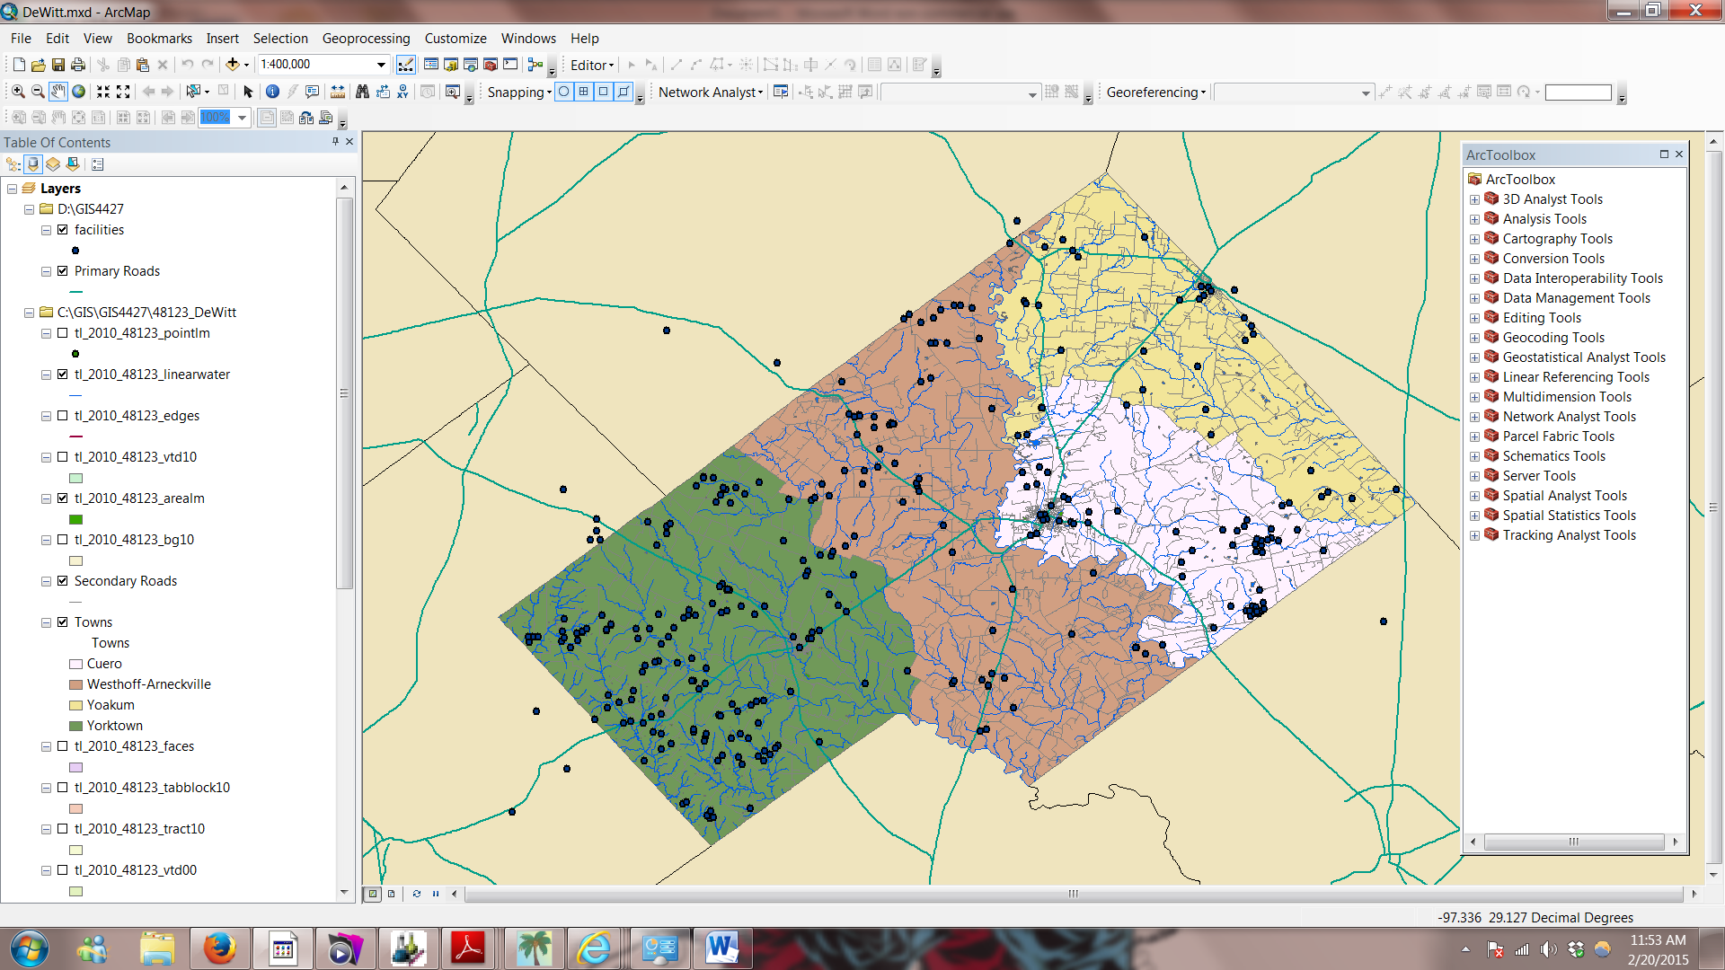

To ensure the successful implementation of emergency procedures in the case of a potentially catastrophic chemical release incident, the reference guide maps must:

* Include current and complete contact information of necessary personnel, gate access information/location, and visual identification of gate access
* Clearly display threat zones for each facility holding EHS chemicals and/or hydrocarbons
* Clearly display all other chemical-holding facilities within a given threat zone
* Determine appropriate streets or intersections to place roadblocks
* Locate and assign nearest fire departments and hospitals as first response to a chemical release incident

Current progress of steps that have already been taken towards the Chemical Release Guide:

* Downloaded Cameo Suite and imported DeWitt County Tier II data
* Created ArcMap document with county, city, road, and river shape files downloaded from U.S. Census Bureau and Texas State Data Center
* Exported Tier II database to zip file. Extracted files and changed file extensions from *.mer* to *.csv* for viewing in Microsoft Excel spreadsheets
* Imported chemical facility XY coordinates and corresponding attributes into ArcMap document from *facilities.csv* Excel spreadsheet and created point layer for chemical facilities
* Imported Excel spreadsheets into ArcMap document (*ChemicalsInInv.csv, ChemInvLocations.csv, ChemInvMixtures.csv, Contacts.csv, ContactsLink.csv*)
* Joined Excel spreadsheets to *facilities.shp* layer through following process:

***Layer Join Field***

***Table Join Field***

***Excel Table File***

***Join Layer***

***FacilityRecordID***

***FacilityRecordID***

***Facilities.shp***

***ChemicalsInInv.csv***

***FacilityRecordID***

***FacilityRecordID***

***Facilities.shp***

***ChemicalInvLocations.csv***

***FacilityRecordID***

***FacilityRecordID***

***Facilities.shp***

***ChemInvMixtures.csv***

***FacilityRecordID***

***ContactsLink.csv***

***OtherRecordID***

***Facilities.shp***

***ContactRecordID***

***Contacts.csv***

***ContactRecordID***

***Facilities.shp***

The following steps will be executed to complete the Chemical Release Guide:

* Confirm data accuracy and consistency of facility layer attribute table, making necessary corrections and edits
* Once received, import data or shape file layers of county fire departments and hospitals and locate them properly on the map
* Join *Contacts2.csv* with *facilities.shp* after correcting inconsistency with *ParentRecordID* field to ensure contact phone numbers match properly with corresponding facilities.
* Create layer from selection of *facilities.shp* of facilities that contain EHS materials and H2S hydrocarbons.
* Research properties and threats of EHS and H2S that are present in the selected facilities layer with Cameo Chemicals Software
* Create threat zone radius polygons for these chemicals using Aloha software and import into ArcMap document with ArcGIS Aloha Extension
* Digitize point layers for roadblock placement and facility gate access for display in guide maps
* Create Thiessen Polygons for first response assignment zoning of closest hospitals and fire departments to facilities
* Create least cost paths for roads layer in Network Analyst for first fire departments and hospitals to gate access locations of facilities
* Create and export one map for each potential EHS/H2S facility chemical release incident in layout view of ArcMap that includes threat zone, facilities within threat zone, roadblock locations, gate access points, fire departments, hospitals, and roads with highlighted least cost paths for responders. Necessary contact information, chemical inventory, and protocol will be listed in a table on each corresponding map.

**Budget**

|  |  |  |  |  |
| --- | --- | --- | --- | --- |
|  |  |  |  |  |
| **Data Collection** |  |  |  |  |
| Weeks 1-6 | Total Hours (4 hours a week * 6 weeks * 2 consultants) | 48 |  |  |
|  | Hourly Pay | | $30 |  |
|  | Sub Total |  | $1,440 |  |
|  |  |  |  |  |
| **Analysis** |  |  |  |  |
| weeks 4-10 | Total Hours ( 10 hours a week * 6 weeks * 2 consultants) | 120 |  |  |
|  | Hourly Pay | | $55 |  |
|  | Sub Total |  | $6,600 |  |
|  |  |  |  |  |
|  | **Total** |  |  | $8,040 |
|  |  |  |  |  |
| **Project Management** | |  |  |  |
|  |  |  |  |  |
| GIS Analyst | Total Hours (15 hours a week * 6 weeks) | 90 |  |  |
| weeks 4-10 | Hourly Pay |  | $36 |  |
|  | Sub Total |  | $3,240 |  |
|  |  |  |  |  |
|  |  |  |  |  |
| Assistant Manager | Total Hours (10 hours a week * 10 weeks) | 100 |  |  |
| weeks 2-12 | Hourly Pay |  | $55 |  |
|  | Sub Total |  | $5,500 |  |
|  |  |  |  |  |
|  |  |  |  |  |
| Project Manager | Total Hours (10 hours a week * 10 weeks) | 100 |  |  |
| weeks 2-12 | Hourly Pay |  | $75 |  |
|  | Sub Total |  | $7,500 |  |
|  |  |  |  |  |
|  | **Total** |  |  | $16,240 |
|  |  |  |  |  |
| **Software Costs** |  |  |  |  |
|  | ArcGIS License ($1500 annual Std User License) |  |  |  |
|  | ( $1500/12 * 3 months of use ) |  | $375 |  |
|  |  |  |  |  |
|  | Adobe Creative Cloud ( $599.88 annual cost) |  |  |  |
|  | ( 599.99/12 * 3 months use) |  | $149.97 |  |
|  |  |  |  |  |
|  | **Total** |  |  | $524.97 |
|  |  |  |  |  |
| **Travel Expenses** | 20 miles @ $0.50 cents/mile |  |  |  |
|  | Sub Total |  | $10 |  |
|  | **Total** |  |  | $10 |
|  |  |  |  |  |
| **Total Costs** |  |  |  | $24,815 |

**Implications**

Our project aims to create useful resources for the emergency responders and planners of DeWitt County, located in South Texas. We will provide easily readable maps detailing the chemical facilities and their surrounding areas and provide important information on how to handle chemical emergencies or fire at these locations. The finished product will help show where to place roadblocks, what areas will be most seriously affected by the event in the surrounding area, and what chemicals are located at each facility. We hope to ensure the safety of the responders and the community by distributing this map to all seven volunteer fire departments in the county. Using our emergency guide, agencies will be better equipped to handle their jobs, help the people of the community by protecting their safety and personal property as well as the property of the oil and gas companies where these chemicals are found.

**Activities & Timeline**

**Client Presentation/ First Client Visit (week 1)**

This is the first week that we met up with the representative from DeWitt County. We were given our request for proposal and learned about the basics of our project and the outcomes that were desired.

**Proposal Preparation (weeks 1 – 4)**

At this time we spent a majority of our efforts on creating the project proposal for the county. We each split up the different sections of the proposal and worked on them during lab time and at home. This includes the design and completion of our company logo.

**Proposal Presentation/ Second Client Visit (week 4)**

This is when we will be having our second meeting and will be presenting the proposal to the DeWitt County representative.

**Data Collection (weeks 1 – 6)**

At this point we will collect any data that may be needed and organize the data that has been given to us in an orderly fashion.

**Analysis (4 – 10)**

This is the step where we do a major portion of the actual map making and the analysis of the data. We will be creating the deliverables to be presented to the county at this stage.

**Progress Report Presentation/ Third Visit (week 9)**

At this point in the project we will be giving a presentation to the representative from DeWitt County on how far we have come on the progress of the project and what our next steps will be to complete the project.

**Final Project Preparations (weeks 11 – 13)**

The final touches will be done on our project, such as making the maps aesthetically pleasing, placing our logo on the maps and making the physical deliverables to be handed out to first responders.

**Project Presentation (week 14)**

We will be presenting our final finished project.

Here is a small table highlighting the activities taken over the 14 weeks of the project.



**Final Deliverables**

Upon completion of this project, South Texas Emergency Consulting will have produced a .pdf document of the Chemical Release Quick Reference Guide, to be given to DeWitt County, TX emergency response organizations. Along with a physical copy of the release guide, the county will receive a file CD containing the following:

* Excel Spreadsheets of Facility and Contact Data
* Shape files
* Metadata
* .pdf of Release Guide
* PowerPoint Presentation

**Participation**

**Robert Gannon ( Project Manager)**

* Cover, Table of Contents, Introduction, Budget, Bibliography, Editing

**Matt Ahrens (Project Assistant)**

* Cover (logo), Literature Review, Implications, Activities and Timeline

**George Caracostis (GIS Analyst)**

* Data Set, Methodology, Final Deliverables, Maps of DeWitt County

**Bibliography**

Cova, T. J. (1999). GIS in emergency management. *Geographical information systems*, *2*, 845-858.

DeWitt County Profile. (2013, January 1). Retrieved February 18, 2015, from http://www.txcip.org/tac/census/profile.php?FIPS=48123

Emrich, C. T., Cutter, S. L., & Weschler, P. J. (2011). GIS and emergency management. *The SAGE Handbook of GIS and Society. London, Sage*, 321-43

Eagle Ford Shale - Overview, News, Companies, Geology, & More. (n.d.). Retrieved February 18, 2015, from <http://eaglefordshale.com/>

Hazard Communications. (n.d.). Retrieved February 18, 2015, from http://gricemarinelab.cofc.edu/resources/safety/hazard-communications.php

(n.d.). Retrieved February 18, 2015, from http://images.clipartpanda.com/texas-outline-clipart-dT76BKXT9.jpeg