Project Manager/GIS Analyst/ Data Collection: Cody Johnston

Graphic Designer/GIS Specialist/Data Collection: Logan Hayner

GIS Analyst/Data Collection: P. Kennedy McMinn

Assistant Project Manager/GIS Analyst/Data Collection: Kathleen Andrews

A Network Analysis of ADA Accessible Routes across the Texas

State University Campus

Prepared by: GeoTex

Table of Contents:

- Introduction
  - Summary
  - Purpose
  - Scope

- Literature Review
  - ADA Guidelines
  - Literature

- Proposal
  - Data
  - Methodology
  - Implications
  - Budget
  - Timetable
  - Final Products

- Conclusions

- Participation

- References

1. Introduction:
1.1. Summary

1.2. Purpose
GeoTex’s objective is to provide wheelchair accessibility routes to every building on campus. The purpose of this is to make navigating the campus as easy as possible for handicapped students by providing them easy to understand maps of accessible routes throughout the university. We will closely examine the ADA’s regulations and the details of Texas State University’s campus in order to make sure that the routes we provide correspond with the ADA’s standard.

1.3. Scope
GeoTex will focus on navigating around the following obstacles:
1. Areas with steep slopes.
2. Construction sites.
3. Areas without sidewalks.
4. Sidewalks without wheelchair accessible curb ramps.
5. Buildings.

GeoTex will propose the construction or creation of the following to circumnavigate the obstacles listed above:
1. Wheelchair ramps.
2. Sidewalks.
3. Wheelchair accessible curb ramps.
4. Wheelchair accessible buildings and elevators.
5. Handrails.

2. Literature Review
GeoTex has closely reviewed the Americans with Disabilities Act’s regulations, which are listed below; in order to make sure that GeoTex works according to the recognized standard. Apart from reviewing rules and regulations, GeoTex has examined the methods other groups have used in solving similar problems.
The article, “Using GIS to meet Accessibility Requirements” written by Jim Baumann describes a very similar project in which the city of San Francisco used ArcGIS to find and prioritize locations the city needed to install or make adjustments to pre-existing wheelchair ramps in order to meet the requirements of the ADA. GeoTex will determine the locations at Texas State University that require wheelchair ramps by priority level, which will be determined based on the ADA’s requirements. Similarly, the project in San Francisco, “prioritizes construction of new ramps based on criteria developed by the San Francisco Mayor’s Office on Disability: requests from a person with a disability, the condition score of existing ramps in the immediate area, and the proximity of the proposed ramp to government facilities such as health clinics, schools, parks, and public transportation.” (Baumann 2012). GeoTex would like to utilize the input of the disabled community in creating routes as well.
GeoTex has also reviewed the critique of San Francisco’s curb-ramp project by ADA consultant Michelle Ohmes, to understand what worked – and what did not – from the San Francisco project. Overall she gave the proposed plan a glowing review and “strongly [suggests] other public agencies use this model as a guide for putting together their overview transition plan for curbs and sidewalks” (Ohmes 2012).

2.1. ADA Regulations (United States Department of Justice Civil Rights Division 2008).
The Americans with Disabilities Act (ADA) has set forth a very clear set of guidelines for the nature of accommodations for those who are in need of wheelchairs or other assisted movement tools. Several of these guidelines are directly pertinent to this study of accessibility on Texas State University’s campus. Guidelines set by the ADA will be used as the official standard for identifying appropriate ramps, curb ramps, and sidewalk routes to incorporate into a comprehensive network of accessible routes covering the campus. Many areas, such as sidewalks, may seem accessible at first glance but do not meet the requirement for minimum grade as set by the ADA. The directly relevant sections of these guidelines are as follows:

Slope of sidewalks: all parts of a route that are not considered a ramp must have a slope that does not exceed 1:20 (one inch increase in slope for every twenty inches in distance). Any section of a route with a slope greater than 1:20 requires a ramp and must include all elements of a ramp. At Texas State University the general slope of the land is much greater than 1:20. This makes it rather complicated to navigate from a wheelchair and is also responsible for the prevalence of large, multi-run ramps throughout the campus.

Curb Ramps (Flared Sides): if a curb ramp is not protected by hand rails and has the potential of the flow of pedestrian traffic crossing it, it must have flared sides. The maximum slope of the flared sides cannot exceed 1:10. The minimum width of the curb ramp cannot be less than 36 inches; this does not include the flared side, if applicable. On this campus the use of flared sides is necessary in most areas requiring a curb ramp due to the high flow of pedestrian traffic and heavy use of wide boardwalks for pedestrian and handicapped traffic.
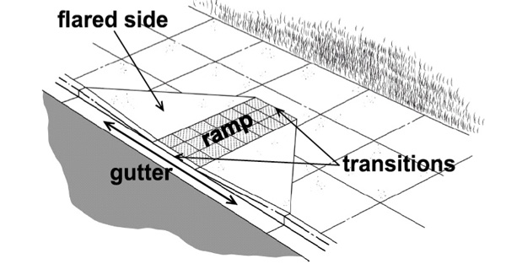
Photo: ADA.gov

Curb Ramps (Returned Curbs): If a curb ramp has a handrail or is out of the flow of pedestrian traffic, it may include returned curbs. Being out of the flow of traffic is defined as a sidewalk wide enough for cross traffic of pedestrians to have adequate space to walk around a wheelchair that is turning onto the curb ramp. In this case there are not flared sides and the curb ramp must be at least 36 inches in width. This style of curb ramp is currently being used in several older areas of campus with low pedestrian cross traffic, such as the street crossing of University drive into Sewell Park.
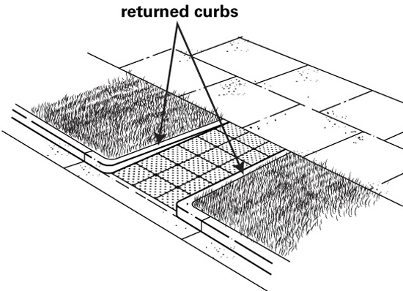
Photo: ADA.gov

Ramps: any section of a route with a slope greater than 1:20 is considered a ramp. A ramp may not have a slope greater than 1:50 at any point. The maximum rise for any single run of a ramp cannot exceed 30 inches. All ramps must include an appropriate handrail. Due to the high slope of campus, many ramps include multiple runs in order to comply with the requirement of not exceeding 30 inches of increase in any single run of a ramp.
On a campus with as complicated of topography as Texas State University, the correct implementation of routes is crucial. There are many areas of the campus where sidewalks are at a much steeper slope than what is appropriate for them to be included as segments in an accessible route. One of the most important aspects of this project is to identify areas of a higher slope than what is legally acceptable and make alternate routes clearly available to those requiring the use of such accommodations. Through this project we will be able to identify clear routes that will ideally ease the technical strain of navigating this campus from a wheelchair.

3. Proposal
3.1. Data
GeoTex will be using the ArcGIS software suite, an Environmental Systems Research Institute (ESRI) product, to conduct our project. We will be using Vector data known as Shapefiles and Raster data for analysis. Much of this data has been collected and provided by Texas State University and various government agencies. Our team will also be collecting data and conducting research in the field.

The following data will be used:

Texas State University - Department of Geography
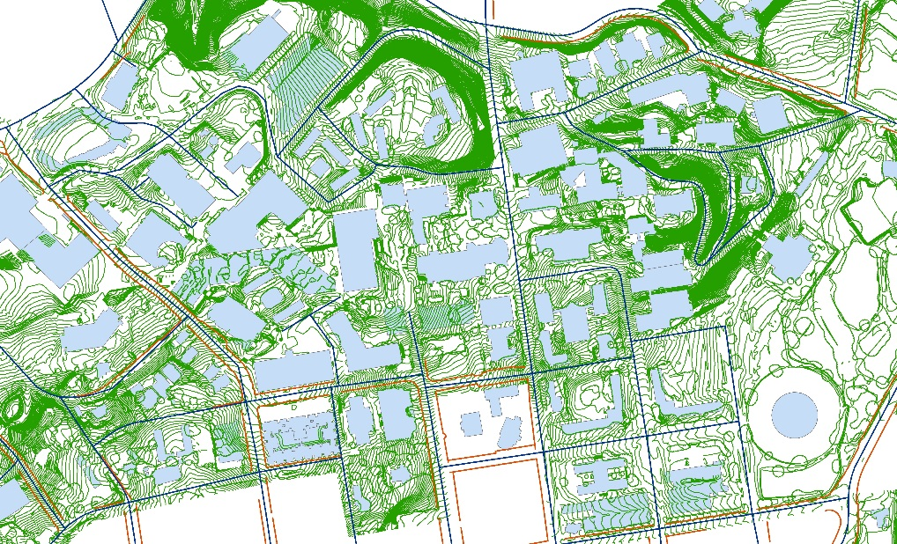
- Sidewalks
- Streets
- Campus buildings
- Topography
- Parking

Map of Sidewalks, Streets, Buildings, and Topography data. Photo by: GeoTex

Texas State University - Facilities Planning Design
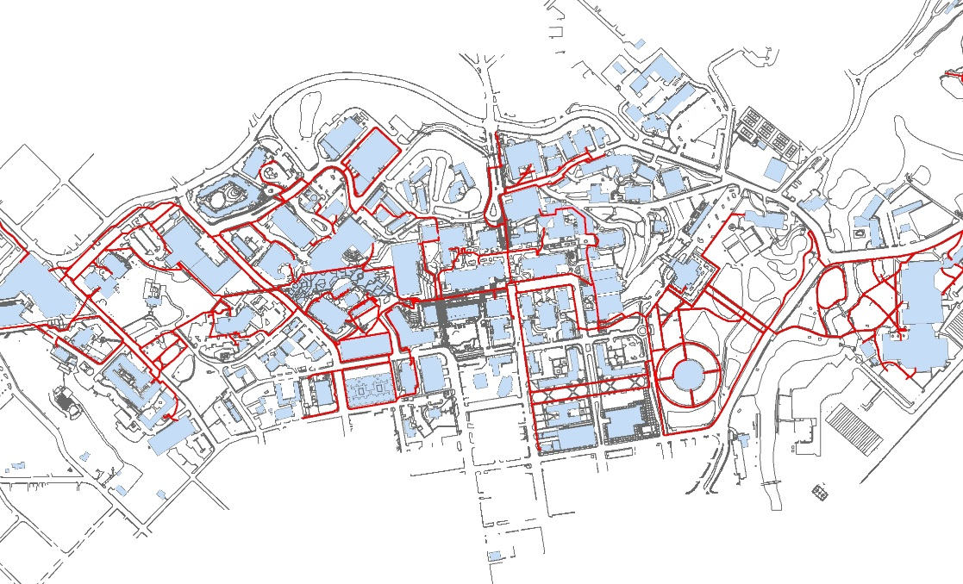
- University Property
- ADA Routes
- Sidewalks
- Building Interiors
- Recycle Bins
- Surfaces
- Lakes
- Greenzone
- Golf Fairways
- Golf Greens Map of current ADA Routes, surfaces, and buildings data. Photo by: GeoTex

The following data will be collected by the GeoTex team:
- Routes through buildings
- Verification of slope
- Verification of routes
- Curb Cut locations

3.3. Implications:
The results of this project will be of paramount assistance to the office of Equity and Access at Texas State University in providing practical assistance to students navigating the campus from a wheel chair. In the future the base information from this analysis can be used to create such items as static route maps as well as interactive route maps on the University website for handicapped students. These interactive features could potentially allow students to look online to find the fastest route between classes before even stepping on campus. This will provide a base set of data to expand upon so areas of future construction can be easily integrated into the system of accessible routes. This base knowledge of a route network will allow the ADA office to have a framework to build upon to increase a variety of assistance and services that can be provided to handicapped students across all areas of campus.
3.4. Budget
Data Collection
 | Total hours (5hrs/week * 4 weeks * 2 consultants) | 40
 | Hourly pay | $25.00/hr
 | Total |  | $1,000
Data Analysis
 | Total hours (5hrs/week * 4 weeks * 2 consultants + 10hrs/week * 6 weeks * 4 consultants) | 280
 | Hourly pay | $30.00/hr
 | Total |  | $8,400
System Management
 | Project Manager
 | Total hours | 90
 | Additional hourly pay | $20/hr
 | Pay | $1,800
 | Assistant Project Manager
 | Total Hours | 90
 | Additional hourly pay | $10/hr
 | Pay | $900
 | Total |  | $2,700
Equipment Costs
 | ArcGIS concurrent license | $3,500
 | GPS receiver | $250
 | Total |  | $3,750
Website Cost
 | Development | $880
 | Domain name | $20
 | Web hosting | $100
 | Maintenance | $500
 | Marketing | $500
 | Total |  | $2,100
Total Costs |  |  | $17,950

3.5. Timetable:
The following are key stages to the development of this project and applicable dates that coincide with them. A progress update with an updated time table will be provided on March 24th to ensure that all parties are aware of the status of the project.
- Data collection: this process will take place over rough 3 week period that will be complete no later than February 5th. Once a sufficient amount of data has been collected to carry out the indented analysis, this will allow for the beginning pre-processing data.
- Data preparation: this stage will slightly overlap with that of data collection during the week of February 5th. The team will emphasize work on ensuring that all collected data is in a workable format and able to be integrated in order to complete analysis. All metadata will be inspected by team members to ensure that it is present and accurate. This step has a projected finish date February 26th.
- Data Analysis/Verification: beginning no later than February 17th, team members will begin appropriate analysis of data as outlined in the previously stated methodology. This step has a target completion date of April 2nd. Included in this stage will be the process of physically going out on campus to examine the routes developed within GIS to visually ensure that they comply with the ADA regulations.
- Data Interpretation: the team will cohesively look at results from data analysis to identify results and significant patterns in results. These will be integrated to produce the final results and findings of the most appropriate routes for wheelchair access across Texas State University. This stage should be completed no later than April 9th.
- Final Presentation Preparation: beginning April 7th, the group will begin formulating the products for final presentation to Texas State University. By this point all work within GIS should be completed and ready to integrate into presentation. Final presentation should be completed no later than April 27th.

Timeline:
The following time line will outline target dates for completion of key segments of this project. Target finish dates are subjective and may be adjusted as needed. Any deviation from set dates will be clearly communicated amongst the group and to the client if applicable.

Task: | Week 1-2  Jan. 19 – Feb. 1 | Week  3-4  Feb. 2-15 | Week 5-6  Feb. 16 – Mar. 1 | Week 7-8  Mar. 2 - 15 | Week 9-10  Mar. 16 - 29 | Week 11-12  Mar. 30 – Apr. 12 | Week 13-14  Apr. 13 - 26 | Week 15  Apr. 27 – May 2
Client Presentation | Jan. 22
Data Collection |  | Target Finish: Feb. 5
Proposal Preparation |  | Target finish: Feb. 10
Proposal Presentation |  |  | Feb. 19
Data Preparation |  | Begin by: Feb. 5 | Target Finish: Feb. 26
Data Analysis |  |  | Begin Analysis: Feb. 17 |  |  | Target Finish: Apr. 2
Progress Update |  |  |  |  | Mar. 24
Data Interpretation |  |  |  |  | Begin by:  Apr. 2 | Target Finish: Apr. 9
Final Presentation Preparation |  |  |  |  |  | Begin by: Apr. 7 | Target Finish:  Apr. 23
Final Presentation |  |  |  |  |  |  |  | May 2

3.6. Final Products
Final Report (2 copies)
Professional Poster
- Campus map of wheelchair accessible routes
Project Website
CD (2 copies)
- Data
- Metadata
- Proposal, Progress, and Final Reports
- PowerPoint Presentations
- Poster

4. Conclusions
Texas State University is known to be a campus with many challenging hills and stairways. Due to ongoing construction on the campus and the surrounding area, it is crucial to provide up-to-date maps of current wheelchair accessible routes. The final goal of this GeoTex project is to assist Texas State University in creating a complete map available to students, faculty, and visitors of all handicap accessible routes around the Texas State campus. Our final campus map will include routes in accordance with all guidelines set forth in the Americans with Disabilities Act.

5. Participation:
Cody Johnston (Project Manager/GIS Analyst/ Data Collection)
- Methodology, Budget, Purpose, Literature Review, Company Name and Logo
Logan Hayner (Graphic Designer/GIS Specialist/Data Collection)
- Introduction, Data, Cost Path Researcher, Presentation and Web Graphics
P. Kennedy McMinn (GIS Analyst/Data Collection)
- ADA Guidelines, Implications, Timetable, Participation
Kathleen Andrews (Assistant Project Manager/GIS Analyst/Data Collection)
- Conclusion, Literature Review, References

- References
Baumann, J. 2012. ADA Compliance: Using GIS to Meet Accessibility Requirements. Public Works. http://www.pwmag.com/ada-compliance/using-gis-to-meet-accessibility-requirements.aspx. (last accessed 5 February 2014).
Ohmes, M. 2012. ADA Compliance: Curb ramps, the San Francisco way. Public Works. http://www.pwmag.com/ada-compliance/curb-ramps-the-san-francisco-way.aspx. (last accessed 5 February 2014).
United States Department of Justice Civil Rights Division. 2008. Americans with Disabilities Act of 1990, as Amended. http://www.ada.gov/pubs/adastatute08.htm. (last accessed 5 February 2014).

