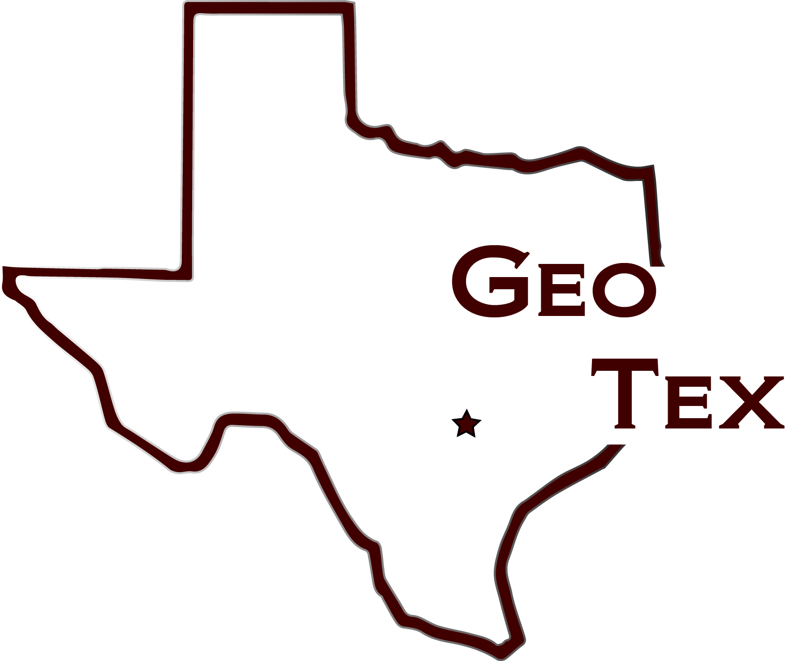

Project Manager/GIS Analyst/ Data Collection: Cody Johnston

Assistant Project Manager/GIS Analyst/Data Collection: Kathleen Andrews

Graphic Designer/GIS Specialist/Data Collection: Logan Hayner

GIS Analyst/Data Collection: P. Kennedy McMinn

A Network Analysis of ADA Accessible Routes On
The Texas State University Campus

Prepared by: GeoTex

Table of Contents
Introduction 1
Purpose: 1
Scope: 2
Project Tasks 2
TASK 1: 2
TASK 2: 3
TASK 3: 3
TIMELINE 4
Conclusion 5
Participation 5

Introduction
GeoTex has been working diligently on the ADA approved handicap accessible routes throughout Texas State University since the project proposal was accepted by the client. GeoTex is submitting this progress report in order to assure Mr. Stafford that the project is being completed in a timely and orderly fashion in compliance with the original proposal.

Purpose
In accordance with our original proposal, GeoTex objective is to provide wheelchair accessible routes to every essential building on Texas State University’s campus. We strive to make navigation as easy as possible for persons with disabilities by providing easy-to-understand maps of accessible routes around the university. We have closely examined the ADA’s regulations, and are continuing to abide by them in our route mapping.
Task 1: Create a map that showing all of the accessible ADA approved non-ramp areas (less than 5% slope).
Task 2: Go into the field with a GPS unit and record the locations of all ramps in the area of the campus being mapped. After recording all the ramp data we will upload it into ArcMap, and determine the slopes of the ramps as well as add them to our map of accessible areas if they meet the ADA’s requirement of less than 2%.
Task 3: Begin routing process, traveling only through areas of approved slope, which will include routes through buildings in order to fully comply with the ADA’s regulations. Lastly, GeoTex will create a user-friendly final map of routes that comply with the ADA’s regulations 100%.
Scope
After discussing the proposal with Mr. Stafford, we agreed on making the geographic extent of the project a little more concentrated in order to save time, but still adequately accommodate Texas State’s students with disabilities. Our final goal will be to create a map of wheelchair accessible routes from Blanco hall to the JC Kellam building. GeoTex will complete the final map no later than April 27, 2014.

Project Tasks
Task 1: Create a map that showing all of the accessible ADA approved non-ramp areas (less than 5% slope).
Work Completed:
- Obtained all necessary data to create ADA approved routes. Data includes buildings, sidewalks, surfaces, existing ADA routes, DEM (Digital Elevation Model), and LiDAR data. DEM was provided by Texas Natural Resources Information System (TNRIS) and all other data was provided by Texas State University Department of Geography.
- Created map of existing wheelchair routes for interpretive use using ArcMap.
- Converted raw LiDAR point data into an ArcMap compatible LAS dataset. LAS dataset was used to create raster surface bare ground elevation data. Elevation raster was used to create slope map of campus to be used in route analysis.
- Created 3D elevation model of campus using raw LiDAR point data.
Work In Progress:
- Design final deliverable slope map to be used in final route analysis.

Task 2: Collect GPS point data of wheelchair ramps in field and import for use in ArcMap.
Work Completed:
- Acquired GPS device from Department of Geography.
Work in Progress:
- Collect GPS point data of all curb-cut and wheelchair ramp locations in field.
- Collect building interior wheelchair accessibility data (ramps, elevators, automatic doors).
Work Scheduled:
- Import GPS data into ArcMap and determine slope between each curb-cut and wheelchair ramp point collected in the field.
Task 3: Design final deliverable ADA approved wheelchair route map using acquired data.
Work Scheduled:
- Develop wheelchair routes that comply with ADA slope, curb-cut, and building interior standards using slope data acquired in Task 1 and GPS data acquired in Task 2.
- Design final deliverable route map.
- Upload all deliverables to the project website.

Timeline
The following timeline has been updated to show the target completion dates of remaining tasks and adjusted dates.
Task: | March 24th-30th | March 31st-April 6th | April 7th-13th | April 14th-20th | April 21st-27th | April 28th-May 4th
Progress Update | March 26th
Identification of Accessibility Gaps |  | Finish by: April 2nd
Formulation of Final Routes |  |  | Finish by: April 7th
Creation of Final Maps/Deliverables |  |  | Begin by: April 7th |  | Finish by: April 23rd
Final Presentation Preparation |  |  | Begin by: April 13th |  | Finish by: April 27th
Final Presentation |  |  |  |  |  | May 2nd

Conclusion
GeoTex final goal is to present Texas State University with a complete map of all ADA compliant routes around central campus. We will comply with all guidelines set forth by the Americans with Disabilities Act and include alternative routes around current construction projects. Ideally our map will be made available online to better assist all students, faculty, and visitors in navigating the Texas State campus.

Participation
Introduction, Purpose, and Scope – Cody Johnston
Project Tasks – Logan Hayner
Updated Timeline – Kennedy McMinn
Conclusion – Kathleen Andrews

