Project Manager/GIS Analyst/ Data Collection: Cody Johnston

Assistant Project Manager/GIS Analyst/Data Collection: Kathleen Andrews

Graphic Designer/GIS Specialist/Data Collection: Logan Hayner

GIS Analyst/Data Collection: P. Kennedy McMinn

Final Network Analysis of ADA Accessible Routes Across the Texas

State University Campus

Prepared by: GeoTex

Table of Contents:

- Introduction
  - Background
  - Problem Statement

- Data
  - Data Acquired
  - Application of Data

- Methods
  - Methodology

- Results
  - Findings
  - Maps

- Discussion
  - Implications
  - Limitations
  - Possible Improvements

- Conclusions

- References

Appendix I: Metadata

Appendix II: Participation

1. Introduction:
1.1. Background
Texas State University is known for its hilly terrain and numerous stairways. This can make it a very difficult campus to navigate for even the most physically fit students. For students with disabilities these hills seem like insurmountable obstacles. The rapidly growing student population of the university over the past decade has inevitably led to an increase in the number of academic buildings and an increase in students in need of accessible routes to navigate the campus. Texas State University contracted GeoTex to create a comprehensive system of accessible routes covering the core of the campus and suggest the creation of new routes and infrastructure to allow further access. The unofficial nature of the existing route map made it necessary to check the routes that had already been laid out and create new routes as well as suggest the location of additional infrastructure to improve accessibility. Without these the campus would remain a daunting obstacle for students with disabilities and inhibit their ability to be a part of the Texas State University community.

1.2. Problem Statement
GeoTex’s objective was to provide wheelchair accessible routes to every building on Texas State University’s campus. Unfortunately, these routes did not already exist in a comprehensive network. The lack of a comprehensive and easy to view network of accessible routes placed an undue burden on students with disabilities needing to navigate between buildings throughout the day. The purpose of this project was to make navigating the campus as easy as possible for handicapped students by providing them with clear and easy to understand maps of accessible routes throughout the university. Beyond just showing where routes are present, different levels of difficultly are indicated on maps to further ease the planning of navigating between buildings.

2. Data
2.1. Data Acquired
GeoTex wanted to know the slope of any and every wheelchair accessible ramp on the Texas State University campus. In order to obtain this information, members of the GeoTex team walked the campus, tested, and recorded the slopes of all the wheelchair accessible ramps. In addition to recording the slope data of the campus wheelchair ramps; GeoTex recorded the location data with a GPS receiver as well.

2.2. Application of Data
GeoTex used the slope and GPS data recorded on campus to help draw and classify the wheelchair accessibility routes provided in the wheelchair accessibility route map (section 4.2).

3. Methods
3.1. Methodology
GeoTex's first task was to develop a high resolution slope map that could be used both as a reference map for the future measurement of ramp slopes in the future and also as an analysis tool in the process of route creation. Raw LiDAR (.las) data was acquired from the Department of Geography. ArcMap's “Create LAS dataset” tool was used to enable the LiDAR data to be manipulated in ArcMap. The resulting LAS dataset consisted of only bare ground returns (code 2) and was used to create an elevation raster of the campus with a resolution of 6 inches using ArcMap's “Convert LAS dataset to Raster” tool. This raster was used to create a raster slope percentage image using ArcMap's “Slope” tool. The final high resolution slope map can be found in the attached shapefiles with the filename “slopeposter2” and also within this document with the title “Texas State University Slope Map”.
With our slope map finalized, we used this information to pinpoint which regioins of campus would have the steepest slopes, and thus, where we should concentrate the most effort and focus. The process of GPS data collection and slope measurement is described in detail in Section 3.2: Field Methods below. The Garmin GPS point data was converted to an ArcMap shapefile using a program called “DNR Garmin”. Once a shapefile had been created, the locations of the points were checked for correctness by comparing the shapefile to notes collected in the field and satellite imagery. Next, routes were drawn (using ArcMap's “Edit” toolbar) between each point with every point representing either the top or bottom of a ramp. Slope data collected manually in the field determined whether the ramp was classified as having a shallow Green Slope (0-5% grade), medium Yellow Slope (5-10% grade), or steep Red Slope (greater than 10% grade).
3.2 Field Methods
The elevation and location of all ramps, sidewalks, and curb cuts was collected using a Garmin eTrex GPS unit. The GPS point data would later be converted to a shapefile using the software “DNR Garmin”. Slope measurements were collected in degrees using the Theodolite and built-in slope applications for the iPhone. These measurements were then converted to percent grade manually. To assist the future process of route drawing, the location of each GPS point collected was marked on a paper surface map of campus. The slope measurement taken for each ramp between two points was recorded on this map as well. Texas State is an extremely hilly campus with rugged terrain, therefore not every slope currently meets Americans with Disabilities Act guidelines. To better assist persons with disabilities in navigating the best route to their destination, we have color coded routes according to grade. Green is under 5% grade, which is in compliance with ADA regulations. Yellow is between 5% - 10% grade and Red is over 10% grade.

4. Results
The summation of GeoTex’s work is an accurate, easy to read, and clearly defined wheelchair accessibility route map. GeoTex strongly believes that this map will greatly assist all students with disabilities, the elderly, and those with heart conditions in navigating Texas State’s hilly campus.
4.1. Findings
Texas State University is a very hilly campus, and therefore it is impossible to be 100% in compliance with the ADA’s slope regulations at all times. However, GeoTex is confident that we have provided an accurate map that shows how to navigate the campus as easily as possible. GeoTex also feels that the routes we have defined as yellow (5%-10% slope) are (for the most part) very feasible for someone with a disability. However, the university should investigate the methods of rectifying the routes which are highlighted red using the methods suggested below.

4.2. Maps
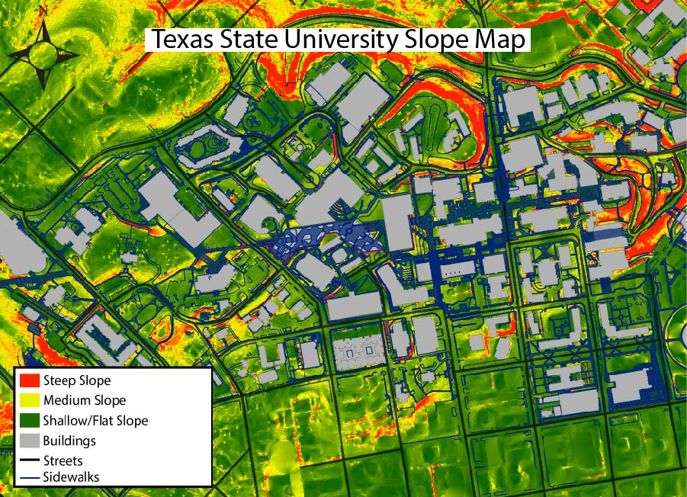
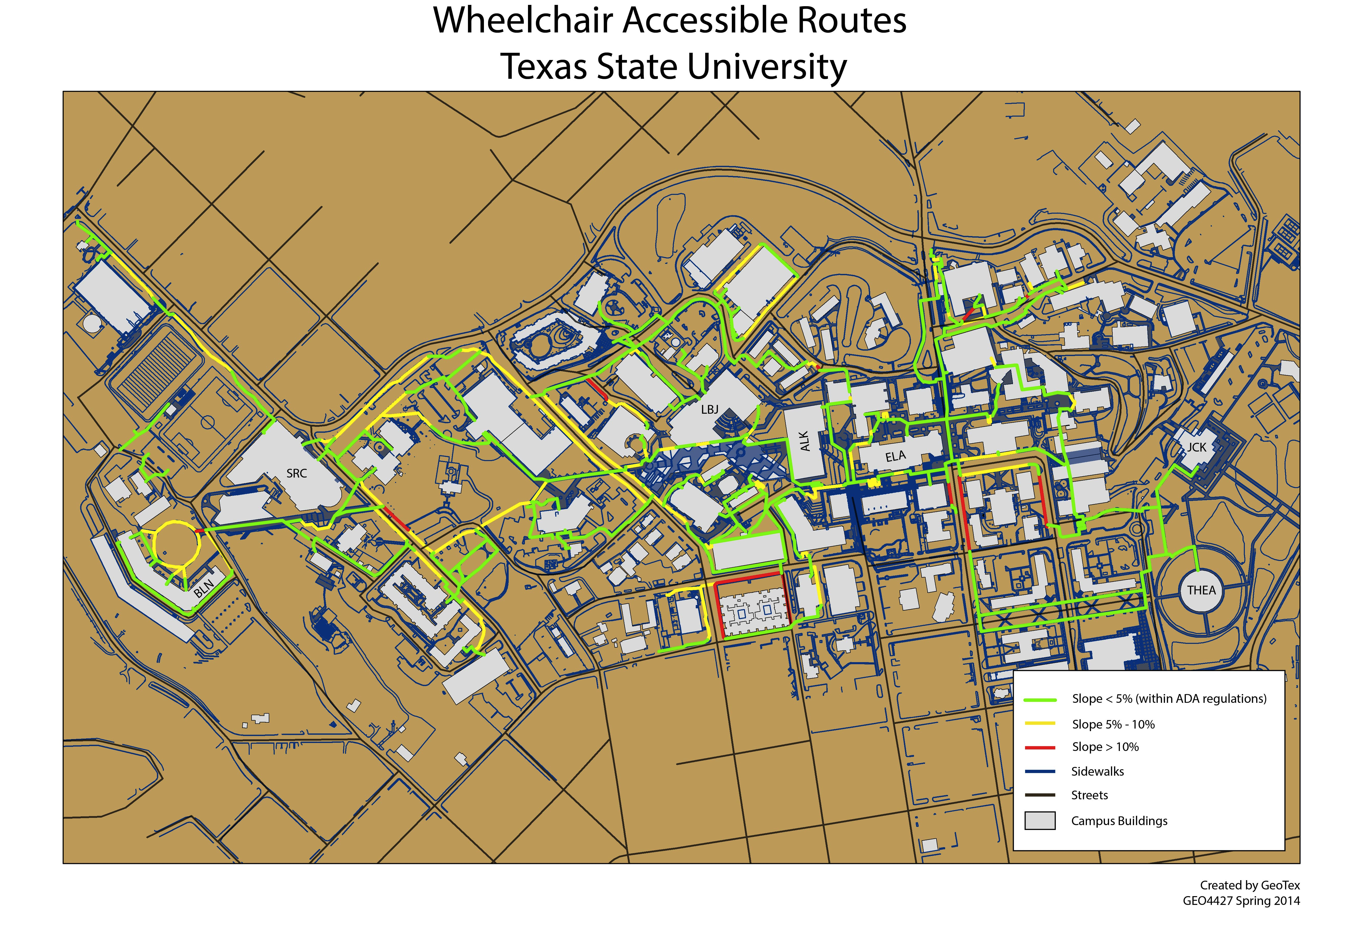
5. Discussion
5.1 Implications
At the beginning of this project it was clear that using GIS was the most suitable choice for analyzing a complex network that required multiple criteria. The applicability of GIS for this problem was never questioned. However, after completion it is clear that creating a comprehensive network meeting all the criteria laid out was easily accomplished using GIS. The results of this study have unfortunately implied that Texas State University has a ways to go to accomplish full coverage across the core of the campus. While all buildings are technically accessible using the final route network, many are still difficult to access and require large detours. Beyond the need for large detours, many routes include sections with a slope that is slightly higher than what is desirable to meet the ADA guidelines. While these sections are unfortunate, they were absolutely necessary to complete the full coverage of the campus core. While we believe these sections are navigable, is would be a marked improvement to eventually have a route network that did not include any areas of questionable slope. The difficulty is that the topography of Texas State University simply does not allow for this in all areas.
5.2. Limitations
Due to time constraints GeoTex was only able to map the area from Blanco Hall to the J.C. Kellam building. This is the campus core, however, and the most heavily trafficked. We have provided Mr. Stafford with data that can be used in the future to finish mapping outlying areas of campus.
5.3. Recommendations
Much of Texas State University’s existing ramp infrastructure is steeper than the ADAs 1:20 regulation. It will take a major construction project to overhaul all the ramps on campus, but GeoTex recommends Texas State University review the estimated cost and time to bring infrastructure up to code and that all future construction projects commit to abiding by Americans with Disabilities Act guidelines. Campus infrastructure can meet regulations by constructing new ramps that meet slope regulations or providing an alternate means of transportation for persons with disabilities. In reference to the latter, one possibility would be the expansion and improvement of the Bobcat Bobbies Service which has been downsized in recent years.

6. Conclusions
GeoTex has created a map of all handicap accessible routes covering the campus core. Due to Texas State University’s hilly terrain, many of the handicap accessible routes fall outside of the ADA’s slope guidelines. In this report we have accurately presented all information gathered over the course of the project, even when our findings do not adhere to the Americans with Disabilities Act guidelines. GeoTex has color-coded all route sections based on their slope to enable persons with disabilities to more easily traverse the Texas State campus.

Appendix I: Metadata

Green_Routes
Shapefile

Tags
Texas State University, ADA, Green Routes, ADA guidelines, 5% slope

Summary
Shapefile contains all routes that are characterized by a slope that does not exceed 5% at any point and are limited to the Texas State University Campus.
Description
1: Time Period:
03/2014 - 05/2014
1.1: Time Period of Content:
Slopes were recorded from LiDAR points acquired from Dr. Jennifer Jensen in March 2014. Routes were formally mapped and inspected in April 2014
1.2: Progress:
Complete. All displayed routes are currently present and accessible as they appear.
2: Theme Keyword:
ADA, Americans with Disabilities Act, Accessibility, Wheel Chair Accessible
2.1: Place Keywords:
Texas State University, San Marcos, Texas, Hays County, TX, Central Texas
3: Point of Contact:
Dr. Alberto Giordano, Texas State University Department of Geography
3.1: Data Set Credit:
Logan Hayner, Cody Johnson, Kathleen Andrews, P. Kennedy McMinn - Texas State University Geography Department
4: Native Data:
ArcMap 10.1
4.1: Attribute Accuracy:
All routes were physically and visually examined and check to ensure the accuracy of the location and slope
4.2: Positional Accuracy:
All routes are locationally accurate. These were physically inspected to ensure locational accuracy.
4.3: Process Contact:
Dr. Alberto Giordano
4.4: Spacial Reference:
Projected Coordinate System: NAD_1983_StatePlane_Texas_South_Central_FIPS_4204_Feet
Projection: Lambert_Conformal_Conic
False_Easting: 1968500.00000000
False_Northing: 13123333.33333333
Central_Meridian: -99.00000000
Standard_Parallel_1: 28.38333333
Standard_Parallel_2: 30.28333333
Latitude_Of_Origin: 27.83333333
Linear Unit: Foot_US
Geographic Coordinate System: GCS_North_American_1983
Datum: D_North_American_1983
Prime Meridian: Greenwich
Angular Unit: Degree
4.5: Direct Spatial Reference Method:
Vector Data Set
Credits
Geo 4427 Spring 2014 GeoTex Logan Hayner Kathleen Andrews P. Kennedy McMinn Cody Johnson Instructor - Dr. Giordano Lab Instructor - Ryan Schuermann
Use limitations
There are no access and use limitations for this item.
Extent
West -97.953687 East -97.937374
North 29.891762 South 29.886146
Scale Range
Maximum (zoomed in) 1:5,000
Minimum (zoomed out) 1:150,000,000

yellowRoutes
Shapefile
Thumbnail Not Available
Tags
There are no tags for this item.

Summary
These are the portions of the Texas State University wheelchair routes where the slope was between 5 percent and 10 percent. The data created from point elevation data collected via GPS in the field and hand measurements (using iPhone slope app) of the slope of each sidewalk ramp.
Description
Section 1: Identification
1.1: Originator
• This data was developed for the Texas State Office of Disability Services by GeoTex. GEO 4427 Spring 2014, Team: Logan Hayner, Kathleen Andrews, Kennedy McMinn, Cody Johnston. Instructor: Dr. Alberto Girodano. Lab Instructor: Ryan Schuermann
1.2: Publication Date
• 2014-05-02
1.3: Title
• Final Network Analysis of ADA Acessible Routes across the Texas State University Campus
1.4: Online Linkage
• http://www.geosites.evans.txstate.edu/g4427/S14/geotex/index.html
1.5.1: Abstract
• These are the portions of the Texas State University wheelchair routes where the slope was between 5 percent and 10 percent. The data created from point elevation data collected via GPS in the field and hand measurements (using iPhone slope app) of the slope of each sidewalk ramp. Format: ArcMap shapefileGeographic Coverage: San Marcos, TX; Texas State University main campusTime period: Collected - 3-31-14 thru 4-24-14
1.5.2: Supplemental Information
• Must be added to map document with green and red routes to be usable/understandable.
1.6: Time Period of Content
• Collected: 3-31-14 thru 4-24-14Distributed/Presented/Published: 5-2-14
1.7.1: Theme Keyword
• location, 013transportation, 018
1.7.2: Place Keyword
• City: San MarcosState: TexasCounty: HaysDescription: Texas State University main campus
1.7.3: Temporal Keyword
• Present day
1.8: Access Constraints
• Available for use by any and all persons or organizations
1.9: Point of Contact
• GeoTex. Specifically, Logan Hayner or Cody Johnston
1.10: Data Set Credit
• GPS data collection: Logan Hayner, Cody Johnston, Kathleen Andrews, Kennedy McMinn Slope measurements: Kathleen AndrewsRoute drawing/ArcMap analysis: Logan Hayner, Cody JohnstonClients/Supervisors: Robert Stafford (Texas State GIS department), Dr. Alberto Giordano (Texas State Department of Geography
1.11: Native Data Set Environment
• Software: ArcGIS version 10.1Operating system: Microsoft Windows 7 and above
Section 2: Data Quality
2.1: Attribute Accuracy Report
• Elevation was collected via GPS, from which slope measurements between each GPS point were calculated. These calculations were verified by hand measurements of slope (with iPhone slope app) and compared to the slope raster SMlasd-bare-HR.tif
2.2: Logical Consistency Report
• Data inconsistencies were checked via field methods mentioned in section 2.1. Elevation measurements were compared to DEM and GoogleEarth elevation data to identify any outliers. Logical inconsistencies were tested and confirmed via manual slope measurements in the field.
2.3: Completeness Report
• Routes were only drawn from GPS points and slopes collected between the limits of: West - Blanco Hall; East - JCK; North - Student Health Center; South - San Jacinto Hall
2.4: Positional Accuracy Report
• Horizontal (x,y) accuracy was verified and rectified by overlaying GPS points with detailed sidewalk, surface, and building data. Vertical (elevation) accuracy was verified with DEM, LiDAR elevation, and GoogleEarth data.
2.5: Process Step
• Stages of processing:
1) GPS point collection
2) Manual slope verification
3) Positional Accuracy verification/assessment
4) Route drawing
2.6: Process Contact
• Logan Hayner
Section 3: Spatial Data Organization
3.1: Indirect Spatial Reference
• GNIS: 1347608
• FIPS: 4204
3.2: Direct Spatial Reference Method
• Vector
Section 4: Spatial Reference
4.1: Horizontal Coordinate System Definition
• Projected Coordinate System: NAD_1983_StatePlane_Texas_South_Central_FIPS_4204_Feet
4.2: Planar Distance Units
• US_Feet
Section 5: Entity and Attributes
5.1: Overview Description
• Each route consists of a vector line colored 'yellow' for slopes with a degree between 3-5 (5%-10%).
Section 6: Distribution Information
6.1: Distributor Contact
• Authors: GeoTex;
Point of Contact: Dr. Alberto Giordano (ag22@txstate.edu)
• Client: Robert Stafford ( rs22@txstate.edu )
• Distributors: Texas State University Office of Disability Services ( ods@txstate.edu ; 512.245.3451 )
Section 7: Metadata Reference
7.1: Metadata Date
• 4-30-14
7.2: Metadata Contact
• Logan Hayner: lh1343@txstate.edu
7.3: Metadata Standard Name
• Content Standard for Digital Geospatial Metadata
7.4: Metadata Standard Version
• As of April 2014: FGDC-STD-001-1998
Credits
GeoTex. GEO 4427 Spring 2014, Team: Logan Hayner, Kathleen Andrews, Kennedy McMinn, Cody Johnston. Instructor: Dr. Alberto Girodano. Lab Instructor: Ryan Schuermann
Use limitations
There are no access and use limitations for this item.
Extent
West -97.953201 East -97.939043
North 29.891463 South 29.886219
Scale Range
Maximum (zoomed in) 1:5,000
Minimum (zoomed out) 1:150,000,000

redRoutes
Shapefile
Tags
Texas State University, San Marcos, Texas, TX, Texas State ADA, ADA, Americans with Disabilities Act, routes, red routes, ramp, ramp slope, over 10 percent slope, slope greater than 10 percent, 10%

Summary
This shapefile contains ramps with over 10% slope on the Texas State University campus in San Marcos, Texas as of April 2014. This data was gathered by GeoTex for the purpose of creating a map of handicap accessible routes on the Texas State campus.
Description
1: Citation
1.1: Originator
Created by GeoTex for GEO4427 Spring 2014
This data was developed by GeoTex for Robert Stafford of the Texas State GIS department and the Texas State University ADA.
1.2: Online Linkage
http://www.geosites.evans.txstate.edu/g4427/S14/geotex/index.html
1.3: Publication_Date
2014/05/02
2: Abstract
Content: Shapefile contains data for ramps with over 10% slope
Data Type: Shapefile Feature Class
Geometry Type: Line
Geographyc Coverage: Texas State University, San Marcos, Texas
Time period of content: 2014/03/26 - 2014/05/02
GeoTex began compiling field data on ramp location and slope in March and delivered the data in May.
2.1: Accuracy
GeoTex used a GARMIN etrex VISTA HCx handheld GPS to gather point location data of ramps, and used the Theodolite app for iPhone and the Compass app for iPhone. As we used multiple devices to check data in the field, we are confident all location and slope data is accurate.
This shapefile contains only the ramp portions with slope exceeding 10%.
2.2: Use Constraints
Must read and fully comprehend the metadata prior to data use.
Acknowledgement of GeoTex as the originator when using the data set as a source.
Data should not be used beyond the limits of the source scale.
The data set is NOT a survey document and should not be utilized as such.
2.3: Spatial Reference
Projected Coordinate System: NAD_1983_StatePlane_Texas_South_Central_FIPS_4204_Feet
Projection: Lambert_Conformal_Conic
False_Easting: 1968500.00000000
False_Northing: 13123333.33333333
Central_Meridian: -99.00000000
Standard_Parallel_1: 28.38333333
Standard_Parallel_2: 30.28333333
Latitude_Of_Origin: 27.83333333
Linear Unit: Foot_US
Geographic Coordinate System: GCS_North_American_1983
Datum: D_North_American_1983
Prime Meridian: Greenwich
Angular Unit: Degree
Texas State University, San Marcos, Texas
2014/03/26 - 2014/05/02
3: Metadata Reference
Metadata completed 2014/05/01
Point of Contact for All Inquiries
Dr. Alberto Giordano (ag22@txstate.edu)
Geography Department, Texas State University, San Marcos, Texas
Credits
Created by GeoTex for GEO4427 Spring 2014
Cody Johnson, Project Manager
Kathleen Andrews, Assistant Project Manager
Logan Hayner, GIS Analyst
Kennedy McMinn, GIS Analyst

Dr. Alberto Giordano, GIS Professor
Ryan Schuermann, Lab Instructor

Use limitations
There are no access and use limitations for this item.
Extent
West -97.951965 East -97.939577
North 29.890825 South 29.886365
Scale Range
Maximum (zoomed in) 1:5,000
Minimum (zoomed out) 1:150,000,000

finalslope
Raster Dataset
Summary
This is a slope map of the Texas State University campus and surrounding areas.
Description
Section 1: Identification
1.1 Originator: Logan Hayner
1.2 Publication date: April 28, 2014
1.3 Title: slopeposter2
1.4 Abstract: This is a GIS data set that depicts the slope on and around the Texas State University campus. .
1.5 Time period of content: This content was developed in April of 2014
1.6: Place keyword: San Marcos, Texas
1.7 Use Constraints:This map is to be used only as a reference of the general slope of Texas State University's campus.
1.8 Data set credit: The Texas State Department of Geography, Jennifer Jensen, Logan Hayner, Kathleen Andrews, Kennedy McMann, and Cody Johnston
Section 2: Data Quality
2.0 Completeness report: This data set strictly includes a general depiction of slope. It contains all that it claims to.
2.1 Process step: This map was created by running the slope tool in arc map based on elevation.
2.2 Process contact: Logan Hayner
Section 3: Spatial Data Organization
3.0 Direct spatial reference method: Raster
Section 4: Spatial Reference
4.1 Horizontal coordinate system: D_North_American_1983
NAD_1983_Texas_Central_FIPS_4203_Feet
4.2 Planar distance units: Feet
Section 5: Entity and Attributes
5.1 Attribute domain values: Range domain- 0-100%
5.2 Overview description:The "High" value of 443.448 is equivalent to 100% slope where as the "Low" value of 0 is equivalent to 0% slope. The numbers represent a change in elevation, and the colors represent the slope based on these changes in elevation. E.g. Low: 0 feet of change=0% slope. Red=0% & green=100% slope.
Section 6: Distribution Information
6.1 Ditributor contact: GeoTex
6.2 Distribution Liability: This map is meant only as a representation of slope, and should not be used as anything other than a visual representation. GeoTex can not be sure of the accuracy of this map. Therefore, If the data is incomplete, incorrect, or misused in any way GeoTex claims no liability.
Section 7: Metadata Reference
7.1 Metadata date: April 30, 2014
7.2 Metadata contact: Cody Johnston
7.3 Metadata use constraints: This metadata is not to be used for anything other than reviewing the map that it is in reference to. I claim no liability for the use of the metadata outside of that.
Credits
There are no credits for this item.
Use limitations
There are no access and use limitations for this item.
Extent
West -97.957178 East -97.933645
North 29.893201 South 29.882985
Scale Range
Maximum (zoomed in) 1:5,000
Minimum (zoomed out) 1:150,000,000

Appendix II: Participation

Cody Johnston:
Report: Data, Results, Maps, Metadata,
Methodology: Acquired buildings, streets, surface etc. from Mr. Stafford, managed time and schedules effectively, Moved all GPS points to their correct locations in ArcMap, converted to slope from the elevation raster, drew the majority of the routes based off of the data collected and acceptable slope (converted from LIDAR data), titled maps, Logan and I came up with the methodology.
Field work: recorded the location and slope data for the northeast section
Metadata: entire finalslope metadata, and edited everyone’s numberings to make them match
* Contributions to previous reports and presentations can be found in Proposal and Progress Report Documents*
Kathleen Andrews:
Final Report: Contributed to Field Methods; Created “Wheelchair Accessible Routes Texas State University” Map; Limitations, Recommendations, Conclusion, Metadata for redRoutes.
Poster: Created design and layout of poster with assistance of Kennedy McMinn.
Logo: Created the GeoTex logo
Field work: Assisted team members in gathering location and slope data with use of the Theodolite app and Level (within the Compass app) on my iPhone.
Final Route Map: Created the final map presented to the client entitled “Wheelchair Accessible Routes Texas State University”.
Other: Along with Cody Johnson, compiled all final maps, reports, power points, and files to be delivered to client.
* Contributions to previous reports and presentations can be found in Proposal and Progress Report Documents*
Logan Hayner:
Report: Authored entire Methodology section; edited and contributed several sentences to Field Methods section; edited Findings section and contributed last sentence; edited Recommendations section and contributed final 2 sentences; formatted Metadata section.
Metadata: Authored entire yellowRoutes.shp metadata in ArcCatalog and in Final Report
Methodology: Acquired LiDAR data from Dept. of Geography. Converted data to LAS dataset, raster, and then slope map. Responsible for the entirety of the final slope map. Uploaded all GPS points to DNR Garmin and converted to shapefiles. Defined projections for all GPS point shapefiles. Created shapefile from and copied routes drawn by Cody in map document (approx 50%), edited/drew all remaining routes.
Field Work: Collected all point data using GPS unit. Recorded (Kathleen measured) slope data for Northeast/South portions of GPS point collection.
Map Design: Created, staged and designed “Texas State University Slope Map” and “Texas State University Wheelchair Accessibility Routes” map in ArcMap and Adobe Illustrator.
* Contributions to previous reports and presentations can be found in Proposal and Progress Report Documents*

Peter Kennedy McMinn:
Report: Drafted format and sent to group to fill in their individual sections. Authored the introduction, problem statement, possible improvements, implications, green_routes metadata, and created the table of contents and cover pages.
Metadata: Authored entire green_routes metadata section in ArcCatalog and Final Report
Methodology: Assisted Cody in the drawing of final routes within ArcMap.
Field Work: Assisited/accompanied Logan in collection of GPS points for routes throughout campus. Recorded and numbered the locations of GPS points collected in notes to later ensure accurate placement within ArcMap. Assisted Kathleen in measuring slope data of ramps in noth and central campus areas.
Maps: Created the Texas State University Routes Map that is present on the poster.
Poster: Assisted Kathleen in the design of the poster and jointly made adjustments to the poster as in accordance with Dr. Giordano’s recommendations. Delivered file for printing and retrieved final poster.
Proposal and Progress Report: Drafted the format for both documents and sent to group to fill in their individual sections.
* Contributions to previous reports and presentations can be found in Proposal and Progress Report Documents*

