

Project Manager: Katy Morris

Assistant Manager: Nick Down

GIS Analyst: Benjamin Hamel

***Freeman Ranch Flood Prediction Model***

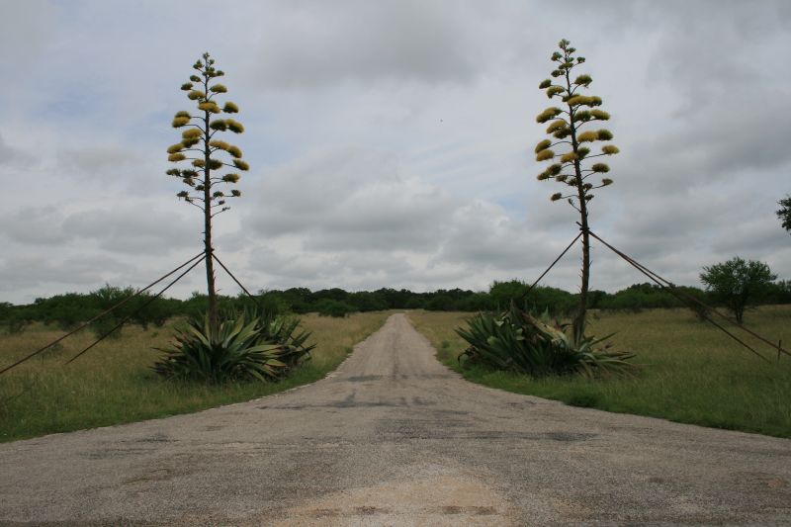

Image Credit: Art Arizpe

Prepared by GeoTrek – The Next Generation

Table of Contents

**Introduction**4 **- 5**

Summary4

Purpose4

Scope5

**Literature Review and Research5 - 6**

**Proposal6 - 10**

Data5

Methodology7

Implications8

Budget9

Timetable10

Final Deliverables10

**Conclusion11**

**References12**

**Participation13**

***Introduction***

***Summary***  
In October 2013 a sudden and large amount of precipitation in the Texas Hill Country area caused a major flood event that was devastating to Freeman Center, also known as Freeman Ranch. Individuals who were at the center were trapped until the flooding subsided, and the ranch suffered $140,000 in fence damage.

GeoTrek: The Next Generation (GeoTrek: TNG) will use a GIS to create a real-time flood prediction model to aid Freeman Ranch in visualizing where flooding is likely to occur, thus helping to minimize the repercussion of flood events in the future.

***Purpose***

The primary goal of this project is to create a flood prediction model for Freeman Ranch to determine which fences, roads, and pastures are most vulnerable to rising waters. This study will provide a real time model of which areas of Freeman Ranch will become inundated at specific time intervals during a precipitation event. It will also identify portions of fence line and access roads that could be considered “high risk zones” or areas that are more likely to be damaged during certain flood levels. The flood prediction model will also be able to recommend what areas of fence line and access roads possibly need to be reinforced with flood gates or break away fence lines so damage will not occur to larger sections of fence lines and roads than is inevitable. Also, the model will be able to determine which areas need to be evacuated of personnel and livestock before a potential flood occurs. This study will help Freeman Ranch have more accurate flood predictions so that flood damage will be less severe.

***Project Scope***

The physical scope of the project lies within the Freeman Ranch which is operated by Texas State University. Areas of high importance for the flood model will include:

1. Fences
2. Access roads for employees
3. Physical infrastructure

The timespan for the flood model will vary due to the nature of flash flooding events. Many different variables can determine how quickly or slowly water levels can rise meaning that the timeframes for an event to study or predict will be flexible.

***Literature Review and Research***

Floods can be considered one of the most devastating natural disasters. Flood prediction models and flood management practices to prevent and maintain the extent of flood damaging. The Texas Hill Country is considered one of the most flash flood prone areas in the United States and has recorded some of the largest precipitation amounts in Texas. This is due to having exposed bedrock, thin soil, and sparse vegetation (Shaiff 2010). Flood prediction models could help alleviate the devastation of potential flash floods in the area. Our study area is Freeman Ranch, located 10 minutes outside of San Marcos, Texas in what is considered the Texas Hill Country.

Through our research we have studied many different approaches to creating a flood prediction model that can help to predict and prevent flood damages from occurring in our study area. We consider the best option to be based on the concept of cellular automation “the cellular framework which uses a regular mesh of grid cells to represent the river catchment studied…Whereby the repeated iteration of a series of rules on each of these cells determines the behavior of the whole system” (Nwilo, Olayinka, and Adzandeh 2012). To generalize, this states that specific values are given to specific cells that are programed to respond accordingly as the simulation of our model progresses. Through our research we have gathered sufficient information on cellular automation and the processes needed to accomplish our goal of creating a viable flood prediction model for the Freeman Ranch.

***Proposal***

***Data***

In order to complete the analysis and flood prediction modeling GeoTrek: TNG will be using various tools in ArcGIS 10.1 in order to determine the extent of a flood event and its potential damage.

The data that we will require to complete these calculations:

* Terrain Data
  + All terrain data can be acquired from the Hays County Digital Elevation Model except for the soil moisture and ground type/ground cover datasets which will be extracted from the Freeman Ranch Geodatabase and the Texas A&M Weather Station
    - Slope
    - Aspect
    - Digital Elevation Model (DEM)
    - Ground Type
    - Ground Cover
    - Watershed
* Freeman Ranch
  + All data will be acquired from the Freeman Ranch geodatabase except for the dam elevations which will be sourced by GeoTrek: TNG analysts
    - Fences
    - Roads
    - Buildings
    - Debris Lines
    - Dam elevation and location
* Weather Data
  + - Flood maps (FEMA)
    - Precipitation (Texas A&M Weather Station)

Much of the data has been compiled into a geodatabase by a previous GIS 4427 group. Therefore, GeoTrek: TNG will need to collect debris line and damage data from the flood event that occurred in October 2013.

***Methodology***

In order to create a real-time flood prediction model our team will:

1. Gather appropriate data

We will gather the necessary data and will determine the variables needed for the analysis.

1. Process data

Then, each variable will be projected as a layer in the GIS that and we will create a grid-system to do the analysis in step 3.

1. Conduct GIS analysis

Next, we will use ArcMap (a component of ArcGIS) to analyze where the flooding will occur using the concept of cellular automation. For this particular project, the variables that will be used to obtain the values per cell are listed under the terrain and weather data. To visualize the real-time results, we will create a time variable to determine where flooding will occur at which time. We will then use the Freeman Ranch data from section to aide in visualizing which areas will be affected at which times.

1. Compare findings to known data

Next, we will compare our results to the known data from the flood event in October 2013, and will iterate the steps in out GIS analysis until our analysis is accurate.

1. Compile final deliverables

Finally, we will create a real-time flood model for users to determine how much flooding will occur after a certain amount of time.

***Implications***

The results of the flood prediction model can be used to determine at what times certain roads, fences, and pastures become jeopardized during a rain storm. As precipitation increases over a shorter period of time the flood prediction model will be able to simulate how flood waters will rise. With this information it will be possible to determine at what time intervals certain areas of Freeman Ranch will be inaccessible will need to be evacuated of all personnel and livestock.

***Budget***

**Freeman Ranch Flooding Prediction Model Budget**

**Data Collection & Analysis**

**Weeks 1-8**

Total Hours (2 hours/week * 4 weeks * 3 consultants) *24*

Hourly Pay *$20.00*

**Total $ 480.00**

***Analysis***

Total Hours (3 hours/week * 4 weeks * 3 consultants) *36*

Hourly Pay $*60.00*

**Total** **$ 2160.00**

**Project Management**

**Weeks 9-15**

*Project Manager*

Total Hours 28

Hourly Pay $ *90.00*

Pay $ *2520.00*

*Assistant Project Manager*

Total Hours 28

Hourly Pay $ *55.00*

Pay $ *1540.00*

*GIS Analyst*

Total Hours 28

Hourly Pay $ *50.00*

Pay $ *1400*

**Total****$ 5460.00**

**Software Costs**

Purchased Data $ 0.00

ArcGIS License ($14,000 [cost of concurrent license]/12 months

90 total hours of use over 3 months)

$ 492.18

Adobe Creative Cloud (599.88 [annual cost]/12 months * 2.5

months of use) $ 124.97

**Total $ 617.15**

**Travel Expenses** 50 miles @ $0.50 cents/mile $ 25.00

**$ 25.00**

**Total Costs $8742.15**

***Timetable***



 Weeks with important dates

* 1/22 – Receive request for proposal from client
* 2/12 – Proposal to client
* 3/26 – Progress report to client
* 5/2 – Final project presentation to client

***Final Deliverables***

By the end of the project we expect to have readily available the following items:

* Final report and an accompanying PowerPoint Presentation
* 2 CD/DVDs containing:
  + All data
  + Metadata
  + All reports
  + Digital copy of poster
  + PowerPoint Presentations
  + Instructions on how to use the CD
* Professional poster for display in the Geography Department.
* Web portal for use by the Freeman Ranch

***Conclusion***

In conclusion, GeoTrek: The Next Generation will create a real-time flood prediction model to aid Freeman Ranch in determining when and where flooding will occur. Our team will use the concept of cellular automation to create a grid system in ArcGIS and apply values to each cell using variables mentioned in the data section of this proposal. We will then apply time intervals to visualize which areas will be affected. With this study we hope to provide Freeman Ranch with more accurate flood predictions and aid them in assessing how to avoid situations like the flood event from October 2013.

References

Journals and Articles

Nwiloe, C. Peter, Olayink, D. Nihinlola, Adzandeh E. Ayila,. Global Journal of Human Social Science Flood Modeling and Vulnerability Assessment of Settlements in the Adamawa State Floodplain Using GIS and Cellullar Framework Approac.

Sharif, H. O., A.A., Bin-Shafique, S., Xie, Hans Zeitler, J (2012), Hydrologic Modeling of an extreme flood In the Guadalupe River in Texas. JAWRA Journal of the American Water Resources Association, 46:881-891. Doi: 10.1111/j.1752-1688.2010.00459x

***Participation***

* Katy Morris: Project Manager, Editor

Summary, Methodology, Timetable, Conclusion

* Nick Down: Assistant Project Manager, Graphic Designer

Cover Page, Title Page, Scope, Data, Budget, Final Deliverables

* Travis Hamel: GIS Analyst, Primary Researcher

Purpose, Literature Review and Research, Implications, References