

Project Manager: Katy Morris

Assistant Manager: Nick Down

GIS Analyst: Benjamin Hamel

***Freeman Ranch Flood Prediction Model***

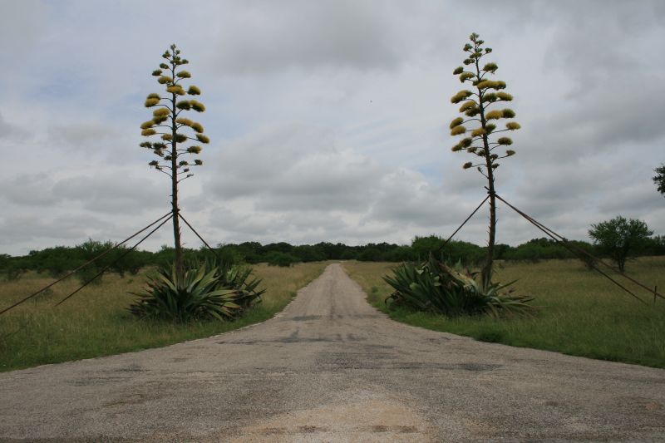

Image Credit: Art Arizpe

Prepared by GeoTrek – The Next Generation

Table of Contents

**Introduction**4 - 5

Summary4

Purpose4

Scope4 - 5

**Tasks**5 **- 7**

Task 015 - 6

Task 026

Task 037

**Revised Timetable7**

**Conclusion8**

**Participation9**

***Introduction***

***Summary***

Following the presentation, and acceptance, of our proposal on Wednesday, February 12, 2014, GeoTrek: The Next Generation (GeoTrek: TNG) began work immediately on this project. This progress report reiterates both the purpose and scope of our project, and informs the interested parties of our current progress.

***Purpose***

The purpose of this project for GeoTrek: TNG is to create a flood inundation model of Freeman Ranch. With this model we hope to provide real time data to better insure the safety of both human personnel and livestock. The flood inundation model will also show which of Freeman Ranch’s fence lines, roads, and structures that can be considered high risk zones during a precipitation event. Below we have laid out our basic tasks:

Task 01: Gather and process data

Task 02: Create model

Task 03: Automate the model and compare findings to known data.

***Scope***

The original scope of the project focused on the immediate boundaries of Freeman Ranch and prioritized three areas of importance when modeling flood inundation:

1. Fences
2. Access roads for employees
3. Physical infrastructure

As an addition and update to the scope of the project the watershed surrounding Freeman Ranch was also delineated and included as a possible area that influences rising waters on Freeman Ranch’s property.

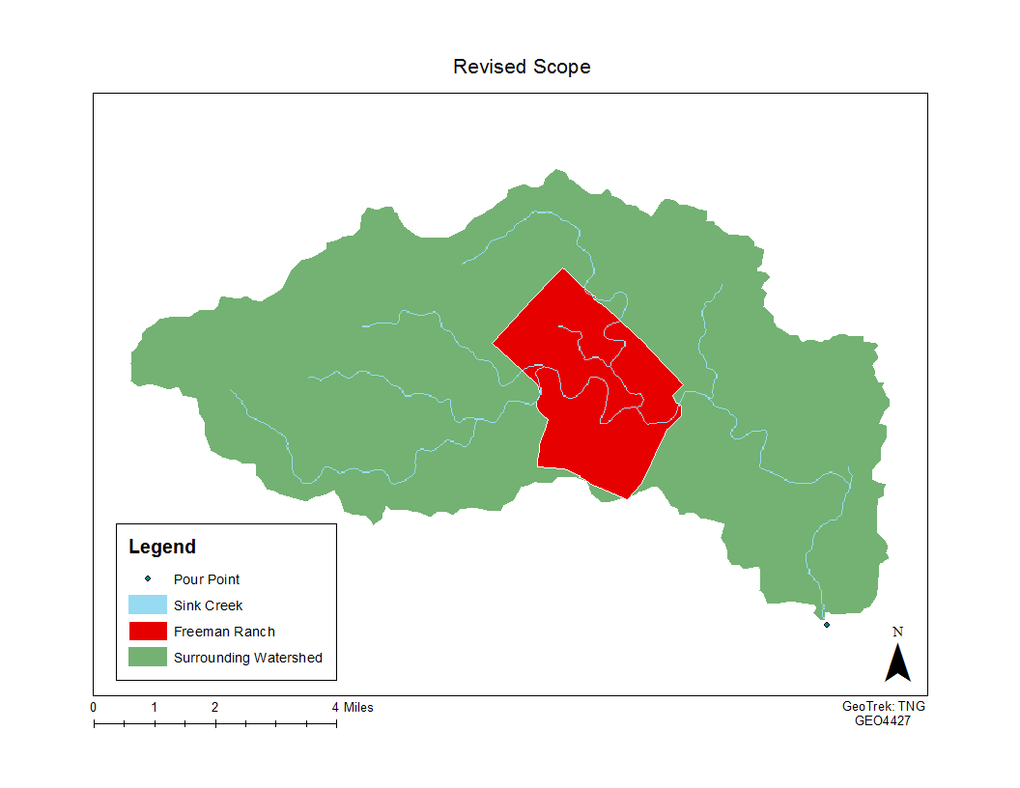

***Tasks***

***Task 01 Data Acquisition and Processing (Completed)***

In order to create an accurate flood model GeoTrek worked extensively with a digital elevation model (DEM) acquired from TNRIS. This allowed us to delineate a watershed and isolate the area of Hays County where it will affect the Freeman Ranch property. Our workflow is visualized as follows:

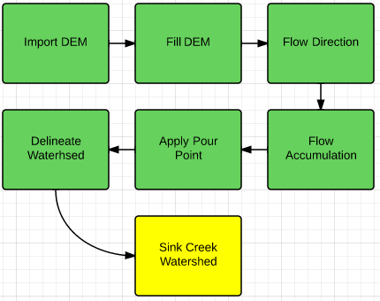

By filling the DEM we were able to fill in points that would cause ArcGIS to calculate the flow direction and accumulation correctly. This allowed us to more accurately calculate the overall flow direction from point to point in the DEM file. Once the direction of flowing water is determined we applied the flow accumulation tool, which allows the computer to determine areas where streams of water would be likely to occur. After calculating these factors and creating a pour point, which allows us to isolate the area of study, the watershed tool allowed us to calculate the areas of the DEM which rainfall could affect during a rain event. We applied an area of stream convergence for Sink Creek in order to calculate the routes that were isolated to areas around Freeman Ranch. Now that this data has been processed it serves as the base of our flood model.

***Task 02 Create model (Work in Progress)***

Since we have created the grid-system, from the DEM, GeoTrek:TNG is currently working on the model that we will use to create the flood inundation model for Freeman Ranch. We have created a basic algorithm (below) that we will expand upon as the project progresses over the next two weeks.

if “waterLyr” is not noData  
 increase cellValue

else if

if surrounding cells have water

if highest neighbor value is greater than current cell value

set cell to water value

else

do nothing  
  
The problem within this task is being able to determine which values for variables will be best to use, especially when we begin testing the time variable that will determine the output of our model. Though, once official testing begins this problem will be solved immediately.

***Task 03 Automate the model and compare findings to known data. (Work Scheduled)***

After completion of the logical model that will allow ArcGIS to run a flood inundation model we will then have ArcGIS begin using the model to automate the watershed. Next, we will conduct a GIS analysis of the Freeman Ranch where we can determine which areas are inundated at which times. After that, we will compare our model to the known data of past precipitation events in the sink creek watershed. Finally, we will be able to compile a list of “high-risk” zones of fence lines, roads, and structures that are in the most flood-prone areas.

***Revised Timetable***

The timetable has been revised to reflect that our team will be spending more time on the GIS analysis than previously expected.



 Weeks with important dates

* 1/22 – Receive request for proposal from client
* 2/12 – Proposal to client
* 3/26 – Progress report to client
* 5/2 – Final project presentation to client

***Conclusion***

In conclusion, GeoTrek: The Next Generation will create a real-time flood prediction model to aid Freeman Ranch in determining when and where flooding will occur. The scope has changed to incorporate the watershed that will affect how the model is implemented. We have also altered the timetable to devote more time the to the GIS analysis. Our team has completed data acquisition and preprocessing, is working on the model that will be used, and will use the concept of cellular automata to implement the model. With this study we hope to provide Freeman Ranch with more accurate flood predictions and aid them in assessing how to avoid situations like the flood event from October 2013.

***Participation***

* Katy Morris: Project Manager, Editor

Summary, Task 02, Timetable, Conclusion

* Nick Down: Assistant Project Manager, Graphic Designer

Cover Page, Title Page, Scope, Task 01

* Travis Hamel: GIS Analyst, Primary Researcher

Purpose, Task 03