

Project Manager: Kathryn Morris

Assistant Manager: Nick Down

GIS Analyst: Benjamin Hamel

***Freeman Ranch Flood Prediction Model***

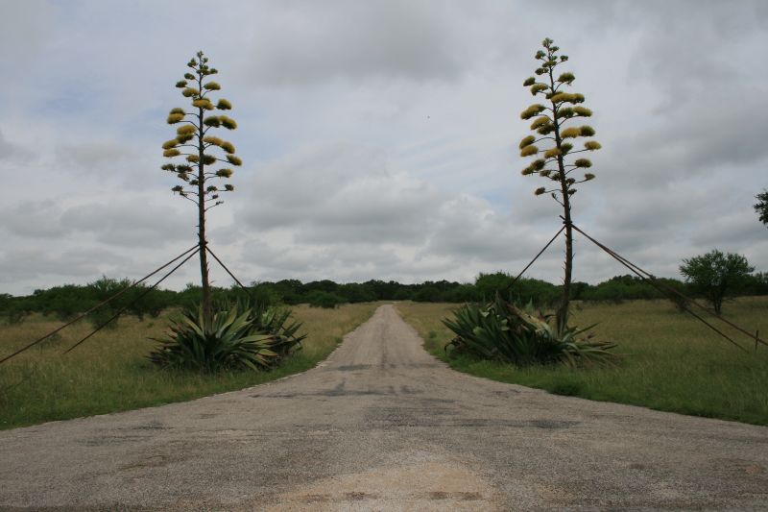

Image Credit: Art Arizpe

Prepared by GeoTrek – The Next Generation

Table of Contents

1. Introduction and Problem Statement4 - 5

Summary/Purpose4

Scope4

Literature Review4 - 5

1. Data5 - 6

DEM Terrain Manipulation5

Freeman GeoDatabase6

1. Methods6 - 12

Delineate Watershed6 - 7

Create and Initial State7

Create a Spread Model7 - 8

Compare Iterations8 - 9

Create a Rise Model9 - 10

Determine High-risk Zones11 - 12

Automate the Process12

1. Results13 - 17
2. Discussion18 - 19

Scope and Capabilities18

Similar Projects18 - 19

Future Construction Projects19

1. **Conclusions19**
2. References20

Appendix I: Metadata21 - 57

Appendix II: Group Membership Participation58

**Introduction**

On October 31st, 2013 the Freeman Ranch Center and surrounding areas encountered almost 12” of rainfall in a matter of just a few hours. The Texas Hill Country is considered one of the most flash flood prone areas in the United States due to its physical composition, including soil type, vegetation and geological formations. (Shaiff 2010) Because of this geological make up the Freeman Ranch Center was severely flooded and experienced over $140,000 worth of damage to the infrastructure on its property as well as trapping many ranch employees on the property due to swollen creeks and rising flood waters. Because of the nature of this flood event and the dangers and the damage that they encountered, the Freeman Ranch personnel have requested GeoTrek: The Next Generation (GeoTrek: TNG) to use a Geographic Information System (GIS) to create a basic flood inundation model to determine which areas of Freeman Ranch will become inundated by water after certain amounts of precipitation and for how long.

*Summary/Purpose*

In order to determine how to predict inundation levels and estimate how a flood event would occur GeoTrek: TNG consultants would work with local watersheds and create a real time model to determine which fences, roads, and other ranch infrastructure are vulnerable to being inundated by water and at what time that they would be inundated during a set amount of rainfall.

*Scope*

The boundaries of this project lie completely within the Freeman Ranch property which is a narrower scope than originally intended, however, the model that GeoTrek has created will be modifiable to a larger watershed surrounding the Freeman Ranch as well.

*Literature Review*

GeoTrek: TNG researched multiple different methods of creating a flood model before settling on the method that was implemented ultimately. The final option selected was based on the concept of cellular automation which uses “the cellular framework which uses a regular mesh of grid cells to represent the river catchment studied…Whereby the repeated iteration of a series of rules on each of these cells determines the behavior of the whole system” (Nwilo, Olayinka, and Adzandeh 2012). This simply is a process that compares cells to their neighbors and determines through precipitation and elevation data how each cell will react to changes in the grid.

**Data**

In order for GeoTrek: TNG to create a flood inundation model the team needed to acquire data on the Freeman Center as well as create and manipulate terrain information in order to meet the scale and scope of the project. There were three main tasks that GeoTrek needed to complete in order to arrive at the final results of the inundation model and this section will outline how the data was manipulated and applied to each portion of the model. Much of the data that we acquired from the Texas State Geography Department and the previous Freeman Ranch Database was projected with different coordinate systems so it was all transformed into NAD1983 and displayed with Texas South Central State Plane (ft.) system.

*DEM Terrain Manipulation*

The original DEM was acquired from the Department of Geography at Texas State University and was used to calculate the watershed of Freeman Ranch. We were required to use this terrain data because the DEM has the information necessary to calculate flow direction, accumulation, and the drainage basin of a specific stream as marked by a pour point. The DEM had a resolution of 30 Meters which allowed us to have a general idea of how rain water would interact with terrain during a precipitation event.

*Freeman GeoDatabase*

The infrastructure features on the Flood Inundation Model were extracted from the Freeman Ranch Geodatabase that GeoTrek previously worked on in Fall 2013. The fences, roads, and building layers were combined in order to create a layer that would serve as an inundation point where water levels rose over a certain amount.

**Methods**

*Delineate Watershed*

In order to create an accurate flood model GeoTrek:TNG worked extensively with the DEM mentioned in the previous section. This allowed us to delineate a watershed and isolate the area of Hays County where it will affect the Freeman Ranch property.

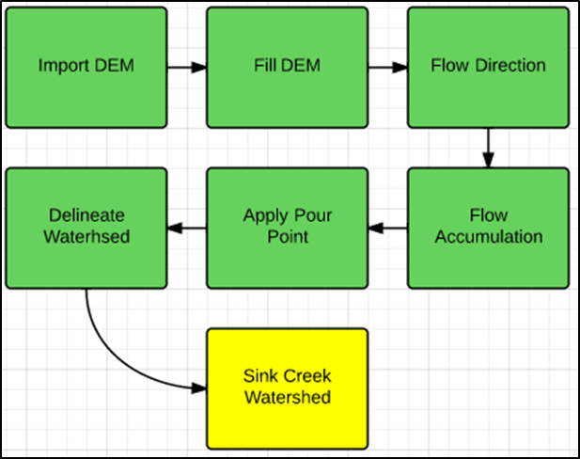

First, we used the fill tool to fill the DEM of all sinks to create a filled DEM layer. Once the sinks were filled, we then ran a flow accumulation model. After the creation of the flow accumulation layer, we could then determine the flow direction. Next, we determined the most appropriate position to place a pour point that we would then use to begin flooding the watershed. With the delineated watershed we finally captured the delineated Sink Creek Watershed, our main study area.

*Create an Initial State*

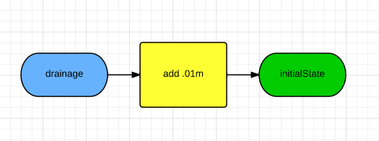

Next, we needed to create an initial state steam in order to begin the flooding. To do this, we needed to determine where drainage occurred, which was the lowest DEM value and then added .01m to that in order to create the stream.

*Create a Spread Model*

After obtaining the initial state (t0) we began to flood the stream by creating a spread model.

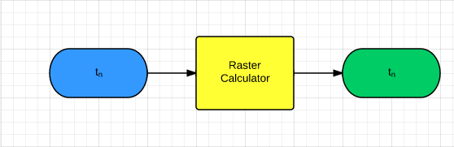

Within Raster Calculator we used conditional statements and zonal statistics to determine the behavior of the water spread. The conditions tested to see if the values of the neighboring cells around a cell were higher, if so then the cell was given the neighborhood max value.

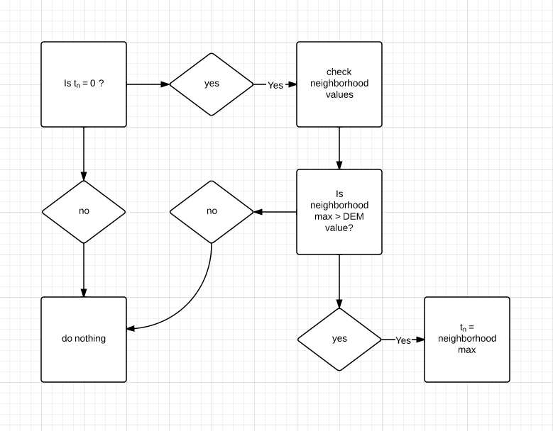

*Compare Iterations*

After iterating the spread we needed to determine when to raise the water. To do this we compared iterations. This helped us determine whether or not the water had stopped spreading.

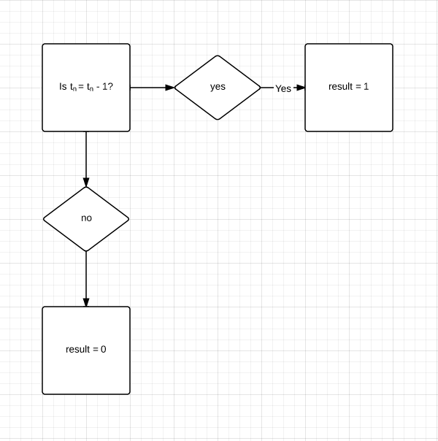

We recorded our results in an excel and found that rising every 3rd iteration was most effective.

*Create a Rise Model*

After determining the appropriate iterations to rise we created a rise model.

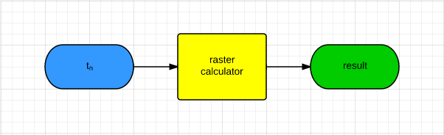

Within raster calculator we used a simple conditional statement to add .001m to the cells that needed to rise.

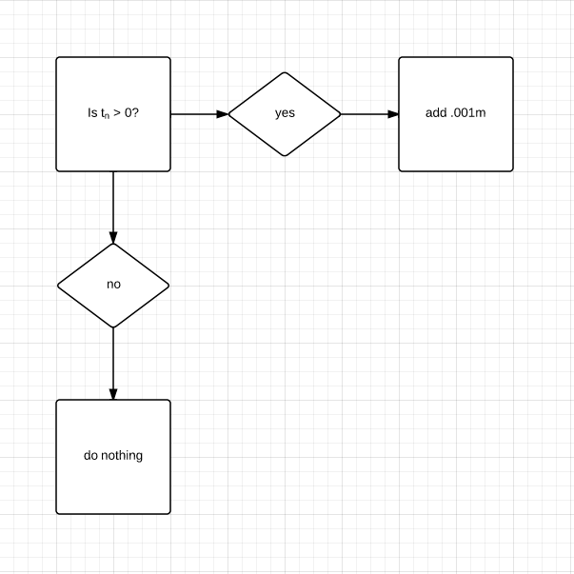

*Determine High-risk Zones*

Next, we needed to determine which infrastructure would be affected at specific time intervals. The infrastructure consisted of fences, buildings, and roads. We created points at which the initial state crossed roads and fences and kept the buildings as point data, we then gave each point a unique name.

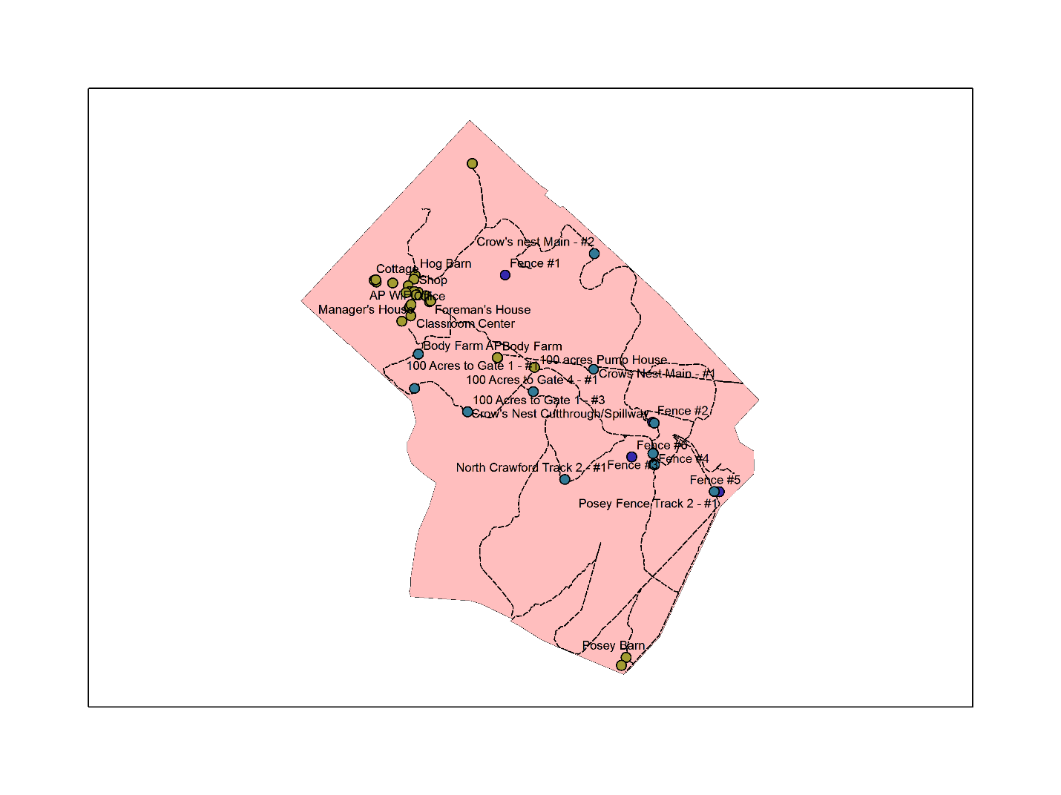

After that, we merged all of the points into one layer. Each type of infrastructure was given an inundation threshold.

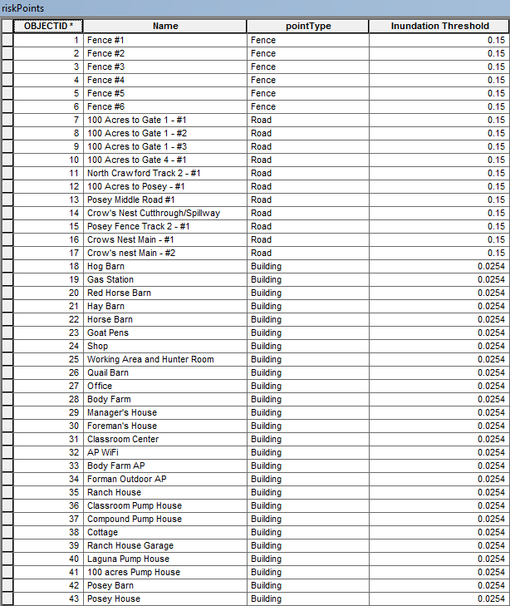

If the water layer reached the threshold, a warning was created.

*Automation*

Finally, we gathered all of our models and, with the help of Ryan Schuermann, created a script to automate the process.

**Results**

As a result, GeoTrek: The Next Generation ended up with a simple flood-prediction model that visualizes the behavior of the flood as well as generates warnings when specific infrastructures are inundated.



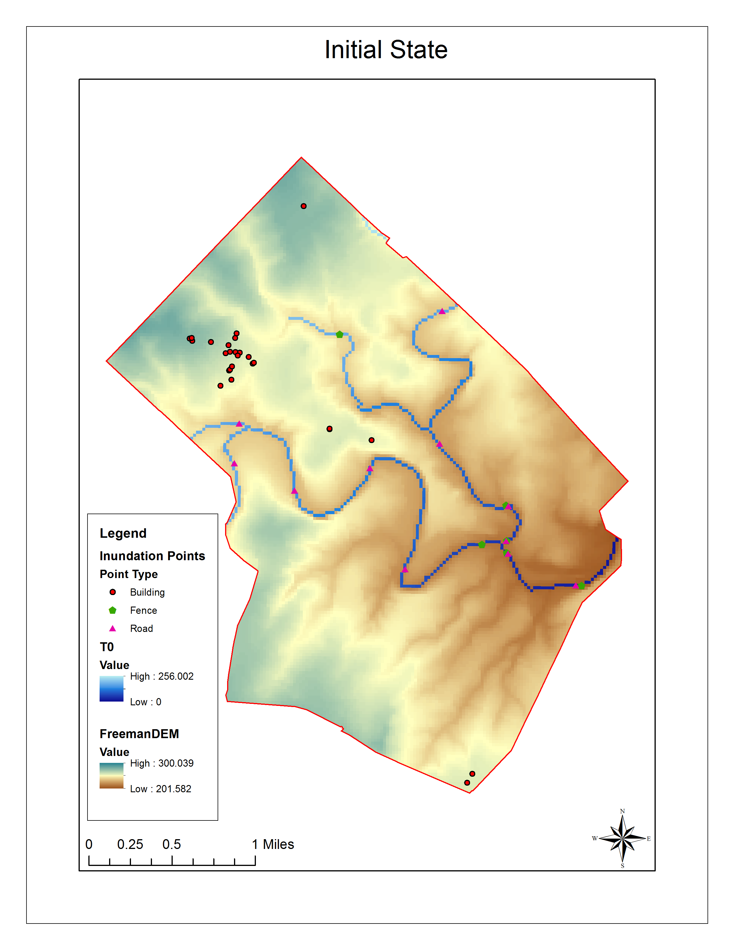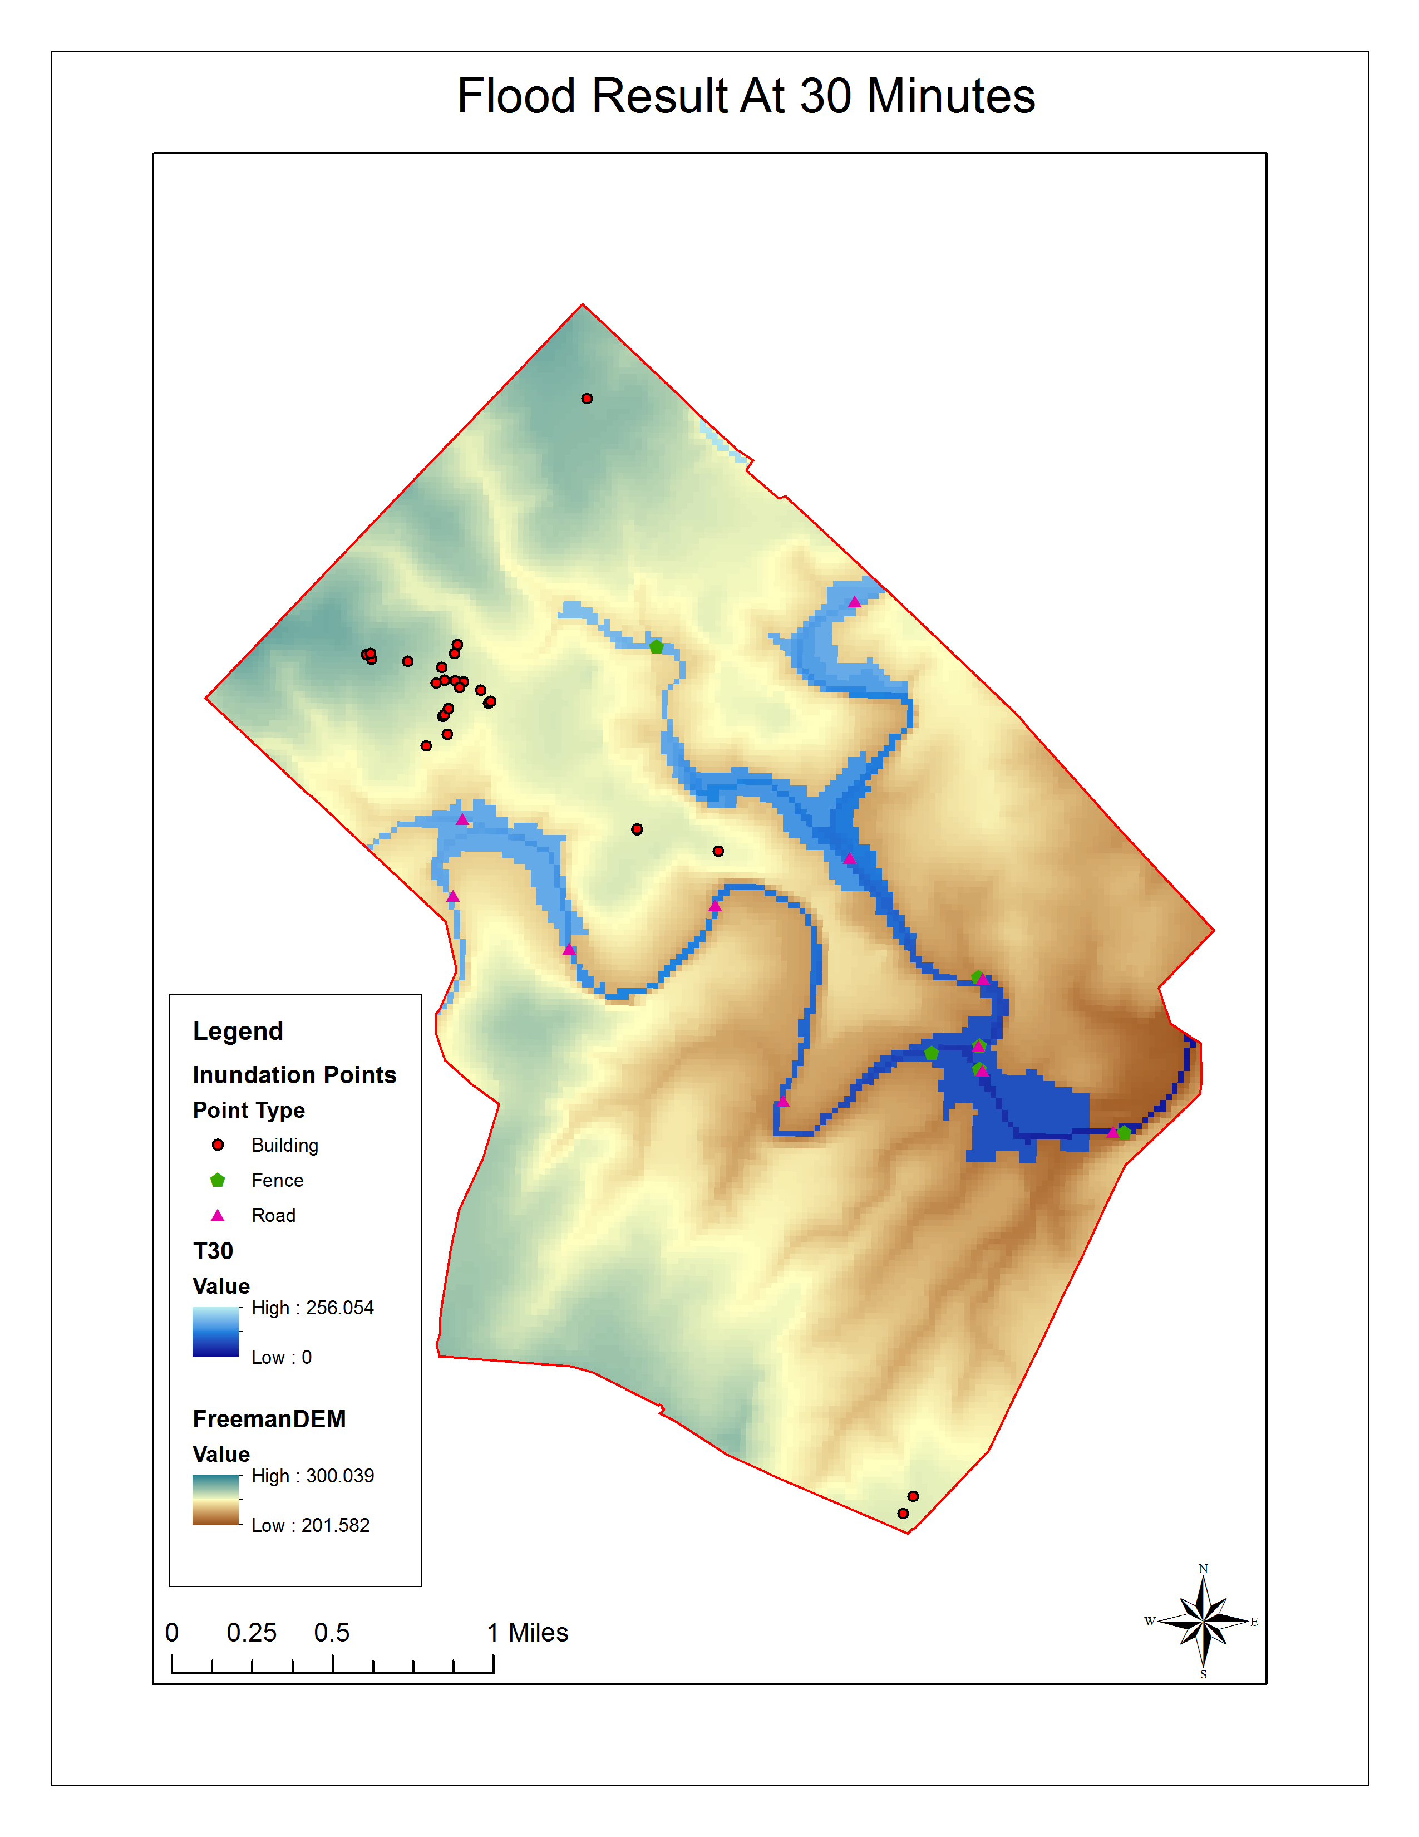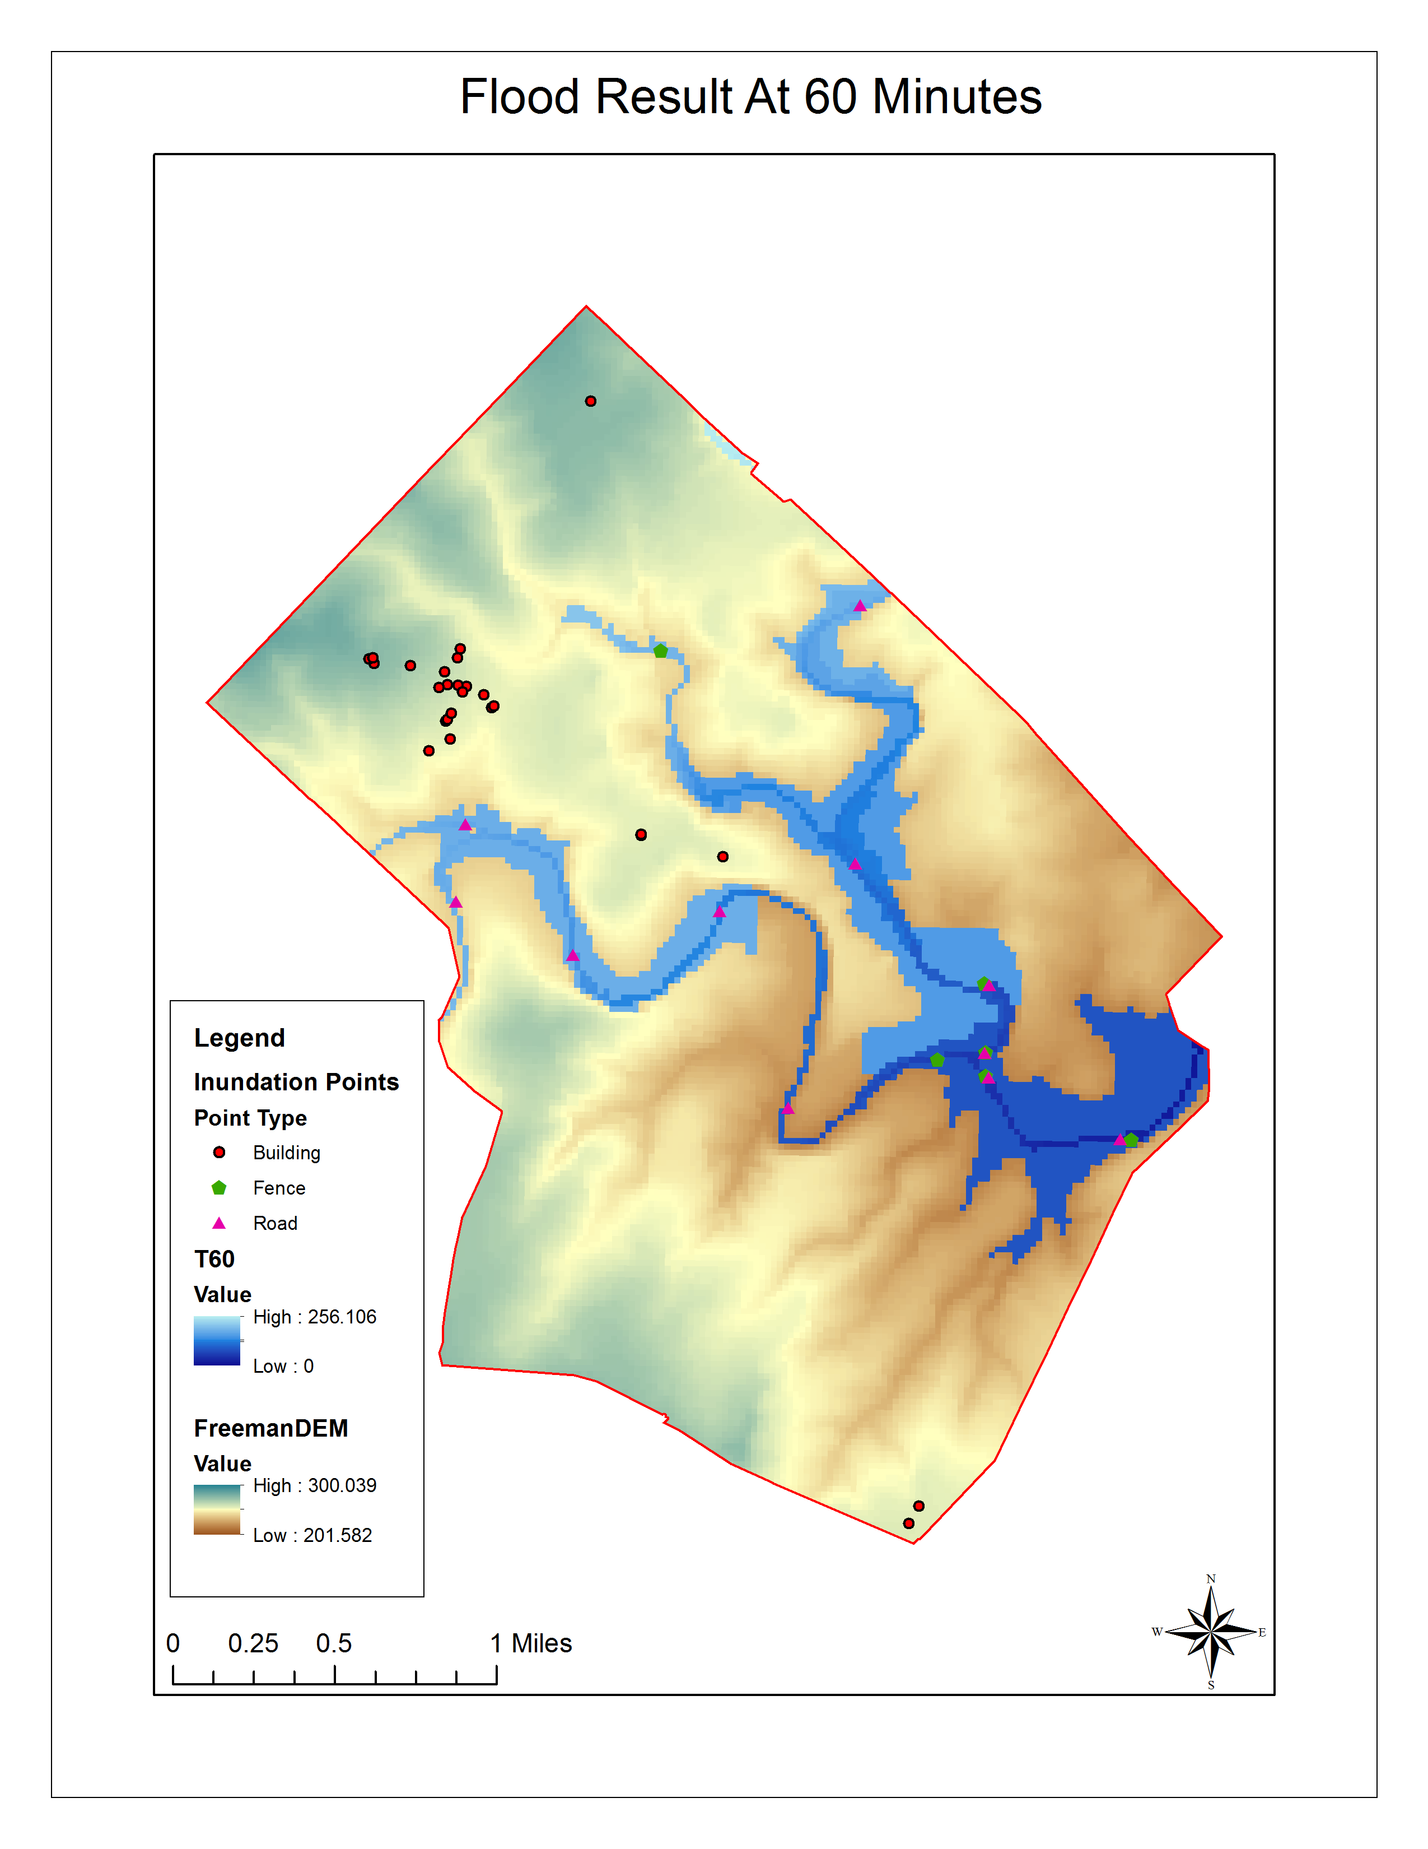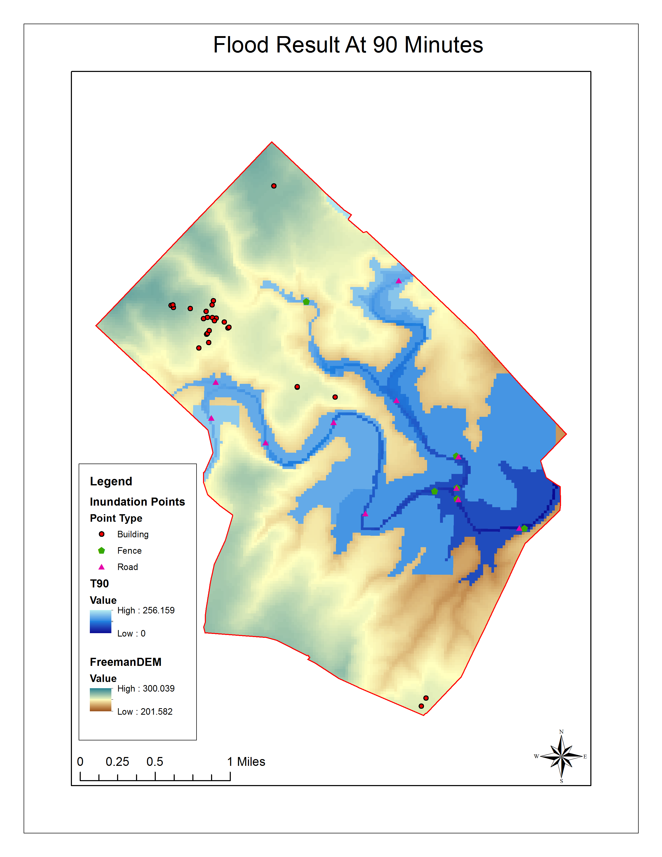

**Discussion**

*Scope and Capabilities*

When creating the watershed for the sink creek area we located our pour point at the confluence of two streams (Sink Creek and an unidentified stream). We noticed that a small segment of Freeman Ranch protruded into the neighboring creeks watershed. After extensive research we determined that the miniscule amount of the ranch that protruded into the other watershed was also located on a higher elevation than the surrounding areas of Freeman Ranch. This being so the small corner of the ranch that was not included in the Sink Creek watershed was determined to be of little or no risk during a rain fall event.

The Sink Creek watershed is much larger than the 4,200 acre education trust of Freeman Ranch. Our model was created only to simulate a rainfall event pertaining to the ranch itself. The ranch is liable to flood if rain occurs on other tributary streams of Sink Creek that run through the ranch. In the time allotted for our project we could not create a model to determine every possible rainfall event in the area. That is why our model is only of Freeman Ranch and considers the rain to fall evenly and continuously across all areas of Freeman ranch.

While running our model we noticed that the rising waters were behaving strangely. The waters were not spreading near the dam the fastest, but at different rates along upper portions of Sink Creek. GeoTrek:TNG contributes this phenomenon to the slope of the surrounding terrain. Different portions of Sink Creek have steeper slops and therefore flood differently.

*Similar Studies*

While researching information about flood inundation projects GeoTrek: TNG studied a flow and sediment transport model known as CAESAR (Cellular Automation Evolutionary Slope and River). CAESAR uses a similar technique of cellular automation as GeoTrek: TNG to conduct their studies. The program is set up for users to input their own data and study area to be able to study river catchments on a flood by flood basis. Using the CAESAR model GeoTrek: TNG compared our results from our flood inundation model to the results we got from CAESAR. After comparing our results to CAESAR it became apparent that the expected high risk areas were inundated at similar times within both flood models. Using CAESAR helped GeoTrek: TNG get a better understanding of how our flood inundation model should work.

*Future Construction Projects*

Now that Freeman Ranch has a working flood inundation model it should make Freeman Ranch a safer place and more flood resistant. Future construction projects on Freeman Ranch will be able to use our flood inundation model to uncover which areas of fence line need to be built with breakaway fences. It will also identify which roadways on the ranch will be in high risk zones and need to be made more structurally sound for safer use during a rain fall event.

**Conclusions**

GeoTrek: The Next Generation has created a working flood inundation model for Freeman Ranch. Freeman Ranch is located in the Sink Creek watershed and is a flash flood prone area. With our flood inundation model users will be able to visualize a rough estimation of when a flood will affect infrastructure. With GeoTrek: TNG’s model Freeman Ranch will become a safer place for both livestock and humans during potential flash flood events.

**References**

Journals and Articles

Nwiloe, C. Peter, Olayink, D. Nihinlola, Adzandeh E. Ayila,. Global Journal of Human Social Science Flood Modeling and Vulnerability Assessment of Settlements in the Adamawa State Floodplain Using GIS and Cellullar Framework Approac.

Sharif, H. O., A.A., Bin-Shafique, S., Xie, Hans Zeitler, J (2012), Hydrologic Modeling of an extreme flood In the Guadalupe River in Texas. JAWRA Journal of the American Water Resources Association, 46:881-891. Doi: 10.1111/j.1752-1688.2010.00459x

**Appendix I. Meta Data**

**FenceRast**

**File Geodatabase Raster Dataset**

**Tags**  
Freeman Ranch Fences

**Summary**

To give users visual representation of the fences on Freeman Ranch

**Description**

Fences located on Freeman Ranch

**Credits**

There are no credits for this item.

**Use limitations**

There are no access and use limitations for this item.

**Extent**

|  |  |  |  |
| --- | --- | --- | --- |
| **West** | -98.121411 | **East** | -97.910286 |
| **North** | 29.982637 | **South** | 29.870657 |

**Scale Range**

|  |  |
| --- | --- |
| **Maximum (zoomed in)** | 1:5,000 |
| **Minimum (zoomed out)** | 1:150,000,000 |

ArcGIS Metadata ▼►

**Topics and Keywords  ▼►**

**\*** Content type  Downloadable Data

*Hide Topics and Keywords ▲*

**Citation  ▼►**

**\*** Title FenceRast

Creation date 2014-04-14 00:00:00

Publication date 2014-04-21 00:00:00

Presentation formats  **\*** digital table

*Hide Citation ▲*

**Citation Contacts  ▼►**

Responsible party

Individual's name Katy Morris

Organization's name Geotrek: The Next Generation

Contact's position Manager

Contact's role  originator

Contact information  ▼►

Phone

Voice 5125578611

Address

Type physical

City San Marcos

Administrative area Texas

Postal code 78666

*Hide Contact information ▲*

Responsible party

Individual's name Nick Down

Organization's name Geotrek: The Next Generation

Contact's position Assistant Manager

Contact's role  author

Contact information  ▼►

Phone

Voice 8324656486

Address

Type physical

City San Marcos

Administrative area Texas

Postal code 78666

*Hide Contact information ▲*

Responsible party

Individual's name Benjamin Hamel

Organization's name GeoTrek: The Next Generation

Contact's position GIS Analyst

Contact's role  author

Contact information  ▼►

Phone

Voice 8325271755

Address

Type physical

Delivery point 501 Franklin

City San Marcos

Administrative area Texas

Postal code 78666

Country US

e-mail address [bth21@txstate.edu](mailto:bth21@txstate.edu?subject=FenceRast)

*Hide Contact information ▲*

Responsible party

Individual's name Alberto Giordano

Organization's name Texas State University, Geography Department

Contact's position Depatment Head

Contact's role  author

Contact information  ▼►

Phone

Voice 5122456581

Address

Type physical

City San Marcos

Administrative area Texas

Postal code 78666

e-mail address [ag@txstate.edu](mailto:ag@txstate.edu?subject=FenceRast)

*Hide Contact information ▲*

*Hide Citation Contacts ▲*

**Resource Details  ▼►**

Dataset languages  **\*** English (UNITED STATES)

Dataset character set  utf8 - 8 bit UCS Transfer Format

Status  completed

Spatial representation type  **\*** grid

**\*** Processing environment Microsoft Windows 7 Version 6.1 (Build 7601) Service Pack 1; Esri ArcGIS 10.1.1.3143

ArcGIS item properties

**\*** Name FenceRast

**\*** Location file://\\Geoserve\Data\G4427\FR_FLOOD\Data\Flood Model.gdb

**\*** Access protocol Local Area Network

*Hide Resource Details ▲*

**Extents  ▼►**

Extent

Geographic extent

Bounding rectangle

Extent type  Extent used for searching

**\*** West longitude -98.121411

**\*** East longitude -97.910286

**\*** North latitude 29.982637

**\*** South latitude 29.870657

**\*** Extent contains the resource Yes

Extent

Description

Semester Project for spring 2014

Temporal extent

Beginning date 2014-01-29 00:00:00

Ending date 2014-05-01 00:00:00

Extent in the item's coordinate system

**\*** West longitude 2997664.294476

**\*** East longitude 3063744.294476

**\*** South latitude 9925040.554628

**\*** North latitude 9964400.554628

**\*** Extent contains the resource Yes

*Hide Extents ▲*

**Resource Maintenance  ▼►**

Resource maintenance

Update frequency  as needed

*Hide Resource Maintenance ▲*

**Spatial Reference  ▼►**

ArcGIS coordinate system

**\*** Type Projected

**\*** Geographic coordinate reference GCS_North_American_1983

**\*** Projection NAD83_Texas_Central

**\*** Coordinate reference details

Projected coordinate system

X origin -124805500

Y origin -81923100

XY scale 35432942.484959878

Z origin -100000

Z scale 10000

M origin -100000

M scale 10000

XY tolerance 0.0032808333333333331

Z tolerance 0.001

M tolerance 0.001

High precision true

Well-known text PROJCS["NAD83_Texas_Central",GEOGCS["GCS_North_American_1983",DATUM["D_North_American_1983",SPHEROID["GRS_1980",6378137.0,298.257222101]],PRIMEM["Greenwich",0.0],UNIT["Degree",0.0174532925199433]],PROJECTION["Lambert_Conformal_Conic"],PARAMETER["false_easting",2296583.333333334],PARAMETER["false_northing",9842500.0],PARAMETER["central_meridian",-100.3333333333333],PARAMETER["standard_parallel_1",31.88333333333333],PARAMETER["standard_parallel_2",30.11666666666667],PARAMETER["latitude_of_origin",29.66666666666667],UNIT["Foot_US",0.3048006096012192]]

Reference system identifier

**\*** Value 0

*Hide Spatial Reference ▲*

**Geoprocessing history  ▼►**

Process

Process name

Date 2014-04-17 13:43:54

Tool location c:\program files (x86)\arcgis\desktop10.1\ArcToolbox\Toolboxes\Conversion Tools.tbx\PointToRaster

Command issued

PointToRaster FenceIntersection FID "W:\G4427\FR_FLOOD\Data\Flood Model.gdb\FenceRast" MOST_FREQUENT NONE 160

Include in lineage when exporting metadata No

*Hide Geoprocessing history ▲*

**Distribution  ▼►**

Distribution format

**\*** Name File Geodatabase Raster Dataset

*Hide Distribution ▲*

**Fields  ▼►**

Details for object VAT_FenceRast  ▼►

**\*** Type Table

**\*** Row count 6

Field OBJECTID  ▼►

**\*** Alias OBJECTID

**\*** Data type OID

**\*** Width 4

**\*** Precision 0

**\*** Scale 0

**\*** Field description

Internal feature number.

**\*** Description source

Esri

**\*** Description of values Sequential unique whole numbers that are automatically generated.

*Hide Field OBJECTID ▲*

Field Value  ▼►

**\*** Alias Value

**\*** Data type Integer

**\*** Width 4

**\*** Precision 0

**\*** Scale 0

*Hide Field Value ▲*

Field Count  ▼►

**\*** Alias Count

**\*** Data type Double

**\*** Width 8

**\*** Precision 0

**\*** Scale 0

*Hide Field Count ▲*

*Hide Details for object VAT_FenceRast ▲*

*Hide Fields ▲*

**Metadata Details  ▼►**

**\*** Metadata language English (UNITED STATES)

Scope of the data described by the metadata  **\*** dataset

Scope name  **\*** dataset

**\*** Last update 2014-04-24

ArcGIS metadata properties

Metadata format ArcGIS 1.0

Standard or profile used to edit metadata FGDC

Created in ArcGIS for the item 2014-04-17 13:43:54

Last modified in ArcGIS for the item 2014-04-24 12:04:50

Automatic updates

Have been performed Yes

Last update 2014-04-24 12:04:50

*Hide Metadata Details ▲*

**Metadata Contacts  ▼►**

Metadata contact

Individual's name Katy Morris

Organization's name Geotrek: The Next Generation

Contact's position Manager

Contact's role  originator

Contact information  ▼►

Phone

Voice 5125578611

Address

Type physical

City San Marcos

Administrative area Texas

Postal code 78666

*Hide Contact information ▲*

Metadata contact

Individual's name Nick Down

Organization's name Geotrek: The Next Generation

Contact's position Assistant Manager

Contact's role  author

Contact information  ▼►

Phone

Voice 8324656486

Address

Type physical

City San Marcos

Administrative area Texas

Postal code 78666

*Hide Contact information ▲*

Metadata contact

Individual's name Benjamin Hamel

Organization's name GeoTrek: The Next Generation

Contact's position GIS Analyst

Contact's role  author

Contact information  ▼►

Phone

Voice 8325271755

Address

Type physical

Delivery point 501 Franklin

City San Marcos

Administrative area Texas

Postal code 78666

Country US

e-mail address [bth21@txstate.edu](mailto:bth21@txstate.edu?subject=FenceRast)

*Hide Contact information ▲*

Metadata contact

Individual's name Alberto Giordano

Organization's name Texas State University, Geography Department

Contact's position Depatment Head

Contact's role  author

Contact information  ▼►

Phone

Voice 5122456581

Address

Type physical

City San Marcos

Administrative area Texas

Postal code 78666

e-mail address [ag@txstate.edu](mailto:ag@txstate.edu?subject=FenceRast)

*Hide Contact information ▲*

*Hide Metadata Contacts ▲*

FGDC Metadata (read-only) ▼►

**Spatial Data Organization  ▼►**

Raster Object Information

Raster Object Type Pixel

Row Count 246

Column Count 413

Vertical Count 1

*Hide Spatial Data Organization  ▲*

**Spatial Reference  ▼►**

Horizontal Coordinate System Definition

Planar

Planar Coordinate Information

Planar Coordinate Encoding Method row and column

Coordinate Representation

Abscissa Resolution 160.000000

Ordinate Resolution 160.000000

*Hide Spatial Reference  ▲*

**Entities and Attributes  ▼►**

Detailed Description

Entity Type

Entity Type Label VAT_FenceRast

Attribute

Attribute Label OBJECTID

Attribute Definition

Internal feature number.

Attribute Definition Source Esri

Attribute Domain Values

Unrepresentable Domain

Sequential unique whole numbers that are automatically generated.

Attribute

Attribute Label Value

Attribute

Attribute Label Count

**Buildings**

**File Geodatabase Raster Dataset**

**Tags**  
Buildings on Freeman Ranch

**Summary**

To allow users to have visual representations of buildings located on Freeman Ranch

**Description**

Buildings located on Freeman Ranch

**Credits**

There are no credits for this item.

**Use limitations**

There are no access and use limitations for this item.

**Extent**

|  |  |  |  |
| --- | --- | --- | --- |
| **West** | -98.121411 | **East** | -97.910286 |
| **North** | 29.982637 | **South** | 29.870657 |

**Scale Range**

|  |  |
| --- | --- |
| **Maximum (zoomed in)** | 1:5,000 |
| **Minimum (zoomed out)** | 1:150,000,000 |

ArcGIS Metadata ▼►

**Topics and Keywords  ▼►**

**\*** Content type  Downloadable Data

*Hide Topics and Keywords ▲*

**Citation  ▼►**

Title Buildings

Creation date 2014-04-15 00:00:00

Publication date 2014-04-21 00:00:00

Presentation formats  **\*** digital table

*Hide Citation ▲*

**Citation Contacts  ▼►**

Responsible party

Individual's name Katy Morris

Organization's name GeoTrek: The Next Generation

Contact's position Team Manager

Contact's role  author

Contact information  ▼►

Address

Type physical

City San Marcos

Administrative area Texas

Postal code 78666

*Hide Contact information ▲*

Responsible party

Individual's name Nick Down

Organization's name GeoTrek: The Next Generation

Contact's position Assistant Manager

Contact's role  author

Responsible party

Individual's name Benjamin Hamel

Organization's name GeoTrek: The Next Generation

Contact's position GIS analyst

Contact's role  author

Contact information  ▼►

Phone

Voice 8325271755

Address

Type physical

Delivery point 501 Franklin

City San Marcos

Administrative area Texas

Postal code 78666

Country US

e-mail address [bth21@txstate.edu](mailto:bth21@txstate.edu?subject=Buildings)

*Hide Contact information ▲*

Responsible party

Individual's name Alberto Giordano

Organization's name Texas State University, Geography Department

Contact's position Department Head

Contact's role  author

*Hide Citation Contacts ▲*

**Resource Details  ▼►**

Dataset languages  **\*** English (UNITED STATES)

Dataset character set  utf8 - 8 bit UCS Transfer Format

Status  completed

Spatial representation type  **\*** grid

**\*** Processing environment Microsoft Windows 7 Version 6.1 (Build 7601) Service Pack 1; Esri ArcGIS 10.1.1.3143

ArcGIS item properties

**\*** Name BuildingRast

**\*** Location file://\\Geoserve\Data\G4427\FR_FLOOD\Data\Flood Model.gdb

**\*** Access protocol Local Area Network

*Hide Resource Details ▲*

**Extents  ▼►**

Extent

Geographic extent

Bounding rectangle

Extent type  Extent used for searching

**\*** West longitude -98.121411

**\*** East longitude -97.910286

**\*** North latitude 29.982637

**\*** South latitude 29.870657

**\*** Extent contains the resource Yes

Extent in the item's coordinate system

**\*** West longitude 2997664.294476

**\*** East longitude 3063744.294476

**\*** South latitude 9925040.554628

**\*** North latitude 9964400.554628

**\*** Extent contains the resource Yes

*Hide Extents ▲*

**Resource Maintenance  ▼►**

Resource maintenance

Update frequency  as needed

*Hide Resource Maintenance ▲*

**Spatial Reference  ▼►**

ArcGIS coordinate system

**\*** Type Projected

**\*** Geographic coordinate reference GCS_North_American_1983

**\*** Projection NAD83_Texas_Central

**\*** Coordinate reference details

Projected coordinate system

X origin -124805500

Y origin -81923100

XY scale 35432942.484959878

Z origin -100000

Z scale 10000

M origin -100000

M scale 10000

XY tolerance 0.0032808333333333331

Z tolerance 0.001

M tolerance 0.001

High precision true

Well-known text PROJCS["NAD83_Texas_Central",GEOGCS["GCS_North_American_1983",DATUM["D_North_American_1983",SPHEROID["GRS_1980",6378137.0,298.257222101]],PRIMEM["Greenwich",0.0],UNIT["Degree",0.0174532925199433]],PROJECTION["Lambert_Conformal_Conic"],PARAMETER["false_easting",2296583.333333334],PARAMETER["false_northing",9842500.0],PARAMETER["central_meridian",-100.3333333333333],PARAMETER["standard_parallel_1",31.88333333333333],PARAMETER["standard_parallel_2",30.11666666666667],PARAMETER["latitude_of_origin",29.66666666666667],UNIT["Foot_US",0.3048006096012192]]

Reference system identifier

**\*** Value 0

*Hide Spatial Reference ▲*

**Geoprocessing history  ▼►**

Process

Process name

Date 2014-04-17 13:47:58

Tool location c:\program files (x86)\arcgis\desktop10.1\ArcToolbox\Toolboxes\Conversion Tools.tbx\PointToRaster

Command issued

PointToRaster Buildings OID "W:\G4427\FR_FLOOD\Data\Flood Model.gdb\BuildingRast" MOST_FREQUENT NONE 160

Include in lineage when exporting metadata No

*Hide Geoprocessing history ▲*

**Distribution  ▼►**

Distribution format

**\*** Name File Geodatabase Raster Dataset

*Hide Distribution ▲*

**Fields  ▼►**

Details for object VAT_BuildingRast  ▼►

**\*** Type Table

**\*** Row count 21

Field OBJECTID  ▼►

**\*** Alias OBJECTID

**\*** Data type OID

**\*** Width 4

**\*** Precision 0

**\*** Scale 0

**\*** Field description

Internal feature number.

**\*** Description source

Esri

**\*** Description of values Sequential unique whole numbers that are automatically generated.

*Hide Field OBJECTID ▲*

Field Value  ▼►

**\*** Alias Value

**\*** Data type Integer

**\*** Width 4

**\*** Precision 0

**\*** Scale 0

*Hide Field Value ▲*

Field Count  ▼►

**\*** Alias Count

**\*** Data type Double

**\*** Width 8

**\*** Precision 0

**\*** Scale 0

*Hide Field Count ▲*

*Hide Details for object VAT_BuildingRast ▲*

*Hide Fields ▲*

**Metadata Details  ▼►**

**\*** Metadata language English (UNITED STATES)

Metadata character set  utf8 - 8 bit UCS Transfer Format

Scope of the data described by the metadata  **\*** dataset

Scope name  **\*** dataset

**\*** Last update 2014-04-24

ArcGIS metadata properties

Metadata format ArcGIS 1.0

Standard or profile used to edit metadata FGDC

Created in ArcGIS for the item 2014-04-17 13:47:58

Last modified in ArcGIS for the item 2014-04-24 12:06:59

Automatic updates

Have been performed Yes

Last update 2014-04-24 12:06:59

*Hide Metadata Details ▲*

**Metadata Contacts  ▼►**

Metadata contact

Individual's name Katy Morris

Organization's name GeoTrek: The Next Generation

Contact's position Team Manager

Contact's role  author

Contact information  ▼►

Address

Type physical

City San Marcos

Administrative area Texas

Postal code 78666

*Hide Contact information ▲*

Metadata contact

Individual's name Benjamin Hamel

Organization's name GeoTrek: The Next Generation

Contact's position GIS analyst

Contact's role  author

Contact information  ▼►

Phone

Voice 8325271755

Address

Type physical

Delivery point 501 Franklin

City San Marcos

Administrative area Texas

Postal code 78666

Country US

e-mail address [bth21@txstate.edu](mailto:bth21@txstate.edu?subject=Buildings)

*Hide Contact information ▲*

Metadata contact

Individual's name Nick Down

Organization's name GeoTrek: The Next Generation

Contact's position Assistant Manager

Contact's role  author

Metadata contact

Individual's name Alberto Giordano

Organization's name Texas State University, Geography Department

Contact's position Department Head

Contact's role  author

*Hide Metadata Contacts ▲*

FGDC Metadata (read-only) ▼►

**Spatial Data Organization  ▼►**

Raster Object Information

Raster Object Type Pixel

Row Count 246

Column Count 413

Vertical Count 1

*Hide Spatial Data Organization  ▲*

**Spatial Reference  ▼►**

Horizontal Coordinate System Definition

Planar

Planar Coordinate Information

Planar Coordinate Encoding Method row and column

Coordinate Representation

Abscissa Resolution 160.000000

Ordinate Resolution 160.000000

*Hide Spatial Reference  ▲*

**Entities and Attributes  ▼►**

Detailed Description

Entity Type

Entity Type Label VAT_BuildingRast

Attribute

Attribute Label OBJECTID

Attribute Definition

Internal feature number.

Attribute Definition Source Esri

Attribute Domain Values

Unrepresentable Domain

Sequential unique whole numbers that are automatically generated.

Attribute

Attribute Label Value

Attribute

Attribute Label Count

*Hide Entities and Attributes ▲*

**FreemanFlowAcc**

**File Geodatabase Raster Dataset**

**Tags**  
There are no tags for this item.

**Summary**

There is no summary for this item.

**Description**

There is no description for this item.

**Credits**

There are no credits for this item.

**Use limitations**

There are no access and use limitations for this item.

**Extent**

|  |  |  |  |
| --- | --- | --- | --- |
| **West** | -98.022262 | **East** | -97.967183 |
| **North** | 29.957545 | **South** | 29.899994 |

**Scale Range**

There is no scale range for this item.

ArcGIS Metadata ▼►

**Topics and Keywords  ▼►**

**\*** Content type  Downloadable Data

*Hide Topics and Keywords ▲*

**Citation  ▼►**

**\*** Title FreemanFlowAcc

Presentation formats  **\*** digital table

*Hide Citation ▲*

**Resource Details  ▼►**

Dataset languages  **\*** English (UNITED STATES)

Spatial representation type  **\*** grid

**\*** Processing environment Microsoft Windows 7 Version 6.1 (Build 7601) Service Pack 1; Esri ArcGIS 10.1.1.3143

ArcGIS item properties

**\*** Name FreemanFlowAcc

**\*** Location file://\\Geoserve\Data\G4427\FR_FLOOD\Data\Flood Model.gdb

**\*** Access protocol Local Area Network

*Hide Resource Details ▲*

**Extents  ▼►**

Extent

Geographic extent

Bounding rectangle

Extent type  Extent used for searching

**\*** West longitude -98.022262

**\*** East longitude -97.967183

**\*** North latitude 29.957545

**\*** South latitude 29.899994

**\*** Extent contains the resource Yes

Extent in the item's coordinate system

**\*** West longitude 3028885.172272

**\*** East longitude 3045905.387694

**\*** South latitude 9935329.611408

**\*** North latitude 9955907.724969

**\*** Extent contains the resource Yes

*Hide Extents ▲*

**Spatial Reference  ▼►**

ArcGIS coordinate system

**\*** Type Projected

**\*** Geographic coordinate reference GCS_North_American_1983

**\*** Projection NAD83_Texas_Central

**\*** Coordinate reference details

Projected coordinate system

X origin -124805500

Y origin -81923100

XY scale 35432942.484959878

Z origin -100000

Z scale 10000

M origin -100000

M scale 10000

XY tolerance 0.0032808333333333331

Z tolerance 0.001

M tolerance 0.001

High precision true

Well-known text PROJCS["NAD83_Texas_Central",GEOGCS["GCS_North_American_1983",DATUM["D_North_American_1983",SPHEROID["GRS_1980",6378137.0,298.257222101]],PRIMEM["Greenwich",0.0],UNIT["Degree",0.0174532925199433]],PROJECTION["Lambert_Conformal_Conic"],PARAMETER["false_easting",2296583.333333334],PARAMETER["false_northing",9842500.0],PARAMETER["central_meridian",-100.3333333333333],PARAMETER["standard_parallel_1",31.88333333333333],PARAMETER["standard_parallel_2",30.11666666666667],PARAMETER["latitude_of_origin",29.66666666666667],UNIT["Foot_US",0.3048006096012192]]

Reference system identifier

**\*** Value 0

*Hide Spatial Reference ▲*

**Geoprocessing history  ▼►**

Process

Date 2014-03-05 11:18:37

Tool location c:\program files (x86)\arcgis\desktop10.1\ArcToolbox\Toolboxes\Spatial Analyst Tools.tbx\FlowAccumulation

Command issued

FlowAccumulation flowDir2 "W:\G4427\FR_FLOOD\Data\Flood Model.gdb\flowAccumulation" # FLOAT

Include in lineage when exporting metadata No

Process

Date 2014-03-24 12:23:21

Tool location c:\program files (x86)\arcgis\desktop10.1\ArcToolbox\Toolboxes\Data Management Tools.tbx\Clip

Command issued

Clip flowAccumulation "3028969.60115338 9935395.40090011 3045845.63380635 9955852.03359301" "W:\G4427\FR_FLOOD\Data\Flood Model.gdb\FreemanFlowAcc" Boundary_Project2 -3.402823e+038 NONE

Include in lineage when exporting metadata No

*Hide Geoprocessing history ▲*

**Distribution  ▼►**

Distribution format

**\*** Name File Geodatabase Raster Dataset

*Hide Distribution ▲*

**Metadata Details  ▼►**

**\*** Metadata language English (UNITED STATES)

Scope of the data described by the metadata  **\*** dataset

Scope name  **\*** dataset

**\*** Last update 2014-04-24

ArcGIS metadata properties

Metadata format ArcGIS 1.0

Created in ArcGIS for the item 2014-03-05 11:18:37

Last modified in ArcGIS for the item 2014-04-24 12:08:12

Automatic updates

Have been performed Yes

Last update 2014-04-24 12:08:12

*Hide Metadata Details ▲*

FGDC Metadata (read-only) ▼►

**Spatial Data Organization  ▼►**

Raster Object Information

Raster Object Type Pixel

Row Count 214

Column Count 177

Vertical Count 1

*Hide Spatial Data Organization  ▲*

**Spatial Reference  ▼►**

Horizontal Coordinate System Definition

Planar

Planar Coordinate Information

Planar Coordinate Encoding Method row and column

Coordinate Representation

Abscissa Resolution 96.159409

Ordinate Resolution 96.159409

**SinkCreek**

**File Geodatabase Raster Dataset**

**Tags**  
 Sink Creek

**Summary**

Visual representation of Sink Creek

**Description**

The primary stream in Freeman Ranch

**Credits**

There are no credits for this item.

**Use limitations**

There are no access and use limitations for this item.

**Extent**

|  |  |  |  |
| --- | --- | --- | --- |
| **West** | -98.403902 | **East** | -97.660398 |
| **North** | 30.378608 | **South** | 29.713399 |

**Scale Range**

|  |  |
| --- | --- |
| **Maximum (zoomed in)** | 1:5,000 |
| **Minimum (zoomed out)** | 1:150,000,000 |

ArcGIS Metadata ▼►

**Topics and Keywords  ▼►**

**\*** Content type  Downloadable Data

*Hide Topics and Keywords ▲*

**Citation  ▼►**

**\*** Title SinkCreek

Publication date 2014-04-21 00:00:00

Presentation formats  **\*** digital table

*Hide Citation ▲*

**Citation Contacts  ▼►**

Responsible party

Individual's name Katy Morris

Organization's name GeoTrek: The Next Generation

Contact's position Manager

Contact's role  originator

Responsible party

Individual's name Nick Down

Organization's name GeoTrek: The Next Generation

Contact's position Assistant Manager

Contact's role  author

Responsible party

Individual's name Benjamin Hamel

Organization's name GeoTrek: The Next Generation

Contact's position GIS Analyst

Contact's role  author

Responsible party

Individual's name Alberto Giordano

Organization's name Texas State University, Geography Department

Contact's position Department Head

Contact's role  author

*Hide Citation Contacts ▲*

**Resource Details  ▼►**

Dataset languages  **\*** English (UNITED STATES)

Dataset character set  utf8 - 8 bit UCS Transfer Format

Status  completed

Spatial representation type  **\*** grid

**\*** Processing environment Microsoft Windows 7 Version 6.1 (Build 7601) Service Pack 1; Esri ArcGIS 10.1.1.3143

ArcGIS item properties

**\*** Name SinkCreek

**\*** Location file://\\Geoserve\Data\G4427\FR_FLOOD\Data\Flood Model.gdb

**\*** Access protocol Local Area Network

*Hide Resource Details ▲*

**Extents  ▼►**

Extent

Geographic extent

Bounding rectangle

Extent type  Extent used for searching

**\*** West longitude -98.403902

**\*** East longitude -97.660398

**\*** North latitude 30.378608

**\*** South latitude 29.713399

**\*** Extent contains the resource Yes

Extent

Description

Spring Semester, 2014

Temporal extent

Beginning date 2014-01-31 00:00:00

Ending date 2014-05-01 00:00:00

Extent in the item's coordinate system

**\*** West longitude 2909070.548457

**\*** East longitude 3139468.492808

**\*** South latitude 9869556.575542

**\*** North latitude 10106781.837943

**\*** Extent contains the resource Yes

*Hide Extents ▲*

**Resource Maintenance  ▼►**

Resource maintenance

Update frequency  as needed

*Hide Resource Maintenance ▲*

**Spatial Reference  ▼►**

ArcGIS coordinate system

**\*** Type Projected

**\*** Geographic coordinate reference GCS_North_American_1983

**\*** Projection NAD83_Texas_Central

**\*** Coordinate reference details

Projected coordinate system

X origin -124805500

Y origin -81923100

XY scale 35432942.484959878

Z origin -100000

Z scale 10000

M origin -100000

M scale 10000

XY tolerance 0.0032808333333333331

Z tolerance 0.001

M tolerance 0.001

High precision true

Well-known text PROJCS["NAD83_Texas_Central",GEOGCS["GCS_North_American_1983",DATUM["D_North_American_1983",SPHEROID["GRS_1980",6378137.0,298.257222101]],PRIMEM["Greenwich",0.0],UNIT["Degree",0.0174532925199433]],PROJECTION["Lambert_Conformal_Conic"],PARAMETER["false_easting",2296583.333333334],PARAMETER["false_northing",9842500.0],PARAMETER["central_meridian",-100.3333333333333],PARAMETER["standard_parallel_1",31.88333333333333],PARAMETER["standard_parallel_2",30.11666666666667],PARAMETER["latitude_of_origin",29.66666666666667],UNIT["Foot_US",0.3048006096012192]]

Reference system identifier

**\*** Value 0

*Hide Spatial Reference ▲*

**Geoprocessing history  ▼►**

Process

Process name

Date 2014-03-17 11:20:57

Tool location c:\program files (x86)\arcgis\desktop10.1\ArcToolbox\Toolboxes\Spatial Analyst Tools.tbx\ExtractByMask

Command issued

ExtractByMask GridExtract Watershed1 "W:\G4427\FR_FLOOD\Data\Flood Model.gdb\SinkCreek"

Include in lineage when exporting metadata No

*Hide Geoprocessing history ▲*

**Distribution  ▼►**

Distribution format

**\*** Name File Geodatabase Raster Dataset

*Hide Distribution ▲*

**Fields  ▼►**

Details for object VAT_SinkCreek  ▼►

**\*** Type Table

**\*** Row count 1

Field OBJECTID  ▼►

**\*** Alias OBJECTID

**\*** Data type OID

**\*** Width 4

**\*** Precision 0

**\*** Scale 0

**\*** Field description

Internal feature number.

**\*** Description source

Esri

**\*** Description of values Sequential unique whole numbers that are automatically generated.

*Hide Field OBJECTID ▲*

Field Value  ▼►

**\*** Alias Value

**\*** Data type Integer

**\*** Width 4

**\*** Precision 0

**\*** Scale 0

*Hide Field Value ▲*

Field Count  ▼►

**\*** Alias Count

**\*** Data type Double

**\*** Width 8

**\*** Precision 0

**\*** Scale 0

*Hide Field Count ▲*

*Hide Details for object VAT_SinkCreek ▲*

*Hide Fields ▲*

**Metadata Details  ▼►**

**\*** Metadata language English (UNITED STATES)

Scope of the data described by the metadata  **\*** dataset

Scope name  **\*** dataset

**\*** Last update 2014-04-24

ArcGIS metadata properties

Metadata format ArcGIS 1.0

Standard or profile used to edit metadata FGDC

Created in ArcGIS for the item 2014-03-17 11:20:57

Last modified in ArcGIS for the item 2014-04-24 12:09:01

Automatic updates

Have been performed Yes

Last update 2014-04-24 12:09:01

*Hide Metadata Details ▲*

**Metadata Contacts  ▼►**

Metadata contact

Individual's name Katy Morris

Organization's name GeoTrek: The Next Generation

Contact's position Manager

Contact's role  originator

Metadata contact

Individual's name Nick Down

Organization's name GeoTrek: The Next Generation

Contact's position Assistant Manager

Contact's role  author

Metadata contact

Individual's name Benjamin Hamel

Organization's name GeoTrek: The Next Generation

Contact's position GIS Analyst

Contact's role  author

Metadata contact

Individual's name Alberto Giordano

Organization's name Texas State University, Geography Department

Contact's position Department Head

Contact's role  author

*Hide Metadata Contacts ▲*

FGDC Metadata (read-only) ▼►

**Spatial Data Organization  ▼►**

Raster Object Information

Raster Object Type Pixel

Row Count 2467

Column Count 2396

Vertical Count 1

*Hide Spatial Data Organization  ▲*

**Spatial Reference  ▼►**

Horizontal Coordinate System Definition

Planar

Planar Coordinate Information

Planar Coordinate Encoding Method row and column

Coordinate Representation

Abscissa Resolution 96.159409

Ordinate Resolution 96.159409

*Hide Spatial Reference  ▲*

**Entities and Attributes  ▼►**

Detailed Description

Entity Type

Entity Type Label VAT_SinkCreek

Attribute

Attribute Label OBJECTID

Attribute Definition

Internal feature number.

Attribute Definition Source Esri

Attribute Domain Values

Unrepresentable Domain

Sequential unique whole numbers that are automatically generated.

Attribute

Attribute Label Value

Attribute

Attribute Label Count

**StandingWater**

**File Geodatabase Raster Dataset**

**Tags**  
Sink Creek

**Summary**

Base water leverl in stream bed

**Description**

standing water in sink creek

**Credits**

There are no credits for this item.

**Use limitations**

There are no access and use limitations for this item.

**Extent**

|  |  |  |  |
| --- | --- | --- | --- |
| **West** | -98.403902 | **East** | -97.660398 |
| **North** | 30.378608 | **South** | 29.713399 |

**Scale Range**

|  |  |
| --- | --- |
| **Maximum (zoomed in)** | 1:5,000 |
| **Minimum (zoomed out)** | 1:150,000,000 |

ArcGIS Metadata ▼►

**Topics and Keywords  ▼►**

**\*** Content type  Downloadable Data

*Hide Topics and Keywords ▲*

**Citation  ▼►**

**\*** Title StandingWater

Publication date 2014-04-21 00:00:00

Presentation formats  **\*** digital table

*Hide Citation ▲*

**Citation Contacts  ▼►**

Responsible party

Individual's name Katy Morris

Organization's name GeoTrek: The Next Generation

Contact's position Manager

Contact's role  originator

Responsible party

Individual's name Nick Down

Organization's name GeoTrek: The Next Generation

Contact's position Assistant Manager

Contact's role  author

Responsible party

Individual's name Benjamin Hamel

Organization's name GeoTrek: The Next Generation

Contact's position GIS Analyst

Contact's role  author

Responsible party

Individual's name Alberto Giordano

Organization's name Texas State University

Contact's position Department Head

Contact's role  author

*Hide Citation Contacts ▲*

**Resource Details  ▼►**

Dataset languages  **\*** English (UNITED STATES)

Dataset character set  utf8 - 8 bit UCS Transfer Format

Status  completed

Spatial representation type  **\*** grid

**\*** Processing environment Microsoft Windows 7 Version 6.1 (Build 7601) Service Pack 1; Esri ArcGIS 10.1.1.3143

ArcGIS item properties

**\*** Name StandingWater

**\*** Location file://\\Geoserve\Data\G4427\FR_FLOOD\Data\Flood Model.gdb

**\*** Access protocol Local Area Network

*Hide Resource Details ▲*

**Extents  ▼►**

Extent

Geographic extent

Bounding rectangle

Extent type  Extent used for searching

**\*** West longitude -98.403902

**\*** East longitude -97.660398

**\*** North latitude 30.378608

**\*** South latitude 29.713399

**\*** Extent contains the resource Yes

Extent

Description

Spring Semester, 2014

Temporal extent

Beginning date 2014-01-31 00:00:00

Ending date 2014-05-01 00:00:00

Extent in the item's coordinate system

**\*** West longitude 2909070.548457

**\*** East longitude 3139468.492808

**\*** South latitude 9869556.575542

**\*** North latitude 10106781.837943

**\*** Extent contains the resource Yes

*Hide Extents ▲*

**Resource Maintenance  ▼►**

Resource maintenance

Update frequency  as needed

*Hide Resource Maintenance ▲*

**Spatial Reference  ▼►**

ArcGIS coordinate system

**\*** Type Projected

**\*** Geographic coordinate reference GCS_North_American_1983

**\*** Projection NAD83_Texas_Central

**\*** Coordinate reference details

Projected coordinate system

X origin -124805500

Y origin -81923100

XY scale 35432942.484959878

Z origin -100000

Z scale 10000

M origin -100000

M scale 10000

XY tolerance 0.0032808333333333331

Z tolerance 0.001

M tolerance 0.001

High precision true

Well-known text PROJCS["NAD83_Texas_Central",GEOGCS["GCS_North_American_1983",DATUM["D_North_American_1983",SPHEROID["GRS_1980",6378137.0,298.257222101]],PRIMEM["Greenwich",0.0],UNIT["Degree",0.0174532925199433]],PROJECTION["Lambert_Conformal_Conic"],PARAMETER["false_easting",2296583.333333334],PARAMETER["false_northing",9842500.0],PARAMETER["central_meridian",-100.3333333333333],PARAMETER["standard_parallel_1",31.88333333333333],PARAMETER["standard_parallel_2",30.11666666666667],PARAMETER["latitude_of_origin",29.66666666666667],UNIT["Foot_US",0.3048006096012192]]

Reference system identifier

**\*** Value 0

*Hide Spatial Reference ▲*

**Geoprocessing history  ▼►**

Process

Process name

Date 2014-03-24 12:16:08

Tool location c:\program files (x86)\arcgis\desktop10.1\ArcToolbox\Toolboxes\Spatial Analyst Tools.tbx\RasterCalculator

Command issued

RasterCalculator Con(IsNull("SinkCreek"),0, "fillDem" + .01) "W:\G4427\FR_FLOOD\Data\Flood Model.gdb\StandingWater"

Include in lineage when exporting metadata No

*Hide Geoprocessing history ▲*

**Distribution  ▼►**

Distribution format

**\*** Name File Geodatabase Raster Dataset

*Hide Distribution ▲*

**Metadata Details  ▼►**

**\*** Metadata language English (UNITED STATES)

Scope of the data described by the metadata  **\*** dataset

Scope name  **\*** dataset

**\*** Last update 2014-04-24

ArcGIS metadata properties

Metadata format ArcGIS 1.0

Standard or profile used to edit metadata FGDC

Created in ArcGIS for the item 2014-03-24 12:16:07

Last modified in ArcGIS for the item 2014-04-24 12:10:46

Automatic updates

Have been performed Yes

Last update 2014-04-24 12:10:46

*Hide Metadata Details ▲*

**Metadata Contacts  ▼►**

Metadata contact

Individual's name Katy Morris

Organization's name GeoTrek: The Next Generation

Contact's position Manager

Contact's role  originator

Metadata contact

Individual's name Nick Down

Organization's name GeoTrek: The Next Generation

Contact's position Assistant Manager

Contact's role  author

Metadata contact

Individual's name Benjamin Hamel

Organization's name GeoTrek: The Next Generation

Contact's position GIS Analyst

Contact's role  author

Metadata contact

Individual's name Alberto Giordano

Organization's name Texas State University

Contact's position Department Head

Contact's role  author

*Hide Metadata Contacts ▲*

FGDC Metadata (read-only) ▼►

**Spatial Data Organization  ▼►**

Raster Object Information

Raster Object Type Pixel

Row Count 2467

Column Count 2396

Vertical Count 1

*Hide Spatial Data Organization  ▲*

**Spatial Reference  ▼►**

Horizontal Coordinate System Definition

Planar

Planar Coordinate Information

Planar Coordinate Encoding Method row and column

Coordinate Representation

Abscissa Resolution 96.159409

Ordinate Resolution 96.159409

**Tn**

**File Geodatabase Raster Dataset**

**Tags**  
Starting Time

**Summary**

Rose the water in Sink Creek to start a base water layer. This is the models starting time and water height. Tn also T0

**Description**

A starting time for the model where TN = no time and no rain yet.

**Credits**

There are no credits for this item.

**Use limitations**

There are no access and use limitations for this item.

**Extent**

|  |  |  |  |
| --- | --- | --- | --- |
| **West** | -98.121411 | **East** | -97.910650 |
| **North** | 29.982553 | **South** | 29.870663 |

**Scale Range**

|  |  |
| --- | --- |
| **Maximum (zoomed in)** | 1:5,000 |
| **Minimum (zoomed out)** | 1:150,000,000 |

ArcGIS Metadata ▼►

**Topics and Keywords  ▼►**

**\*** Content type  Downloadable Data

*Hide Topics and Keywords ▲*

**Citation  ▼►**

Title Tn

Publication date 2014-04-21 00:00:00

Presentation formats  **\*** digital table

*Hide Citation ▲*

**Citation Contacts  ▼►**

Responsible party

Individual's name Katy Morris

Organization's name GeoTrek: TNG

Contact's position Manager

Contact's role  author

Responsible party

Individual's name Nick Down

Organization's name GeoTrek: TNG

Contact's position Assistant Manager

Contact's role  author

Responsible party

Individual's name Benjamin Hamel

Organization's name GeoTrek: TNG

Contact's position GIS analyst

Contact's role  author

Responsible party

Individual's name Alberto Giordano

Organization's name Texas State University: Geography Department

Contact's position Deparment Head

Contact's role  author

*Hide Citation Contacts ▲*

**Resource Details  ▼►**

Dataset languages  **\*** English (UNITED STATES)

Dataset character set  utf8 - 8 bit UCS Transfer Format

Status  completed

Spatial representation type  **\*** grid

**\*** Processing environment Microsoft Windows 7 Version 6.1 (Build 7601) Service Pack 1; Esri ArcGIS 10.1.1.3143

ArcGIS item properties

**\*** Name t1

**\*** Location file://\\Geoserve\Data\G4427\FR_FLOOD\Data\Flood Model.gdb

**\*** Access protocol Local Area Network

*Hide Resource Details ▲*

**Extents  ▼►**

Extent

Geographic extent

Bounding rectangle

Extent type  Extent used for searching

**\*** West longitude -98.121411

**\*** East longitude -97.910650

**\*** North latitude 29.982553

**\*** South latitude 29.870663

**\*** Extent contains the resource Yes

Extent

Description

Spring Semester 2014

Temporal extent

Beginning date 2014-01-31 00:00:00

Ending date 2014-05-01 00:00:00

Extent in the item's coordinate system

**\*** West longitude 2997664.294476

**\*** East longitude 3063629.649161

**\*** South latitude 9925040.554628

**\*** North latitude 9964369.752975

**\*** Extent contains the resource Yes

*Hide Extents ▲*

**Resource Maintenance  ▼►**

Resource maintenance

Update frequency  as needed

*Hide Resource Maintenance ▲*

**Spatial Reference  ▼►**

ArcGIS coordinate system

**\*** Type Projected

**\*** Geographic coordinate reference GCS_North_American_1983

**\*** Projection NAD83_Texas_Central

**\*** Coordinate reference details

Projected coordinate system

X origin -124805500

Y origin -81923100

XY scale 35432942.484959878

Z origin -100000

Z scale 10000

M origin -100000

M scale 10000

XY tolerance 0.0032808333333333331

Z tolerance 0.001

M tolerance 0.001

High precision true

Well-known text PROJCS["NAD83_Texas_Central",GEOGCS["GCS_North_American_1983",DATUM["D_North_American_1983",SPHEROID["GRS_1980",6378137.0,298.257222101]],PRIMEM["Greenwich",0.0],UNIT["Degree",0.0174532925199433]],PROJECTION["Lambert_Conformal_Conic"],PARAMETER["false_easting",2296583.333333334],PARAMETER["false_northing",9842500.0],PARAMETER["central_meridian",-100.3333333333333],PARAMETER["standard_parallel_1",31.88333333333333],PARAMETER["standard_parallel_2",30.11666666666667],PARAMETER["latitude_of_origin",29.66666666666667],UNIT["Foot_US",0.3048006096012192]]

Reference system identifier

**\*** Value 0

*Hide Spatial Reference ▲*

**Geoprocessing history  ▼►**

Process

Process name Raster Calculator

Date 2014-04-02 11:16:47

Tool location c:\program files (x86)\arcgis\desktop10.1\ArcToolbox\Toolboxes\Spatial Analyst Tools.tbx\RasterCalculator

Command issued

RasterCalculator Con("t0" == 0,Con(FocalStatistics("t0", NbrRectangle(3,3,"CELL"),"MAXIMUM") > "FreemanDEM",FocalStatistics("t0", NbrRectangle(3,3,"CELL"),"MAXIMUM"),0),"t0") "W:\G4427\FR_FLOOD\Data\Flood Model.gdb\t1"

Include in lineage when exporting metadata No

*Hide Geoprocessing history ▲*

**Distribution  ▼►**

Distribution format

**\*** Name File Geodatabase Raster Dataset

*Hide Distribution ▲*

**Metadata Details  ▼►**

**\*** Metadata language English (UNITED STATES)

Scope of the data described by the metadata  **\*** dataset

Scope name  **\*** dataset

**\*** Last update 2014-04-24

ArcGIS metadata properties

Metadata format ArcGIS 1.0

Standard or profile used to edit metadata FGDC

Created in ArcGIS for the item 2014-04-02 11:16:47

Last modified in ArcGIS for the item 2014-04-24 12:18:43

Automatic updates

Have been performed Yes

Last update 2014-04-24 12:14:26

*Hide Metadata Details ▲*

**Metadata Contacts  ▼►**

Metadata contact

Individual's name Katy Morris

Organization's name GeoTrek: TNG

Contact's position Manager

Contact's role  author

Metadata contact

Individual's name Nick Down

Organization's name GeoTrek: TNG

Contact's position Assistant Manager

Contact's role  author

Metadata contact

Individual's name Benjamin Hamel

Organization's name GeoTrek: TNG

Contact's position GIS analyst

Contact's role  author

Metadata contact

Individual's name Alberto Giordano

Organization's name Texas State University: Geography Department

Contact's position Deparment Head

Contact's role  author

*Hide Metadata Contacts ▲*

FGDC Metadata (read-only) ▼►

**Spatial Data Organization  ▼►**

Raster Object Information

Raster Object Type Pixel

Row Count 409

Column Count 686

Vertical Count 1

*Hide Spatial Data Organization  ▲*

**Spatial Reference  ▼►**

Horizontal Coordinate System Definition

Planar

Planar Coordinate Information

Planar Coordinate Encoding Method row and column

Coordinate Representation

Abscissa Resolution 96.159409

Ordinate Resolution 96.159409

**Appendix II: Group Members Contribution**

* Katy Morris: Project Manager, Editor

CAESER comparison, collected rainfall data, wrote pseudocode to develop automation, developed models and conditional statements, created maps

Methods, Results

* Nick Down: Assistant Project Manager, Graphic Designer

Preprocessed data, delineated watershed, developed models and conditional statements, implemented models, created maps

Introduction, Data

* Travis Hamel: GIS Analyst, Primary Researcher

Collected rainfall data, delineated watershed

Metadata, Discussion, Conclusion