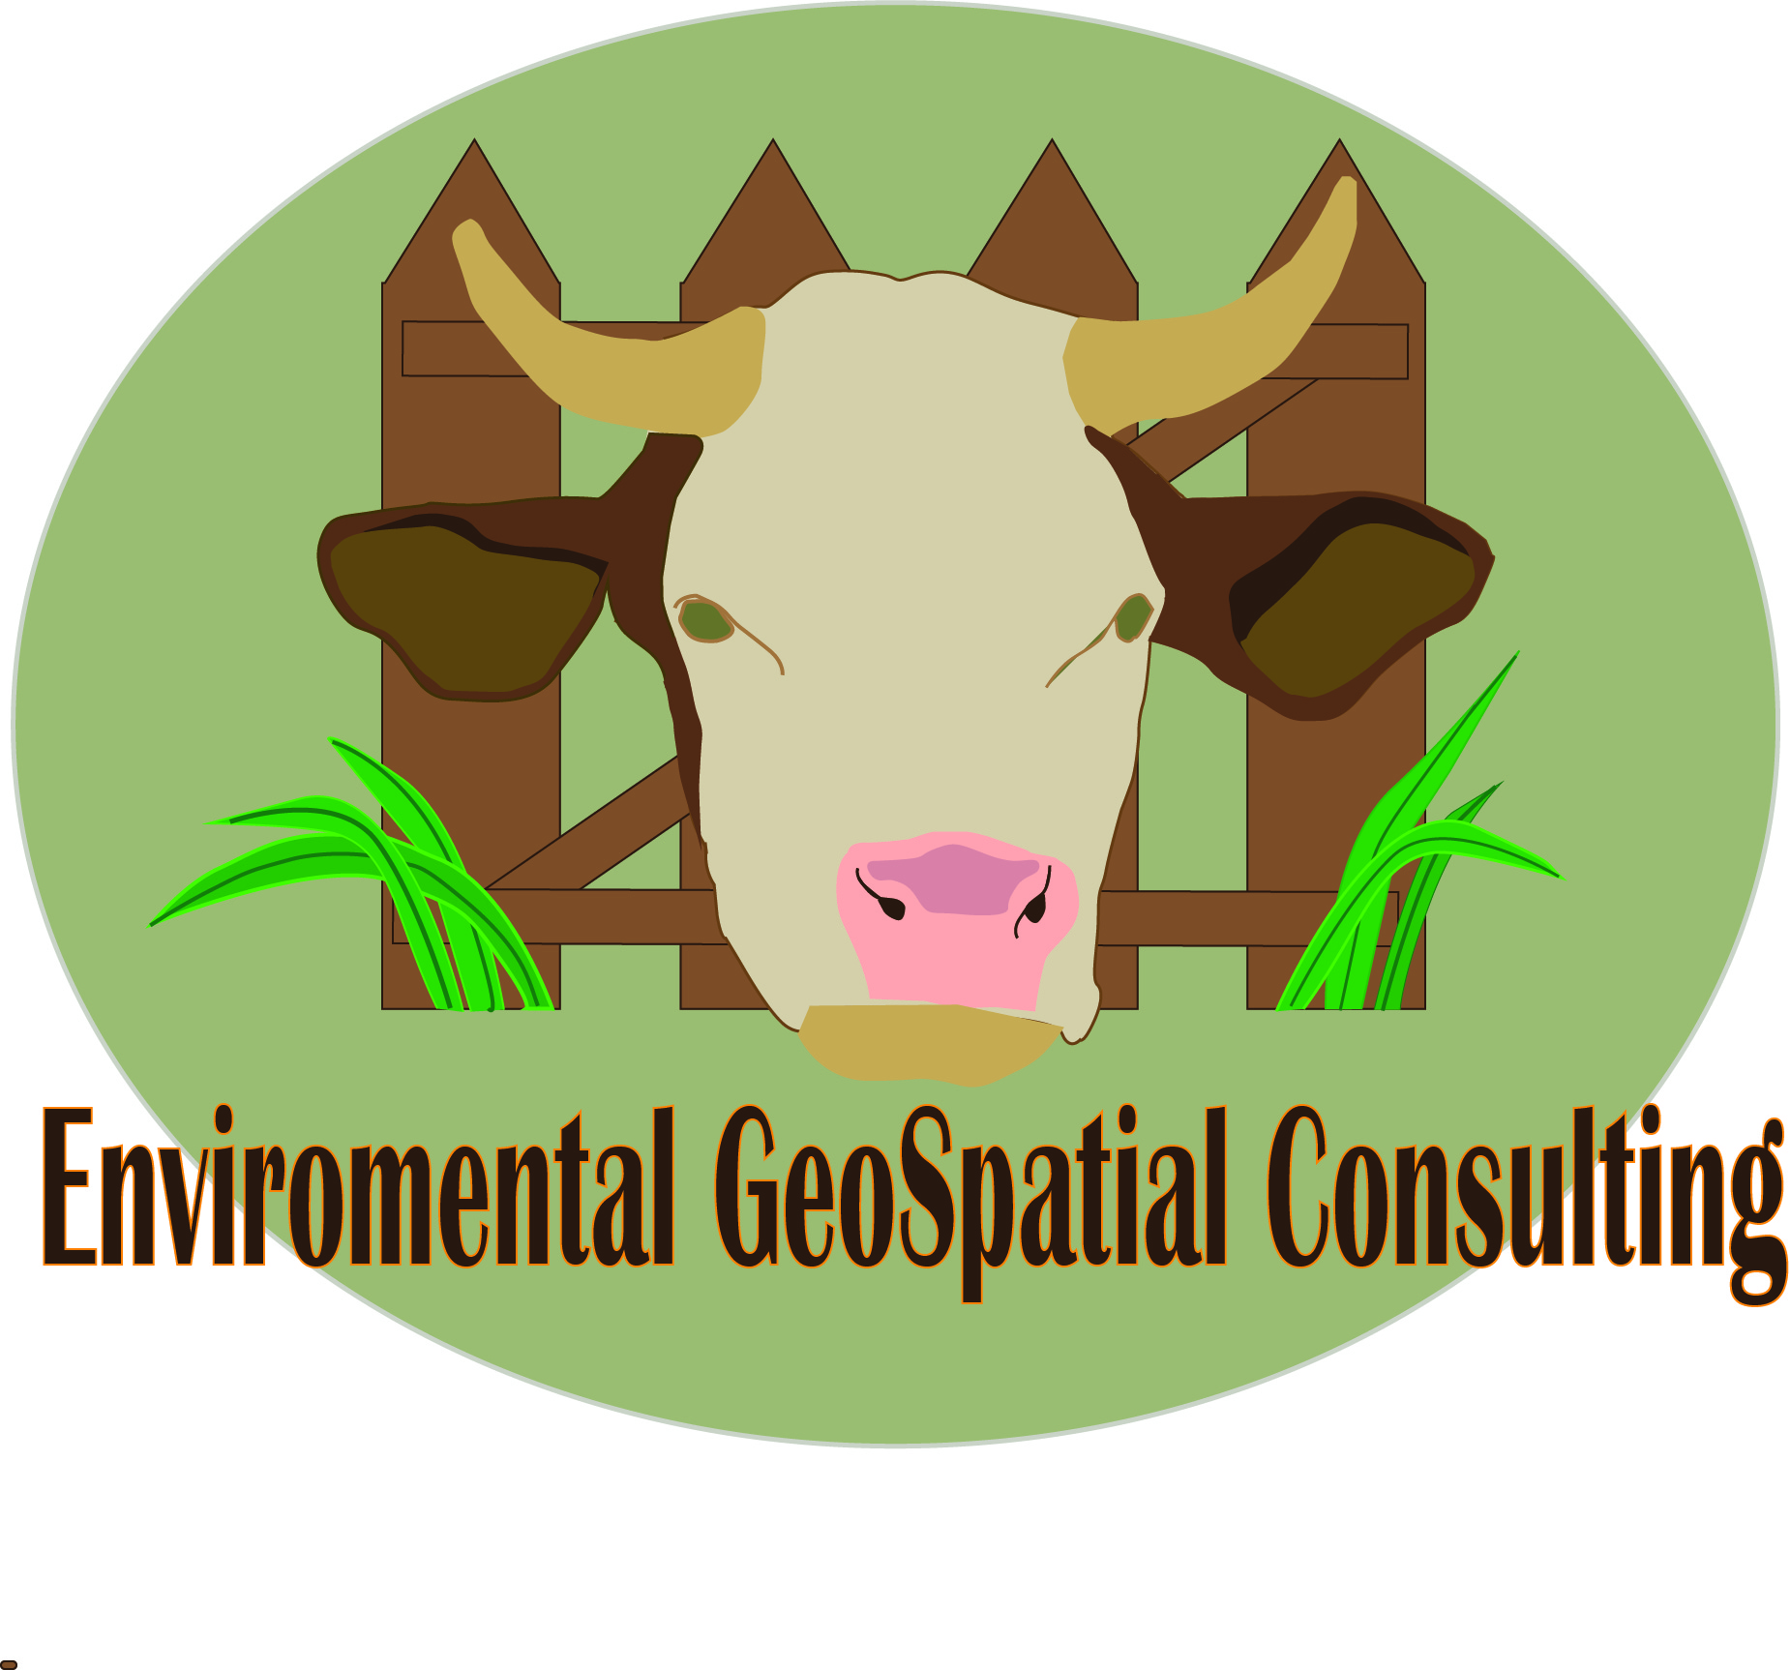
Team Members

Sara Dunlap
Natalie Bowman
David Szpakowski
Table of Contents

I. Introduction ……………………. 3

Summary……. 3
Purpose.……… 3
Scope……..…… 4

II. Literature Review …………… 5

III. Proposal …………………………. 8

Data…………………………….. 7
Methodology……………..… 7
Implications………………... 9
Budget………………………… 11
Timetable……………….…… 12
Final Deliverables………… 13

IV. Conclusions ……………………. 13

V. Participation …………………… 14

VI. Bibliography ………….…….… 15

I. Introduction
Summary
Freeman Ranch is a 4,200 acres plot located between San Marcos and Wimberly along that is stewarded by Texas State University; it is used for education, training, and community outreach. This semester Freeman Ranch will be working with Environmental Geospatial Consulting to further build upon the geodatabase established by GeoTrek in the fall of 2013. Environmental Geospatial Consulting will examine potential grazing land for cattle to determine suitable areas. In October of 2013 an extreme weather event causes changes in physical features, such as fences, around Freeman Ranch, we will assess these changes and update reference maps accordingly.

Purpose
The objective of this study is to expand the geodatabase for Freeman Ranch with a focus on grazeable land acreage, with the secondary objectives of adding on missing data in the area of study to the already existent geodatabase for Freeman Ranch. F.G.S.C. will identify areas of land that are not suitable for grazing as well as rank the areas that are found suitable. The ranking system will be based off of factors such as the distance the area is from the nearest water source, brush density, rock cover, slope, forage, and accessibility. This study will be accomplished through the use of field methods to determine if a plot of land is grazeable and the gathering of spatial data on these areas for analysis. The study will provide maps of the grazeable lands, as well as locations/conditions of certain features on said lands, for the purpose of more sustainable planning in the raising and maintaining of cattle on Freeman Ranch.

Scope:
The geographic extent of our study area is Freeman Ranch, San Marcos, Texas, which is approximately 4,200 acres. Our specific study area will be no more than one miles from the nearest water feature. The study will take approximately four months to complete.

II. Literature Review
The use of geographical information systems (GIS) analysis on estimating grazeable land has begun to become an area of focus for ranches and even states. In 1997 a study focusing on the state of Oregon conducted by Timothy Wade, Bradley Schultz, J.D. Wickham and D.F. Bradford made use of GIS to determine graze-ability of areas of the state in order to model the potential spatial distribution of cattle grazing. This is important to our project as we have been asked to determine how much grazeable land Freeman Ranch currently possesses, and this study uses a methodology that we believe will be useful for our purposes. It is important that we take into consideration vegetation type, percent slope, and distance from water as these factors explain the distribution pattern of the cattle, based off of favorable grazing areas. (Wade, Schultz, Wickham, and Bradford, 1998) In their model they broke down the factors of vegetation, slope, and water into a ranking system in order to identify if an area is grazeable or not, and then rank grazeable areas on how preferable they are to the cattle. These factors will be key in determining where cattle will graze, and ranking the different potential levels for grazeable areas. The study ranked the findings from 0-3, with 0 being no grazing potential, 1 being limited grazing potential, 2 being moderate potential, and 3 having the highest grazing potential. The ranking system was derived through the use of vegetation and topographic data in order to develop two Boolean, raster-based GIS models for the state. The limiting factor for both models’ potential was the vegetation type as fewer areas were classified as ungrazeable because of slope and distance from water. This was probably due to the lack of large scale elevation data (1:24,000), and the use of small scale data instead (1:250,000) which tends to smooth the terrain. This is important to our analysis as it provides a methodology we can use and the cause for the errors in the study’s data should not occur in our analysis because we will be using large scale data for elevation.
Two other studies will aid us in gathering primary data for our analysis. In 2009 Jason C. Hohlt, Robert K. Lyons, C. Wayne Hanselka and David McKown which focused on, and was titled, Estimating Grazeable Acreage for cattle. This study provides us with a field method plan based on six factors: brush density, rock cover, slope, water, forage, and accessibility. We propose to use this information determine why cattle graze in some areas but not others. For our project, we also need to better understand how to determine how much forage the ranch has. To do so, we will use a study by Larry White and Calvin Richardson for Texas Agricultural Extension Services, which we accessed in 2014, that details a seven step process to determine how much forage an area has. These studies provide the methods we will be using to gather primary data that we intend to use to accurately analyze the grazeable land of Freeman Ranch.

III. Proposal
Data
Data Type | Source
Elevation | Texas Natural Resource Information System (TNRIS)
Vegetation | Capital Area Council of Governments
Water Sources | Freeman’s Ranch Geodatabase
Boundaries | Freeman’s Ranch Geodatbase

Methodology
The primary goal of this project is to determine the amount of grazeable land available for development at Freeman Ranch. In order to do this we will look at access to water, accessibility, vegetation, and slope. Cattle generally will not graze at a distance greater than one mile from a water access point on a flat path. Cattle often will avoid steep area or areas with sudden changes in elevation. Cattle prefer to graze on open land. Dense vegetation may make areas that would otherwise be grazeable inaccessible. Heavily forested areas are also often avoided both because they do not tend to contain vegetation palatable to cattle. Utilizing information from the database previously created by GeoTrek and from the public domain, we are able to create scoring system that will determine which areas have the potential to be developed for grazing.
There are approximately 26 drinkers and 11 wells distributed throughout Freeman Ranch. Each one of these water access points fall within one mile of the total possible grazeable land in Freeman Ranch, but not all of them may be accessible because of the fenced boundaries along the property. These fences break the property down into sections; we will measure water accessible areas within each section and excluded areas that fall beyond one mile.
Percent slope | Percent Reduction in Use
0 – 10 | 0
10 – 30 | 30
31- 60 | 60
>60 | 100
The next process is to measure the amount of slope and determine accessibly. We are able to create a scoring system measuring slope which will help determine the likelihood of cattle to venture upon an area of that slope. When observed by Texas Agricultural Extension Services, 95% of the land utilized by cattle had a slope of 11 or less. We are able to create a scoring system measuring slope and the likelihood of cattle to venture upon an area of that slope. Areas between 0-10% receive the highest score, and areas with greater than 60º of slope receive a score of zero.
Once we have determined areas with access to water, and are not impeded by steep ground or brush cover we will compare those with areas with adequate vegetation. Information for vegetation will be collected directly by us and compared to the vegetation information from the Capital Area Council of Governments. This again will be scored by its ability to support cattle with the lowest score going to areas that do not have adequate vegetation. Locations with more that 50% consumable vegetation will receive the highest score in the ranking system. Once we have established values for these different variable we will measure a path from the water access points to calculate the likelihood of cattle using a certain area for grazing. This information should allow us evaluate every acre of Freeman Ranch and its potential for grazing.

Implications
The end results of this data should create a framework for developing grazing land in Freeman Ranch. It will give detailed information about the highest and the lowest quality grazing areas for each area of Freemans Ranch, and will be separated by natural boundaries. This will be useful for future land management and development.
Our final products will include a series of detailed maps of the ranch showing different features such as: grazeable land, the locations of water meters, general infrastructure such as fences, roads, and utility equipment, and finally elevation. These products will be useful to employees of the ranch and students alike. First and most importantly, the grazeable land map will be used to help ranch hands know where cattle are likely to graze and be able to spot limitations as well as develop and use areas to their full potential. Second, since the ranch currently lacks a proper map showing locations of water meters and other utilities our work will be a new resource for ranchers and researchers. This information may prove useful in future construction projects. Third, an updated map of the general infrastructure is needed considering the recent flood. This map will be help the ranch identify infrastructures that may require immediate repair. Finally, a map of elevation on the ranch will be provided for general purposes. We will use this information as a means of determining grazeable land and contributing to the Freeman Ranch geodatabase.

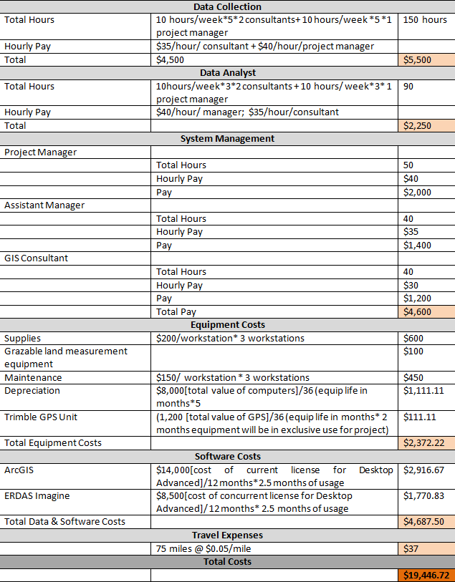
Budget
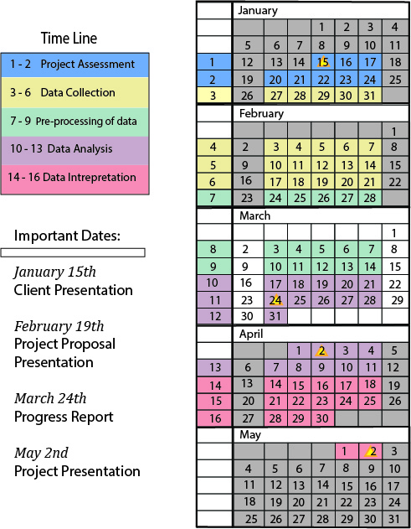
Projected Timetable

Final Deliverables
- Detailed final report and presentation
- CD (multiple copies) containing GIS data, project proposal, reports, and presentations
- Instructions on how to use the CD (“readme” file)
- Hardcopy final maps
- Professional poster for display in the Geography Department
- Professional website

IV. Conclusion
Freeman Geo Spatial Consulting has researched and developed criteria for identifying the grazeability of landscapes. We plan to divide the ranch into sections based on potential for and likelihood of cattle grazing; in addition to physical geographical factors we will also assess artificial features such as the condition/location of water meters and fences to give the client a better frame of reference when working on the ranch. When we have completed this project Freeman Ranch managers will be better equipped to predict and guide the grazing ability of the ranch, and will have greater geographic knowledge of key features located within the ranch.

VI. Participation
Sara Dunlap: Data Analysis: Project Management, Methodology, Timetable, Project Design, Implications, GIS Analyst

Natalie Bowman: Data Analysis: Budget Analysis, Summary, Final Deliverables, Conclusion, GIS Analyst
David Szpakowski: Data Analysis: Literature Review, Purpose, Scope, References, GIS Analyst

VI. Bibliography

Wade, T., B. Schultz, J.D. Wickham, D.F. Bradford. 1998. Modeling the potential spatial distribution of beef cattle grazing using a Geographic Information System. Journal of Arid Environments 38: 325–334.

Hohlt, J., R.K. Lyons, C.W. Hanselka, D. McKown. 2009. Estimating Grazeable Acreage for Cattle. AgriLife Communications Texas A&M.

White, L., C. Richardson. How Much Forage Do You Have? http://texnat.tamu.edu/library/publications/how-much-forage-do-you-have/ (last accessed 10 February 2014)

