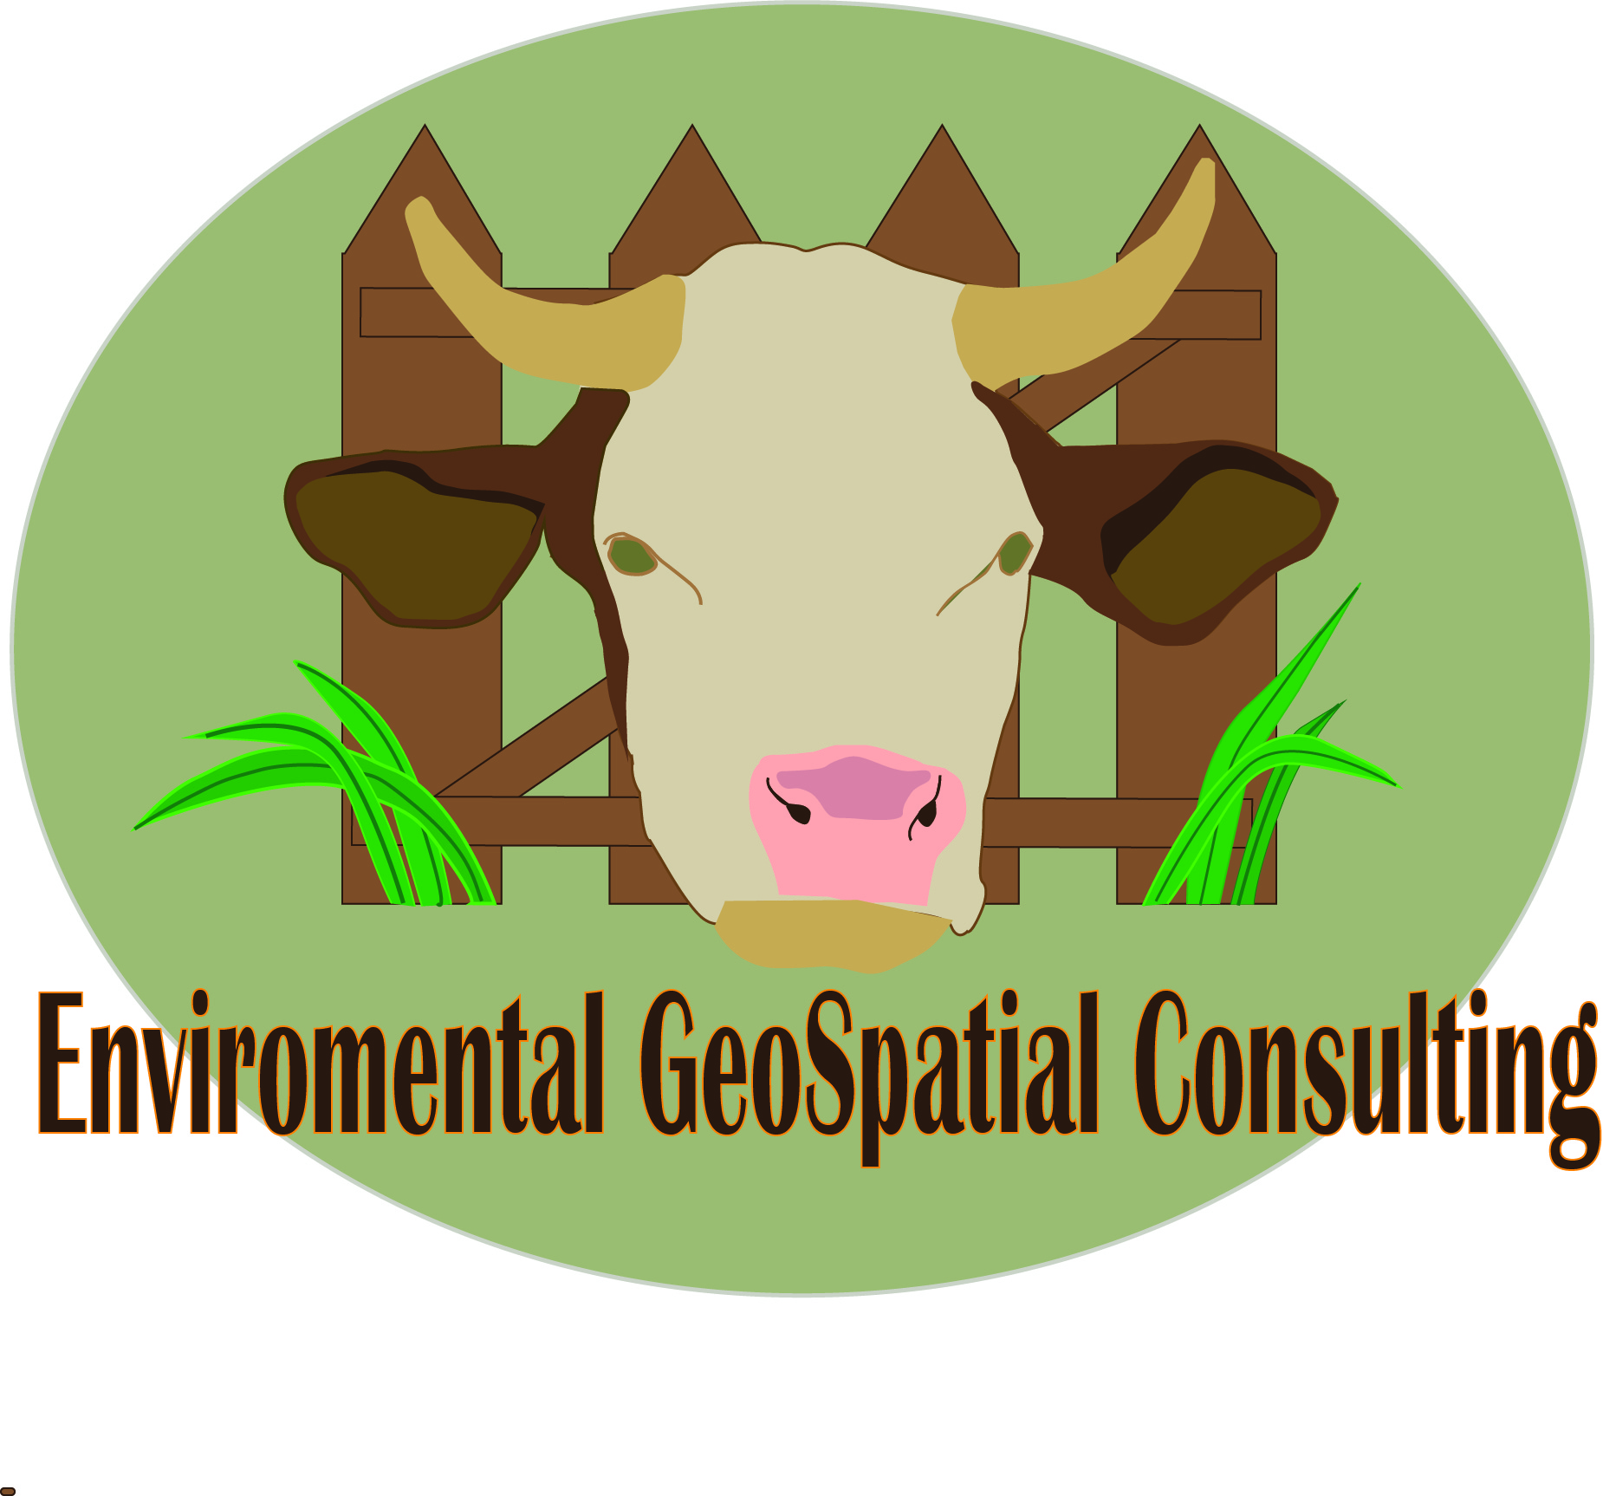
Team Members

Sara Dunlap - Project Manger
David Szpakowski – Asst. Project Manager
Natalie Bowman – GIS Analyst
An Analysis of Grazing Area at the Freeman Center
Table of Contents

I. Introduction 3
Summary 3
Purpose 3
Scope 4
II. Literature Review 5

III. Data 7

IV. Methodology 7

Maps 10
V. Results 14

VI. Implications 16

VII. Conclusion 17

VIII. References 18

Appendix I: Contributions

Appendix II: Metadata

I. Introduction
Summary
In 1981, the Freeman Center was bequeathed to Texas State University for the purpose of farm, ranch, game management, educational, and experimental purposes. In the Fall of 2013, GeoTrek, from Texas State University, created a geodatabase for the Freeman Center; this semester Freeman Ranch is working with Environmental Geospatial Consulting to add to the preexisting geodatabase. In 2013 Texas AgriLife Extension from Texas A&M System worked with Freeman Ranch as part of its research to determine conditions favorable to cattle. We will analysis land area of the Freeman Center to determine which locations have to ability to support cattle using their findings. This knowledge will allow for future planning and development of the center. Other services included creating a 3D model of Freeman Center, as well as an aspect map for the ranch.

Purpose
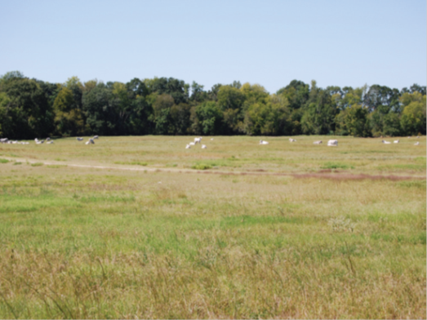
The primary objective of our study is to identify all areas of Freeman Ranch that have to potential to be grazed by cattle. Although the ranch is large, 4,200 acres, much of the area cannot support cattle because of environment factors. A large percentage of the Freeman Center is overgrown with Ashe juniper, Juniperus ashei, which is commonly referred to as ‘cedar.’ This overgrowth of cedar takes up space where palatable grasses could grow, but also prevents access to areas with adequate vegetation. Soil quality in this area can be poor with little top soil, which allows for rocky areas.
Ideal grazing conditions.
Credit: Texas AgriLIFE Extension
Percent slope | Percent Reduction in Use
0 – 10 | 0
10 – 30 | 30
31- 60 | 60
>60 | 100
It is difficult for cattle to tread upon rocky areas, and they will generally avoid them. Cattle often will avoid steep area or areas with sudden changes in elevation. Cattle prefer to graze on open land; when observed by Texas Agricultural Extension Services, 95% of the land utilized by cattle had a slope of 10% or less.
Finally, and most importantly, cattle generally will not graze at a distance greater than one mile from a water access point on a flat path. In short, ideal conditions for cattle are flat, grassy, stretches of land near water. With this knowledge, we are able to measure the amount of space at the Freeman that could be utilized for grazing. We will separate areas that have that potential of grazing, meaning that they meet all of the conditions stated above; for areas that meet all requirements and also are not blocked from access by dense vegetation or steep slope.

Scope
The geographic extent of our study area is Freeman Center, San Marcos, Texas, which is approximately 4,200 acres. The landscape of the Freeman Center coincides with that of the main central Texas, Edwards Aquifer Plateau area. The landscape is characterized by rugged hills, karst hydrology, variable climate and high species diversity. The study took approximately four months to complete.

II. Literature Review
The use of geographical information systems (GIS) analysis on estimating grazeable land has begun to become an area of focus for ranches and even states. In 1997 a study focusing on the state of Oregon conducted by Timothy Wade, Bradley Schultz, J.D. Wickham and D.F. Bradford made use of GIS to determine graze-ability of areas of the state in order to model the potential spatial distribution of cattle grazing. This is important to our project as we have been asked to determine how much grazeable land Freeman Ranch currently possesses, and this study uses a methodology that we believe will be useful for our purposes.
It is important that we take into consideration vegetation type, percent slope, and distance from water as these factors explain the distribution pattern of the cattle, based off of favorable grazing areas. (Wade, Schultz, Wickham, and Bradford, 1998) In their model they broke down the factors of vegetation, slope, and water into a ranking system in order to identify if an area is grazeable or not, and then rank grazeable areas on how preferable they are to the cattle. These factors will be key in determining where cattle will graze, and ranking the different potential levels for grazeable areas. The study ranked the findings from 0-3, with 0 being no grazing potential, 1 being limited grazing potential, 2 being moderate potential, and 3 having the highest grazing potential.
The ranking system was derived through the use of vegetation and topographic data in order to develop two Boolean, raster-based GIS models for the state. The limiting factor for both models’ potential was the vegetation type as fewer areas were classified as ungrazeable because of slope and distance from water. This was probably due to the lack of large scale elevation data (1:24,000), and the use of small scale data instead (1:250,000) which tends to smooth the terrain. This is important to our analysis as it provides a methodology we can use and the cause for the errors in the study’s data should not occur in our analysis because we will be using large scale data for elevation.
Two other studies will aid us in gathering primary data for our analysis. In 2009 Jason C. Hohlt, Robert K. Lyons, C. Wayne Hanselka and David McKown which focused on, and was titled, Estimating Grazeable Acreage for cattle. This study provides us with a field method plan based on six factors: brush density, rock cover, slope, water, forage, and accessibility.
We propose to use this information determine why cattle graze in some areas but not others. For our project, we also need to better understand how to determine how much forage the ranch has. To do so, we will use a study by Larry White and Calvin Richardson for Texas AgriLife Extension Services, which we accessed in 2014, that details a seven step process to determine how much forage an area has. These studies provide the methods we will be using to gather primary data that we intend to use to accurately analyze the grazeable land of Freeman Ranch.

III. Data
Data Type | Source
Elevation | Texas Natural Resource Information System (TNRIS)  Capital Area Council of Governments (CAPCOG)
Contour Lines | Capital Area Council of Governments (CAPCOG)
Vegetation | Capital Area Council of Governments
Water Sources | Freeman Center Geodatabase
Boundaries | Freeman Center Geodatabase
Roads | Freeman Center Geodatabase

IV. Methodology

Grazing Area
In order to determine potential grazable and accessible grazable land at the Freeman Center we considered four main variables: access to water, rock cover, vegetation, and slope, for our analysis. As stated previously, cattle will not travel more them one mile from a water source. There are approximately 26 drinkers and 11 wells distributed throughout Freeman Ranch, all of which within one mile of the total possible grazeable land in Freeman Ranch. Every pasture has access to at least one source of water with the exception of Never Never Land Pasture, which is separated by a gate.
We used aerial photography provided to us by GeoTrek to classify Freeman Center land area into four different categories: heavy vegetation, moderate vegetation, barren areas/rocky terrain, and open area. After establishing the different classifications of land cover at the Freeman Center, we used a digital elevation model (DEM) to extract areas of the ranch where the slope was greater than 30%.
In order to conduct a pass fail analysis, we assigned a value of either 1 or 0 to each variable, the variables being: heavy vegetation, moderate vegetation, barren/rock cover, open area, and slope >30%. The variables for areas unsuitable for grazing (heavy vegetation, moderate vegetation, slope >30%, and barren/rock cover) were given a zero value. Open areas were given a value of one. This method extracted all ground area that had adequate conditions for grazing. This creates what we have term potentially grazable area because the ground it these areas meets all of our basic criteria. This potential grazable area does not consider access to water, trail access, or fences that may prevent access. This leads us to the next major part of our analysis: determining what percentage of this area is accessible to cattle. Although there are areas that meet our basic criteria, obstacles and boundaries render them useless for grazing.
Once our pass-fail analysis was complete, we created polygons of our resulting passing area. Since cattle uses existing roads and trails to travel from one area to another, we included roads and trails in our analysis of accessible areas. We created a 3 meter buffer for the passing vegetation layer, and a five meter buffer for the roads layer. The 3 meter buffer on passing area was creating to join areas that were only separated by light vegetation, and the 5 meter buffer was created to simulate to width of the trail path. The road area was later removed from our final results, so that the road area was not counted toward grazable acres because it does not support adequate vegetation.
Every pasture has access to at least one source of water, with the exception of Never Never Land Pasture. To calculate all accessible areas we divided the total potential grazing area into groups by pasture. At this point we excluded pastures that are currently being utilized for other purposes and thus cannot be used for grazing. Once the total potential grazing area was divided into pastures, we were able to select all areas within each pasture that connected to a water source or connected to a path that could lead cattle to other areas of adequate vegetation. This excluded areas that were surrounded by heavy vegetation. For Never Never Land pasture, we ran the same analysis with the condition that a water source is located within 20 meters of the pasture, due to the fact that Never Never Land could be usable given the condition that the gate was open. Our last step was to exclude the area of sink creek and the dam from our results.

Secondary Objectives
To create 3D model of the Freeman Ranch, we used contour line data at intervals of 35 feet to create an triangular irregular network (TIN), which represents surface morphology. This was used to model the changes in elevation at the freeman center. We were also able to create a map of aspect at the Freeman Center using a digital elevation model (DEM) layer obtained from CAPCOG.

Maps
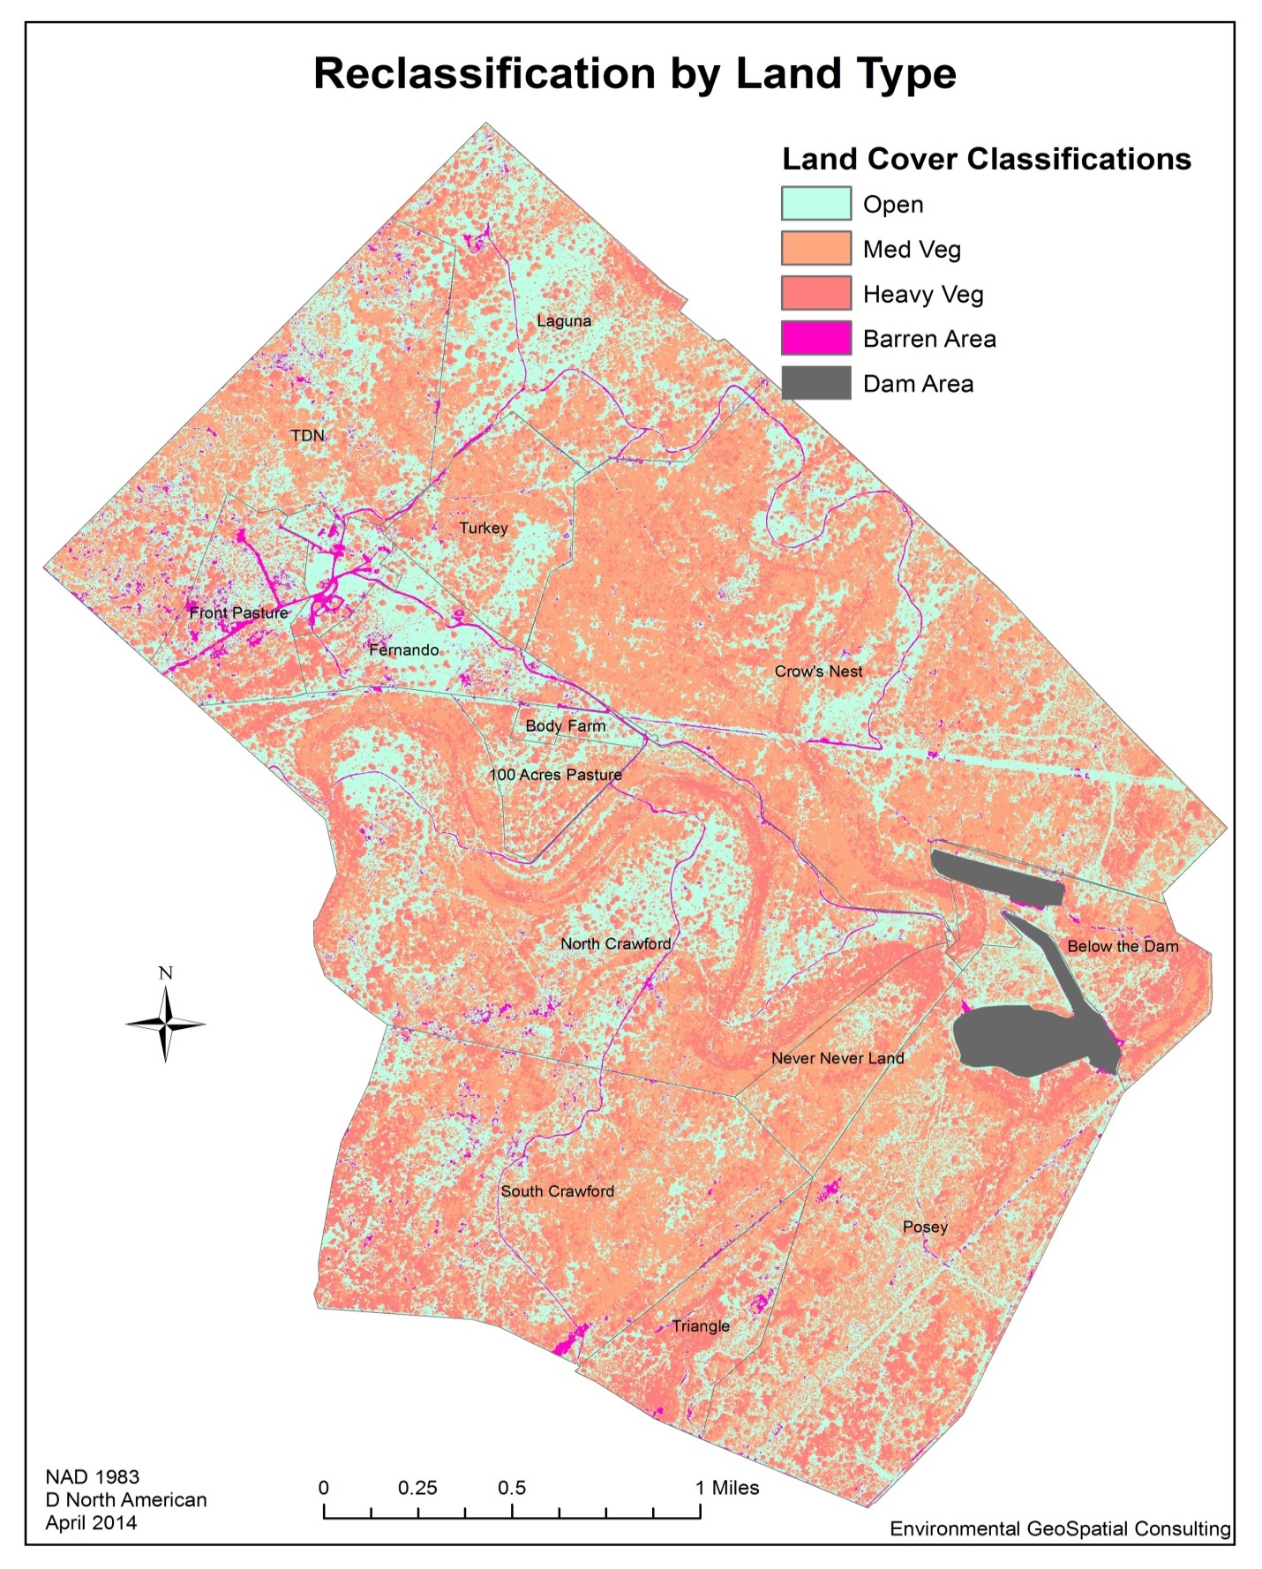
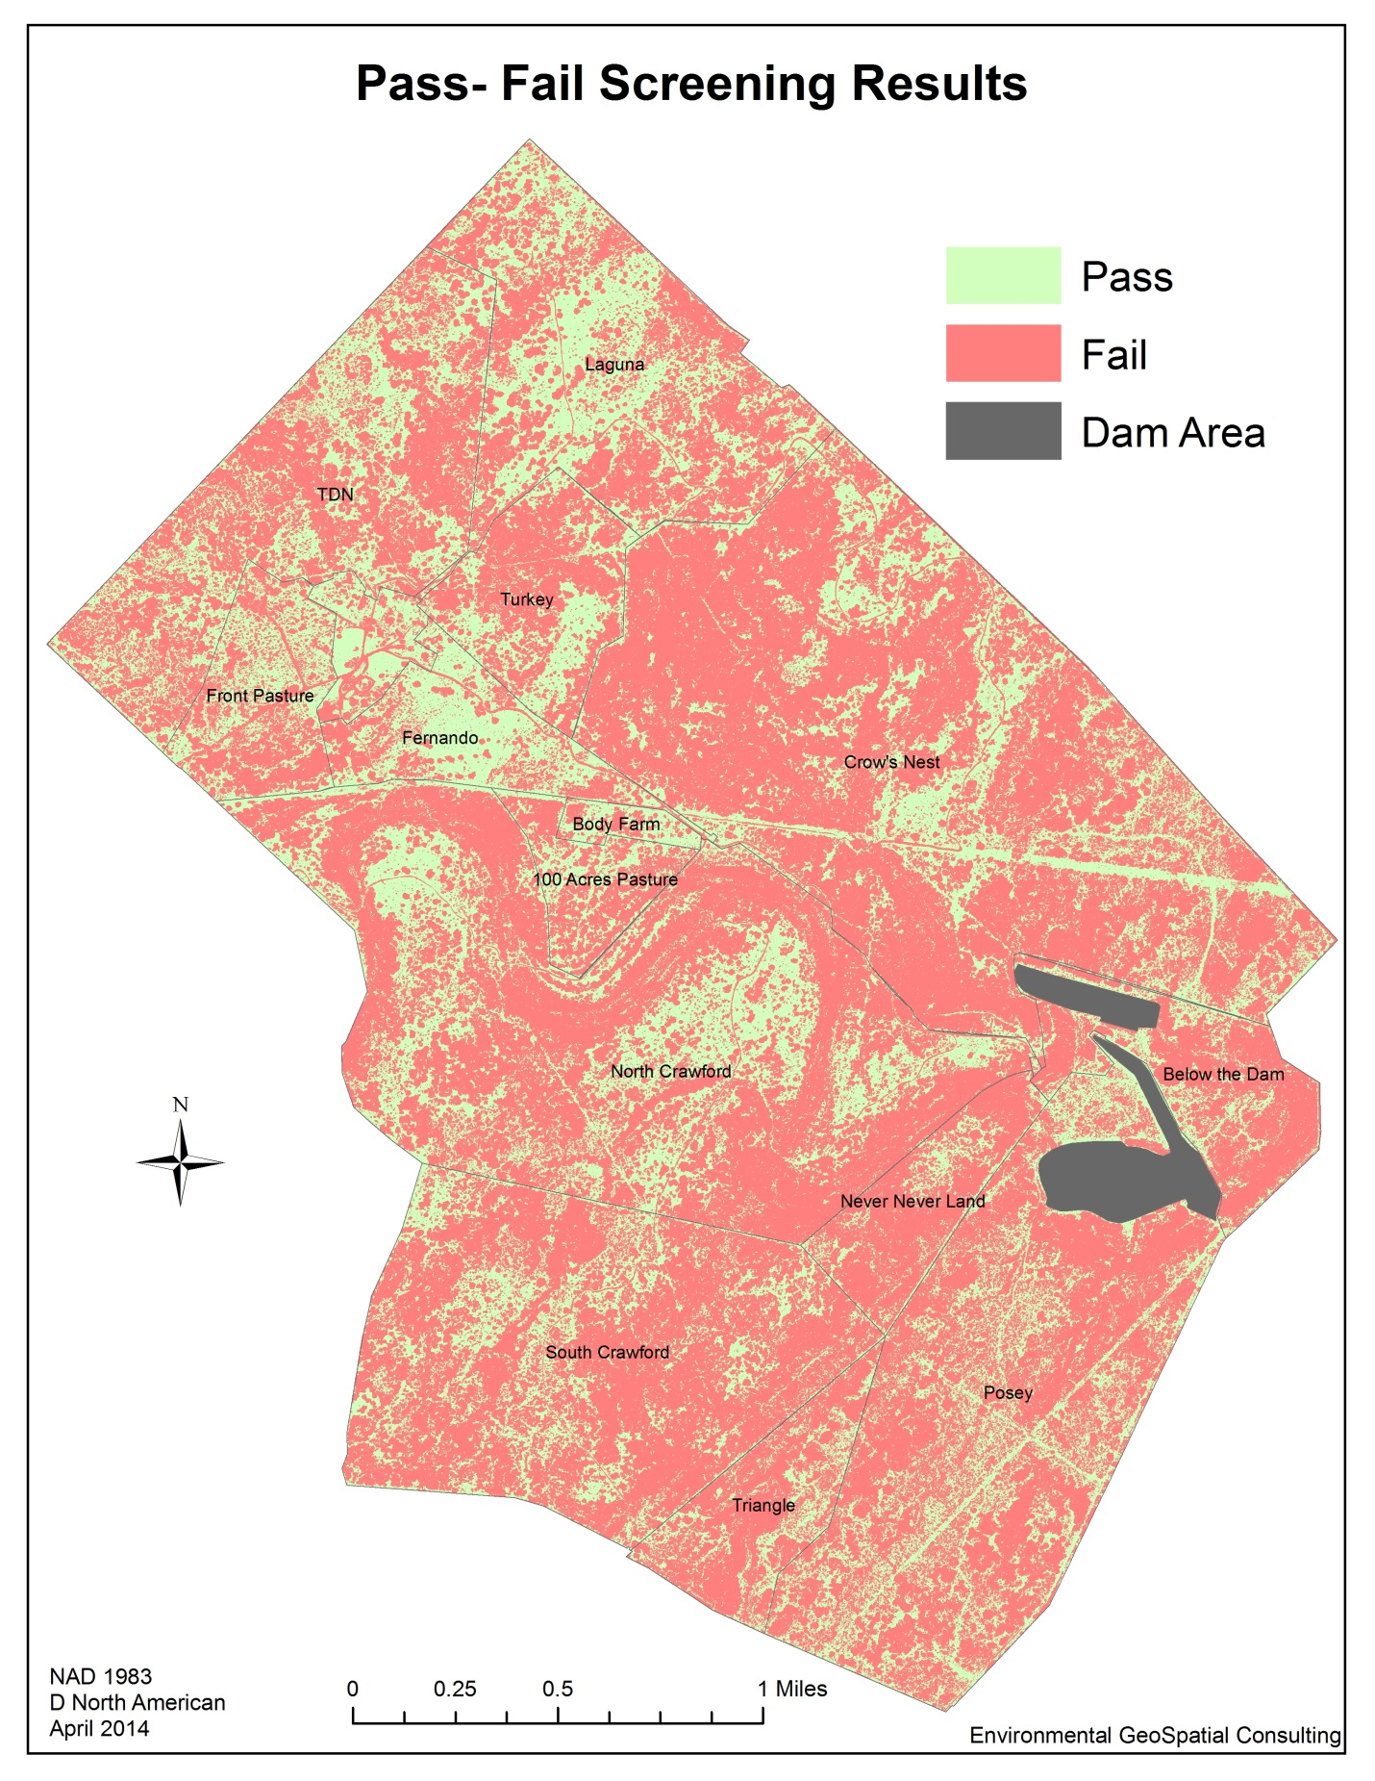
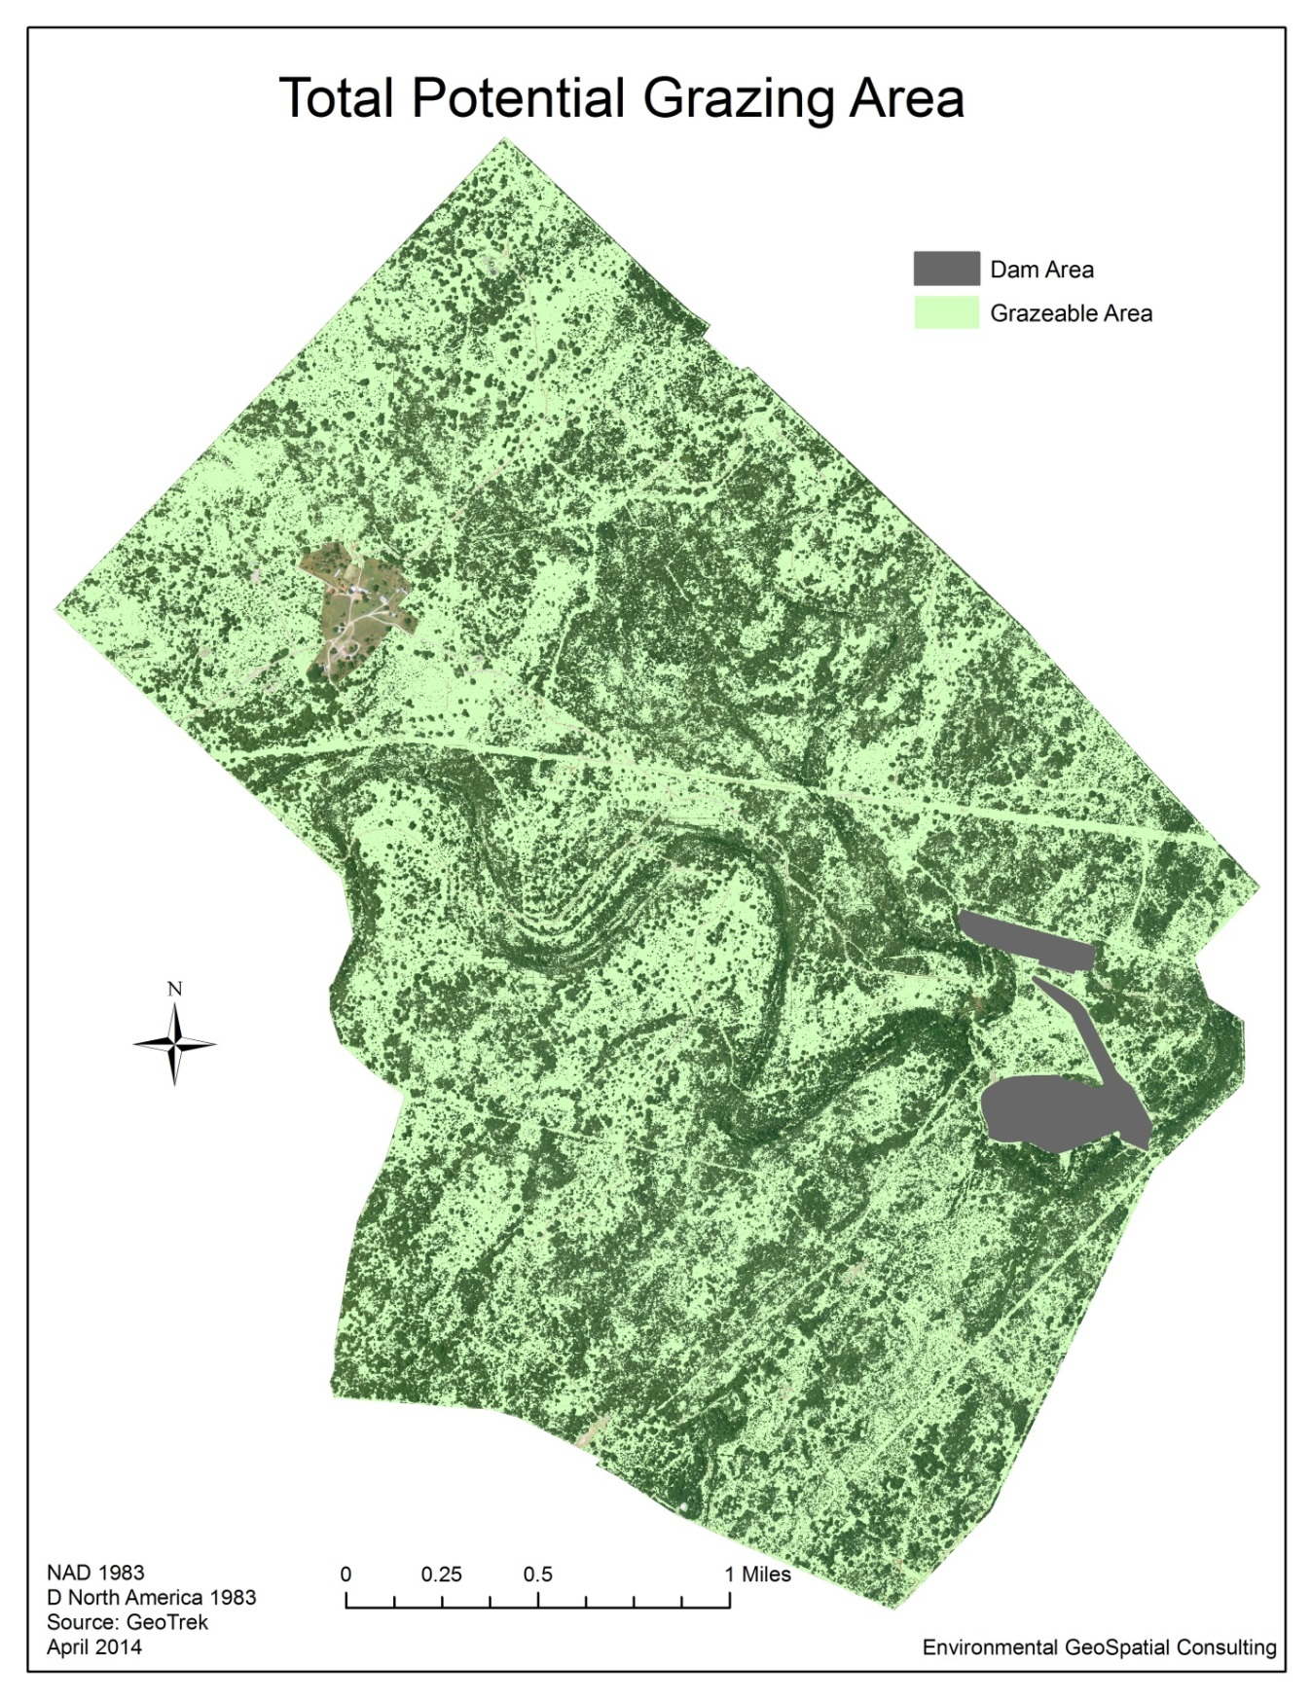
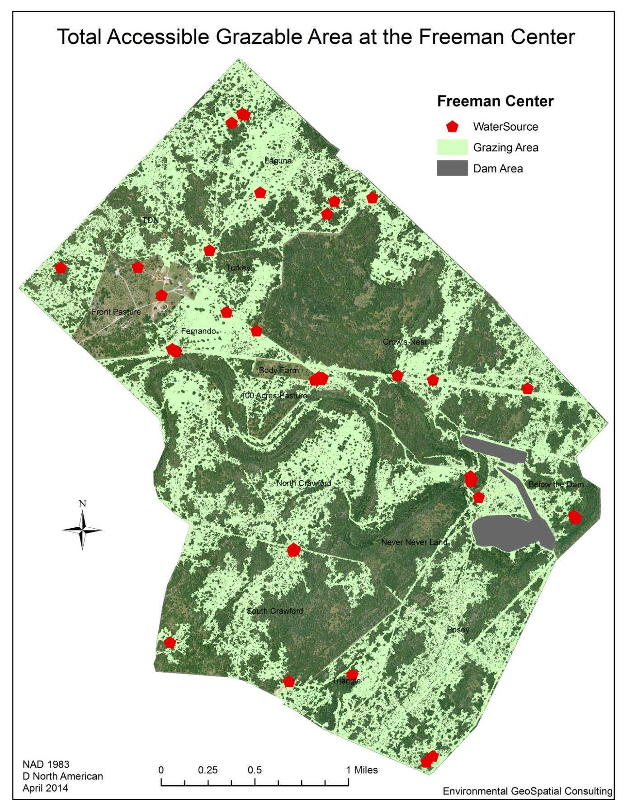
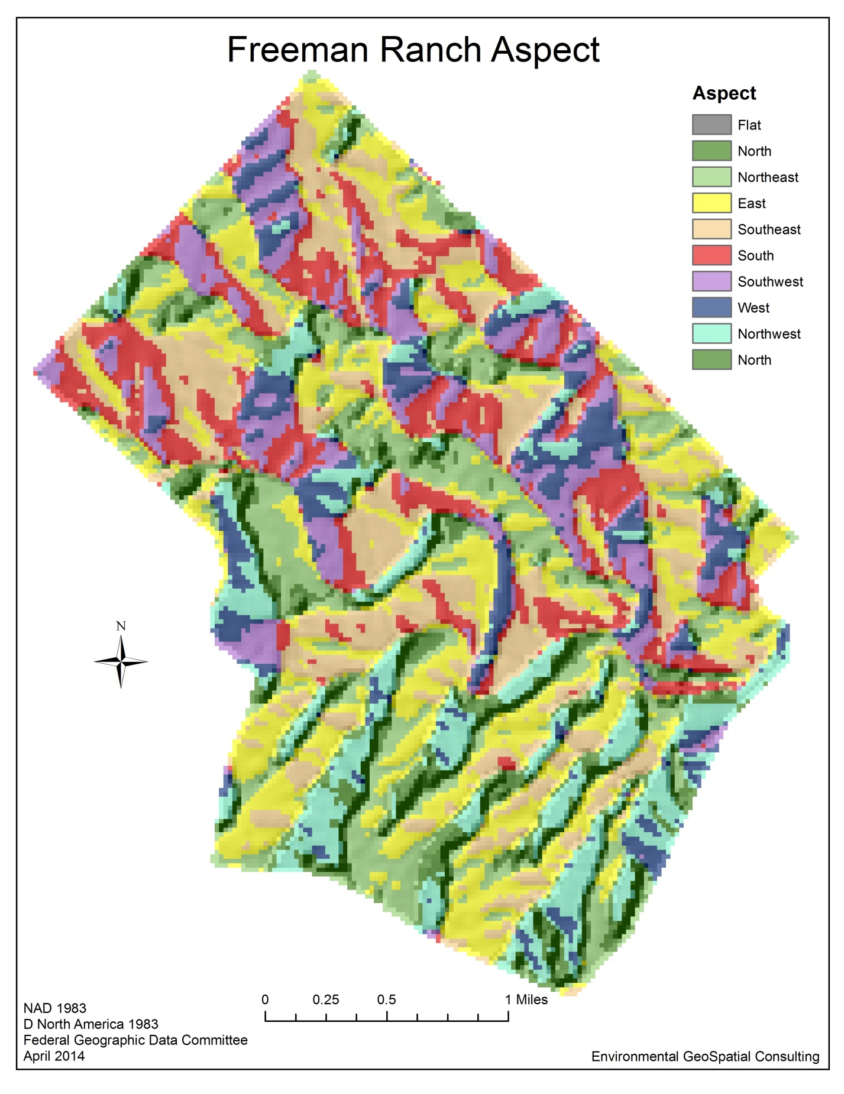

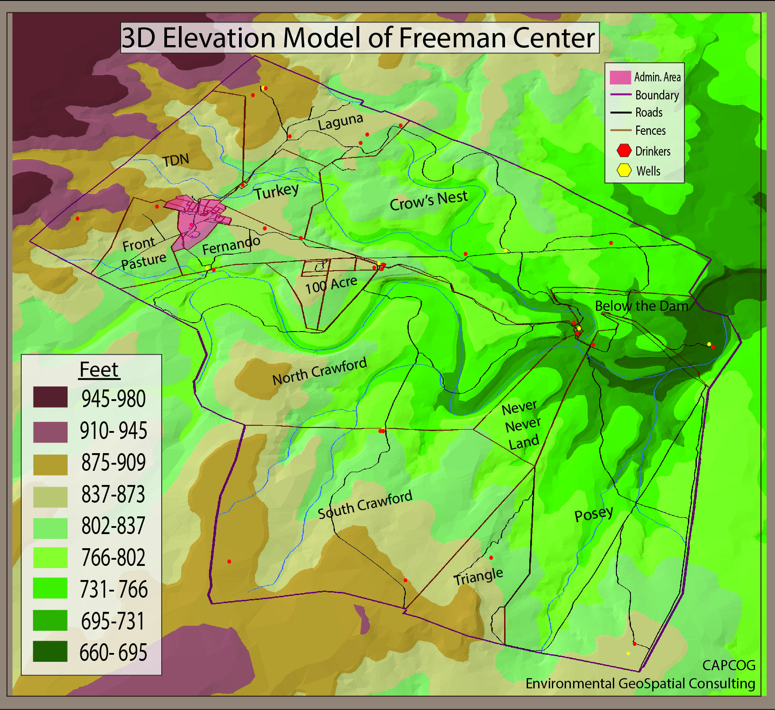

VI. Results
Total Acres | 4,200 | 100%
Total Potential Grazeable Acres | 2,118 | 50.42%
Total Accessible Grazeable Acres | 1,612 | 38.39%
Of the fourteen pastures that make up Freeman Ranch, two are currently unable to support cattle because they are being utilized for other purposes (Body Farm and the Front Pasture). Out of the remaining 12 pastures, Triangle, Posey, Laguna, South Crawford pastures had the highest degree of land area suitable and accessible for grazing. Never Never Land expectedly had the lowest area of useable grazing area. These results were more or less what we expected to find. Out of the 4,200 available at freeman Ranch, only about acres are potential grazable. Of those 2,118 acres, only about 1,612 acres are accessible. Up to 12% of the final grazing area is lost due to lack to access. Realistically, there is always going to be a portion of ground that is inaccessible for a variety of reasons. Improving path conditions and lessening the amount of vegetation would improve grazing conditions the most. We recommend that further analysis be conducted on Freeman Ranch to determine which areas provide vegetation types that are palatable to cattle in order to improve the accuracy of this information and to provide a more complete understanding of the ranch itself.
Total %

Pastures | Total Acres | Total Accesible Acres | % of Total
North Crawford | 752 | 318 | 42%
South Crawford | 507 | 141 | 27.9%
Triangle | 106 | 55 | 51.9%
Never Never Land | 91 | 7 | 7.7%
Posey | 578 | 291 | 50.3%
Below the Dam | 139 | 47 | 33.9%
Turkey | 122 | 52 | 42.6%
100 Acres Pasture | 60 | 25 | 41.6%
Fernando | 106 | 83 | 78.3%
Crow's Nest | 900 | 253 | 28.1%
TDN | 341 | 180 | 78.3%
Laguna | 324 | 192 | 59.2%

Implications
With a system in place for analyzing that amount of grazable acreage at the Freeman Center they will now be able to determine how many cattle can be supported within a certain area. They will be able to visualize grazing locations as a whole and by individual pasture and have information regarding both. A better understanding of grazing at Freeman Center will lead to more sustainable land use in the future, and well maintained populations of cattle within each pasture. This will help prevent overgrazing because it will help ranchers estimate the actually amount of ground that is usable.
This system will be useful both now and in the future for planning and land development. By expanding the geodatabase we are able to increase the body of knowledge of Freeman Ranch and aid it as it continues to expand into the future.

VII. Conclusion
Environmental GeoSpatial Consulting has researched and developed criteria for identifying the grazeability of landscapes. While this data is very useful in its current form, it is not entirely complete. Due it time constrains, we were limited in the amount that we were able to accomplish. The quality of this information could be improved by cross checking estimates through point sampling. This would require fieldwork to verify the accessible or inaccessibility of certain areas.
Tree cover may also create areas where there are paths or trails useful to cattle, but not visible through aerial photography. We tried to rectify these issues where ever we could, but it may lead to a small amount of inaccuracy. With further investigation and diligence this model could provide very detailed information on the areas where cattle may venture, but it this point our results are only approximations.

VIII. References

Wade, T., B. Schultz, J.D. Wickham, D.F. Bradford. 1998. Modeling the potential spatial distribution of beef cattle grazing using a Geographic Information System. Journal of Arid Environments 38: 325–334.

Hohlt, J., R.K. Lyons, C.W. Hanselka, D. McKown. 2009. Estimating Grazeable Acreage for Cattle. AgriLife Communications Texas A&M.

White, L., C. Richardson. How Much Forage Do You Have? http://texnat.tamu.edu/library/publications/how-much-forage-do-you-have/ (last accessed 10 February 2014)

Appendix I: Contributions
Sara Dunlap: Data Analysis: Project Management, Methodology, Timetable, Project Design, Implications, GIS Analyst, Remote Sensing Expert, Graphic Designer, Editor

David Szpakowski: Data Analysis: Assistant Project Manager, Literature Review, Purpose, Scope, References, GIS Analyst, ArcScene Expert

Natalie Bowman: Data Analysis: Budget Analysis, Summary, Final Deliverables, Conclusion, GIS Analyst, Remote Sensing Assistant, 2D Map Creator
Environmental GeoSpatial Consulting
Freeman Center
GIS Data Dictionary

Projection: NAD_1983_UTM_Zone_14N Datum: D North American 1983

File Name | Description | Features | Max Scale | Data Source | Source Date | Revision Date
fr_aspect | Aspect map | Raster | 1:5,000 | FGDC | 1998 | 2014
3D DEM | 3D Map | TIN | 1:5,000 | CAPCOG | 2006 | 2014
Total_Grazable_Area | Final Product | Vector | 1:5,000 | TSU geodatabase | 2012 | 2014

fr_aspect
Raster Dataset

Tags
Aspect

Summary
This layer can be used to visualize the orientation of the slopes on the terrain. This layer is not going to be factored into the final graze-ability map but it may be useful to other parties in the future for other purposes. This layer is as dated as our DEM layer which is from 1998. Any changes in elevation that may have occurred on the property within the last 16 years are not being accounted for.
Description
This layer was created from a DEM layer which we obtained from the Texas State geodatabase, the DEM originated from www.fgdc.gov; the data represents the topography in January 1998. The cell size of our DEM is about 96.16 by 96.16, the spatial reference is NAD83_Texas_Central, the linear unit is in U.S. feet. We clipped our DEM to the Freeman Center property; we then used the aspect tool on this layer. For visual convenience we used the hillshade tool on the aspect layer we created, we then changed the hillshade transparency; this step allowed us to quickly identify southwest facing slopes.
Credits
Professor Alberto Giordano, Lab Instructor Ryan Thomas Schuermann, and Environmental GeoSpation Consultants: (Project Manager) Sara Dunlap, (Assistant Manager) David Szpakowski, and (GIS analyst) Natalie Bowman

Use limitations
There are no access and use limitations for this item.
Extent
West | -98.022170 | East | -97.966787
North | 29.957454 | South | 29.899898
Scale Range
Maximum (zoomed in) | 1:5,000
Minimum (zoomed out) | 1:150,000,000

ArcGIS Metadata ►

Topics and Keywords ►
* Content type Downloadable Data
Hide Topics and Keywords ▲

Citation ►
* Title fr_aspect
Presentation formats * digital map
Hide Citation ▲

Resource Details ►
Dataset languages * English (UNITED STATES)
Spatial representation type * grid
* Processing environment Microsoft Windows 7 Version 6.1 (Build 7601) Service Pack 1; Esri ArcGIS 10.1.1.3143
ArcGIS item properties
* Name fr_aspect
* Location file://W:\G4427\FR_DB\fr_aspect
* Access protocol Local Area Network

Extents ►
Extent
Geographic extent
Bounding rectangle
Extent type Extent used for searching
* West longitude -98.022170
* East longitude -97.966787
* North latitude 29.957454
* South latitude 29.899898
* Extent contains the resource Yes

Extent in the item's coordinate system
* West longitude 3028915.223269
* East longitude 3046031.598100
* South latitude 9935297.392515
* North latitude 9955875.506075
* Extent contains the resource Yes

Hide Extents ▲

Spatial Reference ►
ArcGIS coordinate system
* Type Projected
* Geographic coordinate reference GCS_North_American_1983
* Projection NAD83_Texas_Central
* Coordinate reference details
Projected coordinate system
X origin -124805500
Y origin -81923100
XY scale 35432942.484959878
Z origin -100000
Z scale 10000
M origin -100000
M scale 10000
XY tolerance 0.0032808333333333331
Z tolerance 0.001
M tolerance 0.001
High precision true
Well-known text PROJCS["NAD83_Texas_Central",GEOGCS["GCS_North_American_1983",DATUM["D_North_American_1983",SPHEROID["GRS_1980",6378137.0,298.257222101]],PRIMEM["Greenwich",0.0],UNIT["Degree",0.0174532925199433]],PROJECTION["Lambert_Conformal_Conic"],PARAMETER["false_easting",2296583.333333334],PARAMETER["false_northing",9842500.0],PARAMETER["central_meridian",-100.3333333333333],PARAMETER["standard_parallel_1",31.88333333333333],PARAMETER["standard_parallel_2",30.11666666666667],PARAMETER["latitude_of_origin",29.66666666666667],UNIT["Foot_US",0.3048006096012192]]

Reference system identifier
* Value 0
Hide Spatial Reference ▲

Spatial Data Properties ►
Georectified Grid ►
* Number of dimensions 2
Axis dimensions properties
Dimension type column (x-axis)
* Dimension size 178
* Resolution 96.159409 Foot_US

Axis dimensions properties
Dimension type row (y-axis)
* Dimension size 214
* Resolution 96.159409 Foot_US

* Cell geometry area
* Point in pixel center
* Transformation parameters are available Yes
* Check points are available No
Corner points
* Point 3028915.223269 9935297.392515
* Point 3028915.223269 9955875.506075
* Point 3046031.598100 9955875.506075
* Point 3046031.598100 9935297.392515

* Center point 3037473.410685 9945586.449295
Hide Georectified Grid ▲

ArcGIS Raster Properties ►
General Information
* Pixel depth 32
* Compression type RLE
* Number of bands 1
* Raster format GRID
* Source type continuous
* Pixel type floating point
* No data value -3.4028235e+038
* Has colormap No
* Has pyramids No
Hide ArcGIS Raster Properties ▲

Hide Spatial Data Properties ▲

Spatial Data Content ►
Image Description
* Type of information physical measurement
Band information
* Description FR_Aspect
* Maximum value 359.991150
* Minimum value 0.034290
* Number of bits per value 32
Hide Spatial Data Content ▲

Geoprocessing history ►
Process
Process name
Date 2014-04-21 11:25:31
Tool location c:\program files (x86)\arcgis\desktop10.1\ArcToolbox\Toolboxes\Spatial Analyst Tools.tbx\ExtractByMask
Command issued
ExtractByMask Aspect_Hays2 Boundary W:\G4427\FR_DB\FR_Aspect
Include in lineage when exporting metadata No
Hide Geoprocessing history ▲

Distribution ►
Distribution format
* Name Raster Dataset
Hide Distribution ▲

Metadata Details ►
* Metadata language English (UNITED STATES)
* Metadata character set utf8 - 8 bit UCS Transfer Format
Scope of the data described by the metadata * dataset
Scope name * dataset
* Last update 2014-04-30
ArcGIS metadata properties
Metadata format ArcGIS 1.0
Metadata style FGDC CSDGM Metadata
Standard or profile used to edit metadata FGDC
Created in ArcGIS for the item 2014-04-21 11:25:31
Last modified in ArcGIS for the item 2014-04-30 11:47:08
Automatic updates
Have been performed Yes
Last update 2014-04-30 11:45:14

Hide Metadata Details ▲

3D Map3.sxd
Scene
Thumbnail Not Available
Tags
3D Elevation Model

Summary
This 3D elevation model is not necessary in determining grazable acreage, however it represents the property’s surface with more detail than one could get from a 2D map
Description
The 3D model was created from contours we obtained from CAPCOG. We created a TIN from the contours and used ArcScene to develop the 3D Elevation model.
Credits
Professor Alberto Giordano, Lab Instructor Ryan Thomas Schuermann, and Environmental GeoSpation Consultants: (Project Manager) Sara Dunlap, (Assistant Manager) David Szpakowski, and (GIS analyst) Natalie Bowman
Use limitations
There are no access and use limitations for this item.
Extent
There is no extent for this item.
Scale Range
Maximum (zoomed in) | 1:5,000
Minimum (zoomed out) | 1:150,000,000

ArcGIS Metadata ►

Topics and Keywords ►
* Content type Other Documents
Hide Topics and Keywords ▲

Citation ►
* Title 3D Map3.sxd
Presentation formats * digital model
Hide Citation ▲

Resource Details ►
Dataset languages * English (UNITED STATES)
* Processing environment Microsoft Windows 7 Version 6.1 (Build 7601) Service Pack 1; Esri ArcGIS 10.1.1.3143
Credits
Professor Alberto Giordano, Lab Instructor Ryan Thomas Schuermann, and Environmental GeoSpation Consultants: (Project Manager) Sara Dunlap, (Assistant Manager) David Szpakowski, and (GIS analyst) Natalie Bowman
ArcGIS item properties
* Name 3D Map3.sxd

Hide Resource Details ▲

Distribution ►
Distribution format
* Name Scene
Hide Distribution ▲

Metadata Details ►
* Metadata language English (UNITED STATES)
* Metadata character set utf8 - 8 bit UCS Transfer Format
Scope of the data described by the metadata * dataset
Scope name * dataset
* Last update 2014-04-29
ArcGIS metadata properties
Metadata format ArcGIS 1.0
Metadata style FGDC CSDGM Metadata
Standard or profile used to edit metadata FGDC
Created in ArcGIS for the item 2014-04-29 11:36:12
Last modified in ArcGIS for the item 2014-04-29 11:37:32
Automatic updates
Have been performed Yes
Last update 2014-04-29 11:36:12
Internal description and metadata are synchronized Yes

Total_Grazable_Area
File Geodatabase Feature Class
Thumbnail Not Available
Tags
Grazable Area

Summary
This layer is the final result of this project. It represents land that meets the criteria for grazability: passible vegetation, low rock cover, low slope, and relatively close proximity to water sources. One limitation of this layer is that it is as recent as our most dated layer which is our DEM layer from January1998. Any changes in elevation that may have occurred on the property within the last 16 years are not being accounted for.
Description
This layer was created by conducting a supervised classification of the Freeman_NAIP_2012 image in ERDAS image; this resulted in the creation of 4 classes: barren, heavy vegetation, moderate vegetation, and open areas. Next we used raster calculator to combine a slope layer with the supervised classification layer this gave us a pass/fail layer. We also created a five meter buffer around the roads because during our field work we often noticed cattle grazing on roads. The pass/fail layer was a raster which we converted into a polygon and we merged the buffer with our passable polygon; we then clipped the passable polygon to each pasture layer to determine passable areas within each pasture. To connect overlaps we dissolved each pasture and we did not create multipart features. To consider water sources we selected by location passable areas that intersected or were within 20 meters of water sources. Next we merged all the pastures back together. In order to exclude the dam area from our results we ran the symmetrical distance tool where passable areas intersected the dam and deleted the resulting polygon which resulted in our final product of potential grazable areas.
Credits
Professor Alberto Giordano, Lab Instructor Ryan Thomas Schuermann, and Environmental GeoSpation Consultants: (Project Manager) Sara Dunlap, (Assistant Manager) David Szpakowski, and (GIS analyst) Natalie Bowman,
Use limitations
There are no access and use limitations for this item.
Extent
West | -98.021130 | East | -97.968186
North | 29.956818 | South | 29.900740
Scale Range
Maximum (zoomed in) | 1:5,000
Minimum (zoomed out) | 1:150,000,000

ArcGIS Metadata ►

Topics and Keywords ►
* Content type Downloadable Data
Hide Topics and Keywords ▲

Citation ►
* Title Total_Grazable_Area
Presentation formats * digital map
Hide Citation ▲

Resource Details ►
Dataset languages * English (UNITED STATES)
Spatial representation type * vector
* Processing environment Microsoft Windows 7 Version 6.1 (Build 7601) Service Pack 1; Esri ArcGIS 10.1.1.3143
Credits
Professor Alberto Giordano, Lab Instructor Ryan Thomas Schuermann, and Environmental GeoSpatial Consultants: (Project Manager) Sara Dunlap, (Assistant Manager) David Szpakowski, and (GIS analyst) Natalie Bowman,
ArcGIS item properties
* Name Total_Grazable_Area
* Size 0.000
* Location file://\\Geoserve\Data\G4427\FR_DB\FreemanGrazing.gdb
* Access protocol Local Area Network

Hide Resource Details ▲

Extents ►
Extent
Geographic extent
Bounding rectangle
Extent type Extent used for searching
* West longitude -98.021130
* East longitude -97.968186
* North latitude 29.956818
* South latitude 29.900740
* Extent contains the resource Yes

Extent in the item's coordinate system
* West longitude 594505.467900
* East longitude 599562.255500
* South latitude 3308233.288200
* North latitude 3314403.788200
* Extent contains the resource Yes

Hide Extents ▲

Spatial Reference ►
ArcGIS coordinate system
* Type Projected
* Geographic coordinate reference GCS_North_American_1983
* Projection NAD_1983_UTM_Zone_14N
* Coordinate reference details
Projected coordinate system
Well-known identifier 26914
X origin -5120900
Y origin -9998100
XY scale 10000
Z origin -100000
Z scale 10000
M origin -100000
M scale 10000
XY tolerance 0.001
Z tolerance 0.001
M tolerance 0.001
High precision true
Latest well-known identifier 26914
Well-known text PROJCS["NAD_1983_UTM_Zone_14N",GEOGCS["GCS_North_American_1983",DATUM["D_North_American_1983",SPHEROID["GRS_1980",6378137.0,298.257222101]],PRIMEM["Greenwich",0.0],UNIT["Degree",0.0174532925199433]],PROJECTION["Transverse_Mercator"],PARAMETER["false_easting",500000.0],PARAMETER["false_northing",0.0],PARAMETER["central_meridian",-99.0],PARAMETER["scale_factor",0.9996],PARAMETER["latitude_of_origin",0.0],UNIT["Meter",1.0],AUTHORITY["EPSG",26914]]

Reference system identifier
* Value 26914
* Codespace EPSG
* Version 7.11.2
Hide Spatial Reference ▲

Spatial Data Properties ►
Vector ►
* Level of topology for this dataset geometry only
Geometric objects
Feature class name Total_Grazable_Area
* Object type composite
* Object count 37

Hide Vector ▲

ArcGIS Feature Class Properties ►
Feature class name Total_Grazable_Area
* Feature type Simple
* Geometry type Polygon
* Has topology FALSE
* Feature count 37
* Spatial index TRUE
* Linear referencing FALSE

Hide ArcGIS Feature Class Properties ▲

Hide Spatial Data Properties ▲

Geoprocessing history ►
Process
Process name
Date 2014-04-02 11:01:18
Tool location c:\program files (x86)\arcgis\desktop10.1\ArcToolbox\Toolboxes\Data Management Tools.tbx\CreateFeatureclass
Command issued
CreateFeatureclass W:\G4427\FR_DB\Sara FreemanDam POLYGON # DISABLED DISABLED "PROJCS['NAD_1983_UTM_Zone_14N',GEOGCS['GCS_North_American_1983',DATUM['D_North_American_1983',SPHEROID['GRS_1980',6378137.0,298.257222101]],PRIMEM['Greenwich',0.0],UNIT['Degree',0.0174532925199433]],PROJECTION['Transverse_Mercator'],PARAMETER['false_easting',500000.0],PARAMETER['false_northing',0.0],PARAMETER['central_meridian',-99.0],PARAMETER['scale_factor',0.9996],PARAMETER['latitude_of_origin',0.0],UNIT['Meter',1.0]];-5120900 -9998100 10000;-100000 10000;-100000 10000;0.001;0.001;0.001;IsHighPrecision" # 0 0 0
Include in lineage when exporting metadata No
Process
Process name
Date 2014-04-25 14:27:54
Tool location c:\program files (x86)\arcgis\desktop10.1\ArcToolbox\Toolboxes\Analysis Tools.tbx\SymDiff
Command issued
SymDiff FreemanDam Total_Grazable_Area W:\G4427\FR_DB\Sara\FreemanDam_SymDiff.shp ALL #
Include in lineage when exporting metadata No
Process
Process name
Date 2014-04-25 14:41:53
Tool location c:\program files (x86)\arcgis\desktop10.1\ArcToolbox\Toolboxes\Conversion Tools.tbx\FeatureClassToFeatureClass
Command issued
FeatureClassToFeatureClass FreemanDam_SymDiff "W:\G4427\FR_DB\Freeman Ranch.gdb" Total_Grazable_Area1 # "FID_Freema "FID_Freema" true true false 9 Long 0 9 ,First,#,W:\G4427\FR_DB\Sara\FreemanDam_SymDiff.shp,FID_Freema,-1,-1;Id "Id" true true false 6 Long 0 6 ,First,#,W:\G4427\FR_DB\Sara\FreemanDam_SymDiff.shp,Id,-1,-1;FID_Total_ "FID_Total_" true true false 9 Long 0 9 ,First,#,W:\G4427\FR_DB\Sara\FreemanDam_SymDiff.shp,FID_Total_,-1,-1;Shape_Leng "Shape_Leng" true true false 19 Double 0 0 ,First,#,W:\G4427\FR_DB\Sara\FreemanDam_SymDiff.shp,Shape_Leng,-1,-1;Pasture_Na "Pasture_Na" true true false 50 Text 0 0 ,First,#,W:\G4427\FR_DB\Sara\FreemanDam_SymDiff.shp,Pasture_Na,-1,-1;Shape_Le_1 "Shape_Le_1" true true false 19 Double 0 0 ,First,#,W:\G4427\FR_DB\Sara\FreemanDam_SymDiff.shp,Shape_Le_1,-1,-1;Shape_Area "Shape_Area" true true false 19 Double 0 0 ,First,#,W:\G4427\FR_DB\Sara\FreemanDam_SymDiff.shp,Shape_Area,-1,-1" #
Include in lineage when exporting metadata No
Hide Geoprocessing history ▲

Distribution ►
Distribution format
* Name File Geodatabase Feature Class
Transfer options
* Transfer size 0.000
Hide Distribution ▲

Fields ►
Details for object Total_Grazable_Area ►
* Type Feature Class
* Row count 37
Field OBJECTID ►
* Alias OBJECTID
* Data type OID
* Width 4
* Precision 0
* Scale 0
* Field description
Internal feature number.
* Description source
Esri
* Description of values Sequential unique whole numbers that are automatically generated.
Hide Field OBJECTID ▲

Field Shape ►
* Alias Shape
* Data type Geometry
* Width 0
* Precision 0
* Scale 0
* Field description
Feature geometry.
* Description source
Esri
* Description of values Coordinates defining the features.
Hide Field Shape ▲

Field FID_Total_ ►
* Alias FID_Total_
* Data type Integer
* Width 4
* Precision 0
* Scale 0
Hide Field FID_Total_ ▲

Field Shape_Leng ►
* Alias Shape_Leng
* Data type Double
* Width 8
* Precision 0
* Scale 0
Hide Field Shape_Leng ▲

Field Pasture_Na ►
* Alias Pasture_Na
* Data type String
* Width 50
* Precision 0
* Scale 0
Hide Field Pasture_Na ▲

Field Shape_Le_1 ►
* Alias Shape_Le_1
* Data type Double
* Width 8
* Precision 0
* Scale 0
Hide Field Shape_Le_1 ▲

Field Shape_Length ►
* Alias Shape_Length
* Data type Double
* Width 8
* Precision 0
* Scale 0
* Field description
Length of feature in internal units.
* Description source
Esri
* Description of values Positive real numbers that are automatically generated.
Hide Field Shape_Length ▲

Field Shape_Area ►
* Alias Shape_Area
* Data type Double
* Width 8
* Precision 0
* Scale 0
* Field description
Area of feature in internal units squared.
* Description source
Esri
* Description of values Positive real numbers that are automatically generated.
Hide Field Shape_Area ▲

Hide Details for object Total_Grazable_Area ▲

Hide Fields ▲

Metadata Details ►
* Metadata language English (UNITED STATES)
* Metadata character set utf8 - 8 bit UCS Transfer Format
Scope of the data described by the metadata * dataset
Scope name * dataset
* Last update 2014-04-29
ArcGIS metadata properties
Metadata format ArcGIS 1.0
Standard or profile used to edit metadata FGDC
Created in ArcGIS for the item 2014-04-02 11:01:18
Last modified in ArcGIS for the item 2014-04-29 11:24:57
Automatic updates
Have been performed Yes
Last update 2014-04-29 11:20:00

Hide Metadata Details ▲

FGDC Metadata (read-only) ▼

Detailed Description
Entity Type
Entity Type Label Total_Grazable_Area

Attribute
Attribute Label OBJECTID
Attribute Definition
Internal feature number.
Attribute Definition Source Esri
Attribute Domain Values
Unrepresentable Domain
Sequential unique whole numbers that are automatically generated.

Attribute
Attribute Label Shape
Attribute Definition
Feature geometry.
Attribute Definition Source Esri
Attribute Domain Values
Unrepresentable Domain
Coordinates defining the features.

Attribute
Attribute Label FID_Total_

Attribute
Attribute Label Shape_Leng

Attribute
Attribute Label Pasture_Na

Attribute
Attribute Label Shape_Le_1

Attribute
Attribute Label Shape_Length
Attribute Definition
Length of feature in internal units.
Attribute Definition Source Esri
Attribute Domain Values
Unrepresentable Domain
Positive real numbers that are automatically generated.

Attribute
Attribute Label Shape_Area
Attribute Definition
Area of feature in internal units squared.
Attribute Definition Source Esri
Attribute Domain Values
Unrepresentable Domain
Positive real numbers that are automatically generated.

Hide Entities and Attributes ▲

