|  |  |  |  |
| --- | --- | --- | --- |
|  |  |  |  |
|  |  |  |  |
|  |  |  |  |
|  |  |  |  |
|  |  |  |  |
|  |  |  |  |
|  |  |  |  |
|  |  |  |  |
|  |  |  |  |
|  |  |  |  |
|  |  |  |  |
|  |  |  |  |

|  |  |
| --- | --- |
|  |  |
|  | **Wellness And Lifetime Knowledge (WALK)**  Guilliams, Les, Pennington, Catie, Shreve Geoff  3/25/2013 |
| TIPHER: Sidewalk Inventory | |
| *City of Seguin, Texas* | |
| The Progress Report is an update of our sidewalk inventory/walking map project for TIPHER. | |

# To:

J. Damon Harris, M.S.

Active Living Coordinator

The Institute for Public Health and Education Research, TIPHER

# From:

Wellness And Lifetime Knowledge

Department of Geography

Texas State University

# CC:

Dr. Alberto Giordano

Department of Geography

Texas State University

# Introduction

The purpose of the project is to create a sidewalk inventory of Seguin, TX, and a walking map that shows possible/safe walkable sidewalk routes to schools, parks, and other pedestrian attractors. The geographic extent of the study area is within Seguin’s city limits. The focus will be on the historic downtown district (HDD) and pedestrian attractors. The project began on Jan 28, 2013 and will be completed on May 3, 2013.

WALK (Wellness And Lifetime Knowledge) is conducting field work and collecting the data. TIPHER is providing assistance and advice on the project. The finished project will be handed over to TIPHER, who will present the findings to the City of Seguin and other appropriate stake holders. The project will establish a sidewalk inventory for most of Seguin, TX, and could be used in the creation of a complete sidewalk network, for use by city officials, engineers of Seguin, and non-GIS users.

The format for the collection of field work data has been established for the project. We created a spreadsheet/table showing the following:

* location of the sidewalk
* distance from the curb
* width
* length
* obstructions on sidewalk
* ADA compliance
* material of sidewalk

As a group, we used a tape measure and GPS unit to gather this information. The key to the data collection is establishing an efficient method that can be easily repeated. This makes the data more accurate and easier to understand. It also helps when inputting the data into a table. We are trying to cover the areas of high pedestrian use in the HDD by collecting data. We will continue to do this step until March 30, 2013.

Example of our spreadsheet:

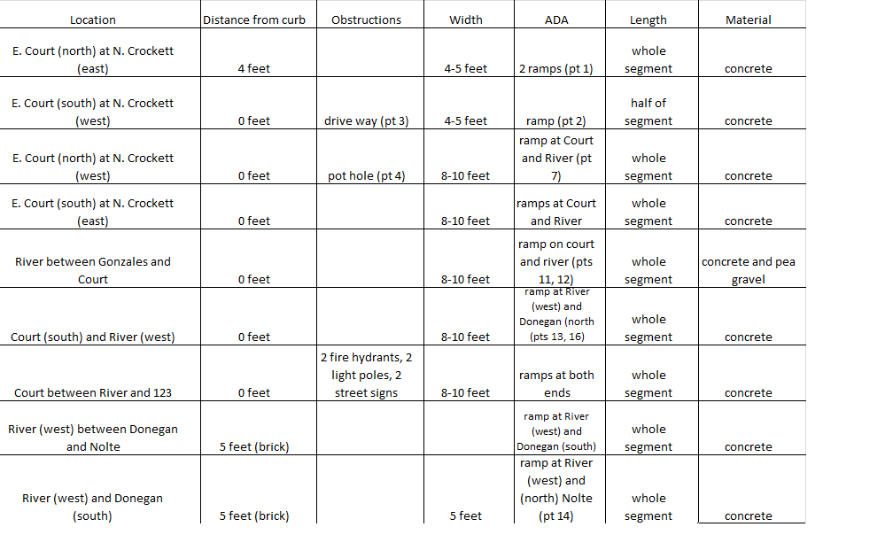

# Items

## Work completed, present work, and future work:

**Task 1: Field work and Input**

During this period, we have begun and continue on with our field work. For this, we are traveling to Seguin and collecting our sidewalk information. After we have gathered our necessary information, we are entering it into the computer so we can use it later for our analysis. We are also using Google Earth to get some of our information.

**Previous Period**

We started with this stage right after the initial proposal and meeting with our client. We decided on the list of characteristics we were going to record. From there, we formed our spreadsheet of our required features to look for and used that to organize our data. Once we had our list we began to make trips to Seguin to gather the information.

**Current Period**

We are still collecting our information. We are beginning to input what we’re accumulating into a spreadsheet so we can eventually add the data to our project. We will be done with the field work data collection on March 30th and will focus on getting the computer work done. Until the 30th we are doing both.

**Next Period**

During the next month we will no longer be doing field work. After the 30th we are moving on.

**Task 2: Chambers of Commerce Data pdf import into usable data set**

**Previous Period**

WALK requested data from the Chambers of Commerce. The data was delivered in a pdf format, which was not usable. The data was pulled from the pdf file, reformatted, ran through a python script pulling out the needed data, into a CSV file (Comma Separated Values file), which was further cleaned up. After this the CSV file was uploaded into a GIS software and geocoded. This created a point layer of pedestrian attractors in Seguin.

**Current Period**

We have completed this task and are no longer working on it.

**Next Period**

We have completed this task and are no longer working on it.

**Task 3: Data Analysis**

During this period we will have gathered all of our data and have it ready for GIS use. We will use that for our analysis. We will look at the information we have to make suggestions of good routes and places to repair or build sidewalks.

**Previous Period**

We have not previously worked on this task.

**Current Period**

We will begin this step after the data collection period is over and everything has been put into the computer and prepared for analysis.

**Next Period**

This is when we are focusing on the analysis. At March 30th, we will be able to focus on analyzing what we have gathered. This will allow us to illustrate the connectivity of the current sidewalks as well as show possible walking routes. From here we can also make recommendations of where to add a segment of sidewalk or repair a broken area.

# Conclusion

The main focus of the project currently is on the HDD. This area has the highest concentration of well-maintained sidewalks. The sidewalks in the HDD are about five feet in width. This is aesthetically pleasing for pedestrians exploring the area.

The main concern with the project is time, in regards to collecting data on all of the sidewalks with in Seguin. Walk will focus on HDD and work in an outward pattern. In order to comply with the safe routes to school program, an emphasis will be placed on schools and parks.