5/3/2013
The Institute for Public Health and Education Research (TIPHER): Proposed Sidewalk Routes
City of Seguin, Texas
Leslie E Guilliams; Caitlin S Pennington; Geoffrey J Shreve
Wellness And Lifetime Knowledge (WALK)

Contents
Contents iii
Introduction 1
Data 4
Methodology 6
Results 11
Discussion 20
Conclusion 25
Bibliography 26
Appendix I: Metadata 30
Appendix II: Group Members Contribution 31

The Institute for Public Health and Education Research (TIPHER): Proposed Sidewalk Routes
City of Seguin, Texas

Introduction
The purpose of the project is to create a sidewalk inventory of Seguin, TX, and a walking map that shows possible sidewalk routes to schools, parks, and other pedestrian attractors. The geographic extent of the study area is within Seguin’s city limits. The focus was on schools as well as the historic downtown district (HDD) and pedestrian attractors. Our group kept in mind that our client was particularly interested in the Safe Routes to School program so one of our models focuses on sidewalks around elementary schools. The project began on Jan 28, 2013 and will be completed on May 3, 2013.
This project was important to conduct because the sidewalks in Seguin as seriously lacking. After looking at the data sets of the roads compared to the sidewalks, it’s easy to see all of the gaps within each segment of sidewalk or segments that are missing completely. TIPHER is striving to low childhood obesity by suggesting kids walk more. The sidewalk to road ratio currently is about 2:23. That is very low and it is difficult to promote walking to a city in which sidewalks are rare. It is unsafe to suggest that children walk more often with that spotty of a sidewalk network.
According to TIPHER data, there is currently 40 miles of sidewalks in Seguin. The problem is that there are gaps in the sidewalk. In our basic proposed sidewalk map, WALK looked at pedestrian attractors such as schools, parks and hospitals. We proposed new sidewalks to complete gaps in the current sidewalk network and create new necessary sidewalks between these locations. This map only accounts for location of current sidewalks and pedestrian attractors. This is the only factor we used to create the routes. This map discovered that about 9 miles could be added to complete the sidewalk network. This further shows the lack of thoroughness of Seguin’s sidewalks.
WALK further investigated the gaps in the sidewalk network or lack of sidewalks with a more detailed proposal. A two mile service area for each school was created with routes originating from population centers 3 miles from the schools in the detailed proposal map. This shows the location of the needed sidewalks within the 1 mile service area of the schools. This was created for the “Safe Routes to School” Program using the existing sidewalks. This way WALK showed the gaps in the current sidewalk network. In regards to routes from elementary schools to population centers, these “needed sidewalks” are our suggestions of where to complete the network. This model suggested adding about 35 miles of sidewalk. This number is so much higher than the basic plan because it was in greater detail and focused on a larger area. With this discovery, the need to expand the sidewalk network is even more apparent. Since this map focused on routes from elementary schools to residential areas, the implications of this model illustrate how it is hard to kids to be able to walk to school safely. It’s healthier for them to walk, but it is difficult to suggest it knowing there isn’t an adequate amount of sidewalks to protect them from cars.

Data
Some of the data used in this project came from the client, TIPHER. They provided data sets for current sidewalks and a road network. It is unclear as to where and how the data sets came to be, but they were consistent with similar data sets and a 2012 aerial photo. The similar road network data aligns with those found from TNRIS and the Census Bureau, two rather credible sources. Using an aerial photo to prove a sidewalk is there can be difficult, since the resolution can skew it or trees and other coverings can hide sidewalks. The photo was downloaded from USDA. Since these data were provided by the client, they were used for the majority of our analysis. With the road network, we performed an analysis of routes between the schools and population centers. The sidewalk layer was used in the analysis to encode the segments of road that are near or have a sidewalk along that part of the road. The encoded segment of road will be used as a factor on the road network to identify preferred routes with existing sidewalks. We created two different models for “Proposed Sidewalks” using these two data sets. Using an eTrex 20 GPS unit, we did some light field work. This included going to Seguin and marking points at every ramp and obstruction in the sidewalk.
One of our models is called the “Basic Model”. For this, we created most of the data. Starting with the given road network and sidewalk inventory, we added pedestrian attractors. These, as defined in our other reports, are the locations that pedestrian would most likely walk to. We chose a few examples of these to show the gaps in the current sidewalk. Using Bing for addresses, and the USDA aerial photo as a reference, we added layers for churches, pharmacies, hospitals, museums, parks, schools, and TLU. The projection for these was NAD UTM Zone 14 and TX South Central State Plane Coordinate System-4200 FT. Using the downtown district as a focus we filled in the gaps manually to these selected locations. This model proposed about 9 miles of sidewalk to add to better complete the sidewalk network.
Our other model was the “Detailed Model”. This one involved more GIS work and came out with almost 35 miles of proposed sidewalk to add. In this model, there were several data that were used. The schools data for this model came from information found on the Seguin ISD website. This listed the addresses for schools. These addresses were placed into a table along with other information. These schools were also broken down by level of education. The focus for this study was on elementary schools. The “School Table” was imported into Arc GIS 10 (the GIS software used for this entire project) and converted into a layer of points. This allowed the schools to be viewed as a point on the map. They were given latitude and longitude coordinate locations and were checked with the aerial photo for accuracy. This helps keep the integrity of the data and were corrections were made where necessary. For this model 2010 block population was also used. This data set was downloaded from the Census Bureau website. The data is used to identify areas of population in regards to the location of schools. It is used as the pedestrian generator for schools in Seguin. This data was cut down to show only the Guadalupe county area. To create the point features on the road network, the US Census 2010 block population polygons are turned into centroid point features; identifying the center for each tract within the Seguin area. This feature set was then used to identify the closest road on the road network, thus creating a pedestrian point generator, to be used in the analysis of routes to and from the schools and the population centers. This method basically takes the homes in a tract and turns them into one point and places that point to the nearest road on the network.

Methodology
We started with the given data sets of sidewalks and road networks. After we found the other sets from other data sources, we began our analysis. We had two different focuses; schools and the historic downtown district (HDD). Our basic model used the HDD as its center. After finding the addresses for the selected pedestrian attractors, listed earlier, and referenced their locations with an aerial photo, layers were added representing these locations. From there, sidewalk gaps were shown more clearly from the HDD to these places. We created a data set of proposed sidewalks by filling in the sidewalks along routes from the HDD to the pedestrian attractors. The GPS points collected from the field work were added into Arc GIS as set of points with some geographical data. Using Excel, we organized some of these points with other data such as the address and if it was a ramp or obstruction. This table was added into our project and joined with the GPS points to give them metadata about the condition of the sidewalk.
For the detailed model, there was a little more GIS work done. The challenge of the project was to create routes, which used the current sidewalks to reduce the cost of creating a complete sidewalk network system to increase the use of the sidewalks and to encourage people to get out and walk from place to place. The data that was supplied did not contain all of the needed fields of data to identify the best walking routes in regards to sidewalk width, location of ADA compliant ramps.
WALK went into the area of study to conduct a pilot project to determine the amount of time to collect data (sidewalk width, location of ADA compliant ramps and etc.) Using an eTrex 20 GPS unit, WALK covered (see appendix for sidewalk measuring document):
- Length: 14402 Feet = 2.72 miles
- Area: 219,803 Square Feet = 5.04 acres
- Intersections: 8
- Time: 2 hours
- People: 3
After completing the plot study of measuring detail sidewalk data, WALK looked into leveraging the power of GIS analysis software, to speed up the process of identifying routes from population centers to Elementary schools in the area of study. To do this the sidewalk network needed to be merged or incorporated into the road network, because the road network is complete and it connects the pedestrian generators and destinations. To do this the data needed to be trimmed to the area of study. To find the population centers, block population data from the 2010 US Census was downloaded for Texas. Guadalupe County was selected from the data set, because the data set is made up of polygons that border to the road network. The centroid of the polygon dataset is found and its location is used to identify the road segment closest to it. To remove the extraneous data from the data set, the street layer was used by creating a one mile buffer around the streets. This was done to select the block population centroids that fell within one mile of the closest road. The area surrounding Seguin is farm land, groups of people live on farms and some of them may go to the nearby schools; the one mile buffer was created to ensure that they would be included in the analysis. The resulting data set is a population center point along the road network. This will be used as the pedestrian generator start location (Figure 1).
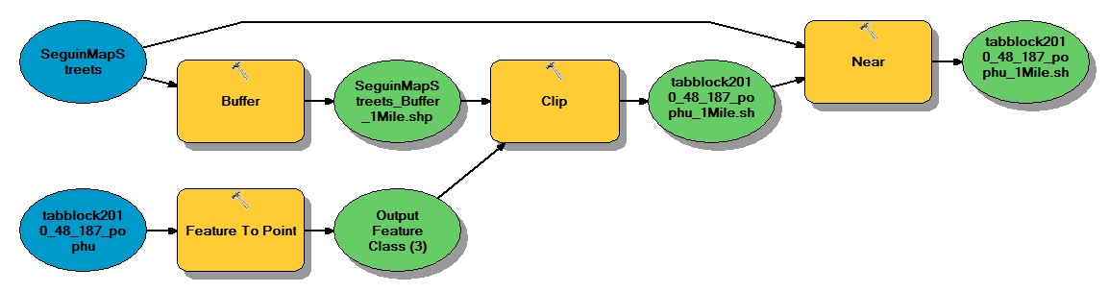
Figure 1
In order to find the best route along a broken sidewalk network, one must create a connected sidewalk network. Since most of the sidewalks follow along the sides of the road network, the road network is used as a network map, with information on the presence of a sidewalk. To create a network map of the sidewalks, a buffer with flat edges, 50 feet distance from the sidewalk with left / right sides done separately. The reason for creating a left / right side buffer is to use the buffers to cut road segments. If the road segment is cut out twice, it generally has a sidewalk on each side of it. The road segments are encoded as having a sidewalk along its path. The left / right road segments are then intersected to find the segments that have been cut out of the road network twice. Because the road has a possible sidewalk on both sides of it, the road is encoded with this information. At this point the left / right segments will have the intersected segments removed from them since these segments have overlapped. The left, right and intersected road segments are then merged into a partial network of sidewalks. This is used to replace the road segments in the network; resulting in a network which has encoded in it the existence of a sidewalk along its path (Figure 2, Figure 3).
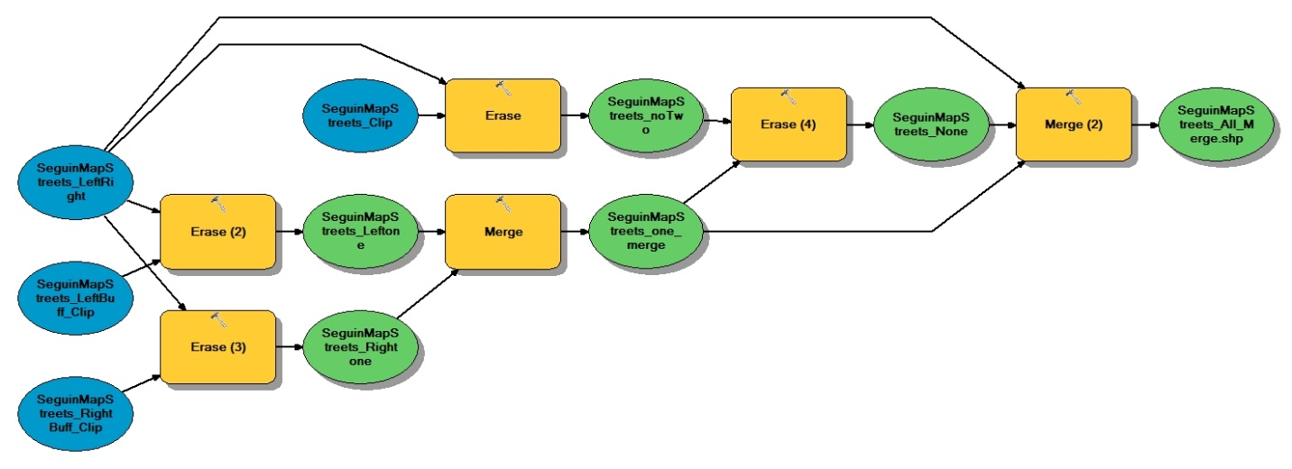
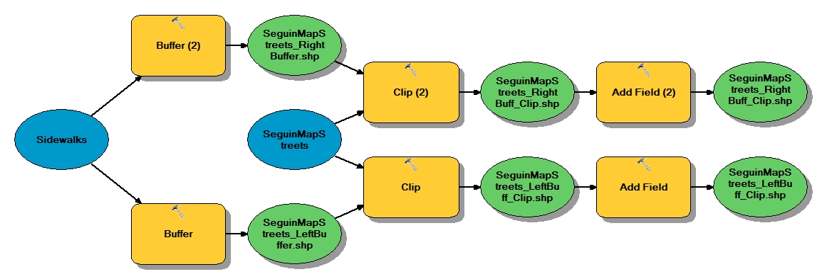
Figure 2
Figure 3
A service area analysis is run on the area of study to find the areas in which to place sidewalk around the schools. The service area uses: ¼, ½, 1 and 2 miles distances along the network to capture the area in which to focus the analysis on. The 2 mile service area is used to select the population centers closest to the schools. As pedestrians converge to the school, they will use the same routes as the ones closest to the schools.
A route analysis is run on the encoded network by using the encoded values. The population centers are in a 3 mile distance from the schools; the analysis weights the road segments, such that the routes with the longest sidewalk length will be chosen over the segments with little or no sidewalks. The routes use the schools as the starting point and the population centers as the end destinations. The routes founded would be the paths needing the least amount of new sidewalk in the 1 mile service areas, completing a path along one side of the road. To create the locations of the needed sidewalks along the identified routes; the sidewalk road network is used to remove the road segments with a sidewalk, leaving only the locations in which to place new sidewalks (Figure 4).
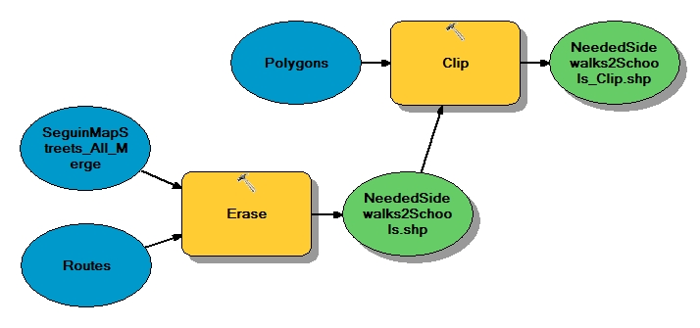
Figure 4

Results
The following times are estimated times based on the pilot study of measuring the sidewalks with in the downtown area of Seguin, Texas.
- 2327 intersections / 4 intersections per hour is about 581.75 hours
- 40.91 miles of sidewalks / 1.3 miles per hour is about 30.08 hours
- 460.71 miles of the road network / 1.3 miles per hour is about 338.76 hours
3 mile sidewalk routes on one side of road statistics:
- Minimum: 1770.30 feet = .34 mile
- Maximum: 20731.60 feet = 3.93 miles
- Sum: 346669.57 feet = 65.66 miles
- Mean: 8888.96 feet = 1.68 miles
- Standard Deviation: 5318.63 feet = 1.01 miles
Needed sidewalk on one side of road statistics:
- Minimum: 381.29 feet = .07 mile
- Maximum: 5280.18 feet = 1.00 mile
- Sum: 180912.93 feet = 34.26 miles
- Mean: 3849.21 feet = .73 mile
- Standard Deviation: 1555.56 feet = .29 mile
For the basic model, it was proposed to add about 9 miles of sidewalk.
Figure 5
Figure 6
Table from adding Excel table added into the layer of GPS points
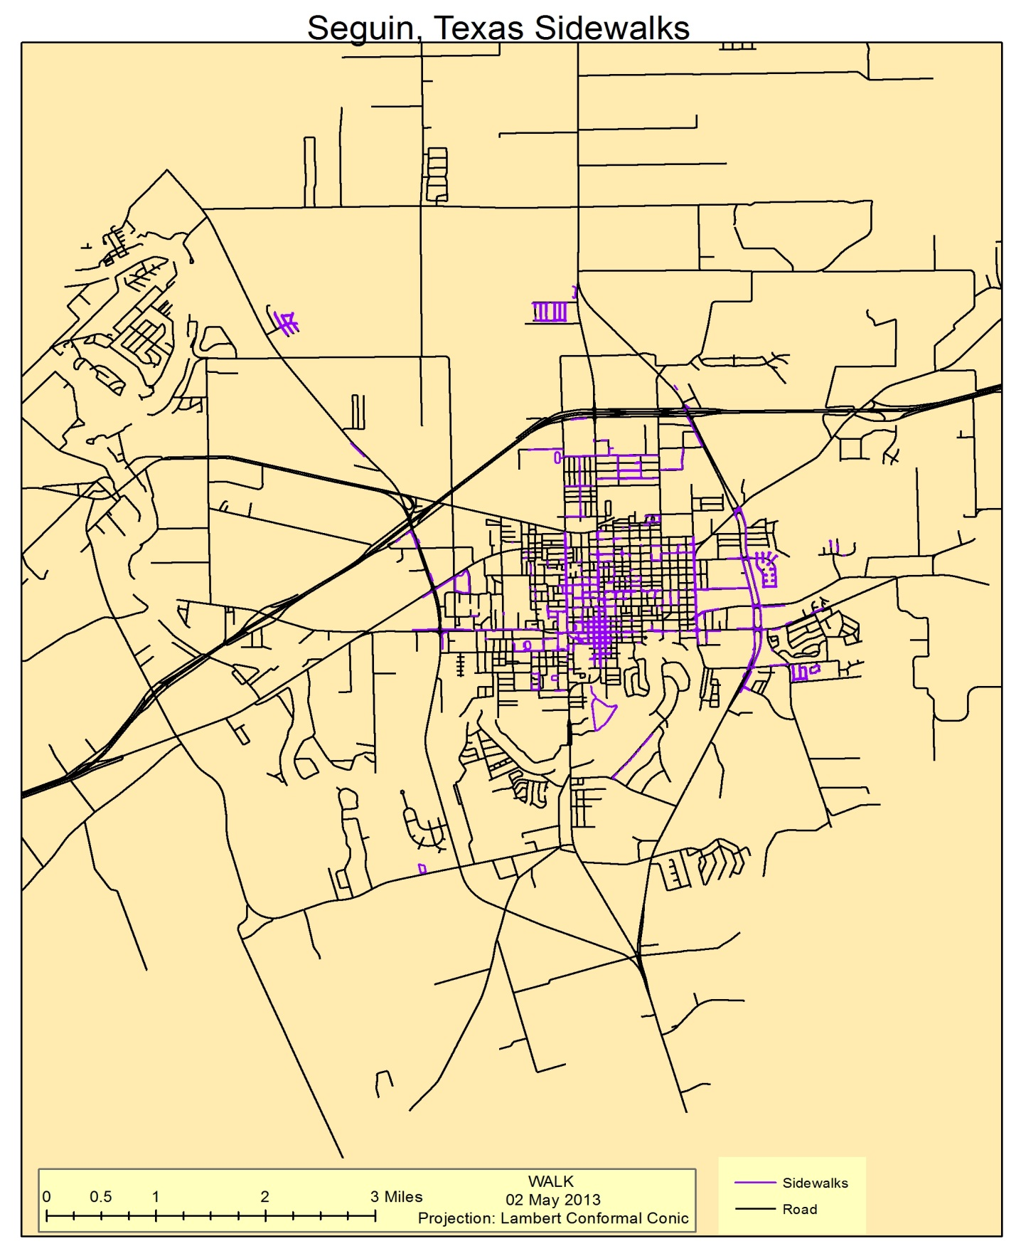Figure 7
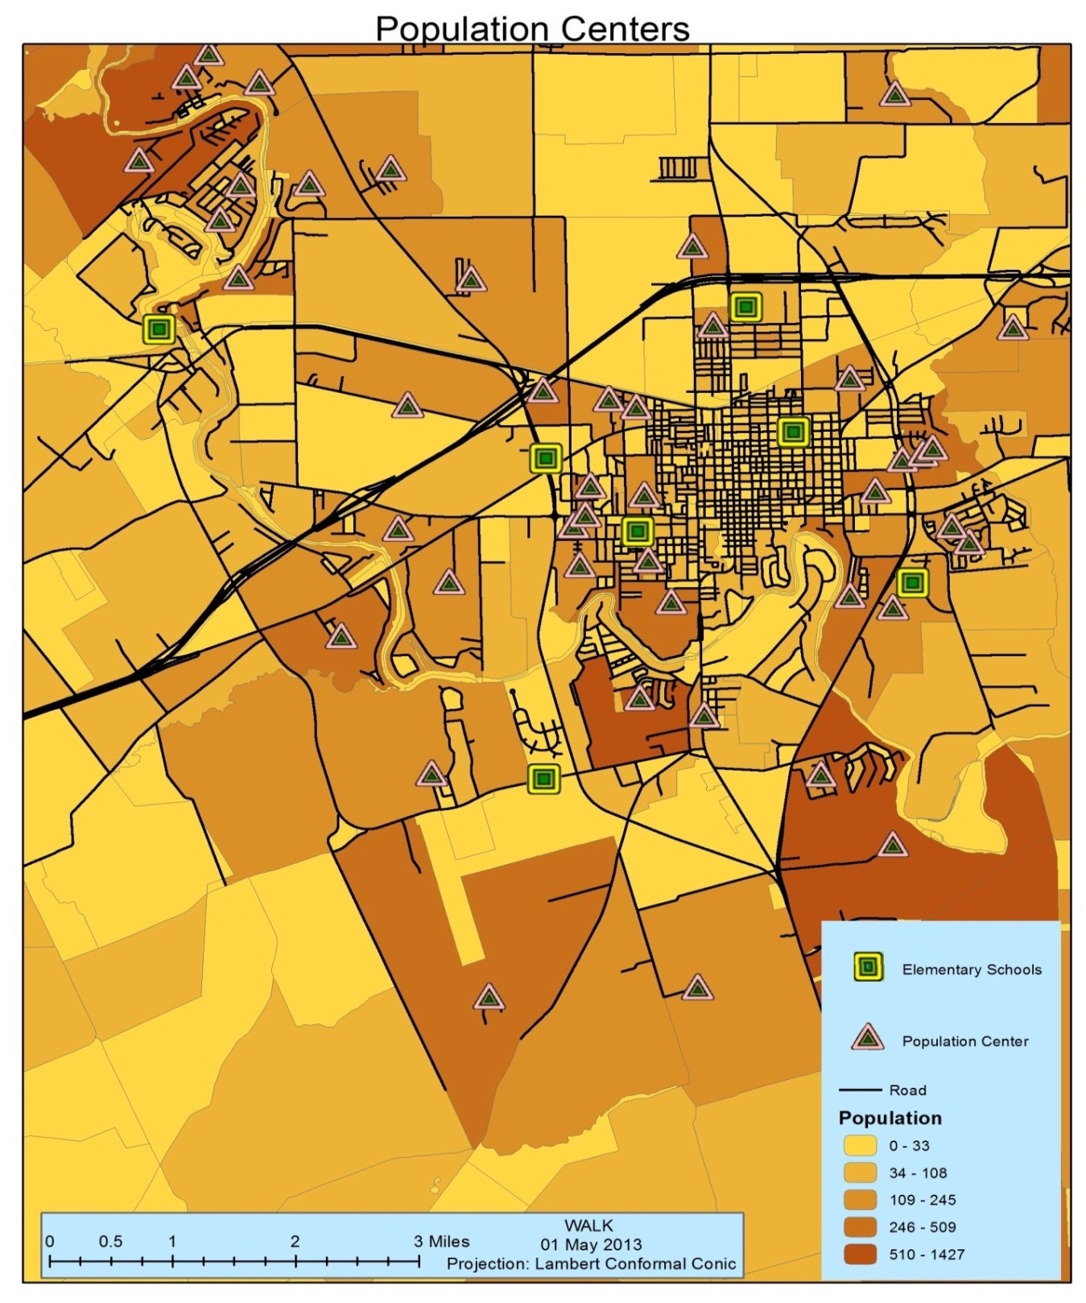
Figure 8
Population by block, using 5 natural breaks.
The population centers represent the closest road to the centroid of the block
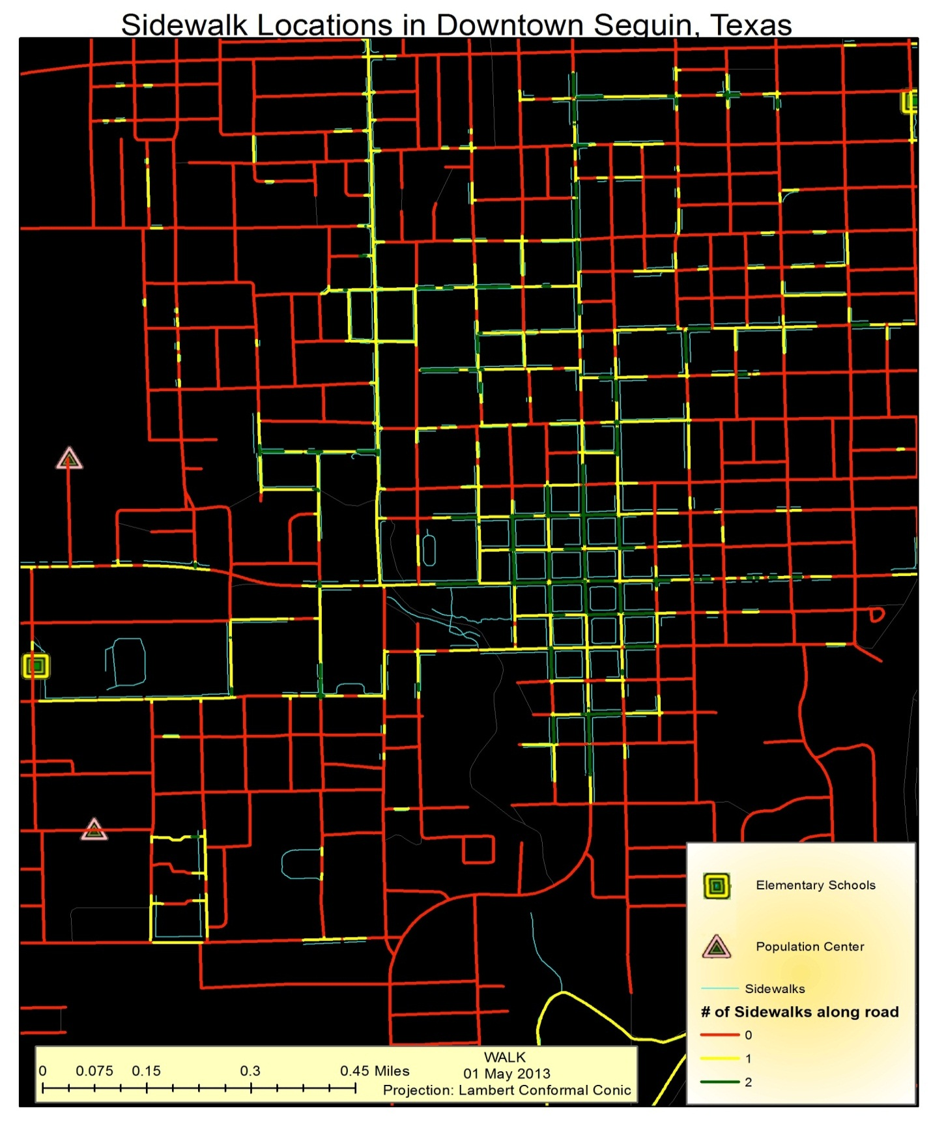Figure 9
Detail of sidewalk locations in downtown Seguin
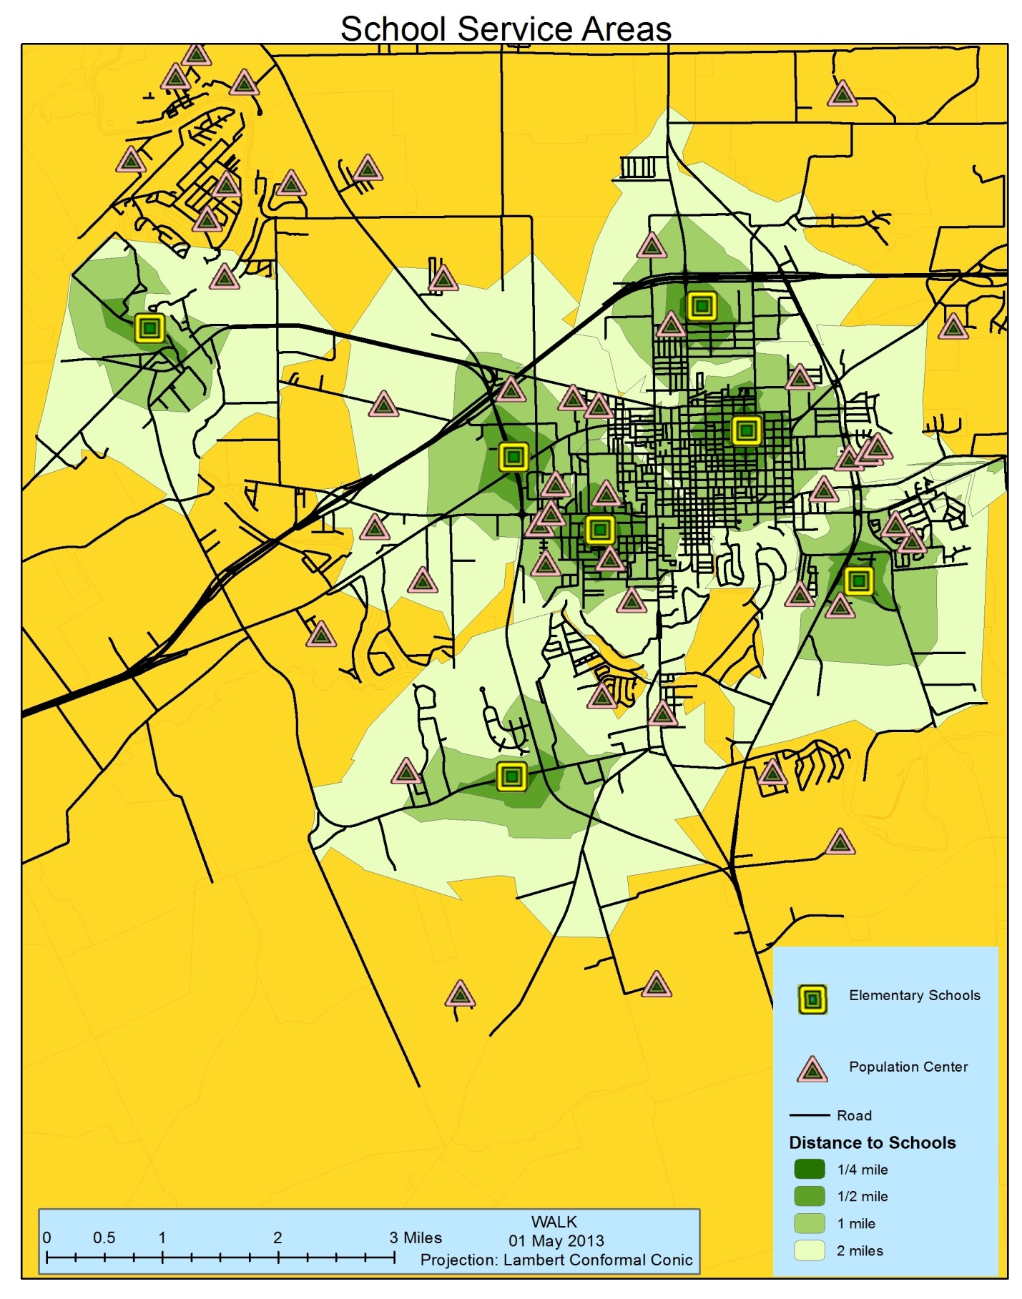Figure 10
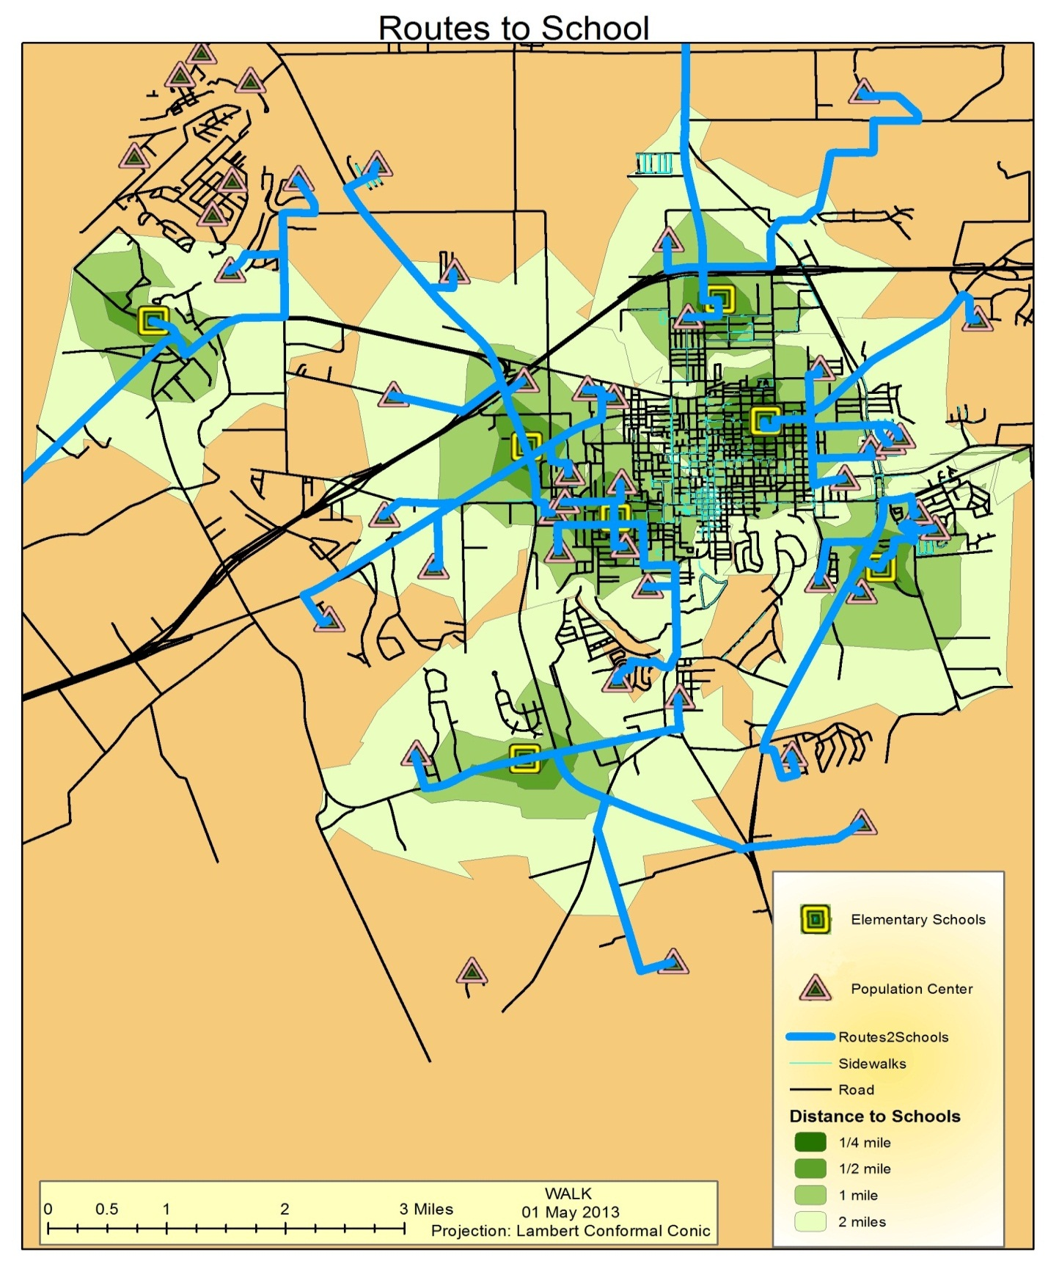Figure 11
3 mile routes to schools from population centers
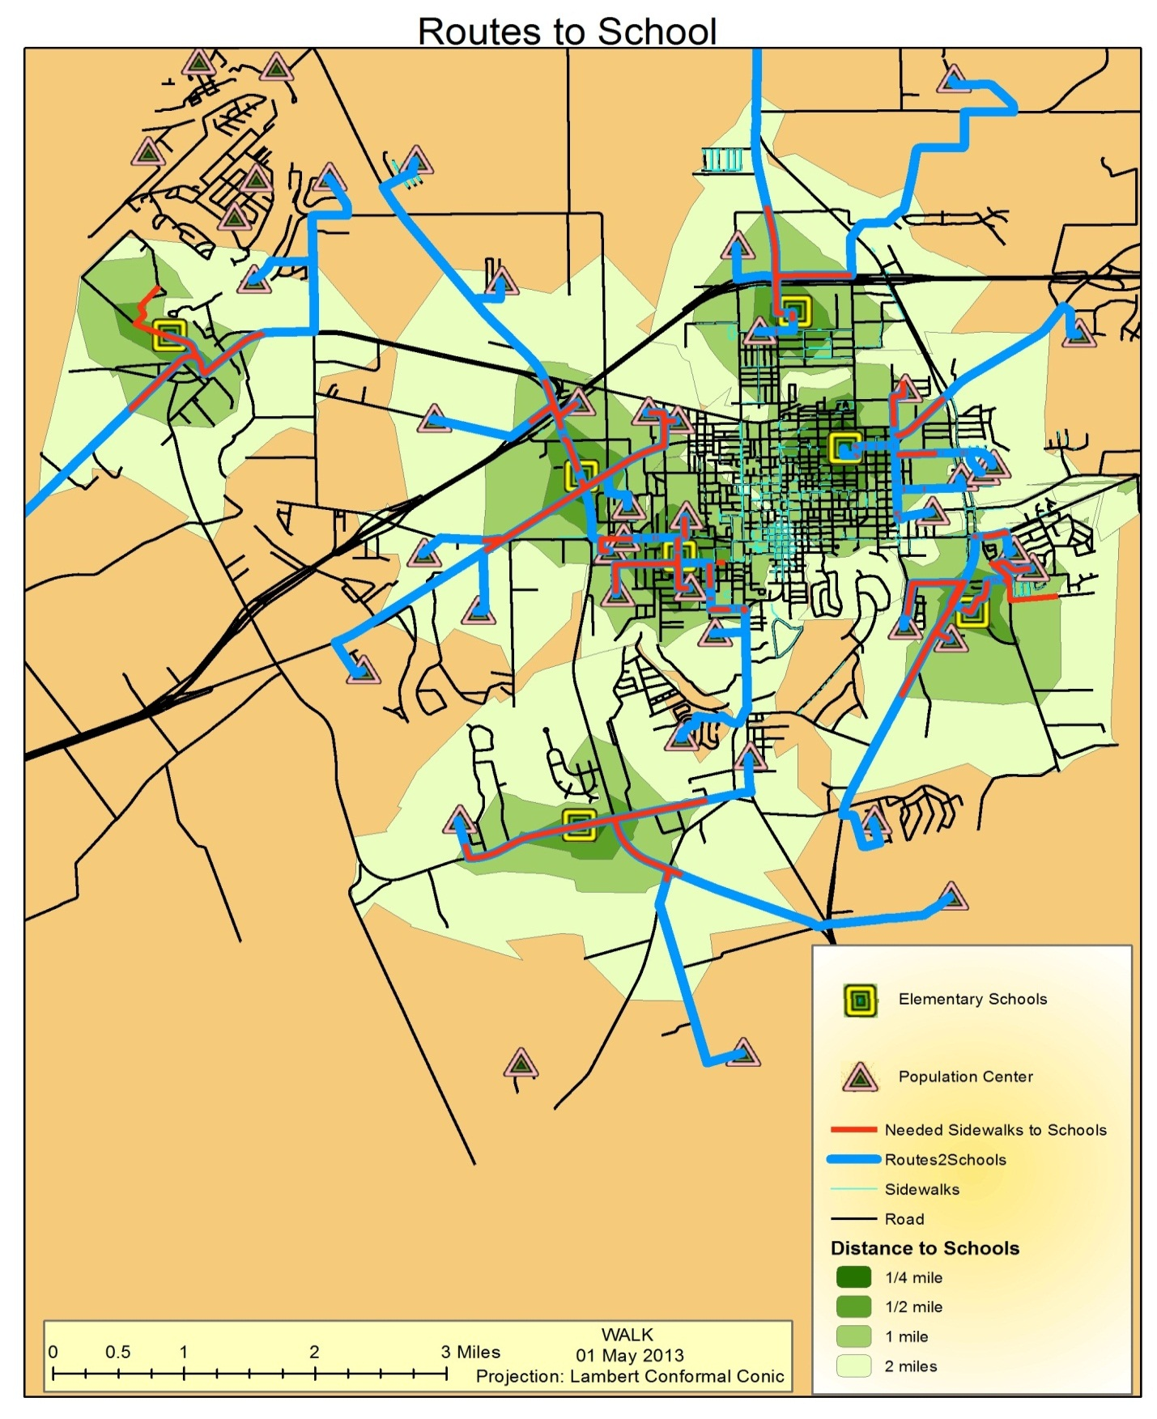Figure 12
Sidewalks needed in a 1 mile service area
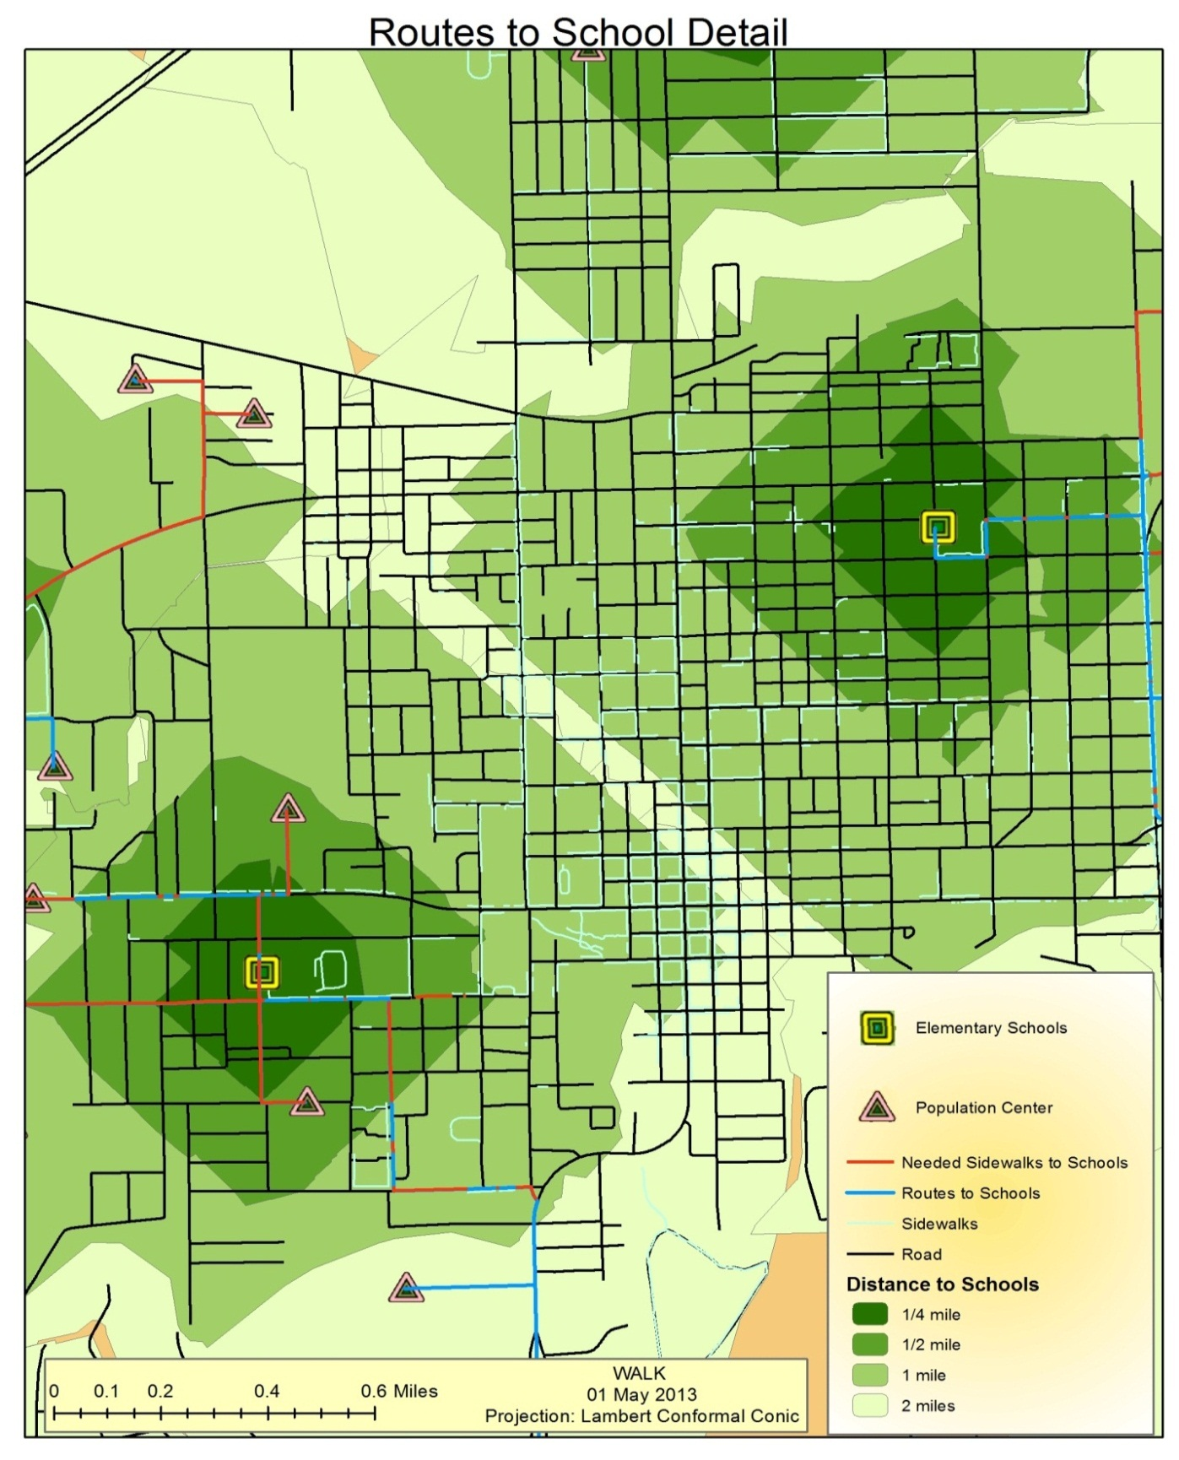Figure 13
Detail of downtown Seguin

Discussion
The analysis on the network looked at sidewalk locations to determine the best routes to use, but it did not take in consideration of major highways or high volume roads. This created routes in which pedestrians would be traveling alongside these high volume roads, which occurred in two of the schools service areas. This needs to further examination to help limit the danger to pedestrians when crossing or traveling along these roads.
While working on the analysis, it was noticed (f) that due to the distance used to create buffers along the sidewalks, which were not meant to be a part of the road network, were in fact incorporated into the network. These occur around walking tracks at some of the schools. There are some sidewalks which follow the road, but move away the buffer away from it. This created artifacts or errors in the data set. Correcting these errors will require removing closed loop tracks or marking them as non- pedestrian paths.
Because of how Arc GIS 10 creates buffers around polylines (lines that have a volume; F), errors were created by: the line turning sharply at the very end of the line, the middle of it curving around a corner, some of the sidewalk polylines are broken up and the direction of the lines drawn are not in a consistent manner. The errors created would leave a very thin buffer crossing a road in a location with no sidewalk present. Another error created was that two sidewalks along one road would encode the road as having only one sidewalk, because the two sidewalks were drawn in opposing directions, placing the left and right sides of the line onto common sides resulting in the road to be clipped once instead of twice. This could be resolved by redrawing all of the sidewalk polylines in an orderly manner or iterate through the sidewalk table and create a buffer for each sidewalk separately and clipping each road segment per each sidewalk segment and then look for intersections.
Due to the type of error identified by the methods used, more time should be spent to correct the sidewalk network or to create a connected sidewalk network to include all walkable paths and cross walks / street crossing locations. If time and money was not an issue, all of the streets / sidewalks should be recreated using a common method of drawing to ensure that north-south paths have a common left/right and the same true of west/east paths; by following a standardized method of creating sidewalk corners and segmentation. The issue with creating the data sets of pedestrian attractors was the projections. We had to manually define them and that becomes tedious. A wrong projection can completely ruin the data.
A limitation we encountered was time and amount of team members. This really affected the amount of field work we could do. We tried in the beginning to perform field work for all of the existing sidewalks. This work included going to Seguin and marking obstructions and ramps along the sidewalks and noting the length and material of it. As shown earlier, it was way too time consuming for this group to do in one semester. It then became a “pilot” for how to measure sidewalks in the future. Knowing now how long it took, doing the field work for this project would not be a real option. There were limits on the amount of free data we could get and how workable that data was. If data could be more easily found for schools with the addresses or population centers of neighborhoods, it would have saved time and more work could have been performed.
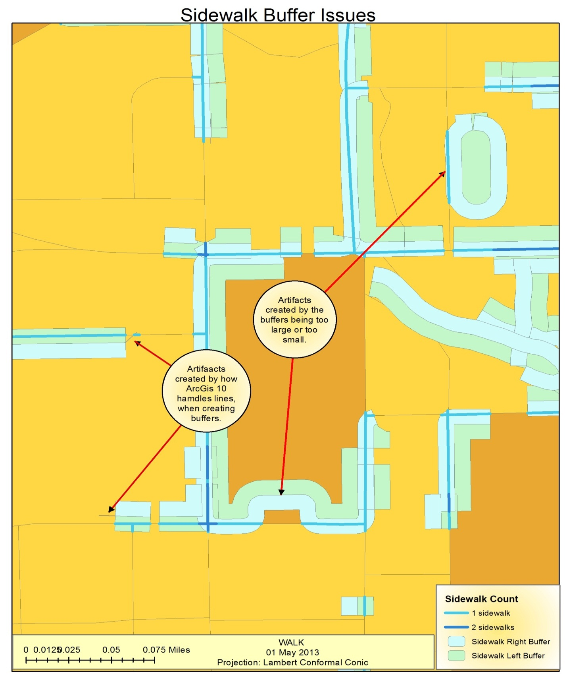
Figure 12
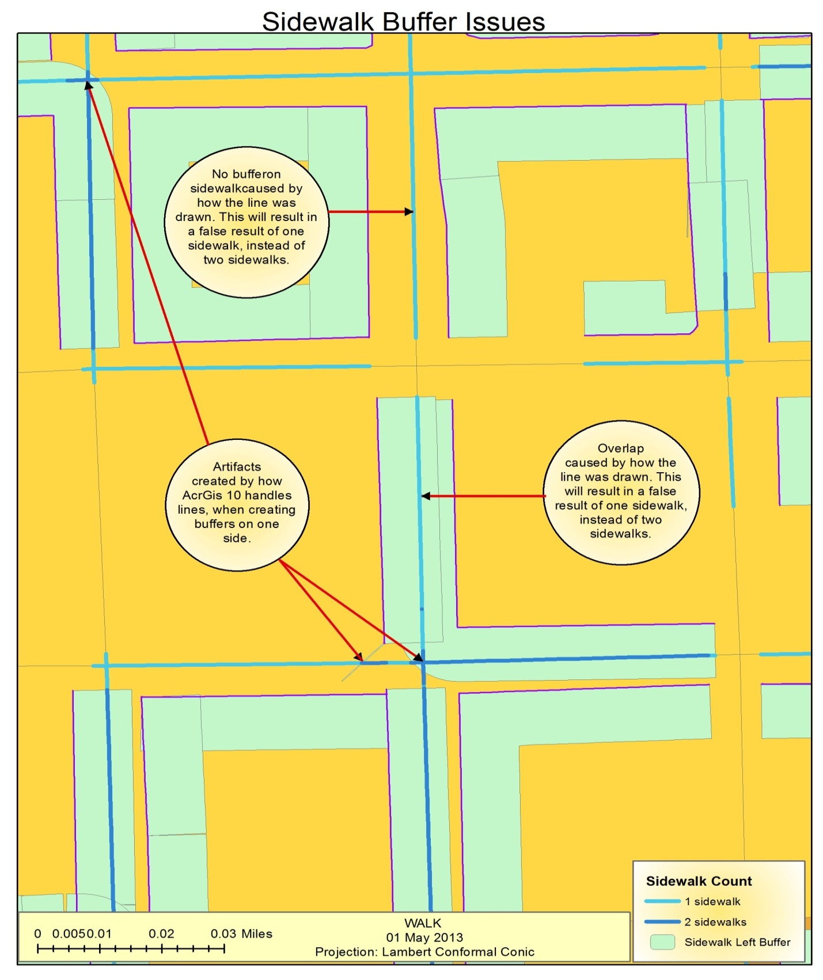
Figure 13
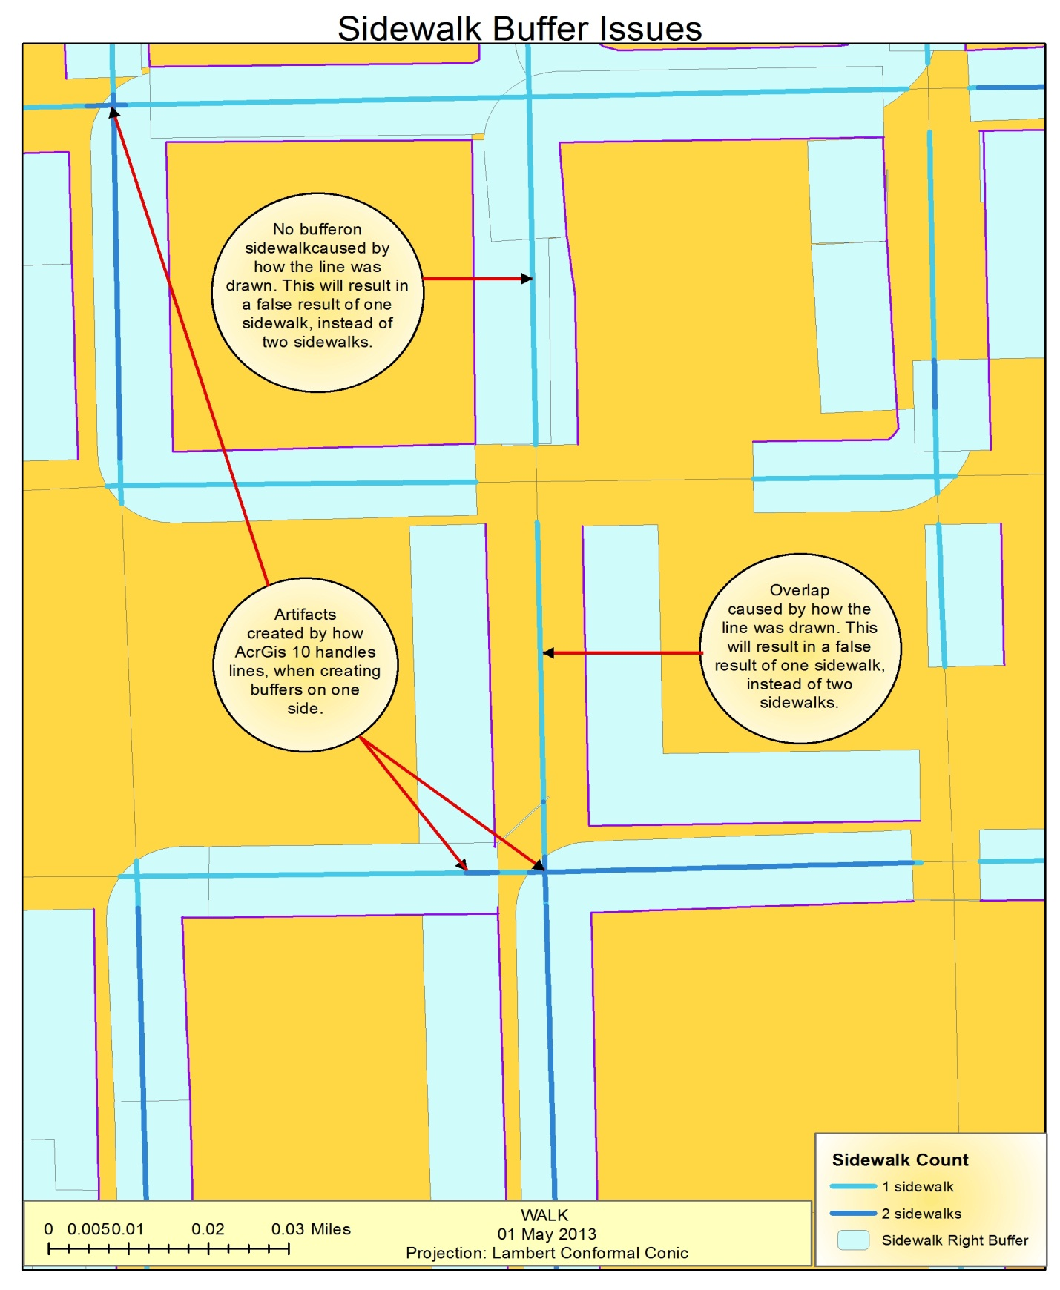
Figure 14

Conclusion
The project was a challenge. The data provided and used is not perfect, allowing creative methods to be explored to develop possible solutions. Due to the nature of this project, to state that the solution found is absolute and solves it with 100 % satisfaction is a false statement. Only by the continued use of the tool sets and methods developed, will we be able to refine the ones created to improve upon previous iterations. From the start of the project, exploration of the problem, looking at the data and utilizing the available tools, has allowed the growth of knowledge in this limited field of study. It is our hope that the results proved, will help improve the quality of life, be the foundation for creating a well-connected pedestrian network, and in the near future, a pedestrian/bike master plan for the city of Seguin, Texas.

Bibliography
Alliance Transportation Group, Inc. 2009. Texarkana Bicycle and Pedestrian Master Plan. Texarkana Metropolitan Planning Organization. Texarkana : Alliance Transportation Group, Inc, 2009. Bicycle and Pedestrian Master Plan.
Alta Planning + Design. 2010. Berkeley Pedestrian Master Plan. Berkeley : s.n., 2010. Berkeley Pedestrian Master Plan.
—. 2012. City of San Mateo - Citywide Pedestrian Master Plan. San Mateo : City of San Mateo, 2012. Citywide Pedestrian Master Plan.
Built environment instruments for walkability, bikeability, and recreation: Disability and universal design relevant? Gray, Jennifer A., Rimmer, James H. and Zimmerman, Jennifer. L. 2012. 2, April 2012, Disability and Health Journal, Vol. 5, pp. 87 - 101. Disability; Universal design; Built environment; Measurement; Instrument; Physical activity; Recreation.
Campese, Anthony , Eden, Chris and Rattan, Arjun . 2012. MODELING WALKABILITY Automating analysis so itis easily repeated. esri.com. [Online] 2012. http://www.esri.com/news/arcuser/0112/files/walkability.pdf.
Chung, Jee-seong . 2003. Pedestrian environment as an urban indicator: developing a GIS model for measuring pedestrian friendliness. OAIster. [Online] 2003. [Cited: Feb 5, 2013.] http://hdl.handle.net/1721.1/65261.
City and County of Denver. 2004. City and County of Denver Pedestrian Master Plan. Denver : s.n., 2004. Pedestrian Master Plan.
City of College Station, Texas. 2002. BIKEWAY AND PEDESTRIAN MASTER PLAN. City of College Station, Texas : s.n., 2002. BIKEWAY AND PEDESTRIAN MASTER PLAN.
City of Sacramento: Department of Transportation. 2006. City of Sacramento: Pedestrian Master Plan - Making Sacramento the Walking Capital. Transportation, City of Sacramento. Sacramento : City of Sacramento: Department of Transportation, 2006. Pedestrian Master Plan.
Design and Pedestrianism in a Smart Growth Development. Glanz, Karen , et al. 2012. March 2012, Environment and Behavior, Vol. 44, pp. 216 - 234. urban design; walking; smart growth; public health; new urbanism; IRVINE-MINNESOTA INVENTORY; PHYSICAL-ACTIVITY; BUILT ENVIRONMENT; TRAVEL-DEMAND; MOVEMENT; AUDIT; SPACE; ENVIRONMENTAL STUDIES; PSYCHOLOGY, MULTIDISCIPLINARY.
Ewing, Reid . PEDESTRIAN AND TRANSIT – FRIENDLY DESIGN:A Primer for Smart Growth. s.l. : PEDESTRIAN AND TRANSIT – FRIENDLY DESIGN:A Primer for Smart Growth.
GIS walking maps to promote physical activity in low-income public housing communities: a qualitative examination. Emmons, Karen and McNeill, Lorna H. 2012. s.l. : Centers for Disease Control and Prevention, Jan 2012, PREVENTING CHRONIC DISEASE, pp. 9 - 8. AFRICAN-AMERICAN; ADULTS; NEIGHBORHOODS; DISPARITIES; WOMEN; URBAN; OLDER; PUBLIC, ENVIRONMENTAL & OCCUPATIONAL HEALTH.
Harford County Government. 2013. DRAFT BICYCLE and PEDESTRIAN MASTER PLAN. Department of Planning and Zoning, Harford County Government. Harford County : Harford County Government, 2013. BICYCLE and PEDESTRIAN MASTER PLAN.
LOCKWOOD, ANDREWS & NEWNAM, INC. 2009. Sidewalk Master Plan. Austin : LOCKWOOD, ANDREWS & NEWNAM, INC., 2009. Sidewalk Master Plan.
Long Live Texans. 2013. Transforming Texas - Long Live Texans. Transforming Texas - Long Live Texans. [Online] Long Live Texans, Feb 2, 2013. [Cited: Feb 12, 2013.] http://www.longlivetexans.com/index.php/site/transforming-texas.
Mapping patterns of pedestrian fatal accidents in Israel. Bekhor, Shlomo, Gitelman, Victoria and Prato, Carlo Giacomo. 2012. 1, January 2012, Accident Analysis & Prevention, Vol. 44, pp. 56-62. Pedestrian fatalities; Accident patterns; Cluster analysis; Kohonen networks.
McNally, Kevin . 2010. Design Guidelines for Walkable Communities. www.uc.edu. [Online] Jan 29, 2010. [Cited: Feb 5, 2013.] http://www.uc.edu/cdc/niehoff_studio/programs/great_streets/w10/reports/design_guidelines.pdf.
Portland Office of Transportation Engineering and Development. 1999. Portland Pedestrian Master Plan. Office of Transportation Engineering and Development. Portland : Portland Office of Transportation, 1999. Pedestrian Master Plan.
State of Hawaii: Department of Tranportation;CH2MHILL;OTAK,inc. 2011. Statewide Pedestrian Master Plan. Tranportation, State of Hawaii. s.l. : State of Hawaii: Department of Tranportatio, 2011. Statewide Pedestrian Master Plan.
The City of Oakland. 2002. Pedestrian Master Plan. Oakland : The City of Oakland, 2002. The City of Oakland - Part of the Land Use and Transportation Elementof the City of Oakland‘s General PlaN.
The development and testing of an audit for the pedestrian environment. Clifton, Kelly J., Livi Smith, Andréa D. and Rodriguez, Daniel . 2006. 1, s.l. : Elsevier B.V., 2006, Landscape and Urban Planning, Vol. 80, pp. 95 - 110. Pedestrian.
The Institute for Public Health and Education Research. 2013. TIPHER - Guadalupe County - Active Living Coalition. TIPHER - Guadalupe County - Active Living Coalition. s.l. : TIPHER, January 28, 2013.
TIPHER. 2000. TIPHER - T I P H E R Welcomes You. [Online] The Institute for Public Health and Education Research, February 9, 2000. [Cited: February 2, 2013.] http://www.tipher.com/.
Walkable Communities and Adolescent Weight. Barker, Dianne C., et al. 2013. 2, Feb 2013, American Journal of Preventive Medicine, Vol. 44, pp. 164 - 168.

Appendix I: Metadata

Appendix II: Group Members Contribution
Catie Pennington: Project Manager
Catie oversaw all aspects of the project. Her responsibilities included keeping team on track, putting together all presentations and reports, divvying up tasks, and setting a timeline. As manager, it was her job to keep the project on schedule and moving smoothly. She assigned tasks to herself for presentations and reports and edited final copies. She participated in field work and created a table within ArcGIS showing the addresses of points taken from the field trip.
Geoff Shreve: GIS Analyst
Geoff was responsible for the basic model. He created most of the data in his map by hand. He looked up all the addresses and created the layers he needed. He created a table showing addresses of the proposed sidewalks for his plan as well as the total amount. Geoff wrote the “Methodology for Measuring Sidewalks” to pass on to the client. He did the tasks the manager assigned to him for the presentations and reports. He participated in field work.
Leslie Guilliams: GIS Analyst
Les was responsible for the detailed model. He gathered several data sets from other sources to use in his analysis. Les fixed issues he found within those data sets to make them applicable to our project. He used several GIS functions to create his in depth map showing suggested places to add sidewalks. He did the tasks the manager assigned to him for the presentations and reports. He participated in field work.

