Cypress Cartographic Solutions
Project Progress Report
March 2013

Team Members:
Rachel Cavin, Manager
James Dodds, Assistant Manager
Taylor Dorn, GIS Analyst
Kyler McNew, GIS Analyst

Cartographic Modeling of Sidewalk
Location Selection for
The City of San Marcos, Texas

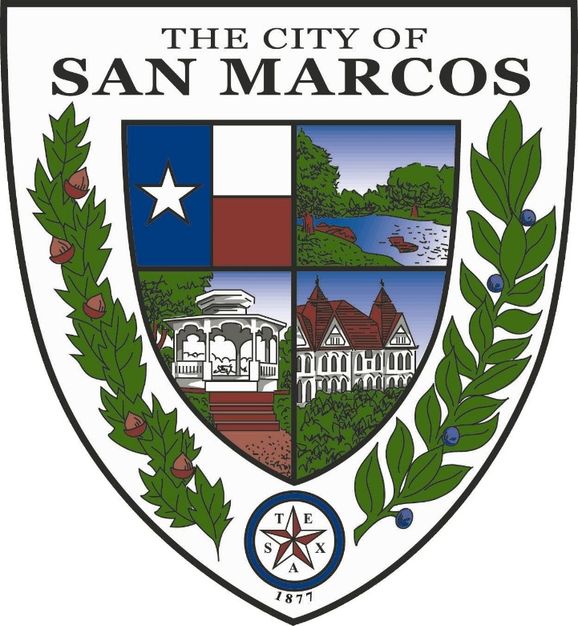

Prepared by
Cypress Cartographic Solutions
March 2013

Table of Contents
Table of Contents 3
Introduction 4
Background 4
Purpose 4
Project Progress 4
Accomplished Tasks 4
Current and Future Tasks 5
Timetable 7
Problems Encountered 5
Conclusion 8
Participation 8

Introduction

Background
The city of San Marcos is a diverse and growing community that includes a variety of features such as the Texas State University campus, natural attractions and the Outlet Malls. Each feature within the city provides challenges as to how members of the community access them. In community crowdsourcing, residents expressed a desire for improved pedestrian infrastructure. After considering the needs of our client The City of San Marcos, Cypress Cartographic Solutions has begun the process of creating a model to be used to prioritize the locations for future sidewalk construction. This model will be able to be used by the City of San Marcos to locate areas in need of sidewalks presently, as well as into the future. The model will use a grid system to subdivide the city into quarter mile squares to be ranked by need of new sidewalks. The squares with the highest scores and the lowest sidewalk to street ratio will then be further analyzed to designate specific sidewalk locations. This portion of the process will be a qualitative analysis, based on our data and an aerial photograph. Along with the model, we will also provide a list and maps of current locations in need of sidewalks within the city. Once completed, we believe our model will provide the City of San Marcos a way to be able to efficiently fund and provide the local community with sidewalks in places that they are needed.

Purpose
This memorandum has been prepared by Cypress Cartographic Solutions for the purpose of updating The City of San Marcos on our current project progress. The purpose of our project is to create a model to identify areas in need of sidewalk improvement, based on the proximity of facilities which generate pedestrian traffic. Throughout the report, the Cypress Cartographic Solutions team will discuss the project details thus far, work that has been completed, current work in progress, and future work that will be completed by the May 3rd deadline. The Cypress Cartographic Solutions team will then provide the city of San Marcos with an assessment of our progress including problems encountered and changes we have made to our methodology since our proposal on February 20th.

Project Progress

Accomplished Tasks

Our team of GIS analysts has been working steadily towards the end goal of a model for selection of sites in need of sidewalk development. The initial phase of our project was completed on schedule with minimal setbacks. This consisted of reviewing relevant literature and considering the best approach for solving the tasks at hand. After presenting this information to the client, Cypress analysts began data collection. In addition to the data given by The City of San Marcos, our team created layers of data which included low income housing areas, Bobcat Tram and CARTS bus routes, retail centers, and other pedestrian traffic generators. Aerial photographs were acquired and combined into one image spanning the entire San Marcos city limits.
As we have moved into the analysis stage of our project we have encountered some minor complications with our methodology. Our initial methodology of creating an initial inverse sidewalk layer proved to be an ineffective use of time and effort and was therefore revised. A new method of analysis was chosen to most effectively analyze the sidewalk needs of the city. This step included making a grid across the city that will allow us to analyze areas of San Marcos most in need of updates in pedestrian infrastructure.

Current and Future Tasks

We have now moved past the data collection and organization phase of the project and into the analysis. The created layers of pedestrian traffic generators have been given rankings of importance and will be used to rank areas of the grid that have many facilities in need of pedestrian access. An additional step will be taken to analyze the length of sidewalks compared with road length in each quarter square mile area to evaluate which areas are most in need of new sidewalk infrastructure. This step will allow the City of San Marcos to effectively plan where to allocate funds for future development. All information and deliverables will also be made available on our website.

At this point, we are moving on as scheduled and expect to deliver all final products and analysis to the City of San Marcos on May 3.

Problems Encountered
Our primary problem has been balancing effectiveness and efficiency in our methods. Our previous methodology would have been extremely effective, yet it had very low efficiency. That method involved creating an inverse sidewalk layer to use for our analysis, which would have enabled us to rank road segments that were missing sidewalks. However, with our time constraints for this project, it would have put us at risk for falling behind. As a result we decided to implement a grid system of quarter square mile cells to isolate important areas of the city to focus on. This will make our analysis much more manageable, without compromising the usefulness of our results. Another issue that has come up is trying to eliminate as much subjectivity as possible. In our new grid system, selection of the cells will be a quantitative, objective process. However, the selection of the sidewalks themselves will be much less objective in this method, as it will be done by manual selection using our maps and aerial photograph. We believe this method will prove useful to The City of San Marcos because it will help select focus areas for sidewalk planning, based on facilities present and current sidewalk length within those areas. With each issue that has presented itself in this project, we have overcome it to the best of our ability.

Progress Examples

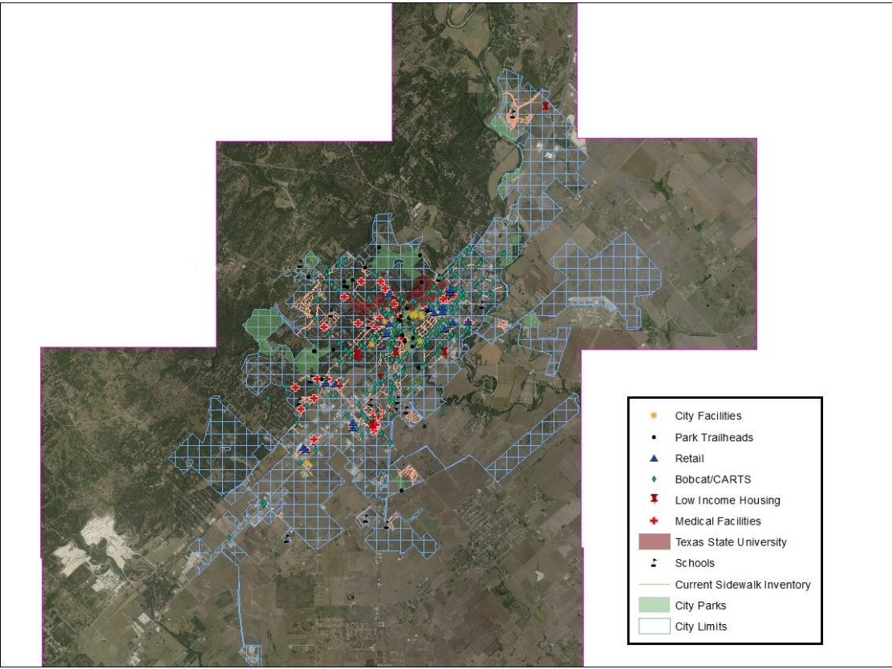
Map 1: The entire scope of our project. Our ¼ mile grid system is visible.

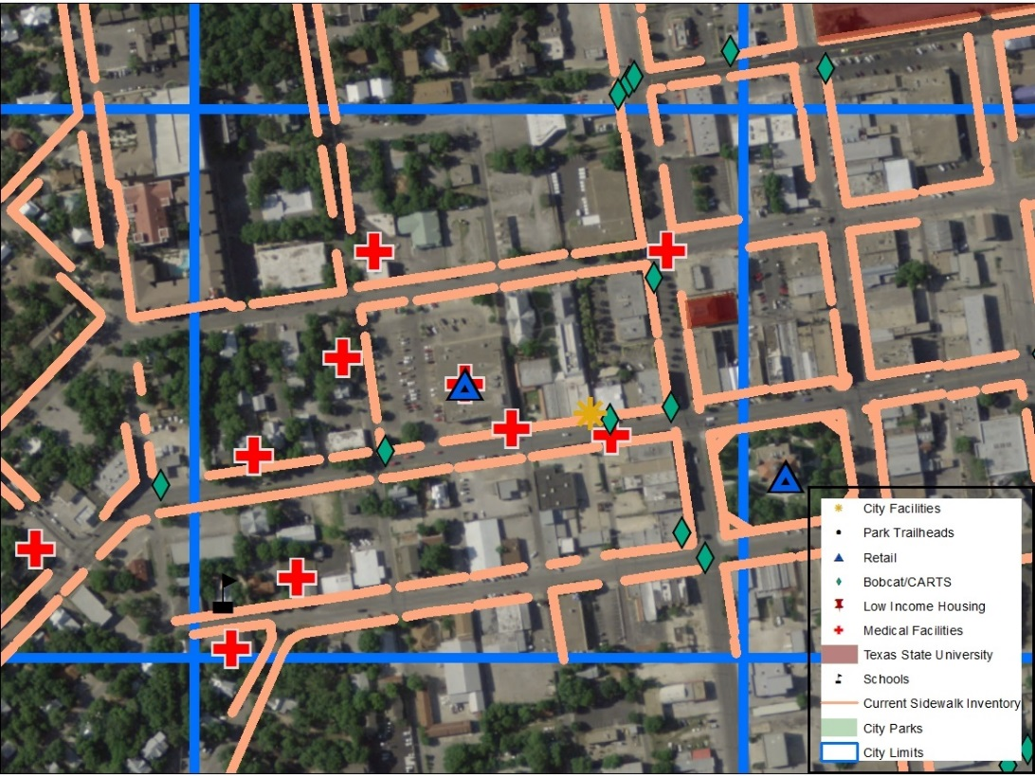
Map 2: A view on a cell within the grid system, with rated factors located within.

Timetable

February
M | T | W | T | F | S | S
 |  |  |  | 1 | 2 | 3
4 | 5 | 6 | 7 | 8 | 9 | 10
11 | 12 | 13 | 14 | 15 | 16 | 17
18 | 19 | 20 | 21 | 22 | 23 | 24
25 | 26 | 27 | 28
Phase 1: Data Collection (Completed)
The first phase of the project will consist of reviewing available literature and collecting data. In order to best serve the City of San Marcos, Cypress Cartographic Solutions will research available information regarding sidewalk infrastructure in municipalities to give an accurate assessment of what the client’s funds may do. At this stage, we will sort through available data as well as create our own in order to develop our model.
Phase 2: Data Processing (Completed)
In phase 2, we will begin to process our data for model development. All data will be converted to the proper format and all necessary transformations will be performed.
Phase 3: Data Analysis (In Progress)
At phase 3, our criteria ranking and weight system will be integrated into a model. After running the model, we will examine results and reformat our model as necessary. Metadata will be checked to ensure accuracy.
Phase 4: Data Interpretation (Future Work)
Phase 4 will involve developing the visualizations of our model results. Maps will be produced which will detail segments along streets within San Marcos which scored high on our sidewalk site model. Our data will then be organized into our final deliverables and presented to our client.

February 20: Proposal Presentation
March 25: Progress Presentation
May 3: Final Product Delivered

March
M | T | W | T | F | S | S
 |  |  |  | 1 | 2 | 3
4 | 5 | 6 | 7 | 8 | 9 | 10
11 | 12 | 13 | 14 | 15 | 16 | 17
18 | 19 | 20 | 21 | 22 | 23 | 24
25 | 26 | 27 | 28 | 29 | 30 | 31

April
M | T | W | T | F | S | S
1 | 2 | 3 | 4 | 5 | 6 | 7
8 | 9 | 10 | 11 | 12 | 13 | 14
15 | 16 | 17 | 18 | 19 | 20 | 21
22 | 23 | 24 | 25 | 26 | 27 | 28
29 | 30

May
M | T | W | T | F | S | S
 |  | 1 | 2 | 3 | 4 | 5
6 | 7 | 8 | 9 | 10 | 11 | 12
13 | 14 | 15 | 16 | 17 | 18 | 19
20 | 21 | 22 | 23 | 24 | 25 | 26
27 | 28 | 29 | 30 | 31

Conclusion
At this point in our project, we are ahead of schedule. We have completed the data collection and processing phases and are currently moving onto the data analysis phase. We have run into a few problems with our methodology; however, we believe that the grid system that we have designed will provide The City of San Marcos with a valuable resource. Much of our time has been allocated to improving our methodology. We now feel we have a reliable methodology and our project will progress without delay. With our data collection and processing phases completed and our methodology improved, we are confident that we will complete the remaining phases and tasks and be able to provide the City of San Marcos their deliverables by the May 3rd deadline.

Participation
Rachel Cavin, Manager: Formatting, Power Point, Quality Control, and Editing.
James Dodds, Assistant Manager: Project Progress, Problems, Power Point, and Conclusion
Taylor Dorn, GIS Analyst: Purpose and Background
Kyler McNew, GIS Analyst: Work Completed, Work in Progress, and Future Work

