Cypress Cartographic Solutions
Final Report
May 2013

Team Members:
Rachel Cavin, Manager
James Dodds, Assistant Manager
Taylor Dorn, GIS Analyst
Kyler McNew, GIS Analyst

Team Members:
Rachel Cavin, Manager
James Dodds, Assistant Manager
Taylor Dorn, GIS Analyst
Kyler McNew, GIS Analyst

Cartographic Modeling of Sidewalk
Location Selection for
The City of San Marcos, Texas

Prepared by
Cypress Cartographic Solutions
May 2013

Table Of Contents
Team Members: 1
Table Of Contents 3
Abstract 3
Introduction 4
Problem Statement 4
Project Purpose 5
Literature Review 5
Data 7
Data Usage and Organization 7
Metadata Information 8
Methods 9
Data Processing 9
Data Analysis 10
Results 13
Discussion 17
Conclusions 19
References 21
Acknowledgements 21
Appendix I: Group Member Participation 22
Appendix II: Sidewalk site locations 23
Appendix III: Metadata 27

Abstract
Our team was asked by the City of San Marcos GIS staff to develop a model for the selection of future sidewalk site locations in San Marcos, Texas. To accomplish this, we gathered data for various facilities that require access and benefit the community. These include schools, doctor offices, and grocery stores, etc. The various factors were then rated based on importance to the community. We then created a grid, which covered the extent of San Marcos city limits, and scored each ¼ square mile cell based on the factor ratings and a ratio of sidewalk length to street length within each cell. We then chose the top fifty cells and selected suitable locations for sidewalk development within each cell using aerial photography. The model resulting from our project is fully repeatable and customizable. The City of San Marcos could use our model as a template to run their own studies with different factors and criteria.

Introduction

The City of San Marcos, Texas is a dynamic and diverse community in the rapidly developing I-35 corridor. In crowd sourcing, conducted by the City of San Marcos, improved pedestrian infrastructure was the most frequent request from city citizens. San Marcos, Texas boasts beautiful outdoor areas, attracting an active outdoors-loving community. The city is home to Texas State University, bringing over 30,000 students to the area as residents or commuters. The community is demographically and economically diverse, requiring transportation options to fit varying lifestyles and needs. By improving pedestrian infrastructure, the city will address many needs of our growing community.

Problem Statement
The City of San Marcos currently has no formal system for the selection of sidewalk development locations. By creating a system to isolate areas in need of consideration, the process of selecting sidewalk development sites could become more efficient and rewarding. A GIS model is one method which could streamline the process of sidewalk selection. By creating a GIS which accurately represents the factors important to sidewalk location selection, areas can be scored for suitability of sidewalk development. GIS is also useful for visualization and mapping of sidewalk sites. If used correctly and developed over time, a GIS model could be a valuable resource for the selection of sidewalk development locations for the City of San Marcos.

Project Purpose
The City of San Marcos requested that we produce a GIS model to select locations within the city limits in need to sidewalk development. They asked that our analysis focus around pedestrian traffic generators, which are public areas that attract pedestrians and benefit from pedestrian access. We were given city facilities, schools, parks, Texas State University, street centerlines, and current sidewalks data from the City of San Marcos GIS. Our team created data for trailheads, transportation, medical facilities, retail centers, and low income housing in Google Earth. We chose to include a ratio of sidewalks to streets in our analysis as well, as this would show areas that were deficient in sidewalks.
The model which resulted from this project is repeatable and fully customizable. Data can be added or taken away, factor ratings and criteria weights can be adjusted to place emphasis on different pedestrian traffic generators, and the process could be duplicated for other pedestrian infrastructure improvement projects in other cities or scales. Below the process and results of our project are detailed. Metadata and group participation are included in the appendices.

Literature Review
Early in the development of our project plan we conducted a literature review to explore methods used by others for selecting sidewalk development locations in GIS or other programs. Numerous studies have been published in which city planners, governments, and others have conducted studies similar to our own. Within these studies we found information which was able to be applied to our own study.
In our literature review we found that sidewalk planning often involves ranking sites hierarchically based on nearby access needs. This had an influence on our own method, as we ranked grid cells based on the facilities within them which require access. The relative importance of factors to be ranked must be designated by GIS analysts, tailoring the ranking to the local needs is crucial. Ranking systems need to be easily understood and comprehensive (Pérez 2010, Zipf 2010). Factors should be selected to accurately represent the community and its needs. Access needs are diverse and plentiful throughout any community. Pedestrian access to businesses and retail centers can fortify the local economy by attracting citizens to conveniently visit these locations (Ehrenfeucht 2010, Loukaitou-Sideris 2010).
Site selection models often score individual locations by totaling ratings and weights in a summation. One study created a system which divided 100 points among factors deemed important to the location of sidewalks (Pérez 2010, Zipf 2010). This method allows for the ranking of factors according to relative importance, as well as hierarchical outputs based on score. Another study rated sidewalks in terms of safety and service, service being specified as ease of travel along a sidewalk path. Once sidewalk strips were rated, the model determined areas which most needed development or improvement (Town of Scituate Massachusetts Board of Selectmen, 2007).
It is difficult to determine precisely how sidewalks should be sited, as access needs are difficult to quantify. Sometimes knowledge of the cultural and economic situation within a community is most useful in determining what is needed (Town of Scituate Massachusetts Board of Selectmen, 2007). Throughout our project we used our own experiences in San Marcos paired with knowledge gained from past studies to develop our sidewalk siting model.

Data

To construct a model to rank potential areas in need of sidewalk development, our model needed to be an accurate virtual representation of the factors which are important in sidewalk site selection. We were given city facilities, schools, parks, Texas State University, street centerlines, and current sidewalks data from the City of San Marcos GIS. Our team created data for trailheads, transportation, medical facilities, retail centers, and low income housing in Google Earth. These data were chosen due to their relevance in citing sidewalks.

Data Usage and Organization
Data was used in different ways throughout our process. Our team broke the ways in which we used our data into two categories: pedestrian traffic generators and supporting data. The pedestrian traffic generators were city facilities, schools, parks and trailheads, Texas State University, bus stops, medical facilities, retail centers, and low-income housing. The supporting data included the street centerlines, sidewalk inventory, and aerial photography.
The pedestrian traffic generators, also referred to as criteria, were split up into factors. These factors were given ratings to rank them by importance and need of sidewalk access. Entire criteria were then weighted, as schools and medical facilities were deemed highly important because of safety reasons. Children need safe routes to and from school, and everyone needs access to doctor’s offices, pharmacies and the hospital. Table 1 shows the ratings and weights of each factor and criteria. Supporting data was used in the ratio of sidewalk length to street length, as well as in the sidewalk site selection process. Our data was generally of good quality, although errors and exclusions are likely present in our dataset. The coordinate system for our dataset was NAD 1983 StatePlane Texas South Central and the projection was Lambert Conformal Conic.
Criteria | Factor | Factor Rating | Weight Value
City Facilities | Activity Center | 9 | 1
 | Public Library | 9
 | City Hall | 7
 | Municipal Building | 10
 | Greenhouse Interpretive Center | 4
 | Dunbar Recreation | 7
 | Downtown Police Patrol | 2
 | Conference Center | 7
Schools | Elementary Schools | 10 | 2
 | Middle Schools | 10
 | High Schools | 8
 | Private/Other Schools | 8
Trails/Parks | Parks | 10 | 1
 | Green space | 4
 | Trailheads | 7
Transit | Texas State University-San Marcos Trams | 8 | 1
 | C.A.R.T.S. | 8
University | Texas State University-San Marcos | 7 | 1
Medical | Hospital | 10 | 2
 | Pharmacy | 10
 | Physicians/Other Medical Offices | 10
Retail | Grocery | 10 | 1
 | Retail Centers | 6
Low Income | Low Income Housing | 8 | 1

Table 1: Pedestrian traffic generator criteria with rated factors and criteria weights. These values were part of the computational component of our model.

Metadata Information
Every layer that was altered or created during our methodology had metadata written to detail the purpose, lineage, and other important information about the layer. Data received from the client did not include initial metadata, so our metadata includes only the lineage since our acquisition. The metadata is included in Appendix II of this report, as well as with the shapefiles in ArcCatalog.

Methods
Throughout our project the methodology underwent changes as we experimented with various processes. Early in our project, we had planned to isolate individual sidewalk gaps in the sidewalk inventory layer and then score each gap according to our criteria. This would have involved manually sorting through thousands of vertices in order to account for gaps in the sidewalk inventory layer. Within the confines of our project timetable, that would have been a difficult task. We considered adjusting the scope of our project by removing residential areas or only focusing on certain zoning types. We decided that this would compromise our project purpose, because we were asked to look at the entire city limits for sidewalk site location. Our group, with help from Dr. Giordano and Ryan Scheurmann, determined that focusing on areas of town rather than individual sidewalk gaps may be a more efficient approach. From this idea our grid system was developed. This method involved dividing the City of San Marcos into ¼ square mile grid cells, making up 773 potential focus areas. The grid system is further detailed throughout the methodology section.

Data Processing
As mentioned in the data section, our data was acquired through multiple sources. Once all data had been gathered, it had to be processed to be suitable for use in our model. Due to the scope of our project all layers were clipped to the size of the San Marcos city limits layer to exclude unnecessary data. Due to each criteria being made up of various factors, the factors needed to be present in the data to rate them accordingly in our model. We created a field in each traffic generator attribute table called “factor” which held this classification. Once the factor field was present in each layer’s attribute table, we merged layers together into their criteria. An example of this was retail centers and grocery stores, because grocery stores was a factor within retail centers. In order for the traffic generator layers which were polygons rather than points to work within our model, we needed a way to change them to point data without impacting the calculations for each grid cell. To do this we added a single point in each grid cell which intersected the polygon before, thus maintaining the points it would have contributed. The points were created by selecting the polygons by location of the grid layer, and then exported them as new shapefiles. They were then converted to a point layer, with each point being placed in the centroid of a grid cell that intersected the previous polygon layer. This process was done for the parks and university layers. Finally, a new field was added to the attribute of the grid layer called “Grid ID” to give each grid cell a specific ID number. Following this step we were ready to enter data analysis.

Data Analysis
The process we used for sidewalk selection was based on GIS suitability modeling, with the goal of mapping a sidewalk site suitability index for our entire study area (Joerin et al, 2001). The first step was converting all traffic generator point layers to raster to prepare them for our analysis method. Once this was completed, each traffic generator layer was reclassified so that their factors were rated according to the values in Table 1. This gave each factor a number representing its importance to where sidewalks are located. Following the factor ratings, all criteria were run through the weighted sum tool. This enabled us to weight the medical and schools criteria twice as high as all other layers. This was done for safety reasons, as children should have a safe route to walk home and community members should have safe access to medical facilities no matter what transportation method they choose. All other criteria remained a weight of one, totaling the criteria weights to 10. The output scores were then reclassified to whole numbers and the layer was converted back to vector. Points falling within each grid cell were then associated with the cell they fell within, based on their GRID_ID attribute, thus giving each cell a score. This resulted in 773 separate tables of point associated with cells. All tables were merged into one single table, which was then joined to the layer Gridclip and exported as a new layer named ScoredGrid. ScoredGrid was a new raster grid layer with each of the 244 cells that had accumulated a score based on the ratings and weights of the factors and criteria which fell within it.
The next step was to rank cells based on their ratio of sidewalk length to street length. In a perfect world, each street would have sidewalks on both sides, leading to a 2:1 ratio of sidewalks to streets. We did this step as an additional criteria for site selection, as cells with a high density of pedestrian traffic generators are important, but some of those areas may already have good sidewalk infrastructure. This allowed us to consider areas which may not have as many facilities, but have lower overall sidewalk infrastructure. All sidewalk and roads data was isolated by the cell within which it fell. We then recalculated their geometry to ensure that each line segment was only as long as the section which fell within the cell. The resulting road and sidewalk lengths for every cell were exported as tables. A new field for the ratio was created, and the ratio was calculated in field calculator. The result was the layer GridRatio which shows the ratio of sidewalks to streets for each grid cell.
Next, we selected the cells with the 50 highest scores from our pedestrian traffic generator system and exported them as their own layer entitled Top50. Additionally, we joined the layer of cells ranked by both pedestrian traffic generators and the ratio and selected those cells that fell within the 50 highest ranked cells as well as had a sidewalk to street ratio below 1. The selection, containing 35 cells, was exported as a new layer called TopCells, and it showed the highest ranking cells which were also most in need of new sidewalk construction along its streets.
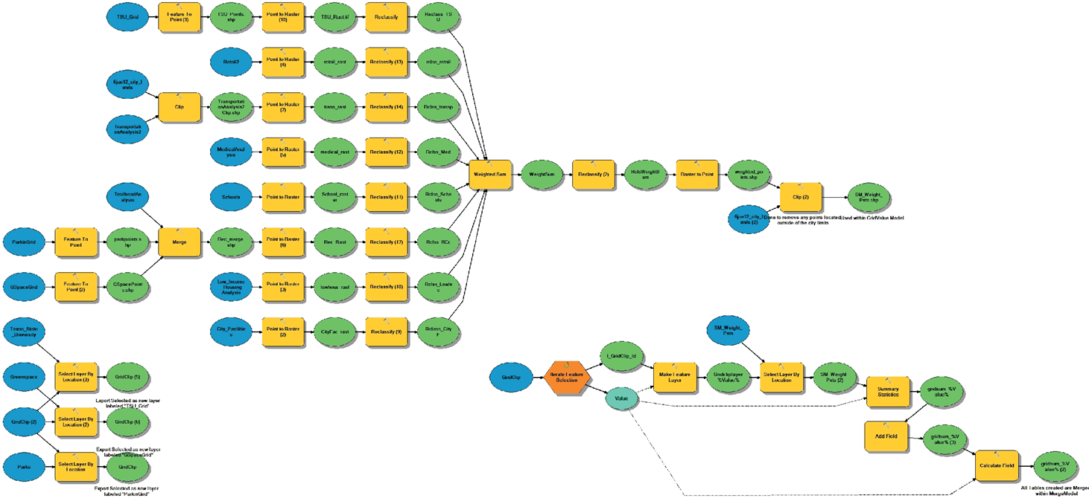
The Top50 layer was used for the final portion of our analysis along with an aerial photograph of San Marcos. For each of our 50 chosen cells in need of sidewalk development, we found missing sidewalks, either as gaps or roads missing sidewalks altogether, and filled them in with linear features. These linear features are the specific sites within the city we recommend for new sidewalk development in San Marcos, Texas. More of these sites are offered in the following results section.
Figure 1: Our data flow diagram exported from ArcGIS 10 Model Builder.

Results
Resulting from our model was a system to rank focus areas within which sites can be selected for sidewalk development. Below are three figures displaying our dataset before we began data analysis, followed by six figures which display our analysis.
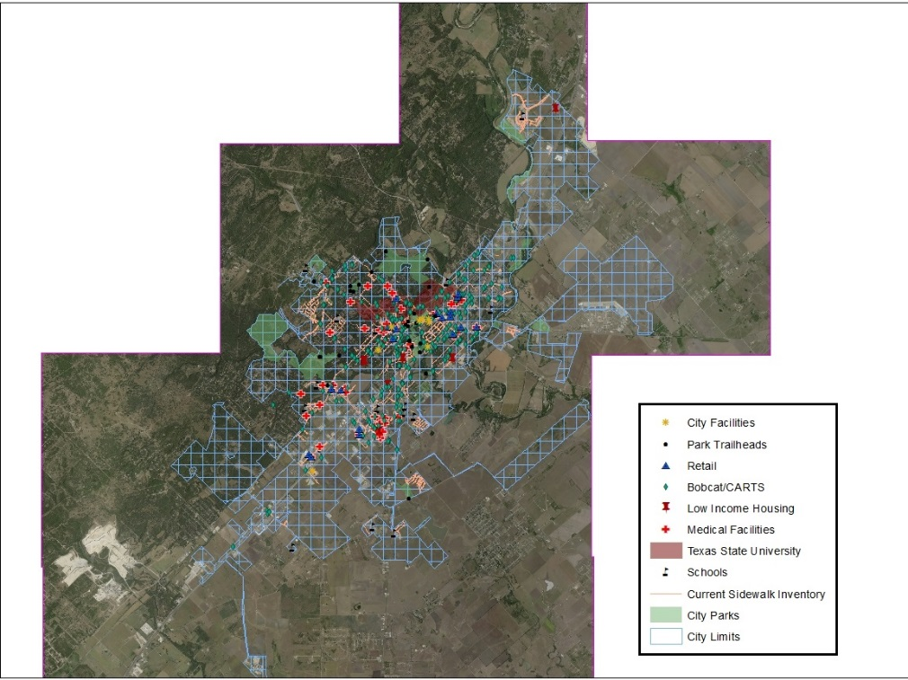
Figure 2: The scope of our project with grid and pedestrian traffic generators displayed. Before analysis took place.
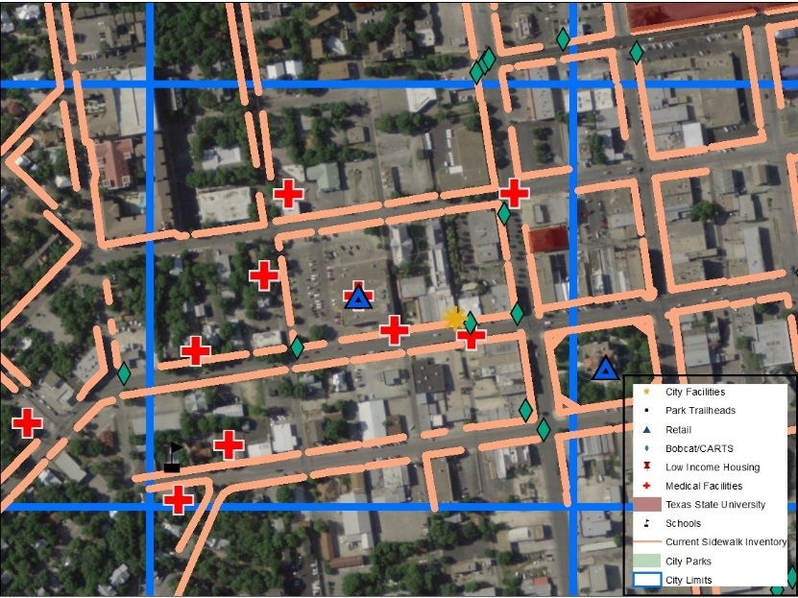
Figure 3: One of the grid cells with pedestrian traffic generators shown within. Before analysis took place.
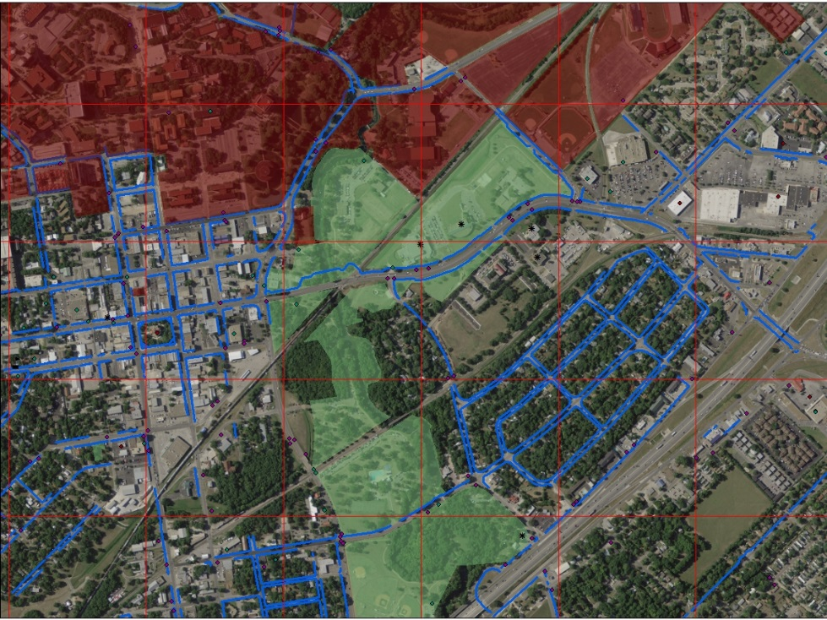
Figure 4: Several grid cells within study area. Before analysis took place.
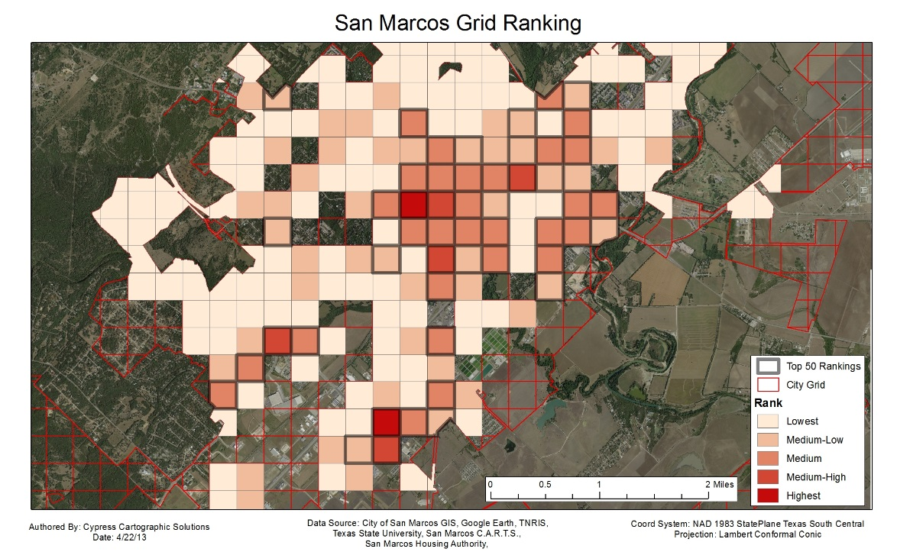
Figure 5: Map showing the cells within the city limits which received a rank from our pedestrian traffic generator scoring system. Some cells are empty due to having a score of zero.
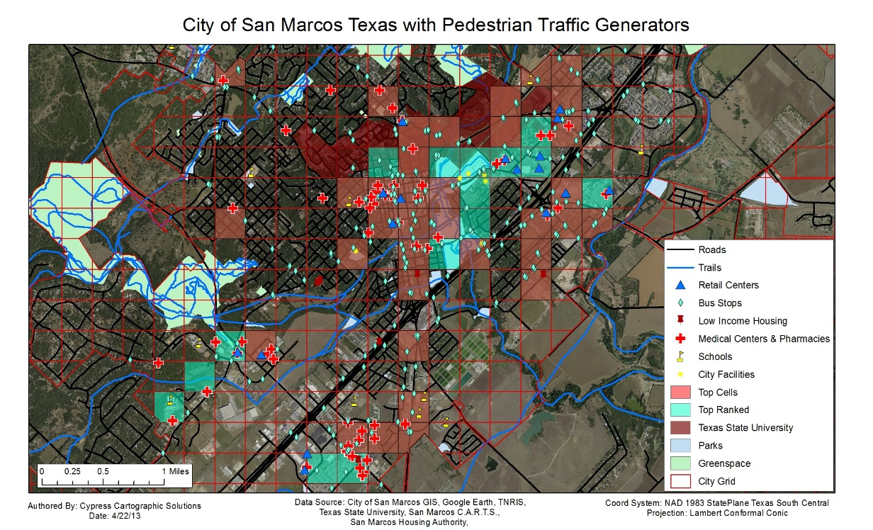
Figure 6: Map showing cells which ranked in the top 50 for both pedestrian traffic generator density and sidewalk to street length ratio.
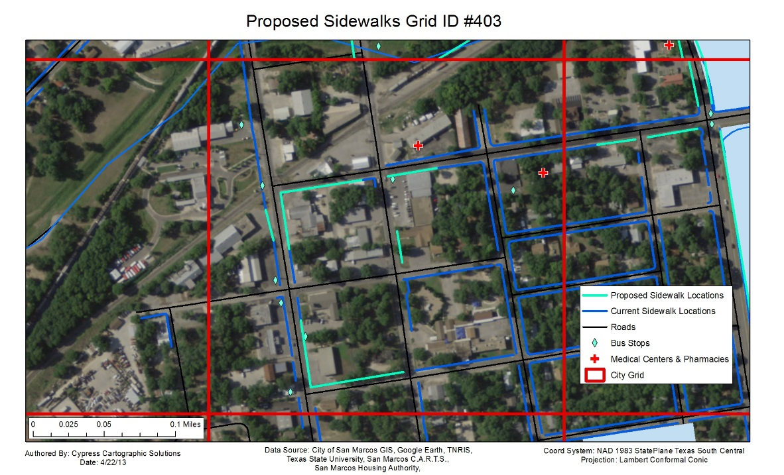
Figure 7: Grid cell number 403 and its proposed sidewalk development sites.
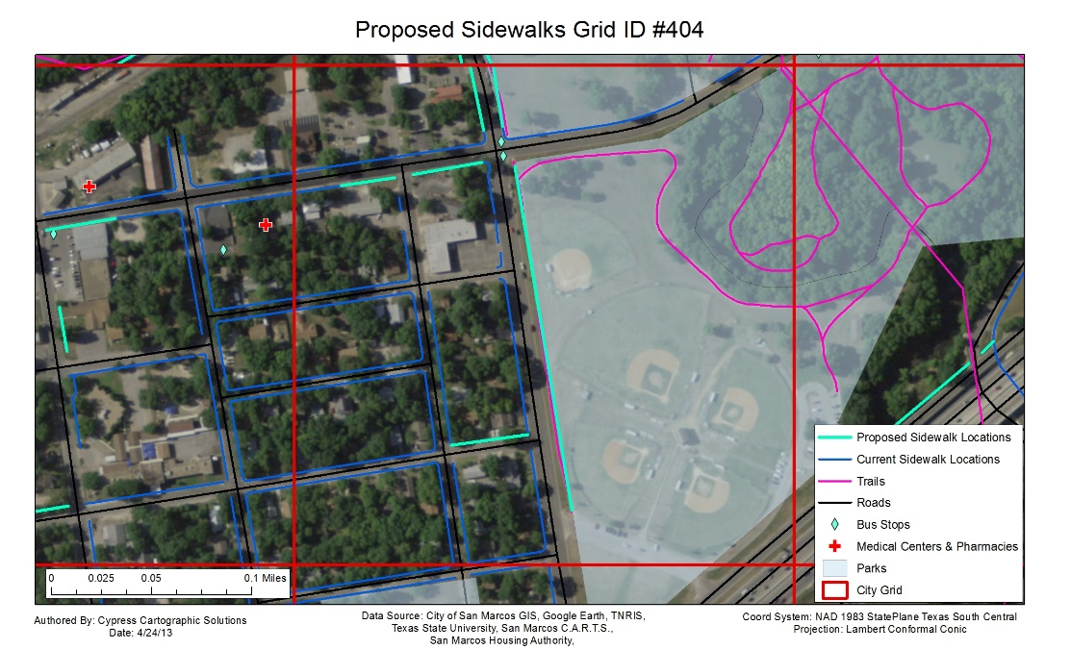
Figure 8: Grid cell number 404 and its proposed sidewalk development sites.
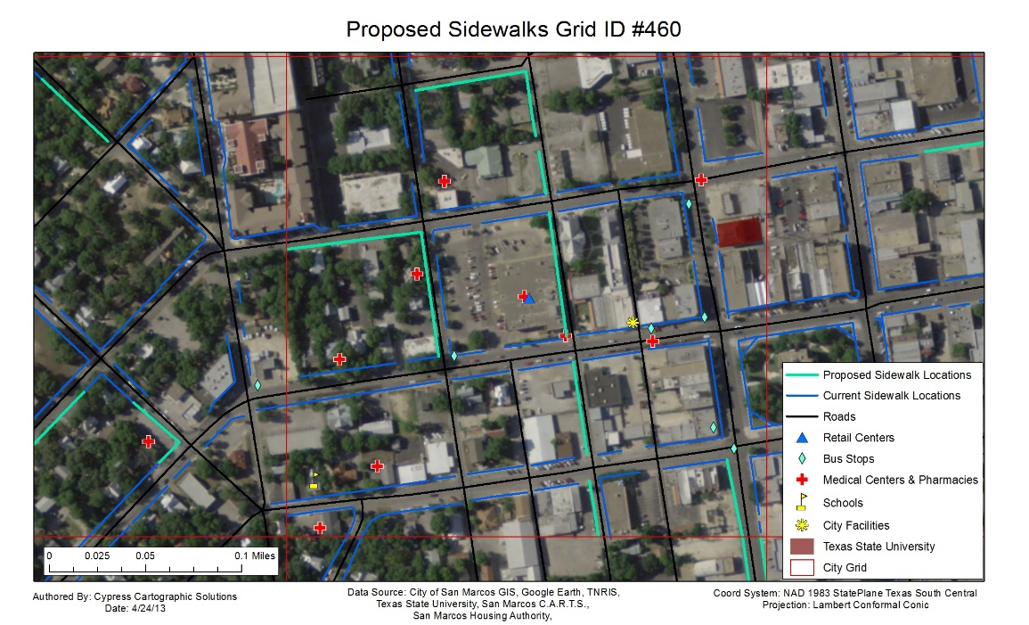
Figure 9: Grid cell number 460 and its proposed sidewalk development sites.
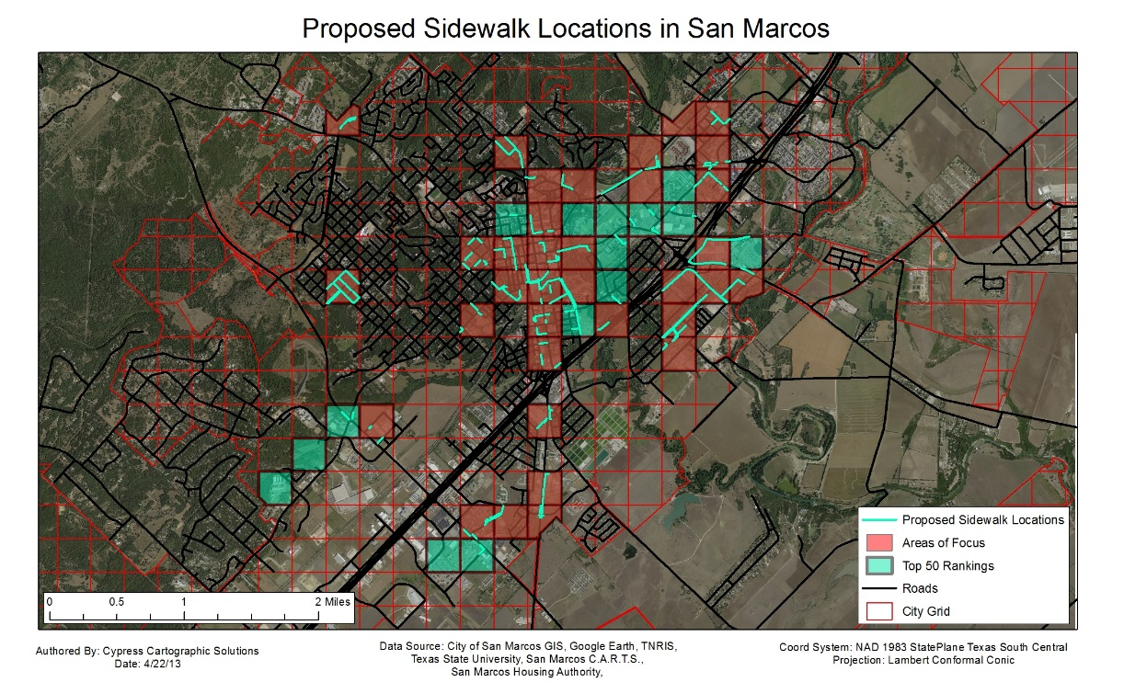
Figure 10: The proposed sidewalk development sites throughout the scope of our project, which are the city limits of San Marcos. In total, we proposed 190 new sidewalk development sites.

Discussion
Overall, our project met the objectives of the class and the requests of the client. It resulted in an automated process for selecting areas to consider for sidewalk development. It does not actually select sites. That would have been difficult to implement with the time and resources available. The model we created can be customized and adjusted by our client to analyze the problem in different ways.
After completing our analysis, as an additional step, we did computations for the high and low cost of developing each segment of sidewalk we proposed. This is in Appendix III of this report. For each sidewalk segment, we calculated a price at $2.50 per square foot and $5.00 per square foot. Each sidewalk is estimated to be 3 feet wide; however, it may vary when they are actually planned. This will allow the City of San Marcos to experiment with our results within the context of their pedestrian infrastructure improvement budget.
The results of the project were mostly consistent with our hypothesis. As seen in Figure 5, the traffic generator high scores were primarily concentrated in the downtown area. Additional areas which received high scores were located along I-35. Some of the sidewalk to street ratio scores were surprising however, as low ratios were located near downtown, which we hadn’t anticipated. Overall, we anticipated our results when we started the project, as we are familiar with the City of San Marcos and how the pedestrian traffic generators are distributed throughout the city.
Although we believe our project adequately meets its objectives and goals, it does have limitations. When we adopted the grid cell methodology, our analysis became less specific. Although the grid cells are useful, because they represent focus areas for sidewalk construction consideration, we didn’t actually select for the specific sidewalk locations. We had to do that manually using other data sources such as the aerial photography. This process is not as direct to the objective as ranking individual sidewalk segments would have been, but it is very efficient and it still yields useful information for our client. Additionally, our data isn’t all comprehensive and temporally current. For example, the aerial photographs were taken in 2008, and it may be concluded that there have been significant changes throughout the city in the five years since. Our pedestrian traffic generators have omissions. The retail centers layer could have had significantly more points. We decided that in order to keep the number of points under control, we would look at this layer primarily from an employment point of view. A large grocery store would employ more people than a boutique, and therefore large grocery stores and other businesses that employ many members of the community were included in the layer
If our team had more time to work on this assignment, we would have done additional analysis at a more specific level. We would have identified every sidewalk gap and missing segment in the city limits, and then we would have developed a model that would have actually ranked them rather than grid cell focus areas. This would have been very labor intensive, but the analysis would have been much more specific to the project objective. It also would have eliminated manual analysis required to site sidewalks which takes place after the model analysis. Our team would have also been more comprehensive with our pedestrian traffic generators. A survey of San Marcos community members would have been beneficial to our ranking and weight system. From this, we could have obtained valuable information about the criteria most important to the citizens of San Marcos. Additionally, ground truthing would have bolstered our sidewalk site selections by ensuring they were appropriate locations for sidewalk construction.
GIS was suitable software for our project. Model builder enabled us to create an efficient and repeatable process for selecting focus areas throughout our project scope. GIS is also very suitable for the creation of visualizations and maps. ArcMap 10 is also very user friendly and could fulfill all of the requirements of the scope of this project. Our only real issue in GIS was that we could not find an efficient method for sorting through thousands of vertices. We searched online for forum discussions, tutorials, and other resources and came up with nothing that would work for our needs. This prompted us to change our methodology, because the manual method for sorting them was far too inefficient. Overall, ArcGIS 10 was an appropriate choice for the construction and visualization of our project.

Conclusions
In conclusion, our project’s purpose was to develop a model for the selection of sidewalk development sites in the City of San Marcos, Texas. San Marcos is a diverse community, but improved pedestrian infrastructure can benefit everyone. The city has a large active, student, and low-income population, all of which may choose to utilize sidewalks to move throughout the city. Our analysis focused around facilities we deemed pedestrian traffic generators, which included schools, medical facilities, and retail centers, etc. These pedestrian traffic generators were rated according to their importance and need of access, then schools and medical facilities had their ratings doubled for safety reasons. They were totaled up within focus areas, which were ¼ square mile grid cells covering our study area. Additionally, we factored in the ratio of sidewalk length to street length within each of these focus areas, as areas with few sidewalks but many streets also need development, even if they have fewer pedestrian traffic generators. From the highest scoring grid cells, we chose 50 and selected specific locations for sidewalks to be sited as future development occurs. We have also calculated the cost of these improvements so that the City of San Marcos can select sites as funds become available.
Overall the project was a success. We fulfilled the needs of our client; however, we had a few setbacks along the process. Our initial methodology was far too labor intensive for the scope of our project, and finding a new method took time away from working towards the end deliverables. However, despite this lull in our progress, we finished on time and accomplished the task. Our group has benefited from this project in numerous ways, including strengthening our teamwork skills, learning the GIS implementation process, improving GIS skills, and understanding how to problem solve in GIS more effectively. This was all of our first experience with creating GIS deliverables for a client, and all of us will likely benefit from this experience in the future.

References
City of Graham. 2006. Graham Pedestrian Transportation Plan. The city of Graham.
City of Peterborough. 2008. Sidewalk Strategic Plan: Phase 1-Sidewalks. The city of Peterborough.
Coleman, V., T. Sufi. 2011. Development and Implementation of the City of Charlotte’s Sidewalk Retrofit Policy.
Concrete Network. 2013. Concrete Price Considerations - Price of Concrete. http://www.concretenetwork.com/concrete-prices.html (Last Accessed April 29th, 2013)
Ehrenfeucht, R., A. Loukaitou-Sideris. 2010. Planning Urban Sidewalks: Infrastructure, Daily Life and Destinations.” Journal Of Urban Design 15.4: 459-471. Environment Complete
Evans-Cowley J. Sidewalk planning and policies in small cities. Journal Of Urban Planning And Development.;132(2):71-75. Available from: Science Citation Index, Ipswich, MA.
HowMuchIsIt. 2010-2013. How Much Does Sidewalk Installation Cost? http://www.howmuchisit.org/sidewalk-installation-cost/ (Last accessed February 7, 2013)
Joerin, Florent, Marius Thériault, and Andre Musy. "Using GIS and outranking multicriteria analysis for land-use suitability assessment." International Journal of Geographical information science 15, no. 2 (2001): 153-174.
Oliver-Solà, J. A. Josa, J. Rieradevall, X. Gabarrell. 2009. Environmental optimization of concrete sidewalks in urban areas. The International Journal of Life Cycle Assessment 14(4): 302-312
Pérez, C., M. Zipf. 2010 A Streamlined Approach to Prioritize Sidewalk Investments.
Town of Scituate Massachusetts Board of Selectmen. 2007. Scituate Sidewalk Study Final Report. The city of Scituate.

Acknowledgements
Cypress Cartographic Solutions would like to thank Dr. Alberto Giordano, Ryan Schuermann, Kenny Skrobanek, and Joan Hickey for all of their help and support throughout this project.

Appendix I: Group Member Participation

Rachel Cavin | Group Manager
- Final Report
- Metadata
- Delegations and decision making.
James Dodds |Assistant Manager
- Model construction
- Methodology Management
- Map Design
Kyler McNew | GIS Analyst
- Model construction
- Manafold webGIS development
Taylor Dorn |GIS Analyst
- Deliverables preparation
- Poster design
- Grid cells to shapefiles.

Appendix II: Sidewalk site locations
FID | Id | Length | Low_Price | High_Price | Sq_ft
0 | 589 | 257 | 1928 | 3855 | 771
1 | 589 | 312 | 2340 | 4680 | 936
2 | 589 | 342 | 2565 | 5130 | 1026
3 | 589 | 322 | 2415 | 4830 | 966
4 | 251 | 486 | 3645 | 7290 | 1458
5 | 271 | 386 | 2895 | 5790 | 1158
6 | 271 | 53 | 398 | 795 | 159
7 | 271 | 157 | 1178 | 2355 | 471
8 | 271 | 129 | 968 | 1935 | 387
9 | 271 | 347 | 2602 | 5205 | 1041
10 | 271 | 261 | 1958 | 3915 | 783
11 | 272 | 385 | 2888 | 5775 | 1155
12 | 272 | 176 | 1320 | 2640 | 528
13 | 272 | 237 | 1778 | 3555 | 711
14 | 273 | 118 | 885 | 1770 | 354
15 | 273 | 133 | 998 | 1995 | 399
16 | 273 | 109 | 818 | 1635 | 327
17 | 273 | 185 | 1388 | 2775 | 555
18 | 273 | 333 | 2498 | 4995 | 999
19 | 295 | 278 | 2085 | 4170 | 834
20 | 295 | 280 | 2100 | 4200 | 840
21 | 295 | 387 | 2902 | 5805 | 1161
22 | 295 | 295 | 2212 | 4425 | 885
23 | 332 | 254 | 1905 | 3810 | 762
24 | 332 | 50 | 375 | 750 | 150
25 | 332 | 397 | 2978 | 5955 | 1191
26 | 333 | 318 | 2385 | 4770 | 954
27 | 333 | 114 | 855 | 1710 | 342
28 | 338 | 115 | 862 | 1725 | 345
29 | 338 | 143 | 1072 | 2145 | 429
30 | 338 | 138 | 1035 | 2070 | 414
31 | 338 | 120 | 900 | 1800 | 360
32 | 338 | 72 | 540 | 1080 | 216
33 | 338 | 273 | 2048 | 4095 | 819
34 | 338 | 265 | 1988 | 3975 | 795
35 | 381 | 410 | 3075 | 6150 | 1230
36 | 381 | 285 | 2138 | 4275 | 855
37 | 381 | 331 | 2482 | 4965 | 993
38 | 385 | 252 | 1890 | 3780 | 756
FID | Id | Length | Low_Price | High_Price | Sq_ft
39 | 385 | 106 | 795 | 1590 | 318
40 | 385 | 275 | 2062 | 4125 | 825
41 | 401 | 147 | 1102 | 2205 | 441
42 | 401 | 159 | 1192 | 2385 | 477
43 | 401 | 66 | 495 | 990 | 198
44 | 401 | 395 | 2962 | 5925 | 1185
45 | 403 | 253 | 1898 | 3795 | 759
46 | 403 | 350 | 2625 | 5250 | 1050
47 | 403 | 119 | 892 | 1785 | 357
48 | 404 | 922 | 6915 | 13830 | 2766
49 | 404 | 144 | 1080 | 2160 | 432
50 | 404 | 186 | 1395 | 2790 | 558
51 | 404 | 206 | 1545 | 3090 | 618
52 | 404 | 165 | 1238 | 2475 | 495
53 | 404 | 176 | 1320 | 2640 | 528
54 | 405 | 44 | 330 | 660 | 132
55 | 405 | 376 | 2820 | 5640 | 1128
56 | 405 | 58 | 435 | 870 | 174
57 | 407 | 829 | 6218 | 12435 | 2487
58 | 407 | 463 | 3472 | 6945 | 1389
59 | 407 | 485 | 3638 | 7275 | 1455
60 | 407 | 450 | 3375 | 6750 | 1350
61 | 407 | 419 | 3142 | 6285 | 1257
62 | 407 | 782 | 5865 | 11730 | 2346
63 | 407 | 1289 | 9668 | 19335 | 3867
64 | 424 | 688 | 5160 | 10320 | 2064
65 | 424 | 723 | 5422 | 10845 | 2169
66 | 424 | 686 | 5145 | 10290 | 2058
67 | 424 | 341 | 2558 | 5115 | 1023
68 | 424 | 329 | 2468 | 4935 | 987
69 | 424 | 299 | 2242 | 4485 | 897
70 | 424 | 714 | 5355 | 10710 | 2142
71 | 424 | 378 | 2835 | 5670 | 1134
72 | 424 | 323 | 2422 | 4845 | 969
73 | 424 | 994 | 7455 | 14910 | 2982
74 | 429 | 434 | 3255 | 6510 | 1302
75 | 429 | 348 | 2610 | 5220 | 1044
76 | 429 | 412 | 3090 | 6180 | 1236
77 | 429 | 173 | 1298 | 2595 | 519
78 | 429 | 476 | 3570 | 7140 | 1428
FID | Id | Length | Low_Price | High_Price | Sq_ft
79 | 429 | 92 | 690 | 1380 | 276
80 | 429 | 246 | 1845 | 3690 | 738
81 | 429 | 331 | 2482 | 4965 | 993
82 | 430 | 926 | 6945 | 13890 | 2778
83 | 430 | 681 | 5108 | 10215 | 2043
84 | 430 | 498 | 3735 | 7470 | 1494
85 | 430 | 301 | 2258 | 4515 | 903
86 | 430 | 124 | 930 | 1860 | 372
87 | 430 | 320 | 2400 | 4800 | 960
88 | 430 | 197 | 1478 | 2955 | 591
89 | 430 | 559 | 4192 | 8385 | 1677
90 | 430 | 584 | 4380 | 8760 | 1752
91 | 431 | 768 | 5760 | 11520 | 2304
92 | 431 | 410 | 3075 | 6150 | 1230
93 | 431 | 613 | 4598 | 9195 | 1839
94 | 431 | 453 | 3398 | 6795 | 1359
95 | 432 | 439 | 3292 | 6585 | 1317
96 | 434 | 153 | 1148 | 2295 | 459
97 | 434 | 1031 | 7732 | 15465 | 3093
98 | 434 | 447 | 3352 | 6705 | 1341
99 | 435 | 500 | 3750 | 7500 | 1500
100 | 435 | 340 | 2550 | 5100 | 1020
101 | 435 | 504 | 3780 | 7560 | 1512
102 | 435 | 765 | 5738 | 11475 | 2295
103 | 435 | 814 | 6105 | 12210 | 2442
104 | 436 | 343 | 2572 | 5145 | 1029
105 | 436 | 770 | 5775 | 11550 | 2310
106 | 459 | 338 | 2535 | 5070 | 1014
107 | 459 | 395 | 2962 | 5925 | 1185
108 | 459 | 342 | 2565 | 5130 | 1026
109 | 459 | 249 | 1868 | 3735 | 747
110 | 459 | 246 | 1845 | 3690 | 738
111 | 459 | 335 | 2512 | 5025 | 1005
112 | 460 | 372 | 2790 | 5580 | 1116
113 | 460 | 346 | 2595 | 5190 | 1038
114 | 460 | 489 | 3668 | 7335 | 1467
115 | 460 | 118 | 885 | 1770 | 354
116 | 460 | 345 | 2588 | 5175 | 1035
117 | 460 | 258 | 1935 | 3870 | 774
118 | 460 | 157 | 1178 | 2355 | 471
FID | Id | Length | Low_Price | High_Price | Sq_ft
119 | 460 | 217 | 1628 | 3255 | 651
120 | 461 | 532 | 3990 | 7980 | 1596
121 | 461 | 561 | 4208 | 8415 | 1683
122 | 461 | 162 | 1215 | 2430 | 486
123 | 461 | 143 | 1072 | 2145 | 429
124 | 462 | 1249 | 9368 | 18735 | 3747
125 | 463 | 570 | 4275 | 8550 | 1710
126 | 466 | 1465 | 10988 | 21975 | 4395
127 | 465 | 443 | 3322 | 6645 | 1329
128 | 466 | 292 | 2190 | 4380 | 876
129 | 466 | 336 | 2520 | 5040 | 1008
130 | 467 | 210 | 1575 | 3150 | 630
131 | 490 | 269 | 2018 | 4035 | 807
132 | 491 | 325 | 2438 | 4875 | 975
133 | 491 | 270 | 2025 | 4050 | 810
134 | 491 | 356 | 2670 | 5340 | 1068
135 | 491 | 190 | 1425 | 2850 | 570
136 | 494 | 245 | 1838 | 3675 | 735
137 | 494 | 94 | 705 | 1410 | 282
138 | 494 | 303 | 2272 | 4545 | 909
139 | 494 | 86 | 645 | 1290 | 258
140 | 494 | 207 | 1552 | 3105 | 621
141 | 495 | 187 | 1402 | 2805 | 561
142 | 495 | 132 | 990 | 1980 | 396
143 | 522 | 290 | 2175 | 4350 | 870
144 | 522 | 111 | 832 | 1665 | 333
145 | 523 | 393 | 2948 | 5895 | 1179
146 | 523 | 418 | 3135 | 6270 | 1254
147 | 525 | 576 | 4320 | 8640 | 1728
148 | 525 | 299 | 2242 | 4485 | 897
149 | 525 | 172 | 1290 | 2580 | 516
150 | 525 | 659 | 4942 | 9885 | 1977
151 | 526 | 131 | 982 | 1965 | 393
152 | 527 | 51 | 382 | 765 | 153
153 | 527 | 203 | 1522 | 3045 | 609
154 | 527 | 78 | 585 | 1170 | 234
155 | 527 | 106 | 795 | 1590 | 318
156 | 527 | 278 | 2085 | 4170 | 834
157 | 527 | 154 | 1155 | 2310 | 462
158 | 527 | 237 | 1778 | 3555 | 711
FID | Id | Length | Low_Price | High_Price | Sq_ft
159 | 527 | 118 | 885 | 1770 | 354
160 | 552 | 328 | 2460 | 4920 | 984
161 | 552 | 256 | 1920 | 3840 | 768
162 | 552 | 386 | 2895 | 5790 | 1158
163 | 552 | 408 | 3060 | 6120 | 1224
164 | 552 | 253 | 1898 | 3795 | 759
165 | 552 | 391 | 2932 | 5865 | 1173
166 | 552 | 336 | 2520 | 5040 | 1008
167 | 556 | 482 | 3615 | 7230 | 1446
168 | 556 | 252 | 1890 | 3780 | 756
169 | 556 | 115 | 862 | 1725 | 345
170 | 556 | 267 | 2002 | 4005 | 801
171 | 558 | 123 | 922 | 1845 | 369
172 | 558 | 59 | 442 | 885 | 177
173 | 558 | 44 | 330 | 660 | 132
174 | 558 | 21 | 158 | 315 | 63
175 | 558 | 65 | 488 | 975 | 195
176 | 558 | 187 | 1402 | 2805 | 561
177 | 558 | 184 | 1380 | 2760 | 552
178 | 558 | 39 | 292 | 585 | 117
179 | 558 | 172 | 1290 | 2580 | 516
180 | 578 | 174 | 1305 | 2610 | 522
181 | 578 | 368 | 2760 | 5520 | 1104
182 | 578 | 151 | 1132 | 2265 | 453
183 | 578 | 238 | 1785 | 3570 | 714
184 | 403 | 517 | 3878 | 7755 | 1551
185 | 403 | 0 | 0 | 0 | 0
186 | 403 | 117 | 878 | 1755 | 351
187 | 403 | 185 | 1388 | 2775 | 555
188 | 287 | 306 | 2295 | 4590 | 918
189 | 288 | 198 | 1485 | 2970 | 594
*Values of zero indicate the segment is under one foot in length.

Appendix III: Metadata

