Date: April 2, 2012
To: Melissa Reynolds
City of New Braunfels Public Works
MReynolds@NBTexas.org
(830) 221-4024
From: GenIuS, Inc.
CC: Dr. Yongmei Lu and Sandy Dischinger

Drainage and Right-of-Way Infrastructure Geodatabase: Progress Report

Summary and Purpose

New Braunfels is a growing city. As the city expands, it endeavors to ensure that its infrastructure keeps pace with its expanding needs. This has been particularly important in the case of drainage infrastructure because of challenges with flooding, information management, and problematic infrastructure in annexed areas. Other cities have used geodatabases to help them manage information on drainage infrastructure and to predict flooding hazards. These local governments have all made successful use of geodatabases in managing records in a centralized manner, demonstrating at-risk areas, and making sound financial decisions regarding infrastructure repairs and upgrades. Thus, in order to support the growth and health of the City of New Braunfels, a geodatabase that inventories drainage and right-of-way structures and their conditions is needed.
This report will detail the progress we have made in designing and testing a drainage geodatabase for the City of New Braunfels. The geodatabase is being designed to meet the Public Works Department’s informational needs and pilot data is being collected to test the functionality and design of the geodatabase to ensure that it will work according to their current and future needs. After this project, the City of New Braunfels Public Works Department will be able to easily maintain and grow this database according to their changing needs.

Schedule
After meeting with the client, Dr. Lu, and Mr. Schuermann the schedule and timeline has changed. The project will include fives phases that will be completed by the deadline. The following is a detailed description of the changes that have been made:
Create Feature Classes and Attributes (March 1 – April 6)
We have created the feature classes and attributes for the geodatabase using Microsoft Excel. These classes have been discussed as a group as well as with the New Braunfels Public Works department to ensure that all necessary data will be covered.
Data Collection (March 23 – April 20)
Data collection began the third week in March and will continue through the third week in April. Garmin eTrex GPS units are used to collect specific points, which are then written into our data input form. This information will then be manually entered into the final geodatabase once it is completed. To test the final data collection method, a Trimble GPS unit belonging to the Public Works department will be used during the final week of data collection.
Geodatabase Design (April 2 – 20)
The geodatabase will be designed throughout April. As data is collected, we will update any feature classes as needed and input the changes into the geodatabase. We will notify the Public Works department of our progresses and discuss any additional changes that may be needed.
Populate Geodatabase (April 6 – 20)
As data collection takes place, the data will then be transferred manually onto ArcMap. Populating the geodatabase will be for demonstration purposes in order to verify the working use of the database.
Analyze Aerial Photography and Pictometry (March 26 – 30: Deleted)
After meeting with the client our team determined that analyzing aerial photography and pictometry will no longer be required to complete this project as planned. Because of this our team will not be conducting an analysis of aerial photography and pictometry.
Finalize Project & Prepare Deliverables (April 23 – 27)
The final week of the project, week 10, will be dedicated to finalizing the geodatabase and prepare all items that are to be delivered to the client on May 4, 2012.

Original Timeline & Updated Timeline

TIMELINE: ORIGINAL
TASKS | WEEKS
 | 1 | 2 | 3 | 4 | 5 | 6 | 7 | 8 | 9 | 10 | 11
 | 2/20 - 2/24 | 2/27 - 3/02 | 3/05 - 3/09 | 3/12 - 3/16 | 3/19 - 3/23 | 3/26 - 3/30 | 4/02 - 4/06 | 4/09 - 4/13 | 4/16 - 4/20 | 4/23 - 4/27 | 4/30 - 5/04
Project Proposal | 22-Feb
Data Collection
Analyze Pictometry & Aerial Photography
Progress Report |  |  |  |  |  |  | 2-Apr
Design Geodatabase & Access Database
Populate Geodatabase
Finalize and Prepare Deliverables
Project Presentation |  |  |  |  |  |  |  |  |  |  | 4-May

TIMELINE: UPDATED
TASKS | WEEKS
 | 1 | 2 | 3 | 4 | 5 | 6 | 7 | 8 | 9 | 10 | 11
 | 2/20 - 2/24 | 2/27 - 3/02 | 3/05 - 3/09 | 3/12 - 3/16 | 3/19 - 3/23 | 3/26 - 3/30 | 4/02 - 4/06 | 4/09 - 4/13 | 4/16 - 4/20 | 4/23 - 4/27 | 4/30 - 5/04
Project Proposal | 22-Feb
Create Feature Classes and Attributes |  | 3/1 -------------------------- 4/6
Data Collection |  |  |  |  | 3/23 -------------------- 4/20
Progress Report |  |  |  |  |  |  | 2-Apr
Design Geodatabase |  |  |  |  |  |  | 4/2 ------- 4/20
Populate Geodatabase |  |  |  |  |  |  | 4/6 ------ 4/20
Finalize and Prepare Deliverables |  |  |  |  |  |  |  |  |  | 4/23 - 4/27
Project Presentation |  |  |  |  |  |  |  |  |  |  | 4-May

Create Feature Classes and Attributes
Work completed: Through a series of meetings, all feature classes and attributes have been created per the client’s request. The coordinate system has also been defined for the geodatabase classes. Some of the original feature classes have been combined with others in order to prevent any overlap in information. Through our meetings with the Public Works Department, we also added numerous fields to the various feature classes, as well as defining certain fields which will be incorporated into all of the feature classes.
Appendix A through Appendix C shows examples of the feature classes’ and attributes’ layouts that are used in the geodatabase.

Data Collection
Work completed: Point features have been collected from the Main Plaza southwest to the Union Pacific Railroad on both sides of W. San Antonio St. The features were collected using the Garmin eTrex GPS units. On March 23 we met with Sandy Dischinger, the Field Operations contact for the project, to begin our test run on data collection. This allows us to collect further data using the correct process. The data collected was entered into our data input form, which will then be transferred into the geodatabase.
Work Remaining: Continue to collect data throughout the rest of our study area. The data collection will be collected using both the Garmin eTrex units as well as the Trimble GPS once the geodatabase is completed.
This is an example of what our data input form looks like. This particular form is for curb cuts. Each feature class will have its own individual form. For the purposes of our project, some of the fields will not be populated. Those fields, which will include MAINTENANCE, MAINTENANCE REPAIR, and MAINTENANCE REPAIR BY, will be set as null values in the geodatabase and can be populated by the City of New Braunfels at a later date.
OBJECT ID | POINT ID | LONG | LAT | ST_SEGMENT ID | ST SIDE | BUILD DATE | CONDITION | TYPE | RAMP TYPE | DRAIN TYPE | ACCESS TYPE
 | 1 | -98.154953 | 29.7089 | 807119 | ODD |  | GOOD
 | 2 | -98.124955 | 29.7091 | 807120 | ODD |  | FAIR
 | 3 | -98.124967 | 29.8001 | 807121 | EVEN |  | GOOD
 | 4 | -98.125001 | 29.8005 | 807122 | EVEN |  | POOR

The map in Appendix D shows our initial test run for data collection. Due to a systematic error in the GPS, the points are not accurate, but this will be corrected. Future data collection will be plotted accurately and the data will be entered into the final geodatabase.

Design Geodatabase with each Feature Class
Work Completed: The curbcuts feature class has been created in the geodatabase. This feature class was used as our test class to verify that the geodatabase is working correctly.
Work Remaining: The remaining feature classes will be created in the geodatabase over the course of the next few weeks. Once this is completed, we will populate the database with the data collected from the field. We will also be submitting the database to the Public Works Department in order to test the database in the field.
The diagram in Appendix E shows the layout of the curb cut feature class and the attributes associated with it. It shows the notes and the maintenance notes tables related to the feature class.

Populate Geodatabase
Work Remaining: Input data that is to be collected into the geodatabase. We will populate the geodatabase manually, using the information stored on the data-input forms and entering it into the geodatabase. Once the final geodatabase design is completed, we will also collect data using the Tremble via ArcPad 7.1 in order to test the functionality of the database.

Deliverables
Work Remaining: The final deliverables will include an instruction manual, a final report, and the website. The instruction manual will detail the creation of the geodatabase, from its inception to its final design. All the associated metadata in creating the database will also be part of the manual.
The final report will include the methodology of the geodatabase, as well as the potential the geodatabase will have in the future.
The website is currently running and will be updated weekly monitoring our progress. It will also contain all of the documents associated with the project.

Conclusion
Thus far, our team has fully completed creating feature classes and their appropriate attributes. We have completed a test run for both data collection and design of the geodatabase. We still have work remain in data collection, designing the geodatabase, populating the geodatabase, finalizing the geodatabase, and preparing deliverables.
Our team is happy to report that we are on track, and that we will have the entire project completed by April 27 and will be prepared to deliver our final project on May 4, 2012.

Appendix A
Curb & Gutter
Attritubute Name | Field Type | Description | Data Input
FEATURE | Text | Feature type | Drop-Down
ID | Long Integer | Feature ID | Input
LONG_1 | Double | Feature Longitude 1 | Input
LAT_1 | Double | Feature Latitude 1 | Input
LONG_2 | Double | Feature Longitude 2 | Input
LAT_2 | Double | Feature Latitude 2 | Input
ST_SEGMENT_ID | Long Integer | Street Segment Number (from Street Centerline data) | Input
ST_SIDE | Text | Odd/Even | Drop-Down
BUILD_DATE | Date | Date of Construction | Input
CONDITION | Text | Good/Fair/Poor | Drop-Down
CURB_WIDTH | Long Integer | Inches | Input
GUTTER_WIDTH | Long Integer | Inches | Input
GUTTER_DEPTH | Long Integer | Inches | Input
Notes:
FEATURE | Text | Feature Type | Drop-Down
ID | Long Integer | Feature ID | Input
DATE | Date | Date | Input
NOTES | Text | Notes | Input
Maintenance Notes:
FEATURE | Text | Feature Type | Drop-Down
ID | Long Integer | Feature ID | Input
DATE | Date | Date | Input
MAINT_TYPE | Text | Maintenance/Repair | Drop-Down
MAINT_BY | Text | City of New Braunfuls/Other (if other - specify in notes) | Drop-Down
MAINT_NOTES | Text | Maintenance Notes | Input
Appendix B
Sidewalk
Attritubute Name | Field Type | Description | Data Input
FEATURE | Text | Feature type | Drop-Down
ID | Long Integer | Feature ID | Input
LONG_1 | Double | Feature Longitude 1 | Input
LAT_1 | Double | Feature Latitude 1 | Input
LONG_2 | Double | Feature Longitude 2 | Input
LAT_2 | Double | Feature Latitude 2 | Input
ST_SEGMENT_ID | Long Integer | Street Segment Number (from Street Centerline data) | Input
ST_SIDE | Text | Odd/Even | Drop-Down
BUILD_DATE | Date | Date of Construction | Input
CONDITION | Text | Good/Fair/Poor | Drop-Down
WIDTH | Long Integer | Feet | Input
OFFSET | Long Integer | Feet | Input
TYPE | Text | Concrete/Asphault/Crushed Granite/Brick/Other | Drop-Down
 |  | *if other - specify in notes
Notes:
FEATURE | Text | Feature Type | Drop-Down
ID | Long Integer | Feature ID | Input
DATE | Date | Date | Input
NOTES | Text | Notes | Input
Maintenance Notes:
FEATURE | Text | Feature Type | Drop-Down
ID | Long Integer | Feature ID | Input
DATE | Date | Date | Input
MAINT_TYPE | Text | Maintenance/Repair | Drop-Down
MAINT_BY | Text | City of New Braunfuls/Other (if other - specify in notes) | Drop-Down
MAINT_NOTES | Text | Maintenance Notes | Input

Appendix C
Inlet
Attritubute Name | Field Type | Description | Data Input
FEATURE | Text | Feature type | Drop-Down
ID | Long Integer | Feature ID | Input
LONG | Double | Feature Longitude | Input
LAT | Double | Feature Latitude | Input
ST_SEGMENT_ID | Long Integer | Street Segment Number (from Street Centerline data) | Input
ST_SIDE | Text | Odd/Even | Drop-Down
BUILD_DATE | Date | Date of Construction | Input
CONDITION | Text | Good/Fair/Poor | Drop-Down
INLET_HEIGHT | Long Integer | Inches | Input
INLET_LENGTH | Long Integer | Inches | Input
DRAIN_LENGTH | Long Integer | Inches | Input
DRAIN_WIDTH | Long Integer | Inches | Input
DRAIN_DEPTH | Long Integer | Inches | Input
Notes:
FEATURE | Text | Feature Type | Drop-Down
ID | Long Integer | Feature ID | Input
DATE | Date | Date | Input
NOTES | Text | Notes | Input
Maintenance Notes:
FEATURE | Text | Feature Type | Drop-Down
ID | Long Integer | Feature ID | Input
DATE | Date | Date | Input
MAINT_TYPE | Text | Maintenance/Repair | Drop-Down
MAINT_BY | Text | City of New Braunfuls/Other (if other - specify in notes) | Drop-Down
MAINT_NOTES | Text | Maintenance Notes | Input

Appendix D

Appendix E
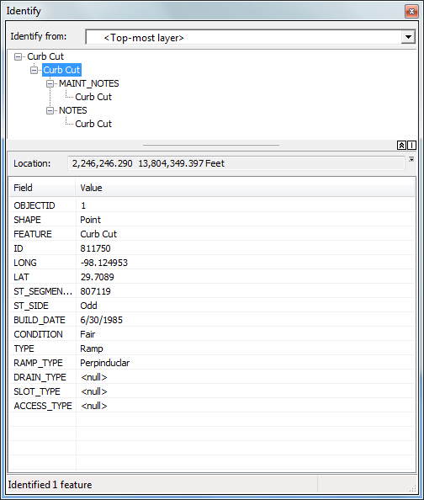
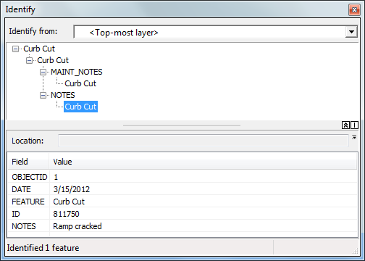
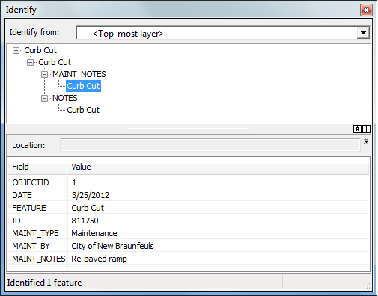

Gonzales, Eric. "Residents' Opposition becomes a Drain on County Flood Project." KENS 5 San Antonio. January 25, 2012. http://www.kens5.com/news/Local-Residents-become-a-drain-on-county-flood-projects-138088268.html (accessed February 2012). "Gruene Crossing Drainage Project Begins Today." KGNB New Braunfels, Texas. January 30, 2012. http://kgnb.am/news/gruene-crossing-drainage-project-begins-today (accessed February 2012).
ESRI. White Papers: GIS Library. http://www.esri.com/library/index.html (accessed February 2012)

