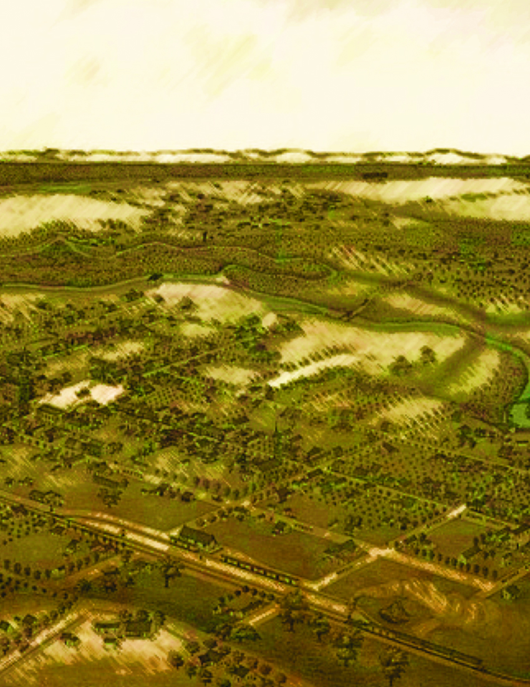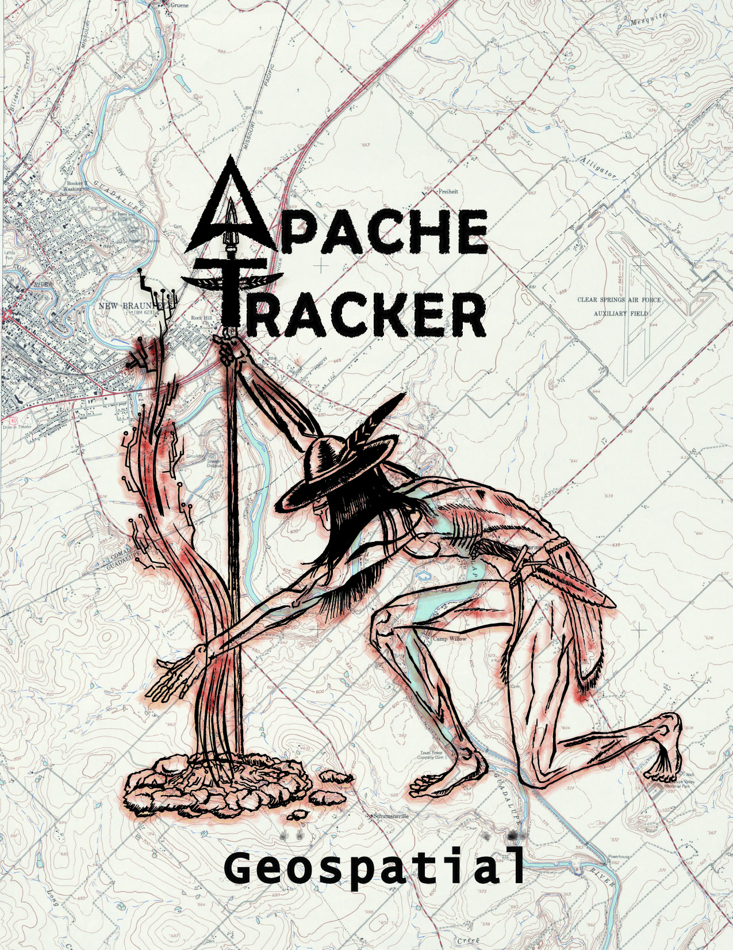**Warrant Visualization and Mapping:**

**Improved Criminal Information Management Using GIS**

***Presented to***

**New Braunfels Police Department**



***Prepared by***

**Apache Tracker Geospatial**



***Cory Vardaman (Project Manager)***

***Lisa Albanese (GIS, IT Technician, Analyst)***

***Joe Clark (Assistant Project Manager)***

***Ethan Roberts (GIS Analyst, Design Specialist)***

**Warrant Visualization and Mapping:**

**Improved Criminal Information Management Using GIS**

Table of Contents

1. ***Introduction***
   1. Summary…………………….……………………………………………..3
   2. Purpose.…………………...………………………………….……………3
   3. Scope………………………………………….………………..………….3
2. ***Proposal***
   1. Data………………………….………..……………………………........…4
   2. Methodology…………………..………..………………………….………5
   3. Implications……………………….……..………………………………...7
   4. Budget.………………………..…………………………………………....8
   5. Timetable.…………………….…………………………………….….……9
   6. Final Deliverables………………..………………………………………..10
3. ***Summary***
   1. Conclusion……………………………………………………………..….10
   2. Roles………………………………………………………………………10
   3. References……………..……………………………………………….….11

1. Introduction

**1.1 Summary**

Without enforcement laws become hollow gestures. When an individual commits a Class C Misdemeanor offence a fine is assessed. Failure to pay this fine results in the issue of a warrant for his or her arrest. Unfortunately, many of these warrants remain un-served for months—or even years—after issue. This situation results not only in offenders feeling that they can "get away with it" but it also generates a considerable administrative backlog. The City of New Braunfels estimates that it has 1,200 un-served local warrants alone, representing about 4 million dollars in unpaid fines.[1] However, these numbers do not indicate a lack of expertise or commitment on the part officers and staff of the city police department but, instead, illustrate the limitations of the current information management system. The incorporation of GIS into law enforcement planning and operations holds the potential to greatly enhance the efficiency and accuracy with which the officers of New Braunfels Police Department perform their vital service to the community.

1.2 Purpose

The Apache Tracker Geospatial Team's ultimate objective is to provide the City of New Braunfels Police Department with a GIS based tool that will increase the efficiency of the warrant serving process. The team will develop an automated tool that, using data already available within the City government and Police Department, will graphically display the location of active warrants on a map for officers and dispatch to reference. Ease of use is of prime importance. The tool will be user-friendly and highly automated, allowing for effective use by personnel unfamiliar with the GIS software. The regularly updated map(s) will:

* Allow officers to proactively pursue outstanding warrants.
* Increase officer safety when responding to calls.
* Assist in route planning and strategy in warrant round up operations.[2]

1.3 Scope

The warrant-mapping tool is envisioned first-and-foremost as an implement to assist the police department in day-to-day operations. As such, the area it covers will be limited to New Braunfels' Extra-Territorial Jurisdiction—the extended area around the city in which NBPD officers would be able to serve warrants. Additionally, the mapping will be limited to active Class C Misdemeanor warrants, of which the NBPD will supply an as yet undetermined number of "scrubbed" sample records for testing purposes. This limitation notwithstanding, one could imagine how—assuming the tool's success—this application could be extended to other offences or used for crime analysis.

2. Proposal

**2.1 Data**

Apache Tracker Geospatial will acquire data from the City of New Braunfels. The City of New Braunfels will supply us with shapefiles that we will use as base layers for mapping purposes. Required shapefiles will include: centerline, streets, streams, parcels, police districts, building footprints, extra territorial jurisdiction and address points (Table 1). Warrant data will be provided by the New Braunfels Police Department in Excel format. Apache Tracker Geospatial will be using ArcGIS 10 to produce the tool that will be utilized by the New Braunfels Police Department.

Table 1 Data Layers and their sources.[3]

|  |  |  |
| --- | --- | --- |
| Data* | File type | Source |
| Address Points | Shapefile | CNB |
| Center Line | Shapefile | CNB |
| Streets | Shapefile | CNB |
| Streams/Water | Shapefile | CNB |
| Building Footprints | Shapefile | CNB |
| Parcels | Shapefile | CNB |
| Police Districts | Shapefile | CNB |
| Extra Territorial Jurisdiction | Shapefile | CNB |
| Warrant Table | *.xls* Table | NBPD |

**2.2 Methodology**

The request for proposal calls for a tool to visualize active municipal warrants by using a geocoding model in order to reproduce updateable warrant maps for dispatch and mobile police units. Based on the needs assessment, our primary task consists of constructing a geocoding model that will spatially assign each warrant’s attributes to their respective physical addresses in an efficient and effective manner. In order to accomplish this, a specific methodology has been outlined:

1. Phase I: Data Preparation/File Conversion
2. Phase II: Basic Warrant Tool Development
3. Phase III: Advanced Tool Construction
4. Phase IV: Tool Proofing and Refinement

**Data Preparation/File Conversion**

* The New Braunfels municipal court issues physical and electronic warrant data to Police Department using the *Encode* system.
* Within the department, data from each individual *.xml* warrant file (AWC) is extracted and sent to the 911 Center Supervisor, Mr. Paul Marler.
* Mr. Marler inputs each individual warrant file into the *CRIMES* dispatch system.

Using this system, Mr. Marler will then be able to “clean” the individual .xml warrant files for effective input into the warrant geo-coding geo-database model.

* Hundreds of individual .xml warrant files will be converted into a single *.xls* spreadsheet that ArcGIS can effectively utilize. For ease of data conversion, it is agreed upon that a sample of active warrants and its attributes will be extracted from the *CRIME* warrants database in a tabular spreadsheet *.xls*. This data will be used as reference data in the geo-coding model.

**Basic Warrant Tool Development**

For this project, we will use the point address data as the primary layer. We will use street data as a secondary layer to catch unmatched addresses. New Braunfels GIS department has provided an address locator on their GIS Services Server.

* The warrant *.xls* file along with the address layers will be used to create an address locator. This will allow the warrant’s address fields to match up with the actual geographic address point layer’s fields allowing a faster naming convention.
* The new standardized warrant address format and the geographic address layers (NB server layers only) previously utilized will again be used to geocode the warrants.

Table 2 Warrant Model Flowchart

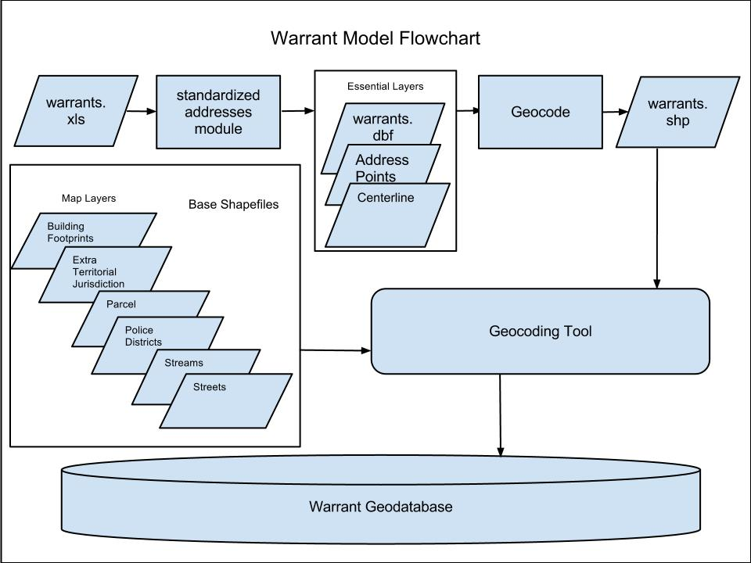

**Advanced Tool Construction**

* The geocoded warrant file (point file) will be the primary file used within the warrant geo-database where additional map layers will be added in order to create an easily referenced map document.

The selected map layers and the geocoded warrant file will be inputted into a file geo-database that can be employed into the NBPD server along with the reference ready map document.

* Each time the model is run through, a new geo-database and map document will be produced. New files will override previous copies to prevent buildup of old files in the geo-database.
* The map document and the geo-database’s layers (including the warrant point file) will be sourced to the NBPD server whereby all ArcGIS users will be able to exploit the active warrant data within the attached map document.

**Tool Proofing and Refinement**

The warrant data model will be recycled throughout each day’s (week’s) active warrant influx generated from the municipal court. This will consist of 300-400 possible new active warrants. In order to appropriately implement the model, a recycling of the warrant data must occur. Base shapefiles, such as street, address and city surface files will be extracted from their GIS Services to provide the most current data available. Since the model simply feeds on an input of new active warrant *.xls* files, it is but a matter of resourcing relative file path names to the newer warrant and map layer files.

* Warrant model will run through updated warrant file scenarios where older files will be resourced to newer ones and the model will be re-implemented.
* Warrant model will be installed within the NBPD server through Mike Parma, GIS Coordinator for New Braunfels. He requests the geo-processing tool output in geo-database format configurable to their ESRI servers.

**Additional Geo-processing Tools**

If time permits, the group will work on additional tools to increase utility of the model. Administrative support expressed interest in using the model for analysis purposes such as mapping hot spots or high-density locations. Field officers expressed interest in the ability to query warrant data to optimize their search based on criteria they feel is important. Mr. Parmer indicated that web-mapping applications, such as querying, are tasks he may have to build into the model in the future.

**2.3 Implications**

This project will aid the New Braunfels Police Department in effectively serving outstanding warrants. Apache Tracker Geospatial will provide a tool that dispatchers will use to produce maps. Officers will have access to these maps and utilize them in the serving of warrants. The tool, once implemented, will provide officers a graphic visualization of outstanding warrants that is currently lacking. This will be an improvement over the current system and will assist in time management and route planning. By updating the maps on a regular basis, the officers will stay abreast of current outstanding warrants that are on their patrol routes and in their districts.

This pertinent information will assist officers as how to proceed in the serving of said warrant or warrants. The NBPD could use the tool, after implementation, as the base for add-on law enforcement applications such as crime analysis, sex offender mapping and other applications.

**2.4 Budget**



**2.5 Timetable**

|  |  |  |  |  |  |  |
| --- | --- | --- | --- | --- | --- | --- |
| FEBRUARY  *February 22nd-Progress Report* | | | | | | |
| Mon | Tue | Wed | Thur | Fri | Sat | Sun |
| *30* | *31* | **1** | **2** | **3** | **4** | **5** |
| **6** | **7** | **8** | **9** | **10** | **11** | **12** |
| **13** | **14** | **15** | **16** | **17** | **18** | **19** |
| **20** | **21** | **22**  **Proposal Presentation** | **23** | **24** | **25** | **26** |
| **27** | **28** | **29** | *1* | *2* | *3* | *4* |

**Phase I: Data Preparation/ File Conversion**

* *. xml* warrant file extraction and cleaning by Mr. Marler
* CRIMES Dispatch system *.xml* “batching” to *.xls* conversion
* Testing of warrant *.xls* file (sample)
* Data collection

|  |  |  |  |  |  |  |
| --- | --- | --- | --- | --- | --- | --- |
| MARCH  *Development* | | | | | | |
| Mon | Tue | Wed | Thur | Fri | Sat | Sun |
| *27* | *28* | *29* | **1** | **2** | **3** | **4** |
| **5** | **6** | **7** | **8** | **9** | **10** | **11** |
| **12** | **13** | **14** | **15** | **16** | **17** | **18** |
| **19** | **20** | **21** | **22** | **23** | **24** | **25** |
| **26** | **27** | **28** | **29** | **30** | **31** | *1* |

**Phase II: Basic Warrant Tool Development Phase**

* Address locator referencing to standardized address format
* Warrant file geo-coding with NB server map layers
* Additional refinement

|  |  |  |  |  |  |  |
| --- | --- | --- | --- | --- | --- | --- |
| APRIL  *April 2nd-Progress Report* | | | | | | |
| Mon | Tue | Wed | Thur | Fri | Sat | Sun |
| *26* | *27* | *28* | *29* | *30* | *31* | **1** |
| **2** Progress Report | **3** | **4** | **5** | **6** | **7** | **8** |
| **9** | **10** | **11** | **12** | **13** | **14** | **15** |
| **16** | **17** | **18** | **19** | **20** | **21** | **22** |
| **23** | **24** | **25** | **27** | **27** | **28** | **29** |
| **30** | *1* | *2* | *3* | *4* | *5* | *6* |

**Phase III: Advanced Tool Construction**

* Geo-coded warrant file implemented with additional map layers to create…
  + File geo-database
  + Map document
* Model streamlining
* Reference map design

**Phase IV: Tool Proofing and Refinement**

* Additional testing of warrant model with data recycling: old warrant s replaced with new warrants
* Warrant model installed and tested on NBPD server
* Troubleshooting
* Additional design considerations

|  |  |  |  |  |  |  |
| --- | --- | --- | --- | --- | --- | --- |
| MAY  *May 4th-Final Report* | | | | | | |
| Mon | Tue | Wed | Thur | Fri | Sat | Sun |
| *30* | **1** | **2** | **3** | **4**  Final Report | **5** | **6** |
| **7** | **8** | **9** | **10** | **11** | **12** | **13** |
| **14** | **15** | **16** | **17** | **18** | **19** | **20** |
| **21** | **22** | **23** | **24** | **25** | **26** | **27** |

2.6 Final Deliverables

* Warrant Tool and Geo-database
* Final Report (Hard Copy)
* Display Poster
* Electronic Data Copy (CD Format)
  + Shapefiles
  + Metadata
  + Final Report
  + Power Point Presentation
  + Manuals
  + Readme File

**Note:** All electronic deliverables will undergo format compatibility in order to ensure client usability in conjunction with the client’s cooperation within the development process.

3. Summary

3.1 Conclusion

An automated warrant mapping tool will provide personnel of the NBPD, with little GIS training, the ability to create and maintain highly useful maps for reference and planning operations. These regularly updated maps will facilitate the proactive pursuit of outstanding warrants as well as increase safety when dealing with in progress calls. The tool will also increase efficiency in the warrant service process, which in turn should help alleviate the administrative backlog and reduce the total of current unpaid fines. Beyond these immediate affects, future use of GIS holds the potential to powerfully enhance the Police Department's information management and planning capabilities.

3.2 Roles

***Cory Vardaman (Project Manager)***

* Summary, Purpose, Scope, Conclusion

***Lisa Albanese (GIS Technician, Webmaster)***

* Methodology

***Joe Clark (Assistant Project Manager)***

* Data, Implications

***Ethan Roberts (GIS Technician, Graphic Design)***

* Illustrations, Budget, Timeline, Final Deliverables

3.3 References

New Braunfels Police Department. Request For Proposal. City of New Braunfels, Texas, January 2012.

ESRI. "A quick tour of creating custom tools." ArcGIS Resource Center Help. http://help.arcgis. com/en/arcgisdesktop/10.0/help/index.html#/A_quick_tour_of_creating_custom_tools/001500000001000000/) (accessed February 2012).

Essic, J. 2005. Batch Parsing XML Metadata for Cataloging GIS Data. *2005 ESRI Education Users Conference*. http://proceedings.esri.com/library/userconf/educ05/papers /pap1627.pdf (last accessed 11 February 2012).

1. New Braunfels Police Department, *Request For Proposal*, City of New Braunfels, Texas, January 2012.
2. NBPD, *Request For Proposal*.
3. Abbreviations CNB City of New Braunfels, NBPD New Braunfels Police Department